Filed by Cyclerion Therapeutics, Inc.
pursuant to Rule 425 under the Securities Act of 1933
and deemed filed pursuant to Rule 14a-12
under the Securities Exchange Act of 1934
Subject Company: Cyclerion Therapeutics, Inc.
Commission File No.: 333-295175
Date: August 12, 2026
This filing relates to the proposed transaction pursuant to the terms of that certain Agreement and Plan of Merger and Reorganization dated as of April 1, 2026, by and among Cyclerion Therapeutics, Inc., a Massachusetts corporation (“Cyclerion”), Cariboos Merger Sub Corp., a Delaware corporation and a wholly-owned subsidiary of Cyclerion (“First Merger Sub”), Cariboos Merger Sub II, LLC, a Delaware limited liability company and wholly-owned subsidiary of Cyclerion (“Second Merger Sub” and, together with First Merger Sub, the “Merger Subs”), and Korsana Biosciences, Inc., a Delaware corporation (“Korsana”) (as may be amended from time to time, the “Merger Agreement”), pursuant to which, among other matters, and subject to the satisfaction or waiver of the conditions set forth in the Merger Agreement, (i) First Merger Sub will merge with and into Korsana, with Korsana continuing as a wholly owned subsidiary of Cyclerion and the surviving corporation of the merger (the “First Merger”) and (ii) immediately following the First Merger and as part of the same overall transaction as the First Merger, Korsana will merge with and into Second Merger Sub.
On August 12, 2026, Cyclerion published the following communication on its X social media account:

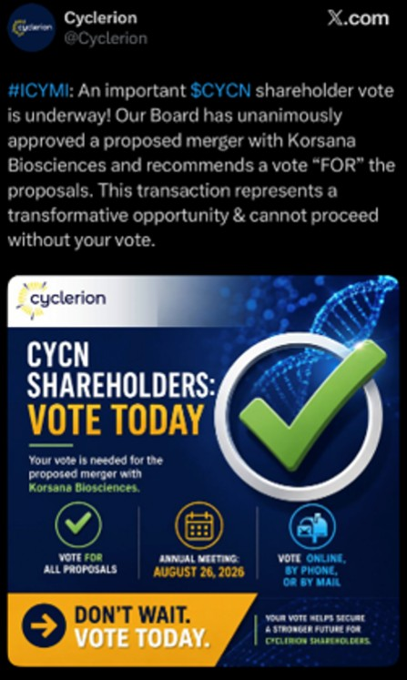
On August 12, 2026, Cyclerion published the following communication on its LinkedIn social media account:

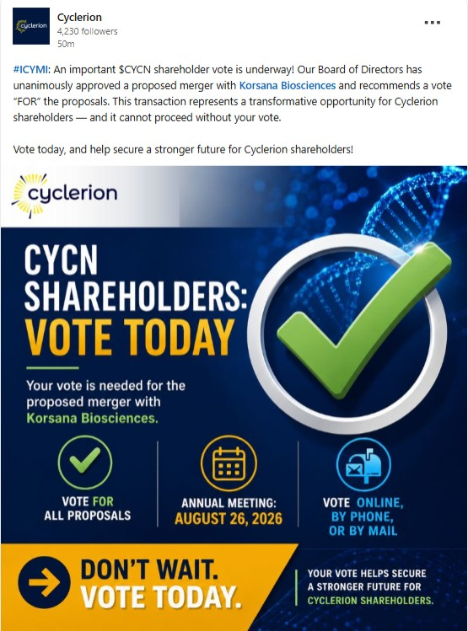

Forward-Looking Statements
This communication contains forward-looking statements (including within the meaning of Section 21E of the Exchange Act and Section 27A of the Securities Act) concerning Cyclerion, Korsana, the proposed transactions and other matters. These forward-looking statements include express or implied statements relating to the development, potential benefits and therapeutic potential of KRSA-028; Korsana having a pipeline of potential best-in-class therapies for neurodegenerative diseases; the strength of Korsana’s leadership team to position Korsana for long-term success, advance KRSA-028 into the clinic, and realize the full potential of the THETA platform; the expected timing of the closing of the Merger; the expected name, Nasdaq listing and ticker symbol of the combined company following completion of the Merger; the expected timing of clinical data from the KRSA-028 research program; and other statements that are not historical fact. The words “anticipate,” “believe,” “contemplate,” “continue,” “could,” “estimate,” “expect,” “intends,” “may,” “might,” “plan,” “possible,” “potential,” “predict,” “project,” “should,” “will,” “would” and similar expressions (including the negatives of these terms or variations of them) may identify forward-looking statements, but the absence of these words does not mean that a statement is not forward-looking. These forward-looking statements are based on current expectations and beliefs concerning future developments and their potential effects. There can be no assurance that future developments affecting Cyclerion, Korsana or the proposed transaction will be those that have been anticipated.
The forward-looking statements contained in this communication are based on current expectations and beliefs concerning future developments and their potential effects and therefore subject to other risks and uncertainties. These risks and uncertainties include, but are not limited to, risks associated with the possible failure to satisfy the conditions to the closing or consummation of the Merger, including Cyclerion’s failure to obtain shareholder approval for the Merger, risks associated with the potential failure to complete the financing transaction in a timely manner or at all, risks associated with the uncertainty as to the timing of the consummation of the Merger and the ability of each of Cyclerion and Korsana to consummate the transactions contemplated by the Merger, risks associated with Cyclerion’s continued listing on Nasdaq until closing of the Merger, the failure or delay in obtaining required approvals from any governmental or quasi-governmental entity necessary to consummate the Merger; the occurrence of any event, change or other circumstance or condition that could give rise to the termination of the Merger prior to the closing or consummation of the Merger, risks associated with the possible failure to realize certain anticipated benefits of the Merger, including with respect to future financial and operating results; the effect of the completion of the Merger on the combined company’s business relationships, operating results and business generally; risks associated with the combined company’s ability to manage expenses and unanticipated spending and costs that could reduce the combined company’s cash resources; risks related to the combined company’s ability to correctly estimate its operating expenses and other events; changes in capital resource requirements; risks related to the inability of the combined company to obtain sufficient additional capital to continue to advance its product candidates or its preclinical programs; the outcome of any legal proceedings that may be instituted against the combined company or any of its directors or officers related to the Merger Agreement or the transactions contemplated thereby; the ability of the combined company to obtain, maintain and protect its intellectual property rights, in particular those related to its product candidates; the combined company’s ability to advance the development of its product candidates or preclinical activities under the timelines it anticipates in planned and future clinical trials; the combined company’s ability to replicate in later clinical trials positive results found in preclinical studies and early-stage clinical trials of its product candidates; the combined company’s ability to realize the anticipated benefits of its research and development programs, strategic partnerships, licensing programs or other collaborations; regulatory requirements or developments and the combined company’s ability to obtain necessary approvals from the U.S. Food and Drug Administration or other regulatory authorities; changes to clinical trial designs and regulatory pathways; competitive responses to the Merger and changes in expected or existing competition; unexpected costs, charges or expenses resulting from the Merger; potential adverse reactions or changes to business relationships resulting from the completion of the Merger; legislative, regulatory, political and economic developments; and those risks and uncertainties and other factors more fully described in filings with the Securities and Exchange Commission, including reports filed on Form 10-K, 10-Q and 8-K and in other filings made by Cyclerion with the SEC from time to time and available at www.sec.gov. These forward-looking statements are based on current expectations, and with regard to the proposed transaction, are based on Cyclerion’s current expectations, estimates and projections about the expected date of closing of the proposed transaction and the potential benefits thereof, its business and industry, management’s beliefs and certain assumptions made by Cyclerion, all of which are subject to change. Such forward-looking statements are made as of the date of this release, and the parties undertake no obligation to update such statements to reflect subsequent events or circumstances, except as otherwise required by securities and other applicable law.

No Offer or Solicitation
This communication is not intended to and does not constitute (i) a solicitation of a proxy, consent or approval with respect to any securities or in respect of the proposed transaction or (ii) an offer to sell or the solicitation of an offer to subscribe for or buy or an invitation to purchase or subscribe for any securities pursuant to the proposed transaction or otherwise, nor shall there be any sale, issuance or transfer of securities in any jurisdiction in contravention of applicable law. No offer of securities shall be made except by means of a prospectus meeting the requirements of the Securities Act or an exemption therefrom. Subject to certain exceptions to be approved by the relevant regulators or certain facts to be ascertained, the public offer will not be made directly or indirectly, in or into any jurisdiction where to do so would constitute a violation of the laws of such jurisdiction, or by use of the mails or by any means or instrumentality (including without limitation, facsimile transmission, telephone and the internet) of interstate or foreign commerce, or any facility of a national securities exchange, of any such jurisdiction.
NEITHER THE SEC NOR ANY STATE SECURITIES COMMISSION HAS APPROVED OR DISAPPROVED OF THE SECURITIES OR DETERMINED IF THIS COMMUNICATION IS TRUTHFUL OR COMPLETE.
Important Additional Information About the Proposed Transaction
This communication does not substitute for the Form S-4, proxy statement/prospectus or for any other document that Cyclerion has filed or may file with the SEC in connection with the proposed transaction. In connection with the proposed transaction between Cyclerion and Korsana, Cyclerion has filed relevant materials with the SEC, including the Form S-4 that contains a proxy statement/prospectus.
CYCLERION URGES INVESTORS AND STOCKHOLDERS TO READ THE FORM S-4, PROXY STATEMENT/PROSPECTUS AND ANY OTHER RELEVANT DOCUMENTS THAT HAVE BEEN OR MAY BE FILED WITH THE SEC, AS WELL AS ANY AMENDMENTS OR SUPPLEMENTS TO THOSE DOCUMENTS, CAREFULLY AND IN THEIR ENTIRETY IF AND WHEN THEY BECOME AVAILABLE
BECAUSE THEY CONTAIN OR WILL CONTAIN IMPORTANT INFORMATION ABOUT CYCLERION, KORSANA, THE PROPOSED TRANSACTION AND RELATED MATTERS.
Investors and stockholders can obtain free copies of the Form S-4 and other documents filed by Cyclerion with the SEC (when they become available) through the website maintained by the SEC at www.sec.gov. In addition, investors and stockholders should note that Cyclerion communicates with investors and the public using its website (www.cyclerion.com) and the investor relations website (www.cyclerion.com/investor-resources) where anyone is able to obtain free copies of the Form S-4 and other documents filed by Cyclerion with the SEC and stockholders are urged to read the Form S-4 and the other relevant materials when they become available before making any voting or investment decision with respect to the proposed transaction.
Participants in the Solicitation
Cyclerion, Korsana and their respective directors and executive officers may be deemed to be participants in the solicitation of proxies from stockholders in connection with the proposed transaction. Information about Cyclerion’s directors and executive officers including a description of their interests in Cyclerion is included in Cyclerion’s Annual Report on Form 10-K, as filed with the SEC on March 30, 2026 and amended on April 30, 2026, and in subsequent reports filed with the SEC. Additional information regarding these persons and their interests in the proposed transaction are included in the Form S-4 relating to the proposed transaction filed with the SEC. These documents can be obtained free of charge from the sources indicated above.

