UNITED STATES

SECURITIES AND EXCHANGE COMMISSION
WASHINGTON, D.C. 20549

FORM 8-K

CURRENT REPORT

Pursuant to Section 13 or 15(d)
of the Securities Exchange Act of 1934

Date of Report (Date of earliest event reported): April 1, 2026

CYCLERION THERAPEUTICS, INC.

(Exact name of Registrant as Specified in Its Charter)

Massachusetts

001-38787

83-1895370

(State or Other Jurisdiction
of Incorporation)

(Commission
File Number)

(IRS Employer
Identification No.)

245 First Street, 18th Floor

Cambridge, Massachusetts 02142
(Address of Principal Executive Offices)

(857) 327-8778

(Registrant’s telephone number, including area code)

N/A

(Former Name or Former Address, if Changed Since Last Report)

Check the appropriate box below if the Form 8-K filing is intended to simultaneously satisfy the filing obligation of the registrant under any of the following provisions:

- Written communications pursuant to Rule 425 under the Securities Act (17 CFR 230.425)

- Soliciting material pursuant to Rule 14a-12 under the Exchange Act (17 CFR 240.14a-12)

- Pre-commencement communications pursuant to Rule 14d-2(b) under the Exchange Act (17 CFR 240.14d-2(b))

- Pre-commencement communications pursuant to Rule 13e-4(c) under the Exchange Act (17 CFR 240.13e-4(c))

Securities registered pursuant to Section 12(b) of the Act:

Title of each class |  | Trading |  | Name of each exchange
 |  | Symbol(s) |  | on which registered
Common Stock, no par value |  | CYCN |  | The Nasdaq Capital Market

Indícate by check mark whether the registrant is an emerging growth company as defined in Rule 405 of the Securities Act of 1933 (§230.405 of this chapter) or Rule 12b-2 of the Securities Exchange Act of 1934 (§240.12b-2 of this chapter).

Emerging growth company ☐

If an emerging growth company, indicate by check mark if the registrant has elected not to use the extended transition period for complying with any new or revised financial accounting standards provided pursuant to Section 13(a) of the Exchange Act. ☐

Item 1.01 Entry into a Material Definitive Agreement.

Merger Agreement

On April 1, 2026, Cyclerion Therapeutics, Inc., a Massachusetts corporation (“Cyclerion”), Cariboos Merger Sub Corp., a Delaware corporation and a wholly owned subsidiary of Cyclerion (“First Merger Sub”), Cariboos Merger Sub II, LLC, a Delaware limited liability company and wholly owned subsidiary of Cyclerion (“Second Merger Sub” and, together with First Merger Sub, “Merger Sub”), and Korsana Biosciences, Inc., a Delaware corporation (“Korsana”), entered into an Agreement and Plan of Merger and Reorganization (the “Merger Agreement”), pursuant to which, among other matters, and subject to the satisfaction or waiver of the conditions set forth in the Merger Agreement, (i) First Merger Sub will merge with and into Korsana, with Korsana continuing as a wholly owned subsidiary of Cyclerion and the surviving corporation of the merger (the “First Merger”), and

- immediately following the First Merger and as part of the same overall transaction as the First Merger, Korsana will merge with and into Second Merger Sub (the “Second Merger” and, together with the First Merger, the “Merger”). The Merger is intended to qualify for federal income tax purposes as a tax-free reorganization under the provisions of Section 368(a) of the Internal Revenue Code of 1986, as amended.

Subject to the terms and conditions of the Merger Agreement, at the effective time of the Merger (the “Effective Time”), (a) each then-outstanding share of Korsana common stock and Korsana preferred stock designated as “Series A Preferred Stock” will be converted into the right to receive a number of shares of Cyclerion common stock calculated in accordance with the Merger Agreement (the “Exchange Ratio”); provided, that in the event the aggregate number of shares of Cyclerion common stock issuable to holders of Korsana capital stock would result in the issuance of shares of Cyclerion common stock to a holder in excess of a specified percentage (initially set at a percentage up to 14.99%) total outstanding shares of Cyclerion common stock (such specified percentage, a “Beneficial Ownership Limitation”), then Cyclerion will issue to any such holder (x) shares of Cyclerion common stock up to such holder’s Beneficial Ownership Limitation and (y) in lieu of any shares in excess of such holder’s Beneficial Ownership Limitation, pre-funded warrants (the “Pre-Funded Warrants”), to purchase a number of shares of Cyclerion common stock upon exercise of such Pre-Funded Warrants equal to such excess shares, (b) each then-outstanding share of Korsana preferred stock designated as “Series Seed Preferred Stock” will be converted into the right to receive a number of shares of Series B Preferred Stock (as defined below) of Cyclerion calculated in accordance with the Merger Agreement, (c) each then-outstanding option to purchase shares of Korsana capital stock will be assumed by Cyclerion, subject to adjustment as set forth in the Merger Agreement, (d) each then-outstanding restricted stock unit award for shares of Korsana capital stock will be assumed by Cyclerion, subject to adjustment as set forth in the Merger Agreement and (e) each then-outstanding warrant to purchase shares of Korsana capital stock will be assumed by Cyclerion, subject to adjustment as set forth in the Merger Agreement. Under the terms of the Merger Agreement, prior to the closing of the Merger, the board of directors of Cyclerion (the “Board”) will accelerate the vesting of all equity awards of Cyclerion then outstanding but not then vested or exercisable. Each option to acquire shares of Cyclerion common stock with an exercise price per share greater than the volume weighted average closing trading price of a share of Cyclerion common stock on The Nasdaq Capital Market (“Nasdaq”) for the five (5) consecutive trading days ending three (3) trading days immediately prior to the date that is five (5) business days before the date of the Cyclerion shareholder meeting (the “Parent Closing Price”) will be cancelled in accordance with the terms of the Merger Agreement. At the closing of the Merger, each option to acquire shares of Cyclerion common stock with an exercise price less than or equal to the Parent Closing Price will be cancelled and converted into the right to receive an amount in cash without interest, less applicable tax withholding, equal to the product obtained by multiplying (i) the excess of the Parent Closing Price over the exercise price per share of the Cyclerion common stock underlying such option by (ii) the number of shares of Cyclerion common stock underlying such option.

-2-

Pursuant to the Exchange Ratio formula in the Merger Agreement, upon the closing of the Merger (and prior to closing of the financing described below), on a pro forma basis and based upon the number of shares of Cyclerion common stock expected to be issued in the Merger, pre-Merger Korsana stockholders will own approximately 1.5% of the combined company and pre-Merger Cyclerion shareholders will own approximately 98.5% of the combined company. For purposes of calculating the Exchange Ratio, (i) shares of Cyclerion common stock underlying options to purchase shares of Cyclerion common stock with an exercise price less than or equal to the Parent Closing Price and other rights to receive shares of Cyclerion common stock (other than options to acquire shares of Cyclerion common stock, to the extent cancelled at or prior to closing of the Merger in accordance with the Merger Agreement) outstanding as of immediately prior to the closing of the Merger will be deemed to be outstanding (on a fully-diluted and as-converted to Cyclerion common stock basis), and (ii) all shares of Korsana common stock underlying outstanding Korsana stock options, restricted stock units, warrants and other rights to receive shares of Korsana capital stock will be deemed to be outstanding (on a fully-diluted and as-converted to Korsana common stock basis), except for certain stock options and other equity awards made to directors, employees, consultants and other service providers of Korsana. The Exchange Ratio will be adjusted to the extent that Cyclerion net cash at closing is less than or greater than $0 and will be based on the amount of proceeds actually received by Korsana in the financing transaction described below, as further described in the Merger Agreement.

In connection with the Merger, Cyclerion will seek the approval of its shareholders to, among other things, (a) issue shares of Cyclerion common stock

issuable in connection with the Merger (including the shares of Cyclerion common stock issuable under the Series B Preferred Stock) and the financing

described below under the rules of Nasdaq, and (b) amend its restated articles of organization to (i) change the name of Cyclerion to Korsana

Biosciences, Inc., (ii) effect a reverse stock split of Cyclerion common stock, (iii) increase the number of shares of Cyclerion common stock that

Cyclerion is authorized to issue, (iv) redomicile Cyclerion from Massachusetts to such jurisdiction as may be determined by Korsana, (v) designate

shares of Cyclerion’s preferred stock as the Series B Preferred Stock and (vi) such other changes as are mutually agreeable to Cyclerion and Korsana

(the “Cyclerion Voting Proposals”). In connection with these matters, Cyclerion intends to file with the Securities and Exchange Commission (the

“SEC”) a registration statement on Form S-4 (the “Form S-4”), which will include a proxy statement and other relevant materials relating to a meeting

of Cyclerion shareholders to be held in connection with the Cyclerion Voting Proposals.

Each of Cyclerion and Korsana has agreed to customary representations, warranties and covenants in the Merger Agreement, including, among others, covenants relating to (1) using commercially reasonable efforts to obtain the regulatory approvals required by applicable law, (2) nonsolicitation of alternative acquisition proposals, (3) the conduct of their respective businesses during the period between the date of signing the Merger Agreement and the closing of the Merger, (4) Cyclerion using commercially reasonable efforts to maintain the existing listing of the Cyclerion common stock on Nasdaq and cause the shares of Cyclerion common stock to be issued in connection with the Merger to be approved for listing on Nasdaq prior to the closing of the Merger, and (5) Cyclerion filing with the SEC the Form S-4.

Consummation of the Merger is subject to certain closing conditions, including, among other things, (1) approval by requisite Cyclerion shareholders of the Cyclerion Voting Proposals, (2) approval by the requisite Korsana stockholders of the adoption and approval of the Merger Agreement and the transactions contemplated thereby, (3) Nasdaq’s approval of the listing application to be submitted in connection with the Merger, (4) Cyclerion’s Form S-4 becoming effective in accordance with the Securities Act of 1933, as amended (the “Securities Act”), and not being subject to any stop order or proceeding seeking a stop order, (5) the expiration of any applicable waiting periods (or extensions thereof) under the Hart Scott-Rodino Antitrust Improvements Act of 1976, as amended, and (6) the securities purchase agreement (described below) being in full force and effect providing for the receipt of not less than $150,000,000. Each party’s

-3-

obligation to consummate the Merger is also subject to other specified customary conditions, including regarding the accuracy of the representations and warranties of the other party, subject to the applicable materiality standard, and the performance in all material respects by the other party of its obligations under the Merger Agreement required to be performed on or prior to the date of the closing of the Merger.

The Merger Agreement contains certain termination rights of each of Cyclerion and Korsana. Upon termination of the Merger Agreement under specified circumstances, Cyclerion may be required to pay Korsana a termination fee and Korsana may be required to pay Cyclerion a termination fee.

Pursuant to Articles of Amendment to Cyclerion’s restated articles of organization to be filed by Cyclerion with the Secretary of the Commonwealth of Massachusetts (the “Articles of Amendment”) in connection with the Merger Agreement and the transactions thereunder, Cyclerion will establish the terms of a new series of preferred stock of Cyclerion designated as Series B Non-Voting Convertible Preferred Stock, no par value per share (the “Series B Preferred Stock”). Holders of the Series B Preferred Stock will be entitled to receive dividends on shares of Series B Preferred Stock equal to, on an as-if-converted-to-Cyclerion common stock basis, and in the same form as dividends actually paid on shares of the Cyclerion common stock. Except as otherwise required by the Articles of Amendment or law, the Series B Preferred Stock will not have voting rights. However, as long as any shares of Series B Preferred Stock are outstanding, Cyclerion will not, without the affirmative vote of the holders of a majority of the then outstanding shares of the Series B Preferred Stock, (a) alter or change adversely the powers, preferences or rights given to the Series B Preferred Stock, (b) alter or amend the description of rights of the Series B Preferred Stock set forth in its articles of organization, (c) amend its articles of organization, bylaws or other charter documents in any manner that adversely affects any rights of the holders of the Series B Preferred Stock, (d) file any articles of amendment, description of rights, preferences, limitations and relative rights of any series of Preferred Stock (as defined in the Articles of Amendment), if such action would adversely alter or change the preferences, rights, privileges or powers of, or restrictions provided for the benefit of the Series B Preferred Stock, (e) issue further shares of the Series B Preferred Stock or increase or decrease (other than by conversion) the number of authorized shares of the Series B Preferred Stock, (f) at any time while at least 30% of the originally issued Series B Preferred Stock remains issued and outstanding, (i) consummate either (A) a Fundamental Transaction (as defined in Cyclerion’s articles of organization) or (B) any merger or consolidation of Cyclerion or other business combination in which the shareholders of Cyclerion immediately before such transaction do not hold at least a majority of the capital stock of Cyclerion immediately after such transaction, (ii) increase the size of the Board, (iii) adopt, amend or repeal any written delegation of authority policy, corporate authority matrix or similar document, framework or schedule unless approved by the unanimous vote of the Board, or (iv) retain or replace Cyclerion’s registered independent public accounting firm, independent compensation consultant or corporate counsel, or (g) enter into any agreement with respect to any of the foregoing. The Articles of Amendment provide that for so long as at least 30% of the Series B Preferred Stock remains issued and outstanding, (i) the holders of record, exclusively and voting together as a separate class on an as-converted to common stock basis, shall be entitled to elect four (4) directors of Cyclerion (the “Preferred Directors”); and (ii) the holders of record of the shares of common stock and of any other class or series of voting stock (including the Series B Preferred Stock), exclusively and voting together as a single class on an as-converted to common stock basis, shall be entitled to elect the balance of the total number of directors of Cyclerion (the “At-Large Directors”); provided, however, for administrative convenience, the initial Preferred Directors may also be appointed by the Board in connection with the approval of the initial issuance of Series B Preferred Stock without a separate action by the holders. The Series B Preferred Stock does not have a preference upon any liquidation, dissolution or winding-up of Cyclerion.

Following the closing of the Merger, each share of Series B Preferred Stock then outstanding shall be convertible, at any time and from time to time, at the option of the holder of the Series B Preferred Stock,

-4-

into a number of shares equal to 1,000 shares of Cyclerion common stock, subject to certain limitations, including that a holder of Series B Preferred Stock is prohibited from converting shares of Series B Preferred Stock into shares of Cyclerion common stock if, as a result of such conversion, such holder, together with its affiliates, would beneficially own more than a specified percentage (initially set at 19.99%) of the total number of shares of Cyclerion common stock issued and outstanding immediately after giving effect to such conversion.

The transaction has received approval by the Board of Directors of both companies and is expected to close in the third quarter of 2026, subject to certain closing conditions, including, among other things, approval by the shareholders of Cyclerion and the stockholders of Korsana and the satisfaction of customary closing conditions.

At the effective time of the Merger, the Board is expected to consist of six (6) members, all of whom will be designated by Korsana. Upon the closing of the transaction, the combined company will be led by Korsana’s president and chief executive officer.

Financing Transaction

Concurrently with the execution and delivery of the Merger Agreement, certain institutional and accredited investors have entered into a securities purchase agreement (the “Purchase Agreement”) with Korsana, pursuant to which they have agreed, subject to the terms and conditions of such agreements, to purchase immediately prior to the Effective Time, shares of Korsana common stock and pre-funded warrants (together, the “PIPE Securities”) for an aggregate purchase price of approximately $380 million in a private placement (the “Private Placement”). The closing of the Private Placement is conditioned on the satisfaction or waiver of the conditions set forth in the Merger Agreement (in addition to other customary closing conditions) and is expected to occur immediately prior to the Effective Time.

The Purchase Agreement contains customary representations and warranties of Korsana, on the one hand, and the investors, on the other hand, and customary indemnification provisions. The Private Placement is also subject to approval of Korsana’s stockholders which is expected to be received at the same time as the approval of the Merger.

Pursuant to the terms of the Purchase Agreement, at closing of the Private Placement, Korsana will enter into a Registration Rights Agreement (the “Registration Rights Agreement”) with the purchasers of the PIPE Securities, which will provide for the registration and resale of the Cyclerion common stock issuable in exchange for the PIPE Securities upon closing of the Merger and the shares of Cyclerion common stock issuable upon exercise of the pre-funded warrants following the Merger, in accordance with the terms of the Registration Rights Agreement.

Shares of Korsana common stock and pre-funded warrants issued pursuant to this financing transaction will be converted into shares of Cyclerion common stock and pre-funded warrants to acquire shares Cyclerion common stock, in accordance with the Exchange Ratio and the Merger Agreement.

Contingent Value Rights Agreement

At or prior to the Effective Time, Cyclerion will enter into a Contingent Value Rights Agreement (the “CVR Agreement”) with a rights agent (“Rights Agent”) pursuant to which Cyclerion’s pre-Merger shareholders will receive one contingent value right (each, a “CVR”) for each outstanding share of Cyclerion common stock and Cyclerion preferred stock held by such shareholder on such date. Each CVR will represent the contractual right to receive certain net proceeds, if any, derived from any consideration that is paid to Cyclerion as a result of the disposition of Cyclerion’s pre-Merger legacy assets, net of any indemnity

-5-

obligations, transaction costs and certain other expenses, during the period beginning on the date of the closing of the Merger and ending (i) with respect to the sale, transfer, license or other disposition of all pre-Merger legacy assets other than those pre-Merger legacy assets described in the following clauses (ii) and (iii), upon the second (2nd) anniversary of the Closing Date, (ii) with respect to Cyclerion’s right to receive payments under that License Agreement, dated June 3, 2021, between Cyclerion and Akebia Therapeutics, Inc. (the “Akebia License Agreement”), the earlier of (A) the fifteenth

(15th) anniversary of the date of entry into the CVR Agreement and (B) the expiration or earlier termination by Akebia Therapeutics, Inc. of the Akebia License Agreement pursuant to its terms, and (iii) with respect to the sale, transfer or other disposition of the shares of common stock of Tisento Therapeutics Holdings, Inc. (“Tisento”) that were acquired by Cyclerion pursuant to that certain Asset Purchase Agreement, dated May 13, 2023, by and among Cyclerion, Tisento and JW Cycle, Inc., the earliest of (A) nine (9) months following the date of the consummation of Tisento’s initial public offering pursuant to a registration statement filed with, and declared effective by, the Securities and Exchange Commission pursuant to the Securities Act, (B) the sale of Tisento, and (C) the seventh (7th) anniversary of the Closing Date.

The contingent payments under the CVR Agreement, if they become payable, will become payable to the Rights Agent for subsequent distribution to the holders of the CVRs. In the event that no such proceeds are received, holders of the CVRs will not receive any payment pursuant to the CVR Agreement. There can be no assurance that any holders of CVRs will receive any payments with respect thereto.

The right to the contingent payments contemplated by the CVR Agreement is a contractual right only and will not be transferable, except in the limited circumstances specified in the CVR Agreement. The CVRs will not be evidenced by a certificate or any other instrument and will not be registered with the SEC. The CVRs will not have any voting or dividend rights and will not represent any equity or ownership interest in Cyclerion or any of its affiliates. No interest will accrue on any amounts payable in respect of the CVRs.

Support Agreements and Lock-Up Agreement

Concurrently with the execution of the Merger Agreement, (i) certain stockholders of Korsana (solely in their respective capacities as Korsana stockholders) holding approximately 43.9% of the outstanding shares of Korsana capital stock have entered into support agreements with Cyclerion and Korsana to vote all of their shares of Korsana capital stock in favor of the adoption and approval of the Merger Agreement and the transactions contemplated thereby and against any alternative acquisition proposals (the “Korsana Support Agreements”) and (ii) the directors and officers of Cyclerion holding approximately 24.2% of the outstanding shares of Cyclerion common stock have entered into support agreements with Cyclerion and Korsana to vote all of their shares of Cyclerion common stock in favor of the Cyclerion Voting Proposals and against any alternative acquisition proposals (the “Cyclerion Support Agreements,” and, together with the Korsana Support Agreements, the “Support Agreements”).

Concurrently with the execution of the Merger Agreement, certain executive officers, directors and stockholders of Korsana have entered into lockup agreements (the “Lock-Up Agreements”) pursuant to which, subject to specified exceptions, they have agreed not to transfer their shares of Cyclerion common stock for the 180-day period following the closing of the Merger.

The preceding summaries of the Merger Agreement, the Articles of Amendment, the Support Agreements, the CVR Agreement, the Purchase Agreement and the Lock-Up Agreements do not purport to be complete and are qualified in their entirety by reference to the Merger Agreement, the form Articles of Amendment, the form of Korsana Support Agreement, the form of Cyclerion Support Agreement, the form of Purchase Agreement, the form of Registration Rights Agreement, the form of Lock-Up Agreement and the form of CVR Agreement, which are filed as Exhibits 2.1, 3.1, 10.1, 10.2, 10.3, 10.4, 10.5 and 10.6, respectively, to this Current Report on Form 8-K and which are incorporated herein by reference. The Merger Agreement

-6-

has been attached as an exhibit to this Current Report on Form 8-K to provide investors and securityholders with information regarding its terms. It is not intended to provide any other factual information about Korsana or Cyclerion or to modify or supplement any factual disclosures about Cyclerion in its public reports filed with the SEC. The Merger Agreement includes representations, warranties and covenants of Korsana, Cyclerion and Merger Sub made solely for the purpose of the Merger Agreement and solely for the benefit of the parties thereto in connection with the negotiated terms of the Merger Agreement. Investors should not rely on the representations, warranties and covenants in the Merger Agreement or any descriptions thereof as characterizations of the actual state of facts or conditions of Korsana, Cyclerion or any of their respective affiliates. Moreover, certain of those representations and warranties may not be accurate or complete as of any specified date, may be subject to a contractual standard of materiality different from those generally applicable to SEC filings or may have been used for purposes of allocating risk among the parties to the Merger Agreement, rather than establishing matters of fact.

Item 5.01 Changes in Control of Registrant.

To the extent required by this Item, the information included in Item 1.01 of this Current Report on Form 8-K is incorporated herein by reference.

Item 5.02 Departure of Directors or Certain Officers; Election of Directors; Appointment of Certain Officers; Compensatory Arrangements of Certain Officers.

To the extent required by this Item, the information included in Item 1.01 of this Current Report on Form 8-K is incorporated herein by reference.

On April 1, 2026, the Company entered into an amended and restated offer letter (the “A&R Graul Offer Letter”) with its Regina Graul, Ph.D., Cyclerion’s President and Chief Executive Officer.

Under the A&R Graul Offer Letter, Ms. Graul will be entitled, at the Board’s discretion, to receive a bonus of up to $150,000 payable upon the consummation of transaction resulting in a change of control of Cyclerion. Ms. Graul is also entitled to (i) severance pay of nine months’ base salary,

- acceleration of vesting of any then unvested shares under then unvested and outstanding Cyclerion equity or equity-based awards and (iii) health insurance premium contributions for twelve (12) months, in each case, following termination without cause or resignation for Good Reason (as defined in the A&R Graul Offer Letter).

The foregoing summary of the principal terms of the A&R Graul Offer Letter does not purport to be complete and is qualified in its entirety by reference to the full copy of the A&R Graul Offer Letter filed hereto as Exhibit 10.7 and incorporated herein by reference.

Item 7.01 Regulation FD Disclosure.

On April 1, 2026, Cyclerion and Korsana issued a joint press release announcing the entry into the Merger Agreement. The press release is furnished as Exhibit 99.1 to this Current Report on Form 8-K and incorporated herein by reference, except that the information contained on the websites referenced in the press release is not incorporated herein by reference.

Furnished as Exhibit 99.2 hereto and incorporated herein by reference is the investor presentation that will be used by Cyclerion and Korsana in connection with the Merger, including the conference call described below.

Cyclerion hosted a conference call to discuss the Merger as well as Korsana’s platform and pipeline assets at 8:00 a.m. Eastern time on April 1, 2026. Furnished as Exhibit 99.3 hereto and incorporated herein by reference is the transcript that was used by Cyclerion and Korsana in connection with the merger agreement announcement conference call.

-7-

The information in this Item 7.01, including Exhibits 99.1, 99.2 and 99.3 attached hereto, shall not be deemed “filed” for purposes of Section 18 of the Securities Exchange Act of 1934, as amended (the “Exchange Act”), or otherwise subject to the liabilities of that section, nor shall it be deemed incorporated by reference in any filing under the Securities Act or the Exchange Act, except as expressly set forth by specific reference in such filing.

Forward-Looking Statements

This Current Report on Form 8-K and the exhibits filed or furnished herewith contain forward-looking statements (including within the meaning of Section 21E of the Exchange Act and Section 27A of the Securities Act) concerning Cyclerion, Korsana, the proposed transactions and other matters. These forward-looking statements include express or implied statements relating to the structure, timing and completion of the proposed Merger; the combined company’s listing on Nasdaq after closing of the proposed Merger; expectations regarding the ownership structure of the combined company; expectations regarding the financing transaction and the closing thereof; the expected executive officers and directors of the combined company; the expected contribution and payment of dividends in connection with the Merger, including the timing thereof; the future operations of the combined company; the nature, strategy and focus of the combined company; the development and commercial potential and potential benefits of any product candidates of the combined company; anticipated preclinical and clinical drug development activities and related timelines, including the expected timing for data and other clinical results; and other statements that are not historical fact. The words “anticipate,” “believe,” “contemplate,” “continue,” “could,” “estimate,” “expect,” “intends,” “may,” “might,” “plan,” “possible,” “potential,” “predict,” “project,” “should,” “will,” “would” and similar expressions (including the negatives of these terms or variations of them) may identify forward-looking statements, but the absence of these words does not mean that a statement is not forward-looking. These forward-looking statements are based on current expectations and beliefs concerning future developments and their potential effects. There can be no assurance that future developments affecting Cyclerion, Korsana or the proposed transaction will be those that have been anticipated.

The forward-looking statements contained in this communication are based on current expectations and beliefs concerning future developments and their potential effects and therefore subject to other risks and uncertainties. These risks and uncertainties include, but are not limited to, risks associated with the possible failure to satisfy the conditions to the closing or consummation of the Merger, including Cyclerion’s failure to obtain shareholder approval for the Merger, risks associated with the potential failure to complete the financing transaction in a timely manner or at all, risks associated with the uncertainty as to the timing of the consummation of the Merger and the ability of each of Cyclerion and Korsana to consummate the transactions contemplated by the Merger, risks associated with Cyclerion’s continued listing on Nasdaq until closing of the Merger, the failure or delay in obtaining required approvals from any governmental or quasi-governmental entity necessary to consummate the Merger; the occurrence of any event, change or other circumstance or condition that could give rise to the termination of the Merger prior to the closing or consummation of the Merger, risks associated with the possible failure to realize certain anticipated benefits of the Merger, including with respect to future financial and operating results; the effect of the completion of the Merger on the combined company’s business relationships, operating results and business generally; risks associated with the combined company’s ability to manage expenses and unanticipated spending and costs that could reduce the combined company’s cash resources; risks related to the combined company’s ability to correctly estimate its operating expenses and other events; changes in capital resource requirements; risks related to the inability of the combined company to obtain sufficient additional capital to continue to advance its product candidates or its preclinical programs; the outcome of any legal proceedings that may be instituted against the combined company or any of its directors or officers related

-8-

to the Merger Agreement or the transactions contemplated thereby; the ability of the combined company to obtain, maintain and protect its intellectual property rights, in particular those related to its product candidates; the combined company’s ability to advance the development of its product candidates or preclinical activities under the timelines it anticipates in planned and future clinical trials; the combined company’s ability to replicate in later clinical trials positive results found in preclinical studies and early-stage clinical trials of its product candidates; the combined company’s ability to realize the anticipated benefits of its research and development programs, strategic partnerships, licensing programs or other collaborations; regulatory requirements or developments and the combined company’s ability to obtain necessary approvals from the U.S. Food and Drug Administration or other regulatory authorities; changes to clinical trial designs and regulatory pathways; competitive responses to the Merger and changes in expected or existing competition; unexpected costs, charges or expenses resulting from the Merger; potential adverse reactions or changes to business relationships resulting from the completion of the Merger; legislative, regulatory, political and economic developments; and those risks and uncertainties and other factors more fully described in filings with the Securities and Exchange Commission, including reports filed on Form 10-K, 10-Q and 8-K and in other filings made by Cyclerion with the SEC from time to time and available at www.sec.gov. These forward-looking statements are based on current expectations, and with regard to the proposed transaction, are based on Cyclerion’s current expectations, estimates and projections about the expected date of closing of the proposed transaction and the potential benefits thereof, its business and industry, management’s beliefs and certain assumptions made by Cyclerion, all of which are subject to change. Such forward-looking statements are made as of the date of this release, and the parties undertake no obligation to update such statements to reflect subsequent events or circumstances, except as otherwise required by securities and other applicable law.

No Offer or Solicitation

This Current Report on Form 8-K and the exhibits filed or furnished herewith are not intended to and do not constitute (i) a solicitation of a proxy, consent or approval with respect to any securities or in respect of the proposed transaction or (ii) an offer to sell or the solicitation of an offer to subscribe for or buy or an invitation to purchase or subscribe for any securities pursuant to the proposed transaction or otherwise, nor shall there be any sale, issuance or transfer of securities in any jurisdiction in contravention of applicable law. No offer of securities shall be made except by means of a prospectus meeting the requirements of the Securities Act or an exemption therefrom. Subject to certain exceptions to be approved by the relevant regulators or certain facts to be ascertained, the public offer will not be made directly or indirectly, in or into any jurisdiction where to do so would constitute a violation of the laws of such jurisdiction, or by use of the mails or by any means or instrumentality (including without limitation, facsimile transmission, telephone and the internet) of interstate or foreign commerce, or any facility of a national securities exchange, of any such jurisdiction.

NEITHER THE SEC NOR ANY STATE SECURITIES COMMISSION HAS APPROVED OR DISAPPROVED OF THE SECURITIES OR DETERMINED IF THIS CURRENT REPORT ON FORM 8-K AND THE EXHIBITS FILED OR FURNISHED HEREWITH ARE TRUTHFUL OR COMPLETE.

Important Additional Information About the Proposed Transaction Will be Filed with the SEC

This Current Report on Form 8-K and the exhibits filed or furnished herewith are not substitutes for any other document that Cyclerion may file with the SEC in connection with the proposed transaction, including the registration statement on Form S-4 (the “Form S-4”) that will contain a proxy statement and prospectus. In connection with the proposed transaction between Cyclerion and Korsana, Cyclerion intends to file relevant materials with the SEC, including the Form S-4. CYCLERION URGES INVESTORS AND SHAREHOLDERS TO READ THE REGISTRATION STATEMENT, INCLUDING THE PROXY STATEMENT/PROSPECTUS CONTAINED THEREIN, AND ANY

-9-

OTHER RELEVANT DOCUMENTS THAT MAY BE FILED WITH THE SEC, AS WELL AS ANY AMENDMENTS OR SUPPLEMENTS TO THESE DOCUMENTS, CAREFULLY AND IN THEIR ENTIRETY IF AND WHEN THEY BECOME AVAILABLE BECAUSE THEY WILL CONTAIN IMPORTANT INFORMATION ABOUT CYCLERION, KORSANA, THE PROPOSED TRANSACTION AND RELATED MATTERS. Investors and shareholders will be able to obtain free copies of the Form S-4 and other documents filed by Cyclerion with the SEC (when they become available) through the website maintained by the SEC at www.sec.gov. In addition, investors and shareholders should note that Cyclerion communicates with investors and the public using its website (https://www.cyclerion.com/) and the investor relations website (https://ir.cyclerion.com/) where anyone will be able to obtain free copies of the Registration Statement and included proxy statement/prospectus and other documents filed by Cyclerion with the SEC and shareholders are urged to read the Registration Statement and included proxy statement/prospectus and the other relevant materials when they become available before making any voting or investment decision with respect to the proposed transaction.

Participants in the Solicitation

Cyclerion, Korsana and their respective directors and executive officers may be deemed to be participants in the solicitation of proxies from shareholders in connection with the proposed transaction. Information about Cyclerion’s directors and executive officers, including a description of their interests in Cyclerion is included in Cyclerion’s most recent definitive proxy statement, as filed with the SEC on April 29, 2025. Additional information regarding these persons and their interests in the proposed transaction will be included in the proxy statement/prospectus relating to the proposed transaction when it is filed with the SEC. These documents can be obtained free of charge from the sources indicated above.

-10-

Item 9.01 Financial Statements and Exhibits.

(d) Exhibits.

Exhibit |  |  |  |  |  |  |  |  |  |  |  | Description
Number
2.1* |  | Agreement and Plan of Merger and Reorganization, dated as of April 1, 2026, by and among Cyclerion Therapeutics, Inc., Cariboos
 |  | Merger Sub Corp., Cariboos Merger Sub II, LLC and Korsana Biosciences, Inc.
3.1 |  | Form of Articles of Amendment to the Restated Articles of Organization of Cyclerion Therapeutics, Inc.
10.1 |  | Form of Korsana Support Agreement
10.2 |  | Form of Cyclerion Support Agreement
10.3 |  | Form of Korsana Securities Purchase Agreement
10.4 |  | Form of Registration Rights Agreement
10.5 |  | Form of Lock-Up Agreement
10.6 |  | Form of CVR Agreement
10.7 |  | A&R Graul Offer Letter
99.1 |  | Press Release, issued on April 1, 2026
99.2 |  | Investor Presentation, dated April 2026
99.3 |  | Conference Call Transcript dated April 1, 2026

104Cover Page Interactive Data File (formatted as Inline XBRL)

* Exhibits and/or schedules have been omitted pursuant to Item 601(a)(5) of Regulation S-K. The registrant hereby undertakes to furnish supplementally copies of any of the omitted exhibits and schedules upon request by the SEC; provided, however, that the registrant may request confidential treatment pursuant to Rule 24b-2 under the Exchange Act for any exhibits or schedules so furnished.

-11-

SIGNATURES

Pursuant to the requirements of the Securities Exchange Act of 1934, the registrant has duly caused this report to be signed on its behalf by the undersigned hereunto duly authorized.

CYCLERION THERAPEUTICS, INC.

(Registrant)

 | By:. | /s/ Regina Graul, Ph.D
Date: April 1, 2026 | Name: | Regina Graul, Ph.D.
 | Title: | President and Chief Executive Officer

Exhibit 2.1

Confidential

Execution Version

AGREEMENT AND PLAN OF MERGER AND REORGANIZATION

among:

KORSANA BIOSCIENCES, INC.;

CARIBOOS MERGER SUB CORP.;

CARIBOOS MERGER SUB II, LLC; and

CYCLERION THERAPEUTICS, INC.

Dated as of April 1, 2026

 | TABLE OF CONTENTS
 |  | Page
Section 1. Definitions and Interpretative Provisions |  | 3
1.1 | Definitions | 3
1.2 | Other Definitional and Interpretative Provisions | 18
Section 2. Description of Transaction |  | 19
2.1 | The Merger | 19
2.2 | Effects of the Merger | 19
2.3 | Closing; First Effective Time; Second Effective Time | 19
2.4 | Organizational Documents; Directors and Officers | 20
2.5 | Conversion of Company, First Merger Sub and Second Merger Sub Equity Securities | 21
2.6 | Closing of the Company’s Transfer Books | 23
2.7 | Surrender of Company Capital Stock | 23
2.8 | Calculation of Parent Net Cash and Company Valuation | 24
2.9 | Contingent Value Right | 27
2.10 | Further Action | 27
2.11 | Intended Tax Treatment | 27
2.12 | Withholding | 27
2.13 | Appraisal Rights | 28
Section 3. Representations and Warranties of the Company |  | 28
3.1 | Due Organization; Subsidiaries | 28
3.2 | Organizational Documents | 29
3.3 | Authority; Binding Nature of Agreement | 29
3.4 | Vote Required | 29
3.5 | Non-Contravention; Consents | 29
3.6 | Capitalization | 30
3.7 | Financial Statements | 31
3.8 | Absence of Changes | 32
3.9 | Absence of Undisclosed Liabilities | 32
3.10 | Title to Assets | 32
3.11 | Real Property; Leasehold | 33
3.12 | Intellectual Property | 33
3.13 | Agreements, Contracts and Commitments | 35
3.14 | Compliance; Permits; Restrictions | 37
3.15 | Legal Proceedings; Orders | 39
3.16 | Tax Matters | 40
 | A-2
3.17 | Employee and Labor Matters; Benefit Plans | 41
3.18 | Environmental Matters | 43
3.19 | Insurance | 43
3.20 | No Financial Advisors | 44
3.21 | Transactions with Affiliates | 44
3.22 | Privacy and Data Security | 44
3.23 | Trade Control Laws | 44
3.24 | Ownership of Parent Capital Stock | 45
3.25 | No Other Representations or Warranties | 45
Section 4. Representations and Warranties of Parent, First Merger Sub and Second Merger Sub |  | 45
4.1 | Due Organization; Subsidiaries | 45
4.2 | Organizational Documents | 46
4.3 | Authority; Binding Nature of Agreement | 46
4.4 | Vote Required | 47
4.5 | Non-Contravention; Consents | 47
4.6 | Capitalization | 48
4.7 | SEC Filings; Financial Statements | 49
4.8 | Absence of Changes | 51
4.9 | Absence of Undisclosed Liabilities | 51
4.10 | Title to Assets | 52
4.11 | Real Property; Leasehold | 52
4.12 | Intellectual Property | 52
4.13 | Agreements, Contracts and Commitments | 54
4.14 | Compliance; Permits; Restrictions | 56
4.15 | Legal Proceedings; Orders | 58
4.16 | Tax Matters | 59
4.17 | Employee and Labor Matters; Benefit Plans | 60
4.18 | Environmental Matters | 62
4.19 | Insurance | 62
4.20 | Transactions with Affiliates | 63
4.21 | No Financial Advisors | 63
4.22 | Valid Issuance | 63
4.23 | Privacy and Data Security | 63
4.24 | Trade Control Laws | 63
4.25 | No Other Representations or Warranties | 64
 | A-3
Section 5. Certain Covenants of the Parties |  | 64
5.1 | Operation of Parent’s Business | 64
5.2 | Operation of the Company’s Business | 67
5.3 | Access and Investigation | 68
5.4 | No Solicitation | 69
5.5 | Notification of Certain Matters | 70
Section 6. Additional Agreements of the Parties |  | 70
6.1 | Registration Statement, Proxy Statement | 70
6.2 | Company Stockholder Written Consent | 72
6.3 | Parent Shareholder Meeting | 74
6.4 | Efforts; Regulatory Approvals | 76
6.5 | Company Options; Company RSUs; Company Warrants | 77
6.6 | Employee Benefits | 78
6.7 | Indemnification of Officers and Directors | 79
6.8 | Disclosure | 81
6.9 | Listing | 81
6.10 | Tax Matters | 81
6.11 | Legends | 82
6.12 | Officers and Directors | 83
6.13 | Termination of Certain Agreements and Rights | 83
6.14 | Section 16 Matters | 83
6.15 | Allocation Information | 83
6.16 | Parent SEC Documents | 83
6.17 | Obligations of Merger Subs | 83
6.18 | Parent Pre-Closing Dividend | 83
6.19 | Company Pre-Closing Financing | 84
6.20 | Termination of Certain Agreements | 84
Section 7. Conditions Precedent to Obligations of Each Party |  | 84
7.1 | Regulatory Approvals | 84
7.2 | No Restraints | 84
7.3 | Stockholder Approval | 84
7.4 | Listing | 84
7.5 | Effectiveness of Registration Statement | 84
Section 8. Additional Conditions Precedent to Obligations of Parent and Merger Subs |  | 85
8.1 | Accuracy of Representations | 85
8.2 | Performance of Covenants | 85
 | A-4
8.3 | Documents | 85
8.4 | No Company Material Adverse Effect | 86
8.5 | Company Stockholder Written Consent | 86
8.6 | Company Pre-Closing Financing | 86
Section 9. Additional Conditions Precedent to Obligation of the Company |  | 86
9.1 | Accuracy of Representations | 86
9.2 | Performance of Covenants | 86
9.3 | Documents | 87
9.4 | No Parent Material Adverse Effect | 87
9.5 | Parent Pre-Closing Dividend | 87
9.6 | Parent Articles of Amendment | 87
9.7 | Termination of Agreements | 87
Section 10. Termination |  | 87
10.1 | Termination | 87
10.2 | Effect of Termination | 89
10.3 | Expenses; Termination Fees | 89
Section 11. Miscellaneous Provisions |  | 90
11.1 | Non-Survival of Representations and Warranties | 90
11.2 | Amendment | 91
11.3 | Waiver | 91
11.4 | Entire Agreement; Counterparts; Exchanges by Electronic Transmission | 91
11.5 | Applicable Law; Jurisdiction; WAIVER OF RIGHT TO TRIAL BY JURY | 91
11.6 | Assignability | 92
11.7 | Notices | 92
11.8 | Cooperation | 92
11.9 | Severability | 93
11.10 | Other Remedies; Specific Performance | 93
11.11 | No Third-Party Beneficiaries | 93
Exhibits:

Exhibit A-1 Form of Parent Shareholder Support Agreement

Exhibit A-2 Form of Company Stockholder Support Agreement

Exhibit B Form of Lock-Up Agreement

Exhibit C Form of Subscription Agreement

A-5

Exhibit D-1 First Certificate of Merger, including certificate of incorporation of the First Step Surviving Corporation attached as Exhibit A thereto, incorporated by reference into this Agreement

Exhibit D-2 Second Certificate of Merger, incorporated by reference into this Agreement

Exhibit E Form of Parent Articles of Amendment Schedule

Exhibit F Form of CVR Agreement

Exhibit G Form of Pre-Funded Warrant

A-6

AGREEMENT AND PLAN OF MERGER AND REORGANIZATION

THIS AGREEMENT AND PLAN OF MERGER AND REORGANIZATION (this “Agreement”) is made and entered into as of April 1, 2026, by and among CYCLERION THERAPEUTICS, INC., a Massachusetts corporation (“Parent”), CARIBOOS MERGER SUB CORP., a Delaware corporation and wholly owned subsidiary of Parent (“First Merger Sub”), CARIBOOS MERGER SUB II, LLC, a Delaware limited liability company and wholly owned subsidiary of Parent (“Second Merger Sub” and, together with First Merger Sub, “Merger Subs” and each, a “Merger Sub”), and KORSANA BIOSCIENCES, INC., a Delaware corporation (the “Company”). Certain capitalized terms used in this Agreement are defined in Section 1.

RECITALS

A. Parent and the Company intend to effect a merger of First Merger Sub with and into the Company (the “First Merger”) in accordance with this Agreement and the DGCL. Upon consummation of the First Merger, First Merger Sub will cease to exist and the Company will become a wholly owned subsidiary of Parent.

B. Immediately following the First Merger and as part of the same overall transaction as the First Merger, the Company will merge with and into Second Merger Sub (the “Second Merger” and, together with the First Merger, the “Merger”), with Second Merger Sub being the surviving entity of the Second Merger.

C. The Parties intend that, (i) the First Merger and the Second Merger, taken together, will constitute an integrated transaction described in Rev. Rul. 2001-46, 2001-2 C.B. 321 that qualifies as a “reorganization” within the meaning of Section 368(a) of the Code, and (ii) this Agreement will constitute, and is hereby adopted as, a plan of reorganization within the meaning of Treasury Regulations Sections 1.368-2(g) and 1.368-3(a).

D. The Parent Board has (i) determined that the Contemplated Transactions are fair to, advisable and in the best interests of Parent and its stockholders, (ii) adopted, approved and declared advisable this Agreement and the Contemplated Transactions, including the issuance of shares of Parent Capital Stock to the stockholders of the Company pursuant to the terms of this Agreement, and (iii) determined to recommend, upon the terms and subject to the conditions set forth in this Agreement, that the shareholders of Parent vote to approve this Agreement and thereby approve the Parent Shareholder Matters, including the Contemplated Transactions, and against any competing proposals.

E. The First Merger Sub Board has (i) determined that the Contemplated Transactions are fair to, advisable, and in the best interests of First Merger Sub and its sole stockholder, (ii) approved and declared advisable this Agreement and the Contemplated Transactions, and (iii) determined to recommend, upon the terms and subject to the conditions set forth in this Agreement, that the stockholder of First Merger Sub votes to adopt this Agreement and thereby approve the Contemplated Transactions, and against any competing proposals.

F. The sole member of the Second Merger Sub has (i) determined that the Contemplated Transactions are fair to, advisable, and in the best interests of Second Merger Sub and its sole member, (ii) approved and declared advisable this Agreement and the Contemplated Transactions, and

- determined to recommend, upon the terms and subject to the conditions set forth in this Agreement, that the sole member of Second Merger Sub votes to adopt this Agreement and thereby approve the Contemplated Transactions, and against any competing proposals.

G. The Company Board has (i) determined that the Contemplated Transactions are fair to, advisable and in the best interests of the Company and its stockholders, (ii) approved and declared advisable this Agreement and the Contemplated Transactions, and (iii) determined to recommend, upon the terms and subject to the conditions set forth in this Agreement, that the stockholders of the Company vote to adopt this Agreement and thereby approve the Contemplated Transactions.

H. Concurrently with the execution and delivery of this Agreement and as a condition and inducement to the Company’s willingness to enter into this Agreement, each of the officers and directors set forth on Section A of the Parent Disclosure Letter (solely in their capacity as shareholders of Parent) are executing support agreements in favor of the Company in substantially the form attached hereto as Exhibit A-1 (the “Parent Shareholder Support Agreement”), pursuant to which such Persons have, subject to the terms and conditions set forth therein, agreed to vote all of their shares of Parent Capital Stock in favor of the approval of this Agreement and thereby approve the Contemplated Transactions, and, if deemed necessary by Parent, an amendment to Parent’s articles of organization and bylaws to effect the Contemplated Transactions, and against any competing proposals.

I. Concurrently with the execution and delivery of this Agreement and as a condition and inducement to Parent’s willingness to enter into this Agreement, each of the officers, directors and stockholders of the Company listed on Section A of the Company Disclosure Letter (solely in their capacity as stockholders of the Company), collectively representing the Required Company Stockholder Vote, are executing support agreements in favor of Parent in substantially the form attached hereto as Exhibit A-2 (the “Company Stockholder Support Agreement”), pursuant to which such Persons have, subject to the terms and conditions set forth therein, agreed to vote all of their shares of Company Capital Stock in favor of the adoption of this Agreement and thereby approve the Contemplated Transactions, and against any competing proposals.

J. Concurrently with the execution and delivery of this Agreement and as a condition and inducement to Parent’s and the Company’s willingness to enter into this Agreement, the stockholders, officers and directors of the Company listed on Section B of the Company Disclosure Letter are executing lock-up agreements in substantially the form attached hereto as Exhibit B (the “Lock-Up Agreement,” and collectively, the “Lock-Up Agreements”).

K. It is expected that, within two (2) Business Days following the date the Registration Statement is declared effective under the Securities Act, the holders of shares of Company Capital Stock sufficient to adopt and approve this Agreement and the Merger as required under the DGCL and the Company’s certificate of incorporation and bylaws will execute and deliver an action by written consent adopting this Agreement, in form and substance reasonably acceptable to Parent, in order to obtain the Required Company Stockholder Vote.

L. Concurrently with the execution and delivery of this Agreement, certain investors have executed a Securities Purchase Agreement in the form attached hereto as Exhibit C among the Company and the Persons named therein (including as may be amended, restated and/or superseded from time to time, collectively, the “Subscription Agreement”), pursuant to which such Persons have agreed to purchase, in the amounts set forth therein, shares of Company Common Stock and pre-funded warrants to purchase Company Common Stock immediately prior to the First Effective Time (the “Company Pre-Closing Financing”).

2

AGREEMENT

The Parties, intending to be legally bound, agree as follows:

Section 1. Definitions and Interpretative Provisions.

1.1 Definitions.

- For purposes of this Agreement (including this Section 1):

“Acceptable Confidentiality Agreement” means a confidentiality agreement containing terms not materially less restrictive in the aggregate to the counterparty thereto than the terms of the Confidentiality Agreement, except such confidentiality agreement need not contain any standstill, non-solicitation or no hire provisions. Notwithstanding the foregoing, a Person who has previously entered into a confidentiality agreement with Parent relating to a potential Acquisition Proposal on terms that are not materially less restrictive than the Confidentiality Agreement with respect to the scope of coverage and restrictions on disclosure and use shall not be required to enter into a new or revised confidentiality agreement, and such existing confidentiality agreement shall be deemed to be an Acceptable Confidentiality Agreement.

“Accrued Pre-Closing Tax Amount” means any accrued and unpaid Taxes of Parent and its Subsidiaries for Tax periods (or portions thereof) ending on or before the Closing Date either (a) for which the applicable Tax Returns have not been filed as of the Closing Date or (b) that have been shown as due but not paid on Tax Returns that have been filed as of the Closing Date, in each case, (1) determined on a jurisdiction-by-jurisdiction basis, which amount may not be less than zero with respect to any Tax in any jurisdiction or period, (2) computed without taking into account any refunds or overpayments (or credits in lieu thereof), (3) computed taking into account estimated payments, Tax attribute carryovers and carryforwards solely to the extent that such payments, carryovers, or carryforwards are available to reduce Taxes or taxable income, as applicable, for such period at a “more likely than not” or higher level of comfort, (4) determined in accordance with the past accounting methods and practices of Parent and its Subsidiaries, except to the extent that any such method or practice is not supportable at a “more likely than not” or higher level of comfort, (5) determined by excluding any Tax credits transferred pursuant to Section 6418 of the Code (or any corresponding, similar or analogous provision of state, local or non-U.S. Law), and

- with respect to any period that includes but does not end on the Closing Date, the amount allocated to the portion of such period ending on or before the Closing Date shall be: (i) in the case of Taxes that are based upon or related to income, sales, proceeds, profits, receipts, wages, compensation, or similar items and all other Taxes that are not imposed on a periodic basis, be deemed equal to the amount of such Taxes which would be payable if the taxable period of Parent and its Subsidiaries ended as of the close of business on the Closing Date based on an interim closing of the books (except that exemptions, allowances, and deductions that are otherwise calculated on an annual basis (including depreciation and amortization deductions, other than with respect to property placed in service after the Closing) shall be apportioned on a daily basis); and (ii) in the case of Taxes not described in clause (i), imposed on a periodic basis, be deemed equal to the amount of such Taxes for the entire period (or, in the case of such Taxes determined on an arrears basis, the amount of such Taxes for the immediately preceding period), multiplied by a fraction the numerator of which is the number of calendar days in the period ending on the Closing Date and the denominator of which is the number of calendar days in the entire period.

“Acquisition Inquiry” means, with respect to a Party, an inquiry, indication of interest or request for non-public information (other than an inquiry, indication of interest or request for information made or submitted by the Company, on the one hand, or Parent, on the other hand, to the other Party) that could reasonably be expected to lead to an Acquisition Proposal.

“Acquisition Proposal” means, with respect to a Party, any offer or proposal, whether written or oral (other than an offer or proposal made or submitted by or on behalf of the Company or any of its Affiliates, on the one hand, or by or on behalf of Parent or any of its Affiliates, on the other hand, to the other Party) contemplating or otherwise relating to any Acquisition Transaction with such Party.

3

“Acquisition Transaction” means any transaction or series of related transactions (other than any Parent Legacy Transaction or the Company Pre-Closing Financing) involving:

- any merger, consolidation, amalgamation, share exchange, business combination, issuance of securities, acquisition of securities, reorganization, recapitalization, tender offer, exchange offer or other similar transaction: (i) in which a Person or “group” (as defined in the Exchange Act and the rules promulgated thereunder) of Persons directly or indirectly acquires beneficial or record ownership of securities representing more than 20% of the outstanding securities of any class of voting securities of a Party or any of its Subsidiaries or (ii) in which a Party or any of its Subsidiaries issues securities representing more than 20% of the outstanding securities of any class of voting securities of such Party or any of its Subsidiaries, or issues securities convertible into more than 20% of the outstanding securities of any class of voting securities of such Party or any of its Subsidiaries; or

- any sale, lease, exchange, transfer, license, acquisition or disposition of any business or businesses or assets that constitute or account for 20% or more of the consolidated book value or the fair market value of the assets of a Party and its Subsidiaries, taken as a whole.

“Affiliate” shall have the meaning given to such term in Rule 145 under the Securities Act.

“Affordable Care Act” means the Patient Protection and Affordable Care Act.

“Anticipated Closing Date” means the anticipated Closing Date, as agreed upon by Parent and the Company.

“Business Day” means any day other than (a) Saturday or Sunday; or (b) a day on which banks in the Commonwealth of Massachusetts are authorized or obligated to be closed.

“COBRA” means the Consolidated Omnibus Budget Reconciliation Act of 1985, as set forth in Section 4980B of the Code and Section 6 of Title I of ERISA.

“Code” means the Internal Revenue Code of 1986, as amended.

“Company Associate” means any current employee, independent contractor, officer or director of the Company.

“Company Board” means the board of directors of the Company.

“Company Capital Stock” means the Company Common Stock and the Company Preferred Stock.

“Company Capitalization Representations” means the representations and warranties of the Company set forth in Sections 3.6(a) and 3.6(d).

“Company Common Stock” means the common stock, $0.0001 par value per share, of the Company.

“Company Contract” means any Contract: (a) to which the Company is a Party, (b) by which the Company is or may become bound or under which the Company has, or may become subject to, any obligation or (c) under which the Company has or may acquire any right or interest.

4

“Company Employee Plan” means any Employee Plan that the Company (a) sponsors, maintains, administers, or contributes to, (b) may reasonably be expected to have any Liability, or (c) utilizes to provide benefits to or otherwise cover any current or former employee, officer, director or other service provider of the Company (or their spouses, dependents, or beneficiaries), but excluding any Employee Plan in which the Company participates that is sponsored by any professional employer organization.

“Company Fundamental Representations” means the representations and warranties of the Company set forth in Sections 3.1(a), 3.2, 3.3, 3.4, 3.5(a)(i), and 3.20.

“Company IP Rights” means all Intellectual Property rights that are owned or purported to be owned by, assigned to, exclusively licensed to, or controlled by the Company that are necessary for, or used or held for use in, the operation of the business of the Company as presently conducted.

“Company IP Rights Agreement” means any Contract governing, related to or pertaining to any Company IP Rights other than any confidential information provided under confidentiality agreements.

“Company Key Employee” means any executive officer of the Company.

“Company Material Adverse Effect” means any Effect that, considered together with all other Effects that have occurred prior to the date of determination of the occurrence of a Company Material Adverse Effect, has or would reasonably be expected to have a material adverse effect on the business, financial condition, assets, liabilities or results of operations of the Company, taken as a whole; provided, however, that Effects arising or resulting from the following shall not be taken into account in determining whether there has been a Company Material Adverse Effect: (a) the announcement of this Agreement or the pendency of the Contemplated Transactions (provided, that this clause (a) will be disregarded for purposes of any representation or warranty the purpose of which is to expressly address the consequences of the execution and delivery of this Agreement, the consummation of the Contemplated Transactions, or the performance of the obligations hereunder or thereunder), (b) the taking of any action, or the failure to take any action, by the Company that is required to undertake, or refrain from undertaking (as applicable), to comply with the terms of this Agreement, (c) any natural disaster, calamity or epidemics, pandemics or other force majeure events, or any act or threat of terrorism or war, any armed hostilities or terrorist activities (including any escalation or general worsening of any of the foregoing) anywhere in the world or any governmental or other response or reaction to any of the foregoing, (d) any change in generally accepted accounting principles in the United States (“GAAP”) or applicable Law or the interpretation thereof, (e) general economic or political conditions or conditions generally affecting the industries in which the Company operates, or (f) any change in the cash position of the Company which results from operations in the Ordinary Course of Business; except in each case with respect to clauses (c), (d) and (e), to the extent disproportionately affecting the Company relative to other similarly situated companies in the industries in which the Company operates.

“Company Merger Shares” means the product determined by multiplying (a) the Post-Closing Parent Shares by (b) the Company Allocation Percentage, in which:

- “Aggregate Valuation” means the sum of (i) the Company Valuation, plus (ii) the Parent Valuation.

- “Company Allocation Percentage” means the percentage (rounded to four decimal places) determined by subtracting (i) the Parent Allocation Percentage from (ii) 100 percent.

- “Company Equity Value” means $268,400,000.

5

- “Company Outstanding Shares” means, without duplication, the total number of shares of Company Capital Stock outstanding immediately prior to the First Effective Time (including any shares of Company Common Stock or Company Preferred Stock that are issued in, or issuable upon the exercise or conversion of securities issued in, the Company Pre-Closing Financing), expressed on a fully diluted and as-converted-to-Company Common Stock basis assuming, without limitation or duplication, the exercise of all Company Options, Company RSUs, Company Warrants or other rights or commitments to receive shares of Company Common Stock or Company Preferred Stock (or securities convertible or exercisable into shares of Company Common Stock or Company Preferred Stock), whether conditional or unconditional or vested or unvested, that are outstanding as of immediately prior to the First Effective Time; provided that “Company Outstanding Shares” shall exclude any Company Options, Company RSUs, Company Warrants and any other equity awards issued under the Company Stock Plan (including any shares of Company Common Stock issuable upon the exercise of such Company Options, Company Warrants or other equity awards) issued to directors, employees, consultants or other service providers following the date hereof but prior to the Closing (collectively, the “Service Provider Grants”).

- “Company Valuation” means (i) the Company Equity Value, plus (ii) the amount of proceeds actually received by the Company from the Company Pre-Closing Financing.

- “Exchange Ratio” means the ratio (rounded to four decimal places) equal to the quotient obtained by dividing (i) the Company Merger Shares by (ii) the Company Outstanding Shares.

- “Parent Allocation Percentage” means the quotient (expressed as a percentage and rounded to four decimal places) determined by dividing (i) the Parent Valuation by (ii) the Aggregate Valuation.

- “Parent Outstanding Shares” means, without duplication, (including, without limitation, the effects of the Nasdaq Reverse Split, if completed, prior to the First Effective Time) the total number of shares of Parent Capital Stock outstanding immediately prior to the First Effective Time expressed on a fully-diluted basis and as converted to Parent Common Stock basis and assuming, without limitation or duplication, (i) the issuance of shares of Parent Common Stock in respect of all In the Money Parent Options, warrants or other rights or commitments to receive shares of Parent Common Stock or Parent Preferred Stock (or securities convertible or exercisable into shares of Parent Common Stock or Parent Preferred Stock, but excluding any Parent Capital Stock issued as Merger Consideration), whether conditional or unconditional, that are outstanding as of immediately prior to the First Effective Time, and (ii) the settlement in shares of Parent Common Stock of Parent Restricted Stock Awards outstanding as of immediately prior to the First Effective Time on a net settlement basis as provided in Section 6.6(e). Notwithstanding any of the foregoing, no Out of the Money Parent Options shall be included in the total number of shares of Parent Common Stock outstanding for purposes of determining the Parent Outstanding Shares.

- “Parent Valuation” means (i) $10,000,000, minus (ii) the amount by which Parent Net Cash is less than $0, plus (iii) the amount by which Parent Net Cash exceeds $0.

- “Post-Closing Parent Shares” mean the quotient determined by dividing (i) the Parent Outstanding Shares by (ii) the Parent Allocation Percentage.

6

“Company Options” means options or other rights to purchase shares of Company Capital Stock issued by the Company.

“Company Preferred Stock” means the shares of the Company’s capital stock designated as preferred stock, including the Company Series Seed Preferred Stock and Company Series A Preferred Stock.

“Company Registered IP” means all Company IP Rights that are owned or exclusively licensed by the Company that are registered, filed or issued under the authority of, with or by any Governmental Authority, including all patents, registered copyrights and registered trademarks and all applications and registrations for any of the foregoing.

“Company Series A Preferred Stock” means a series of the Company’s preferred stock designated as Series A Preferred Stock, $0.0001 par value per share.

“Company Series Seed Preferred Stock” means a series of the Company’s preferred stock designated as Series Seed Preferred Stock, $0.0001 par value per share.

“Company RSU” means each restricted stock unit award for shares of Company Capital Stock issued by the Company.

“Company Stock Plan” means the Company’s 2025 Equity Incentive Plan.

“Company Triggering Event” shall be deemed to have occurred if, at any time prior to the adoption of this Agreement and the approval of the Contemplated Transactions by the Required Company Stockholder Vote: (a) the Company Board shall have made a Company Board Adverse Recommendation Change; (b) the Company Board or any committee thereof shall have publicly approved, endorsed or recommended any Acquisition Proposal; or (c) the Company shall have entered into any letter of intent or similar document or any Contract relating to any Acquisition Proposal.

“Company Warrants” means warrants (including any pre-funded warrants) to purchase shares of Company Capital Stock issued by the Company.

“Confidentiality Agreement” means the mutual non-disclosure agreement dated as of March 10, 2026, between the Company and Parent.

“Consent” means any approval, consent, ratification, permission, waiver or authorization (including any Governmental Authorization).

“Contemplated Transactions” means the Merger and the other transactions contemplated by this Agreement (other than any Parent Legacy Transaction and the Parent Articles of Amendment), including the CVR Agreement, the Company Pre-Closing Financing and the Nasdaq Reverse Split (to the extent applicable and deemed necessary or advisable by Parent and the Company).

“Contract” means, with respect to any Person, any written agreement, contract, subcontract, lease (whether for real or personal property), mortgage, license, or other legally binding commitment or undertaking of any nature to which such Person is a party or by which such Person or any of its assets are bound or affected under applicable Law.

7

“Delisting Event” means (i) the filing of a Form 25 with respect to the shares of Parent Common Stock by Parent or Nasdaq with the SEC,

- any other cessation of listing of the Parent Common Stock on Nasdaq, whether or not a Form 25 has been filed yet, or (iii) thirty (30) days after formal notification by Nasdaq of its determination to delist the shares of Parent Common Stock from Nasdaq unless, during such thirty (30) day period, Parent has received notice from Nasdaq that Nasdaq has withdrawn its formal notification or otherwise determined not to delist the shares of Parent Common Stock from Nasdaq.

“DGCL” means the General Corporation Law of the State of Delaware, as amended.

“DLLCA” means the Delaware Limited Liability Company Act.

“Effect” means any effect, change, event, circumstance, or development.

“Employee Plan” means (a) an “employee benefit plan” within the meaning of Section 3(3) of ERISA whether or not subject to ERISA; (b) other plan, program, policy or arrangement providing for stock options, restricted stock awards, stock purchases, equity-based compensation, bonuses (including any annual bonuses and retention bonuses) or other incentives, severance pay, deferred compensation, employment, compensation, change in control or transaction bonuses, supplemental, vacation, retirement benefits (including post-retirement health and welfare benefits), pension benefits, profit-sharing benefits, fringe benefits, life insurance benefits, perquisites, health benefits, medical benefits, dental benefits, vision benefits, and all other employee benefit plans, agreements, and arrangements, not described in (a) above; and (c) all other plans, programs, policies or arrangements providing compensation to employees, consultants and non-employee directors.

“Encumbrance” means any lien, pledge, hypothecation, charge, mortgage, security interest, lease, exclusive license, option, easement, reservation, servitude, adverse title, claim, infringement, interference, option, right of first refusal, preemptive right, community property interest or restriction or encumbrance of any nature (including any restriction on the voting of any security, any restriction on the transfer of any security or other asset, any restriction on the receipt of any income derived from any asset, any restriction on the use of any asset and any restriction on the possession, exercise or transfer of any other attribute of ownership of any asset).

“Enforceability Exceptions” means the (a) Laws of general application relating to bankruptcy, insolvency and the relief of debtors and (b) rules of law governing specific performance, injunctive relief and other equitable remedies.

“Entity” means any corporation (including any nonprofit corporation), partnership (including any general partnership, limited partnership or limited liability partnership), joint venture, estate, trust, company (including any company limited by shares, limited liability company or joint stock company), firm, society or other enterprise, association, organization or entity, and each of its successors.

“Environmental Law” means any federal, state, local or foreign Law relating to pollution or protection of human health or the environment (including ambient air, surface water, ground water, land surface or subsurface strata), including any law or regulation relating to emissions, discharges, releases or threatened releases of Hazardous Materials, or otherwise relating to the manufacture, processing, distribution, use, treatment, storage, disposal, transport or handling of Hazardous Materials.

“ERISA Affiliate” means, with respect to any Entity, any other Person that would be treated as a single employer with such Entity or part of the same “controlled group” as such Entity under Sections 414(b), (c), (m) or (o) of the Code.

“ERISA” means the Employee Retirement Income Security Act of 1974, as amended.

8

“Exchange Act” means the Securities Exchange Act of 1934, as amended.

“First Merger Sub Board” means the board of directors of First Merger Sub.

“Governmental Authority” means any: (a) nation, state, commonwealth, province, territory, county, municipality, district or other jurisdiction of any nature, (b) federal, state, local, municipal, foreign, supra-national or other government, (c) governmental or quasi-governmental authority of any nature (including any governmental division, department, agency, commission, bureau, instrumentality, official, ministry, fund, foundation, center, organization, unit, body or Entity and any court or other tribunal, and for the avoidance of doubt, any taxing authority) or (d) self-regulatory organization (including Nasdaq).

“Governmental Authorization” means any: (a) permit, license, certificate, franchise, permission, variance, exception, order, approval, clearance, registration, qualification or authorization issued, granted, given or otherwise made available by or under the authority of any Governmental Authority or pursuant to any Law or (b) right under any Contract with any Governmental Authority.

“Hazardous Materials” means any pollutant, chemical, substance and any toxic, infectious, carcinogenic, reactive, corrosive, ignitable or flammable chemical, or chemical compound, or hazardous substance, material or waste, whether solid, liquid or gas, that is subject to regulation, control or remediation under any Environmental Law, including without limitation, crude oil or any fraction thereof, and petroleum products or by-products.

“HSR Act” means the U.S. Hart-Scott-Rodino Antitrust Improvements Act of 1976, as amended.

“In the Money Parent Option” shall mean Parent Options with an exercise price equal to or less than the Parent Closing Price.

“Intellectual Property” means: (a) United States, foreign and international patents, patent applications, including all provisionals, nonprovisionals, substitutions, divisionals, continuations, continuations-in-part, reissues, extensions, supplementary protection certificates, reexaminations, term extensions, certificates of invention and the equivalents of any of the foregoing, statutory invention registrations, invention disclosures and inventions (collectively, “Patents”), (b) trademarks, service marks, trade names, domain names, corporate names, brand names, URLs, trade dress, logos and other source identifiers, including registrations and applications for registration thereof and goodwill associated therewith,

- copyrights, including registrations and applications for registration thereof, (d) software, including all source code, object code and related documentation, (e) formulae, customer lists, trade secrets, know-how, confidential information and other proprietary rights and intellectual property, whether patentable or not, and (f) all United States and foreign rights arising under or associated with any of the foregoing.

“IRS” means the United States Internal Revenue Service.

“Knowledge” means, (a) with respect to an individual, that such individual is actually aware of the relevant fact or that such individual would reasonably be expected to know such fact in the ordinary course of the performance of such individual’s employment responsibilities, and (b) with respect to any Person that is an Entity the Knowledge of any executive officer of such Person as of the date such knowledge is imputed. With respect to any matters relating to Intellectual Property, such awareness or reasonable expectation to have knowledge does not require any such individual to conduct or have conducted or obtain or have obtained any freedom to operate opinions of counsel or any Intellectual Property rights clearance searches.

9

“Law” means any federal, state, national, supra-national, foreign, local or municipal or other law, statute, constitution, principle of common law, resolution, ordinance, code, edict, decree, rule, regulation, ruling or requirement issued, enacted, adopted, promulgated, implemented or otherwise put into effect by or under the authority of any Governmental Authority (including under the authority of Nasdaq or the Financial Industry Regulatory Authority).

“Legal Proceeding” means any action, suit, litigation, arbitration, proceeding (including any civil, criminal, administrative, investigative or appellate proceeding), hearing, inquiry, audit, examination or investigation commenced, brought, conducted or heard by or before any court or other Governmental Authority or any arbitrator or arbitration panel.

“MBCA” means the Massachusetts Business Corporation Act, as amended.

“Minimum Concurrent Investment Amount” means $150,000,000.

“Multiemployer Plan” means a “multiemployer plan,” as defined in Section 3(37) or 4001(a)(3) of ERISA.

“Multiple Employer Plan” means a “multiple employer plan” within the meaning of Section 413(c) of the Code or Section 3(40) of ERISA.

“Multiple Employer Welfare Arrangement” means a “multiple employer welfare arrangement” within the meaning of Section 3(40) of ERISA.

“Nasdaq Reverse Split” means a reverse stock split of all outstanding shares of Parent Common Stock effected by Parent for the purpose of maintaining compliance with Nasdaq listing standards.

“Nasdaq” means The Nasdaq Stock Market.

“Order” means any judgment, order, writ, injunction, ruling, decision or decree of (that is binding on a Party), or any plea agreement, corporate integrity agreement, resolution agreement or deferred prosecution agreement with, or any settlement under the jurisdiction of, any court or Governmental Authority.

“Ordinary Course of Business” means, in the case of each of the Company and Parent, such actions taken in the ordinary course of its business and consistent with its past practice or, with respect to the Company, the customary practices of a recently formed company at a similar stage of development.

“Organizational Documents” means, with respect to any Person (other than an individual), (a) the certificate or articles of association or incorporation or organization or limited partnership or limited liability company, and any joint venture, limited liability company, operating or partnership agreement and other similar documents adopted or filed in connection with the creation, formation or organization of such Person and (b) all bylaws, regulations and similar documents or agreements relating to the organization or governance of such Person, in each case, as amended or supplemented.

“Out of the Money Parent Options” shall mean Parent Options with an exercise price greater than the Parent Closing Price.

“Parent Articles of Amendment Schedule” means a schedule to the Parent Articles of Amendment in the form attached hereto as Exhibit E.

10

“Parent Associate” means any current employee, independent contractor, officer or director of Parent or any of its Subsidiaries.

“Parent Balance Sheet” means the audited balance sheet of Parent as of December 31, 2025, included in Parent’s Report on Form 10-K for the year ended December 31, 2025, as filed with the SEC.

“Parent Board” means the board of directors of Parent.

“Parent Capital Stock” means the Parent Common Stock and the Parent Preferred Stock.

“Parent Capitalization Representations” means the representations and warranties of Parent and Merger Subs set forth in Sections 4.6(a) and 4.6(d).

“Parent Closing Price” means the volume weighted average closing trading price of a share of Parent Common Stock on Nasdaq for the five

- consecutive trading days ending three (3) trading days immediately prior to the Calculation Date as reported by Bloomberg L.P. “Parent Common Stock” means the common stock, no par value per share, of Parent.

“Parent Contract” means any Contract: (a) to which Parent is a party, (b) by which Parent or any Parent IP Rights or any other asset of Parent is or may become bound or under which Parent has, or may become subject to, any obligation or (c) under which Parent has or may acquire any right or interest.

“Parent Convertible Preferred Stock” means the series of Parent’s non-voting convertible preferred stock, no par value per share, with the rights, preferences, powers and privileges specified in the Parent Articles of Amendment Schedule.

“Parent Employee Plan” means any Employee Plan that Parent or any of its Subsidiaries (a) sponsors, maintains, administers, or contributes to,

- may reasonably be expected to have any Liability, or (c) utilizes to provide benefits to or otherwise cover any current or former employee, officer,

director or other service provider of Parent or any of its Subsidiaries (or their spouses, dependents, or beneficiaries), but excluding any Employee Plan in which the Parent or any of its Subsidiaries participates that is sponsored by any professional employer organization.

“Parent Fundamental Representations” means the representations and warranties of Parent and Merger Subs set forth in Sections 4.1(a), 4.2, 4.3, 4.4, 4.5(a)(i), and 4.21.

“Parent IP Rights Agreement” means any Contract governing, related or pertaining to any Parent IP Rights.

“Parent IP Rights” means all Intellectual Property owned, licensed or controlled by Parent that is necessary for, or used or held for use in, the operation of the business of Parent.

“Parent Key Employee” means (i) an executive officer of Parent; and (ii) any employee of Parent that reports directly to the Parent Board or to an executive officer of Parent.

“Parent Legacy Business” means the business of Parent as conducted at any time prior to the date of this Agreement, including but not limited to business related to the assets listed on Section 1.1(a) of the Parent Disclosure Letter.

11

“Parent Material Adverse Effect” means any Effect that, considered together with all other Effects that have occurred prior to the date of determination of the occurrence of the Parent Material Adverse Effect, has or would reasonably be expected to have a material adverse effect on the business, financial condition, assets, liabilities or results of operations of Parent and its Subsidiaries, taken as a whole; provided, however, that Effects arising or resulting from the following shall not be taken into account in determining whether there has been a Parent Material Adverse Effect: (a) the announcement of this Agreement or the pendency of the Contemplated Transactions (provided, that this clause (a) will be disregarded for purposes of any representation or warranty the purpose of which is to expressly address the consequences of the execution and delivery of this Agreement, the consummation of the Contemplated Transaction or the performance of the obligations hereunder or thereunder), (b) any change in the stock price or trading volume of Parent Common Stock (it being understood, however, that any Effect causing or contributing to any change in stock price or trading volume of Parent Common Stock may be taken into account in determining whether a Parent Material Adverse Effect has occurred, unless such Effects are otherwise excepted from this definition), (c) the taking of any action, or the failure to take any action, by Parent that it is required to undertake, or refrain from undertaking (as applicable), to comply with the terms of this Agreement, (d) any natural disaster, calamity or epidemics, pandemics or other force majeure events, or any act or threat of terrorism or war, any armed hostilities or terrorist activities (including any escalation or general worsening of any of the foregoing) anywhere in the world, or any governmental or other response or reaction to any of the foregoing, (e) any change in GAAP or applicable Law or the interpretation thereof, (f) general economic or political conditions or conditions generally affecting the industries in which Parent or any of its Subsidiaries operates, or (g) failure to achieve or maintain any minimum level of Parent Net Cash; except, in each case with respect to clauses (d), (e) and (f), to the extent materially and disproportionately affecting Parent or any of its Subsidiaries, taken as a whole, relative to other similarly situated companies in the industries in which Parent or any of its Subsidiaries operates. Notwithstanding the above, a Delisting Event shall constitute a Parent Material Adverse Effect, provided that the Company has not refused or unreasonably delayed its consent to reasonable actions by Parent to maintain the listing of Parent Common Stock on Nasdaq.

“Parent Net Cash” means without duplication, (a) Parent’s unrestricted cash and cash equivalents and marketable securities determined, to the extent in accordance with GAAP, in a manner consistent with the manner in which such items were historically determined and in accordance with the financial statements (including any related notes) contained or incorporated by reference in the Parent SEC Documents and the Parent Balance Sheet, including any proceeds actually received from any Parent Legacy Transaction prior to the Calculation Date, plus (b) the prepaid expenses set forth on Section 1.1(b) of the Parent Disclosure Letter, if any, minus (c) the sum of unpaid consolidated short-term and long-term contractual obligations and liabilities accrued by Parent as of the Closing Date, in each case determined in accordance with GAAP and, to the extent in accordance with GAAP, in a manner consistent with the manner in which such items were historically determined and in accordance with the financial statements including any related notes) contained or incorporated by reference in the Parent SEC Documents and the Parent Balance Sheet, minus (d) the aggregate amount (without duplication) of all fees and expenses incurred by Parent prior to the First Effective Time in connection with the negotiation, execution and delivery of this Agreement and the Contemplated Transactions or any Parent Legacy Transaction, including: (i) any fees and expenses of legal counsel, accountants, financial advisors, investment bankers, brokers, consultants, tax advisors, and other professional advisors of Parent in connection with the Contemplated Transactions or any Parent Legacy Transaction; (ii) 50% of the fees paid to the SEC in connection with filing the Registration Statement and any amendments and supplements thereto, with the SEC; (iii) 50% of the fees and expenses incurred in connection with the printing, mailing and distribution of the Proxy Statement and any amendments and supplements thereto, (iv) 50% of all Antitrust Fees, (v) 50% of any Nasdaq Fees, (vi) any CVR Fees, (vii) any bonus, retention payments, severance, change-in-control payments or similar payment obligations (including payments with “single-trigger” provisions triggered at and as of the consummation of the transactions contemplated hereby) that are due or payable

12

to any director, officer, employee or consultant as a result of the consummation of the Contemplated Transactions or any Parent Legacy Transaction, together with any payroll Taxes associated therewith; (viii) the costs associated with obtaining the “D&O tail policy” pursuant to Section 6.7, and (ix) all costs and expenses associated with any dividend of any excess Parent Net Cash, in each case, to the extent unpaid as of the First Effective Time, minus
- all remaining rent payments and fees and expenses associated with terminating the Parent Real Estate Leases, minus (f) the Accrued Pre-Closing Tax Amount, minus (g) all costs and expenses relating to the winding down of Parent Legacy Business, including the sale, license or other disposition of any or all of the Parent Legacy Business (including, for clarity, any change-in-control payments, Contract termination or breakage costs or similar payment obligations that are due or payable to any Person to effect the winding down of Parent Legacy Business) to the extent unpaid as of the Closing, including any costs incurred by the Company (including the Surviving Entity) following the Closing minus (h) the Parent Stock Option Cash Consideration, minus

- to the extent not declared and paid prior to delivery of the Parent Net Cash Schedule, the Parent Pre-Closing Dividend Amount (if any). For avoidance of doubt, the calculation of Parent Net Cash may result in a number below $0.

“Parent Options” means options or other rights to purchase shares of Parent Common Stock, including those granted by Parent pursuant to any Parent Stock Plan.

“Parent Preferred Stock” means the shares of Parent Capital Stock designated as preferred stock, no par value per share, including the Parent Convertible Preferred Stock.

“Parent Registered IP” means all Parent IP Rights that are owned or exclusively licensed by Parent that are registered, filed or issued under the authority of, with or by any Governmental Authority, including all patents, registered copyrights and registered trademarks and all applications for any of the foregoing.

“Parent Restricted Stock Award” means an award of restricted shares of Parent Common Stock.

“Parent Triggering Event” shall be deemed to have occurred if, prior to the approval of this Agreement and the Contemplated Transactions by Parent’s shareholders and subject to Section 6.3(c): (a) Parent shall have failed to include in the Proxy Statement the Parent Board Recommendation,

- the Parent Board or any committee thereof shall have made a Parent Board Adverse Recommendation Change or subject to Section 6.3(e), publicly proposed, endorsed or recommended any Acquisition Proposal or (c) Parent shall have entered into any letter of intent or similar document or any Contract relating to any Acquisition Proposal (other than an Acceptable Confidentiality Agreement permitted pursuant to Section 5.4).

“Party” or “Parties” means the Company, Merger Sub and Parent.

“Permitted Alternative Agreement” means a definitive agreement that contemplates or otherwise relates to an Acquisition Transaction that constitutes a Superior Offer.

“Permitted Encumbrance” means (a) any statutory liens for current Taxes not yet due and payable or for Taxes that are being contested in good faith by the appropriate proceedings and for which adequate reserves will be or have been made on the Company Financial Statements or the Parent Balance Sheet, as applicable, in accordance with GAAP (in a manner reasonably consistent with the manner in which such items were historically determined), (b) minor non-monetary liens that have arisen in the Ordinary Course of Business and that neither (in any case or in the aggregate): (i) result from a breach of Contract or violation of Law in any material respect nor (ii) materially detract from the value of the assets subject thereto or materially impair the operations of the Company or Parent, as applicable, (c) statutory liens to secure obligations to landlords, lessors or renters under leases or rental agreements, (d) deposits or pledges made

13

in connection with, or to secure payment of, workers’ compensation, unemployment insurance or similar programs mandated by Law, (e) statutory liens in favor of carriers, warehousemen, mechanics and materialmen, to secure claims for labor, materials or supplies for amounts that are not yet due and payable and (f) liens arising under applicable securities Law.

“Person” means any individual, Entity or Governmental Authority.

“Personal Information” means any data or information that constitutes “personal information,” “personal data,” “personally identifiable information,” “protected health information,” or any analogous term under applicable Law, including any such information that identifies, relates to, describes, is linked to, is reasonably capable of being associated with, or could reasonably be linked, directly or indirectly, with any identified or identifiable individual or household.

“Privacy Laws” mean, collectively, (a) all Laws governing privacy, data protection, data security, trans-border data flow, data loss, data theft, breach notification, data localization, sending solicited or unsolicited electronic mail or text messages, cookies or other tracking technology, or the collection, handling, use, maintenance, storage, disclosure, transfer, or other processing of Personal Information, including any such legally binding requirements set forth in regulations and agreements containing consent orders published by regulatory authorities of competent jurisdiction such as the U.S. Federal Trade Commission, U.S. Federal Communications Commission, or state data protection authorities, including HIPAA, Section 5 of the Federal Trade Commission Act, the Controlling the Assault of Non-Solicited Pornography And Marketing Act, the Telephone Consumer Protection Act and U.S. state consumer protection and data breach notification Laws, and (b) any legally binding requirements of any self-regulatory organizations governing data privacy, data protection, data security, trans-border data flow, data loss, data theft, breach notification, data localization, sending solicited or unsolicited electronic mail or text messages, cookies or other tracking technology, or the collection, handling, use, maintenance, storage, disclosure, transfer, or other processing of Personal Information, including the Payment Card Industry Data Security Standard.

“Representatives” means with respect to a Person, such Person’s directors, officers, employees, agents, attorneys, accountants, investment bankers, advisors and other representatives.

“Sarbanes-Oxley Act” means the Sarbanes-Oxley Act of 2002.

“SEC” means the United States Securities and Exchange Commission.

“Securities Act” means the Securities Act of 1933, as amended.

“Subsequent Transaction” means any Acquisition Transaction (with all references to 20% in the definition of Acquisition Transaction being treated as references to 50% for these purposes).

“Subsidiary” means, with respect to an Entity, a Person if such Person directly or indirectly owns or purports to own, beneficially or of record,

- an amount of voting securities or other interests in such Entity that is sufficient to enable such Person to elect at least a majority of the members of such entity’s board of directors or other governing body or (b) at least 50% of the outstanding equity, voting, beneficial or financial interests in such Entity.

“Superior Offer” means an unsolicited bona fide written Acquisition Proposal (with all references to 20% in the definition of Acquisition Transaction being treated as references to 50% for these purposes) that: (a) was not obtained or made as a direct or indirect result of a breach of this Agreement, (b) is on terms and conditions that the Parent Board or the Company Board, as applicable, determines in good faith, based

14

on such matters that it deems relevant (including the likelihood of consummation thereof and the financing terms thereof), as well as any written offer by the other Party to this Agreement to amend the terms of this Agreement, and following consultation with its outside legal counsel and financial advisors, if any, are more favorable, from a financial point of view, to Parent’s shareholders or the Company’s stockholders, as applicable, than the terms of the Contemplated Transactions, (c) is not subject to any financing conditions (and if financing is required, such financing is then fully committed to the third party) and (d) is reasonably capable of being completed on the terms proposed.

“Tax Return” means any return (including any information return), report, statement, declaration, claim or refund, estimate, schedule, notice, notification, form, election, certificate or other document or information, and any amendment or supplement to any of the foregoing, filed or required to be filed with any Governmental Authority (or provided to a payee) in connection with the determination, assessment, collection or payment of any Tax or in connection with the administration, implementation or enforcement of or compliance with any Law relating to any Tax.

“Tax” means any U.S. federal, state, local, foreign or other tax, including any income tax, franchise tax, capital gains tax, gross receipts tax, value-added tax, surtax, estimated tax, employment tax, unemployment tax, national health insurance tax, environmental tax, excise tax, ad valorem tax, transfer tax, conveyance tax, stamp tax, sales tax, use tax, property tax, business tax, withholding tax, payroll tax, social security tax, customs duty, licenses tax, alternative or add-on minimum or other tax or similar charge, duty, levy, fee, tariff, impost, obligation or assessment in the nature of a tax (whether imposed directly or through withholding and whether or not disputed), and including any fine, penalty, addition to tax, interest or additional amount imposed by a Governmental Authority with respect thereto (or attributable to the nonpayment thereof).

“Treasury Regulations” means the United States Treasury regulations promulgated under the Code.

(b) Each of the following terms is defined in the Section set forth opposite such term:

Terms |  |  | Section
AAA |  |  | 2.8(f)
Accounting Firm |  |  | 2.8(f)
Agreement |  |  | Preamble
Allocation Certificate |  | 6.15
Antitrust Fees |  |  | 6.4(b)
Assumed Option |  |  | 6.5(a)
Assumed RSU Award |  |  | 6.5(b)
Assumed Warrant |  |  | 6.5(c)
Balance Sheet Date |  |  | 3.7(a)
Beneficial Ownership Limitation |  |  | 2.5(h)
Calculation Date |  |  | 2.8(a)
Capitalization Date |  |  | 4.6(a)
Certificate of Merger |  | 2.3
Certifications |  |  | 4.7(a)
Closing Date |  | 2.3
Closing |  | 2.3
Company 409A Plan |  |  | 3.17(j)
 |  | 15

Company Board Adverse Recommendation Change | 6.2(d)
Company Board Recommendation | 6.2(c)
Company Disclosure Letter | Section 3
Company Financial Statements | 3.7(a)
Company Intervening Event | 6.2(d)
Company Material Contract | 3.13(a)
Company Material Contracts | 3.13(a)
Company Permits | 3.14(b)
Company Product Candidates | 3.14(d)
Company Real Estate Leases | 3.11
Company Regulatory Permits | 3.14(d)
Company Required S-4 Information | 6.1(d)
Company Stockholder Consent Review Period | 6.2(b)
Company Stockholder Support Agreement | Recital
Company Stockholder Written Consents | 6.2(a)
Company Termination Fee | 10.3(b)
Company Valuation Calculation | 2.8(b)
Company Valuation Delivery Date | 2.8(b)
Company Valuation Determination Time | 2.8(b)
Company Valuation Dispute Notice | 2.8(c)
Company Valuation Response Date | 2.8(c)
Company Valuation Schedule | 2.8(b)
Company | Preamble
Costs | 6.7(a)
CVR | 2.9(a)
CVR Agreement | 2.9(a)
CVR Fees | 2.9(a)
D&O Indemnified Parties | 6.7(a)
Dispute Notice | 2.8(c)
Dissenting Shares | 2.13(a)
Drug/Device Regulatory Agency | 3.14(b)
Employment-Related Laws | 3.17(k)
End Date | 10.1(b)
Exchange Agent | 2.7(a)
FDA | 3.14(b)
FDCA | 3.14(c)
First Certificate of Merger | 2.3
First Effective Time | 2.3
First Merger | Recital
First Step Surviving Corporation | 2.1
Form S-4 | 6.1(a)
Intended Tax Treatment | 2.11
Liability | 3.9
 | 16

Lock-Up Agreement | Recital
Lock-Up Agreements | Recital
Merger Consideration | 2.5(a)(iii)
Merger Subs | Preamble
Merger | Recital
Nasdaq Fees | 6.9
Nasdaq Listing Application | 6.9
Notice Period | 6.2(d)
Ordinary Course Agreement | 3.16(g)
Parent 409A Plan | 4.17(j)
Parent Articles of Amendment | 2.4(b)(ii)
Parent Board Adverse Recommendation Change | 6.3(c)
Parent Board Recommendation | 6.3(b)
Parent Common Stock Payment Shares | 2.5(a)(ii)
Parent Disclosure Letter | Section 4
Parent Intervening Event | 6.3(c)
Parent Legacy Transaction | 5.1(c)(i)
Parent Material Contract | 4.13(a)
Parent Net Cash Calculation | 2.8(a)
Parent Net Cash Schedule | 2.8(a)
Parent Notice Period | 6.3(c)
Parent Permits | 4.14(b)
Parent Pre-Closing Dividend | 5.1(c)(ii)
Parent Pre-Closing Dividend Amount | 5.1(c)(ii)
Parent Product Candidates | 4.14(d)
Parent Real Estate Leases | 4.11
Parent Regulatory Permits | 4.14(d)
Parent SEC Documents | 4.7(a)
Parent Shareholder Matters | 6.3(a)
Parent Shareholder Meeting | 6.3(a)
Parent Shareholder Support Agreement | Recital
Parent Stock Plans | 4.6(c)
PHSA | 3.14(c)
Post-Closing Welfare Plan | 6.6(b)
Pre-Closing Period | 5.1(a)
Pre-Funded Warrants | 2.5(a)(ii)
Privacy Policies | 3.22
Proxy Statement | 6.1(a)
Registration Statement | 6.1(a)
Remaining Entitlement | 2.5(a)(ii)
Required Company Stockholder Vote | 3.4
Required Parent Shareholder Vote | 4.4
Response Date | 2.8(c)
 | 17

SEC Documents | 6.16
Second Certificate of Merger | 2.3
Second Effective Time | 2.3
Second Merger | Recital
Securities | 2.5(g)
Stockholder Notice | 6.2(b)
Subscription Agreement | Recital
Surviving Entity | 2.1
Tax Certificates | 6.10(c)
Transaction Litigation | 6.4(c)
WARN Act | 3.17(k)

1.2 Other Definitional and Interpretative Provisions. The words “hereof,” “herein” and “hereunder” and words of like import used in this Agreement shall refer to this Agreement as a whole and not to any particular provision of this Agreement. The captions herein are included for convenience of reference only and shall be ignored in the construction or interpretation hereof. References to Sections, Exhibits and Schedules are to Sections, Exhibits and Schedules of this Agreement unless otherwise specified. Any capitalized terms used in any Exhibit or Schedule but not otherwise defined therein shall have the meaning as defined in this Agreement. Any singular term in this Agreement shall be deemed to include the plural, and any plural term the singular, the masculine gender shall include the feminine and neuter genders; the feminine gender shall include the masculine and neuter genders; and the neuter gender shall include masculine and feminine gender. Whenever the words “include,” “includes” or “including” are used in this Agreement, they shall be deemed to be followed by the words “without limitation,” whether or not they are in fact followed by those words or words of like import. The word “or” is not exclusive. “Writing,” “written” and comparable terms refer to printing, typing and other means of reproducing words (including electronic media) in a visible form. References to any agreement or Contract (except for references to any agreements or Contracts listed on the Parent Disclosure Letter or Company Disclosure Letter) are to that agreement or Contract as amended, modified or supplemented from time to time in accordance with the terms hereof and thereof. The Exhibits to this Agreement, the Parent Disclosure Letter and the Company Disclosure Letter are integral parts of the interpretation of this Agreement, but only Exhibit D-1 (including Exhibit A to such Exhibit) and Exhibit D-2 are incorporated by reference and made a part hereof for purposes of Section 251 of the DGCL. References to any Person include the successors and permitted assigns of that Person. References to any statute are to that statute and to the rules and regulations promulgated thereunder, in each case as amended, modified, re-enacted thereof, substituted, from time to time. References to “$” and “dollars” are to the currency of the United States. All accounting terms used herein will be interpreted, and all accounting determinations hereunder will be made, in accordance with GAAP unless otherwise expressly specified. References from or through any date shall mean, unless otherwise specified, from and including or through and including, respectively. All references to “days” shall be to calendar days unless otherwise indicated as a “Business Day.” Except as otherwise specifically indicated, for purposes of measuring the beginning and ending of time periods in this Agreement (including for purposes of “Business Day” and for hours in a day or Business Day), the time at which a thing, occurrence or event shall begin or end shall be deemed to occur in the Eastern time zone of the United States. The Parties agree that any rule of construction to the effect that ambiguities are to be resolved against the drafting Party shall not be applied in the construction or interpretation of this Agreement. The Parties agree that the Company Disclosure Letter and the Parent Disclosure Letter shall be arranged in sections and subsections corresponding to the numbered and lettered sections and subsections contained in Section 3 and Section 4, respectively. The disclosures in any section or subsection of the Company Disclosure Letter or the Parent Disclosure Letter shall qualify other sections and subsections in Section 3 or Section 4, respectively, to the extent it is readily apparent from a reading of the disclosure that

18

such disclosure is applicable to such other sections and subsections. The words “delivered” or “made available” mean, with respect to any documentation, that prior to 5:00 p.m. (New York City time) on the date that is the day prior to the date of this Agreement, a copy of such material has been (a) posted to and continuously made available by a Party to the other Party and its Representatives in the electronic data room maintained by such disclosing Party for the purposes of the Contemplated Transactions or (b) delivered by or on behalf of a Party or its Representatives to the other Party or its Representatives via electronic mail or in hard copy form prior to the execution of this Agreement.

Section 2. Description of Transaction.

2.1 The Merger. Upon the terms and subject to the conditions set forth in this Agreement, at the First Effective Time, First Merger Sub shall be merged with and into the Company, and the separate existence of First Merger Sub shall cease. The Company will continue as the surviving corporation in the First Merger (the “First Step Surviving Corporation”). Upon the terms and subject to the conditions set forth in this Agreement, at the Second Effective Time, the First Step Surviving Corporation will merge with and into Second Merger Sub, and the separate existence of the First Step Surviving Corporation shall cease. As a result of the Second Merger, Second Merger Sub will continue as the surviving entity in the Second Merger (the “Surviving Entity”).

2.2 Effects of the Merger. The First Merger shall have the effects set forth in this Agreement and in the applicable provisions of the DGCL. As a result of the First Merger, the Company will become a wholly owned subsidiary of Parent. The Second Merger shall have the effects set forth in this Agreement and in the applicable provisions of the DGCL and the DLLCA.

2.3 Closing; First Effective Time; Second Effective Time. Unless this Agreement is earlier terminated pursuant to the provisions of Section 10, and subject to the satisfaction or waiver of the conditions set forth in Section 7, Section 8 and Section 9, the consummation of the Merger (the “Closing”) shall take place remotely, as promptly as practicable (but in no event later than the second Business Day following the satisfaction or waiver of the last to be satisfied or waived of the conditions set forth in Section 7, Section 8 and Section 9, other than those conditions that by their nature are to be satisfied at the Closing, but subject to the satisfaction or waiver of each of such conditions), or at such other time, date and place as Parent and the Company may mutually agree in writing. The date on which the Closing actually takes place is referred to as the “Closing Date.” Immediately prior to the Closing on the Closing Date, Parent shall file the Parent Articles of Amendment with the office of the Secretary of the Commonwealth of Massachusetts. At the Closing, (i) the Parties shall cause the First Merger to be consummated by executing and filing with the Secretary of State of the State of Delaware a certificate of merger with respect to the Merger, satisfying the applicable requirements of the DGCL and in form and substance attached hereto as Exhibit D-1 and incorporated herein by reference (the “First Certificate of Merger”) and (ii) the Parties shall cause the Second Merger to be consummated by executing and filing with the Secretary of State of the State of Delaware a certificate of merger with respect to the Second Merger, satisfying the applicable requirements of the DGCL and the DLLCA and in form and substance attached hereto as Exhibit D-2 and incorporated herein by reference (the “Second Certificate of Merger” and together with the First Certificate of Merger, the “Certificate of Merger”). The First Merger shall become effective at the time of the filing of such Certificate of Merger with the Secretary of State of the State of Delaware or at such later time as may be specified in such Certificate of Merger with the consent of Parent and the Company (the time as of which the Merger becomes effective being referred to as the “First Effective Time”). The Second Merger shall become effective at the time of the filing of such Second Certificate of Merger with the Secretary of State of the State of Delaware or at such later time as may be specified in such Second Certificate of Merger with the consent of Parent and the Company (the time as of which the Second Merger becomes effective being referred to as the “Second Effective Time”).

19

2.4 Organizational Documents; Directors and Officers.

  - At the First Effective Time:

    - The certificate of incorporation of the First Step Surviving Corporation shall be amended and restated in the Merger to read as set forth on Exhibit A to the First Certificate of Merger, until thereafter amended as provided by the DGCL and such certificate of incorporation;

    - The bylaws of the First Step Surviving Corporation shall be identical to the bylaws of the Company as in effect immediately prior to the First Effective Time, until thereafter amended as provided by the DGCL and such bylaws; and

    - The directors and officers of the First Step Surviving Corporation, each to hold office in accordance with the certificate of incorporation and bylaws of the First Step Surviving Corporation, shall be such persons as are set forth in Section 6.12 of the Company Disclosure Letter, unless otherwise designated by the Company prior to the First Effective Time.

  - At the Second Effective Time:

    - The certificate of formation of the Surviving Entity shall be the certificate of formation of Second Merger Sub as in effect immediately prior to the Second Effective Time, until thereafter amended as provided by the DLLCA and such certificate of formation; provided, however, that at the Second Effective Time (as part of the Second Certificate of Merger), the certificate of formation shall be amended to
- change the name of the Surviving Entity to “Korsana Biosciences Operating Company LLC,” and (B) make such other changes as are directed by the Company;

    - The limited liability company agreement of the Surviving Entity shall be amended and restated in its entirety to read identically to the limited liability company agreement of Second Merger Sub as in effect immediately prior to the Second Effective Time, until thereafter amended as provided by the DLLCA and such limited liability company agreement; provided, however, that following the Second Effective Time (but as soon thereafter as practicable), the limited liability company agreement shall be amended to change the name of the Surviving Entity to “Korsana Biosciences Operating Company LLC”;

    - The articles of organization of Parent shall be identical to the articles of organization of Parent immediately prior to the Second Effective Time, until thereafter amended as provided by the MBCA and such articles of organization; provided, however, that immediately prior to the Second Effective Time, Parent shall file articles of amendment to its articles of organization to (i) change the name of Parent to “Korsana Biosciences, Inc.”, (ii) effect the Nasdaq Reverse Split, (iii) increase the number of shares of Parent Capital Stock that Parent is authorized to issue to a number determined by the Company, in its sole discretion, such amount to be sufficient to allow for consummation of the Contemplated Transactions, (iv) redomicile Parent from the Commonwealth of Massachusetts to such jurisdiction as may be determined by the Company, (v) designate shares of Parent Preferred Stock as the Parent Convertible Preferred Stock and (vi) make such other changes as are mutually agreeable to Parent and the Company (such amendment, the “Parent Articles of Amendment”);

20

- The directors and officers of Parent, each to hold office in accordance with the articles of organization and bylaws of Parent, shall be as set forth in Section 6.12; and

- The directors and officers of Surviving Entity, each to hold office in accordance with the certificate of formation and limited liability company agreement of Second Merger Sub, shall be as set forth in Section 6.12 after giving effect to the provisions of Section 6.12, or such other persons as shall be designated by the Company prior to Closing.

2.5 Conversion of Company, First Merger Sub and Second Merger Sub Equity Securities.

- At the First Effective Time, by virtue of the Merger and without any further action on the part of Parent, Merger Subs, the Company or any stockholder of the Company or shareholder of Parent:

- any shares of Company Capital Stock held as treasury stock immediately prior to the First Effective Time shall be canceled and retired and shall cease to exist, and no consideration shall be delivered in exchange therefor; and

- subject to Section 2.5(c) and Section 2.5(a)(iii) below, each share of Company Capital Stock (including any shares of Company Capital Stock issued pursuant to the Company Pre-Closing Financing) outstanding immediately prior to the First Effective Time (excluding shares of Company Capital Stock to be canceled pursuant to Section 2.5(a)(i) and excluding Dissenting Shares) shall be converted solely into the right to receive a number of shares of Parent Common Stock equal to the Exchange Ratio (the “Parent Common Stock Payment Shares”); provided, however, that, in the event the aggregate number of shares of Parent Common Stock issuable to any holder of Company Capital Stock at the Closing would result in the issuance of shares of Parent Common Stock in an amount (when aggregated with all Securities then beneficially owned by such Person and its affiliates (as calculated pursuant to Section 13(d) of the Exchange Act and Rule 13d-3 promulgated thereunder)) in excess of such holder’s Beneficial Ownership Limitation (if any), Parent shall issue to any such holder of Company Capital Stock (x) shares of Parent Common Stock up to such holder’s Beneficial Ownership Limitation, and (y) in lieu of any shares of Parent Common Stock in excess of the Beneficial Ownership Limitation (such excess shares, the “Remaining Entitlement”), pre-funded warrants, substantially in the form attached hereto as Exhibit G (“Pre-Funded Warrants”), to purchase a number of shares of Parent Common Stock upon exercise of such Pre-Funded Warrants equal to the Remaining Entitlement, in such manner to provide any such holder of Company Capital Stock with the same economic effect as contemplated by this Agreement; and

- subject to Section 2.5(c) and notwithstanding Section 2.5(a)(ii) above, each share of Company Series Seed Preferred Stock outstanding immediately prior to the First Effective Time (excluding shares of Company Series Seed Preferred Stock to be canceled pursuant to Section 2.5(a)(i) and excluding Dissenting Shares) shall be converted solely into the right to receive a number of shares of Parent Convertible Preferred Stock equal to (x) the Exchange Ratio divided by (y) 1,000 (such shares of Parent Convertible Preferred Stock, together with the Parent Common Stock Payment Shares and Pre-Funded Warrants described in Section 2.5(a)(ii), the “Merger Consideration”).

21

- If any shares of Company Capital Stock outstanding immediately prior to the First Effective Time are unvested or are subject to a repurchase option or a risk of forfeiture under any applicable restricted stock purchase agreement or other similar agreement with the Company, then the shares of Parent Capital Stock issued in exchange for such shares of Company Capital Stock will to the same extent be unvested and subject to the same repurchase option or risk of forfeiture, and such shares of Parent Capital Stock shall accordingly be marked with appropriate legends. The Company shall take all actions that may be necessary to ensure that, from and after the First Effective Time, Parent is entitled to exercise any such repurchase option or other right set forth in any such restricted stock purchase agreement or other agreement.

- No fractional shares of Parent Capital Stock shall be issued in connection with the Merger, and no certificates or scrip for any such fractional shares shall be issued. Any holder of Company Capital Stock who would otherwise be entitled to receive a fraction of a share of Parent Common Stock (on a per position basis) shall receive from Parent, in lieu of such fractional share and upon surrender by such holder of a letter of transmittal in accordance with Section 2.7 and any accompanying documents as required therein: (i) one share of Parent Common Stock if the aggregate amount of fractional shares of Parent Common Stock such holder of Company Capital Stock would otherwise be entitled to is equal to or exceeds 0.50; or (ii) no shares of Parent Common Stock if the aggregate amount of fractional shares of Parent Common Stock such holder of Company Capital Stock would otherwise be entitled to is less than 0.50, with no cash being paid for any fractional share eliminated by such rounding. Any fractional shares of Parent Preferred Stock that a holder of Company Preferred Stock would otherwise be entitled to receive shall be aggregated with all fractional shares of Parent Preferred Stock issuable to such holder and any remaining fractional shares shall be, in lieu of such fractional share and upon surrender by such holder of a letter of transmittal in accordance with Section 2.7 and any accompanying documents as required therein, rounded up to the nearest whole share of Parent Preferred Stock.

- All Company Options (including any Service Provider Grants) outstanding immediately prior to the First Effective Time shall be treated in accordance with Section 6.5(a). All Company Warrants outstanding immediately prior to the First Effective Time shall be treated in accordance with Section 6.5(c). All Company RSUs outstanding immediately prior to the First Effective Time shall be treated in accordance
with Section 6.5(b).

- Each share of common stock, $0.0001 par value per share, of First Merger Sub issued and outstanding immediately prior to the First Effective Time shall be converted into and exchanged for one validly issued, fully paid and nonassessable share of common stock, $0.0001 par value per share, of the First Step Surviving Corporation. Each book entry share of First Merger Sub evidencing ownership of any such shares shall, as of the First Effective Time, evidence ownership of such shares of common stock of the First Step Surviving Corporation.

- If, between the date of this Agreement and the First Effective Time, the outstanding Company Capital Stock or Parent Capital Stock shall have been changed into, or exchanged for, a different number of shares or a different class, by reason of any stock dividend, subdivision, reclassification, recapitalization, split (including the Nasdaq Reverse Split to the extent such split has not previously been taken into account in calculating the Exchange Ratio), combination or exchange of shares or other like change, the Exchange Ratio shall, to the extent necessary, be equitably adjusted to reflect such change to the extent necessary to provide the holders of Company Capital Stock, Company Options, Company RSUs, Company Warrants and Parent Capital Stock with the same economic effect as contemplated by this Agreement prior to such stock dividend, subdivision, reclassification, recapitalization, split, combination or exchange of shares or other like change; provided, however, that nothing herein will be construed to permit the Company or Parent to take any action with respect to Company Capital Stock or Parent Capital Stock, respectively, that is prohibited or not expressly permitted by the terms of this Agreement.

22

  - At the Second Effective Time, by virtue of the Second Merger and without any action on the part of Parent, the First Step Surviving Corporation, Second Merger Sub or their respective stockholders, each share of the First Step Surviving Corporation issued and outstanding immediately prior to the Second Effective Time shall be canceled and extinguished without any conversion thereof and no payment or distribution shall be made with respect thereto.

  - For purposes of this Agreement, the “Beneficial Ownership Limitation” may be set at the discretion of each holder of Company Capital Stock to a percentage designated by such Person to the Company between 0% and 19.99% of the number of shares of the Parent Common Stock outstanding immediately after giving effect to the issuance of the Merger Consideration (collectively, the “Securities”); provided that such percentage shall be set at 9.99% for any holder of Company Capital Stock that does not make such designation to the Company at least ten
- Business Days prior to the Closing. Notwithstanding the foregoing, by written notice to the Surviving Entity, any Person may reset the Beneficial Ownership Limitation percentage to a higher or lower percentage, not to exceed 19.99%; provided that any increase will not be effective until the sixty-first (61st) day after such written notice is delivered to the Surviving Entity. Upon such a change by any Person of the Beneficial Ownership Limitation, the Beneficial Ownership Limitation may not be further amended by such Person without first providing the minimum notice required by this Section 2.5(h).

2.6 Closing of the Company’s Transfer Books. At the First Effective Time: (a) all Company Capital Stock outstanding immediately prior to the First Effective Time shall be treated in accordance with Section 2.5(a), and all holders of certificates representing Company Capital Stock that were outstanding immediately prior to the First Effective Time shall cease to have any rights as stockholders of the Company and (b) the stock transfer books of the Company shall be closed with respect to all Company Capital Stock outstanding immediately prior to the First Effective Time. No further transfer of any such Company Capital Stock shall be made on such stock transfer books after the First Effective Time.

2.7 Surrender of Company Capital Stock.

  - On or prior to the Closing Date, Parent and the Company shall jointly select a reputable bank, transfer agent or trust company to act as exchange agent in the Merger (the “Exchange Agent”). At the First Effective Time, Parent shall deposit with the Exchange Agent evidence of book-entry shares representing the shares of Parent Capital Stock issuable pursuant to Section 2.5(a) in exchange for Company Capital Stock.

  - Promptly after the First Effective Time, the Parties shall cause the Exchange Agent to mail to the Persons who were record holders of shares of Company Capital Stock that were converted into the right to receive the Merger Consideration: (i) a letter of transmittal in customary form and containing such provisions as Parent may reasonably specify (including a provision confirming that (A) delivery of physical stock certificates representing shares of Company Capital Stock, (the “Company Stock Certificates”) shall be effected, and risk of loss and title shall pass, only upon delivery of such Company Stock Certificates to the Exchange Agent), and (B) a holder of uncertificated shares of Company Capital Stock shall not be required to deliver Company Stock Certificates and in lieu thereof, the Exchange Agent shall receive an “agent’s message” in customary form (or such other evidence, if any, as the Exchange Agent may require, with respect to such uncertificated shares of Company Capital Stock) and

- instructions for effecting the surrender of Company Stock Certificates, or uncertificated shares of Company Capital Stock, in exchange for book-entry shares of Parent Capital Stock. Upon surrender of a Company Stock Certificate or other reasonable evidence of the ownership of uncertificated Company Capital Stock to the Exchange Agent for exchange, together with a duly executed letter of transmittal and such other documents as may be reasonably required by the Exchange Agent or Parent: (A) the holder of such Company Stock Certificate or uncertificated shares of Company Capital Stock shall be entitled to receive in exchange

23

therefor book-entry shares representing the Merger Consideration (in a number of whole shares of Parent Capital Stock) that such holder has the right to receive pursuant to the provisions of Section 2.5(a) and Section 2.5(c) and (B) the Company Stock Certificate or uncertificated shares of Company Capital Stock so surrendered shall be canceled. Until surrendered as contemplated by this Section 2.7(b), each Company Stock Certificate or uncertificated shares of Company Capital Stock shall be deemed, from and after the First Effective Time, to represent only the right to receive book-entry shares of Parent Capital Stock representing the Merger Consideration. If any Company Stock Certificate shall have been lost, stolen or destroyed, Parent may, in its discretion and as a condition precedent to the delivery of any shares of Parent Capital Stock, require the owner of such lost, stolen or destroyed Company Stock Certificate to provide an applicable affidavit with respect to such Company Stock Certificate and post a bond indemnifying Parent against any claim suffered by Parent related to the lost, stolen or destroyed Company Stock Certificate or any Parent Capital Stock issued in exchange therefor as Parent may reasonably request.

- No dividends or other distributions declared or made with respect to Parent Capital Stock with a record date after the First Effective Time shall be paid to the holder of any unsurrendered Company Stock Certificate with respect to the shares of Parent Capital Stock that such holder has the right to receive in the Merger until such holder surrenders such Company Stock Certificate or uncertificated shares of Company Capital Stock or provides an affidavit of loss or destruction in lieu thereof in accordance with this Section 2.7 (at which time such holder shall be entitled, subject to the effect of applicable abandoned property, escheat or similar Laws, to receive all such dividends and distributions, without interest).

- Any shares of Parent Capital Stock deposited with the Exchange Agent that remain undistributed to holders of Company Capital Stock as of the date that is 180 days after the Closing Date shall be delivered to Parent upon demand, and any holders of Company Capital Stock who have not theretofore surrendered their Company Stock Certificates or uncertificated shares of Company Capital Stock in accordance with this Section 2.7 shall thereafter look only to Parent for satisfaction of their claims for Parent Capital Stock and any dividends or distributions with respect to shares of Parent Capital Stock.

- No Person shall be liable to any holder of any Company Capital Stock or to any other Person with respect to any shares of Parent Capital Stock (or dividends or distributions with respect thereto) or for any cash amounts delivered to any public official pursuant to any applicable abandoned property Law, escheat Law or similar Law.

2.8 Calculation of Parent Net Cash and Company Valuation.

(a) No later than five (5) Business Days before the date of the Parent Shareholder Meeting set forth in the Proxy Statement (the

“Calculation Date”), Parent will deliver to the Company a schedule (the “Parent Net Cash Schedule”) setting forth, in reasonable detail, Parent’s good

faith, estimated calculation of the components of Parent Net Cash (the “Parent Net Cash Calculation,” and the date of delivery of such schedule being

the “Parent Net Cash Schedule Delivery Date”) as of 11:59 p.m. on the Business Day prior to the Anticipated Closing Date (the “Cash

Determination Time”) prepared and certified, via certificate in the form reasonably acceptable to the Company, by Parent’s chief financial officer (or if

there is no chief financial officer at such time, the principal financial and accounting officer for Parent). Parent shall make available to the Company

(electronically to the greatest extent possible) as reasonably requested by the Company, the work papers and back-up materials used or useful in

preparing the Parent Net Cash Schedule and, if reasonably requested by the Company, Parent’s internal finance personnel and its accountants and

counsel during Parent’s normal business hours and upon reasonably advanced written notice. The Parent Net Cash Calculation shall include Parent’s

determination, as of the Cash Determination Time, of the defined terms in Section 1.1(b) necessary to calculate the Exchange Ratio. During the period

beginning on the Parent Net Cash Schedule Delivery Date and ending on the Calculation Date, the Company shall have an opportunity to review the

Parent Net Cash Schedule and Parent shall

24

reasonably cooperate with the Company in good faith to respond to any questions regarding the Parent Net Cash Schedule raised by the Company; provided that this shall in no way limit or otherwise affect the Company’s remedies under this Agreement or otherwise, or constitute an acknowledgement by the Company of the accuracy of the amounts reflected therein. Notwithstanding anything else in this Agreement, the Company may require Parent to deliver a new Parent Net Cash Schedule if the Closing Date is more than twenty (20) days after the Calculation Date, which date of delivery shall be deemed the “Calculation Date” hereunder.

- No later than the Calculation Date, the Company will deliver to Parent a schedule (the “Company Valuation Schedule”) setting forth, in reasonable detail, the Company’s good faith, estimated calculations of the components of the Company Valuation (the “Company Valuation Calculation,” and the date of delivery of such schedule being the “Company Valuation Delivery Date”) as of 11:59 p.m. on the last Business Day prior to the Anticipated Closing Date (the “Company Valuation Determination Time”) prepared and certified, via certificate in the form reasonably acceptable to Parent, by the Company’s chief financial officer (or if there is no chief financial officer at such time, the principal financial and accounting officer for the Company). The Company shall make available to Parent (electronically to the greatest extent possible) as reasonably requested by Parent, the work papers and back-up materials used or useful in preparing the Company Valuation Schedule and, if reasonably requested by Parent, the Company’s internal finance personnel and its accountants and counsel during the Company’s normal business hours and upon reasonably advanced written notice. During the period after the delivery of the Company Valuation Schedule and prior to the Closing, Parent shall have an opportunity to review the Company Valuation Schedule and the Company shall reasonably cooperate with Parent in good faith to respond to any questions regarding the Company Valuation Schedule raised by Parent; provided, that this shall in no way limit or otherwise affect the Parent’s remedies under this Agreement or otherwise, or constitute an acknowledgement by Parent of the accuracy of the amounts reflected therein.

- No later than three (3) Business Days after the Parent Net Cash Schedule Delivery Date (the last day of such period, the

“Response Date”), the Company shall have the right to dispute any part of the Parent Net Cash Calculation by delivering a written notice to that effect to Parent (a “Dispute Notice”). Any Dispute Notice shall identify in reasonable detail and to the extent known the nature and amounts of any proposed revisions to the Parent Net Cash Calculation and will be accompanied by reasonably detailed materials supporting the basis for such revisions.

- No later than three (3) Business Days after the Company Valuation Delivery Date (the last day of such period, the “Company Valuation Response Date”), Parent shall have the right to dispute any part of the Company Valuation Calculation by delivering a written notice to that effect to the Company (a “Company Valuation Dispute Notice”) and any Company Valuation Dispute Notice shall identify in reasonable detail and to the extent known the nature and amounts of any proposed revisions to the Company Valuation Calculation and will be accompanied by reasonably detailed materials supporting the basis for such revisions.

- If, on or prior to the Response Date, the Company notifies Parent in writing that it has no objections to the Parent Net Cash Calculation or, if on the Response Date, the Company fails to deliver a Dispute Notice as provided in Section 2.8(c), then the Parent Net Cash Calculation as set forth in the Parent Net Cash Schedule shall be deemed to have been finally determined for purposes of this Agreement and to represent the Parent Net Cash at the Cash Determination Time for purposes of this Agreement.

- If, on or prior to the Company Valuation Response Date, Parent notifies the Company in writing that it has no objections to the Company Valuation Calculation or, if on the Company Valuation Response Date, Parent fails to deliver a Company Valuation Dispute Notice as provided in Section 2.8(d), then the Company Valuation Calculation as set forth in the Company Valuation Schedule shall be deemed to have been finally determined for purposes of this Agreement and to represent the Company Valuation at the Company Valuation Determination Time for purposes of this Agreement.

25

- If the Company delivers a Dispute Notice on or prior to the Response Date, then Representatives of Parent and the Company shall promptly meet and attempt in good faith to resolve the disputed item(s) and negotiate an agreed-upon determination of Parent Net Cash, which agreed upon the Parent Net Cash amount shall be deemed to have been finally determined for purposes of this Agreement and to represent the Parent Net Cash at the Cash Determination Time for purposes of this Agreement. If Parent delivers a Company Valuation Dispute Notice on or prior to the Company Valuation Response Date, then Representatives of Parent and the Company shall promptly meet and attempt in good faith to resolve the disputed item(s) and negotiate an agreed-upon determination of the components of the Company Valuation, which agreed upon Company Valuation amount shall be deemed to have been finally determined for purposes of this Agreement and to represent the Company Valuation at the Company Valuation Determination Time for purposes of this Agreement.

- If Representatives of Parent and the Company are unable to negotiate an agreed-upon determination of Parent Net Cash as of the Cash Determination Time pursuant or the components of Company Valuation as of the Company Valuation Determination Time, in each case pursuant to Section 2.8(g) within three days after delivery of the Dispute Notice or the Company Valuation Dispute Notice, as applicable (or such other period as Parent and the Company may mutually agree upon), then any remaining disagreements as to the calculation of Parent Net Cash or Company Valuation shall be referred to an independent auditor of recognized national standing jointly selected by Parent and the Company. If the parties are unable to select an independent auditor within five (5) days, then either Parent or the Company may thereafter request that either the Boston, Massachusetts Office of the American Arbitration Association or the New York, New York Office of the American Arbitration Association (“AAA”) make such selection (either the independent auditor jointly selected by both parties or such independent auditor selected by the AAA, the “Accounting Firm”). Parent and the Company shall promptly deliver to the Accounting Firm the work papers and back-up materials used in preparing the Parent Net Cash Schedule and the Dispute Notice and the Company Valuation Schedule and the Company Valuation Dispute Notice, and Parent and the Company shall use commercially reasonable efforts to cause the Accounting Firm to make its determination within five (5) Business Days of accepting its selection. Parent and the Company shall be afforded the opportunity to present to the Accounting Firm any material related to the unresolved disputes and to discuss the issues with the Accounting Firm; provided, however, that no such presentation or discussion shall occur without the presence of a Representative of each of Parent and the Company. The determination of the Accounting Firm shall be limited to the disagreements submitted to the Accounting Firm. The determination of the amount of Parent Net Cash or the components of the Company Valuation made by the Accounting Firm shall be made in writing delivered to each of Parent and the Company, shall be final and binding on Parent and the Company and shall (absent manifest error) be deemed to have been finally determined for purposes of this Agreement and to represent the Parent Net Cash at the Cash Determination Time or the components of the Company Valuation at the Company Valuation Determination Time for purposes of this Agreement. The Parties shall delay the Closing until the resolution of the matters described in this Section 2.8(h). The fees and expenses of the Accounting Firm shall be allocated between Parent and the Company in the same proportion that the disputed amount of the Parent Net Cash or the Company Valuation that was unsuccessfully disputed by such Party (as finally determined by the Accounting Firm) bears to the total disputed amount of the Parent Net Cash amount or the components of the Company Valuation. If this Section 2.8(h) applies as to the determination of the Parent Net Cash at the Cash Determination Time or to the determination of the components of the Company Valuation at the Company Valuation Determination Time, as applicable, upon resolution of the matter in accordance with this Section 2.8(h), the Parties shall not be required to determine Parent Net Cash or the Company Valuation again even though the Closing may occur later than the Anticipated Closing Date, except that either Parent and the Company may request a redetermination of Parent Net Cash or the Company Valuation if the Closing Date is more than thirty (30) days after the Anticipated Closing Date.

26

2.9 Contingent Value Right.

- Prior to the First Effective Time, Parent shall declare a distribution (the “Closing Distribution”) to holders of Parent Common Stock and Parent Preferred Stock of record as of immediately prior to the First Effective Time (including, for the avoidance of doubt, those shares of Parent Common Stock with respect to Parent Restricted Stock Awards accelerated pursuant to Section 6.6(e)) of the right to receive one contingent value right (each, a “CVR”) for each outstanding share of Parent Common Stock or Parent Preferred Stock held by such stockholder as of such date (less applicable withholding taxes), each representing the right to receive contingent payments upon the occurrence of certain events set forth in, and subject to and in accordance with the terms and conditions of, the Contingent Value Rights Agreement in the form attached hereto as Exhibit F (the “CVR Agreement”). The record date for the Closing Distribution shall be the close of business on the Business Day prior to the date on which the First Effective Time occurs and the payment date for which shall be three (3) Business Days after the First Effective Time; provided that the payment of such distribution may be conditioned upon the occurrence of the First Effective Time.

- Parent and the Exchange Agent shall, at or prior to the First Effective Time, duly authorize, execute and deliver the CVR Agreement, subject to any reasonable revisions to the CVR Agreement that are requested by such Exchange Agent and are reasonably acceptable to the Company and Parent.

- Parent shall pay all costs and fees associated with any action contemplated by this Section 2.9 (the “CVR Fees”).

2.10 Further Action. If, at any time after the First Effective Time, any further action is determined by the Surviving Entity to be necessary or desirable to carry out the purposes of this Agreement or to vest the Surviving Entity with full right, title and possession of and to all rights and property of the Company, then the officers and directors of the Surviving Entity shall be fully authorized, and shall use their and its commercially reasonable efforts (in the name of the Company, in the name of First Merger Sub, in the name of Second Merger Sub, in the name of the Surviving Entity and otherwise) to take such action.

2.11 Intended Tax Treatment. The Parties acknowledge and agree that, for U.S. federal (and applicable state and local) income Tax purposes, the First Merger and the Second Merger, taken together, are intended to constitute an integrated transaction described in Rev. Rul. 2001-46, 2001-2 C.B. 321 that qualifies as a “reorganization” within the meaning of Section 368(a) of the Code (the “Intended Tax Treatment”). The Parties adopt this Agreement as a “plan of reorganization” within the meaning of Treasury Regulations Sections 1.368-2(g) and 1.368-3(a).

2.12 Withholding. Each of the Exchange Agent, Parent and the Surviving Entity shall be entitled to deduct and withhold from any consideration deliverable pursuant to this Agreement to any Person such amounts as are required to be deducted or withheld from such consideration under applicable Law; provided that, with respect to any non-compensatory amounts, the Exchange Agent, Parent and the Surviving Entity shall use commercially reasonable efforts to promptly notify such Persons of any intention to withhold any portion of such consideration and cooperate with any requests by such Persons to reduce or eliminate any such withholding to the extent permitted by applicable Law. To the extent such amounts are so deducted or withheld and remitted to the appropriate Governmental Authority, such amounts shall be treated for all purposes under this Agreement as having been paid to the Person to whom such amounts would otherwise have been paid. All payments made under this agreement that constitute compensation to employees for services for Tax purposes shall be made through the payroll of the Surviving Entity or Parent, as applicable.

27

2.13 Appraisal Rights.

- Notwithstanding any provision of this Agreement to the contrary, shares of Company Capital Stock that are outstanding immediately prior to the First Effective Time and which are held by stockholders or owned by beneficial owners who have exercised and perfected appraisal rights for such shares of Company Capital Stock in accordance with the DGCL (collectively, the “Dissenting Shares”) shall not be converted into or represent the right to receive the Merger Consideration described in Section 2.5 attributable to such Dissenting Shares. Such stockholders or beneficial owners shall be entitled to receive payment of the fair value of such shares of Company Capital Stock held by them in accordance with the DGCL, unless and until such stockholders or beneficial owners fail to perfect or effectively withdraw or otherwise lose their appraisal rights under the DGCL. All Dissenting Shares held by stockholders or owned by beneficial owners who shall have failed to perfect or shall have effectively withdrawn or lost their right to appraisal of such shares of Company Capital Stock under the DGCL (whether occurring before, at or after the First Effective Time) shall thereupon be deemed to be converted into and to have become exchangeable for, as of the First Effective Time, the right to receive the Merger Consideration, without interest, attributable to such Dissenting Shares upon their surrender in the manner provided in Sections 2.5 and 2.7.

- The Company shall give Parent prompt written notice of any demands by dissenting stockholders or beneficial owners received by the Company, withdrawals of such demands and any other instruments served on the Company and any material correspondence received by the Company in connection with such demands, and Parent shall have the right to participate in all negotiations and proceedings with respect to such demands. The Company shall not, except with Parent’s prior written consent, not to be unreasonably withheld, delayed or conditioned, make any payment with respect to, or settle or offer to settle, any such demands, or approve any withdrawal of any such demands or agree to do any of the foregoing.

Section 3. Representations and Warranties of the Company.

Except as set forth in the written disclosure document delivered by the Company to Parent (the “Company Disclosure Letter”) concurrently with the execution of this Agreement, the Company represents and warrants to Parent and Merger Subs as follows:

3.1 Due Organization; Subsidiaries.

- The Company is a corporation duly incorporated, validly existing and in good standing under the laws of the State of Delaware and has all necessary power and authority: (i) to conduct its business in the manner in which its business is currently being conducted, (ii) to own or lease and use its property and assets in the manner in which its property and assets are currently owned or leased and used and (iii) to perform its obligations under all Contracts by which it is bound.

- The Company is duly licensed and qualified to do business, and is in good standing (to the extent applicable in such jurisdiction), under the Laws of all jurisdictions where the nature of its business in the manner in which its business is currently being conducted requires such licensing or qualification other than in jurisdictions where the failure to be so qualified individually or in the aggregate would not be reasonably expected to have a Company Material Adverse Effect.

28

- The Company has no Subsidiaries and the Company does not own any capital stock or membership interests of, or any equity, ownership or profit sharing interest of any nature in, or control, directly or indirectly, any other Entity. The Company is not and has never otherwise been, directly or indirectly, a party to, member of or participant in any partnership, joint venture or similar business entity. The Company has not agreed and is not obligated to make, nor is the Company bound by any Contract under which it may become obligated to make, any future investment in or capital contribution to any other Entity. The Company has not, at any time, been a general partner of, and has not otherwise been liable for any of the debts or other obligations of, any general partnership, limited partnership or other Entity.

3.2 Organizational Documents. The Company has delivered to Parent accurate and complete copies of the Organizational Documents of the Company. The Company is not in breach or violation of its Organizational Documents in any material respect.

3.3 Authority; Binding Nature of Agreement. The Company has all necessary corporate power and authority to enter into and to perform its obligations under this Agreement and to consummate the Contemplated Transactions, subject to obtaining the Required Company Stockholder Vote (as defined below). The Company Board has (a) determined that the Contemplated Transactions are fair to, advisable and in the best interests of the Company and its stockholders, (b) approved and declared advisable this Agreement and the Contemplated Transactions and (c) determined to recommend, upon the terms and subject to the conditions set forth in this Agreement, that the stockholders of the Company vote to adopt this Agreement and thereby approve the Contemplated Transactions. This Agreement has been duly executed and delivered by the Company and assuming the due authorization, execution and delivery by Parent, First Merger Sub and Second Merger Sub, constitutes the legal, valid and binding obligation of the Company, enforceable against the Company in accordance with its terms, subject to the Enforceability Exceptions.

3.4 Vote Required. The affirmative vote (or written consent) of the holders of (a) a majority of the shares of Company Capital Stock outstanding on the record date, voting as a single class on an as-converted basis, and (b) the holders of a majority of the shares of Company Preferred Stock outstanding on the record date and entitled to vote thereon, voting as a separate class, is the only vote of the holders of any class or series of Company Capital Stock necessary to adopt and approve this Agreement and approve the Contemplated Transactions (collectively, the “Required Company Stockholder Vote”).

3.5 Non-Contravention; Consents.

  - Assuming the accuracy of representations set forth in Section 4.5 hereof, except (i) as set forth in Section 3.5(a) of the Company Disclosure Letter, (ii) the Required Company Stockholder Vote, (iii) compliance with any applicable requirements of the HSR Act (if applicable) and

- the filing of the Certificate of Merger required by the DGCL or DLLCA and the filing of the Parent Articles of Amendment required by the MBCA, neither (x) the execution, delivery or performance of this Agreement by the Company, nor (y) the consummation of the Contemplated Transactions, will directly or indirectly (with or without notice or lapse of time):

    - contravene, conflict with or result in a violation of any of the provisions of the Company’s Organizational Documents;

    - contravene, conflict with or result in a material violation of, or give any Governmental Authority or other Person the right to challenge the Contemplated Transactions or to exercise any remedy or obtain any relief under, any Law or any Order to which the Company, or any of the assets owned or used by the Company, is subject;

29

  - contravene, conflict with or result in a material violation of any of the terms or requirements of, or give any Governmental Authority the right to revoke, withdraw, suspend, cancel, terminate or modify, any Governmental Authorization that is held by the Company or that otherwise relates to the business of the Company, or any of the assets owned, leased or used by the Company;

  - contravene, conflict with or result in a violation or breach of, or result in a default under, any provision of any Company Material Contract, or give any Person the right to: (A) declare a default or exercise any remedy under any Company Material Contract, (B) any material payment, rebate, chargeback, penalty or change in delivery schedule under any Company Material Contract, (C) accelerate the maturity or performance of any Company Material Contract or (D) cancel, terminate or modify any term of any Company Material Contract, except in the case of any nonmaterial breach, default, penalty or modification; or

  - result in the imposition or creation of any Encumbrance upon or with respect to any asset owned or used by the Company (except for Permitted Encumbrances).

- Except for (i) the Required Company Stockholder Vote, (ii) the filing of the Certificate of Merger with the Secretary of State of the State of Delaware pursuant to the DGCL or DLLCA and the filing of the Parent Articles of Amendment with the Secretary of the Commonwealth of Massachusetts pursuant to the MBCA, (iii) compliance with any applicable requirements of the HSR Act (if applicable) and (iv) such consents, waivers, approvals, orders, authorizations, registrations, declarations and filings as may be required under applicable federal and state securities laws, and (iv) as set forth in Section 3.5(b) of the Company Disclosure Letter, the Company was not, is not, nor will be required to make any filing with or give any notice to, or to obtain any Consent from, any Person in connection with (x) the execution, delivery or performance of this Agreement or (y) the consummation of the Contemplated Transactions.

- No state takeover statute or similar Law applies or purports to apply to the Merger, this Agreement, the Company Stockholder Support Agreements or any of the Contemplated Transactions.

3.6 Capitalization.

- The authorized capital stock of the Company consists of (i) 122,363,552 shares of Company Common Stock of which 6,000,000 shares have been issued and are outstanding as of the date hereof, and (ii) 95,500,000 shares of Company Preferred Stock of which 95,500,000 shares have been issued and are outstanding as of the date hereof. The Company does not hold any shares of its capital stock in its treasury. As of the date of this Agreement, the Company Capital Stock is held by the Persons and in the amounts set forth in Section 3.6(a) of the Company Disclosure Letter, which further sets forth for each such Person (i) the name of such Person and the number of shares held, (ii) the class and series of such shares, (iii) the number of the applicable book-entry positions representing such shares or the number of the certificate representing such shares, and (iv) whether such Person is or has ever been an employee. Each share of Company Preferred Stock is convertible into one share of Company Common Stock. There are no declared or accrued but unpaid dividends with respect to any shares of the Company Capital Stock and the Company has never declared or paid any dividend or other distribution.

- All of the outstanding Company Capital Stock as set out in Section 3.6(a) of the Company Disclosure Letter have been duly authorized and validly issued, and are fully paid and nonassessable and are free of any Encumbrances other than Encumbrances set forth in the Organizational Documents, arising under applicable securities Laws or Encumbrances created by Parent. None of the

30

outstanding Company Capital Stock is entitled or subject to any preemptive right, right of participation, right of maintenance or any similar right and none of the outstanding Company Capital Stock is subject to any right of first refusal in favor of the Company. Except as contemplated herein, there is no Company Contract relating to the voting or registration of, or restricting any Person from purchasing, selling, pledging or otherwise disposing of (or granting any option or similar right with respect to), any Company Capital Stock. The Company is not under any obligation, nor is it bound by any Contract pursuant to which it may become obligated, to repurchase, redeem or otherwise acquire any outstanding Company Capital Stock or other securities. Section 3.6(b) of the Company Disclosure Letter accurately and completely describes all repurchase rights held by the Company with respect to Company Capital Stock (including shares issued pursuant to the exercise of stock options) and specifies which of those repurchase rights are currently exercisable.

- The Company has reserved 20,584,336 shares of Company Common Stock for issuance to officers, directors, employees and consultants of the Company pursuant to the Company Stock Plan. As of the date hereof, 12,444,298 shares of Company Common Stock remain available for issuance pursuant to the Company Stock Plan. Except for the Company Stock Plan and as set forth on Section 3.6(c) of the Company Disclosure Letter, the Company does not have any stock option plan or any other plan, program, agreement or arrangement providing for any equity-based compensation for any Person. Section 3.6(c) of the Company Disclosure Letter sets forth the following information with respect to each Company Option and Company RSU outstanding as of the date hereof: (i) the name of the holder, (ii) the number of shares of Company Common Stock subject to such Company Option or Company RSU as of the date hereof, (iii) the exercise price of such Company Option, (iv) the date on which such Company Option or Company RSU was granted, (v) the applicable vesting schedule, including any acceleration provisions, (vi) the date on which such Company Option expires, (vii) whether such Company Option is intended to be an “incentive stock option” (as defined in the Code) or a nonqualified stock option and (viii) the Stock Plan pursuant to which such Company Option or Company RSU was granted.

- Except as set forth on Section 3.6(d) of the Company Disclosure Letter, there is no: (i) outstanding subscription, option, call, warrant or right (whether or not currently exercisable) to acquire any Company Capital Stock or other securities of the Company, (ii) outstanding security, instrument or obligation that is or may become convertible into or exchangeable for any shares of the capital stock or other securities of the Company, (iii) stockholder rights plan (or similar plan commonly referred to as a “poison pill”) or Contract under which the Company is or may become obligated to sell or otherwise issue any Company Capital Stock or any other securities or (iv) condition or circumstance that may give rise to or provide a basis for the assertion of a claim by any Person to the effect that such Person is entitled to acquire or receive any shares of capital stock or other securities of the Company. There are no outstanding or authorized stock appreciation, phantom stock, profit participation or other similar rights with respect to the Company.

- All outstanding Company Capital Stock, Company Options, Company RSUs and other securities of the Company have been issued and granted in compliance in all material respects with (i) all applicable securities laws and other applicable Law and (ii) all requirements set forth in applicable Contracts.

- The Company Capital Stock are uncertificated.

3.7 Financial Statements.

- The Company has delivered to Parent accurate and complete copies of its unaudited financial statements for the period ended December 31, 2025 (the “Balance Sheet Date”) (collectively, the “Company Financial Statements”).

31

- The Company maintains a system of internal accounting controls designed to provide reasonable assurance that: (i) transactions are executed in accordance with management’s general or specific authorizations, (ii) transactions are recorded as necessary to permit preparation of the financial statements of the Company in conformity with GAAP and to maintain accountability of the Company’s assets, (iii) access to the Company’s assets is permitted only in accordance with management’s general or specific authorization and (iv) the recorded accountability for the Company’s assets is compared with the existing assets at regular intervals and appropriate action is taken with respect to any differences. The Company maintains internal controls consistent with the practices of similarly situated private companies over financial reporting that provides reasonable assurance regarding the reliability of financial reporting and the preparation of financial statements for external purposes.

- Section 3.7(c) of the Company Disclosure Letter lists, and the Company has delivered to Parent accurate and complete copies of the documentation creating or governing, all securitization transactions and “off-balance sheet arrangements” (as defined in Item 303(c) of Regulation S-K under the Exchange Act) effected by the Company.

- There have been no formal internal investigations regarding financial reporting or accounting policies and practices discussed with, reviewed by or initiated at the direction of the chief executive officer, chief financial officer or general counsel of the Company, the Company Board or any committee thereof. Neither the Company nor its independent auditors have identified (i) any significant deficiency or material weakness in the design or operation of the system of internal accounting controls utilized by the Company, (ii) any fraud, whether or not material, that involves the Company, the Company’s management or other employees who have a role in the preparation of financial statements or the internal accounting controls utilized by the Company or (iii) any claim or allegation regarding any of the foregoing.

3.8 Absence of Changes. Except as set forth on Section 3.8 of the Company Disclosure Letter, since the Balance Sheet Date, the Company has conducted its business only in the Ordinary Course of Business (except for the execution and performance of this Agreement and the discussions, negotiations and transactions related thereto) and there has not been any (a) Company Material Adverse Effect or (b) action, event or occurrence that would have required consent of Parent pursuant to Section 5.2(b) of this Agreement had such action, event or occurrence taken place after the execution and delivery of this Agreement.

3.9 Absence of Undisclosed Liabilities. Since the Balance Sheet Date, the Company does not have any liability, indebtedness, obligation,

expense, claim, deficiency, guaranty or endorsement of any kind, whether accrued, absolute, contingent, matured, unmatured or otherwise (each a

“Liability”), except for: (a) Liabilities disclosed, reflected or reserved against (or to be disclosed, reflected or reserved against) in Company Financial

Statements, (b) normal and recurring current Liabilities that have been incurred by the Company since the date hereof in the Ordinary Course of

Business (none of which relates to any breach of contract, breach of warranty, tort, infringement or violation of Law), (c) Liabilities for performance of

obligations of the Company under Company Contracts, (d) Liabilities incurred in connection with the Contemplated Transactions, and (e) Liabilities

described in Section 3.9 of the Company Disclosure Letter.

3.10 Title to Assets. The Company owns and has good and valid title to, or, in the case of leased properties and assets, valid leasehold interests in, all tangible properties or tangible assets and equipment used or held for use in its business or operations or purported to be owned by it, including all tangible assets reflected in the books and records of the Company as being owned by the Company. All of such assets are owned or, in the case of leased assets, leased by the Company free and clear of any Encumbrances, other than Permitted Encumbrances.

32

3.11 Real Property; Leasehold. The Company does not own and has never owned any real property, nor is the Company party to any agreement to purchase or sell any real property. The Company has made available to Parent (a) an accurate and complete list of all real properties with respect to which the Company directly or indirectly holds a valid leasehold interest as well as any other real estate that is in the possession of or leased by the Company and (b) copies of all leases under which any such real property is possessed (the “Company Real Estate Leases”), each of which is in full force and effect, with no existing material default thereunder by the Company or to the Company’s Knowledge, the other party thereto.

3.12 Intellectual Property.

- Section 3.12(a) of the Company Disclosure Letter is an accurate, true and complete listing of all Company Registered IP.

- Section 3.12(b) of the Company Disclosure Letter accurately identifies (i) all Company Contracts pursuant to which any Company IP Rights are licensed to the Company (other than (A) any non-customized software that (1) is so licensed solely in executable or object code form pursuant to a nonexclusive, internal use software license and other Intellectual Property associated with such software and (2) is not incorporated into, or material to the development, manufacturing or distribution of, any of the Company’s products or services, (B) any Intellectual Property licensed on a nonexclusive basis ancillary to the purchase or use of services, equipment, reagents or other materials, (C) any confidential information provided under confidentiality agreements and (D) agreements between Company and its employees in Company’s standard form thereof) and (ii) whether the license or licenses granted to the Company are exclusive or nonexclusive.

- Section 3.12(c) of the Company Disclosure Letter accurately identifies each Company Contract pursuant to which any Person has been granted any license or covenant not to sue under, or otherwise has received or acquired any right (whether or not currently exercisable) or interest in, any Company IP Rights (other than (i) any confidential information provided under confidentiality agreements and (ii) any Company IP Rights nonexclusively licensed to academic collaborators, suppliers or service providers for the sole purpose of enabling such academic collaborator, supplier or service providers to provide services for the Company’s benefit).

- The Company is not bound by, and no Company IP Rights are subject to, any Contract containing any covenant or other provision that in any way limits or restricts the ability of the Company to use, exploit, assert or enforce any Company IP Rights anywhere in the world.

- The Company exclusively owns all right, title and interest to and in Company IP Rights (other than (i) Company IP Rights licensed to the Company, or co-owned rights each as identified in Section 3.12(e) of the Company Disclosure Letter, (ii) any non-customized software that (A) is licensed to the Company solely in executable or object code form pursuant to a nonexclusive, internal use software license and other Intellectual Property associated with such software and (B) is not incorporated into, or material to the development, manufacturing or distribution of, any of the Company’s products or services and (iii) any Intellectual Property licensed on a nonexclusive basis ancillary to the purchase or use of equipment, reagents or other materials), in each case, free and clear of any Encumbrances (other than Permitted Encumbrances). Without limiting the generality of the foregoing:

  - All documents and instruments necessary to register or apply for or renew registration of Company Registered IP have been validly executed, delivered and filed in a timely manner with the appropriate Governmental Authority.

33

    - Each Person who is or was an employee or contractor of the Company and who is or was involved in the creation or development of any Intellectual Property for the Company has signed a valid, enforceable agreement containing a present assignment of such Intellectual Property to the Company and confidentiality provisions protecting trade secrets and confidential information of the Company.

    - To the Knowledge of the Company, no current or former stockholder, officer, director or employee of the Company has any claim, right (whether currently exercisable, or exercisable in the future) or interest to or in any Company IP Rights purported to be owned by the Company. To the Knowledge of the Company, no employee of the Company is (A) bound by or otherwise subject to any Contract restricting him or her from performing his or her duties for the Company or (B) in breach of any Contract with any former employer or other Person concerning Company IP Rights purported to be owned by the Company or confidentiality provisions protecting trade secrets and confidential information comprising Company IP Rights purported to be owned by the Company.

    - No funding, facilities or personnel of any Governmental Authority or any university, college, research institute or other educational institution were used, directly or indirectly, to develop or create, in whole or in part, any Company IP Rights in which the Company has an ownership interest, except for any such funding or use of facilities or personnel that does not result in such Governmental Authority or institution owning such Company IP Rights or the right to receive royalties or other remuneration for the practice of such Company IP Rights as of the date of this Agreement.

    - The Company has taken reasonable steps to maintain the confidentiality of and otherwise protect and enforce its rights in all proprietary information that the Company holds, or purports to hold, as confidential or a trade secret.

    - The Company has not assigned or otherwise transferred ownership of, or agreed to assign or otherwise transfer ownership of, any Company IP Rights to any other Person.

  - The Company has delivered or made available to Parent, a complete and accurate copy of all Company IP Rights Agreements. With respect to each of the Company IP Rights Agreements: (i) each such agreement is valid and binding on the Company and in full force and effect,

- the Company has not received any written notice of termination or cancellation under such agreement, or received any written notice of breach or default under such agreement, which breach has not been cured or waived and (iii) the Company, and to the Knowledge of the Company, no other party to any such agreement, is not in breach or default thereof in any material respect.

  - The manufacture, marketing, offering for sale, sale, importation, use or intended use or other disposal of any product as currently sold or under development by the Company does not violate any license or agreement between the Company and any other third party, and, to the Knowledge of the Company, does not infringe or misappropriate any valid and issued Patent right or other Intellectual Property of any other Person, which infringement or misappropriation would reasonably be expected to have a Company Material Adverse Effect. To the Knowledge of the Company, no third party is infringing upon any Patents owned by Company within the Company IP Rights, or otherwise violating any Company IP Rights Agreement.

34

- As of the date of this Agreement, Company is not a party to any Legal Proceeding (including, but not limited to, opposition, interference or other proceeding in any patent or other government office) contesting the validity, enforceability, claim construction, ownership or right to use, sell, offer for sale, license or dispose of any Company IP Rights. The Company has not received any written notice asserting that any Company IP Rights or the proposed use, sale, offer for sale, license or disposition of products, methods or processes claimed or covered thereunder infringes or misappropriates or violates the rights of any other Person or that the Company has otherwise infringed, misappropriated or otherwise violated any Intellectual Property of any Person. None of the Company IP Rights is subject to any outstanding order of, judgment of, decree of or agreement with any Governmental Authority that limits the ability of the Company to exploit any Company IP Rights.

- Each item of Company Registered IP is and at all times has been filed and maintained in compliance in all material respects with all applicable Law and all filings, payments and other actions required to be made or taken to maintain such item of Company Registered IP in full force and effect have been made by the applicable deadline. To the Knowledge of the Company, all Company Registered IP that is issued or granted is valid and enforceable.

- To the Knowledge of the Company, no trademark (whether registered or unregistered) or trade name owned, used or applied for by the Company conflicts or interferes with any trademark (whether registered or unregistered) or trade name owned, used or applied for by any other Person. None of the goodwill associated with or inherent in any trademark (whether registered or unregistered) in which the Company has or purports to have an ownership interest has been impaired as determined by the Company in accordance with GAAP.

- Except as set forth in Sections 3.12(b), 3.12(c) or 3.12(k) of the Company Disclosure Letter or as contained in “off-the-shelf” license agreements entered into in the Ordinary Course of Business by the Company, (i) the Company is not bound by any Contract to indemnify, defend, hold harmless or reimburse any other Person with respect to any Intellectual Property infringement, misappropriation, or similar claim which is material to the Company, taken as a whole, and (ii) the Company has never assumed, or agreed to discharge or otherwise take responsibility for, any existing or potential liability of another Person for infringement, misappropriation, or violation of any Intellectual Property right, which assumption, agreement or responsibility remains in force as of the date of this Agreement.

- The Company is not party to any Contract that, as a result of such execution, delivery and performance of this Agreement, will cause the grant of any license or other right to any Company IP Rights, result in breach of, default under or termination of such Contract with respect to any Company IP Rights, or impair the right of the Company or the Surviving Entity and its Subsidiaries to use, sell or license or enforce any Company IP Rights or portion thereof, except for the occurrence of any such grant or impairment that would not individually or in the aggregate, reasonably be expected to result in a Company Material Adverse Effect.

3.13 Agreements, Contracts and Commitments.

- Section 3.13(a) of the Company Disclosure Letter lists the following Company Contracts in effect as of the date of this Agreement other than the Subscription Agreement (each, a “Company Material Contract” and collectively, the “Company Material Contracts”):

  - each Company Contract relating to any agreement of indemnification or guaranty not entered into in the Ordinary Course of

Business;

  - each Company Contract containing (A) any covenant limiting the freedom of the Company or the Surviving Entity to engage in any line of business or compete with any Person, or limiting the development, manufacture or distribution of the Company’s products or services (B) any most-favored pricing arrangement, (C) any exclusivity provision or (D) any non-solicitation provision;

35

- each Company Contract (A) pursuant to which any Person granted the Company an exclusive license under any Intellectual Property, or (B) pursuant to which the Company granted any Person an exclusive license under any Company IP Rights;

- each Company Contract relating to capital expenditures and requiring payments after the date of this Agreement in excess of $250,000 pursuant to its express terms and not cancelable without penalty;

- each Company Contract containing any royalty, dividend or similar arrangement based on the revenues or profits of the Company or of a product;

- each Company Contract relating to the disposition or acquisition of material assets or any ownership interest in any Entity, in each case, involving payments in excess of $250,000 after the date of this Agreement;

- each Company Contract relating to any mortgages, indentures, loans, notes or credit agreements, security agreements or other agreements or instruments relating to the borrowing of money or extension of credit in excess of $250,000 or creating any material Encumbrances with respect to any assets of the Company or any loans or debt obligations with officers or directors of the Company;

- each Company Contract requiring payment by or to the Company after the date of this Agreement in excess of $250,000 pursuant to its express terms relating to: (A) any distribution agreement (identifying any that contain exclusivity provisions), (B) any agreement involving provision of services or products with respect to any pre-clinical or clinical development activities of the Company, (C) any dealer, distributor, joint marketing, alliance, joint venture, cooperation, development or other agreement currently in force under which the Company has continuing obligations to develop or market any product, technology or service, or any agreement pursuant to which the Company has continuing obligations to develop any Intellectual Property that will not be owned, in whole or in part, by the Company or (D) any Contract to license any patent, trademark registration, service mark registration, trade name or copyright registration to or from any third party to manufacture or produce any product, service or technology of the Company or any Contract to sell, distribute or commercialize any products or service of the Company, in each case, except for Company Contracts entered into in the Ordinary Course of Business;

- each Company Contract with any Person, including any financial advisor, broker, finder, investment banker or other Person, providing advisory services to the Company in connection with the Contemplated Transactions and requiring payments by Company after the date in this Agreement in excess of $250,000 pursuant to its express terms;

- each Company Contract to which the Company is a party or by which any of its assets and properties is currently bound, which involves annual obligations of payment by, or annual payments to, the Company in excess of $1,000,000;

- each Company Contract entered into in settlement of any Legal Proceeding or other dispute pursuant to which the Company has outstanding obligations to pay consideration in excess of $250,000;

36

  - any other Company Contract that is not terminable at will (with no penalty or payment) by the Company, and (A) which involves payment or receipt by the Company after the date of this Agreement under any such agreement, contract or commitment of more than $250,000 in the aggregate, or obligations after the date of this Agreement in excess of $250,000 in the aggregate or (B) that is material to the business or operations of the Company taken as a whole; or

  - Company Real Estate Leases.

- The Company has delivered or made available to Parent accurate and complete copies of all Company Material Contracts, including all amendments thereto. There are no Company Material Contracts that are not in written form. The Company has not, nor to the Company’s Knowledge, as of the date of this Agreement has any other party to a Company Material Contract, breached, violated or defaulted under, or received notice that it breached, violated or defaulted under, any of the terms or conditions of any Company Material Contract in such a manner, and, if such Company Material Contract provides for a cure period, the Company or such other party fails to have cured such breach, violation or default, so that any other party or the Company, as the case may be, is permitted to modify, cancel or terminate any such Company Material Contract, or would permit any other party to seek damages which would reasonably be expected to have a Company Material Adverse Effect. As to the Company, as of the date of this Agreement, each Company Material Contract is valid, binding, enforceable and in full force and effect, subject to the Enforceability Exceptions. No Person is renegotiating, or has a right pursuant to the terms of any Company Material Contract to change, any material amount paid or payable to the Company under any Company Material Contract or any other material term or provision of any Company Material Contract.

3.14 Compliance; Permits; Restrictions.

- The Company is, and has been in material compliance with all applicable Laws. No investigation, claim, suit, proceeding, audit, Order or other Legal Proceeding or action by any Governmental Authority is pending or, to the Knowledge of the Company, threatened against the Company. There is no agreement or Order binding upon the Company which (i) has or would reasonably be expected to have the effect of prohibiting or materially impairing any business practice of the Company, any acquisition of material property by the Company or the conduct of business by the Company as currently conducted, (ii) is reasonably likely to have an adverse effect on the Company’s ability to comply with or perform any covenant or obligation under this Agreement or (iii) is reasonably likely to have the effect of preventing, delaying, making illegal or otherwise interfering with the Contemplated Transactions.

- Except for matters regarding the U.S. Food and Drug Administration (or any successor agency thereto) (“FDA”) or other comparable Governmental Authority responsible for regulation of the development, testing, manufacturing, processing, storage, labeling, sale, marketing, advertising, distribution and importation or exportation of drug or medical device products (“Drug/Device Regulatory Agency”), the Company holds all required Governmental Authorizations for the operation of the business of the Company as currently conducted (the “Company Permits”). Section 3.14(b) of the Company Disclosure Letter identifies each Company Permit. The Company is in material compliance with the terms of the Company Permits. No Legal Proceeding is pending or, to the Knowledge of the Company, threatened, which seeks to revoke, substantially limit, suspend or materially modify any Company Permit. The rights and benefits of each Company Permit will be available to the Surviving Entity or its Subsidiaries, as applicable, immediately after the Second Effective Time on terms substantially identical to those enjoyed by the Company as of the date of this Agreement and immediately prior to the First Effective Time.

37

- There are no Legal Proceedings pending or, to the Knowledge of the Company, threatened with respect to an alleged violation by the Company of the Federal Food, Drug, and Cosmetic Act (“FDCA”), the Public Health Service Act (“PHSA”), FDA regulations adopted thereunder, the Controlled Substances Act or any other similar Law promulgated by a Drug/Device Regulatory Agency.

- The Company holds all required Governmental Authorizations issuable by any Drug/Device Regulatory Agency necessary for the conduct of the business of the Company as currently conducted, and the development, testing, manufacturing, processing, storage, labeling, sale, marketing, advertising, distribution and importation or exportation, as currently conducted, of any of its products or product candidates (the “Company Product Candidates”) (collectively, the “Company Regulatory Permits”), and no such Company Regulatory Permit has been (i) revoked, withdrawn, suspended, cancelled or terminated or (ii) modified in any adverse manner, other than immaterial adverse modifications. Section 3.14(d) of the Company Disclosure Letter identifies each Company Regulatory Permit. The Company has timely maintained and is in compliance in all material respects with the Company Regulatory Permits and has not received any written notice or correspondence or, to the Knowledge of the Company, other communication from any Drug/Device Regulatory Agency regarding (A) any material violation of or failure to comply materially with any term or requirement of any Company Regulatory Permit or (B) any revocation, withdrawal, suspension, cancellation, termination or material modification of any Company Regulatory Permit. The Company has made available to Parent all material information requested by Parent in the Company’s possession or control relating to material Company Product Candidates and the development, testing, manufacturing, processing, storage, labeling, sale, marketing, advertising, distribution and importation or exportation of the Company Product Candidates, including but not limited to complete copies of the following (to the extent there are any): (x) adverse event reports; preclinical, clinical and other study reports and material study data; inspection reports, notices of adverse findings, untitled letters, warning letters, filings and letters and other written correspondence to and from any Drug/Device Regulatory Agency; and meeting minutes with any Drug/Device Regulatory Agency and (y) similar reports, material study data, notices, letters, filings, correspondence and meeting minutes with any other Governmental Authority. All such information is accurate and complete in all material respects.

- All clinical, preclinical and other studies and tests conducted by or on behalf of, or sponsored by, the Company, or in which the Company or its current products or product candidates, including the Company Product Candidates, have participated, were, and, if still pending, are being conducted in accordance in all material respects with standard medical and scientific research procedures, in accordance in all material respects with the applicable protocols and in compliance in all material respects with the applicable regulations of the Drug/Device Regulatory Agencies and other applicable Law, including 21 C.F.R. Parts 11, 50, 54, 56, 58, 312 and 812. The Company has not received any written notices, correspondence or other communications from any Drug/Device Regulatory Agency, Governmental Authority, institutional review board, ethics committee or safety monitoring committee requiring, or to the Knowledge of the Company threatening to initiate, any action to place a clinical hold order on, or otherwise terminate, delay or suspend any clinical studies conducted by or on behalf of, or sponsored by, the Company or in which the Company or its current products or product candidates, including the Company Product Candidates, have participated. Further, no clinical investigator, researcher or clinical staff participating in any clinical study conducted by or, to the Knowledge of the Company, on behalf of the Company has been disqualified from participating in studies involving the Company Product Candidates, and to the Knowledge of the Company, no such administrative action to disqualify such clinical investigators, researchers or clinical staff has been threatened or is pending.

- The Company is not, and to the Knowledge of the Company, no contract manufacturer with respect to any Company Product Candidate, is the subject of any pending or, to the Knowledge of the Company, threatened investigation in respect of its business or products, including Company Product Candidates, by the FDA pursuant to its “Fraud, Untrue Statements of Material Facts,

38

Bribery, and Illegal Gratuities” Final Policy set forth in 56 Fed. Reg. 46191 (September 10, 1991) and any amendments thereto or by any other Drug/Device Regulatory Agency under a comparable policy. Neither the Company, nor any of its officers, directors, employees or agents have been debarred or excluded from participation in any federal healthcare programs. The Company has not, and to the Knowledge of the Company, no contract manufacturer, nor their respective officers, employees or agents, with respect to any Company Product Candidate has committed any acts, made any statement or failed to make any statement, in each case in respect of its business or products that would violate the FDA’s “Fraud, Untrue Statements of Material Facts, Bribery, and Illegal Gratuities” Final Policy, and any amendments thereto or a comparable policy of any other Drug/Device Regulatory Agency. None of the Company, and to the Knowledge of the Company, any contract manufacturer with respect to any Company Product Candidate, or any of their respective officers, employees or agents is currently or has been debarred, convicted of any crime or is engaging or has engaged in any conduct that could result in a debarment or exclusion under (i) 21 U.S.C. Section 335a or (ii) any similar applicable Law. To the Knowledge of the Company, no debarment or exclusionary claims, actions, proceedings or investigations in respect of their business or products are pending or threatened against the Company, and to the Knowledge of the Company, any contract manufacturer with respect to any Company Product Candidate, or any of their respective officers, employees or agents.

- All manufacturing operations conducted by, or to the Knowledge of the Company, for the benefit of the Company in connection with any Company Product Candidate have been and are being conducted in compliance in all material respects with applicable Laws, including the FDA’s standards for current good manufacturing practices, including applicable requirements contained in 21 C.F.R. Parts 210, 211 and 600-610 and the respective counterparts thereof promulgated by Governmental Authorities in countries outside the United States.

- Neither the Company nor, to the Knowledge of the Company, any manufacturing site of a contract manufacturer or laboratory, with respect to any Company Product Candidate, (i) is subject to a Drug/Device Regulatory Agency shutdown or import or export prohibition or (ii) has received any Form FDA 483, notice of violation, warning letter, untitled letter or similar correspondence or notice from the FDA or other Drug/Device Regulatory Agency alleging or asserting material noncompliance with any applicable Law, in each case, that have not been complied with or closed to the satisfaction of the relevant Drug/Device Regulatory Agency, and, to the Knowledge of the Company, neither the FDA nor any other Drug/Device Regulatory Agency is considering such action.

3.15 Legal Proceedings; Orders.

- There is no pending Legal Proceeding and, to the Knowledge of the Company, no Person has threatened in writing to commence any Legal Proceeding: (i) that involves the Company or any Company Associate (in his or her capacity as such) or any of the material assets owned or used by the Company or (ii) that challenges, or that may have the effect of preventing, delaying, making illegal or otherwise interfering with, the Contemplated Transactions.

- There is no Order to which the Company, or any of the material assets owned or used by the Company, is subject. To the Knowledge of the Company, no officer or Company Key Employee is subject to any Order that prohibits such officer or Company Key Employee from engaging in or continuing in any conduct, activity or practice relating to the Company or any material assets owned or used by the Company.

39

3.16 Tax Matters.

- The Company has timely filed (or caused to be timely filed) all income Tax Returns and all other material Tax Returns required to be filed by the Company under applicable Law (taking into account any applicable extensions). All such Tax Returns were true, correct and complete in all material respects. Subject to exceptions as would not be material, no written claim has been made by a Governmental Authority in a jurisdiction where the Company does not file Tax Returns that the Company is subject to taxation by that jurisdiction.

- All material amounts of Taxes due and owing by the Company (whether or not shown on any Tax Return) have been timely paid (taking into account any applicable extensions).

- The Company has withheld and paid to the appropriate Governmental Authority all material Taxes required to have been withheld and paid in connection with any amounts paid or owing to any employee, independent contractor, creditor, stockholder or other third party.

- There are no Encumbrances for a material amount of Taxes (other Encumbrances described in clause (a) of the definition of “Permitted Encumbrances”) upon any of the assets of the Company.

- No deficiencies for a material amount of Taxes with respect to the Company have been claimed, proposed or assessed by any Governmental Authority in writing that have not been timely paid in full. There are no pending (or, based on written notice, threatened) material audits, assessments, examinations or other actions for or relating to any liability in respect of Taxes of the Company. The Company has not granted a waiver of any statute of limitations in respect of a material amount of Taxes or an extension of time with respect to a material Tax assessment or deficiency that, in each case, is currently in effect, other than waivers resulting from automatically granted extensions of time to file Tax Returns.

- The Company has not been a United States real property holding corporation within the meaning of Section 897(c)(2) of the Code in the last five (5) years.

- The Company is not a party to any Tax allocation, Tax sharing or similar agreement (including indemnity arrangements), other than customary commercial Contracts entered into in the Ordinary Course of Business the primary purpose of which does not relate to Tax (an “Ordinary Course Agreement”).

- The Company has not been a member of an affiliated group filing a consolidated U.S. federal income Tax Return (other than a group the common parent of which is the Company). The Company has no Liability for the Taxes of any Person under Treasury Regulations Section 1.1502-6 (or any similar provision of state, local, or foreign law), as a transferee or successor, or by Contract (other than an Ordinary Course Agreement).

- The Company has not distributed stock of another Person, or has had its stock distributed by another Person, in a transaction that was purported or intended to be governed in whole or in part by Section 355 of the Code or Section 361 of the Code.

- The Company has not entered into any transaction identified as a “listed transaction” for purposes of Treasury Regulations Sections 1.6011-4(b)(2) or 301.6111-2(b)(2).

- The Company is not aware of any facts or circumstances and has not taken or agreed to take any action, in each case, that would reasonably be expected to prevent or impede the Intended Tax Treatment.

40

3.17 Employee and Labor Matters; Benefit Plans.

  - The Company has made available to Parent a list (on an anonymized basis) setting forth, for each Company Associate who is an employee of the Company, whether full- or part-time, such employee’s annual salary (or if hourly, hourly rate), most recent annual bonus received, and current annual bonus opportunity. No Company Key Employee has indicated to the Company that he or she intends to resign or retire as a result of the transactions contemplated by this Agreement or otherwise. The Company has made available to Parent a list (on an anonymized basis) setting forth, for each Company Associate who is an individual independent contractor engaged by the Company, such contractor’s rate of compensation.

  - The employment of the Company’s employees is terminable by the Company at will. The Company has made available to Parent accurate and complete copies of all employee manuals and handbooks, to the extent currently effective and material.

  - The Company is not a party to, bound by the terms of, and does not have a duty to bargain under, any collective bargaining agreement or other Contract with a labor organization representing its employees, and there are no labor organizations representing or, to the Knowledge of the Company, purporting to represent or seeking to represent any employees of the Company.

  - Section 3.17(d) of the Company Disclosure Letter lists all Company Employee Plans (other than employment arrangements which are terminable “at will” without any contractual obligation on the part of the Company to make any severance, termination, change in control or similar payment and that are substantively identical to the employment arrangements made available to Parent).

  - Each Company Employee Plan that is intended to be qualified under Section 401(a) of the Code has received a favorable determination or opinion letter with respect to such qualified status from the IRS. To the Knowledge of the Company, nothing has occurred that would reasonably be expected to adversely affect the qualified status of any such Company Employee Plan or the exempt status of any related trust.

  - Each Company Employee Plan has been established, maintained and operated in compliance, in all material respects, with its terms all applicable Law, including, without limitation, the Code, ERISA and the Affordable Care Act. No Legal Proceeding (other than those relating to routine claims for benefits) is pending or, to the Knowledge of the Company, threatened with respect to any Company Employee Plan. All payments and/or contributions required to have been made with respect to all Company Employee Plans either have been made or have been accrued in accordance with the terms of the applicable Company Employee Plan and applicable Law except as would not be material to the Company.

  - Neither the Company nor any of its ERISA Affiliates maintains, contributes to or is required to contribute to, or has, in the past six (6) years, maintained, contributed to or been required to contribute to (i) any “employee benefit plan” that is or was subject to Title IV or Section 302 of ERISA or Section 412 of the Code, (ii) a Multiemployer Plan, (iii) any funded welfare benefit plan within the meaning of Section 419 of the Code,
- any Multiple Employer Plan, or (v) any Multiple Employer Welfare Arrangement. Neither the Company nor any of its ERISA Affiliates has in the past six (6) years incurred any liability under Title IV of ERISA.

  - No Company Employee Plan provides for, and the Company has not promised to provide any, medical or other welfare benefits to any service provider beyond termination of service or retirement, other than (i) pursuant to COBRA or an analogous state law requirement or

- continuation coverage through the end of the month in which such termination or retirement occurs. The Company does not sponsor or maintain any self-funded medical or long-term disability benefit plan.

41

- No Company Employee Plan is subject to any law of a foreign jurisdiction outside of the United States.

- Each Company Employee Plan that constitutes in any part a “nonqualified deferred compensation plan” (as such term is defined under Section 409A(d)(1) of the Code and the guidance thereunder) (each, a “Company 409A Plan”) has been operated and maintained in all material respects in operational and documentary compliance with the requirements of Section 409A of the Code and the applicable guidance thereunder. No payment to be made under any Company 409A Plan is or, when made in accordance with the terms of the Company 409A Plan, will be subject to the penalties of Section 409A(a)(1) of the Code.

- The Company is, and has been, in material compliance with all applicable federal, state and local laws, rules and regulations respecting employment, employment practices, terms and conditions of employment, worker classification, tax withholding, prohibited discrimination, retaliation and harassment, equal employment, fair employment practices, meal and rest periods, immigration status, employee and workplace safety and health, wages (including overtime wages), compensation, hours of work, “plant closings” and “mass layoffs” within the meaning of the Worker Adjustment and Retraining Act of 1988 or similar state or local law (the “WARN Act”), labor practices or disputes, restrictive covenants, employment agreements, workers’ compensation and long-term disability policies, leaves of absence and worker privacy (collectively, “Employment-Related Laws”), and in each case, with respect to employees of the Company: (i) has withheld and reported all material amounts required by law or by agreement to be withheld and reported with respect to wages, salaries and other payments to employees, (ii) is not liable for any material amounts of arrears of wages, severance pay or any Taxes or any penalty for failure to comply with any of the foregoing and (iii) is not liable for any material payment to any trust or other fund governed by or maintained by or on behalf of any Governmental Authority, with respect to unemployment compensation benefits, social security or other benefits or obligations for employees (other than routine payments to be made in the Ordinary Course of Business). There are no material Legal Proceedings, claims, labor disputes or organizing activities, or grievances pending or, to the Knowledge of the Company, threatened or reasonably anticipated against or involving the Company or any trustee of the Company relating to any employee, contingent worker, director, employment agreement or Employee Plan (other than routine claims for benefits) or Employment-Related Laws. To the Knowledge of the Company, there are no material pending or threatened or reasonably anticipated claims or actions against the Company or any trustee under any workers’ compensation policy or long-term disability policy. The Company is not a party to a conciliation agreement, consent decree or other agreement or Order with any federal, state or local agency or Governmental Authority with respect to employment practices.

- The Company has no material liability with respect to any misclassification, since its incorporation, of: (i) any Person as an independent contractor rather than as an employee, (ii) any employee leased from another employer or (iii) any employee currently or formerly classified as exempt from overtime wages. The Company has not taken any action which would constitute a “plant closing” or “mass layoff” within the meaning of the WARN Act, issued any notification of a plant closing or mass layoff required by the WARN Act (nor has the Company been under any requirement or obligation to issue any such notification), or incurred any liability or obligation under the WARN Act that remains unsatisfied.

- To the Company’s Knowledge, there has never been, nor has there been any threat of, any strike, slowdown, work stoppage, lockout, job action, union, organizing activity, question concerning representation or any similar activity or dispute, by or with respect to any Company Associates. No event has occurred within the past six months, and no condition or circumstance exists, that, to the Company’s Knowledge, might directly or indirectly be likely to give rise to or provide a basis for the commencement of any such strike, slowdown, work stoppage, lockout, job action, union organizing activity, question concerning representation or any similar activity or dispute.

42

- The Company is not, nor has the Company been, engaged in any material unfair labor practice within the meaning of the National Labor Relations Act. There is no material Legal Proceeding, claim, labor dispute or grievance pending or, to the Knowledge of the Company, threatened or reasonably anticipated relating to any employment contract, privacy right, labor dispute, wages and hours, leave of absence, plant closing notification, workers’ compensation policy, long-term disability policy, harassment, retaliation, immigration, employment statute or regulation, safety or discrimination matter involving any current or former employee of the Company including charges of unfair labor practices or discrimination complaints.

- There is no contract, agreement, plan or arrangement to which the Company is a party or by which it is bound to compensate any of its employees or other service providers for any income or excise taxes paid pursuant to Section 4999 or Section 409A of the Code.

- The Company is not a party to any Contract that as a result of the execution and delivery of this Agreement, the stockholder approval of this Agreement, nor the consummation of the transactions contemplated hereby, could (either alone or in conjunction with any other event) result in, or cause the accelerated vesting, payment, funding or delivery of, or increase the amount or value of, any payment or benefit to any employee, officer, director or other service provider of the Company.

3.18 Environmental Matters. The Company has complied with all applicable Environmental Laws, which compliance includes the possession by the Company of all permits and other Governmental Authorizations required under applicable Environmental Laws and compliance with the terms and conditions thereof, except for any failure to be in compliance that, individually or in the aggregate, would not result in a Company Material Adverse Effect. The Company has not received any written notice or other communication (in writing or otherwise), whether from a Governmental Authority, citizens group, employee or otherwise, that alleges that the Company is not in compliance with any Environmental Law and, to the Knowledge of the Company, there are no circumstances that may prevent or interfere with the Company’s compliance with any Environmental Law in the future, except where such failure to comply would not reasonably be expected to have a Company Material Adverse Effect. To the Knowledge of the Company: (i) no current or prior owner of any property leased or controlled by the Company has received any written notice or other communication relating to property owned or leased at any time by the Company, whether from a Governmental Authority, citizens group, employee or otherwise, that alleges that such current or prior owner or the Company is not in compliance with or violated any Environmental Law relating to such property and

- the Company has no material liability under any Environmental Law. The Company has made available all environmental site assessments, environmental audits and other material environmental documents in the Company’s possession or control relating to the Company, including the Company’s business and current or former facilities.

3.19 Insurance. The Company has delivered to Parent accurate and complete copies of all material insurance policies and all material self-insurance programs and arrangements relating to the business, assets, liabilities and operations of the Company. Each of such insurance policies is in full force and effect and the Company is in compliance in all material respects with the terms thereof. Other than customary end of policy notifications from insurance carriers, the Company has not received any notice or other communication regarding any actual or possible: (i) cancellation or invalidation of any insurance policy or (ii) refusal or denial of any coverage, reservation of rights or rejection of any material claim under any insurance policy. The Company has provided timely written notice to the appropriate insurance carrier(s) of each Legal Proceeding pending against the Company, and no such carrier has issued a denial of coverage or a reservation of rights with respect to any such Legal Proceeding, or informed the Company of its intent to do so.

43

3.20 No Financial Advisors. Except as set forth on Section 3.20 of the Company Disclosure Letter, no broker, finder or investment banker is entitled to any brokerage fee, finder’s fee, opinion fee, success fee, transaction fee or other fee or commission in connection with the Contemplated Transactions based upon arrangements made by or on behalf of the Company.

3.21 Transactions with Affiliates. Section 3.21 of the Company Disclosure Letter describes any material transactions or relationships between, on one hand, the Company and, on the other hand, any (a) executive officer or director of the Company or any of such executive officer’s or director’s immediate family members, (b) owner of more than 5% of the voting power of the outstanding Company Capital Stock or (c) to the Knowledge of the Company, any “related person” (within the meaning of Item 404 of Regulation S-K under the Securities Act) of any such officer, director or owner (other than the Company) in the case of each of (a), (b) or (c) that is of the type that would be required to be disclosed under Item 404 of Regulation S-K under the Securities Act.

3.22 Privacy and Data Security. The Company is and has at all times been in compliance with all applicable Privacy Laws and the applicable terms of any Company Contracts governing privacy, data protection, data security, trans-border data flow, data loss, data theft, or breach notification, data localization, sending solicited or unsolicited electronic mail or text messages, cookies or other tracking technology, or the collection, handling, use, maintenance, storage, disclosure, transfer, or other processing of, Personal Information (including any such information of individuals, clinical trial participants, patients, patient family members, caregivers or advocates, physicians and other health care professionals, clinical trial investigators, researchers, pharmacists that interact with the Company in connection with the operation of the Company’s business), except, in each case, for such noncompliance as has not had, and would not reasonably be expected to have, individually or in the aggregate, a Company Material Adverse Effect. To the Knowledge of the Company, the Company (a) has implemented and maintains reasonable written policies and procedures that materially comply with applicable Privacy Laws and are designed to protect the privacy and security of Personal Information (the “Privacy Policies”) and (b) has complied with such Privacy Policies, except for such noncompliance as has not had, and would not reasonably be expected to have, individually or in the aggregate, a Company Material Adverse Effect. To the Knowledge of the Company, no Legal Proceeding has been asserted or threatened against the Company by any Person alleging a violation of Privacy Laws, Privacy Policies, or the applicable terms of any Company Contracts governing privacy, data protection, data security, trans-border data flow, data loss, data theft, or breach notification, data localization, sending solicited or unsolicited electronic mail or text messages, cookies or other tracking technology, or the collection, handling, use, maintenance, storage, disclosure, transfer, or other processing of, Personal Information. To the Knowledge of the Company, there have been no data security incidents or data breaches or other adverse events or incidents that have resulted in any unauthorized access, use, disclosure, modification or destruction of, Personal Information or other data in the possession or control of the Company or any service provider acting on behalf of the Company, in each case, where such incident, breach or event resulted in a notification obligation to any Person under applicable Law or pursuant to the terms of any Company Contract. To the Knowledge of the Company, the Company is not a “covered entity” or a “business associate” as those terms are defined under the Health Insurance Portability and Accountability Act, as amended.

3.23 Trade Control Laws. Since the Company’s incorporation, the Company have been in material compliance with all applicable anti-corruption, import, export control, and economic and trade sanctions laws, regulations, statutes, and orders, including the U.S. Foreign Corrupt Practices Act of 1977, as amended, the Export Administration Regulations, the International Traffic in Arms Regulations, and the regulations administered by the Office of Foreign Assets Control of the U.S. Department of the Treasury

44

(the “Trade Laws”) and have obtained, or are otherwise qualified to rely upon, all material import and export licenses, consents, notices, waivers, approvals, orders, authorizations, registrations, declarations or other authorizations from, and made any filings with, any Governmental Authority required for (a) the import, export, and reexport of products, services, software and technologies and (b) releases of technologies and software to foreign nationals (the “Trade Approvals”). There are no pending or threatened claims against the Company, nor any actions, conditions, facts, or circumstances that would reasonably be expected to give rise to any material future claims with respect to the Trade Laws or Trade Approvals.

3.24 Ownership of Parent Capital Stock. None of the Company, their directors or, to the Knowledge of the Company, any of its officers, Affiliates, or employees of the Company or any of its controlled Affiliates (a) has owned any shares of Parent’s capital stock; or (b) has been an “interested stockholder” (as defined in Chapter 110F of the MBCA) of Parent, in each case during the three years prior to the date hereof.

3.25 No Other Representations or Warranties. The Company hereby acknowledges and agrees that, except for the representations and warranties contained in this Agreement, neither Parent nor any other person on behalf of Parent makes any express or implied representation or warranty with respect to Parent or with respect to any other information provided to the Company, any of its stockholders or any of their respective Affiliates in connection with the Contemplated Transactions, and (subject to the express representations and warranties of Parent set forth in Section 4 (in each case as qualified and limited by the Parent Disclosure Letter)) none of the Company, or any of its Representatives or stockholders, has relied on any such information (including the accuracy or completeness thereof).

Section 4. Representations and Warranties of Parent, First Merger Sub and Second Merger Sub.

Except (i) as set forth in the written disclosure document delivered by Parent to the Company (the “Parent Disclosure Letter”) concurrently with the execution of this Agreement or (ii) as disclosed in the Parent SEC Documents filed with the SEC prior to the date hereof and publicly available on the SEC’s Electronic Data Gathering Analysis and Retrieval system (but (A) without giving effect to any amendment thereof filed with, or furnished to the SEC on or after the date hereof and (B) excluding any disclosures contained under the heading “Risk Factors” and any disclosure of risks included in any “forward-looking statements” disclaimer or in any other section to the extent they are forward-looking statements or cautionary, predictive or forward-looking in nature), it being understood that any matter disclosed in the Parent SEC Documents shall be deemed to be disclosed in a section of the Parent Disclosure Letter only to the extent that is readily apparent from a reading of such Parent SEC Documents that is applicable to such section or subsection of the Parent Disclosure Letter, Parent, First Merger Sub and Second Merger Sub represent and warrant to the Company as follows:

4.1 Due Organization; Subsidiaries.

  - Parent is a corporation duly incorporated, validly existing and in good standing under the Laws of the Commonwealth of Massachusetts and has all necessary corporate power and authority: (i) to conduct its business in the manner in which its business is currently being conducted, (ii) to own or lease and use its property and assets in the manner in which its property and assets are currently owned or leased and used and
- to perform its obligations under all Contracts by which it is bound. Merger Sub is a corporation duly incorporated, validly existing and in good standing under the Laws of the State of Delaware, and has all necessary corporate power and authority: (i) to conduct its business in the manner in which its business is currently being conducted, (ii) to own or lease and use its property and assets in the manner in which its property and assets are currently owned or leased and used and (iii) to perform its obligations under all Contracts by which it is bound. Since the date of its incorporation, Merger Subs have not engaged in any activities other than in connection with or as contemplated by this Agreement.

45

- Each of Parent and its Subsidiaries is licensed and qualified to do business, and is in good standing (to the extent applicable in such jurisdiction), under the Laws of all jurisdictions where the nature of its business in the manner in which its business is currently being conducted requires such licensing or qualification other than in jurisdictions where the failure to be so qualified individually or in the aggregate would not be reasonably expected to have a Parent Material Adverse Effect.

- Except as set forth on Section 4.1(c) of the Parent Disclosure Letter, Parent has no Subsidiaries other than Merger Subs, and Parent does not own any capital stock of, or any equity, ownership or profit sharing interest of any nature in, or control, directly or indirectly, any other Entity other than Merger Subs. Except as set forth on Section 4.1(c) of the Parent Disclosure Letter, Parent is not and has not otherwise been, directly or indirectly, a party to, member of or participant in any partnership, joint venture or similar business entity. Parent has not agreed and is not obligated to make, nor is Parent bound by any Contract under which it may become obligated to make, any future investment in or capital contribution to any other Entity. Parent has not, at any time, been a general partner of, and has not otherwise been liable for any of the debts or other obligations of, any general partnership, limited partnership or other Entity.

4.2 Organizational Documents. Parent has delivered to the Company accurate and complete copies of Parent’s Organizational Documents.

Parent is not in breach or violation of its Organizational Documents in any material respect.

4.3 Authority; Binding Nature of Agreement. Parent and each Merger Sub has all necessary corporate power and authority to enter into and to perform its obligations under this Agreement and to consummate the Contemplated Transactions, subject to obtaining the Required Parent Shareholder Vote. The Parent Board has: (a) determined that the Contemplated Transactions are fair to, advisable and in the best interests of Parent and its stockholders, (b) adopted, approved and declared advisable this Agreement and the Contemplated Transactions, including the issuance of shares of Parent Capital Stock to the stockholders of the Company pursuant to the terms of this Agreement and (c) determined to recommend, upon the terms and subject to the conditions set forth in this Agreement, that the shareholders of Parent vote to approve the Contemplated Transactions, and, if deemed necessary by Parent and the Company, the amendment to the articles of organization of Parent to (i) change the name of Parent to “Korsana Biosciences, Inc.”, (ii) effect the Nasdaq Reverse Split and (iii) make such other changes as are mutually agreeable to Parent and the Company pursuant to the terms of this Agreement. The First Merger Sub Board (by unanimous written consent) has: (x) determined that the Contemplated Transactions are fair to, advisable and in the best interests of First Merger Sub and its sole stockholder, (y) deemed advisable and approved this Agreement and the Contemplated Transactions and (z) determined to recommend, upon the terms and subject to the conditions set forth in this Agreement, that the stockholder of First Merger Sub vote to adopt this Agreement and thereby approve the Contemplated Transactions. The sole member of Second Merger Sub has: (A) determined that the Contemplated Transactions are fair to, advisable, and in the best interests of Second Merger Sub and the sole member; and (B) deemed advisable and approved this Agreement and the Contemplated Transactions This Agreement has been duly executed and delivered by Parent and Merger Subs and, assuming the due authorization, execution and delivery by the Company and the accuracy of the representations set forth in Section 3.24, constitutes the legal, valid and binding obligation of Parent and Merger Subs, enforceable against each of Parent and Merger Subs in accordance with its terms, subject to the Enforceability Exceptions.

46

4.4 Vote Required. Assuming the accuracy of the representations set forth in Section 3.24, the affirmative vote of a majority of the shares of Parent Common Stock properly cast is the only vote of the holders of any class or series of Parent’s capital stock necessary to approve this Agreement, the Contemplated Transactions, and thereby approve (a) the issuance of Parent Common Stock that represent (or are convertible into) more than twenty percent (20%) of the shares of Parent Common Stock outstanding immediately prior to the First Effective Time to the Company stockholders in connection with the Contemplated Transactions and the change of control of Parent resulting from the Contemplated Transactions, in each case pursuant to the Nasdaq rules and (b) clauses (ii) through (vi) of the definition of “Parent Articles of Amendment” (collectively, the “Required Parent Shareholder Vote”).

4.5 Non-Contravention; Consents.

  - Subject to obtaining the Required Parent Shareholder Vote, compliance with any applicable requirements of the HSR Act (if applicable) and the filing of the Certificate of Merger required by the DGCL or DLLCA and the filing of the Parent Articles of Amendment pursuant to the MBCA, and assuming the accuracy of the representations set forth in Section 3.5 hereof, neither (x) the execution, delivery or performance of this Agreement by Parent or Merger Subs, nor (y) the consummation of the Contemplated Transactions, will directly or indirectly (with or without notice or lapse of time):

    - contravene, conflict with or result in a violation of any of the provisions of the Organizational Documents of Parent or its

Subsidiaries;

    - contravene, conflict with or result in a material violation of, or give any Governmental Authority or other Person the right to challenge the Contemplated Transactions or to exercise any remedy or obtain any relief under, any Law or any Order to which Parent or its Subsidiaries or any of the assets owned or used by Parent or its Subsidiaries, is subject;

    - contravene, conflict with or result in a material violation of any of the terms or requirements of, or give any Governmental Authority the right to revoke, withdraw, suspend, cancel, terminate or modify, any Governmental Authorization that is held by Parent or its Subsidiaries or that otherwise relates to the business of Parent, or any of the assets owned, leased or used by Parent;

    - contravene, conflict with or result in a violation or breach of, or result in a default under, any provision of any Parent Material Contract, or give any Person the right to: (A) declare a default or exercise any remedy under any Parent Material Contract, (B) any material payment, rebate, chargeback, penalty or change in delivery schedule under any such Parent Material Contract, (C) accelerate the maturity or performance of any Parent Material Contract or (D) cancel, terminate or modify any term of any Parent Material Contract, except in the case of any nonmaterial breach, default, penalty or modification; or

    - result in the imposition or creation of any Encumbrance upon or with respect to any asset owned or used by Parent or its Subsidiaries (except for Permitted Encumbrances).

  - Except for (i) any Consent set forth on Section 4.5(a) of the Parent Disclosure Letter under any Parent Contract, (ii) the Required Parent Shareholder Vote, (iii) the filing of the Certificate of Merger with the Secretary of State of the State of Delaware pursuant to the DGCL or DLLCA and the filing of the Parent Articles of Amendment with the Secretary of the Commonwealth of Massachusetts pursuant to the MBCA,
- compliance with any applicable requirements of the HSR Act (if applicable) and (v) such consents, waivers, approvals, orders, authorizations, registrations, declarations and filings as may be required under applicable federal and state securities laws, neither Parent nor any of its Subsidiaries was, is or will be required to make any filing with or give any notice to, or to obtain any Consent from, any Person in connection with (x) the execution, delivery or performance of this Agreement or (y) the consummation of the Contemplated Transactions.

47

- The Parent Board and the First Merger Sub Board have taken and will take all actions necessary to ensure that the restrictions applicable to business combinations contained in Chapter 110F of the MBCA are, and will be, inapplicable to the execution, delivery and performance of this Agreement and to the consummation of the Contemplated Transactions. No other state takeover statute or similar Law applies or purports to apply to the Merger, this Agreement or any of the other Contemplated Transactions.

4.6 Capitalization.

  - The authorized Parent Capital Stock consists of (i) 400,000,000 shares of Parent Common Stock, no par value per share, of which 4,330,314 shares have been issued and are outstanding as of March 30, 2026 (the “Capitalization Date”), and (ii) 100,000,000 shares of Parent Preferred Stock, no par value per share, of which 351,037 shares have been designated as Series A Convertible Preferred Stock and are issued and outstanding as of the Capitalization Date. Parent does not hold any shares of Parent Capital Stock in its treasury.

  - All of the outstanding shares of Parent Common Stock have been duly authorized and validly issued, and are fully paid and nonassessable and are free of any Encumbrances other than Encumbrances set forth in the Organizational Documents or under applicable securities Laws. None of the outstanding shares of Parent Common Stock is entitled or subject to any preemptive right, right of participation, right of maintenance or any similar right and none of the outstanding shares of Parent Common Stock is subject to any right of first refusal in favor of Parent. Except as contemplated herein, there is no Parent Contract relating to the voting or registration of, or restricting any Person from purchasing, selling, pledging or otherwise disposing of (or granting any option or similar right with respect to), any shares of Parent Common Stock. Parent is not under any obligation, nor is Parent bound by any Contract pursuant to which it may become obligated, to repurchase, redeem or otherwise acquire any outstanding shares of Parent Common Stock or other securities. Section 4.6(b) of the Parent Disclosure Letter accurately and completely describes all repurchase rights held by Parent with respect to shares of Parent Common Stock (including shares issued pursuant to the exercise of stock options) and specifies which of those repurchase rights are currently exercisable.

  - Except for the 2019 Equity Incentive Plan and Amended and Restated 2010 Employee, Director and Consultant Equity Incentive Plan (as may be amended from time to time, the “Parent Stock Plans”), the Parent 2019 Employee Stock Purchase Plan and except as set forth on Section 4.6(c) of the Parent Disclosure Letter, Parent does not have any stock option plan or any other plan, program, agreement or arrangement providing for any equity-based compensation for any Person. As of the Capitalization Date, Parent has reserved 589,952 shares of Parent Common Stock for issuance under the Parent Stock Plans, 282,809 shares have been reserved for issuance upon exercise or settlement of Parent Options, as applicable, granted under the Parent Stock Plans, and 306,905 shares remain available for future issuance pursuant to the Parent Stock Plans. As of the Capitalization Date, Parent has reserved 90,948 shares of Parent Common Stock for future issuance pursuant to the Parent 2019 Employee Stock Purchase Plan. Section 4.6(c) of the Parent Disclosure Letter sets forth the following information with respect to each Parent Option and Parent Restricted Stock Award outstanding as of the Capitalization Date, as applicable: (i) the name of the holder, (ii) the number of shares of Parent Common Stock subject to such Parent Option and Parent Restricted Stock Awards as of the Capitalization Date, (iii) the exercise price of such Parent Option,

- the date on which such Parent Option or Parent Restricted Stock Award was granted, (v) the applicable vesting schedule, (vi) the date on which such Parent Option expires, and (vii) whether such Parent Option is intended to be an “incentive stock option” (as defined in the Code) or a nonqualified stock option.

48

- Except for outstanding shares of (x) Parent Preferred Stock, (y) Parent Options or Parent Restricted Stock Awards, or (z) as set forth on Section 4.6(d) of the Parent Disclosure Letter, there is no: (i) outstanding subscription, option, call, warrant or right (whether or not currently exercisable) to acquire any shares of Parent Capital Stock or other securities of Parent, (ii) outstanding security, instrument or obligation that is or may become convertible into or exchangeable for any shares of Parent Capital Stock or other securities of Parent, (iii) stockholder rights plan (or similar plan commonly referred to as a “poison pill”) or Contract under which Parent is or may become obligated to sell or otherwise issue any shares of its capital stock or any other securities or (iv) condition or circumstance that may give rise to or provide a basis for the assertion of a claim by any Person to the effect that such Person is entitled to acquire or receive any shares of capital stock or other securities of Parent. Except as set forth on Section 4.6(d) of the Parent Disclosure Letter, there are no outstanding or authorized stock appreciation, phantom stock, profit participation or other similar rights with respect to Parent.

- All outstanding shares of Parent Common Stock, Parent Options and Parent Restricted Stock Awards, and other securities of Parent have been issued and granted in compliance in all material respects with (i) all applicable securities laws and other applicable Law and (ii) all requirements set forth in applicable Contracts.

- With respect to Parent Options and Parent Restricted Stock Awards granted, to the Knowledge of Parent, except as would be material to Parent, (i) each grant of a Parent Option or Parent Restricted Stock Award was duly authorized no later than the date on which the grant of such Parent Option and Parent Restricted Stock Award was by its terms to be effective (the “Parent Grant Date”) by all necessary corporate action, including, as applicable, approval by the Parent Board (or a duly constituted and authorized committee thereof) or duly authorized officer and any required stockholder approval by the necessary number of votes or written consents, (ii) each Parent Option and Parent Restricted Stock Award grant was made in accordance with the terms of the Parent Stock Plan pursuant to which it was granted and all other applicable Law and regulatory rules or requirements, and (iii) the per share exercise price of each Parent Option was not less than the fair market value of a share of Parent Common Stock on the applicable Parent Grant Date.

4.7 SEC Filings; Financial Statements.

  - Since January 1, 2023, Parent has filed or furnished, as applicable, on a timely basis all forms, statements, certifications, reports and documents required to be filed or furnished by it with the SEC under the Exchange Act or the Securities Act (the “Parent SEC Documents”). As of the time it was filed with the SEC (or, if amended or superseded by a filing prior to the date of this Agreement, then on the date of such filing), each of the Parent SEC Documents complied in all material respects with the applicable requirements of the Securities Act or the Exchange Act (as the case may be) and as of the time they were filed, none of the Parent SEC Documents contained any untrue statement of a material fact or omitted to state a material fact required to be stated therein or necessary in order to make the statements therein, in light of the circumstances under which they were made, not misleading. The certifications and statements required by (i) Rule 13a-14 under the Exchange Act and (ii) 18 U.S.C. §1350 (Section 906 of the Sarbanes-Oxley Act) relating to the Parent SEC Documents (collectively, the “Certifications”) are accurate and complete and comply as to form and content with all applicable Laws. As used in this Section 4.7 the term “file” and variations thereof shall be broadly construed to include any manner in which a document or information is furnished, supplied or otherwise made available to the SEC.

  - The financial statements (including any related notes) contained or incorporated by reference in the Parent SEC Documents:

- complied as to form in all material respects with the Securities Act and the Exchange Act, as applicable, and the published rules and regulations of the SEC applicable thereto, (ii) were prepared in accordance with GAAP (except as may be indicated in the notes to

49

such financial statements or, in the case of unaudited financial statements, as permitted by Form 10-Q of the SEC, and except that the unaudited financial statements may not contain footnotes and are subject to normal and recurring year-end adjustments that are not reasonably expected to be material in amount) applied on a consistent basis unless otherwise noted therein throughout the periods indicated and (iii) fairly present, in all material respects, the financial position of Parent as of the respective dates thereof and the results of operations and cash flows of Parent for the periods covered thereby. Other than as expressly disclosed in the Parent SEC Documents filed prior to the date hereof or as required by GAAP, SEC rule or policy or applicable Law, there has been no material change in Parent’s accounting methods or principles that would be required to be disclosed in Parent’s financial statements in accordance with GAAP. The books of account and other financial records of Parent and each of its Subsidiaries are true and complete in all material respects.

- Parent’s auditor has at all times since its engagement by Parent as Parent’s auditor been: (i) a registered public accounting firm (as defined in Section 2(a)(12) of the Sarbanes-Oxley Act), (ii) to the Knowledge of Parent, “independent” with respect to Parent within the meaning of Regulation S-X under the Exchange Act and (iii) to the Knowledge of Parent, in compliance with subsections (g) through (l) of Section 10A of the Exchange Act and the rules and regulations promulgated by the SEC and the Public Company Accounting Oversight Board thereunder.

- Except as set forth on Section 4.7(d) of the Parent Disclosure Letter (“Prior Nasdaq Notice”), Parent has not received any comment letter from the SEC or the staff thereof or any correspondence from Nasdaq or the staff thereof relating to the delisting or maintenance of listing of the Parent Common Stock on Nasdaq. Parent has not disclosed any unresolved comments in the Parent SEC Documents. Parent has delivered to Company true, correct and complete copies of all material notices, correspondence and communications (including any deficiency notices, staff determinations, compliance plans, hearing requests or determinations) between Parent and Nasdaq during the past two years relating to Parent’s compliance with Nasdaq listing standards. The matters underlying the Prior Nasdaq Notice have been fully and finally resolved and Parent has received a determination from Nasdaq in writing that Parent has regained compliance with the applicable listing standards and that the matters underlying the Prior Nasdaq Notice have been so fully and finally determined. No hearing, appeal, monitoring period, exception, probationary status, compliance plan, or other remedial or supervisory condition is pending or remains in effect with respect to the matters underlying the Prior Nasdaq Notice. Parent is not currently subject to any panel monitor, grace period, or other conditional listing status arising out of the Prior Nasdaq Notice. No facts or circumstances exist that would reasonably be expected to give rise to a recurrence of the deficiency underlying the Prior Nasdaq Notice. As of the date hereof, no delisting determination has been issued and no trading suspension in respect of Parent’s securities is in effect. Parent has timely filed all reports required to be filed by it under the Exchange Act, and such filings comply in all material respects with applicable requirements of the SEC and Nasdaq listing standards. Parent is in compliance in all material respects with Nasdaq listing standards.

- Since January 1, 2023, there have been no formal internal investigations regarding financial reporting or accounting policies and practices discussed with, reviewed by or initiated at the direction of the chief executive officer, chief financial officer or general counsel of Parent, the Parent Board or any committee thereof, other than ordinary course audits or reviews of accounting policies and practices or internal controls required by the Sarbanes-Oxley Act.

- Parent is in compliance in all material respects with the applicable provisions of the Sarbanes-Oxley Act, the Exchange Act and the applicable listing and governance rules and regulations of Nasdaq.

50

- Parent maintains a system of internal control over financial reporting (as defined in Rules 13a-15(f) and 15d-15(f) of the Exchange Act) that is sufficient to provide reasonable assurance regarding the reliability of financial reporting and the preparation of financial statements for external purposes in accordance with GAAP, including policies and procedures sufficient to provide reasonable assurance (i) that Parent maintains records that in reasonable detail accurately and fairly reflect Parent’s transactions and dispositions of assets, (ii) that transactions are recorded as necessary to permit preparation of financial statements in accordance with GAAP, (iii) that receipts and expenditures are made only in accordance with the authorization policy and (iv) regarding prevention or timely detection of the unauthorized acquisition, use or disposition of Parent’s assets that could have a material effect on Parent’s financial statements. Parent has evaluated the effectiveness of Parent’s internal control over financial reporting and, to the extent required by applicable Law, presented in any applicable Parent SEC Document that is a report on Form 10-K or Form 10-Q (or any amendment thereto) its conclusions about the effectiveness of the internal control over financial reporting as of the end of the period covered by such report or amendment based on such evaluation. Parent has disclosed to Parent’s auditors and the Audit Committee of the Parent Board (and made available to the Company a summary of the significant aspects of such disclosure) (A) all significant deficiencies and material weaknesses in the design or operation of internal control over financial reporting that are reasonably likely to adversely affect Parent’s ability to record, process, summarize and report financial information and (B) any fraud, whether or not material, that involves management or other employees who have a significant role in Parent’s or its Subsidiaries’ internal control over financial reporting. Except as disclosed in the Parent SEC Documents filed prior to the date hereof, Parent’s internal control over financial reporting is effective at the reasonable assurance level and Parent has not identified any material weaknesses in the design or operation of Parent’s internal control over financial reporting.

- Parent’s “disclosure controls and procedures” (as defined in Rules 13a-15(e) and 15d-15(e) of the Exchange Act) are designed to ensure that all information (both financial and nonfinancial) required to be disclosed by Parent in the reports that it files or submits under the Exchange Act is recorded, processed, summarized and reported within the time periods specified in the rules and forms of the SEC, and that all such information is accumulated and communicated to Parent’s principal executive officer and principal financial officer as appropriate to allow timely decisions regarding required disclosure and to make the Certifications and such disclosure controls and procedures are effective. Parent has carried out evaluation of the effectiveness of its disclosure controls and procedures as required by Rule 13a-15 of the Exchange Act.

4.8 Absence of Changes. Except as set forth on Section 4.8 of the Parent Disclosure Letter, between the Balance Sheet Date and the date of this Agreement, Parent has conducted its business only in the Ordinary Course of Business (except for the execution and performance of this Agreement and the discussions, negotiations and transactions related thereto) and there has not been any (a) Parent Material Adverse Effect or (b) action, event or occurrence that would have required consent of the Company pursuant to Section 5.1(b) of this Agreement had such action, event or occurrence taken place after the execution and delivery of this Agreement.

4.9 Absence of Undisclosed Liabilities. Since the Balance Sheet Date, neither Parent nor any of its Subsidiaries has any Liability except

for: (a) Liabilities disclosed, reflected or reserved against in the Parent Balance Sheet, (b) normal and recurring current Liabilities that have been

incurred by Parent or its Subsidiaries since the date of the Parent Balance Sheet in the Ordinary Course of Business (none of which relates to any breach

of contract, breach of warranty, tort, infringement or violation of Law), (c) Liabilities for performance of obligations of Parent or any of its Subsidiaries

under Parent Contracts, (d) Liabilities incurred in connection with the Contemplated Transactions, and (e) Liabilities described in Section 4.9 of the

Parent Disclosure Letter.

51

4.10 Title to Assets. Each of Parent and its Subsidiaries owns, and has good and valid title to, or, in the case of leased properties and assets, valid leasehold interests in, all tangible properties or tangible assets and equipment used or held for use in its business or operations or purported to be owned by it, including all tangible assets reflected on the Parent Balance Sheet or in the books and records of Parent as being owned by Parent. All of such assets are owned or, in the case of leased assets, leased by Parent or any of its Subsidiaries free and clear of any Encumbrances, other than Permitted Encumbrances.

4.11 Real Property; Leasehold. Neither Parent nor any of its Subsidiaries owns or has ever owned any real property, nor is Parent party to any agreement to purchase or sell any real property. Parent has made available to the Company (a) an accurate and complete list of all real properties with respect to which Parent directly or indirectly holds a valid leasehold interest as well as any other real estate that is in the possession of or leased by Parent or any of its Subsidiaries and (b) copies of all leases under which any such real property is possessed (the “Parent Real Estate Leases”), each of which is in full force and effect, with no existing material default thereunder by Parent or its Subsidiaries or, to Parent’s Knowledge, the other party thereto.

4.12 Intellectual Property.

- Section 4.12(a) of the Parent Disclosure Letter is an accurate, true and complete listing of all Parent Registered IP.

- Section 4.12(b) of the Parent Disclosure Letter accurately identifies (i) all Parent Contracts pursuant to which any Parent IP Rights are licensed to Parent (other than (A) any non-customized software that (1) is so licensed solely in executable or object code form pursuant to a nonexclusive, internal use software license and other Intellectual Property associated with such software and (2) is not incorporated into, or material to the development, manufacturing, or distribution of, any of Parent products or services, (B) any Intellectual Property licensed on a nonexclusive basis ancillary to the purchase or use of services, equipment, reagents or other materials, (C) any confidential information provided under confidentiality agreements and (D) agreements between Parent and its employees in Parent’s standard form thereof) and (ii) whether the license or licenses granted to Parent are exclusive or nonexclusive.

- Section 4.12(c) of the Parent Disclosure Letter accurately identifies each Parent Contract pursuant to which any Person has been granted any license or covenant not to sue under, or otherwise has received or acquired any right (whether or not currently exercisable) or interest in, any Parent IP Rights (other than (i) any confidential information provided under confidentiality agreements and (ii) any Parent IP Rights nonexclusively licensed to academic collaborators, suppliers or service providers for the sole purpose of enabling such academic collaborator, supplier or service providers to provide services for Parent’s benefit).

- Neither Parent nor any of its Subsidiaries is bound by, and no Parent IP Rights are subject to, any Contract containing any covenant or other provision that in any way limits or restricts the ability of Parent or any of its Subsidiaries to use, exploit, assert, or enforce any Parent IP Rights anywhere in the world.

- Parent or one of its Subsidiaries exclusively owns all right, title, and interest to and in the Parent IP Rights (other than (i) Parent IP Rights licensed to Parent, or co-owned rights each as identified in Section 4.12(e) of the Parent Disclosure Letter, (ii) any non-customized software that (A) is licensed to Parent solely in executable or object code form pursuant to a nonexclusive, internal use software license and other Intellectual Property associated with such software and (B) is not incorporated into, or material to the development, manufacturing or distribution of, any of Parent or its Subsidiaries’ products or services and (iii) any Intellectual Property licensed on a nonexclusive basis ancillary to the purchase or use of equipment, reagents or other materials), in each case, free and clear of any Encumbrances (other than Permitted Encumbrances). Without limiting the generality of the foregoing:

  - All documents and instruments necessary to register or apply for or renew registration of Parent Registered IP have been validly executed, delivered, and filed in a timely manner with the appropriate Governmental Authority.

52

  - Each Person who is or was an employee or contractor of Parent or any of its Subsidiaries and who is or was involved in the creation or development of any Intellectual Property for Parent or any of its Subsidiaries has signed a valid, enforceable agreement containing a present assignment of such Intellectual Property to Parent or such Subsidiary and confidentiality provisions protecting trade secrets and confidential information of Parent and its Subsidiaries.

  - To the Knowledge of Parent, no current or former stockholder, officer, director or employee of Parent or any of its Subsidiaries has any claim, right (whether currently exercisable, or exercisable in the future), or interest to or in any Parent IP Rights purported to be owned by Parent. To the Knowledge of Parent, no employee of Parent or any of its Subsidiaries is (a) bound by or otherwise subject to any Contract restricting him or her from performing his or her duties for Parent or such Subsidiary or (b) in breach of any Contract with any former employer or other Person concerning Parent IP Rights purported to be owned by Parent or such Subsidiary or confidentiality provisions protecting trade secrets and confidential information comprising Parent IP Rights purported to be owned by Parent or such Subsidiary.

  - No funding, facilities or personnel of any Governmental Authority were used, directly or indirectly, to develop or create, in whole or in part, any Parent IP Rights in which Parent or any of its Subsidiaries has an ownership interest.

  - Parent and each of its Subsidiaries has taken reasonable steps to maintain the confidentiality of and otherwise protect and enforce its rights in all proprietary information that Parent or such Subsidiary holds, or purports to hold, as confidential or a trade secret.

  - Parent or any of its Subsidiaries has not assigned or otherwise transferred ownership of, or agreed to assign or otherwise transfer ownership of, any Parent IP Rights to any other Person.

- Parent has delivered, or made available to the Company, a complete and accurate copy of all material Parent IP Rights

Agreements.

- The manufacture, marketing, offering for sale, sale, importation, use or intended use or other disposal of any product as currently sold or under development by Parent does not violate any license or agreement between Parent or its Subsidiaries and any third party in any material respect, and, to the Knowledge of Parent, does not infringe or misappropriate any valid and issued Patent right or other Intellectual Property of any other Person, which infringement or misappropriation would reasonably be expected to have a Parent Material Adverse Effect. To the Knowledge of Parent, no third party is infringing upon any Patents owned by Parent within the Parent IP Rights, or violating any Parent IP Rights Agreement.

53

- As of the date of this Agreement, Parent is not a party to any Legal Proceeding (including, but not limited to, opposition, interference or other proceeding in any patent or other government office) contesting the validity, ownership or right to use, sell, offer for sale, license or dispose of any Parent IP Rights. Parent has not received any written notice asserting that any Parent Registered IP or the proposed use, sale, offer for sale, license or disposition of any products, methods or processes claimed or covered thereunder infringes or misappropriates or violates the rights of any other Person or that Parent or any of its Subsidiaries have otherwise infringed, misappropriated or otherwise violated any Intellectual Property of any Person.

- To the Knowledge of Parent, no trademark (whether registered or unregistered) or trade name owned, used or applied for by Parent conflicts or interferes with any trademark (whether registered or unregistered) or trade name owned, used or applied for by any other Person except as would not have a Parent Material Adverse Effect. None of the goodwill associated with or inherent in any trademark (whether registered or unregistered) in which Parent has or purports to have an ownership interest has been impaired as determined by Parent in accordance with GAAP (in a manner consistent with the manner in which such items were historically determined and in accordance with the financial statements (including any related notes) contained or incorporated by reference in the Parent SEC Documents and the Parent Balance Sheet).

- Except as may be set forth in the Contracts listed on Section 4.12(b), 4.12(c) or 4.12(k) of the Parent Disclosure Letter or as contained in “off-the-shelf” license agreements entered into in the Ordinary Course of Business by Parent, (i) Parent is not bound by any Contract to indemnify, defend, hold harmless or reimburse any other Person with respect to any Intellectual Property infringement, misappropriation or similar claim which is material to Parent taken as a whole and (ii) Parent has never assumed, or agreed to discharge or otherwise take responsibility for, any existing or potential liability of another Person for infringement, misappropriation or violation of any Intellectual Property right, which assumption, agreement or responsibility remains in force as of the date of this Agreement.

- Neither Parent nor any of its Subsidiaries is party to any Contract that, as a result of such execution, delivery and performance of this Agreement, will cause the grant of any license or other right to any Parent IP Rights, result in breach of, default under or termination of such Contract with respect to any Parent IP Rights, or impair the right of Parent or the Surviving Entity and its Subsidiaries to use, sell or license or enforce any Parent IP Rights or portion thereof, except for the occurrence of any such grant or impairment that would not individually or in the aggregate, reasonably be expected to result in a Parent Material Adverse Effect.

4.13 Agreements, Contracts and Commitments.

- Section 4.13 of the Parent Disclosure Letter identifies each Parent Contract that is in effect as of the date of this Agreement other than a Parent Employee Plan (each, an “Parent Material Contract” and collectively, the “Parent Material Contracts”):

  - each Parent Contract requiring payments by Parent after the date of this Agreement in excess of $100,000 pursuant to its express terms relating to the employment of, or the performance of employment-related services by, any Parent Associate providing employment related, consulting or independent contractor services, not terminable by Parent on thirty (30) calendar days’ or less notice without liability;

  - each Parent Contract relating to any agreement of indemnification or guaranty not entered into in the Ordinary Course of

Business;

  - each Parent Contract containing (A) any covenant limiting the freedom of Parent or any of its Subsidiaries to engage in any line of business or compete with any Person, or limiting the development, manufacture or distribution of the Parent’s products or services (B) any most-favored pricing arrangement, (C) any exclusivity provision or (D) any non-solicitation provision;

54

- each Parent Contract (A) pursuant to which any Person granted Parent an exclusive license under any Intellectual Property, or (B) pursuant to which Parent granted any Person an exclusive license under any Parent IP Rights;

- each Parent Contract containing any royalty, dividend or similar arrangement based on the revenues or profits of Parent, any of its Subsidiaries, or of a product;

- each Parent Contract relating to capital expenditures and requiring payments after the date of this Agreement in excess of $100,000 pursuant to its express terms and not cancelable without penalty;

- each Parent Contract relating to the disposition or acquisition of material assets or any ownership interest in any Entity, in each case, involving payments in excess of $100,000 after the date of this Agreement;

- each Parent Contract entered into in settlement of any Legal Proceeding or other dispute pursuant to which Parent or any of its Subsidiaries has outstanding obligations to pay consideration in excess of $100,000;

- each Parent Contract relating to any mortgages, indentures, loans, notes or credit agreements, security agreements or other agreements or instruments relating to the borrowing of money or extension of credit in excess of $100,000 or creating any material Encumbrances with respect to any assets of Parent or any loans or debt obligations with officers or directors of Parent;

- each Parent Contract requiring payment by or to Parent after the date of this Agreement in excess of $100,000 pursuant to its express terms relating to: (A) any distribution agreement (identifying any that contain exclusivity provisions), (B) any agreement involving provision of services or products with respect to any pre-clinical or clinical development activities of Parent, (C) any dealer, distributor, joint marketing, alliance, joint venture, cooperation, development or other agreement currently in force under which Parent or any of its Subsidiaries has continuing obligations to develop or market any product, technology or service, or any agreement pursuant to which Parent or any of its Subsidiaries has continuing obligations to develop any Intellectual Property that will not be owned, in whole or in part, by Parent or such Subsidiary or (D) any Contract to license any patent, trademark registration, service mark registration, trade name or copyright registration to or from any third party to manufacture or produce any product, service or technology of Parent or any of its Subsidiaries or any Contract to sell, distribute or commercialize any products or service of Parent or any of its Subsidiaries, in each case, except for Parent Contracts entered into in the Ordinary Course of Business;

- each Parent Contract with any Person, including any financial advisor, broker, finder, investment banker or other Person, providing advisory services to Parent in connection with the Contemplated Transactions and requiring payments by Parent after the date in this Agreement in excess of $100,000 pursuant to its express terms;

- each Parent Contract to which Parent or any of its Subsidiaries is a party or by which any of their assets and properties is currently bound (other than Parent Real Estate Leases), which involves annual obligations of payment by, or annual payments to, Parent or such Subsidiary in excess of $100,000;

55

  - any Parent Real Estate Lease;

  - a Contract disclosed in or required to be disclosed in Section 4.12(b) or Section 4.12(c) of the Parent Disclosure Letter; or

  - any other Parent Contract (other than Parent Real Estate Leases) that is not terminable at will (with no penalty or payment) by Parent or any of its Subsidiaries, and (A) which involves payment or receipt by Parent or such Subsidiary after the date of this Agreement under any such agreement, contract or commitment of more than $100,000 in the aggregate, or obligations after the date of this Agreement in excess of $100,000 in the aggregate or (B) that is material to the business or operations of Parent and its Subsidiaries taken as a whole.

- Parent has delivered or made available to the Company accurate and complete copies of all Parent Material Contracts, including all amendments thereto. There are no Parent Material Contracts that are not in written form. Parent has not nor, to Parent’s Knowledge as of the date of this Agreement, has any other party to a Parent Material Contract, breached, violated or defaulted under, or received notice that it breached, violated or defaulted under, any of the terms or conditions of any Parent Material Contract in such a manner, and, if such Parent Material Contract provides for a cure period, Parent or such other party fails to have cured such breach, violation or default, so that any other party or Parent, as the case may be, is permitted to modify, cancel or terminate any such Parent Material Contract, or would permit any other party to seek damages which would reasonably be expected to have a Parent Material Adverse Effect. As to Parent and its Subsidiaries, as of the date of this Agreement, each Parent Material Contract is valid, binding, enforceable and in full force and effect, subject to the Enforceability Exceptions. No Person is renegotiating, or has a right pursuant to the terms of any Parent Material Contract to change, any material amount paid or payable to Parent under any Parent Material Contract or any other material term or provision of any Parent Material Contract.

4.14 Compliance; Permits; Restrictions.

- Parent and each of its Subsidiaries is, and since January 1, 2025, has been in material compliance with all applicable Laws. No investigation, claim, suit, proceeding, audit, Order or other action by any Governmental Authority is pending or, to the Knowledge of Parent, threatened against Parent or any of its Subsidiaries. There is no agreement or Order binding upon Parent or any of its Subsidiaries which (i) has or would reasonably be expected to have the effect of prohibiting or materially impairing any business practice of Parent or any of its Subsidiaries, any acquisition of material property by Parent or any of its Subsidiaries or the conduct of business by Parent or any of its Subsidiaries as currently conducted, (ii) is reasonably likely to have an adverse effect on Parent’s ability to comply with or perform any covenant or obligation under this Agreement or (iii) is reasonably likely to have the effect of preventing, delaying, making illegal or otherwise interfering with the Contemplated Transactions.

- Except for matters regarding the FDA or other Drug/Device Regulatory Agency, each of Parent and its Subsidiaries holds all required Governmental Authorizations that are material to the operation of the business of Parent and Merger Subs as currently conducted (collectively, the “Parent Permits”). Section 4.14(b) of the Parent Disclosure Letter identifies each Parent Permit. Each of Parent and its Subsidiaries is in material compliance with the terms of the Parent Permits. No Legal Proceeding is pending or, to the Knowledge of Parent, threatened, which seeks to revoke, substantially limit, suspend or materially modify any Parent Permit. The rights and benefits of each Parent Permit, if any, will be available to Parent and the Surviving Entity immediately after the Second Effective Time on terms substantially identical to those enjoyed by Parent and its Subsidiaries as of the date of this Agreement and immediately prior to the First Effective Time.

56

  - There are no Legal Proceedings pending or, to the Knowledge of Parent, threatened with respect to an alleged violation by Parent or any of its Subsidiaries of the FDCA, PHSA, FDA regulations adopted thereunder, the Controlled Substances Act or any other similar Law promulgated by a Drug/Device Regulatory Agency.

  - Each of Parent and its Subsidiaries holds all required Governmental Authorizations issuable by any Drug/Device Regulatory Agency necessary for the conduct of the business of Parent and Merger Subs as currently conducted, and, as applicable, the development, testing, manufacturing, processing, storage, labeling, sale, marketing, advertising, distribution and importation or exportation, as currently conducted, of any of its product candidates (the “Parent Product Candidates”) (the “Parent Regulatory Permits”), and no such Parent Regulatory Permit has been
- revoked, withdrawn, suspended, cancelled or terminated or (ii) modified in any adverse manner other than immaterial adverse modifications.

Section 4.14(d) of the Parent Disclosure Letter identifies each Parent Regulatory Permit. Parent has timely maintained and is in compliance in all material respects with the Parent Regulatory Permits and neither Parent nor or any of its Subsidiaries has, since January 1, 2025, received any written notice or correspondence or, to the Knowledge of Parent, other communication from any Drug/Device Regulatory Agency regarding (A) any material violation of or failure to comply materially with any term or requirement of any Parent Regulatory Permit or (B) any revocation, withdrawal, suspension, cancellation, termination or material modification of any Parent Regulatory Permit. Parent has made available to the Company all material information requested by the Company in Parent’s or its Subsidiaries’ possession or control relating to material Parent Product Candidates and the development, testing, manufacturing, processing, storage, labeling, sale, marketing, advertising, distribution and importation or exportation of the Parent Product Candidates, including, but not limited to, complete copies of the following (to the extent there are any): (x) adverse event reports; pre-clinical, clinical and other study reports and material study data; inspection reports, notices of adverse findings, untitled letters, warning letters, filings and letters and other written correspondence to and from any Drug/Device Regulatory Agency; and meeting minutes with any Drug/Device Regulatory Agency and

- similar reports, material study data, notices, letters, filings, correspondence and meeting minutes with any other Governmental Authority. All such information is accurate and complete in all material respects.

  - All clinical, pre-clinical and other studies and tests conducted by or on behalf of, or sponsored by, Parent or its Subsidiaries, in which Parent or its Subsidiaries or their respective product candidates, including the Parent Product Candidates, have participated were, since January 1, 2025, and, if still pending, are being conducted in accordance in all material respects with standard medical and scientific research procedures, and in compliance in all material respects with the applicable regulations of the Drug/Device Regulatory Agencies and other applicable Law, including 21 C.F.R. Parts 11, 50, 54, 56, 58, 312 and 812. Since January 1, 2025, neither Parent nor any of its Subsidiaries has received any written notices, correspondence, or other communications from any Drug/Device Regulatory Agency requiring or, to the Knowledge of Parent, any action to place a clinical hold order on, or otherwise terminate, delay or suspend any clinical studies conducted by or on behalf of, or sponsored by, Parent or any of its Subsidiaries or in which Parent or any of its Subsidiaries or its current product candidates, including the Parent Product Candidates, have participated. Further, no clinical investigator, researcher or clinical staff participating in any clinical study conducted by or, to the Knowledge of Parent, on behalf of Parent or any of its Subsidiaries has been disqualified from participating in studies involving the Parent Product Candidates, and to the Knowledge of Parent, no such administrative action to disqualify such clinical investigators, researchers or clinical staff has been threatened or is pending.

57

  - Neither Parent nor any of its Subsidiaries and, to the Knowledge of Parent, any contract manufacturer with respect to any Parent Product Candidate is the subject of any pending or, to the Knowledge of Parent, threatened investigation in respect of its business or products by the FDA pursuant to its “Fraud, Untrue Statements of Material Facts, Bribery, and Illegal Gratuities” Final Policy set forth in 56 Fed. Reg. 46191 (September 10, 1991) and any amendments thereto or by any other Drug/Device Regulatory Agency under a comparable policy. Neither Parent nor any of its Subsidiaries and, to the Knowledge of Parent, any contract manufacturer, nor their respective officers, employees or agents, with respect to any Parent Product Candidate has committed any acts, made any statement or failed to make any statement, in each case in respect of its business or products that would violate FDA’s “Fraud, Untrue Statements of Material Facts, Bribery, and Illegal Gratuities” Final Policy, and any amendments thereto. None of Parent, any of its Subsidiaries, and to the Knowledge of Parent, any contract manufacturer with respect to any Parent Product Candidate, or any of their respective officers, employees or agents is currently or has been debarred, convicted of any crime or is engaging or has engaged in any conduct that could result in a material debarment or exclusion under (i) 21 U.S.C. Section 335a or (ii) any similar applicable Law. To the Knowledge of Parent, no material debarment or exclusionary claims, actions, proceedings or investigations in respect of their business or products are pending or threatened against Parent, any of its Subsidiaries, and to the Knowledge of the Parent, any contract manufacturer with respect to any Parent Product Candidate, or any of its officers, employees or agents.

  - All manufacturing operations conducted by, or to the Knowledge of Parent, for the benefit of, Parent or its Subsidiaries in connection with any Parent Product Candidate, since January 1, 2025, have been and are being conducted in compliance in all material respects with applicable Laws, including the FDA’s standards for current good manufacturing practices, including applicable requirements contained in 21 C.F.R. Parts 210 and 211, and the respective counterparts thereof promulgated by Governmental Authorities in countries outside the United States.

  - None of Parent, any of its Subsidiaries, and to the Knowledge of Parent, any manufacturing site of a contract manufacturer or laboratory, with respect to any Parent Product Candidate, (i) is subject to a Drug/Device Regulatory Agency shutdown or import or export prohibition or

- has, since January 1, 2025, received any Form FDA 483, notice of violation, warning letter, untitled letter or similar correspondence or notice from the FDA or other Drug/Device Regulatory Agency alleging or asserting material noncompliance with any applicable Law, in each case, that have not been complied with or closed to the satisfaction of the relevant Drug/Device Regulatory Agency, and, to the Knowledge of Parent, neither the FDA nor any other Drug/Device Regulatory Agency is considering such action.

4.15 Legal Proceedings; Orders.

- There is no pending Legal Proceeding and, to the Knowledge of Parent, no Person has threatened in writing to commence any Legal Proceeding: (i) that involves Parent or any of its Subsidiaries or any Parent Associate (in his or her capacity as such) or any of the material assets owned or used by Parent or any of its Subsidiaries or (ii) that challenges, or that may have the effect of preventing, delaying, making illegal or otherwise interfering with, the Contemplated Transactions.

- There is no Order to which Parent or any of its Subsidiaries, or any of the material assets owned or used by Parent or any of its Subsidiaries is subject. To the Knowledge of Parent, no officer or other Parent Key Employee or any of its Subsidiaries is subject to any Order that prohibits such officer or employee from engaging in or continuing in any conduct, activity or practice relating to the business of Parent or any of its Subsidiaries or any material assets owned or used by Parent or any of its Subsidiaries.

58

4.16 Tax Matters.

- Each of Parent and each of its Subsidiaries has timely filed (or caused to be timely filed) all income Tax Returns and all other material Tax Returns required to be filed by it under applicable Law (taking into account any applicable extensions). All such Tax Returns were true, correct and complete in all material respects. Subject to exceptions as would not be material, no written claim has been made by a Governmental Authority in a jurisdiction where Parent or any of its Subsidiaries does not file Tax Returns that Parent or any of its Subsidiaries is subject to taxation by that jurisdiction.

- All material amounts of Taxes due and owing by Parent or any of its Subsidiaries (whether or not shown on any Tax Return) have been timely paid (taking into account any applicable extensions).

- Each of Parent and each of its Subsidiaries has withheld and paid to the appropriate Governmental Authority all material Taxes required to have been withheld and paid in connection with any amounts paid or owing to any employee, independent contractor, creditor, stockholder or other third party.

- There are no Encumbrances for a material amount of Taxes (other Encumbrances described in clause (a) of the definition of “Permitted Encumbrances”) upon any of the assets of Parent or any of its Subsidiaries.

- No deficiencies for a material amount of Taxes with respect to Parent or any of its Subsidiaries have been claimed, proposed or assessed by any Governmental Authority in writing that have not been timely paid in full. There are no pending (or, based on written notice, threatened) material audits, assessments, examinations or other actions for or relating to any liability in respect of Taxes of Parent or any of its Subsidiaries. Neither Parent nor any of its Subsidiaries has granted a waiver of any statute of limitations in respect of a material amount of Taxes or an extension of time with respect to a material Tax assessment or deficiency that, in each case, is currently in effect, other than waivers resulting from automatically granted extensions of time to file Tax Returns.

- Neither Parent nor any of its Subsidiaries is a party to any Tax allocation, Tax sharing or similar agreement (including indemnity arrangements), other than Ordinary Course Agreements.

- Neither Parent nor any of its Subsidiaries has been a member of an affiliated group filing a consolidated U.S. federal income Tax Return (other than a group the common parent of which is Parent). Neither Parent nor any of its Subsidiaries has any material Liability for the Taxes of any Person (other than Parent or its Subsidiaries) under Treasury Regulations Section 1.1502-6 (or any similar provision of state, local, or foreign law), as a transferee or successor, or by Contract (other than an Ordinary Course Agreement).

- Neither Parent nor any of its Subsidiaries has distributed stock of another Person, or has had its stock distributed by another Person, in a transaction that was purported or intended to be governed in whole or in part by Section 355 of the Code or Section 361 of the Code.

- Neither Parent nor any of its Subsidiaries has entered into any transaction identified as a “listed transaction” for purposes of Treasury Regulations Sections 1.6011-4(b)(2) or 301.6111-2(b)(2).

- Neither Parent nor any of its Subsidiaries is aware of any facts or circumstances or has taken or agreed to take any action, in each case, that would reasonably be expected to prevent or impede the Intended Tax Treatment.

59

4.17 Employee and Labor Matters; Benefit Plans.

  - The Parent has made available to Company a list setting forth, for each Parent Associate who is an employee of Parent or any of its Subsidiaries, such employee’s name, employer, title, hire date, location, whether full- or part-time, whether active or on leave (and, if on leave, the expected return), whether exempt from the Fair Labor Standards Act and applicable state law, annual salary (or if hourly, hourly rate), most recent annual bonus received and current annual bonus opportunity. The Parent has made available to Company a list setting forth, for each Parent Associate who is an individual independent contractor engaged by Parent or any of its Subsidiaries, such contractor’s name, duties and rate of compensation.

  - The employment of Parent’s employees is terminable by Parent at will. Parent has made available to the Company accurate and complete copies of all employee manuals and handbooks, to the extent currently effective and material.

  - Parent is not a party to, bound by the terms of, and does not have a duty to bargain under, any collective bargaining agreement or other Contract with a labor organization representing any of its employees, and there are no labor organizations representing or, to the Knowledge of Parent, purporting to represent or seeking to represent any employees of Parent.

  - Section 4.17(d) of the Parent Disclosure Letter lists all Parent Employee Plans (other than employment arrangements which are terminable “at will” without any contractual obligation on the part of Parent or any of its Subsidiaries to make any severance, termination, change in control or similar payment and that are substantively identical to the employment arrangements made available to the Company).

  - Each Parent Employee Plan that is intended to be qualified under Section 401(a) of the Code has received a favorable determination or opinion letter with respect to such qualified status from the IRS. To the Knowledge of Parent, nothing has occurred that would reasonably be expected to adversely affect the qualified status of any such Parent Employee Plan or the exempt status of any related trust.

  - Each Parent Employee Plan has been established, maintained and operated in compliance, in all material respects, with its terms all applicable Law, including, without limitation, the Code, ERISA and the Affordable Care Act. No Legal Proceeding (other than those relating to routine claims for benefits) is pending or, to the Knowledge of Parent, threatened with respect to any Parent Employee Plan. All payments and/or contributions required to have been made with respect to all Parent Employee Plans either have been made or have been accrued in accordance with the terms of the applicable Parent Employee Plan and applicable Law except as would not be material to Parent.

  - Neither Parent nor any of its ERISA Affiliates maintains, contributes to or is required to contribute to, or has, in the past six

- years, maintained, contributed to or been required to contribute to (i) any “employee benefit plan” that is or was subject to Title IV or Section 302 of ERISA or Section 412 of the Code, (ii) a Multiemployer Plan, (iii) any funded welfare benefit plan within the meaning of Section 419 of the Code, (iv) any Multiple Employer Plan, or (v) any Multiple Employer Welfare Arrangement. Neither Parent nor any of its ERISA Affiliates has in the past six

- years incurred any liability under Title IV of ERISA.

  - No Parent Employee Plan provides for, and neither Parent nor any of its Subsidiaries has promised to provide any, medical or other welfare benefits to any service provider beyond termination of service or retirement, other than (i) pursuant to COBRA or an analogous state law requirement or (ii) continuation coverage through the end of the month in which such termination or retirement occurs. Parent does not sponsor or maintain any self-funded medical or long-term disability benefit plan.

60

  - No Parent Employee Plan is subject to any law of a foreign jurisdiction outside of the United States.

  - Each Parent Employee Plan that constitutes in any part a “nonqualified deferred compensation plan” (as such term is defined under Section 409A(d)(1) of the Code and the guidance thereunder) (each, a “Parent 409A Plan”) has been operated and maintained in all material respects in operational and documentary compliance with the requirements of Section 409A of the Code and the applicable guidance thereunder. No payment to be made under any Parent 409A Plan is or, when made in accordance with the terms of the Parent 409A Plan, will be subject to the penalties of Section 409A(a)(1) of the Code.

  - Parent is in material compliance with all Employment-Related Laws and in each case, with respect to the employees of Parent:

- has withheld and reported all material amounts required by law or by agreement to be withheld and reported with respect to wages, salaries and other payments to employees, (ii) is not liable for any material amounts of arrears of wages, severance pay or any Taxes or any penalty for failure to comply with any of the foregoing and (iii) is not liable for any material payment to any trust or other fund governed by or maintained by or on behalf of any Governmental Authority, with respect to unemployment compensation benefits, social security or other benefits or obligations for employees (other than routine payments to be made in the Ordinary Course of Business). There are no material Legal Proceedings, claims, labor disputes or organizing activities, or grievances pending or, to the Knowledge of Parent, threatened or reasonably anticipated against or involving Parent or any trustee of Parent relating to any employee, contingent worker, director, employment agreement or Parent Employee Plan (other than routine claims for benefits) or Employment-Related Laws. To the Knowledge of Parent, there are no material pending or threatened or reasonably anticipated claims or actions against Parent, any Parent trustee or any trustee of any Subsidiary of Parent under any workers’ compensation policy or long-term disability policy. Parent is not a party to a conciliation agreement, consent decree or other agreement or Order with any federal, state or local agency or Governmental Authority with respect to employment practices.

  - Parent has no material liability with respect to any misclassification within the past three (3) years of: (i) any Person as an independent contractor rather than as an employee, (ii) any employee leased from another employer or (iii) any employee currently or formerly classified as exempt from overtime wages. In the past three (3) years, Parent has not taken any action which would constitute a “plant closing” or “mass layoff” within the meaning of the WARN Act, issued any notification of a plant closing or mass layoff required by the WARN Act (nor has Parent been under any requirement or obligation to issue any such notification), or incurred any liability or obligation under the WARN Act that remains unsatisfied.

  - To the Knowledge of Parent, there has never been, nor has there been any threat of, any strike, slowdown, work stoppage, lockout, job action, union, organizing activity, question concerning representation or any similar activity or dispute, with respect to any Parent Associate. No event has occurred within the past six months, and no condition or circumstance exists, that, to the Knowledge of Parent, might directly or indirectly be likely to give rise to or provide a basis for the commencement of any such strike, slowdown, work stoppage, lockout, job action, union organizing activity, question concerning representation or any similar activity or dispute.

61

- Parent is not, nor has Parent been, engaged in any material unfair labor practice within the meaning of the National Labor Relations Act. There is no material Legal Proceeding, claim, labor dispute or grievance pending or, to the Knowledge of Parent, threatened or reasonably anticipated relating to any employment contract, privacy right, labor dispute, wages and hours, leave of absence, plant closing notification, workers’ compensation policy, long-term disability policy, harassment, retaliation, immigration, employment statute or regulation, safety or discrimination matter involving any current or former employee of Parent, including charges of unfair labor practices or discrimination complaints.

- There is no contract, agreement, plan or arrangement to which Parent or any of its Subsidiaries is a party or by which it is bound to compensate any of its employees or other service providers for any income or excise taxes paid pursuant to Section 4999 or Section 409A of the Code.

- Neither Parent nor any of its Subsidiaries is a party to any Contract that as a result of the execution and delivery of this Agreement, the stockholder approval of this Agreement, nor the consummation of the transactions contemplated hereby, could (either alone or in conjunction with any other event) (i) result in the payment of any “parachute payment” within the meaning of Section 280G of the Code or (ii) result in, or cause the accelerated vesting, payment, funding or delivery of, or increase the amount or value of, any payment or benefit to any employee, officer, director or other service provider of Parent or any of its Subsidiaries.

4.18 Environmental Matters. Since January 1, 2025, Parent and each of its Subsidiaries has complied with all applicable Environmental Laws, which compliance includes the possession by Parent of all permits and other Governmental Authorizations required under applicable Environmental Laws and compliance with the terms and conditions thereof, except for any failure to be in compliance that, individually or in the aggregate, would not result in a Parent Material Adverse Effect. Neither Parent nor any of its Subsidiaries has received since January 1, 2025, any written notice or other communication (in writing or otherwise), whether from a Governmental Authority, citizens group, employee or otherwise, that alleges that Parent or any of its Subsidiaries is not in compliance with any Environmental Law, and, to the Knowledge of Parent, there are no circumstances that may prevent or interfere with Parent’s or any of its Subsidiaries’ compliance with any Environmental Law in the future, except where such failure to comply would not reasonably be expected to have a Parent Material Adverse Effect. To the Knowledge of Parent: (i) no current or prior owner of any property leased or controlled by Parent or any of its Subsidiaries has received since January 1, 2025, any written notice or other communication relating to property owned or leased at any time by Parent or any of its Subsidiaries, whether from a Governmental Authority, citizens group, employee or otherwise, that alleges that such current or prior owner or Parent or any of its Subsidiaries is not in compliance with or violated any Environmental Law relating to such property and (ii) neither Parent nor any of its Subsidiaries has any material liability under any Environmental Law. Parent has made available all environmental site assessments, environmental audits and other material environmental documents in the Parent’s possession or control relating to the Parent and its Subsidiaries, including the Parent’s and its Subsidiaries’ business and current or former facilities.

4.19 Insurance. Parent has delivered to the Company accurate and complete copies of all material insurance policies and all material self-insurance programs and arrangements relating to the business, assets, liabilities and operations of Parent and its Subsidiaries (including Merger Subs). Each of such insurance policies is in full force and effect and Parent and its Subsidiaries (including Merger Subs) are in compliance in all material respects with the terms thereof. Other than customary end of policy notifications from insurance carriers, since January 1, 2025, neither Parent nor any of its Subsidiaries has received any notice or other communication regarding any actual or possible: (i) cancellation or invalidation of any insurance policy or (ii) refusal or denial of any coverage, reservation of rights or rejection of any material claim under any insurance policy. Each of Parent and its Subsidiaries (including Merger Subs) has provided timely written notice to the appropriate insurance carrier(s) of each Legal Proceeding pending against Parent or such Subsidiary for which Parent or such Subsidiary has insurance coverage, and no such carrier has issued a denial of coverage or a reservation of rights with respect to any such Legal Proceeding, or informed Parent or any of its Subsidiaries of its intent to do so.

62

4.20 Transactions with Affiliates. Except as set forth in the Parent SEC Documents filed prior to the date of this Agreement, since the date of Parent’s last proxy statement filed with the SEC, no event has occurred that would be required to be reported by Parent pursuant to Item 404 of Regulation S-K promulgated by the SEC.

4.21 No Financial Advisors. Except as set forth on Section 4.21 of the Parent Disclosure Letter, no broker, finder or investment banker is entitled to any brokerage fee, finder’s fee, opinion fee, success fee, transaction fee or other fee or commission in connection with the Contemplated Transactions based upon arrangements made by or on behalf of Parent.

4.22 Valid Issuance. The Parent Common Stock to be issued in the Merger will, when issued in accordance with the provisions of this Agreement, be validly issued, fully paid and nonassessable. The Parent Common Stock issuable upon (a) exercise of any Assumed Warrant, (b) exercise of any Pre-Funded Warrant, and (c) conversion of any Parent Preferred Stock, upon issuance in accordance with the terms of the applicable Assumed Warrant, Pre-Funded Warrant and Parent Articles of Amendment (respectively), will be validly issued, fully paid and nonassessable.

4.23 Privacy and Data Security. Parent and its Subsidiaries are and since January 1, 2025, have been in compliance with all applicable Privacy Laws and the applicable terms of any Parent Contracts governing privacy, data protection, data security, trans-border data flow, data loss, data theft, or breach notification, data localization, sending solicited or unsolicited electronic mail or text messages, cookies or other tracking technology, or the collection, handling, use, maintenance, storage, disclosure, transfer, or other processing of, Personal Information (including any such information of individuals, clinical trial participants, patients, patient family members, caregivers or advocates, physicians and other health care professionals, clinical trial investigators, researchers, pharmacists that interact with Parent or any of its Subsidiaries in connection with the operation of Parent’s and its Subsidiaries’ business), except, in each case, for such noncompliance as has not had, and would not reasonably be expected to have, individually or in the aggregate, a Parent Material Adverse Effect. To the Knowledge of Parent, Parent (i) has implemented and maintains reasonable Privacy Policies that materially comply with applicable Privacy Laws and are designed to protect the privacy and security of Personal Information and (ii) has complied with such Privacy Policies, except for such noncompliance as has not had, and would not reasonably be expected to have, individually or in the aggregate, a Parent Material Adverse Effect. To the Knowledge of Parent, no Legal Proceeding has been asserted or threatened against Parent by any Person alleging a violation of Privacy Laws, Privacy Policies, or the applicable terms of any Parent Contracts governing privacy, data protection, data security, trans-border data flow, data loss, data theft, or breach notification, data localization, sending solicited or unsolicited electronic mail or text messages, cookies or other tracking technology, or the collection, handling, use, maintenance, storage, disclosure, transfer, or other processing of, Personal Information. To the Knowledge of Parent, there have been no data security incidents or data breaches, or other adverse events or incidents that have resulted in any unauthorized access, use, disclosure, modification or destruction of, Personal Information or other data in the possession or control of Parent or any service provider acting on behalf of Parent, in each case, where such incident, breach, or event has resulted in a notification obligation to any Person under applicable Law or pursuant to the terms of any Parent Contract. To the Knowledge of Parent, Parent is not a “covered entity” or a “business associate” as those terms are defined under the Health Insurance Portability and Accountability Act, as amended.

4.24 Trade Control Laws. Since March 1, 2023, Parent and its Subsidiaries have been in material compliance with all applicable Trade Laws and have obtained, or are otherwise qualified to rely upon, all material Trade Approvals. There are no pending or threatened claims against the Parent or its Subsidiaries, nor any actions, conditions, facts or circumstances that would reasonably be expected to give rise to any material future claims with respect to the Trade Laws or Trade Approvals.

63

4.25 No Other Representations or Warranties. Parent hereby acknowledges and agrees that, except for the representations and warranties contained in this Agreement, neither the Company nor any of its Subsidiaries nor any other person on behalf of the Company makes any express or implied representation or warranty with respect to the Company or with respect to any other information provided to Parent, Merger Subs or stockholders or any of their respective Affiliates in connection with the Contemplated Transactions, and (subject to the express representations and warranties of the Company set forth in Section 3 (in each case as qualified and limited by the Company Disclosure Letter)) none of Parent, Merger Subs nor any of their respective Representatives or stockholders, has relied on any such information (including the accuracy or completeness thereof).

Section 5. Certain Covenants of the Parties.

5.1 Operation of Parent’s Business.

- Except (i) as expressly contemplated or permitted by this Agreement, (ii) as set forth in Section 5.1(a) of the Parent Disclosure Letter, (iii) as required by applicable Law, or (iv) unless the Company shall otherwise consent in writing (which consent shall not be unreasonably withheld, delayed or conditioned), during the period commencing on the date of this Agreement and continuing until the earlier to occur of the termination of this Agreement pursuant to Section 10 and the First Effective Time (the “Pre-Closing Period”), Parent shall, and shall cause its Subsidiaries to, use commercially reasonable efforts to (x) conduct its business and operations in the Ordinary Course of Business and in material compliance with all applicable Law and the requirements of all Contracts that constitute Parent Material Contracts and (y) continue to pay material outstanding accounts payable and other material current Liabilities (including payroll) when due and payable.

- Except (i) as expressly contemplated or permitted by this Agreement, (ii) as set forth in Section 5.1(b) of the Parent Disclosure Letter, (iii) as required by applicable Law, or (iv) with the prior written consent of the Company (which consent shall not be unreasonably withheld, delayed or conditioned), at all times during the Pre-Closing Period, Parent shall not, nor shall it cause or permit any of Subsidiaries to, do any of the following:

  - declare, accrue, set aside or pay any dividend (other than the Parent Pre-Closing Dividend Amount, if any, and the Closing Distribution) or make any other distribution in respect of any shares of its capital stock or repurchase, redeem or otherwise reacquire any shares of its capital stock or other securities, (except for shares of Parent Common Stock from terminated employees, directors or consultants of Parent or in connection with the payment of the exercise price or withholding Taxes incurred upon the exercise, settlement or vesting of any award or purchase rights granted under any Parent equity incentive plan in accordance with the terms of such award in effect on the date of this Agreement);

  - except as required to give effect to anything in contemplation of the Closing, amend any of its Organizational Documents, or effect or be a party to any merger, consolidation, share exchange, business combination, recapitalization, reclassification of shares, stock split, reverse stock split or similar transaction except, for the avoidance of doubt, the Contemplated Transactions;

64

- sell, issue, grant, pledge or otherwise dispose of or encumber or authorize the issuance of: (A) any capital stock or other security (except for Parent Common Stock issued upon the valid exercise or settlement of outstanding Parent Options or Parent Restricted Stock Awards, as applicable), (B) any option, warrant or right to acquire any capital stock or any other security or (C) any instrument convertible into or exchangeable for any capital stock or other security;

- form any Subsidiary or acquire any equity interest or other interest in any other Entity or enter into a joint venture with any

other Entity;

- (A) lend money to any Person (except for the advancement of reasonable and customary expenses to employees, directors and consultants in the Ordinary Course of Business), (B) incur or guarantee any indebtedness for borrowed money, (C) guarantee any debt securities of others or (D) other than the incurrence or payment of expenses pursuant to the terms of this Agreement, make any capital expenditure or commitment in excess of $100,000;

- (A) adopt, establish or enter into any Parent Employee Plan, including, for the avoidance of doubt, any equity awards plans, (B) cause or permit any Parent Employee Plan to be amended other than as required by law or in order to make amendments for the purposes of compliance with Section 409A of the Code, (C) pay any bonus or make any profit-sharing or similar payment to (except with respect to obligations in place on the date of this Agreement pursuant to any Parent Employee Plan disclosed to the Company), or increase the amount of the wages, salary, commissions, fringe benefits or other compensation or remuneration payable to, any of its directors, officers, employees or consultants, (D) increase the severance or change of control benefits offered to any current or new employees, directors or consultants, or (E) hire any officer, employee or consultant;

- acquire any material asset or sell, lease, license or otherwise irrevocably dispose of any of its assets or properties, or grant any Encumbrance with respect to such assets or properties;

- sell, assign, transfer, license, sublicense or otherwise dispose of any material Parent IP Rights (other than pursuant to non-exclusive licenses in the Ordinary Course of Business or pursuant to the consummation of any Parent Legacy Transaction);

- other than in the Ordinary Course of Business: (A) make, change or revoke any material Tax election; (B) file any amended income or other material Tax Return; (C) adopt or change any material accounting method in respect of Taxes; (D) enter into any material Tax closing agreement, settle any material Tax claim or assessment; (E) consent to any extension or waiver of the limitation period applicable to or relating to any material Tax claim or assessment; or (F) surrender any material claim for refund;

- waive, settle or compromise any pending or threatened Legal Proceeding against Parent or any of its Subsidiaries, other than waivers, settlements or agreements (A) for an amount not in excess of $100,000 in the aggregate (excluding amounts to be paid under existing insurance policies or renewals thereof) and (B) that do not impose any material restrictions on the operations or businesses of Parent or its Subsidiaries, taken as a whole, or any equitable relief on, or the admission of wrongdoing by Parent or any of its Subsidiaries;

- forgive any loans to any Person, including its employees, officers, directors or Affiliate;

65

- terminate or modify in any material respect, or fail to exercise renewal rights with respect to, any material insurance policy;

- (A) materially change pricing or royalties or other payments set or charged by Parent or any of Subsidiaries to its customers or licensees or (B) agree to materially change pricing or royalties or other payments set or charged by Persons who have licensed Intellectual Property to Parent or any of Subsidiaries;

- delay or fail to repay when due any material obligation, including accounts payable and accrued expenses;

- enter into, amend in a manner adverse to Parent or terminate any Parent Material Contract outside of the Ordinary Course of

Business; or

- agree, resolve or commit to do any of the foregoing.

Nothing contained in this Agreement shall give the Company, directly or indirectly, the right to control or direct the operations of Parent prior to the First Effective Time. Prior to the First Effective Time, Parent shall exercise, consistent with the terms and conditions of this Agreement, complete unilateral control and supervision over its business operations.

- Notwithstanding any provision herein to the contrary (including the foregoing provisions of this Section 5.1), Parent:

  - may engage in the sale, license, transfer, disposition, divestiture or other monetization transaction (i.e., a royalty transaction) or winding down of the Parent Legacy Business (including terminating its Parent Real Estate Leases and other Parent Contracts) (each, a “Parent Legacy Transaction”) and, in connection with any Parent Legacy Transaction, (A) establish one or more Subsidiaries to hold assets of the Parent Legacy Business, (B) transfer to any such Subsidiary any or all of the assets of the Parent Legacy Business and the liabilities and obligations related thereto, and (C) take such other steps that are reasonably necessary to prepare for a Parent Legacy Transaction; provided, however, that to the extent any Parent Legacy Transaction results in material obligations of Parent that will extend beyond Closing (other than the right of Parent to receive proceeds as a result of such Parent Legacy Transaction), such terms shall be reasonably acceptable to the Company and any such post-Closing obligations shall be a reduction to Parent Net Cash; and

  - shall, if and to the extent Parent reasonably expects the Parent Net Cash to exceed $5,000,000, and may otherwise elect to, in each case, prior to the First Effective Time, declare and pay a dividend on the shares of Parent Common Stock and Parent Preferred Stock outstanding (excluding for the avoidance of doubt any shares of Parent Capital Stock issuable pursuant to the Contemplated Transactions) up to an amount, to be determined in accordance with Section 2.8, equal to the aggregate of Parent’s reasonable, good faith approximation of the amount by which Parent Net Cash will exceed $0 (such dividend, the “Parent Pre-Closing Dividend” and such amount, the “Parent Pre-Closing Dividend Amount”).

66

5.2 Operation of the Company’s Business.

(a) Except (i) as expressly contemplated or permitted by this Agreement or the Subscription Agreement, (ii) as set forth in

Section 5.2(a) of the Company Disclosure Letter, (iii) as required by applicable Law, (iv) with respect to any Company Pre-Closing Financing, which is

expressly permitted, or (v) unless Parent shall otherwise consent in writing (which consent shall not be unreasonably withheld, delayed or conditioned),

during the Pre-Closing Period the Company shall use commercially reasonable efforts to conduct its business and operations in the Ordinary Course of

Business and in material compliance with all applicable Law and the requirements of all Contracts that constitute Company Material Contracts. For the

avoidance of doubt, during the Pre-Closing Period, Ordinary Course of Business, with respect to the Company, shall also include such build-out,

expansion, and development activities as are customary and reasonable for biotechnology companies at a stage of development substantially similar to

that of the Company as of the date hereof, including, without limitation, activities relating to personnel hiring and retention, laboratory and office

expansion, clinical and regulatory infrastructure development, manufacturing scale-up (including engagement of contract development and

manufacturing organizations), implementation of quality and compliance systems, and other operational capability enhancements; provided, however,

that nothing in this Section 5.2 shall be construed to permit the Company to take any action that is expressly prohibited or restricted by the terms of this

Agreement.

- Except (i) as expressly contemplated or permitted by this Agreement or the Subscription Agreement, (ii) as set forth in Section 5.2(b) of the Company Disclosure Letter, (iii) as required by applicable Law, (iv) in connection with any Company Pre-Closing Financing, which is expressly permitted, or actions taken in the Ordinary Course of Business, or (v) with the prior written consent of Parent (which consent shall not be unreasonably withheld, delayed or conditioned), at all times during the Pre-Closing Period, the Company shall not do any of the following:

  - declare, accrue, set aside or pay any dividend or make any other distribution in respect of any shares of its capital stock; or repurchase, redeem or otherwise reacquire any shares of Company Capital Stock or other securities (except for shares of Company Common Stock from terminated employees, directors or consultants of the Company);

  - except as required to give effect to anything in contemplation of the Closing, amend any of its Organizational Documents, or effect or be a party to any merger, consolidation, share exchange, business combination, recapitalization, reclassification of shares, stock split, reverse stock split or similar transaction except, for the avoidance of doubt, the Contemplated Transactions;

  - other than in the Ordinary Course of Business, sell, issue, grant, or authorize any of the foregoing actions with respect to the shares of Company Capital Stock outstanding as of the date of this Agreement: (A) any capital stock or other security of the Company (except for shares of outstanding Company Common Stock issued upon the valid exercise of Company Options or Company Warrants), (B) any option, warrant or right to acquire any capital stock or any other security or (C) any instrument convertible into or exchangeable for any capital stock or other security of the Company;

  - other than in the Ordinary Course of Business, acquire any equity interest or other interest in any other Entity or enter into a joint venture with any other Entity;

  - (A) lend money to any Person, (B) incur or guarantee any indebtedness for borrowed money, or (C) guarantee any debt

securities of others;

  - sell, lease, license or otherwise irrevocably dispose of any of its assets or properties, or grant any Encumbrance with respect to such assets or properties, except in the Ordinary Course of Business;

67

- sell, assign, transfer, license, sublicense or otherwise dispose of any material Company IP Rights (other than pursuant to non-exclusive licenses);

- waive, settle or compromise any pending or threatened Legal Proceeding against the Company, other than waivers, settlements or agreements (A) for an amount not in excess of $100,000 in the aggregate (excluding amounts to be paid under existing insurance policies or renewals thereof) and (B) that do not impose any material restrictions on the operations or businesses of the Company or any equitable relief on, or the admission of wrongdoing by the Company;

- other than in the Ordinary Course of Business: (A) make, change or revoke any material Tax election; (B) file any amended income or other material Tax Return; (C) adopt or change any material accounting method in respect of Taxes; (D) enter into any material Tax closing agreement, settle any material Tax claim or assessment; (E) consent to any extension or waiver of the limitation period applicable to or relating to any material Tax claim or assessment; or (F) surrender any material claim for refund;

- enter into, amend in a manner adverse to the Company or terminate any Company Material Contract outside of the Ordinary Course of Business; or

- agree, resolve or commit to do any of the foregoing.

Nothing contained in this Agreement shall give Parent, directly or indirectly, the right to control or direct the operations of the Company prior to the First Effective Time. Prior to the First Effective Time, the Company shall exercise, consistent with the terms and conditions of this Agreement, complete unilateral control and supervision over its business operations.

5.3 Access and Investigation.

- Subject to the terms of the Confidentiality Agreement, which the Parties agree will continue in full force following the date of this Agreement, during the Pre-Closing Period, upon reasonable notice, Parent, on the one hand, and the Company, on the other hand, shall and shall use commercially reasonable efforts to cause such Party’s Representatives to: (a) provide the other Party and such other Party’s Representatives with reasonable access during normal business hours to such Party’s Representatives, personnel, property and assets and to all existing books, records, Tax Returns, work papers and other documents and information relating to such Party and its Subsidiaries, (b) provide the other Party and such other Party’s Representatives with such copies of the existing books, records, Tax Returns, work papers, product data, and other documents and information relating to such Party and its Subsidiaries, and with such additional financial, operating and other data and information regarding such Party and its Subsidiaries as the other Party may reasonably request, (c) permit the other Party’s officers and other employees to meet, upon reasonable notice and during normal business hours, with the chief financial officer and other officers and managers of such Party responsible for such Party’s financial statements and the internal controls of such Party to discuss such matters as the other Party may deem necessary, and (d) make available to the other Party copies of any material notice, report or other document filed with or sent to or received from any Governmental Authority in connection with the Contemplated Transactions. Any investigation conducted by either Parent or the Company pursuant to this Section 5.3 shall be conducted in such manner as not to interfere unreasonably with the conduct of the business of the other Party.

68

- Notwithstanding anything herein to the contrary in this Section 5.3, no access or examination contemplated by this Section 5.3 shall be permitted to the extent that it would require any Party or its Subsidiaries to waive the attorney-client privilege or attorney work product privilege, or violate any applicable Law; provided that such Party or its Subsidiary (i) shall be entitled to withhold only such information that may not be provided without causing such violation or waiver, (ii) shall provide to the other Party all related information that may be provided without causing such violation or waiver (including, to the extent permitted, redacted versions of any such information) and (iii) shall enter into such effective and appropriate joint-defense agreements or other protective arrangements as may be reasonably requested by the other Party in order that all such information may be provided to the other Party without causing such violation or waiver.

5.4 No Solicitation.

  - Each of Parent and the Company agrees that, during the Pre-Closing Period, neither it nor any of its Subsidiaries shall, nor shall it or any of its Subsidiaries authorize or permit any of its Representatives to, directly or indirectly: (i) solicit, initiate or knowingly encourage, induce or facilitate the communication, making, submission or announcement of any Acquisition Proposal or Acquisition Inquiry or take any action that could reasonably be expected to lead to an Acquisition Proposal or Acquisition Inquiry, (ii) furnish any non-public information regarding such Party to any Person in connection with or in response to an Acquisition Proposal or Acquisition Inquiry, (iii) engage in discussions or negotiations with any Person with respect to any Acquisition Proposal or Acquisition Inquiry (other than to inform such Person of the existence of the provisions in this Section 5.4),

- approve, endorse or recommend any Acquisition Proposal, (v) execute or enter into any letter of intent or any Contract contemplating or otherwise relating to any Acquisition Transaction or (vi) publicly propose to do any of the foregoing; provided, however, that, (x) any public disclosures made in compliance with Section 6.3(e) shall not constitute a violation of this Section 5.4 and (y) notwithstanding anything contained in this Section 5.4 and subject to compliance with this Section 5.4, prior to the approval of this Agreement by a Party’s stockholders (i.e., the Required Company Stockholder Vote, in the case of the Company, or the Required Parent Shareholder Vote in the case of Parent), such Party may furnish non-public information regarding such Party and its Subsidiaries to, and enter into discussions or negotiations with, any Person in response to a bona fide written Acquisition Proposal by such Person which such Party’s board of directors determines in good faith, after consultation with such Party’s financial advisors and outside legal counsel, constitutes, or is reasonably likely to result in, a Superior Offer (and is not withdrawn) if: (A) such Acquisition Proposal was not obtained or made as a direct or indirect result of a breach of this Agreement, (B) the board of directors of such Party concludes in good faith based on the advice of outside legal counsel, that the failure to take such action would reasonably be expected to be inconsistent with the board of directors’ fiduciary duties under applicable Law, (C) at least two (2) Business Days prior to initially furnishing any such nonpublic information to, or entering into discussions with, such Person, such Party gives the other Party written notice of the identity of such Person and of such Party’s intention to furnish nonpublic information to, or enter into discussions with, such Person, (D) such Party receives from such Person an executed Acceptable Confidentiality Agreement and (E) at least two (2) Business Days prior to furnishing any such nonpublic information to such Person, such Party furnishes such nonpublic information to the other Party (to the extent such information has not been previously furnished by such Party to the other Party). Without limiting the generality of the foregoing, each Party acknowledges and agrees that, in the event any Representative of such Party takes any action that, if taken by such Party, would constitute a breach of this Section 5.4 by such Party, the taking of such action by such Representative shall be deemed to constitute a breach of this Section 5.4 by such Party for purposes of this Agreement.

  - If any Party or any Representative of such Party receives an Acquisition Proposal or Acquisition Inquiry at any time during the Pre-Closing Period, then such Party shall promptly (and in no event later than one (1) Business Day after such Party becomes aware of such Acquisition Proposal or Acquisition Inquiry) advise the other Party in writing of such Acquisition Proposal or Acquisition Inquiry (including the identity of the Person making or submitting such Acquisition Proposal or Acquisition Inquiry, and the terms thereof). Such Party shall keep the other Party reasonably informed with respect to the status and terms of any such Acquisition Proposal or Acquisition Inquiry and any material modification or material proposed modification thereto.

69

- Each Party shall immediately cease and cause to be terminated any existing discussions, negotiations and communications with any Person that relate to any Acquisition Proposal or Acquisition Inquiry as of the date of this Agreement and request the destruction or return of any nonpublic information provided to such Person within twenty-four (24) hours following the execution and delivery of this Agreement.

5.5 Notification of Certain Matters. During the Pre-Closing Period, each of the Company, on the one hand, and Parent, on the other hand, shall promptly notify the other (and, if in writing, furnish copies of) if any of the following occurs: (a) any notice or other communication is received from any Person alleging that the Consent of such Person is or may be required in connection with any of the Contemplated Transactions, (b) any Legal Proceeding against or involving or otherwise affecting such Party or its Subsidiaries is commenced, or, to the Knowledge of such Party, threatened against such Party or, to the Knowledge of such Party, any director or officer of such Party, (c) such Party becomes aware of any inaccuracy in any representation or warranty made by such Party in this Agreement or (d) the failure of such Party to comply with any covenant or obligation of such Party; in each case that could reasonably be expected to make the timely satisfaction of any of the conditions set forth in Section 7, Section 8 or Section 9, as applicable, impossible or materially less likely. No such notice shall be deemed to supplement or amend the Company Disclosure Letter or the Parent Disclosure Letter for the purpose of (x) determining the accuracy of any of the representations and warranties made by the Company in this Agreement or (y) determining whether any condition set forth in Section 7, Section 8 or Section 9 has been satisfied. Any failure by either Party to provide notice pursuant to this Section 5.5 shall not be deemed to be a breach for purposes of Section 8.2 or Section 9.2, as applicable, unless such failure to provide such notice was made with such Party’s Knowledge that such failure to provide notice would reasonably be expected to constitute a breach of this Section 5.5.

Section 6. Additional Agreements of the Parties.

6.1 Registration Statement, Proxy Statement.

  - As promptly as practicable after the date of this Agreement, Parent, in cooperation with the Company, shall prepare and file with the SEC a registration statement on Form S-4 (the “Form S-4”), in which a proxy statement relating to the Parent Shareholder Meeting to be held in connection with the Merger (together with any amendments thereof or supplements thereto, the “Proxy Statement”) shall be included as a part (the Proxy Statement and the Form S-4, collectively, the “Registration Statement”), in connection with the registration under the Securities Act of the shares of Parent Common Stock (including any Parent Common Stock issuable upon (I) conversion of the Parent Convertible Preferred Stock or
- exercise of any Assumed Warrant) to be issued by virtue of the Contemplated Transactions, other than any shares of Parent Capital Stock which are not permitted to be registered on Form S-4 pursuant to applicable Law. Parent shall use commercially reasonable efforts to (i) cause the Registration Statement to comply with applicable rules and regulations promulgated by the SEC, (ii) cause the Registration Statement to become effective as promptly as practicable, and (iii) respond promptly to any comments or requests of the SEC or its staff related to the Registration Statement. Parent shall use commercially reasonable efforts to take all actions required under any applicable federal, state, securities and other Laws in connection with the issuance of shares of Parent Capital Stock pursuant to the Contemplated Transactions (including any Parent Common Stock issuable upon (I) conversion of the Parent Convertible Preferred Stock or (II) exercise of any Assumed Warrant). Each of the Parties shall reasonably cooperate with the other Party and furnish all information concerning itself and its Affiliates, as applicable, to the other Parties that is required by law to be included in the Registration Statement as the other Parties may reasonably request in connection with such actions and the preparation of the Registration Statement and Proxy Statement. In furtherance and not in limitation of the foregoing, Parent shall use its reasonable best efforts to file the Form S-4 no later than 30 Business Days following the date hereof.

70

- Parent covenants and agrees that the Registration Statement (and the letter to stockholders, notice of meeting and form of proxy included therewith) (i) will comply as to form in all material respects with the requirements of applicable U.S. federal securities laws, and (ii) other than with respect to information supplied by or on behalf of the Company to Parent for inclusion in the Registration Statement, will not contain any untrue statement of a material fact or omit to state any material fact required to be stated therein or necessary in order to make the statements made therein, in light of the circumstances under which they were made, not misleading. The Company covenants and agrees that the information supplied by or on behalf of the Company to Parent for inclusion in the Registration Statement will not contain any untrue statement of a material fact or omit to state any material fact required to be stated therein or necessary in order to make such information, in light of the circumstances under which they were made, not misleading. Notwithstanding the foregoing, neither Party makes any covenant, representation or warranty with respect to statements made in the Registration Statement (and the letter to stockholders, notice of meeting and form of proxy included therewith), if any, based on information provided by the other Party or any of its Representatives regarding such other Party or its Affiliates for inclusion therein.

- Parent shall use commercially reasonable efforts to cause the Proxy Statement to be mailed to Parent’s shareholders as promptly as practicable after the Registration Statement is declared effective under the Securities Act. If at any time before the First Effective Time, (i) Parent, Merger Subs or the Company (A) become aware of any event or information that, pursuant to the Securities Act or the Exchange Act, should be disclosed in an amendment or supplement to the Registration Statement or Proxy Statement, (B) receives notice of any SEC request for an amendment or supplement to the Registration Statement or for additional information related thereto, or (C) receives SEC comments on the Registration Statement, or (ii) the information provided in the Registration Statement has become “stale” and new information should be disclosed in an amendment or supplement to the Registration Statement, as the case may be, then such Party, as the case may be, shall promptly inform the other Parties thereof and shall cooperate with such other Parties in Parent filing such amendment or supplement with the SEC (and, if appropriate, in mailing such amendment or supplement to the Parent shareholders) or otherwise addressing such SEC request or comments and each Party and shall use their commercially reasonable efforts to cause any such amendment to become effective, if required. Parent shall promptly notify the Company if it becomes aware (1) that the Registration Statement has become effective, (2) of the issuance of any stop order or suspension of the qualification or registration of the Parent Capital Stock issuable in connection with the Contemplated Transactions (including any Parent Common Stock issuable upon (I) conversion of the Parent Convertible Preferred Stock or (II) exercise of any Assumed Warrant) for offering or sale in any jurisdiction, or (3) any order of the SEC related to the Registration Statement, and shall promptly provide to the Company copies of all written correspondence between it or any of its Representatives, on the one hand, and the SEC or staff of the SEC, on the other hand, with respect to the Registration Statement and all orders of the SEC relating to the Registration Statement. The Company and Parent shall each pay 50% of (i) the fees paid in connection with filing the Registration Statement and any amendments and supplements thereto, and (ii) the fees and expenses in connection with the printing, mailing and distribution of the Proxy Statement and any amendments and supplements.

- The Company shall reasonably cooperate with Parent and provide, and cause its Representatives to provide, Parent and its Representatives, with all true, correct and complete information regarding the Company that is required by Law to be included in the Registration Statement or reasonably requested by Parent to be included in the Registration Statement (collectively, the “Company Required S-4 Information”). Without limiting the foregoing, the Company will use commercially reasonable efforts to cause to be delivered to Parent a consent letter of the Company’s independent

71

accounting firm, dated no later than the date on which the Registration Statement is filed with the SEC (and reasonably satisfactory in form and substance to Parent), that is customary in scope and substance for consent letters delivered by independent public accountants in connection with registration statements similar to the Registration Statement. The Company and its legal counsel shall be given reasonable opportunity to review and comment on the Registration Statement, including all amendments and supplements thereto, prior to the filing thereof with the SEC, and on the response to any comments of the SEC on the Registration Statement, prior to the filing thereof with the SEC. Parent may file the Registration Statement, or any amendment or supplement thereto, without the prior consent of the Company, provided that Parent has included the Company Required S-4 Information in the Registration Statement in substantially the same form as it was provided to Parent by the Company pursuant to this Section 6.1; provided, further, that if the prior consent of the Company is not obtained then, notwithstanding anything else herein, the Company makes no covenant or representation regarding the portion of such information supplied by or on behalf of the Company to Parent for inclusion in such Registration Statement that the Company reasonably identifies prior to such filing of the Registration Statement.

6.2 Company Stockholder Written Consent.

  - Promptly after the Registration Statement has been declared effective under the Securities Act, and in any event no later than two

- Business Days thereafter, the Company shall obtain the approval by written consent from Company stockholders sufficient for the Required Company Stockholder Vote in lieu of a meeting pursuant to Section 228 of the DGCL, for purposes of (i) adopting and approving this Agreement and the Contemplated Transactions, (ii) acknowledging that the approval given thereby is irrevocable and that such stockholder is aware of its rights to demand appraisal for its shares pursuant to Section 262 of the DGCL, and that such stockholder has received and read a copy of Section 262 of the DGCL and (iii) acknowledging that by its approval of the Merger it is not entitled to appraisal rights with respect to its shares in connection with the Merger and thereby waives any rights to receive payment of the fair value of its capital stock under the DGCL (the “Company Stockholder Written Consents”). Under no circumstances shall the Company assert that any other approval or consent is necessary by its stockholders to approve this Agreement and the Contemplated Transactions.

  - Reasonably promptly following receipt of the Required Company Stockholder Vote, the Company shall prepare and mail a notice (the “Stockholder Notice”) to every stockholder of the Company that did not execute the Company Stockholder Written Consent, if any. The Stockholder Notice shall (i) be a statement to the effect that the Company Board determined that the Merger is advisable in accordance with
Section 251(b) of the DGCL and in the best interests of the stockholders of the Company and approved and adopted this Agreement, the Merger and the other Contemplated Transactions, (ii) provide the stockholders of the Company to whom it is sent with notice of the actions taken in the Company Stockholder Written Consent, including the adoption and approval of this Agreement, the Merger and the other Contemplated Transactions in accordance with Section 228(e) of the DGCL and the certificate of incorporation and bylaws of the Company and (iii) include a description of the appraisal rights of the Company’s stockholders available under the DGCL, along with such other information as is required thereunder and pursuant to applicable Law. All materials (including any amendments thereto) submitted to the stockholders of the Company in accordance with this Section 6.2(b) shall be subject to Parent’s advance review (the period of time starting upon delivery of any such materials to Parent and ending upon resolution of any good faith comments raised by Parent, the “Company Stockholder Consent Review Period”), and the Company shall consider in good faith any comments raised by Parent in connection with Parent’s review.

  - The Company agrees that, subject to Section 6.2(d): (i) the Company Board shall recommend that the Company’s stockholders vote to adopt and approve this Agreement and the Contemplated Transactions and shall use commercially reasonable efforts to solicit such approval within the time set forth in Section 6.2(a) (the recommendation of the Company Board that the Company’s stockholders

72

vote to adopt and approve this Agreement being referred to as the “Company Board Recommendation”) and (ii) the Company Board Recommendation shall not be withdrawn or modified (and the Company Board shall not publicly propose to withdraw or modify the Company Board Recommendation) in a manner adverse to Parent, and no resolution by the Company Board or any committee thereof to withdraw or modify the Company Board Recommendation in a manner adverse to Parent or to adopt, approve or recommend (or publicly propose to adopt, approve or recommend) any Acquisition Proposal shall be adopted or proposed.

  - Notwithstanding anything to the contrary contained in Section 6.2(c), and subject to compliance with Section 5.4 and Section 6.2, if at any time prior to approval and adoption of this Agreement by the Required Company Stockholder Vote, (i) the Company receives a bona fide unsolicited written Acquisition Proposal that did not result from a breach of Section 5.4 or Section 6.2 and that the Company Board determines, following consultation with its outside legal counsel and financial advisor, to be a Superior Offer, or (ii) as a result of a material development or change in circumstances (other than any such event, development or change to the extent (A) known or reasonably foreseeable to the Company, the Company Board or any of its executive officers as of the date of this Agreement or (B) related to (1) any Acquisition Proposal, Acquisition Inquiry, Acquisition Transaction or the consequences thereof, (2) any events, developments or changes relating to Parent or Merger Subs, or

- the fact, in and of itself, that the Company meets or exceeds internal budgets, plans or forecasts of its revenues, earnings or other financial performance or results of operations) that affects the business, assets or operations of the Company that occurs or arises after the date of this Agreement (a “Company Intervening Event”), the Company Board may withhold, amend, withdraw or modify the Company Board Recommendation (or publicly propose to withhold, amend, withdraw or modify the Company Board Recommendation) in a manner adverse to Parent (collectively, a “Company Board Adverse Recommendation Change”) if, but only if, (x) in the case of a Superior Offer, following the receipt of and on account of such Superior Offer, (i) the Company Board determines in good faith, based on the advice of its outside legal counsel, that the failure to withhold, amend, withdraw or modify the Company Board Recommendation would reasonably be expected to be inconsistent with its fiduciary duties under applicable Law, (ii) the Company has, during the Notice Period (as defined below), negotiated with Parent in good faith to make such adjustments to the terms and conditions of this Agreement so that such Acquisition Proposal ceases to constitute a Superior Offer and (iii) if, Parent has delivered to the Company a written offer to alter the terms or conditions of this Agreement during the Notice Period, the Company Board shall have determined in good faith, based on the advice of its outside legal counsel and financial advisor, that the failure to withhold, amend, withdraw or modify the Company Board Recommendation would reasonably be expected to be inconsistent with its fiduciary duties under applicable Law (after taking into account such alterations of the terms and conditions of this Agreement); provided that (1) Parent receives written notice from the Company confirming that the Company Board has determined to change its recommendation at least four (4) Business Days in advance of the Company Board Adverse Recommendation Change (the “Notice Period”), which notice shall include a description in reasonable detail of the reasons for such Company Board Adverse Recommendation Change, and written copies of any relevant proposed transaction agreements with any party making a potential Superior Offer, (2) during any Notice Period, Parent shall be entitled to deliver to the Company one or more counterproposals to such Acquisition Proposal and the Company will, and cause its Representatives to, negotiate with Parent in good faith (to the extent Parent desires to negotiate) to make such adjustments in the terms and conditions of this Agreement so that the applicable Acquisition Proposal ceases to constitute a Superior Offer and (3) in the event of any material amendment to any Superior Offer (including any revision in the amount, form or mix of consideration the Company’s stockholders would receive as a result of such potential Superior Offer), the Company shall be required to provide Parent with notice of such material amendment and the Notice Period shall be extended, if applicable, to ensure that at least three (3) Business Days remain in the Notice Period following such notification during which the parties shall comply again with the requirements of this Section 6.2(d) and the Company Board shall not make a Company Board Adverse Recommendation Change prior to the end of such Notice Period as so extended (it being understood that there may be multiple extensions) or (y) in the case of a Company Intervening Event, the Company promptly notifies Parent, in

73

writing, within the Notice Period before making a Company Board Adverse Recommendation Change, which notice shall state expressly the material facts and circumstances related to the applicable Company Intervening Event and that the Company Board intends to make a Company Board Adverse Recommendation Change, and the Company shall have given Parent two (2) Business Days thereafter to propose revisions to the terms of this Agreement or make other proposals so that such Company Intervening Event would no longer necessitate a Company Board Adverse Recommendation Change.

- The Company’s obligation to solicit the consent of its stockholders to sign the Company Stockholder Written Consent in accordance with Section 6.2(a) shall not be limited or otherwise affected by the commencement, disclosure, announcement or submission of any Superior Offer or other Acquisition Proposal or Acquisition Inquiry or Company Intervening Event, or by any Company Board Adverse Recommendation Change.

6.3 Parent Shareholder Meeting.

  - Parent shall take all action necessary under applicable Law to call, give notice of and hold a meeting of the holders of Parent Common Stock to consider and vote to approve (I) the issuance of shares of Parent Common Stock that represent (or are convertible into) more than twenty percent (20%) of the shares of Parent Common Stock outstanding immediately prior to the First Effective Time to the Company stockholders in connection with the Contemplated Transactions and the change of control of Parent resulting from the Contemplated Transactions, in each case pursuant to the Nasdaq rules and (II) clauses (ii) through (vi) of the definition of “Parent Articles of Amendment” (collectively, the “Parent Shareholder Matters” and such meeting, the “Parent Shareholder Meeting”). The Parent Shareholder Meeting shall be held as promptly as practicable after the date that the Registration Statement is declared effective under the Securities Act, and in any event, no later than forty-five (45) days after the effective date of the Registration Statement. Parent shall take reasonable measures to ensure that all proxies solicited in connection with the Parent Shareholder Meeting are solicited in compliance with all applicable Law. Notwithstanding anything to the contrary contained herein, if on the date of the Parent Shareholder Meeting, or a date preceding the date on which the Parent Shareholder Meeting is scheduled, Parent reasonably believes that (i) it will not receive proxies sufficient to obtain the Required Parent Shareholder Vote, whether or not a quorum would be present, (ii) it will not have sufficient shares of Parent Common Stock represented (whether in person or by proxy) to constitute a quorum necessary to conduct the business of the Parent Shareholder Meeting or (iii) that the failure to postpone or adjourn the Parent Shareholder Meeting would reasonably be expected to be inconsistent with its fiduciary obligations under applicable Law, Parent may postpone or adjourn, or make one or more successive postponements or adjournments of, the Parent Shareholder Meeting as long as the date of the Parent Shareholder Meeting is not postponed or adjourned more than an aggregate of 45 days in connection with any postponements or adjournments.

  - Parent agrees that (i) the Parent Board shall recommend that the holders of Parent Common Stock vote to approve the Parent Shareholder Matters and shall use commercially reasonable efforts to solicit such approval within the timeframe set forth in Section 6.3(a) above and

- the Proxy Statement shall include a statement to the effect that the Parent Board recommends that Parent’s shareholders vote to approve the Parent Shareholder Matters (the recommendation of the Parent Board being referred to as the “Parent Board Recommendation”).

  - Notwithstanding anything to the contrary contained in Section 6.3(b), and subject to compliance with Section 5.4 and

Section 6.3, the Parent Board may withhold, amend, withdraw or modify the Parent Board Recommendation (or publicly propose to withhold, amend, withdraw or modify the Parent Board Recommendation) in a manner adverse to the Company (a “Parent Board Adverse Recommendation Change”) if, at any time prior to approval and adoption of this Agreement by the Required Parent Shareholder Vote, (i) Parent receives a bona fide written Acquisition Proposal that the

74

Parent Board determines, following consultation with its outside legal counsel and financial advisor, to be a Superior Offer or (ii) as a result of a material development or change in circumstances (other than any such event, development or change to the extent related to (A) any Acquisition Proposal, Acquisition Inquiry, Acquisition Transaction or the consequences thereof, (B) the fact, in and of itself, that Parent meets or exceeds internal budgets, plans or forecasts of its revenues, earnings or other financial performance or results of operations, or (C) any Parent Legacy Transaction) that affects the business, assets or operations of Parent that occurs or arises after the date of this Agreement (a “Parent Intervening Event”), if, but only if,

- in the case of a Superior Offer, following the receipt of and on account of such Superior Offer, (i) the Parent Board determines in good faith, based on the advice of its outside legal counsel, that the failure to withhold, amend, withdraw or modify the Parent Board Recommendation would reasonably be expected to be inconsistent with its fiduciary duties under applicable Law, (ii) Parent has, and has caused its financial advisors and outside legal counsel to, during the Parent Notice Period (as defined below), negotiated with the Company in good faith to make such adjustments to the terms and conditions of this Agreement so that such Acquisition Proposal ceases to constitute a Superior Offer, and (iii) if, after the Company has delivered to Parent a written offer to alter the terms or conditions of this Agreement during the Parent Notice Period, the Parent Board shall have determined in good faith, based on the advice of its outside legal counsel and financial advisor, that the failure to withhold, amend, withdraw or modify the Parent Board Recommendation would reasonably be expected to be inconsistent with its fiduciary duties under applicable Law (after taking into account such alterations of the terms and conditions of this Agreement); provided that (1) the Company receives written notice from Parent confirming that the Parent Board has determined to change its recommendation at least four (4) Business Days in advance of the Parent Board Adverse Recommendation Change (the “Parent Notice Period”), which notice shall include a description in reasonable detail of the reasons for such Parent Board Adverse Recommendation Change, and written copies of any relevant proposed transaction agreements with any party making a potential Superior Offer,

(2) during any Parent Notice Period, the Company shall be entitled to deliver to Parent one or more counterproposals to such Acquisition Proposal and Parent will, and cause its Representatives to, negotiate with the Company in good faith (to the extent the Company desires to negotiate) to make such adjustments in the terms and conditions of this Agreement so that the applicable Acquisition Proposal ceases to constitute a Superior Offer and (3) in the event of any material amendment to any Superior Offer (including any revision in the amount, form or mix of consideration the Parent’s shareholders would receive as a result of such potential Superior Offer), Parent shall be required to provide the Company with notice of such material amendment and the Parent Notice Period shall be extended, if applicable, to ensure that at least three (3) Business Days remain in the Parent Notice Period following such notification during which the parties shall comply again with the requirements of this Section 6.3(c) and the Parent Board shall not make a Parent Board Adverse Recommendation Change prior to the end of such Parent Notice Period as so extended (it being understood that there may be multiple extensions) or (y) in the case of a Parent Intervening Event, Parent promptly notifies the Company, in writing, within the Parent Notice Period before making a Parent Board Adverse Recommendation Change, which notice shall state expressly the material facts and circumstances related to the applicable Parent Intervening Event and that the Parent Board intends to make a Parent Board Adverse Recommendation Change.

  - Parent’s obligation to call, give notice of and hold the Parent Shareholder Meeting in accordance with Section 6.3(a) shall not be limited or otherwise affected by the commencement, disclosure, announcement or submission of any Superior Offer, Acquisition Proposal or Acquisition Inquiry, or by any Parent Board Adverse Recommendation Change.

  - Nothing contained in this Agreement shall prohibit Parent or the Parent Board from (i) complying with Rules 14d-9 and 14e-2(a) promulgated under the Exchange Act; provided, however, that any disclosure made by Parent or the Parent Board pursuant to Rules 14d-9 and 14e-2(a) shall be limited to a statement that Parent is unable to take a position with respect to the bidder’s tender offer unless the Parent Board determines in good faith, after consultation with its outside legal counsel, that such

75

statement would reasonably be expected to be inconsistent with its fiduciary duties under applicable Law; (ii) complying with Item 1012(a) of Regulation M-A promulgated under the Exchange Act; (iii) informing any Person of the existence of the provisions contained in Section 5.4; or

- making any disclosure that the Parent Board (or a committee thereof), after consultation with its outside legal counsel, has determined in good faith is required by applicable Law or by any listing or trading rules or regulations of Nasdaq; provided that, in the case of (iv), Parent shall provide the Company with a reasonable opportunity to review any such disclosure not less than two (2) Business Days prior to the making thereof (to the extent practicable) and shall consider in good faith any comments from the Company thereto.

6.4 Efforts; Regulatory Approvals.

  - The Parties shall use commercially reasonable efforts to obtain all regulatory approvals required by applicable Law to consummate the Contemplated Transactions. In addition, and without limiting the generality of the foregoing, each Party (i) shall make all filings and other submissions (if any) and give all notices (if any) required to be made and given by such Party in connection with the Contemplated Transactions,
- shall use commercially reasonable efforts to obtain each Consent (if any) reasonably required to be obtained (pursuant to any applicable Law or Contract, or otherwise) by such Party in connection with the Contemplated Transactions or for such Contract to remain in full force and effect, (iii) shall use commercially reasonable efforts to lift any injunction prohibiting, or any other legal bar to, the Contemplated Transactions and (iv) shall use commercially reasonable efforts to satisfy the conditions precedent to the consummation of this Agreement.

  - Notwithstanding the generality of the foregoing, each Party shall use commercially reasonable efforts to file or otherwise submit, as soon as practicable after the date of this Agreement, all applications, notices, reports and other documents reasonably required to be filed by such Party with or otherwise submitted by such Party to any Governmental Authority with respect to the Contemplated Transactions, and to submit promptly any additional information requested by any such Governmental Authority. Without limiting the generality of the foregoing, the Parties shall prepare and file, if required, (a) the notification and report forms required to be filed under the HSR Act within fifteen (15) Business Days after the date of this Agreement and (b) any notification or other document required to be filed in connection with the Merger under any applicable foreign Law relating to antitrust or competition matters, no later than fifteen (15) Business Days after the date the Company and Parent receive notification (in writing or otherwise) from the Federal Trade Commission, the Department of Justice, any state attorney general, foreign antitrust or competition authority or other Governmental Authority that a filing is required in connection with antitrust or competition matters. Parent and the Company shall each pay 50% of all filing fees required to be paid by the Parties in connection with any notification and report forms required to be filed under the HSR Act or any notification or other document required to be filed in connection with the Merger under any applicable foreign Law relating to antitrust or competition matters (collectively, “Antitrust Fees”).

  - Without limiting the generality of the foregoing, Parent shall give the Company prompt written notice (email being sufficient) of any litigation against Parent and/or its directors relating to this Agreement or the Contemplated Transactions (“Transaction Litigation”) (including by providing copies of all pleadings with respect thereto) and keep the Company reasonably informed with respect to the status thereof. Parent will (i) give the Company the opportunity to participate in, but not control, the defense, settlement or prosecution of any Transaction Litigation (to the extent that the attorney-client privilege is not undermined or otherwise adversely affected; provided that Parent and the Company will use commercially reasonable efforts to find alternative solutions to not undermine or adversely affect the privilege such as entering into common interest agreements, joint defense agreements or similar agreements), (ii) consult with the Company with respect to the defense, settlement and prosecution of any Transaction Litigation and (iii) consider in good faith the Company’s advice with respect to such Transaction Litigation. Parent will obtain the prior written consent of the Company (such consent not to be unreasonably withheld, conditioned or delayed) prior to settling or satisfying any such claim.

76

6.5 Company Options; Company RSUs; Company Warrants.

  - At the First Effective Time, Parent shall assume each Company Stock Plan and each Company Option (including any Service Provider Grants), whether vested or unvested, that is outstanding immediately prior to the First Effective Time shall, at the First Effective Time, cease to represent a right to acquire shares of Company Common Stock and shall be converted, at the First Effective Time, into an option to purchase shares of Parent Common Stock (an “Assumed Option”), on the same terms and conditions (including any vesting provisions and any provisions providing for accelerated vesting upon certain events) as were applicable under such Company Option as of immediately prior to the First Effective Time, except for administrative or ministerial changes as determined by the Company Board (or, following the First Effective Time, the Parent Board or compensation committee). The number of shares of Parent Common Stock subject to each such Assumed Option shall be equal to (i) the number of shares of Company Common Stock subject to the respective Company Option immediately prior to the First Effective Time multiplied by (ii) the Exchange Ratio, rounded down, if necessary, to the nearest whole share of Parent Common Stock, and such Assumed Option shall have an exercise price per share (rounded up to the nearest whole cent) equal to (A) the exercise price per share of the Company Common Stock otherwise purchasable pursuant to the respective Company Option immediately prior to the First Effective Time divided by (B) the Exchange Ratio; provided that in the case of any Company Option to which Section 421 of the Code applies as of immediately prior to the First Effective Time (taking into account the effect of any accelerated vesting thereof, if applicable) by reason of its qualification under Section 422 of the Code, the exercise price, the number of shares of Parent Common Stock subject to such option and the terms and conditions of exercise of such option shall be determined in a manner consistent with the requirements of Section 424(a) of the Code; provided further, that in the case of any Assumed Option to which Section 409A of the Code applies as of the First Effective Time, the exercise price, the number of shares of Parent Common Stock subject to such option and the terms and conditions of exercise of such option shall be determined in a manner consistent with the requirements of Section 409A of the Code in order to avoid the imposition of any additional taxes thereunder. The Company Board shall, prior to the First Effective Time, take all actions necessary to effect the foregoing.

  - At the First Effective Time, each award of Company RSU (including any Service Provider Grants), whether vested or unvested, that is outstanding immediately prior to the First Effective Time shall, at the First Effective Time, cease to represent a right to acquire shares of Company Common Stock and shall be converted, at the First Effective Time, into a restricted stock unit award to acquire shares of Parent Common Stock (an “Assumed RSU Award”), on the same terms and conditions (including any vesting provisions and any provisions providing for accelerated vesting upon certain events) as were applicable under such Company RSU as of immediately prior to the First Effective Time, except for administrative or ministerial changes as determined by the Company Board (or, following the First Effective Time, the Parent Board or compensation committee). Each such Assumed RSU Award shall represent the right to receive, upon settlement, that number of shares of Parent Common Stock as is equal to: (i) the number of shares of Company Common Stock subject to the respective Company RSU immediately prior to the First Effective Time multiplied by

- the Exchange Ratio, rounded down, if necessary, to the nearest whole share of Parent Common Stock; provided, that in the case of any Assumed RSU Award to which Section 409A of the Code applies as of the First Effective Time, the number of shares of Parent Common Stock subject to such restricted stock unit and the terms and conditions governing such restricted stock unit shall be determined in a manner consistent with the requirements of Section 409A of the Code in order to avoid the imposition of any additional taxes thereunder. The Company Board shall, prior to the First Effective Time, take all actions necessary to effect the foregoing.

77

- At the First Effective Time, each Company Warrant (including any pre-funded Company Warrant issued pursuant to the Company Pre-Closing Financing), whether vested or unvested, that is outstanding immediately prior to the First Effective Time shall, at the First Effective Time, cease to represent a right to acquire shares of Company Capital Stock and shall be converted, at the First Effective Time, into a warrant to purchase shares of Parent Common Stock (an “Assumed Warrant”), on the same terms and conditions (including any vesting provisions and any provisions providing for accelerated vesting upon certain events) as were applicable under such Assumed Warrant as of immediately prior to the First Effective Time. The number of shares of Parent Common Stock subject to each such Assumed Warrant shall be equal to (i) the number of shares of the Company Common Stock subject to each Assumed Warrant immediately prior to the First Effective Time multiplied by (ii) the Exchange Ratio (rounded up to the next whole share of Parent Common Stock to the extent the aggregate amount of fractional shares of Parent Common Stock such holder of Assumed Warrants would otherwise be entitled to is equal to or exceeds 0.50, and otherwise rounded down), and such Assumed Warrant shall have an exercise price per share (rounded up to the nearest whole cent) equal to (A) the exercise price per share of the Company Common Stock otherwise purchasable pursuant to such Assumed Warrant immediately prior to the First Effective Time divided by (B) the Exchange Ratio. The Company Board shall, prior to the First Effective Time, take all actions necessary to effect the foregoing.

6.6 Employee Benefits.

- Parent shall comply with the terms of any employment, severance, retention, change of control, or similar agreement specified on Section 4.17(d) or contemplated by Section 5.1(b) of the Parent Disclosure Letter, subject to the provisions of such agreements. The parties acknowledge and agree that the Merger shall not constitute a “change in control” (or term of similar import) under any Company Employee Plan.

- From and after the First Effective Time, with respect to each benefit plan maintained by Parent or the Surviving Entity that is an “employee welfare benefit plan” as defined in Section 3(1) of ERISA (each, a “Post-Closing Welfare Plan”) in which any current or former employee of Parent is or becomes eligible to participate (including under COBRA), Parent and the Surviving Entity shall use commercially reasonable efforts to cause each such Post-Closing Welfare Plan to (i) waive all limitations as to pre-existing conditions, waiting periods, required physical examinations and exclusions with respect to participation and coverage requirements applicable under such Post-Closing Welfare Plan for such current or former Parent employee and his or her eligible dependents to the same extent that such pre-existing conditions, waiting periods, required physical examinations and exclusions would not have applied or would have been waived under the corresponding Parent Employee Plan in which such current or former Parent employee was a participant immediately prior to his or her commencement of participation in such Post-Closing Welfare Plan, and (ii) provide each such current or former Parent employee and his or her eligible dependents with credit for any co-payments and deductibles paid in the plan year that includes the First Effective Time, and prior to the date that, such current or former Parent employee commences participation in such Post-Closing Welfare Plan in satisfying any applicable co-payment or deductible requirements under such Post-Closing Welfare Plan for the applicable plan year, to the extent that such expenses were recognized for such purposes under the comparable Parent Employee Plan.

- Parent 401(k) Plan. Unless directed otherwise by the Company in writing no less than three (3) Business Days before the Closing Date, Parent shall have, at least one (1) Business Day prior to the Closing Date, (i) ceased contributions to, and adopted written resolutions (or taken other necessary and appropriate action(s)) to terminate any Parent Employee Plan that is intended to qualify under Section 401(a) of the Code with a cash or deferred arrangement described in Section 401(k) of the Code (collectively, the “401(k) Plans”) in compliance with such 401(k) Plan’s terms and the requirements of applicable Law, (ii) made all employee and employer contributions to the 401(k) Plans for all periods of

78

service prior to the Closing Date, including such contributions that would have been made on behalf of 401(k) Plan participants had the Merger not occurred (regardless of any service or end-of-year employment requirements) but prorated for the portion of the plan year that ends on the Closing Date, and (iii) 100% vested all participants under the 401(k) Plans, with such termination, contributions and vesting effective no later than one (1) day prior to the Closing Date. Parent shall provide the Company copies of all such corporate actions or documentation related to the same at least three (3) Business Days before their adoption or approval for the Company’s reasonable review and comment.

  - Parent Options. As of immediately prior to the First Effective Time, each Parent Option that is then outstanding but not then vested or exercisable shall become immediately vested (with all performance conditions associated with such Parent Options, if any, deemed satisfied in full) and exercisable in full. At the First Effective Time, each In the Money Parent Option that is then outstanding shall be canceled and the holder thereof shall be entitled to receive (i) an amount in cash without interest, less any applicable tax withholding, equal to the product obtained by multiplying (A) the excess of the Parent Closing Price over the exercise price per share of the Parent Common Stock underlying such Parent Option by
- the number of shares of the Parent Common Stock underlying such Parent Option (such amount, the “Parent Stock Option Cash Consideration”). Parent shall cause the Surviving Entity to pay the Parent Stock Option Cash Consideration, less applicable withholdings, at or within ten (10) Business Days after the First Effective Time. At the First Effective Time, each Out of the Money Parent Option shall be cancelled for no consideration. Prior to the Closing, the Parent Board shall have adopted appropriate resolutions and taken all other actions necessary and appropriate to provide for the foregoing.

  - Parent Restricted Stock Awards. As of immediately prior to the First Effective Time, the Parent Board shall have adopted appropriate resolutions and taken all other actions necessary and appropriate to provide that the vesting of each outstanding and unvested Parent Restricted Stock Award shall be accelerated in full effective as of immediately prior to the First Effective Time, contingent on the occurrence of the Closing. Notwithstanding anything herein to the contrary, the tax withholding obligations for each holder receiving shares of Parent Common Stock in accordance with the preceding sentence shall be satisfied by Parent withholding from issuance that number of shares of Parent Common Stock calculated by multiplying the legally-required withholding rate for such holder in connection with such issuance by the number of shares of Parent Common Stock to be issued in accordance with the preceding sentence, and rounding up to the nearest whole share and remitting such withholding in cash to the appropriate taxing authorities. Prior to the Closing, the Parent Board shall have adopted appropriate resolutions and taken all other actions necessary and appropriate to provide for the foregoing.

6.7 Indemnification of Officers and Directors.

- From the First Effective Time through the sixth anniversary of the date on which the First Effective Time occurs, each of Parent and the Surviving Entity shall indemnify and hold harmless each person who is now, or has been at any time prior to the date hereof, or who becomes prior to the First Effective Time, a director or officer of Parent or the Company, respectively (the “D&O Indemnified Parties”), against all claims, losses, liabilities, damages, judgments, fines and reasonable fees, costs and expenses, including attorneys’ fees and disbursements (collectively, “Costs”), incurred in connection with any claim, action, suit, proceeding or investigation, whether civil, criminal, administrative or investigative, arising out of or pertaining to the fact that the D&O Indemnified Party is or was a director or officer of Parent or of the Company, whether asserted or claimed prior to, at or after the First Effective Time, in each case, to the fullest extent permitted under the DGCL or the MBCA, as applicable. Each D&O Indemnified Party will be entitled to advancement of expenses incurred in the defense of any such claim, action, suit, proceeding or investigation from each of Parent and the Surviving Entity, jointly and severally, upon receipt by Parent or the Surviving Entity from the D&O Indemnified Party of a request therefor; provided that any such person to whom expenses are advanced provides an undertaking to Parent, to the

79

extent then required by the DGCL or the MBCA, as applicable, to repay such advances if it is ultimately determined that such person is not entitled to indemnification. Without otherwise limiting the D&O Indemnified Parties’ rights with regards to counsel, following the First Effective Time, the D&O Indemnified Parties shall be entitled to continue to retain Ropes & Gray LLP or such other counsel selected by the D&O Indemnified Parties.

- The Organizational Documents of the Surviving Entity shall contain, and Parent shall cause the Organizational Documents of the Surviving Entity to so contain, provisions no less favorable with respect to indemnification, advancement of expenses and exculpation of present and former directors and officers as those presently set forth in the certificate of incorporation and bylaws of Parent.

- From and after the First Effective Time, (i) the Surviving Entity shall fulfill and honor in all respects the obligations of the Company to its D&O Indemnified Parties as of immediately prior to the Closing pursuant to any indemnification provisions under the Company’s Organizational Documents and pursuant to any indemnification agreements between the Company and such D&O Indemnified Parties, with respect to claims arising out of matters occurring at or prior to the First Effective Time and (ii) Parent shall fulfill and honor in all respects the obligations of Parent to its D&O Indemnified Parties as of immediately prior to the Closing pursuant to any indemnification provisions under Parent’s Organizational Documents and pursuant to any indemnification agreements between Parent and such D&O Indemnified Parties, with respect to claims arising out of matters occurring at or prior to the First Effective Time.

- From and after the First Effective Time, Parent shall maintain directors’ and officers’ liability insurance policies, with an effective date as of the Closing Date, on commercially reasonable terms and conditions and with coverage limits customary for U.S. public companies similarly situated to Parent. In addition, Parent shall purchase at its sole expense, prior to the First Effective Time, a six (6) year prepaid “D&O tail policy” for the non-cancelable extension of the directors’ and officers’ liability coverage of Parent’s existing directors’ and officers’ insurance policies for a claims reporting or discovery period of at least six (6) years from and after the First Effective Time with respect to any claim related to any period of time at or prior to the First Effective Time with terms, conditions, retentions and limits of liability that are no less favorable than the coverage provided under Parent’s existing policies as of the date of this Agreement, or otherwise acceptable to Parent, except that Parent will not commit or spend on such “D&O Tail policy” annual premiums in excess of 250% of the annual premiums paid by Parent in its last full fiscal year prior to the date hereof for Parent’s current policies of directors’ and officers’ liability insurance and fiduciary liability insurance (nor, for the avoidance of doubt, shall Parent be obligated to spend any specific amount), and if such premiums for such “D&O tail policy” would exceed 250% of such annual premium, then Parent shall purchase policies that provide the maximum coverage available at an annual premium equal to 250% of such annual premium. The Company shall in good faith cooperate with Parent prior to the First Effective Time with respect to the procurement of such “D&O tail policy.”

- From and after the First Effective Time, Parent shall pay all expenses, including reasonable attorneys’ fees, that are incurred by the persons referred to in this Section 6.7 in connection with their enforcement of the rights provided to such persons in this Section 6.7.

- The provisions of this Section 6.7 are intended to be in addition to the rights otherwise available to the current and former officers and directors of Parent and the Company by Law, charter, statute, bylaw or agreement, and shall operate for the benefit of, and shall be enforceable by, each of the D&O Indemnified Parties, their heirs and their Representatives.

- In the event Parent or the Surviving Entity or any of their respective successors or assigns (i) consolidates with or merges into any other Person and shall not be the continuing or surviving corporation or entity of such consolidation or merger or (ii) transfers all or substantially all of its properties and assets to any Person, then, and in each such case, proper provision shall be made so that the successors and assigns of Parent or the Surviving Entity, as the case may be, shall succeed to the obligations set forth in this Section 6.7. Parent shall cause the Surviving Entity to perform all of the obligations of the Surviving Entity under this Section 6.7.

80

6.8 Disclosure. The Parties shall use their commercially reasonable efforts to agree to the text of any initial press release and Parent’s Form 8-K announcing the execution and delivery of this Agreement. Without limiting any Party’s obligations under the Confidentiality Agreement, no Party shall, and no Party shall permit any of its Subsidiaries or any of its Representative to, issue any press release or make any public disclosure regarding the Contemplated Transactions unless: (a) the other Party shall have approved such press release or disclosure in writing, such approval not to be unreasonably conditioned, withheld or delayed; or (b) such Party shall have determined in good faith, upon the advice of outside legal counsel, that such disclosure is required by applicable Law and, to the extent practicable, before such press release or disclosure is issued or made, such Party advises the other Party of, and consults with the other Party regarding, the text of such press release or disclosure; provided, however, that each of the Company and Parent may make any public statement in response to specific questions by the press, analysts, investors or those attending industry conferences or financial analyst conference calls, so long as any such statements are consistent with previous press releases, public disclosures or public statements made by the Company or Parent in compliance with this Section 6.8. Notwithstanding the foregoing, a Party need not consult with any other Parties in connection with such portion of any press release, public statement or filing to be issued or made pursuant to Section 6.2(d) or pursuant to

Section 6.3(e).

6.9 Listing. At or prior to the First Effective Time, Parent shall use its commercially reasonable efforts to (a) maintain its listing on Nasdaq until the First Effective Time and to obtain approval of the listing of the combined corporation on Nasdaq, (b) to the extent required by the rules and regulations of Nasdaq, prepare and submit to Nasdaq a notification form for the listing of the shares of Parent Common Stock to be issued in connection with the Contemplated Transactions, and to cause such shares to be approved for listing (subject to official notice of issuance); (c) prepare and timely submit to Nasdaq a notification form for the Nasdaq Reverse Split (if required) and to submit a copy of the amendment to Parent’s articles of organization effecting the Nasdaq Reverse Split, certified by the Secretary of the Commonwealth of Massachusetts, to Nasdaq on the Closing Date; and

- to the extent required by Nasdaq Marketplace Rule 5110, assist the Company in preparing and filing an initial listing application for the Parent Capital Stock on Nasdaq (including any Parent Common Stock issuable upon conversion thereof) (the “Nasdaq Listing Application”) and to cause such Nasdaq Listing Application to be conditionally approved prior to the First Effective Time. Each Party will reasonably promptly inform the other Party of all verbal or written communications between Nasdaq and such Party or its Representatives. The Parties will use commercially reasonable efforts to coordinate with respect to compliance with Nasdaq rules and regulations. The Party not filing the Nasdaq Listing Application will cooperate with the other Party as reasonably requested by such filing Party with respect to the Nasdaq Listing Application and promptly furnish to such filing Party all information concerning itself and its members that may be required or reasonably requested in connection with any action contemplated by this Section 6.9. The Company and Parent shall each pay 50% of Nasdaq fees associated with any action contemplated by this Section 6.9, including any fees related to the engagement of a consultant (the “Nasdaq Fees”).

6.10 Tax Matters.

- The Parties shall use reasonable best efforts (and each shall cause its Affiliates) to cause the Merger to qualify for the Intended Tax Treatment. No Party shall take any actions, or fail to take any action, which action or failure to act would reasonably be expected to prevent or impede the Intended Tax Treatment. The Parties shall report the Contemplated Transactions for all applicable Tax

81

purposes in a manner that is consistent with the Intended Tax Treatment. No Party shall take any position that is inconsistent with the Intended Tax Treatment during the course of any audit, litigation or other proceeding with respect to Taxes, in each case, unless otherwise required by a determination within the meaning of Section 1313(a) of the Code. The Parties shall comply with the recordkeeping and information reporting requirements imposed on them to support the Intended Tax Treatment, including, but not limited to, those set forth in Treasury Regulation Section 1.368-3.

- Parent shall promptly notify the Company if, at any time before the First Effective Time, Parent becomes aware of any fact or circumstance that could reasonably be expected to prevent, cause a failure of, or impede the Intended Tax Treatment. The Company shall promptly notify Parent if, at any time before the First Effective Time, the Company becomes aware of any fact or circumstance that could reasonably be expected to prevent, cause a failure of, or impede the Intended Tax Treatment.

- If the SEC requires that an opinion with respect to the Intended Tax Treatment be prepared and submitted in connection with the Registration Statement and Proxy Statement, (i) the Company shall use its reasonable best efforts to cause Gibson, Dunn and Crutcher LLP (or such other nationally recognized law or accounting firm reasonably satisfactory to the Company) to furnish an opinion (as so required and subject to customary assumptions and limitations), (ii) Parent shall use its reasonable best efforts to cause Ropes & Gray LLP (or such other nationally recognized law or accounting firm reasonably satisfactory to Parent) to furnish an opinion (as so required and subject to customary assumptions and limitations), and (iii) Parent and the Company shall each deliver to each of Gibson, Dunn and Crutcher LLP (or such other nationally recognized law or accounting firm reasonably satisfactory to the Company) and Ropes & Gray LLP (or such other nationally recognized law or accounting firm reasonably satisfactory to Parent) a Tax certificate, dated as of the date the Registration Statement and Proxy Statement shall have been declared effective by the SEC and signed by an officer of Parent or the Company, as applicable, containing customary representations and covenants reasonably acceptable to the Company and Parent, as applicable, in each case, as reasonably necessary and appropriate to enable such advisors to render such opinions (the “Tax Certificates”). Each of Parent and the Company shall use its reasonable best efforts not to take or cause to be taken any action that would cause to be untrue (or fail to take or cause not to be taken any action which would cause to be untrue) any of the Tax certifications, covenants or representations included in the Tax Certificates.

- Parent and the Company shall reasonably cooperate in the preparation, execution and filing of all Tax Returns, questionnaires, applications or other documents regarding any real property transfer, sales, use, transfer, value added, stock transfer and stamp taxes, and transfer, recording, registration and other fees and similar Taxes which become payable in connection with the Merger that are required or permitted to be filed on or before the First Effective Time. Each of Parent and the Company shall pay, without deduction from any consideration or other amounts payable or otherwise deliverable pursuant to this Agreement and without reimbursement from the other party, any such Taxes or fees imposed on it by any Governmental Authority, which becomes payable in connection with the Merger.

6.11 Legends. Parent shall be entitled to place appropriate legends on the book entries and/or certificates evidencing any shares of Parent Capital Stock to be received in the Merger by equityholders of the Company who may be considered “affiliates” of Parent for purposes of Rules 144 and 145 under the Securities Act reflecting the restrictions set forth in Rules 144 and 145 and to issue appropriate stop transfer instructions to the transfer agent for any such shares of Parent Capital Stock.

82

6.12 Officers and Directors. Until successors are duly elected or appointed and qualified in accordance with applicable Law, the Parties shall take all necessary action so that the Persons listed on Section 6.12 of the Company Disclosure Letter are elected or appointed, as applicable, to the positions of officers or directors of Parent and the Surviving Entity, as set forth therein, to serve in such positions effective as of the Second Effective Time. If any Person listed on Section 6.12 of the Company Disclosure Letter is unable or unwilling to serve as officer or director of Parent or the Surviving Entity, as set forth therein, the Company shall designate a successor. Notwithstanding the foregoing, at any time prior to the Second Effective Time, the Company shall have a right to amend Section 6.12 of the Company Disclosure Letter, with respect to officers and directors of Parent and Surviving Entity, in its sole discretion. The Company shall use reasonable best efforts to cause each of the Persons that will serve as directors and officers of the Parent following the Closing to execute and deliver a Lock-Up Agreement prior to Closing.

6.13 Termination of Certain Agreements and Rights. Each of Parent and the Company shall cause any stockholder agreements, voting agreements, registration rights agreements, co-sale agreements and any other similar Contracts between either Parent or the Company and any holders of Parent Common Stock or Company Capital Stock, respectively (collectively, the “Investor Agreements”), including any such Contract granting any Person investor rights, rights of first refusal, registration rights or director registration rights, to be terminated immediately prior to the First Effective Time, without any liability being imposed on the part of Parent or the Surviving Entity.

6.14 Section 16 Matters. Prior to the First Effective Time, Parent shall take all such steps as may be required to cause any acquisitions of Parent Common Stock and any options to purchase Parent Common Stock in connection with the Contemplated Transactions, by each individual who is reasonably expected to become subject to the reporting requirements of Section 16(a) of the Exchange Act with respect to Parent, to be exempt under Rule 16b-3 promulgated under the Exchange Act.

6.15 Allocation Information. The Company will prepare and deliver to Parent prior to the Closing a spreadsheet setting forth (as of immediately prior to the First Effective Time) (a) each holder of (i) Company Capital Stock, (ii) Company Options, (iii) Company RSUs, and

- Company Warrants, (b) such holder’s name and address, (c) with respect to holders of Company Capital Stock, the number or percentage and type of Company Capital Stock held as of the Closing Date for each such holder and (d) the number of shares of Parent Capital Stock, Assumed Options, Assumed RSU Awards, and Assumed Warrants to be issued to such holder pursuant to this Agreement in respect of the Company Capital Stock, Company Options, Company RSUs and Company Warrants held by such holder as of immediately prior to the First Effective Time (the “Allocation Certificate”).

6.16 Parent SEC Documents. From the date of this Agreement to the First Effective Time, Parent shall use commercially reasonable efforts to timely file with the SEC all registration statements, proxy statements, Certifications, reports, schedules, exhibits, forms and other documents required to be filed by Parent with the SEC under the Exchange Act or the Securities Act (“SEC Documents”). As of its filing date, or if amended after the date of this Agreement, as of the date of the last such amendment, each SEC Document filed by Parent with the SEC (a) shall comply in all material respects with the applicable requirements of the Exchange Act and the Securities Act, and (b) shall not contain any untrue statement of a material fact or omit to state any material fact required to be stated therein or necessary in order to make the statements made therein, in light of the circumstances under which they were made, not misleading.

6.17 Obligations of Merger Subs. Parent will take all action necessary to cause each Merger Sub to perform its obligations under this Agreement and to consummate the Merger on the terms and conditions set forth in this Agreement.

6.18 Parent Pre-Closing Dividend. If Parent declares the Parent Pre-Closing Dividend, then, prior to the First Effective Time, Parent shall deposit the Parent Pre-Closing Dividend Amount with Parent’s transfer agent for further distribution to the holders of the shares of Parent Common Stock and to the holders of the shares of Parent Preferred Stock, in each case, outstanding as of the record date of the Parent Pre-Closing Dividend.

83

6.19 Company Pre-Closing Financing. In the event the structure of the Company Pre-Closing Financing either violates applicable Law or prevents or materially delays Parent from causing the Registration Statement to become effective in a timely manner, and in any event sixty (60) days prior to the End Date, then Parent and the Company shall, and shall use their reasonable best efforts to cause the investors in the Company Pre-Closing Financing, to cause the Company Pre-Closing Financing to be amended, modified and/or restructured such that such investment occurs as a direct acquisition of shares of Parent Capital Stock substantially contemporaneously with the Closing in a manner which preserves to the extent possible, the amount of funds ultimately received by Parent and its Subsidiaries, and the number of Parent shares ultimately held by the investor in respect of such amounts as though the Company Pre-Closing Financing has been consummated by its terms. In the event that all conditions in the Subscription Agreements have been satisfied, the Company shall use its reasonable best efforts to take, or to cause to be taken, all actions required, necessary or that it otherwise deems to be proper or advisable to consummate the transactions contemplated by the Subscription Agreements on the terms described therein, including using its reasonable best efforts to enforce its rights under the Subscription Agreements to cause such investors to pay to (or as directed by) the Company the applicable purchase price under each such investor’s applicable Subscription Agreement in accordance with its terms.

6.20 Termination of Certain Agreements. Promptly following the date hereof, Parent will take all action necessary to terminate each of those agreements listed on Section 6.20 of the Parent Disclosure Letter.

Section 7. Conditions Precedent to Obligations of Each Party.

The obligations of each Party to effect the Merger and otherwise consummate the Contemplated Transactions to be consummated at the Closing are subject to the satisfaction or, to the extent permitted by applicable law, the written waiver by each of the Parties, at or prior to the Closing, of each of the following conditions:

7.1 Regulatory Approvals. Any applicable waiting periods (or any extensions thereof) under the HSR Act and any applicable foreign Law relating to antitrust or competition matters shall have expired or otherwise been terminated.

7.2 No Restraints. No Order preventing the consummation of the Contemplated Transactions shall have been issued by any Governmental Authority of competent jurisdiction and remain in effect and there shall not be any Law which has the effect of making the consummation of the Contemplated Transactions illegal.

7.3 Stockholder Approval. (a) Parent shall have obtained the Required Parent Shareholder Vote (but solely with respect to such items as are necessary to consummate the transactions contemplated by this Agreement) and (b) the Company shall have obtained the Required Company Stockholder Vote.

7.4 Listing. The Nasdaq Listing Application shall have been approved by Nasdaq.

7.5 Effectiveness of Registration Statement. The Registration Statement shall have become effective in accordance with the provisions of the Securities Act, and shall not be subject to any stop order or Legal Proceeding seeking a stop order with respect to the Registration Statement that has not been withdrawn.

84

Section 8. Additional Conditions Precedent to Obligations of Parent and Merger Subs.

The obligations of Parent and Merger Subs to effect the Merger and otherwise consummate the transactions to be consummated at the Closing are subject to the satisfaction or the written waiver by Parent, at or prior to the Closing, of each of the following conditions:

8.1 Accuracy of Representations. The Company Fundamental Representations shall have been true and correct in all material respects as of the date of this Agreement and shall be true and correct on and as of the Closing Date with the same force and effect as if made on and as of such date (except to the extent such representations and warranties are specifically made as of a particular date, in which case such representations and warranties shall be true and correct as of such date). The Company Capitalization Representations shall have been true and correct in all respects as of the date of this Agreement and shall be true and correct on and as of the Closing Date with the same force and effect as if made on and as of such date, except, in each case, (x) for such inaccuracies which are de minimis, individually or in the aggregate, (y) for those representations and warranties which address matters only as of a particular date (which representations and warranties shall have been true and correct, subject to the qualifications as set forth in the preceding clause (x), as of such particular date). The representations and warranties of the Company contained in this Agreement (other than the Company Fundamental Representations and the Company Capitalization Representations) shall have been true and correct as of the date of this Agreement and shall be true and correct on and as of the Closing Date with the same force and effect as if made on the Closing Date except (a) in each case, or in the aggregate, where the failure to be so true and correct would not reasonably be expected to have a Company Material Adverse Effect (without giving effect to any references therein to any Company Material Adverse Effect or other materiality qualifications) or (b) for those representations and warranties which address matters only as of a particular date (which representations shall have been true and correct, subject to the qualifications as set forth in the preceding clause (a), as of such particular date) (it being understood that, for purposes of determining the accuracy of such representations and warranties, any update of or modification to the Company Disclosure Letter made or purported to have been made after the date of this Agreement shall be disregarded).

8.2 Performance of Covenants. The Company shall have performed or complied with in all material respects all agreements and covenants required to be performed or complied with by it under this Agreement at or prior to the First Effective Time.

8.3 Documents. Parent shall have received the following documents, each of which shall be in full force and effect:

- a certificate executed by the Chief Executive Officer or Chief Financial Officer of the Company certifying (i) that the conditions set forth in Sections 8.1, 8.2, 8.4 and 8.5 have been duly satisfied and (ii) that the information (other than emails and addresses) set forth in the Allocation Certificate delivered by the company in accordance with Section 6.15 is true and accurate in all respects as of the Closing Date;

- a certificate pursuant to Treasury Regulations Sections 1.1445-2(c) and 1.897-2(h), together with a form of notice to the IRS in accordance with the requirements of Treasury Regulations Section 1.897-2(h), in each case, in form and substance reasonably acceptable to Parent;

- the Company Valuation Schedule;

- the Allocation Certificate; and

85

- the Lock-Up Agreements, duly executed by the Persons listed on Section B of the Company Disclosure Letter, which shall be in

full force and effect.

8.4 No Company Material Adverse Effect. Since the date of this Agreement, there shall not have occurred any Company Material Adverse Effect that is continuing.

8.5 Company Stockholder Written Consent. The Company Stockholder Written Consent executed by the stockholders of the Company collectively constituting the Required Company Stockholder Vote shall have been obtained and remain in full force and effect.

8.6 Company Pre-Closing Financing. The Subscription Agreement shall be in full force and effect and proceeds of not less than the Minimum Concurrent Investment Amount shall have been received by the Company or will be received by the Company substantially concurrently with the Closing in connection with the consummation of the transactions contemplated by the Subscription Agreement.

Section 9. Additional Conditions Precedent to Obligation of the Company.

The obligations of the Company to effect the Merger and otherwise consummate the transactions to be consummated at the Closing are subject to the satisfaction or the written waiver by the Company, at or prior to the Closing, of each of the following conditions:

9.1 Accuracy of Representations. The Parent Fundamental Representations shall have been true and correct in all material respects as of the date of this Agreement and shall be true and correct on and as of the Closing Date with the same force and effect as if made on and as of such date (except to the extent such representations and warranties are specifically made as of a particular date, in which case such representations and warranties shall be true and correct as of such date). The Parent Capitalization Representations shall have been true and correct in all respects as of the date of this Agreement and shall be true and correct on and as of the Closing Date with the same force and effect as if made on and as of such date, except, in each case, (x) for such inaccuracies which are de minimis, individually or in the aggregate, (y) for those representations and warranties which address matters only as of a particular date (which representations and warranties shall have been true and correct, subject to the qualifications as set forth in the preceding clause (x), as of such particular date). The representations and warranties of Parent and Merger Subs contained in this Agreement (other than the Parent Fundamental Representations and the Parent Capitalization Representations) shall have been true and correct as of the date of this Agreement and shall be true and correct on and as of the Closing Date with the same force and effect as if made on the Closing Date except (a) in each case, or in the aggregate, where the failure to be so true and correct would not reasonably be expected to have a Parent Material Adverse Effect (without giving effect to any references therein to any Parent Material Adverse Effect or other materiality qualifications) or (b) for those representations and warranties which address matters only as of a particular date (which representations shall have been true and correct, subject to the qualifications as set forth in the preceding clause (a), as of such particular date) (it being understood that, for purposes of determining the accuracy of such representations and warranties, any update of or modification to the Parent Disclosure Letter made or purported to have been made after the date of this Agreement shall be disregarded).

9.2 Performance of Covenants. Parent and Merger Subs shall have performed or complied with in all material respects all of their agreements and covenants required to be performed or complied with by each of them under this Agreement at or prior to the First Effective Time.

86

9.3 Documents. The Company shall have received the following documents, each of which shall be in full force and effect:

(a) a certificate executed by an executive officer of Parent certifying that the conditions set forth in Sections 9.1, 9.2 and 9.4 have

been duly satisfied;

- written resignations in forms satisfactory to the Company, dated as of the Closing Date and effective as of the Closing executed by the officers and directors of Parent who are not to continue as officers or directors of Parent pursuant to Section 6.12 hereof; and

- the Parent Net Cash Schedule.

9.4 No Parent Material Adverse Effect. Since the date of this Agreement, there shall not have occurred any Parent Material Adverse Effect that is continuing.

9.5 Parent Pre-Closing Dividend. If Parent declares the Parent Pre-Closing Dividend, then the Parent Pre-Closing Dividend Amount shall have been deposited by Parent with Parent’s transfer agent for further distribution to the holders of the shares of Parent Common Stock outstanding as of the record date of the Parent Pre-Closing Dividend.

9.6 Parent Articles of Amendment. The Parent Articles of Amendment shall have been duly filed with the Secretary of the Commonwealth of Massachusetts, containing at least such amendments as are necessary to consummate the transactions contemplated by this Agreement.

9.7 Termination of Agreements. Parent shall have terminated each of those agreements listed on Section 6.20 of the Parent Disclosure

Letter.

Section 10. Termination.

10.1 Termination. This Agreement may be terminated prior to the First Effective Time (whether before or after adoption of this Agreement by the Company’s stockholders and whether before or after approval of the Parent Shareholder Matters by Parent’s shareholders, unless otherwise specified below):

- by mutual written consent of Parent and the Company;

- by either Parent or the Company if the Merger shall not have been consummated by October 1, 2026 (subject to possible extension as provided in this Section 10.1(b), the “End Date”); provided, however, that the right to terminate this Agreement under this Section 10.1(b) shall not be available to the Company or Parent if such Party’s (or in the case of Parent, Merger Subs’) action or failure to act has been a principal cause of the failure of the Merger to occur on or before the End Date and such action or failure to act constitutes a breach of this Agreement; provided further, however, that, in the event that (i) the SEC has not declared effective under the Securities Act the Registration Statement or (ii) the waiting periods (and extensions thereof) applicable to the Merger under the HSR Act have not expired or otherwise been terminated by the date which is ninety (90) days prior to the End Date, then either the Company or Parent shall be entitled to extend the End Date for an additional ninety (90) days by notice to the other Party;

- by either Parent or the Company if a court of competent jurisdiction or other Governmental Authority shall have issued a final and nonappealable Order having the effect of permanently restraining, enjoining or otherwise prohibiting the Contemplated Transactions;

87

- by Parent if the Required Company Stockholder Vote shall not have been obtained within two (2) Business Days of the Registration Statement becoming effective in accordance with the provisions of the Securities Act; provided, however, that if the Registration Statement becomes effective during or immediately prior to the beginning of Company Stockholder Consent Review Period, the two (2) Business Day period set forth herein shall be tolled until the end of the Company Stockholder Consent Review Period; provided further, however, that once the Required Company Stockholder Vote has been obtained (whether timely or not), Parent may not terminate this Agreement pursuant to this Section 10.1(d);

- by either Parent or the Company if (i) the Parent Shareholder Meeting (including any adjournments and postponements thereof) shall have been held and completed and Parent’s shareholders shall have taken a final vote on the Parent Shareholder Matters and (ii) the Parent Shareholder Matters shall not have been approved at the Parent Shareholder Meeting (or at any adjournment or postponement thereof) by the Required Parent Shareholder Vote; provided, however, that the right to terminate this Agreement under this Section 10.1(e) shall not be available to Parent where the failure to obtain the Required Parent Shareholder Vote shall have been caused by the action or failure to act of Parent and such action or failure to act constitutes a material breach by Parent of this Agreement;

- by the Company (at any time prior to the approval of the Parent Shareholder Matters by the Required Parent Shareholder Vote) if a Parent Triggering Event shall have occurred;

- by Parent (at any time prior to the adoption of this Agreement and the approval of the Contemplated Transactions by the Required Company Stockholder Vote) if a Company Triggering Event shall have occurred;

- by the Company, if a Delisting Event occurs;

- by the Company, upon a breach of any representation, warranty, covenant or agreement set forth in this Agreement by Parent or Merger Subs or if any representation or warranty of Parent or Merger Subs shall have become inaccurate, in either case, such that the conditions set forth in Section 9.1 or Section 9.2 would not be satisfied as of the time of such breach or as of the time such representation or warranty shall have become inaccurate; provided that the Company is not then in material breach of any representation, warranty, covenant or agreement under this Agreement; provided, further, that if such inaccuracy in Parent’s or Merger Subs’ representations and warranties or breach by Parent or Merger Subs is curable by Parent or Merger Subs, then the Company shall not be permitted to terminate this Agreement pursuant to this Section 10.1(i) as a result of such particular breach or inaccuracy until the earlier of (A) the expiration of a thirty (30) day period commencing upon delivery of written notice from the Company to Parent or Merger Subs of such breach or inaccuracy and its intention to terminate pursuant to this Section 10.1(i) and (B) Parent or Merger Subs (as applicable) ceasing to exercise commercially reasonable efforts to cure such breach following delivery of written notice from the Company to Parent or Merger Subs of such breach or inaccuracy and its intention to terminate pursuant to this Section 10.1(i) (it being understood that the Company shall not be permitted to terminate this Agreement pursuant to this Section 10.1(i) as a result of such particular breach or inaccuracy if such breach by Parent or Merger Subs is cured prior to such termination becoming effective);

- by Parent, upon a breach of any representation, warranty, covenant or agreement set forth in this Agreement by the Company or if any representation or warranty of the Company shall have become inaccurate, in either case, such that the conditions set forth in Section 8.1 or Section 8.2 would not be satisfied as of the time of such breach or as of the time such representation or warranty shall have become inaccurate; provided that Parent is not then in material breach of any representation, warranty, covenant or agreement under this Agreement; provided, further, that if such inaccuracy in the Company’s representations and warranties or breach by the Company is curable by the Company then Parent shall not be permitted to terminate this Agreement pursuant to this Section 10.1(j) as a result of such particular breach or inaccuracy until the earlier of (i) the expiration of a thirty (30) day period commencing upon delivery of

88

written notice from Parent to the Company of such breach or inaccuracy and its intention to terminate pursuant to this Section 10.1(j) and (ii) the Company ceasing to exercise commercially reasonable efforts to cure such breach following delivery of written notice from Parent to the Company of such breach or inaccuracy and its intention to terminate pursuant to this Section 10.1(j) (it being understood that Parent shall not be permitted to terminate this Agreement pursuant to this Section 10.1(j) as a result of such particular breach or inaccuracy if such breach by the Company is cured prior to such termination becoming effective); or

- by Parent (at any time prior to the approval of the Parent Shareholder Matters by the Required Parent Shareholder Vote) and following compliance with all of the requirements set forth in the proviso to this Section 10.1(k), upon the Parent Board authorizing Parent to enter into a Permitted Alternative Agreement; provided, however, that Parent shall not enter into any Permitted Alternative Agreement unless: (i) Parent shall have complied in all material respects with its obligations under Section 5.4 and Section 6.3, (ii) the Parent Board shall have determined in good faith, after consultation with its outside legal counsel, that the failure to enter into such Permitted Alternative Agreement would reasonably be expected to be inconsistent with its fiduciary obligations under applicable Law and (iii) Parent shall concurrently pay to the Company the Company Termination Fee in accordance with Section 10.3(b).

The Party desiring to terminate this Agreement pursuant to this Section 10.1 (other than pursuant to Section 10.1(a) shall give a notice of such termination to the other Party specifying the provisions hereof pursuant to which such termination is made and the basis therefor described in reasonable detail.

10.2 Effect of Termination. In the event of the termination of this Agreement as provided in Section 10.1, this Agreement shall be of no further force or effect; provided, however, that (a) this Section 10.2, Section 10.3 and Section 11 (other than Section 11.8) and the related definitions of the defined terms in such sections shall survive the termination of this Agreement and shall remain in full force and effect and (b) the termination of this Agreement and the provisions of Section 10.3 shall not relieve any Party of any liability for fraud or for any willful and material breach of any representation, warranty, covenant, obligation or other provision contained in this Agreement.

10.3 Expenses; Termination Fees.

- Except as set forth in this Section 10.3 and Section 6.9, all fees and expenses incurred in connection with this Agreement and the Contemplated Transactions shall be paid by the Party incurring such expenses, whether or not the Merger is consummated; it being clarified that the Company and Parent shall each pay 50% of (i) the fees paid in connection with filing the Registration Statement and any amendments and supplements thereto, and (ii) the fees and expenses in connection with the printing, mailing and distribution of the Proxy Statement and any amendments and supplements.

- If (i) this Agreement is terminated by Parent or the Company pursuant to Section 10.1(e) or by the Company pursuant to Section 10.1(f), (ii) at any time after the date of this Agreement and prior to the Parent Shareholder Meeting, a bona fide third party Acquisition Proposal for a change of control transaction with respect to Parent shall have been publicly announced, disclosed or otherwise communicated to the Parent Board (and shall not have been publicly withdrawn) and (iii) within twelve (12) months after the date of such termination, Parent enters into a definitive agreement with respect to a Subsequent Transaction or consummates a Subsequent Transaction (excluding in each case any transactions occurring in connection with the liquidation, dissolution and winding up of Parent), then Parent shall pay to the Company, within ten (10) Business Days after termination (or, if applicable, upon such entry into a definitive agreement or consummation of a Subsequent Transaction), a nonrefundable fee in an amount equal to $235,000 (the “Company Termination Fee”).

89

  - If (i) this Agreement is terminated by Parent pursuant to Section 10.1(d) or to Section 10.1(g), (ii) at any time after the date of this Agreement and before obtaining the Required Company Stockholder Vote, an Acquisition Proposal with respect to the Company shall have been publicly announced, disclosed or otherwise communicated to the Company Board (and shall not have been publicly withdrawn) and (iii) within twelve
- months after the date of such termination, the Company enters into a definitive agreement with respect to a Subsequent Transaction or consummates a Subsequent Transaction, then the Company shall pay to Parent, within ten (10) Business Days after termination (or, if applicable, upon such entry into a definitive agreement or consummation of a Subsequent Transaction, a nonrefundable fee in an amount equal to $10,736,000 (the “Parent Termination Fee”).

  - If either Party fails to pay when due any amount payable by it under this Section 10.3, then (i) such Party shall reimburse the other Party for reasonable costs and expenses (including reasonable fees and disbursements of counsel) incurred in connection with the collection of such overdue amount and the enforcement by the other Party of its rights under this Section 10.3 and (ii) such Party shall pay to the other Party interest on such overdue amount (for the period commencing as of the date such overdue amount was originally required to be paid and ending on the date such overdue amount is actually paid to the other Party in full) at a rate per annum equal to the “prime rate” (as announced by Bank of America or any successor thereto) in effect on the date such overdue amount was originally required to be paid plus three percent.

  - The Parties agree that, subject to Section 10.2, the payment of the fees and expenses set forth in this Section 10.3 shall be the sole and exclusive remedy of each Party following a termination of this Agreement under the circumstances described in this Section 10.3, it being understood that in no event shall either Parent or the Company be required to pay the individual fees or damages payable pursuant to this Section 10.3 on more than one occasion. Subject to Section 10.2, following the payment of the fees and expenses set forth in this Section 10.3 by a Party, (i) such Party shall have no further liability to the other Party in connection with or arising out of this Agreement or the termination thereof, any breach of this Agreement by the other Party giving rise to such termination, or the failure of the Contemplated Transactions to be consummated, (ii) no other Party or their respective Affiliates shall be entitled to bring or maintain any other claim, action or proceeding against such Party or seek to obtain any recovery, judgment or damages of any kind against such Party (or any partner, member, stockholder, director, officer, employee, Subsidiary, Affiliate, agent or other Representative of such Party) in connection with or arising out of this Agreement or the termination thereof, any breach by such Party giving rise to such termination or the failure of the Contemplated Transactions to be consummated and (iii) all other Parties and their respective Affiliates shall be precluded from any other remedy against such Party and its Affiliates, at law or in equity or otherwise, in connection with or arising out of this Agreement or the termination thereof, any breach by such Party giving rise to such termination or the failure of the Contemplated Transactions to be consummated. Each of the Parties acknowledges that (x) the agreements contained in this Section 10.3 are an integral part of the Contemplated Transactions, (y) without these agreements, the Parties would not enter into this Agreement and (z) any amount payable pursuant to this Section 10.3 is not a penalty, but rather is liquidated damages in a reasonable amount that will compensate the Parties in the circumstances in which such amount is payable; provided, however, that nothing in this Section 10.3(e) shall limit the rights of the Parties under Section 11.10.

Section 11. Miscellaneous Provisions.

11.1 Non-Survival of Representations and Warranties. The representations and warranties of the Company, Parent and Merger Subs contained in this Agreement or any certificate or instrument delivered pursuant to this Agreement shall terminate at the First Effective Time, and only the covenants that by their terms survive the First Effective Time and this Section 11 shall survive the First Effective Time.

90

11.2 Amendment. This Agreement may be amended with the approval of the respective boards of directors of the Company, Merger Subs and Parent at any time (whether before or after the adoption and approval of this Agreement by the Company’s stockholders or before or after obtaining the Required Parent Shareholder Vote); provided, however, that after any such approval of this Agreement by a Party’s stockholders, no amendment shall be made which by Law requires further approval of such stockholders without the further approval of such stockholders. This Agreement may not be amended except by an instrument in writing signed on behalf of each of the Company, Merger Subs and Parent.

11.3 Waiver.

- Any provision hereof may be waived by the waiving Party solely on such Party’s own behalf, without the consent of any other Party. No failure on the part of any Party to exercise any power, right, privilege or remedy under this Agreement, and no delay on the part of any Party in exercising any power, right, privilege or remedy under this Agreement, shall operate as a waiver of such power, right, privilege or remedy; and no single or partial exercise of any such power, right, privilege or remedy shall preclude any other or further exercise thereof or of any other power, right, privilege or remedy.

- No Party shall be deemed to have waived any claim arising out of this Agreement, or any power, right, privilege or remedy under this Agreement, unless the waiver of such claim, power, right, privilege or remedy is expressly set forth in a written instrument duly executed and delivered on behalf of such Party and any such waiver shall not be applicable or have any effect except in the specific instance in which it is given.

11.4 Entire Agreement; Counterparts; Exchanges by Electronic Transmission. This Agreement and the other schedules, exhibits, certificates, instruments and agreements referred to in this Agreement constitute the entire agreement and supersede all prior agreements and understandings, both written and oral, among or between any of the Parties with respect to the subject matter hereof and thereof; provided, however, that the Confidentiality Agreement shall not be superseded and shall remain in full force and effect in accordance with its terms; provided, further, that only Exhibit D-1 (including Exhibit A to such Exhibit) and Exhibit D-2 are incorporated by reference and made a part hereof for purposes of Section 251 of the DGCL. This Agreement may be executed in several counterparts, each of which shall be deemed an original and all of which shall constitute one and the same instrument. The exchange of a fully executed Agreement (in counterparts or otherwise) by all Parties by electronic transmission in PDF format shall be sufficient to bind the Parties to the terms and conditions of this Agreement.

11.5 Applicable Law; Jurisdiction; WAIVER OF RIGHT TO TRIAL BY JURY. This Agreement shall be governed by, and construed in accordance with, the laws of the State of Delaware, regardless of the laws that might otherwise govern under applicable principles of conflicts of laws, except to the extent the provisions of the Laws of the Commonwealth of Massachusetts are mandatorily applicable to the fiduciary duties of the board of directors or officers of Parent; provided, that the provisions of this Agreement related to the filing of the Parent Articles of Amendment with the office of the Secretary of the Commonwealth of Massachusetts which by their nature are governed by the Laws of the Commonwealth of Massachusetts shall be governed and construed in accordance with the Laws of the Commonwealth of Massachusetts. In any action or proceeding between any of the Parties arising out of or relating to this Agreement or any of the Contemplated Transactions, each of the Parties: (a) irrevocably and unconditionally consents and submits to the exclusive jurisdiction and venue of the Court of Chancery of the State of Delaware or, to the extent such court does not have subject matter jurisdiction, the Superior Court of the State of Delaware or the United States District Court for the District of Delaware, (b) agrees that all claims in respect of such action or proceeding shall be heard and determined exclusively in accordance with clause (a) of this Section 11.5, (c) waives any objection to laying venue in any such action or proceeding in such courts, (d) waives any objection that such courts are an inconvenient forum or do not have jurisdiction over any Party, (e) agrees that service of process upon such Party in any such action or proceeding shall be effective if notice is given in accordance with Section 11.7 of this Agreement and (f) irrevocably and unconditionally waives the right to trial by jury.

91

11.6 Assignability. This Agreement shall be binding upon, and shall be enforceable by and inure solely to the benefit of, the Parties and their respective successors and permitted assigns; provided, however, that neither this Agreement nor any of a Party’s rights or obligations hereunder may be assigned or delegated by such Party without the prior written consent of the other Party, and any attempted assignment or delegation of this Agreement or any of such rights or obligations by such Party without the other Party’s prior written consent shall be void and of no effect.

11.7 Notices. All notices and other communications hereunder shall be in writing and shall be deemed to have been duly delivered and received hereunder (a) one (1) Business Day after being sent for next Business Day delivery, fees prepaid, via a reputable international overnight courier service, (b) upon delivery in the case of delivery by hand or (c) on the date delivered in the place of delivery if sent by email (with a written or electronic confirmation of delivery) prior to 6:00 p.m. (New York City time), otherwise on the next succeeding Business Day, in each case to the intended recipient as set forth below:

if to Parent or Merger Subs:

Cyclerion Therapeutics, Inc.

245 First Street, 18th Floor

Cambridge, MA 02142

Attention: Regina Graul, Ph.D.

Email: ***

with a copy to (which shall not constitute notice):

Ropes & Gray LLP

Prudential Tower, 800 Boylston Street

Boston, MA 02199

Attention: Zachary R. Blume; William J. Michener

Email: ***

if to the Company:

Korsana Biosciences, Inc.

221 Crescent Street Building 23, Suite 105

Waltham, MA 02453

Attention: Maddy Zeylikman

Email: ***

with a copy to (which shall not constitute notice):

Gibson, Dunn & Crutcher LLP

One Embarcadero Center, Suite 2600

San Francisco, CA 94111

Attention: Ryan Murr, Branden Berns, Evan Shepherd

Email: ***

11.8 Cooperation. Each Party agrees to cooperate fully with the other Party and to execute and deliver such further documents, certificates, agreements and instruments and to take such other actions as may be reasonably requested by the other Party to evidence or reflect the Contemplated Transactions and to carry out the intent and purposes of this Agreement.

92

11.9 Severability. Any term or provision of this Agreement that is invalid or unenforceable in any situation in any jurisdiction shall not affect the validity or enforceability of the remaining terms and provisions of this Agreement or the validity or enforceability of the offending term or provision in any other situation or in any other jurisdiction. If a final judgment of a court of competent jurisdiction declares that any term or provision of this Agreement is invalid or unenforceable, the Parties agree that the court making such determination shall have the power to limit such term or provision, to delete specific words or phrases or to replace such term or provision with a term or provision that is valid and enforceable and that comes closest to expressing the intention of the invalid or unenforceable term or provision, and this Agreement shall be valid and enforceable as so modified. In the event such court does not exercise the power granted to it in the prior sentence, the Parties agree to replace such invalid or unenforceable term or provision with a valid and enforceable term or provision that will achieve, to the extent possible, the economic, business and other purposes of such invalid or unenforceable term or provision.

11.10 Other Remedies; Specific Performance. Except as otherwise provided herein, any and all remedies herein expressly conferred upon a Party will be deemed cumulative with and not exclusive of any other remedy conferred hereby, or by law or equity upon such Party, and the exercise by a Party of any one remedy will not preclude the exercise of any other remedy. The Parties agree that irreparable damage for which monetary damages, even if available, would not be an adequate remedy, would occur in the event that any of the provisions of this Agreement were not performed in accordance with their specific terms (including failing to take such actions as are required of it hereunder to consummate this Agreement) or were otherwise breached. It is accordingly agreed that the Parties shall be entitled to an injunction or injunctions to prevent breaches of this Agreement and to enforce specifically the terms and provisions hereof in the Court of Chancery of the State of Delaware or, to the extent such court does not have subject matter jurisdiction, the Superior Court of the State of Delaware or the United States District Court for the District of Delaware, this being in addition to any other remedy to which they are entitled at law or in equity, and each of the Parties waives any bond, surety or other security that might be required of any other Party with respect thereto. Each of the Parties further agrees that it will not oppose the granting of an injunction, specific performance or other equitable relief on the basis that any other Party has an adequate remedy at law or that any award of specific performance is not an appropriate remedy for any reason at law or in equity.

11.11 No Third-Party Beneficiaries. Nothing in this Agreement, express or implied, is intended to or shall confer upon any Person (other than the Parties and the D&O Indemnified Parties to the extent of their respective rights pursuant to Section 6.7) any right, benefit or remedy of any nature whatsoever under or by reason of this Agreement.

[Remainder of page intentionally left blank]

93

IN WITNESS WHEREOF, the Parties have caused this Agreement to be executed as of the date first above written.

CYCLERION THERAPEUTICS, INC.

By: | /s/ Regina Graul
Name: | Regina Graul
Title: | Chief Executive Officer and President
CARIBOOS MERGER SUB CORP.
By: | /s/ Regina Graul
Name: | Regina Graul
Title: | President
CARIBOOS MERGER SUB II, LLC
By: | /s/ Regina Graul
Name: | Regina Graul
Title: | Chief Executive Officer and President

[Signature Page to Agreement and Plan of Merger and Reorganization]

IN WITNESS WHEREOF, the Parties have caused this Agreement to be executed as of the date first above written.

KORSANA BIOSCIENCES, INC.

By: | /s/ Jonathan Violin
Name: | Jonathan Violin
Title: | Chief Executive Officer

[Signature Page to Agreement and Plan of Merger and Reorganization]

Exhibit A-1

Form of Parent Shareholder Support Agreement

Exhibit A-2

Form of Company Stockholder Support Agreement

Exhibit B

Form of Lock-Up Agreement

Exhibit C

Form of Subscription Agreement

Exhibit D-1

Form of First Certificate of Merger

Exhibit D-2

Form of Second Certificate of Merger

Exhibit E

Form of Parent Articles of Amendment Schedule

Exhibit F

Form of CVR Agreement

Exhibit G

Form of Pre-Funded Warrant

Exhibit 3.1
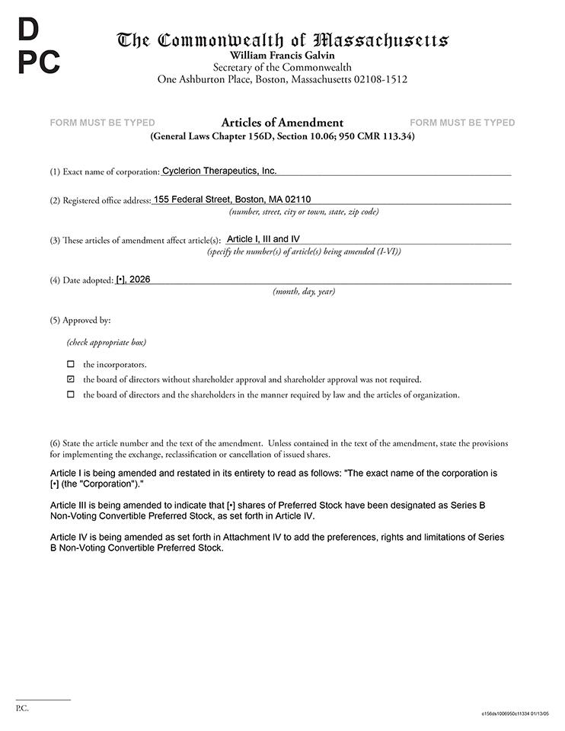

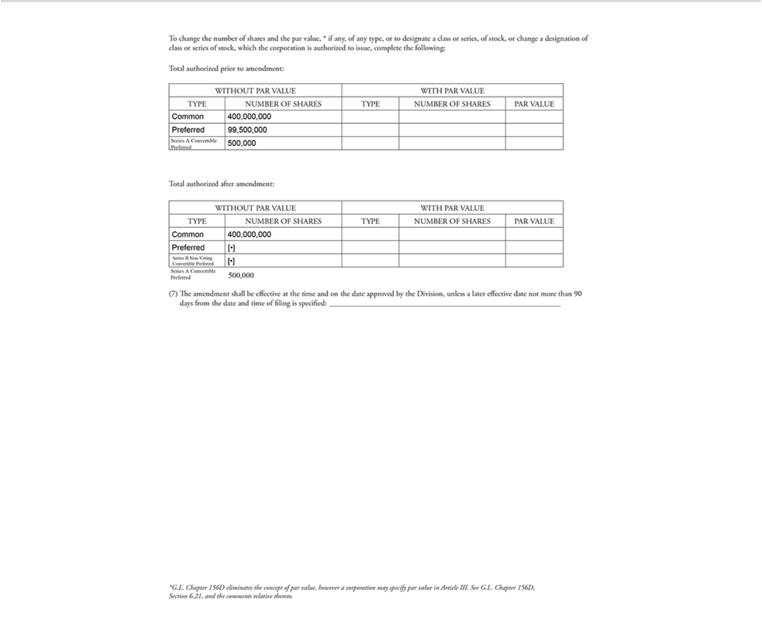



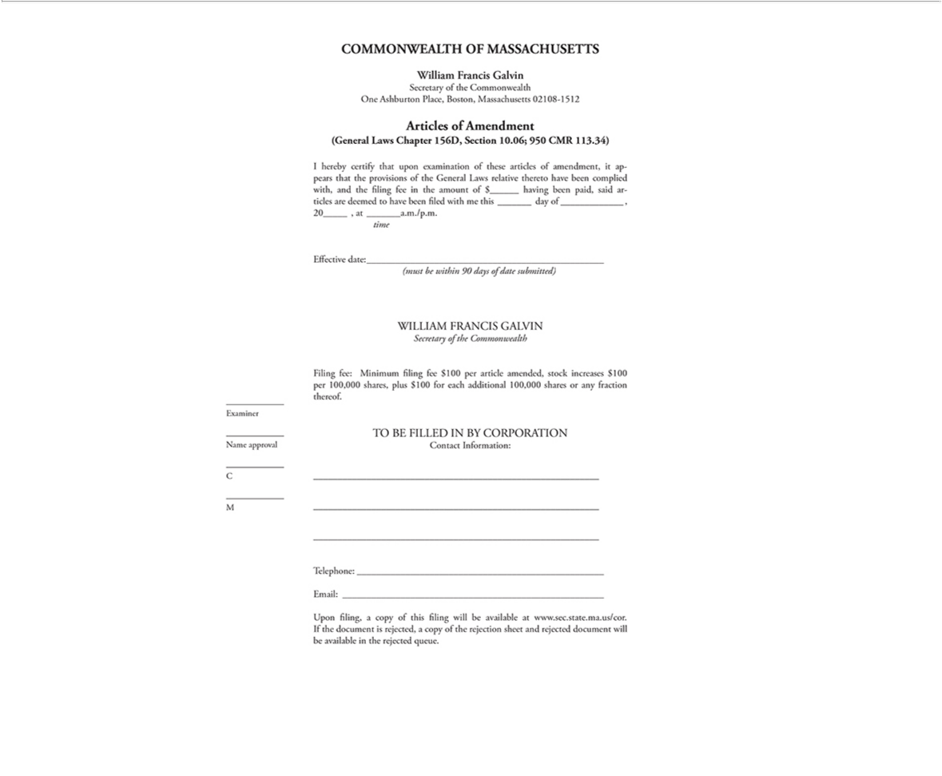

Confidential

Final Form

ATTACHMENT IV

DESCRIPTION OF SERIES B CONVERTIBLE PREFERRED STOCK

- Designation and Amount of Series B Preferred Stock.

This series of Preferred Stock shall be designated as “Series B Non-Voting Convertible Preferred Stock” and the number of shares constituting the Corporation’s Series B Non-Voting Convertible Preferred Stock (the “Series B Non-Voting Preferred Stock”) shall be [__] shares, which are being issued pursuant to the terms of the Agreement and Plan of Merger, dated as of the date hereof, by and among the Corporation, Cariboos Merger Sub Corp., a Delaware corporation and wholly owned subsidiary of the Corporation, Cariboos Merger Sub II, LLC, a Delaware limited liability company and Korsana Biosciences, Inc., a Delaware corporation (the “Merger Agreement”). The Series B Non-VotingPreferred Stock shall have the designations, powers, preferences and relative, participating, optional or other special rights, and the qualifications, limitations or restrictions thereof, of such shares of Preferred Stock, in addition to any provisions set forth in these Restated Articles of Organization that are applicable to the Preferred Stock of all classes and series, set forth below:

1. Definitions. For the purposes of this section, the following terms shall have the following meanings:

“Affiliate” means any Person that, directly or indirectly through one or more intermediaries, controls or is controlled by or is under common control with a Person, as such terms are used in and construed under Rule 405 of the Securities Act of 1933, as amended.

“Business Day” means any day except any Saturday, any Sunday, any day which is a federal legal holiday in the United States or any day on which banking institutions in the State of New York are authorized or required by law or other governmental action to close.

“Buy-In” shall have the meaning set forth in Section 6.5.2.

“Closing Sale Price” means, for any security as of any date, the last closing trade price for such security immediately prior to 4:00 p.m., New York City time, on the principal Trading Market where such security is listed or traded, as reported by Bloomberg, L.P. (or an equivalent, reliable reporting service), or if the foregoing do not apply, the last trade price of such security in the over-the-counter market on the electronic bulletin board for such security as reported by Bloomberg, L.P., or, if no last trade price is reported for such security by Bloomberg, L.P., the average of the bid prices of any market makers for such security as reported on the OTC Pink Market by OTC Markets Group, Inc. If the Closing Sale Price cannot be calculated for a security on a particular date on any of the foregoing bases, the Closing Sale Price of such security on such date shall be the fair market value as determined in good faith by the Board of Directors of the Corporation.

“Commission” means the United States Securities and Exchange Commission.

“Common Stock” means the Corporation’s common stock, no par value, and stock of any other class of securities into which such securities may hereafter be reclassified or changed.

“Conversion Shares” means, collectively, the shares of Common Stock issuable upon conversion of the shares of Series B Non-Voting Preferred Stock in accordance with the terms hereof.

“Exchange Act” means the Securities Exchange Act of 1934, as amended, and the rules and regulations promulgated thereunder.

“Holder” means a holder of shares of Series B Non-Voting Preferred Stock.

“Person” means an individual or corporation, partnership, trust, incorporated or unincorporated association, joint venture, limited liability company, joint stock company, government (or an agency or subdivision thereof) or other entity of any kind.

“Trading Day” means a day on which the principal Trading Market is open for business.

“Trading Market” means any of the following markets or exchanges on which the Common Stock is listed or quoted for trading on the date in question: the NYSE American, the Nasdaq Capital Market, the Nasdaq Global Market, the Nasdaq Global Select Market, or the New York Stock Exchange (or any successors to any of the foregoing).

- Designation, Amount and Par Value. The series of Preferred Stock shall be designated as the Corporation’s Series B Non-Voting Convertible Preferred Stock (the “Series B Non-Voting Preferred Stock”) and the number of shares so designated shall be [__]. Each share of Series B Non-Voting Preferred Stock shall have no par value.

- Dividends. Holders shall be entitled to receive, and the Corporation shall pay, dividends on shares of the Series B Non-Voting Preferred Stock (on an as-if-converted-to-Common-Stock basis, without regard to the Beneficial Ownership Limitation (as defined below)) equal to and in the same form, and in the same manner, as dividends (other than dividends on shares of the Common Stock payable in the form of Common Stock) actually paid on shares of the Common Stock when, as and if such dividends (other than dividends payable in the form of Common Stock) are paid on shares of the Common Stock. Other than as set forth in the previous sentence, no other dividends shall be paid on shares of Series B Non-Voting Preferred Stock, and the Corporation shall pay no dividends (other than dividends payable in the form of Common Stock) on shares of the Common Stock unless it simultaneously complies with the previous sentence.

- Voting Rights.

4.1 Except as otherwise provided herein or as otherwise required by the the Massachusetts Business Corporation Act (M.G.L. c. 156D) (“Mass Law”), the Series B Non-Voting Preferred Stock shall have no voting rights. However, as long as any shares of Series B Non-Voting Preferred Stock are outstanding, the Corporation shall not, without the affirmative vote of the holders of a majority of the then outstanding shares of the Series B Non-Voting Preferred Stock: (i) alter or change adversely the powers, preferences or rights given to the Series B Non-Voting Preferred Stock or alter or amend the rights, powers, preferences and other terms of the Preferred Stock set forth herein (this “Description of Rights”), amend or repeal any provision of, or add any provision to, the Articles of Incorporation (including this Description of Rights) or Amended and Restated Bylaws of the Corporation, or file any articles of amendment, descriptions of rights, preferences, limitations and relative rights of any series of Preferred Stock, if such action would adversely alter or change the preferences, rights, privileges or powers of, or restrictions provided for the benefit of the Series B Non-Voting Preferred Stock, regardless of whether any of the foregoing actions shall be by means of amendment to the Articles of Incorporation or by merger, consolidation, recapitalization, reclassification, conversion or otherwise, (ii) issue further shares of Series B Non-Voting Preferred Stock or increase or decrease (other than by conversion) the number of authorized shares of Series B Non-Voting Preferred Stock, (iii) at any time while at least 30% of the originally issued Series B Non-Voting Preferred Stock remains issued and outstanding, (A) consummate (I) any Fundamental Transaction (as defined below) or (II) any merger or consolidation of the Corporation with or into another entity or any stock sale to, or other business combination in which the stockholders of the Corporation immediately before such transaction

2

do not hold at least a majority of the capital stock of the Corporation immediately after such transaction, (B) increase the size of the Board of Directors of the Corporation, (C) adopt, amend or repeal any written delegation of authority policy, corporate authority matrix or similar document, framework or schedule unless such adoption, amendment or repeal has been approved by the unanimous vote of the Board of Directors of the Corporation or
- retain or replace the Corporation’s registered independent public accounting firm, independent compensation consultant or corporate counsel or (iv) enter into any agreement with respect to any of the foregoing. Holders of shares of Common Stock acquired upon the conversion of shares of Series B Non-Voting Preferred Stock shall be entitled to the same voting rights as each other holder of Common Stock.

4.2 Any vote required or permitted under Section 4.1 may be taken at a meeting of the Holders or through the execution of an action by written consent in lieu of such meeting, provided that the consent is executed by Holders representing a majority of the outstanding shares of Series B Non-Voting Preferred Stock.

4.3 Election of Directors.

4.3.1 At all times when at least 30% of the originally issued Series B Non-Voting Preferred Stock remains issued and outstanding, (i) the holders of record of the shares of Series B Non-Voting Preferred Stock, exclusively and voting together as a separate class on an as-converted to Common Stock basis, shall be entitled to elect four directors of the Corporation (the “Preferred Directors”); and (iii) the holders of record of the shares of Common Stock and of any other class or series of voting stock (including the Series B Non-Voting Preferred Stock), exclusively and voting together as a single class on an as-converted to Common Stock basis, shall be entitled to elect the balance of the total number of directors of the Corporation (the “At-Large Directors”); provided, however, for administrative convenience, the initial Preferred Directors may also be appointed by the Board of Directors in connection with the approval of the initial issuance of Series B Non-Voting Preferred Stock without a separate action by the holders of Series B Non-Voting Preferred Stock.

4.3.2 Any Preferred Director elected as provided in Section 4.3.1 may be removed without cause by, and only by, the affirmative vote of the holders of a majority of the shares of the Series B Non-Voting Preferred Stock, given either at a special meeting of such stockholders duly called for that purpose or pursuant to a written consent of stockholders.

4.3.3 If the holders of shares of the Series B Non-Voting Preferred Stock fail to elect a sufficient number of directors to fill all directorships for which they are entitled to elect directors pursuant to Section 4.3.1 (and to the extent any of such directorships is not otherwise filled by a director appointed in accordance with the proviso in Section 4.3.1), then any directorship not so filled shall remain vacant until such time as the holders of the Series B Non-Voting Preferred Stock fill such directorship in accordance with Section 4.3.1.

4.3.4 At any meeting held for the purpose of electing a Preferred Director, the presence in person or by proxy of the holders of a majority of the outstanding shares of the Series B Non-Voting Preferred Stock shall constitute a quorum for the purpose of electing such Preferred Director.

4.3.5 Each Preferred Director shall be entitled to [three] votes on each matter presented to the Board of Directors.

- Rank; Liquidation.

5.1 The Series B Non-Voting Preferred Stock shall rank on parity with the Common Stock, the Corporation’s Series A Convertible Preferred Stock as to distributions of assets upon liquidation, dissolution or winding up of the Corporation, whether voluntarily or involuntarily.

3

5.2 Upon any liquidation, dissolution or winding-up of the Corporation, whether voluntary or involuntary (a “Liquidation”), each Holder shall be entitled to receive out of the assets, whether capital or surplus, of the Corporation the same amount that a holder of Common Stock would receive if the Series B Non-Voting Preferred Stock were fully converted (disregarding for such purpose any Beneficial Ownership Limitations) to Common Stock which amounts shall be paid pari passu with all holders of Common Stock, plus an additional amount equal to any dividends declared on but unpaid to such shares. If, upon any such Liquidation, the assets of the Corporation shall be insufficient to pay the Holders of shares of the Series B Non-Voting Preferred Stock the amount required under the preceding sentence, then all remaining assets of the Corporation shall be distributed ratably to the Holders and the holders of Common Stock in accordance with the respective amounts that would be payable on all such securities if all amounts payable thereon were paid in full. For the avoidance of any doubt, a Fundamental Transaction shall not be deemed a Liquidation unless the Corporation expressly declares that such Fundamental Transaction shall be treated as if it were a Liquidation.

- Conversion.

6.1 Reserved.

6.2 Conversion at Option of Holder. Subject to Section 6.4 and Section 6.5.3, each share of Series B Non-Voting Preferred Stock then outstanding shall be convertible, at any time and from time to time, at the option of the Holder thereof, into a number of shares of Common Stock equal to the Conversion Ratio, subject to the Beneficial Ownership Limitation (each, an “Optional Conversion”). Holders shall effect conversions by providing the Corporation with the form of conversion notice attached hereto as Annex A (a “Notice of Conversion”), duly completed and executed. Provided the Corporation’s transfer agent is participating in the Depository Trust Company (“DTC”) Fast Automated Securities Transfer program, the Notice of Conversion may specify, at the Holder’s election, whether the applicable Conversion Shares shall be credited to the account of the Holder’s prime broker with DTC through its Deposit Withdrawal Agent Commission system (a “DWAC Delivery”). The date on which an Optional Conversion shall be deemed effective (the “Conversion Date”) shall be the Trading Day that the Notice of Conversion, completed and executed, is sent via email to, and received during regular business hours by, the Corporation; provided, that the original certificate(s) (if any) representing such shares of Series B Non-Voting Preferred Stock being converted, duly endorsed, and the accompanying Notice of Conversion, are received by the Corporation within two

- Trading Days thereafter. In all other cases, the Conversion Date shall be defined as the Trading Day on which the original certificate(s) (if any) representing such shares of Series B Non-Voting Preferred Stock being converted, duly endorsed, and the accompanying Notice of Conversion, are received by the Corporation. The calculations set forth in the Notice of Conversion shall control in the absence of manifest or mathematical error.

6.3 Conversion Ratio. The “Conversion Ratio” for each share of Series B Non-Voting Preferred Stock shall be 1,000 shares of Common Stock issuable upon the conversion (the “Conversion”) of each share of Series B Non-Voting Preferred Stock (corresponding to a ratio of 1,000:1), subject to adjustment as provided herein.

6.4 Beneficial Ownership Limitation. Notwithstanding anything herein to the contrary, the Corporation shall not effect any

conversion of any share of Series B Non-Voting Preferred Stock, and a Holder shall not have the right to convert any portion of the Series B Non-Voting

Preferred Stock pursuant to Section 6.2, to the extent that, after giving effect to such attempted conversion set forth on an applicable Notice of

Conversion (as defined in this Description of Rights) with respect to the Series B Preferred Stock, such Holder (or any of such Holder’s Affiliates or any

other Person who would be a beneficial owner of Common Stock beneficially owned by the Holder for purposes of Section 13(d) or Section 16 of the

Exchange Act and the applicable rules and regulations of the Commission, including any “group” of which the Holder is a member (the foregoing,

“Attribution Parties”)) would beneficially own a number of shares of Common Stock in excess of the Beneficial Ownership Limitation. For purposes of

the foregoing sentence, the aggregate number of shares of Common Stock beneficially owned by

4

such Holder and its Attribution Parties shall include the number of shares of Common Stock issuable upon conversion of the Series B Non-Voting Preferred Stock subject to the Notice of Conversion, with respect to which such determination is being made, but shall exclude the number of shares of Common Stock which are issuable upon (A) conversion of the remaining, unconverted Series B Non-Voting Preferred Stock beneficially owned by such Holder or any of its Attribution Parties, and (B) exercise or conversion of the unexercised or unconverted portion of any other securities of the Corporation (including any warrants) beneficially owned by such Holder or any of its Attribution Parties that are subject to and would exceed a limitation on conversion or exercise similar to the limitation contained herein. Except as set forth in the preceding sentence, for purposes of this Section 6.4, beneficial ownership shall be calculated in accordance with Section 13(d) of the Exchange Act and the applicable rules and regulations of the Commission, and the terms “beneficial ownership” and “beneficially own” have the meanings ascribed to such terms therein. In addition, for purposes hereof, “group” has the meaning set forth in Section 13(d) of the Exchange Act and the applicable rules and regulations of the Commission. For purposes of this Section 6.4, in determining the number of outstanding shares of Common Stock, a Holder may rely on the number of outstanding shares of Common Stock as stated in the most recent of the following: (A) the Corporation’s most recent periodic or annual filing with the Commission, as the case may be, (B) a more recent public announcement by the Corporation that is filed with the Commission, or (C) a more recent notice by the Corporation or the Corporation’s transfer agent to the Holder setting forth the number of shares of Common Stock then outstanding. Upon the written request of a Holder (which may be by email), the Corporation shall, within two (2) Trading Days thereof, confirm in writing to such Holder (which may be via email) the number of shares of Common Stock then outstanding. In any case, the number of outstanding shares of Common Stock shall be determined after giving effect to any actual conversion or exercise of securities of the Corporation, including shares of Series B Non-Voting Preferred Stock, by such Holder or its Attribution Parties since the date as of which such number of outstanding shares of Common Stock was last publicly reported or confirmed to the Holder. The “Beneficial Ownership Limitation” shall initially be set at the discretion of each Holder to a percentage designated by such Holder on its signature page to the Purchase Agreement or otherwise between 0% and 19.99% of the number of shares of the Common Stock outstanding or deemed to be outstanding as of the applicable measurement date, and such percentage shall be set at 19.99% for any Holder that does not make such designation in the Purchase Agreement or otherwise. The Corporation shall be entitled to rely on representations made to it by the Holder in any Notice of Conversion regarding its Beneficial Ownership Limitation. Notwithstanding the foregoing, by written notice to the Corporation (email being sufficient), (i) the Holder may reset the Beneficial Ownership Limitation percentage to a higher percentage, not to exceed

19.99%, which increase will not be effective until the sixty-first (61st) day after such written notice is delivered to the Corporation, and (ii) the Holder may reset the Beneficial Ownership Limitation percentage to a lower percentage. Upon such a change by a Holder of the Beneficial Ownership Limitation, not to exceed 19.99%, the Beneficial Ownership Limitation may not be further amended by such Holder without first providing the minimum notice required by this Section 6.4. Notwithstanding the foregoing, (x) at any time following notice of a Fundamental Transaction, the Holder may waive and/or change the Beneficial Ownership Limitation effective immediately upon written notice to the Corporation and may reinstitute a Beneficial Ownership Limitation at any time thereafter effective immediately upon written notice to the Corporation and (y) at any time that the beneficial ownership of shares of Common Stock of a Holder (together with any of such Holder’s Attribution Parties) is equal to or less than 9.00% of the number of shares of Common Stock outstanding as of any given date, then such Holder’s Beneficial Ownership Limitation shall automatically be set to 9.99%. The provisions of this Section 6.4 shall be construed, corrected and implemented in a manner so as to effectuate the intended Beneficial Ownership Limitation herein contained and the shares of Common Stock underlying the Securities in excess of the Beneficial Ownership Limitation shall not be deemed to be beneficially owned by the Purchaser for any purpose including for purposes of Section 13(d) or Rule 16a-1(a)(1) of the Exchange Act.

5

6.5 Mechanics of Conversion.

6.5.1 Delivery of Certificate or Electronic Issuance. Upon Conversion not later than two (2) Trading Days after the applicable Conversion Date, or if the Holder requests the issuance of physical certificate(s), two (2) Trading Days after receipt by the Corporation of the original certificate(s) representing such shares of Series B Non-Voting Preferred Stock being converted, duly endorsed, and the accompanying Notice of Conversion (the “Share Delivery Date”), the Corporation shall either: (a) deliver, or cause to be delivered, to the converting Holder a physical certificate or certificates representing the number of Conversion Shares being acquired upon the conversion of shares of Series B Non-Voting Preferred Stock, or

- in the case of a DWAC Delivery (if so requested by the Holder), electronically transfer such Conversion Shares by crediting the account of the Holder’s prime broker with DTC through its DWAC system. If in the case of any Notice of Conversion such certificate or certificates for the Conversion Shares are not delivered to or as directed by or, in the case of a DWAC Delivery, such shares are not electronically delivered to or as directed by, the applicable Holder by the Share Delivery Date, the applicable Holder shall be entitled to elect to rescind such Notice of Conversion by written notice to the Corporation at any time on or before its receipt of such certificate or certificates for Conversion Shares or electronic receipt of such shares, as applicable, in which event the Corporation shall promptly return to such Holder any original Series B Non-Voting Preferred Stock certificate delivered to the Corporation and such Holder shall promptly return to the Corporation any Common Stock certificates or otherwise direct the return of any shares of Common Stock delivered to the Holder through the DWAC system, representing the shares of Series B Non-Voting Preferred Stock unsuccessfully tendered for conversion to the Corporation.

6.5.2 Obligation Absolute. Subject to Section 6.4 and subject to Holder’s right to rescind a Notice of Conversion pursuant to Section 6.5.1, the Corporation’s obligation to issue and deliver the Conversion Shares upon conversion of Series B Non-Voting Preferred Stock in accordance with the terms hereof are absolute and unconditional, irrespective of any action or inaction by a Holder to enforce the same, any waiver or consent with respect to any provision hereof, the recovery of any judgment against any Person or any action to enforce the same, or any setoff, counterclaim, recoupment, limitation or termination, or any breach or alleged breach by such Holder or any other Person of any obligation to the Corporation or any violation or alleged violation of law by such Holder or any other Person, and irrespective of any other circumstance which might otherwise limit such obligation of the Corporation to such Holder in connection with the issuance of such Conversion Shares. Subject to Section 6.4 and subject to Holder’s right to rescind a Notice of Conversion pursuant to Section 6.5.1, in the event a Holder shall elect to convert any or all of its Series B Non-Voting Preferred Stock, the Corporation may not refuse conversion based on any claim that such Holder or anyone associated or affiliated with such Holder has been engaged in any violation of law, agreement or for any other reason, unless an injunction from a court, on notice to Holder, restraining and/or enjoining conversion of all or part of the Series B Non-Voting Preferred Stock of such Holder shall have been sought and obtained by the Corporation, and the Corporation posts a surety bond for the benefit of such Holder in the amount of 150% of the value of the Conversion Shares into which would be converted the Series B Non-Voting Preferred Stock which is subject to such injunction, which bond shall remain in effect until the completion of arbitration/litigation of the underlying dispute and the proceeds of which shall be payable to such Holder to the extent it obtains judgment. In the absence of such injunction, the Corporation shall, subject to Section 6.4 and subject to Holder’s right to rescind a Notice of Conversion pursuant to Section 6.5.1, issue Conversion Shares upon a properly noticed conversion.

6.5.3 Cash Settlement. If, at any time after the the initial issuance of the Series B Non-Voting Preferred Stock, the Corporation fails to deliver to a Holder such certificate or certificates, or electronically deliver (or instruct its transfer agent to electronically deliver) such shares in the case of a DWAC Delivery, pursuant to Section 6.5.1 on or prior to the third (3rd) Trading Day after the Share Delivery Date applicable to such conversion (other than a failure caused by (i) materially incorrect or incomplete information provided by Holder to the Corporation or (ii) the application of the Beneficial Ownership Limitation, then, unless the Holder has rescinded the applicable Notice of Conversion pursuant to Section 6.5.1, the Corporation shall, at the request of the Holder, pay an amount equal to the Fair Value (as defined below) of such undelivered shares, with such payment to be made within two Business Days from the date of request by the Holder, whereupon the Corporation’s obligations to deliver such shares underlying the Notice of Conversion shall be extinguished upon payment in full of the Fair Value of such undelivered shares. For purposes of this Section 6.5.3, the “Fair Value” of shares shall be fixed with reference to the last reported Closing Sale Price on the principal Trading Market on which the Common Stock is listed as of the Trading Day immediately prior to the date on which the Notice of Conversion is delivered

6

to the Corporation. For the avoidance of doubt, the cash settlement provisions set forth in this Section 6.5.3 shall be available irrespective of the reason for the Corporation’s failure to timely deliver Conversion Shares (other than a failure caused by (i) materially incorrect or incomplete information provided by Holder to the Corporation or (ii) the application of the Beneficial Ownership Limitation, including due to limitations set forth in Section 6.5.6, due to applicable Trading Market rules.

6.5.4 Buy-In on Failure to Timely Deliver Certificates. If the Corporation fails to deliver to a Holder the applicable certificate or certificates or to effect a DWAC Delivery, as applicable, by the Share Delivery Date pursuant to Section 6.5.1 (other than a failure caused by materially incorrect or incomplete information provided by Holder to the Corporation or the application of the Beneficial Ownership Limitation), and if after such Share Delivery Date such Holder is required by its brokerage firm to purchase (in an open market transaction or otherwise), or the Holder’s brokerage firm otherwise purchases, shares of Common Stock to deliver in satisfaction of a sale by such Holder of the Conversion Shares which such Holder was entitled to receive upon the conversion relating to such Share Delivery Date (a “Buy-In”), then the Corporation shall (A) pay in cash to such Holder (in addition to any other remedies available to or elected by such Holder) the amount by which (x) such Holder’s total purchase price (including any brokerage commissions) for the shares of Common Stock so purchased exceeds (y) the product of (1) the aggregate number of shares of Common Stock that such Holder was entitled to receive from the conversion at issue multiplied by (2) the actual sale price at which the sell order giving rise to such purchase obligation was executed (including any brokerage commissions) and (B) at the option of such Holder, either reissue (if surrendered) the shares of Series B Non-Voting Preferred Stock equal to the number of shares of Series B Non-Voting Preferred Stock submitted for conversion or deliver to such Holder the number of shares of Common Stock that would have been issued if the Corporation had timely complied with its delivery requirements under Section 6.5.1. For example, if a Holder purchases shares of Common Stock having a total purchase price of $11,000 to cover a Buy-In with respect to an attempted conversion of shares of Series B Non-Voting Preferred Stock with respect to which the actual sale price (including any brokerage commissions) giving rise to such purchase obligation was a total of $10,000 under clause (A) of the immediately preceding sentence, the Corporation shall be required to pay such Holder $1,000. The Holder shall provide the Corporation written notice, within three (3) Trading Days after the occurrence of a Buy-In, indicating the amounts payable to such Holder in respect of such Buy-In together with applicable confirmations and other evidence reasonably requested by the Corporation. Nothing herein shall limit a Holder’s right to pursue any other remedies available to it hereunder, at law or in equity including, without limitation, a decree of specific performance and/or injunctive relief with respect to the Corporation’s failure to timely deliver certificates representing shares of Common Stock upon conversion of the shares of Series B Non-Voting Preferred Stock as required pursuant to the terms hereof or the cash settlement remedy set forth in Section 6.5.3; provided, however, that the Holder shall not be entitled to both (i) require the reissuance of the shares of Series B Non-Voting Preferred Stock submitted for conversion for which such conversion was not timely honored and

- receive the number of shares of Common Stock that would have been issued if the Corporation had timely complied with its delivery requirements under Section 6.5.1.

6.5.5 Reservation of Shares Issuable Upon Conversion. The Corporation covenants that at all times it will reserve and keep available out of its authorized and unissued shares of Common Stock for the sole purpose of issuance upon conversion of the Series B Non-Voting Preferred Stock, free from preemptive rights or any other actual contingent purchase rights of Persons other than the Holders of the Series B Non-Voting Preferred Stock, not less than such aggregate number of shares of the Common Stock as shall be issuable (taking into account the adjustments of Section 7) upon the conversion of all outstanding shares of Series B Non-Voting Preferred Stock. The Corporation covenants that all shares of Common Stock that shall be so issuable shall, upon issue, be duly authorized, validly issued, fully paid and non-assessable.

6.5.6 Fractional Shares. No fractional shares of Common Stock shall be issued upon conversion of the Series B Non-Voting Preferred Stock, no certificates or scrip for any such fractional shares shall be issued and no cash shall be paid for any such fractional shares. Any fractional shares of Common Stock that a Holder of Series B Non-Voting Preferred Stock would otherwise be entitled to receive shall be aggregated

7

with all fractional shares of Common Stock issuable to such Holder and any remaining fractional shares shall be rounded up to the nearest whole share. Whether or not fractional shares would be issuable upon such conversion shall be determined on the basis of the total number of shares of Series B Non-Voting Preferred Stock the Holder seeks to convert into Common Stock and the aggregate number of shares of Common Stock issuable upon such conversion.

6.5.7 Transfer Taxes. The issuance of certificates for shares of the Common Stock upon conversion of the Series B Non-Voting Preferred Stock shall be made without charge to any Holder for any documentary stamp or similar taxes that may be payable in respect of the issue or delivery of such certificates, provided that the Corporation shall not be required to pay any tax that may be payable in respect of any transfer involved in the issuance and delivery of any such certificate upon conversion in a name other than that of the registered Holder(s) of such shares of Series B Non-Voting Preferred Stock and the Corporation shall not be required to issue or deliver such certificates unless or until the Person or Persons requesting the issuance thereof shall have paid to the Corporation the amount of such tax or shall have established to the satisfaction of the Corporation that such tax has been paid.

6.6 Status as Stockholder. Upon each Conversion Date, (i) the shares of Series B Non-Voting Preferred Stock being converted shall be deemed converted into shares of Common Stock and (ii) the Holder’s rights as a holder of such converted shares of Series B Non-Voting Preferred Stock shall cease and terminate, excepting only the right to receive certificates for such shares of Common Stock and to any remedies provided herein or otherwise available at law or in equity to such Holder because of a failure by the Corporation to comply with the terms of this Description of Rights. In all cases, the Holder shall retain all of its rights and remedies for the Corporation’s failure to convert Series B Non-Voting Preferred Stock.

- Certain Adjustments.

7.1 Stock Dividends and Stock Splits. If the Corporation, at any time while this Series B Non-Voting Preferred Stock is

outstanding: (A) pays a stock dividend or otherwise makes a distribution or distributions payable in shares of Common Stock (which, for avoidance of

doubt, shall not include any shares of Common Stock issued by the Corporation upon conversion of this Series B Non-Voting Preferred Stock) with

respect to the then outstanding shares of Common Stock; (B) subdivides outstanding shares of Common Stock into a larger number of shares; or

- combines (including by way of a reverse stock split) outstanding shares of Common Stock into a smaller number of shares, then the Conversion Ratio shall be multiplied by a fraction of which the numerator shall be the number of shares of Common Stock (excluding any treasury shares of the Corporation) outstanding immediately after such event and of which the denominator shall be the number of shares of Common Stock outstanding immediately before such event (excluding any treasury shares of the Corporation). Any adjustment made pursuant to this Section 7.1 shall become effective immediately after the record date for the determination of stockholders entitled to receive such dividend or distribution and shall become effective immediately after the effective date in the case of a subdivision or combination.

7.2 Fundamental Transaction. If, at any time while this Series B Non-Voting Preferred Stock is outstanding, (A) the Corporation effects any merger or consolidation of the Corporation with or into another Person or any stock sale to, or other business combination (including, without limitation, a reorganization, recapitalization, spin-off, share exchange or scheme of arrangement) with or into another Person (other than such a transaction in which the Corporation is the surviving or continuing entity and its Common Stock is not exchanged for or converted into other securities, cash or property), (B) the Corporation effects any sale, lease, transfer or exclusive license of all or substantially all of its assets in one transaction or a series of related transactions, (C) any tender offer or exchange offer by the Corporation is completed pursuant to which more than 50% of the Common Stock not held by the Corporation is exchanged for or converted into other securities, cash or property, or (D) the Corporation effects any reclassification of the Common Stock or any compulsory share exchange pursuant (other than as a result of a dividend, subdivision or combination covered by Section 7.1) to which the Common Stock is

8

effectively converted into or exchanged for other securities, cash or property (in any such case, a “Fundamental Transaction”), then, upon any subsequent conversion of this Series B Non-Voting Preferred Stock the Holders shall have the right to receive, in lieu of the right to receive Conversion Shares, for each Conversion Share that would have been issuable upon such conversion immediately prior to the occurrence of such Fundamental Transaction, the same kind and amount of securities, cash or property as it would have been entitled to receive upon the occurrence of such Fundamental Transaction if it had been, immediately prior to such Fundamental Transaction, the holder of one share of Common Stock (the “Alternate Consideration”). For purposes of any such subsequent conversion, the determination of the Conversion Ratio shall be appropriately adjusted to apply to such Alternate Consideration based on the amount of Alternate Consideration issuable in respect of one share of Common Stock in such Fundamental Transaction, and the Corporation shall adjust the Conversion Ratio in a reasonable manner reflecting the relative value of any different components of the Alternate Consideration. If holders of Common Stock are given any choice as to the securities, cash or property to be received in a Fundamental Transaction, then the Holders shall be given the same choice as to the Alternate Consideration it receives upon any conversion of this Series B Non-Voting Preferred Stock following such Fundamental Transaction. To the extent necessary to effectuate the foregoing provisions, any successor to the Corporation or surviving entity in such Fundamental Transaction shall file a new description of terms, certificate of designations or similar with the same terms and conditions and issue to the Holders new preferred stock consistent with the foregoing provisions and evidencing the Holders’ right to convert such preferred stock into Alternate Consideration. The terms of any agreement to which the Corporation is a party and pursuant to which a Fundamental Transaction is effected shall include terms requiring any such successor or surviving entity to comply with the provisions of this Section 7.2 and ensuring that this Series B Non-Voting Preferred Stock (or any such replacement security) will be similarly adjusted upon any subsequent transaction analogous to a Fundamental Transaction. The Corporation shall cause to be delivered to each Holder, at its last address as it shall appear upon the stock books of the Corporation, written notice of any Fundamental Transaction at least 20 calendar days prior to the date on which such Fundamental Transaction is expected to become effective or close.

7.3 Calculations. All calculations under this Section 7 shall be made to the nearest cent or the nearest 1/100th of a share, as the case may be. For purposes of this Section 7, the number of shares of Common Stock deemed to be issued and outstanding as of a given date shall be the sum of the number of shares of Common Stock (excluding any treasury shares of the Corporation) issued and outstanding.

- Redemption. The shares of Series B Non-Voting Preferred Stock shall not be redeemable; provided, however, that the foregoing shall not limit the ability of the Corporation to purchase or otherwise deal in such shares to the extent otherwise permitted hereby and by law, nor shall the foregoing limit the Holder’s rights under Section 6.5.3.

- Transfer. A Holder may transfer any shares of Series B Non-Voting Preferred Stock together with the accompanying rights set forth herein, held by such Holder without the consent of the Corporation; provided that such transfer is in compliance with applicable securities laws. The Corporation shall in good faith (i) do and perform, or cause to be done and performed, all such further acts and things, and (ii) execute and deliver all such other agreements, certificates, instruments and documents, in each case, as any holder of Series B Non-Voting Preferred Stock may reasonably request in order to carry out the intent and accomplish the purposes of this Section 9. The transferee of any shares of Series B Non-Voting Preferred Stock shall be subject to the Beneficial Ownership Limitation applicable to the transferor as of the time of such transfer.

- Series B Non-Voting Preferred Stock Register. The Corporation shall maintain at its principal executive offices (or such other office or agency of the Corporation as it may designate by notice to the Holders in accordance with Section 11), a register for the Series B Non-Voting Preferred Stock, in which the Corporation shall record (i) the name, address, and electronic mail address of each holder in whose name the shares of Series B Non-Voting Preferred Stock have been issued and (ii) the name, address, and electronic mail address of each transferee of any shares of Series B Non-Voting Preferred Stock. The Corporation may deem and treat the registered Holder of shares of Series B Non-Voting Preferred Stock as the absolute owner thereof for the purpose of any conversion thereof and for all other purposes. The Corporation shall keep the register open and available at all times during business hours for inspection by any holder of Series B Non-Voting Preferred Stock or his, her or its legal representatives.

9

- Notices. Any notice required or permitted by the provisions of this Description of Rights to be given to a Holder of shares of Series B Non-Voting Preferred Stock shall be mailed, postage prepaid, to the post office address last shown on the records of the Corporation, or given by electronic communication in compliance with the provisions of the Mass Law, and shall be deemed sent upon such mailing or electronic transmission.

- Book-Entry; Certificates. The Series B Non-Voting Preferred Stock will be issued in book-entry form; provided that, if a Holder requests that such Holder’s shares of Series B Non-Voting Preferred Stock be issued in certificated form, the Corporation will instead issue a stock certificate to such Holder representing such Holder’s shares of Series B Non-Voting Preferred Stock. To the extent that any shares of Series B Non-Voting Preferred Stock are issued in book-entry form, references herein to “certificates” shall instead refer to the book-entry notation relating to such shares.

- Lost or Mutilated Series B Non-Voting Preferred Stock Certificate. If a Holder’s Series B Non-Voting Preferred Stock certificate shall be mutilated, lost, stolen or destroyed, the Corporation shall execute and deliver, in exchange and substitution for and upon cancellation of a mutilated certificate, or in lieu of or in substitution for a lost, stolen or destroyed certificate, a new certificate for the shares of Series B Non-Voting Preferred Stock so mutilated, lost, stolen or destroyed, but only upon receipt of evidence of such loss, theft or destruction of such certificate, and of the ownership hereof reasonably satisfactory to the Corporation.

- Waiver. Any waiver by the Corporation or a Holder of a breach of any provision of this Description of Rights shall not operate as or be construed to be a waiver of any other breach of such provision or of any breach of any other provision of this Description of Rights or a waiver by any other Holders. The failure of the Corporation or a Holder to insist upon strict adherence to any term of this Description of Rights on one or more occasions shall not be considered a waiver or deprive that party (or any other Holder) of the right thereafter to insist upon strict adherence to that term or any other term of this Description of Rights. Any waiver by the Corporation or a Holder must be in writing. Notwithstanding any provision in this Description of Rights to the contrary, any provision contained herein and any right of the Holders of Series B Non-Voting Preferred Stock granted hereunder may be waived as to all shares of Series B Non-Voting Preferred Stock (and the Holders thereof) upon the written consent of the Holders of not less than a majority of the shares of Series B Non-Voting Preferred Stock then outstanding, provided, however, that the Beneficial Ownership Limitation applicable to a Holder, and any provisions contained herein that are related to such Beneficial Ownership Limitation, cannot be modified, waived or terminated without the consent of such Holder, provided further, that any proposed waiver that would, by its terms, have a disproportionate and materially adverse effect on any Holder shall require the consent of such Holder(s).

- Severability. Whenever possible, each provision hereof shall be interpreted in a manner as to be effective and valid under applicable law, but if any provision hereof is held to be prohibited by or invalid under applicable law, then such provision shall be ineffective only to the extent of such prohibition or invalidity, without invalidating or otherwise adversely affecting the remaining provisions hereof.

10

- Status of Converted Series B Non-Voting Preferred Stock. If any shares of Series B Non-Voting Preferred Stock shall be converted or redeemed by the Corporation, such shares shall, to the fullest extent permitted by applicable law, be retired and cancelled upon such acquisition, and shall not be reissued as a share of Series B Non-Voting Preferred Stock. Any share of Series B Non-Voting Preferred Stock so acquired shall, upon its retirement and cancellation, and upon the taking of any action required by applicable law, resume the status of authorized but unissued shares of preferred stock and shall no longer be designated as Series B Non-Voting Preferred Stock.

[Remainder of Page Intentionally Left Blank]

11

ANNEX A

NOTICE OF CONVERSION

(TO BE EXECUTED BY THE REGISTERED HOLDER IN ORDER TO CONVERT SHARES OF SERIES B NON-VOTING CONVERTIBLE

PREFERRED STOCK)

The undersigned Holder hereby irrevocably elects to convert the number of shares of Series B Non-Voting Preferred Stock indicated below, represented in book-entry form, into shares of common stock, no par value (the “Common Stock”), of Cyclerion Therapeutics, Inc., a Massachusetts corporation (the “Corporation”), as of the date written below. If securities are to be issued in the name of a Person other than the undersigned, the undersigned will pay all transfer taxes payable with respect thereto. Capitalized terms utilized but not defined herein shall have the meaning ascribed to such terms in the Articles of Amendment (the “Articles of Amendment”) filed by the Corporation with the Secretary of the Commonwealth of Massachusetts on [__], 2026.

As of the date hereof, the number of shares of Common Stock beneficially owned by the undersigned Holder (together with such Holder’s Attribution Parties), including the number of shares of Common Stock issuable upon conversion of the Series B Non-Voting Preferred Stock subject to this Notice of Conversion, but excluding the number of shares of Common Stock which are issuable upon (A) conversion of the remaining, unconverted Series B Non-Voting Preferred Stock beneficially owned by such Holder or any of its Attribution Parties, and (B) exercise or conversion of the unexercised or unconverted portion of any other securities of the Corporation (including any warrants) beneficially owned by such Holder or any of its Attribution Parties that are subject to a limitation on conversion or exercise similar to the limitation contained in Section 6.4 of the Attachment IV of the Articles of Amendment, is _____%. For purposes hereof, beneficial ownership shall be calculated in accordance with Section 13(d) of the Exchange Act and the

applicable regulations of the Commission. In addition, for purposes hereof, “group” has the meaning set forth in Section 13(d) of the Exchange Act and the applicable regulations of the Commission.

CONVERSION CALCULATIONS:

Date to Effect Conversion:

Number of shares of Series B Non-Voting Preferred Stock owned prior to Conversion:

Number of shares of Series B Non-Voting Preferred Stock to be Converted:

Number of shares of Common Stock to be Issued:

Address for delivery of physical certificates:

For DWAC Delivery, please provide the following:

Broker No.:
Account No.:

[HOLDER]

By:
Name:

Title:

Exhibit 10.1

CONFIDENTIAL

Final Form

COMPANY SUPPORT AGREEMENT

This Support Agreement (this “Agreement”) is made and entered into as of April 1, 2026, by and among Korsana Biosciences, Inc., a Delaware corporation (the “Company”), Cyclerion Therapeutics, Inc., a Massachusetts corporation (“Parent”), and the undersigned stockholder of the Company (the “Stockholder” and each of the Stockholder, Company, and Parent a “Party” and, collectively, the “Parties”). Capitalized terms used herein but not otherwise defined shall have the respective meanings ascribed to such terms in the Merger Agreement (as defined below).

RECITALS

WHEREAS, concurrently with the execution and delivery hereof, Parent, the Company and Cariboos Merger Sub Corp., a Delaware corporation and a wholly owned subsidiary of Parent (the “First Merger Sub”), and Cariboos Merger Sub II, LLC a Delaware limited liability company (the “Second Merger Sub”), have entered into an Agreement and Plan of Merger and Reorganization (as such agreement may be amended or supplemented from time to time pursuant to the terms thereof, the “Merger Agreement”), pursuant to which (i) the First Merger Sub will merge with and into the Company, with the Company surviving the merger as the surviving corporation and a wholly owned subsidiary of Parent and (ii) the Company will merge with and into the Second Merger Sub, with Second Merger Sub being the surviving entity of the Second Merger, upon the terms and subject to the conditions set forth in the Merger Agreement (together, the “Merger”).

WHEREAS, as of the date hereof, the Stockholder is the beneficial owner (as defined in Rule 13d-3 under the Exchange Act) of such number of shares of Company Capital Stock as indicated in Appendix A.

WHEREAS, as a condition and inducement to the willingness of Parent to enter into the Merger Agreement, Parent has required that Stockholder enter into this Agreement.

NOW, THEREFORE, intending to be legally bound, the Parties hereby agree as follows:

- Certain Definitions. For all purposes of this Agreement, the following terms shall have the following respective meanings:

  - “Constructive Sale” means, with respect to any security, (i) a short sale with respect to such security, (ii) entering into or acquiring a derivative contract with respect to such security, (iii) entering into or acquiring a futures or forward contract to deliver such security or (iv) entering into any other hedging or other derivative transaction that has the effect of either directly or indirectly changing the economic benefits or risks of ownership of such security.

  - “Shares” means (i) all shares of Company Capital Stock and any other equity securities of the Company beneficially owned by the Stockholder as of the date hereof, including such securities indicated in Appendix A, (ii) all additional shares of Company Capital Stock acquired, whether beneficially or of record, by the Stockholder during the period commencing with the execution and delivery of this Agreement and expiring on the Expiration Date, and (iii) any shares of Company Capital Stock or other equity securities of the Company that are issued to such Stockholder or such Stockholder acquires or with respect to which such Stockholder otherwise acquires sole or shared voting power (including any proxy), whether beneficial or of record, or otherwise owned by such Stockholder after the execution and delivery of this Agreement and expiring on the Expiration Date, whether by exercise of any Company Options or otherwise, including, without limitation, by gift, succession, in the event of a stock split or as a dividend or distribution of any Shares.

Page 1

    - “Transfer” or “Transferred” means, with respect to any security, the direct or indirect assignment, sale, transfer, tender, exchange, pledge or hypothecation, or the grant, creation or suffrage of an Encumbrance, lien, security interest or encumbrance in or upon, or the gift, grant or placement in trust, or the Constructive Sale or other disposition of such security (including transfers by testamentary or intestate succession, by domestic relations order or other court order, or otherwise by operation of law) or any right, title or interest therein (including any right or power to vote to which the holder thereof may be entitled, whether such right or power is granted by proxy or otherwise), or the record or beneficial ownership thereof, the offer to make such a sale, transfer, Constructive Sale or other disposition, and each agreement, arrangement or understanding, whether or not in writing, to effect any of the foregoing.

  - Transfer and Voting Restrictions. The Stockholder covenants to Parent and the Company as follows:

    - Except as otherwise permitted by Section 2(c), during the period commencing with the execution and delivery of this Agreement and expiring on the Expiration Date (as defined below), the Stockholder shall not Transfer any of the Stockholder’s Shares, publicly announce its intention to Transfer any of its Shares.

    - Except as otherwise permitted by this Agreement or otherwise permitted or required by order of a court of competent jurisdiction or a Governmental Authority, the Stockholder will not commit any act that would restrict the Stockholder’s legal power, authority and right to vote all of the Shares held by the Stockholder or otherwise prevent or disable the Stockholder from performing any of his, her or its obligations under this Agreement. Without limiting the generality of the foregoing, except for this Agreement and as otherwise permitted by this Agreement, the Stockholder shall not enter into any voting agreement with any person or entity with respect to any of the Stockholder’s Shares, grant any person or entity any proxy (revocable or irrevocable) or power of attorney with respect to any of the Shares, deposit any Shares in a voting trust or otherwise enter into any agreement or arrangement with any person or entity in each case which has the effect of limiting or affecting the Stockholder’s legal power, authority or right to execute and deliver the Company Stockholder Written Consents.

    - Except as otherwise permitted by this Agreement or otherwise permitted or required by order of a court of competent jurisdiction or a Governmental Entity, the Stockholder will not enter into any Contract, option, commitment or other arrangement or understanding with respect to the direct or indirect Transfer of any right, title or interest (including any right or power to vote to which the holder thereof may be entitled whether such right or power is granted by proxy or otherwise) to any Shares or take any action that would reasonably be expected to make any representation or warranty of such Stockholder contained herein untrue or incorrect or have the effect of restricting the Stockholder’s legal power, authority and right to vote all of the Shares or would otherwise prevent or disable such Stockholder from performing any of such Stockholder’s obligations under this Agreement.

    - Notwithstanding anything else herein to the contrary, the Stockholder may, at any time, Transfer Shares (i) by will or other testamentary document or by intestacy to the legal representative, heir, beneficiary or a member of the immediate family of the Stockholder or, if the Stockholder is a corporation, partnership or other entity, to an immediate family member of a beneficial owner of the Shares held by the Stockholder,
- to such Stockholder’s Affiliates (in each case, directly or indirectly), (iii) to any trust or other entity for the direct or indirect benefit of the Stockholder or the immediate family of the Stockholder (or, if the Stockholder is a corporation, partnership or other entity, for the direct or indirect benefit of an immediate family member of a beneficial owner of the Shares held by the Stockholder) or otherwise for estate tax or estate planning purposes, (iv) in the case of a Stockholder who is not a natural person, by pro rata distributions from the Stockholder to its members, partners, or shareholders pursuant to

Page 2

the Stockholder’s organizational documents, (v) purchased from the Company pursuant to the Company Pre-Closing Financing on or about the Closing Date (including any shares of the Company issued upon conversion of any pre-funded warrants of Parent), (vi) pursuant to applicable Law or by operation of law pursuant to a qualified domestic relations order or in connection with a divorce settlement and (vii) pursuant to the exercise of any option to purchase any Company Capital Stock or settlement of any restricted stock units, including in order to pay the exercise price of such option or otherwise satisfy taxes applicable thereto; provided, that in the cases of clauses (i)-(vi), (x) such Transferred Shares shall continue to be bound by this Agreement and (y) the applicable direct transferee (if any) of such Transferred Shares shall have executed and delivered to Parent and the Company a support agreement substantially identical to this Agreement upon consummation of the Transfer if not already a party thereto. Any action taken in violation of Section 2(a) through Section 2(d) shall be null and void ab initio.

  - Notwithstanding anything to the contrary herein, nothing in this Agreement shall obligate the Stockholder to exercise any option or any other right to acquire any shares of Company Capital Stock.

- Agreement to Vote Shares. The Stockholder covenants to Parent and the Company as follows:

  - Until the Expiration Date, at every meeting of the stockholders of the Company, however called, and at every adjournment or postponement thereof, and on every action or approval by written consent of the stockholders of the Company, the Stockholder shall be present (in person or by proxy) and vote, or exercise its right to consent with respect to, all Shares held by the Stockholder (A) in favor of the adoption and approval of the Merger Agreement, (B) in favor of approval of the Contemplated Transactions, (C) against approval of any proposal made in opposition to, or in competition with, the Merger Agreement or the consummation of the Contemplated Transactions and (D) against any Acquisition Proposal.

  - If the Stockholder is the beneficial owner, but not the record holder, of Shares, the Stockholder agrees to take all actions necessary to cause the record holder and any nominees to be present (in person or by proxy) and vote all the Stockholder’s Shares in accordance with this Section 3.

  - In the event of a stock split, stock dividend or distribution, or any change in the capital stock of the Company by reason of any split-up, reverse stock split, recapitalization, combination, reclassification, reincorporation, exchange of shares or the like, the term “Shares” shall be deemed to refer to and include such shares as well as all such stock dividends and distributions and any securities into which or for which any or all of such shares may be changed or exchanged or which are received in such transaction.

- Action in Stockholder Capacity Only. The Stockholder is entering into this Agreement solely in the Stockholder’s capacity as a record holder and/or beneficial owner, as applicable, of its Shares and not in the Stockholder’s capacity as a director or officer of the Company. Nothing herein shall limit or affect the Stockholder’s ability to exercise the Stockholder’s fiduciary duties as an officer or director of the Company.

- Irrevocable Proxy. The Stockholder hereby revokes (or agrees to cause to be revoked) any proxies that the Stockholder has heretofore granted with respect to its Shares. In the event and to the extent that the Stockholder fails to vote the Shares in accordance with Section 3 at any applicable meeting of the stockholders of the Company or pursuant to any applicable written consent of the stockholders of the Company, the Stockholder shall be deemed to have irrevocably granted to, and appointed, Parent, as his, her or its proxy and attorney-in-fact (with full power of substitution), for and in its name, place and stead,

Page 3

to (a) attend any all meetings of the Company stockholders with respect to any of the matters specified in Section 3 and (b) vote, express consent, dissent or grant, withhold or issue instructions to the record holder to vote his, her or its Shares in any action by written consent of Company stockholders or at any meeting of the Company’s stockholders called with respect to any of the matters specified in, and in accordance and consistent with, Section 3 of this Agreement. Parent agrees not to exercise the proxy granted herein for any purpose other than the purposes described in this Agreement. Except as otherwise provided for herein (including the next sentence), the Stockholder hereby affirms that the irrevocable proxy is coupled with an interest and may under no circumstances be revoked and that such irrevocable proxy is executed and intended to be irrevocable (and as such shall survive and not be affected by the death, incapacity, mental illness or insanity of the Stockholder, as applicable) and shall not be terminated by operation of law or upon the occurrence of any other event other than the termination of this Agreement pursuant to Section 9. Notwithstanding any other provisions of this Agreement, the irrevocable proxy granted hereunder shall automatically terminate on the Expiration Date. The Stockholder authorizes such attorney and proxy to substitute any other Person to act hereunder, to revoke any substitution and to file this proxy and any substitution or revocation with the Secretary of Company. The Stockholder hereby affirms that the proxy set forth in this Section 5 is given in connection with and granted in consideration of and as an inducement to Parent and the Merger Subs to enter into the Merger Agreement and that such proxy is given to secure the obligations of the Stockholder under Section 3. With respect to any Shares that are owned beneficially by the Stockholder but are not held of record by the Stockholder (other than shares beneficially owned by the Stockholder that are held in the name of a bank, broker or nominee), the Stockholder shall take all action necessary to cause the record holder of such Shares to grant the irrevocable proxy and take all other actions provided for in this Section 5 with respect to such Shares.

  - No Solicitation. The Stockholder agrees not to directly or indirectly, including through any of its officers, directors or agents, take any action that the Company is prohibited from taking pursuant to Section 5.4 of the Merger Agreement and Section 5.4 of the Merger Agreement is hereby incorporated by reference mutatis mutandis. The Stockholder hereby represents and warrants that the Stockholder has read Section 5.4 of the Merger Agreement.

  - Documentation and Information. The Stockholder shall permit and hereby authorizes Parent and the Company to publish and disclose in all documents and schedules filed with the SEC, and any press release or other disclosure document that Parent or the Company reasonably determines to be necessary in connection with the Merger and any of the Contemplated Transactions, a copy of this Agreement, the Stockholder’s identity and ownership of the Shares and the nature of the Stockholder’s commitments and obligations under this Agreement.

  - No Exercise of Appraisal Rights; Waivers. The Stockholder hereby irrevocably and unconditionally (a) waives, and agrees to cause to be waived and to prevent the exercise of, any rights of appraisal, any dissenters’ rights and any similar rights (including any notice requirements related thereto) relating to the Contemplated Transactions that Stockholder may have by virtue of, or with respect to, any Shares under any applicable Law (including all rights under Section 262 of the DGCL, a copy of which is attached hereto as Appendix B) and (b) agrees that the Stockholder will not bring, commence, institute, maintain, prosecute or voluntarily aid or participate in any action, claim, suit or cause of action, in law or in equity, in any court or before any Governmental Authority, which (i) challenges the validity of or seeks to enjoin the operation of any provision of this Agreement or

- alleges that (A) the execution and delivery of this Agreement by the Stockholder breaches any duty that such Stockholder has (or may be alleged to have) to the Company or to the other Company stockholders, (B) the approval of the Merger Agreement by the Company Board breaches any fiduciary duty of the Company Board or any member thereof, or (C) the Contemplated Transactions constitute a breach of any fiduciary duty of the Company Board or any member thereof; provided, that (x) the Stockholder may defend against, contest or settle any such action, claim, suit or cause of action brought against the Stockholder that relates solely to the Stockholder’s capacity as a

Page 4

director, officer or securityholder of the Company and (y) the foregoing shall not limit or restrict in any manner the Stockholder from enforcing the Stockholder’s rights under this Agreement and the other agreements entered into by the Stockholder in connection herewith, or otherwise in connection with the Merger, including the Stockholder’s right to receive the Merger Consideration pursuant to the terms of the Merger Agreement.

  - Representations and Warranties of the Stockholder. The Stockholder hereby represents and warrants to Parent and the Company as follows:

    - (i) The Stockholder is the beneficial owner of the shares of Company Capital Stock indicated in Appendix A (each of which shall be deemed to be “held” by the Stockholder for purposes of Section 3 unless otherwise expressly stated with respect to any shares in Appendix A), free and clear of any and all Encumbrances (except for any Encumbrance that may be imposed pursuant to this Agreement, any lock-up agreement entered into by and between the Stockholder, the Company and Parent, and Encumbrances arising under applicable securities or community property laws); and
- the Stockholder does not beneficially own any securities of the Company other than the shares of Company Capital Stock and rights to purchase shares of Company Capital Stock set forth in Appendix A.

    - Except as otherwise provided in this Agreement, the Stockholder has full power and authority to (i) make, enter into and carry out the terms of this Agreement and (ii) vote all of its Shares in the manner set forth in this Agreement without the consent or approval of, or any other action on the part of, any other person or entity (including any Governmental Authority). Without limiting the generality of the foregoing, the Stockholder has not entered into any voting agreement (other than this Agreement) with any person with respect to any of the Stockholder’s Shares, granted any person any proxy (revocable or irrevocable) or power of attorney with respect to any of the Stockholder’s Shares, deposited any of the Stockholder’s Shares in a voting trust or entered into any arrangement or agreement with any person limiting or affecting the Stockholder’s legal power, authority or right to vote the Stockholder’s Shares on any matter.

    - This Agreement has been duly and validly executed and delivered by the Stockholder and (assuming the due authorization, execution and delivery by the other Parties) constitutes a valid and binding agreement of the Stockholder enforceable against the Stockholder in accordance with its terms, subject to the Enforceability Exceptions. The execution and delivery of this Agreement by the Stockholder and the performance by the Stockholder of the agreements and obligations hereunder will not result in any breach or violation of or be in conflict with or constitute a default under any term of any Contract or, if applicable, any provision of an organizational document (including a certificate of incorporation) to or by which the Stockholder is a party or bound, or any applicable law to which the Stockholder (or any of the Stockholder’s assets) is subject or bound, except for any such breach, violation, conflict or default which, individually or in the aggregate, would not reasonably be expected to materially impair or adversely affect the Stockholder’s ability to perform its obligations under this Agreement.

    - The execution, delivery and performance of this Agreement by the Stockholder do not and will not require any consent, approval, authorization or permit of, action by, filing with or notification to, any Governmental Authority, except for any such consent, approval, authorization, permit, action, filing or notification the failure of which to make or obtain, individually or in the aggregate, has not and would not materially impair the Stockholder’s ability to perform its obligations under this Agreement.

    - The Stockholder has had the opportunity to review the Merger Agreement and this Agreement with counsel of the Stockholder’s own choosing. The Stockholder has had an opportunity to review with its own tax advisors the tax consequences of the Merger and the Contemplated Transactions. The Stockholder understands that it must rely solely on its advisors and not on any statements or

Page 5

representations made by Parent, the Company or any of their respective agents or representatives with respect to the tax consequences of the Merger and the Contemplated Transactions. The Stockholder understands that such Stockholder (and not Parent, the Company or the Surviving Entity) shall be responsible for such Stockholder’s tax liability that may arise as a result of the Merger or the Contemplated Transactions. The Stockholder understands and acknowledges that the Company, Parent and the Merger Subs are entering into the Merger Agreement in reliance upon the Stockholder’s execution, delivery and performance of this Agreement.

  - With respect to the Stockholder, as of the date hereof, there is no action, suit, investigation or proceeding pending against, or, to the knowledge of the Stockholder, threatened against, the Stockholder or any of the Stockholder’s properties or assets (including the Shares) that would reasonably be expected to prevent or materially delay or impair the ability of the Stockholder to perform its obligations hereunder or to consummate the transactions contemplated hereby.

- Certain Agreements. Each Stockholder, by this Agreement, and with respect to such Stockholder’s Shares, severally and not jointly, hereby agrees to terminate, subject to the occurrence of, and effective immediately prior to, the First Effective Time any stockholder agreements, voting agreements, registration rights agreements, co-sale agreements and any other similar Contracts between the Company and holders of Company Capital Stock, including rights under any letter agreement providing for redemption rights, put rights, purchase rights, information rights, rights to consult with and advise management, inspection rights, preemptive rights, board of directors observer rights or rights to receive information delivered to the board of directors or other similar rights not generally available to stockholders of the Company between the Stockholder and the Company, including Investor Agreements, but excluding, for the avoidance of doubt, any rights the Stockholder may have that relate to any indemnification, commercial, development or employment agreements or arrangements between such Stockholder and the Company or any subsidiary of the Company, which shall survive in accordance with their terms. Each Stockholder hereby terminates and waives all rights of first refusal, redemption rights and rights of notice of the Merger and the other transactions contemplated by the Merger Agreement, effective as of immediately prior to, and contingent upon, the First Effective Time.

- Termination. This Agreement shall terminate and shall cease to be of any further force or effect as of the earliest of (a) such date and time as the Merger Agreement shall have been terminated pursuant to the terms thereof, (b) the First Effective Time and (c) the time this Agreement is terminated upon the written agreement of the Stockholder, the Company and Parent (the “Expiration Date”); provided, however, that (i) Section 12 shall survive the termination of this Agreement and (ii) the termination of this Agreement shall not relieve any Party from any liability for any material and willful breach of this Agreement prior to the First Effective Time.

- Miscellaneous Provisions.

  - Amendments. No amendment of this Agreement shall be effective against any Party unless it shall be in writing and signed by each of

the Parties.

  - Entire Agreement; Counterparts; Exchanges by Electronic Transmission or Facsimile. This Agreement constitutes the entire agreement between the Parties and supersedes all other prior agreements, arrangements and understandings, both written and oral, among the Parties with respect to the subject matter hereof. This Agreement may be executed in several counterparts, each of which shall be deemed an original and all of which shall constitute one and the same instrument. The exchange of a fully executed Agreement (in counterparts or otherwise) by all Parties by facsimile or electronic transmission in PDF format shall be sufficient to bind the Parties to the terms and conditions of this Agreement.

Page 6

- Applicable Law; Jurisdiction. This Agreement shall be governed by, and construed in accordance with, the laws of the State of Delaware, regardless of the laws that might otherwise govern under applicable principles of conflicts of laws. In any action or proceeding between any of the Parties arising out of or relating to this Agreement, each of the Parties: (i) irrevocably and unconditionally consents and submits to the exclusive jurisdiction and venue of the Court of Chancery of the State of Delaware or, to the extent such court does not have subject matter jurisdiction, the Superior Court of the State of Delaware or the United States District Court for the District of Delaware, (ii) agrees that all claims in respect of such action or proceeding shall be heard and determined exclusively in accordance with clause (i) of this Section 12(c), (iii) waives any objection to laying venue in any such action or proceeding in such courts, (iv) waives any objection that such courts are an inconvenient forum or do not have jurisdiction over any Party, (v) agrees that service of process upon such Party in any such action or proceeding shall be effective if notice is given in accordance with Section 12(h) of this Agreement and (vi) irrevocably and unconditionally waives the right to trial by jury.

- Assignment. This Agreement shall be binding upon, and shall be enforceable by and inure solely to the benefit of, the Parties and their respective successors and permitted assigns; provided, however, that neither this Agreement nor any of a Party’s rights or obligations hereunder may be assigned or delegated (except pursuant to the Merger) by such Party without the prior written consent of the other Parties, and any attempted assignment or delegation of this Agreement or any of such rights or obligations by such Party without the other Parties’ prior written consent shall be void and of no effect.

- No Third-Party Rights. Nothing in this Agreement, express or implied, is intended to or shall confer upon any Person any right, benefit or remedy of any nature whatsoever under or by reason of this Agreement.

- Severability. Any term or provision of this Agreement that is invalid or unenforceable in any situation in any jurisdiction shall not affect the validity or enforceability of the remaining terms and provisions of this Agreement or the validity or enforceability of the offending term or provision in any other situation or in any other jurisdiction. If a final judgment of a court of competent jurisdiction declares that any term or provision of this Agreement is invalid or unenforceable, the Parties agree that the court making such determination shall have the power to limit such term or provision, to delete specific words or phrases or to replace such term or provision with a term or provision that is valid and enforceable and that comes closest to expressing the intention of the invalid or unenforceable term or provision, and this Agreement shall be valid and enforceable as so modified. In the event such court does not exercise the power granted to it in the prior sentence, the Parties agree to replace such invalid or unenforceable term or provision with a valid and enforceable term or provision that will achieve, to the extent possible, the economic, business and other purposes of such invalid or unenforceable term or provision.

- Specific Performance. Except as otherwise provided herein, any and all remedies herein expressly conferred upon a Party will be deemed cumulative with and not exclusive of any other remedy conferred hereby, or by law or equity upon such Party, and the exercise by a Party of any one remedy will not preclude the exercise of any other remedy. The Parties agree that irreparable damage for which monetary damages, even if available, would not be an adequate remedy, would occur in the event that any of the provisions of this Agreement were not performed in accordance with their specific terms (including failing to take such actions as are required of it hereunder to consummate this Agreement) or were otherwise breached. It is accordingly agreed that the Parties shall be entitled to an injunction or injunctions to prevent breaches of this Agreement and to enforce specifically the terms and provisions hereof the Court of Chancery of the State of Delaware or, to the extent such court does not have subject matter jurisdiction, the Superior Court of the State of Delaware or the United States District Court for the District of Delaware, this being in addition to any other remedy to which they are entitled at law or in

Page 7

equity, and each of the Parties waives any bond, surety or other security that might be required of any other Party with respect thereto. Each of the Parties further agrees that it will not oppose the granting of an injunction, specific performance or other equitable relief on the basis that any other Party has an adequate remedy at law or that any award of specific performance is not an appropriate remedy for any reason at law or in equity.

- Notices. All notices and other communications hereunder shall be in writing and shall be deemed duly delivered (i) one (1) Business Day after being sent for next Business Day delivery, fees prepaid, via a reputable international overnight courier service, (ii) upon delivery in the case of delivery by hand or (iii) on the date delivered in the place of delivery if sent by email or facsimile (with a written or electronic confirmation of delivery) prior to 6:00 p.m. (New York City time), otherwise on the next succeeding Business Day, (A) if to the Company or Parent, to the address, electronic mail address or facsimile provided in Section 11.7 of the Merger Agreement, including to the persons designated therein to receive copies; and/or (B) if to the Stockholder, to the Stockholder’s address, electronic mail address or facsimile shown below Stockholder’s signature to this Agreement.

- Confidentiality. Except to the extent required by applicable Law or regulation, the Stockholder shall hold any non-public information regarding the Company, this Agreement, the Merger Agreement and the Contemplated Transactions in strict confidence and shall not divulge any such information to any third person, except to the extent such information has been publicly disclosed by the Company or Parent in connection with their entry into the Merger Agreement and this Agreement; provided, however, that the Stockholder may disclose such information to its Affiliates, attorneys, accountants, consultants, and other advisors (provided that such Persons are subject to confidentiality obligations at least as restrictive as those contained herein). Neither the Stockholder nor any of its Affiliates (other than the Company, whose actions shall be governed by the Merger Agreement), shall issue or cause the publication of any press release or other public announcement with respect to the Company, Parent, the Merger Subs, this Agreement, the Contemplated Transactions, the Merger Agreement or the other transactions contemplated hereby or thereby without the prior written consent of the Company and Parent, except as may be required by applicable Law in which circumstance such announcing Party shall make reasonable efforts to consult with the Company and Parent to the extent practicable.

- Interpretation. The words “hereof,” “herein” and “hereunder” and words of like import used in this Agreement shall refer to this Agreement as a whole and not to any particular provision of this Agreement. The captions herein are included for convenience of reference only and shall be ignored in the construction or interpretation hereof. References to Sections and Appendixes are to Sections and Appendixes of this Agreement unless otherwise specified. Any capitalized terms used in any Appendix but not otherwise defined therein shall have the meaning as defined in this Agreement. Any singular term in this Agreement shall be deemed to include the plural, and any plural term the singular, the masculine gender shall include the feminine and neuter genders; the feminine gender shall include the masculine and neuter genders; and the neuter gender shall include masculine and feminine gender. Whenever the words “include,” “includes” or “including” are used in this Agreement, they shall be deemed to be followed by the words “without limitation,” whether or not they are in fact followed by those words or words of like import. The word “or” is not exclusive. “Writing,” “written” and comparable terms refer to printing, typing and other means of reproducing words (including electronic media) in a visible form. References to any agreement or Contract are to that agreement or Contract as amended, modified or supplemented from time to time in accordance with the terms hereof and thereof. References to any Person include the successors and permitted assigns of that Person. References to any statute are to that statute and to the rules and regulations promulgated thereunder, in each case as amended, modified, re-enacted thereof, substituted, from time to time. References to “$” and “dollars” are to the currency of the United States. All accounting terms used herein will be interpreted, and all accounting determinations hereunder will be made, in accordance with GAAP unless otherwise expressly specified. References from or through any date shall

Page 8

mean, unless otherwise specified, from and including or through and including, respectively. All references to “days” shall be to calendar days unless otherwise indicated as a “Business Day.” Except as otherwise specifically indicated, for purposes of measuring the beginning and ending of time periods in this Agreement (including for purposes of “Business Day” and for hours in a day or Business Day), the time at which a thing, occurrence or event shall begin or end shall be deemed to occur in the Eastern time zone of the United States. The Parties agree that any rule of construction to the effect that ambiguities are to be resolved against the drafting Party shall not be applied in the construction or interpretation of this Agreement.

[Remainder of Page Left Intentionally Blank]

Page 9

IN WITNESS WHEREOF, the undersigned have caused this Agreement to be duly executed as of the date first above written.

COMPANY:

KORSANA BIOSCIENCES, INC.

By:
Name:

Title:

[Signature Page to Company Stockholder Support Agreement]

IN WITNESS WHEREOF, the undersigned have caused this Agreement to be duly executed as of the date first above written.

PARENT:

CYCLERION THERAPEUTICS, INC.

By:
Name:

Title:

[Signature Page to Company Stockholder Support Agreement]

IN WITNESS WHEREOF, the undersigned have caused this Agreement to be duly executed as of the date first above written.

[STOCKHOLDER],

in his/her capacity as the Stockholder:

Signature:

Address:

[Signature Page to Company Stockholder Support Agreement]

Appendix A

Appendix B

Exhibit 10.2

CONFIDENTIAL

Final Form

PARENT SUPPORT AGREEMENT

This Support Agreement (this “Agreement”) is made and entered into as of April 1, 2026, by and among Korsana Biosciences, Inc., a Delaware corporation (the “Company”), Cyclerion Therapeutics, Inc., a Massachusetts corporation (“Parent”), and the undersigned shareholder of Parent (the “Shareholder” and each of the Shareholder, Company, and Parent a “Party” and, collectively, the “Parties”). Capitalized terms used herein but not otherwise defined shall have the respective meanings ascribed to such terms in the Merger Agreement (as defined below).

RECITALS

WHEREAS, concurrently with the execution and delivery hereof, Parent, the Company and Cariboos Merger Sub Corp., a Delaware corporation and a wholly owned subsidiary of Parent (the “First Merger Sub”) and Cariboos Merger Sub II, LLC a Delaware limited liability company (the “Second Merger Sub”), have entered into an Agreement and Plan of Merger and Reorganization (as such agreement may be amended or supplemented from time to time pursuant to the terms thereof, the “Merger Agreement”), pursuant to which (i) the First Merger Sub will merge with and into the Company, with the Company surviving the merger as the surviving corporation and a wholly owned subsidiary of Parent and (ii) the Company will merge with and into the Second Merger Sub, with Second Merger Sub being the surviving entity of the Second Merger, upon the terms and subject to the conditions set forth in the Merger Agreement (together, the “Merger”).

WHEREAS, as of the date hereof, the Shareholder is the beneficial owner (as defined in Rule 13d-3 under the Exchange Act) of such number of shares of Parent Capital Stock as indicated in Appendix A.

WHEREAS, as a condition and inducement to the willingness of the Company to enter into the Merger Agreement, Parent has required that Shareholder enter into this Agreement.

NOW, THEREFORE, intending to be legally bound, the Parties hereby agree as follows:

- Certain Definitions. For all purposes of this Agreement, the following terms shall have the following respective meanings:

  - “Constructive Sale” means, with respect to any security, (i) a short sale with respect to such security, (ii) entering into or acquiring a derivative contract with respect to such security, (iii) entering into or acquiring a futures or forward contract to deliver such security or (iv) entering into any other hedging or other derivative transaction that has the effect of either directly or indirectly changing the economic benefits or risks of ownership of such security.

  - “Shares” means (i) all shares of Parent Capital Stock and any other equity securities of Parent beneficially owned by the Shareholder as of the date hereof, including such securities indicated in Appendix A, (ii) all additional shares of Parent Capital Stock acquired, whether beneficially owned or of record, by the Stockholder during the period commencing with the execution and delivery of this Agreement and expiring on the Expiration Date, and (iii) any shares of capital stock or other equity securities of Parent that such Shareholder acquires or with respect to which such Shareholder otherwise acquires sole or shared voting power (including any proxy), whether beneficial or of record, or otherwise owned by such Shareholder after the execution and delivery of this Agreement and expiring on the Expiration Date, whether by exercise of any Parent Options or otherwise, including, without limitation, by gift, succession, in the event of a stock split or as a dividend or distribution of any Shares.

Page 1

    - “Transfer” or “Transferred” means, with respect to any security, the direct or indirect assignment, sale, transfer, tender, exchange, pledge or hypothecation, or the grant, creation or suffrage of an Encumbrance, lien, security interest or encumbrance in or upon, or the gift, grant or placement in trust, or the Constructive Sale or other disposition of such security (including transfers by testamentary or intestate succession, by domestic relations order or other court order, or otherwise by operation of law) or any right, title or interest therein (including any right or power to vote to which the holder thereof may be entitled, whether such right or power is granted by proxy or otherwise), or the record or beneficial ownership thereof, the offer to make such a sale, transfer, Constructive Sale or other disposition, and each agreement, arrangement or understanding, whether or not in writing, to effect any of the foregoing.

  - Transfer and Voting Restrictions. The Shareholder covenants to Parent and the Company as follows:

    - Except as otherwise permitted by Section 2(d), during the period commencing with the execution and delivery of this Agreement and expiring on the Expiration Date (as defined below), the Shareholder shall not Transfer any of the Shareholder’s Shares, publicly announce its intention to Transfer any of its Shares.

    - Except as otherwise permitted by this Agreement or otherwise permitted or required by order of a court of competent jurisdiction or a Governmental Authority, the Shareholder will not commit any act that would restrict the Shareholder’s legal power, authority and right to vote all of the Shares held by the Shareholder or otherwise prevent or disable the Shareholder from performing any of his, her or its obligations under this Agreement. Without limiting the generality of the foregoing, except for this Agreement, and as otherwise permitted by this Agreement, the Shareholder shall not enter into any voting agreement with any person or entity with respect to any of the Shareholder’s Shares, grant any person or entity any proxy (revocable or irrevocable) or power of attorney with respect to any of the Shares, deposit any Shares in a voting trust or otherwise enter into any agreement or arrangement with any person or entity in each case which has the effect of limiting or affecting the Shareholder’s legal power, authority or right to vote the Shareholder’s Shares in favor of the Parent Shareholder Matters.

    - Except as otherwise permitted by this Agreement or otherwise permitted or required by order of a court of competent jurisdiction or a Governmental Entity, the Stockholder will not enter into any Contract, option, commitment or other arrangement or understanding with respect to the direct or indirect Transfer of any right, title or interest (including any right or power to vote to which the holder thereof may be entitled whether such right or power is granted by proxy or otherwise) to any Shares or take any action that would reasonably be expected to make any representation or warranty of such Stockholder contained herein untrue or incorrect or have the effect of restricting the Stockholder’s legal power, authority and right to vote all of the Shares or would otherwise prevent or disable such Stockholder from performing any of such Stockholder’s obligations under this Agreement.

    - Notwithstanding anything else herein to the contrary, the Shareholder may, at any time, Transfer Shares (i) by will or other testamentary document or by intestacy to the legal representative, heir, beneficiary or a member of the immediate family of the Shareholder or, if the Shareholder is a corporation, partnership or other entity, to an immediate family member of a beneficial owner of the Shares held by the Shareholder,
- to such Shareholder’s Affiliates (in each case, directly or indirectly), (iii) to any trust or other entity for the direct or indirect benefit of the Shareholder or the immediate family of the Shareholder (or, if the Shareholder is a corporation, partnership or other entity, for the direct or indirect benefit of an immediate family member of a beneficial owner of the Shares held by the Shareholder) or otherwise for estate tax or estate planning purposes, (iv) in the case of a Shareholder who is not a natural person, by pro rata distributions from the Shareholder to its members, partners, or shareholders pursuant to

Page 2

the Shareholder’s organizational documents, (v) pursuant to applicable Law or by operation of law pursuant to a qualified domestic relations order or in connection with a divorce settlement and (vi) pursuant to the exercise of any option to purchase any Parent Capital Stock, including in order to pay the exercise price of such option or otherwise satisfy taxes applicable thereto; provided, that in the cases of clauses (i)-(v), (x) such Transferred Shares shall continue to be bound by this Agreement and (y) the applicable direct transferee (if any) of such Transferred Shares shall have executed and delivered to Parent and the Company a support agreement substantially identical to this Agreement upon consummation of the Transfer if not already a party thereto. Any action taken in violation of Section 2(a) through Section 2(d) shall be null and void ab initio.

  - Notwithstanding anything to the contrary herein, nothing in this Agreement shall obligate the Shareholder to exercise any option or any other right to acquire any shares of Parent Capital Stock.

- Agreement to Vote Shares. The Shareholder covenants to Parent and the Company as follows:

  - Until the Expiration Date, at every meeting of the Shareholders of Parent called to vote upon the Parent Shareholder Matters, however called, and at every adjournment or postponement thereof, and on every action or approval by written consent of the shareholders of Parent, the Shareholder shall be present (in person or by proxy) and vote, or exercise its right to consent with respect to, all Shares held by the Shareholder (A) in favor of the Parent Shareholder Matters, and (B) against any Acquisition Proposal.

  - If the Shareholder is the beneficial owner, but not the record holder, of Shares, the Shareholder agrees to take all actions necessary to cause the record holder and any nominees to be present (in person or by proxy) and vote all the Shareholder’s Shares in accordance with this Section 3.

  - In the event of a stock split, stock dividend or distribution, or any change in the capital stock of Parent by reason of any split-up, reverse stock split, recapitalization, combination, reclassification, reincorporation, exchange of shares or the like, the term “Shares” shall be deemed to refer to and include such shares as well as all such stock dividends and distributions and any securities into which or for which any or all of such shares may be changed or exchanged or which are received in such transaction.

- Action in Shareholder Capacity Only. The Shareholder is entering into this Agreement solely in the Shareholder’s capacity as a record holder and beneficial owner, as applicable, of its Shares and not in the Shareholder’s capacity as a director or officer of Parent. Nothing herein shall limit or affect the Shareholder’s ability to exercise the Shareholder’s fiduciary duties as an officer or director of Parent.

- Irrevocable Proxy. The Shareholder hereby revokes (or agrees to cause to be revoked) any proxies that the Shareholder has heretofore granted with respect to its Shares. In the event and to the extent that the Shareholder fails to vote the Shares in accordance with Section 3 at any applicable meeting of the shareholders of Parent or pursuant to any applicable written consent of the shareholders of Parent, the Shareholder shall be deemed to have irrevocably granted to, and appointed, the Company as his, her or its proxy and attorney-in-fact (with full power of substitution), for and in its name, place and stead, to (a) attend any all meetings of the Parent shareholders with respect to any of the matters specified in Section 3 and (b) vote, express consent, dissent or grant, withhold or issue instructions to the record holder to vote his, her or its Shares in any action by written consent of Parent shareholders or at any meeting of Parent shareholders called with respect to any of the matters specified in, and in accordance and consistent with, Section 3 of this Agreement. The Company agrees not to exercise the proxy granted herein for any purpose

Page 3

other than the purposes described in this Agreement. Except as otherwise provided for herein (including the next sentence), the Shareholder hereby affirms that the irrevocable proxy is coupled with an interest and may under no circumstances be revoked and that such irrevocable proxy is executed and intended to be irrevocable (and as such shall survive and not be affected by the death, incapacity, mental illness or insanity of the Shareholder, as applicable) and shall not be terminated by operation of law or upon the occurrence of any other event other than the termination of this Agreement pursuant to Section 9. Notwithstanding any other provisions of this Agreement, the irrevocable proxy granted hereunder shall automatically terminate on the Expiration Date. The Shareholder authorizes such attorney and proxy to substitute any other Person to act hereunder, to revoke any substitution and to file this proxy and any substitution or revocation with the Secretary of Parent. The Shareholder hereby affirms that the proxy set forth in this Section 5 is given in connection with and granted in consideration of and as an inducement to the Company to enter into the Merger Agreement and that such proxy is given to secure the obligations of the Shareholder under Section 3. With respect to any Shares that are owned beneficially by the Shareholder but are not held of record by the Shareholder (other than shares beneficially owned by the Shareholder that are held in the name of a bank, broker or nominee), the Shareholder shall take all action necessary to cause the record holder of such Shares to grant the irrevocable proxy and take all other actions provided for in this Section 5 with respect to such Shares.

- No Solicitation. The Shareholder agrees not to directly or indirectly, including through any of its officers, directors or agents, take any action that Parent is prohibited from taking pursuant to Section 5.4 of the Merger Agreement and Section 5.4 of the Merger Agreement is hereby incorporated by reference mutatis mutandis. The Stockholder hereby represents and warrants that the Stockholder has read Section 5.4 of the Merger Agreement.

- Documentation and Information. The Shareholder shall permit and hereby authorizes Parent and the Company to publish and disclose in all documents and schedules filed with the SEC, and any press release or other disclosure document that Parent or the Company reasonably determines to be necessary in connection with the Merger and any of the Contemplated Transactions, a copy of this Agreement, the Shareholder’s identity and ownership of the Shares and the nature of the Shareholder’s commitments and obligations under this Agreement.

- Representations and Warranties of the Shareholder. The Shareholder hereby represents and warrants to Parent and the Company as follows:

  - (i) The Shareholder is the beneficial or record owner of the shares of Parent Capital Stock indicated in Appendix A (each of which shall be deemed to be “held” by the Shareholder for purposes of Section 3 unless otherwise expressly stated with respect to any shares in Appendix A), free and clear of any and all Encumbrances (except for any Encumbrance that may be imposed pursuant to this Agreement and Encumbrances arising under applicable securities or community property laws); and (ii) the Shareholder does not beneficially own any securities of Parent other than the shares of Parent Capital Stock and rights to purchase shares of Parent Capital Stock set forth in Appendix A.

  - Except as otherwise provided in this Agreement, the Shareholder has full power and authority to (i) make, enter into and carry out the terms of this Agreement and (ii) vote all of its Shares in the manner set forth in this Agreement without the consent or approval of, or any other action on the part of, any other person or entity (including any Governmental Authority). Without limiting the generality of the foregoing, the Shareholder has not entered into any voting agreement (other than this Agreement) with any person with respect to any of the Shareholder’s Shares, granted any person any proxy (revocable or irrevocable) or power of attorney with respect to any of the Shareholder’s Shares, deposited any of the Shareholder’s Shares in a voting trust or entered into any arrangement or agreement with any person limiting or affecting the Shareholder’s legal power, authority or right to vote the Shareholder’s Shares on any matter.

Page 4

  - This Agreement has been duly and validly executed and delivered by the Shareholder and (assuming the due authorization, execution and delivery by the other Parties) constitutes a valid and binding agreement of the Shareholder enforceable against the Shareholder in accordance with its terms, subject to the Enforceability Exceptions. The execution and delivery of this Agreement by the Shareholder and the performance by the Shareholder of the agreements and obligations hereunder will not result in any breach or violation of or be in conflict with or constitute a default under any term of any Contract or, if applicable, any provision of an organizational document (including a certificate of incorporation) to or by which the Shareholder is a party or bound, or any applicable law to which the Shareholder (or any of the Shareholder’s assets) is subject or bound, except for any such breach, violation, conflict or default which, individually or in the aggregate, would not reasonably be expected to materially impair or adversely affect the Shareholder’s ability to perform its obligations under this Agreement.

  - The execution, delivery and performance of this Agreement by the Shareholder do not and will not require any consent, approval, authorization or permit of, action by, filing with or notification to, any Governmental Authority, except for any such consent, approval, authorization, permit, action, filing or notification the failure of which to make or obtain, individually or in the aggregate, has not and would not materially impair the Shareholder’s ability to perform its obligations under this Agreement.

  - The Shareholder has had the opportunity to review the Merger Agreement and this Agreement with counsel of the Shareholder’s own choosing. The Shareholder has had an opportunity to review with its own tax advisors the tax consequences of the Merger and the Contemplated Transactions. The Shareholder understands that it must rely solely on its advisors and not on any statements or representations made by Parent, the Company or any of their respective agents or representatives with respect to the tax consequences of the Merger and the Contemplated Transactions. The Shareholder understands that such Shareholder (and not Parent, the Company or the Surviving Corporation) shall be responsible for such Shareholder’s tax liability that may arise as a result of the Merger or the Contemplated Transactions. The Shareholder understands and acknowledges that the Company, Parent and the Merger Subs are entering into the Merger Agreement in reliance upon the Shareholder’s execution, delivery and performance of this Agreement.

  - With respect to the Shareholder, as of the date hereof, there is no action, suit, investigation or proceeding pending against, or, to the knowledge of the Shareholder, threatened against, the Shareholder or any of the Shareholder’s properties or assets (including the Shares) that would reasonably be expected to prevent or materially delay or impair the ability of the Shareholder to perform its obligations hereunder or to consummate the transactions contemplated hereby.

- Termination. This Agreement shall terminate and shall cease to be of any further force or effect as of the earliest of (a) such date and time as the Merger Agreement shall have been terminated pursuant to the terms thereof, (b) the First Effective Time, (c) the amendment of the Merger Agreement, without the prior written consent of the Shareholder, in a manner that affects the economics or material terms of the Merger Agreement in a manner that is adverse to the Shareholder and (d) the time this Agreement is terminated upon the written agreement of the Shareholder, the Company and Parent (the “Expiration Date”); provided, however, that (i) Section 10 shall survive the termination of this Agreement, and (ii) the termination of this Agreement shall not relieve any Party from any liability for any material and willful breach of this Agreement prior to the First Effective Time.

Page 5

- Miscellaneous Provisions.

  - Amendments. No amendment of this Agreement shall be effective against any Party unless it shall be in writing and signed by each of

the Parties.

  - Entire Agreement; Counterparts; Exchanges by Electronic Transmission or Facsimile. This Agreement constitutes the entire agreement between the Parties and supersedes all other prior agreements, arrangements and understandings, both written and oral, among the Parties with respect to the subject matter hereof. This Agreement may be executed in several counterparts, each of which shall be deemed an original and all of which shall constitute one and the same instrument. The exchange of a fully executed Agreement (in counterparts or otherwise) by all Parties by facsimile or electronic transmission in PDF format shall be sufficient to bind the Parties to the terms and conditions of this Agreement.

  - Applicable Law; Jurisdiction. This Agreement shall be governed by, and construed in accordance with, the laws of the State of Delaware, regardless of the laws that might otherwise govern under applicable principles of conflicts of laws, except to the extent the provisions of the laws of the Commonwealth of Massachusetts are mandatorily applicable to the Merger or the fiduciary duties of the board of directors or officers of Parent and provided, that the provisions of this Agreement which by their terms are governed by the laws of the Commonwealth of Massachusetts shall be governed and construed in accordance with the laws of the Commonwealth of Massachusetts. In any action or proceeding between any of the Parties arising out of or relating to this Agreement, each of the Parties: (i) irrevocably and unconditionally consents and submits to the exclusive jurisdiction and venue of the Court of Chancery of the State of Delaware or, to the extent such court does not have subject matter jurisdiction, the Superior Court of the State of Delaware or the United States District Court for the District of Delaware, (ii) agrees that all claims in respect of such action or proceeding shall be heard and determined exclusively in accordance with clause (i) of this Section 10(c), (iii) waives any objection to laying venue in any such action or proceeding in such courts, (iv) waives any objection that such courts are an inconvenient forum or do not have jurisdiction over any Party, (v) agrees that service of process upon such Party in any such action or proceeding shall be effective if notice is given in accordance with Section 10(h) of this Agreement and (vi) irrevocably and unconditionally waives the right to trial by jury.

  - Assignment. This Agreement shall be binding upon, and shall be enforceable by and inure solely to the benefit of, the Parties and their respective successors and permitted assigns; provided, however, that neither this Agreement nor any of a Party’s rights or obligations hereunder may be assigned or delegated (except pursuant to the Merger) by such Party without the prior written consent of the other Parties, and any attempted assignment or delegation of this Agreement or any of such rights or obligations by such Party without the other Parties’ prior written consent shall be void and of no effect.

  - No Third-Party Rights. Nothing in this Agreement, express or implied, is intended to or shall confer upon any Person any right, benefit or remedy of any nature whatsoever under or by reason of this Agreement.

  - Severability. Any term or provision of this Agreement that is invalid or unenforceable in any situation in any jurisdiction shall not affect the validity or enforceability of the remaining terms and provisions of this Agreement or the validity or enforceability of the offending term or provision in any other situation or in any other jurisdiction. If a final judgment of a court of competent jurisdiction declares that any term or provision of this Agreement is invalid or unenforceable, the Parties agree that the court making such determination shall have the power to limit such term or provision, to delete specific words or phrases or to replace such term or provision with a term or provision that is valid and enforceable and that comes closest to expressing the intention of the invalid or unenforceable term or provision, and this Agreement shall be valid and enforceable as so modified. In the event such court does not exercise the power granted to it in the prior sentence, the Parties agree to replace such invalid or unenforceable term or provision with a valid and enforceable term or provision that will achieve, to the extent possible, the economic, business and other purposes of such invalid or unenforceable term or provision.

Page 6

- Specific Performance. Except as otherwise provided herein, any and all remedies herein expressly conferred upon a Party will be deemed cumulative with and not exclusive of any other remedy conferred hereby, or by law or equity upon such Party, and the exercise by a Party of any one remedy will not preclude the exercise of any other remedy. The Parties agree that irreparable damage for which monetary damages, even if available, would not be an adequate remedy, would occur in the event that any of the provisions of this Agreement were not performed in accordance with their specific terms (including failing to take such actions as are required of it hereunder to consummate this Agreement) or were otherwise breached. It is accordingly agreed that the Parties shall be entitled to an injunction or injunctions to prevent breaches of this Agreement and to enforce specifically the terms and provisions hereof the Court of Chancery of the State of Delaware or, to the extent such court does not have subject matter jurisdiction, the Superior Court of the State of Delaware or the United States District Court for the District of Delaware, this being in addition to any other remedy to which they are entitled at law or in equity, and each of the Parties waives any bond, surety or other security that might be required of any other Party with respect thereto. Each of the Parties further agrees that it will not oppose the granting of an injunction, specific performance or other equitable relief on the basis that any other Party has an adequate remedy at law or that any award of specific performance is not an appropriate remedy for any reason at law or in equity.

- Notices. All notices and other communications hereunder shall be in writing and shall be deemed duly delivered (i) one (1) Business Day after being sent for next Business Day delivery, fees prepaid, via a reputable international overnight courier service, (ii) upon delivery in the case of delivery by hand or (iii) on the date delivered in the place of delivery if sent by email or facsimile (with a written or electronic confirmation of delivery) prior to 6:00 p.m. (New York City time), otherwise on the next succeeding Business Day, (A) if to the Company or Parent, to the address, electronic mail address or facsimile provided in Section 11.7 of the Merger Agreement, including to the persons designated therein to receive copies; and/or (B) if to the Shareholder, to the Shareholder’s address, electronic mail address or facsimile shown below Shareholder’s signature to this Agreement.

- Confidentiality. Except to the extent required by applicable Law or regulation, the Shareholder shall hold any non-public information regarding the Company, this Agreement, the Merger Agreement and the Contemplated Transactions in strict confidence and shall not divulge any such information to any third person, except to the extent such information has been publicly disclosed by the Company or Parent in connection with their entry into the Merger Agreement and this Agreement; provided, however, that the Shareholder may disclose such information to its Affiliates, attorneys, accountants, consultants, and other advisors (provided, that such Persons are subject to confidentiality obligations at least as restrictive as those contained herein). Neither the Shareholder nor any of its Affiliates (other than Parent, whose actions shall be governed by the Merger Agreement), shall issue or cause the publication of any press release or other public announcement with respect to Parent, this Agreement, the Contemplated Transactions, the Merger Agreement or the other transactions contemplated hereby or thereby without the prior written consent of the Company and Parent, except as may be required by applicable Law in which circumstance such announcing Party shall make reasonable efforts to consult with the Company and Parent to the extent practicable.

Page 7

- Interpretation. The words “hereof,” “herein” and “hereunder” and words of like import used in this Agreement shall refer to this Agreement as a whole and not to any particular provision of this Agreement. The captions herein are included for convenience of reference only and shall be ignored in the construction or interpretation hereof. References to Sections and Appendixes are to Sections and Appendixes of this Agreement unless otherwise specified. Any capitalized terms used in any Appendix but not otherwise defined therein shall have the meaning as defined in this Agreement. Any singular term in this Agreement shall be deemed to include the plural, and any plural term the singular, the masculine gender shall include the feminine and neuter genders; the feminine gender shall include the masculine and neuter genders; and the neuter gender shall include masculine and feminine gender. Whenever the words “include,” “includes” or “including” are used in this Agreement, they shall be deemed to be followed by the words “without limitation,” whether or not they are in fact followed by those words or words of like import. The word “or” is not exclusive. “Writing,” “written” and comparable terms refer to printing, typing and other means of reproducing words (including electronic media) in a visible form. References to any agreement or Contract are to that agreement or Contract as amended, modified or supplemented from time to time in accordance with the terms hereof and thereof. References to any Person include the successors and permitted assigns of that Person. References to any statute are to that statute and to the rules and regulations promulgated thereunder, in each case as amended, modified, re-enacted thereof, substituted, from time to time. References to “$” and “dollars” are to the currency of the United States. All accounting terms used herein will be interpreted, and all accounting determinations hereunder will be made, in accordance with GAAP unless otherwise expressly specified. References from or through any date shall mean, unless otherwise specified, from and including or through and including, respectively. All references to “days” shall be to calendar days unless otherwise indicated as a “Business Day.” Except as otherwise specifically indicated, for purposes of measuring the beginning and ending of time periods in this Agreement (including for purposes of “Business Day” and for hours in a day or Business Day), the time at which a thing, occurrence or event shall begin or end shall be deemed to occur in the Eastern time zone of the United States. The Parties agree that any rule of construction to the effect that ambiguities are to be resolved against the drafting Party shall not be applied in the construction or interpretation of this Agreement.

[Remainder of Page Left Intentionally Blank]

Page 8

IN WITNESS WHEREOF, the undersigned have caused this Agreement to be duly executed as of the date first above written.

COMPANY:

KORSANA BIOSCIENCES, INC.

By:
Name:

Title:

[Signature Page to Parent Shareholder Support Agreement]

IN WITNESS WHEREOF, the undersigned have caused this Agreement to be duly executed as of the date first above written.

PARENT:

CYCLERION THERAPEUTICS, INC.

By:
Name:

Title:

[Signature Page to Parent Shareholder Support Agreement]

IN WITNESS WHEREOF, the undersigned have caused this Agreement to be duly executed as of the date first above written.

[SHAREHOLDER],

in his/her capacity as the Shareholder:

Signature:
Address:

[Signature Page to Parent Shareholder Support Agreement]

Appendix A

Exhibit 10.3

Confidential

Final Form

SECURITIES PURCHASE AGREEMENT

This SECURITIES PURCHASE AGREEMENT (this “Agreement”) is dated as of April 1, 2026, by and among Korsana Biosciences, Inc., a Delaware corporation (the “Company”), and each of the Persons listed on Exhibit A attached to this Agreement (each, an “Investor” and together, the “Investors”).

WHEREAS, the Company and the Investors are executing and delivering this Agreement in reliance upon the exemption from securities registration afforded by Section 4(a)(2) of the U.S. Securities Act of 1933, as amended (the “Securities Act”);

WHEREAS, the Company desires to sell to the Investors, and each Investor desires to purchase from the Company, severally and not jointly,

upon the terms and subject to the conditions stated in this Agreement, (A) shares (the “Initial Shares”) of the Company’s common stock, par value

$0.0001 per share (the “Common Stock”), including Common Stock being issued pursuant to any cancellation or conversion of Convertible Securities

(as defined below) at a per share purchase price equal to the Share Price, and/or (B) the pre-funded warrants to purchase shares of Common Stock (the

“Pre-Funded Warrants”) substantially in the form attached hereto as Exhibit B at a per warrant price equal to the Pre-Funded Warrant Price (as defined

below);

WHEREAS, contemporaneously with the sale of the Initial Shares and/or the Pre-Funded Warrants at Closing, the parties hereto will execute and deliver a Registration Rights Agreement, in the form attached hereto as Exhibit C, pursuant to which the Company will agree to provide certain registration rights in respect of the Shares (as defined below) under the Securities Act and applicable state securities laws; and

WHEREAS, the Company is party to that certain Agreement and Plan of Merger and Reorganization by and among the Company, Cyclerion Therapeutics, Inc., a Massachusetts corporation (“Parent”), Cariboos Merger Sub Corp., a Delaware corporation and wholly-owned subsidiary of Parent (“First Merger Sub”), and Cariboos Merger Sub II, LLC, a Delaware limited liability company and wholly owned subsidiary of Parent (“Second Merger Sub”), dated April 1, 2026 (as amended from time to time, including on or around the date hereof, the “Merger Agreement”), pursuant to which (i) First Merger Sub will merge with and into Company, with Company surviving and becoming a wholly-owned subsidiary of Parent (the “First Merger”), (ii) immediately following the First Merger and as part of the same overall transaction as the First Merger, the Company will merge with and into Second Merger Sub (the “Second Merger” and, together with the First Merger, the “Merger”), with Second Merger Sub being the surviving entity of the Second Merger, and (iii) Parent will change its name to Korsana Biosciences, Inc. (“TopCo”).

NOW THEREFORE, in consideration of the mutual agreements, representations, warranties and covenants herein contained, the Company and each Investor, severally and not jointly, agree as follows:

1. Definitions. As used in this Agreement, the following terms shall have the following respective meanings:

“2025 SEC Reports” means (a) Parent’s Annual Report on Form 10-K for the fiscal year ended December 31, 2025 and (b) any Quarterly Reports on Form 10-Q or any Current Reports on Form 8-K filed or furnished (as applicable) by Parent after January 1, 2026 and prior to the Business Day immediately preceding the date hereof, together in each case with any documents incorporated by reference therein or exhibits thereto.

“Additional Securities” has the meaning set forth in Section 8.15 hereof.

“Affiliate” means, with respect to any Person, any other Person that, directly or indirectly through one or more intermediaries, controls, is controlled by or is under common control with such Person.

“Aggregate Purchase Amount” has the meaning set forth in Section 2.2 hereof.

“Agreement” has the meaning set forth in the recitals hereof.

“Amended and Restated Bylaws” means the bylaws of the Company, as currently in effect and as in effect on the Closing Date.

“Amended and Restated Certificate of Incorporation” means the Certificate of Incorporation of the Company, as currently in effect and as in effect on the Closing Date.

“Beneficial Ownership Limitation” has the meaning set forth in Section 2.1 hereof.

“Benefit Plan” or “Benefit Plans” means employee benefit plans as defined in Section 3(3) of ERISA and all other employee benefit practices or arrangements, including, without limitation, any such practices or arrangements providing severance pay, sick leave, vacation pay, salary continuation for disability, retirement benefits, deferred compensation, bonus pay, incentive pay, stock options or other stock-based compensation, hospitalization insurance, medical insurance, life insurance, scholarships or tuition reimbursements, maintained by the Company or to which the Company or any of its Subsidiaries is obligated to contribute for employees or former employees of the Company and its Subsidiaries.

“Board of Directors” means the board of directors of the Company.

“Business Day” means any day except any Saturday, any Sunday, any day which is a federal legal holiday in the United States or any day on which banking institutions in the State of New York are authorized or required by law or other governmental action to close.

“Closing” has the meaning set forth in Section 2.2 hereof.

“Closing Date” has the meaning set forth in Section 2.2 hereof.

“Code” means the U.S. Internal Revenue Code of 1986, as amended.

“Commitment Amount” has the meaning set forth in Section 2.1 hereof.

“Common Stock” has the meaning set forth in the recitals hereof.

“Company” means Korsana Biosciences, Inc. for all periods prior to the Effective Time and TopCo for all periods following the Effective Time.

“Company Presentation” means that certain Korsana Biosciences Overview Presentation, dated March, 2026.

“Confidential Data” has the meaning set forth in Section 3.30 hereof.

“Contribution” has the meaning set forth in Section 2.2 hereof.

“Convertible Security” means a convertible note issued by the Company or any of its Subsidiaries.

“Disclosure Document” has the meaning set forth in Section 5.3 hereof.

2

“Disclosure Time” has the meaning set forth in Section 5.3 hereof.

“Drug Regulatory Agency” means the U.S. Food and Drug Administration (“FDA”) or other foreign, state, local or comparable governmental authority responsible for regulation of the research, development, testing, manufacturing, processing, storage, labeling, sale, marketing, advertising, distribution and importation or exportation of drug or biological products and drug or biological product candidates.

“Environmental Laws” has the meaning set forth in Section 3.15 hereof.

“ERISA” means the U.S. Employee Retirement Income Security Act of 1974, as amended.

“Exchange Act” means the U.S. Securities Exchange Act of 1934, as amended, and all of the rules and regulations promulgated thereunder.

“Financial Statements” has the meaning set forth in Section 3.8 hereof.

“Fundamental Representations” means the representations and warranties made by the Company in Sections 3.1 (Organization and Power), 3.4 (Authorization), 3.5 (Valid Issuance) and 3.26 (Brokers and Finders).

“GAAP” has the meaning set forth in Section 3.8 hereof.

“GDPR” has the meaning set forth in Section 3.31 hereof.

“Governmental Authorizations” has the meaning set forth in Section 3.11 hereof.

“Health Care Laws” has the meaning set forth in Section 3.21 hereof.

“HIPAA” has the meaning set forth in Section 3.30 hereof.

“Indemnified Persons” has the meaning set forth in Section 5.10(a).

“Initial Shares” has the meaning set forth in the recitals hereof.

“Intellectual Property” has the meaning set forth in Section 3.12 hereof.

“Investor” and “Investors” have the meanings set forth in the recitals hereof.

“Investor Majority” means, (i) prior to the Closing, the Investors committed to purchase at least a majority of the Securities, which majority shall include any Investor who, together with any affiliated or related funds or commonly managed funds, has committed to purchase at least $30 million of the Securities, and (ii) following the Closing, the Investors who hold (as of such time) at least a majority of the Securities (in each case, including any Pre-Funded Warrant Shares issuable upon full exercise of the Pre-Funded Warrants without regard to any limitation on the exercise of the Pre-Funded Warrants set forth therein).

“IT Systems” has the meaning set forth in Section 3.30 hereof.

“Material Adverse Effect” means any change, event, circumstance, development, condition, occurrence or effect that, individually or in the aggregate, (a) was, is, or would reasonably be expected to be, materially adverse to the business, financial condition, properties, assets, liabilities, stockholders’ equity or results of operations of the Company and its Subsidiaries, taken as a whole, or (b) materially delays or

3

materially impairs the ability of the Company to timely comply, or prevents the Company from complying, with its obligations under this Agreement, the other Transaction Agreements, or with respect to the Closing, or would reasonably be expected to do so; provided, however, that none of the following will be deemed in themselves, either alone or in combination, to constitute, and that none of the following will be taken into account in determining whether there has been or will be, a Material Adverse Effect under subclause (a) of this definition:

- any change generally affecting the economy, financial markets or political, economic or regulatory conditions in the United States or any other geographic region in which the Company or its Subsidiaries conducts business, provided that the Company or its Subsidiaries are not disproportionately affected thereby;

- general financial, credit or capital market conditions, including interest rates or exchange rates, or any changes therein, provided that the Company or its Subsidiaries are not disproportionately affected thereby;

- any change that generally affects industries in which the Company and its Subsidiaries conduct business, provided that the Company and its Subsidiaries are not disproportionately affected thereby;

- earthquakes, hurricanes, tsunamis, tornadoes, floods, mudslides, fires or other natural disasters, weather conditions, global pandemics, including the COVID-19 pandemic and related strains, epidemic or similar health emergency, and other force majeure events in the United States or any other location, provided that the Company and its Subsidiaries are not disproportionately affected thereby;

- national or international political or social conditions (or changes in such conditions), whether or not pursuant to the declaration of a national emergency or war, or the occurrence of any military or terrorist attack, provided that the Company and its Subsidiaries are not disproportionately affected thereby;

- material changes in laws after the date of this Agreement; and

- in and of itself, any material failure by the Company or its Subsidiaries to meet any published or internally prepared estimates of drug development timelines (it being understood that the facts and circumstances giving rise to such failure may be deemed to constitute, and may be taken into account in determining whether there has been, a Material Adverse Effect to the extent that such facts and circumstances are not otherwise described in clauses (i)-(v) of this definition).

“Nasdaq” means the Nasdaq Stock Market LLC.

“National Exchange” means (i) on and prior to the Closing Date, the Nasdaq Capital Market, and (ii) following the Closing Date, any of the following markets or exchanges on which the Common Stock is listed or quoted for trading on the date in question, together with any successor thereto: the NYSE American, The New York Stock Exchange, the Nasdaq Global Market, the Nasdaq Global Select Market and the Nasdaq Capital Market.

“Parent” has the meaning set forth in the recitals hereof.

“Person” means an individual, partnership, corporation, limited liability company, business trust, joint stock company, trust, unincorporated association, joint venture or any other entity or organization.

4

“Personal Data” has the meaning set forth in Section 3.30 hereof.

“Placement Agent” means each of Jefferies LLC, TD Securities (USA) LLC, Stifel, Nicolaus & Company, Incorporated, UBS Securities LLC and Wedbush & Co., LLC.

“Pre-Funded Warrant Price” means an amount equal to (i) the Share Price minus (ii) $0.0001.

“Pre-Funded Warrant Shares” has the meaning set forth in Section 2.1 hereof.

“Pre-Funded Warrants” has the meaning set forth in the recitals hereof.

“Privacy Laws” has the meaning set forth in Section 3.31 hereof.

“Privacy Statements” has the meaning set forth in Section 3.31 hereof.

“Process” or “Processing” has the meaning set forth in Section 3.31 hereof.

“Registration Rights Agreement” has the meaning set forth in Section 6.1(j) hereof.

“Regulatory Agencies” has the meaning set forth in Section 3.20 hereof.

“Rule 144” means Rule 144 promulgated by the SEC pursuant to the Securities Act, as such rule may be amended from time to time, or any similar rule or regulation hereafter adopted by the SEC having substantially the same effect as such rule.

“SEC” means the U.S. Securities and Exchange Commission.

“Securities” has the meaning set forth in Section 2.1 hereof.

“Securities Act” has the meaning set forth in the recitals hereof.

“Share Price” means an amount equal to (i) the Company Valuation (as defined in the Merger Agreement but excluding the amount of proceeds actually received by the Company hereunder), divided by (ii) the number of Company Outstanding Shares (as defined in the Merger Agreement but excluding the Securities being issued hereunder) as of immediately prior to the Closing.

“Shares” means the Initial Shares and the Pre-Funded Warrant Shares.

“Short Sales” include, without limitation, (i) all “short sales” as defined in Rule 200 promulgated under Regulation SHO under the Exchange Act, whether or not against the box, and all types of direct and indirect stock pledges, forward sale contracts, options, puts, calls, short sales, swaps, “put equivalent positions” (as defined in Rule 16a-1(h) under the Exchange Act) and similar arrangements (including on a total return basis), and (ii) sales and other transactions through non-U.S. broker dealers or non-U.S. regulated brokers (but shall not be deemed to include the location and/or reservation of borrowable shares of Common Stock), in each case, solely to the extent it has the same economic effect as a “short sale” (as defined in Rule 200 promulgated under Regulation SHO under the Exchange Act).

“Subsidiaries” has the meaning set forth in Section 3.1 hereof.

“Tax” or “Taxes” means any and all federal, state, local, foreign and other taxes, levies, fees, imposts, duties and charges of whatever kind (including any interest, penalties or additions to the tax imposed in connection therewith or with respect thereto), whether or not imposed on the Company or its

5

Subsidiaries, including, without limitation, taxes imposed on, or measured by, income, franchise, profits or gross receipts, and also ad valorem, value added, sales, use, service, real or personal property, capital stock, license, payroll, withholding, employment, social security, workers’ compensation, unemployment compensation, utility, severance, production, excise, stamp, occupation, premium, windfall profits, transfer and gains taxes and customs duties.

“Tax Returns” means returns, reports, information statements and other documentation (including any additional or supporting material) filed or maintained, or required to be filed or maintained, in connection with the calculation, determination, assessment or collection of any Tax and shall include any amended returns required as a result of examination adjustments made by the Internal Revenue Service or other Tax authority.

“Transaction Agreements” means this Agreement, the Merger Agreement, the Pre-Funded Warrants, the Registration Rights Agreement and any other documents or agreements explicitly contemplated hereunder or thereunder.

“Transfer Agent” means, with respect to the Common Stock, Computershare Trust Company, N.A., or such other financial institution that provides transfer agent services as Topco may engage from time to time.

“Transfer Taxes” means all real property transfer, sales, use, value added, stamp, documentary, recording, registration, conveyance, stock transfer, intangible property transfer, personal property transfer, gross receipts, registration, duty, securities transactions or similar fees or Taxes (together with any interest, penalty, or addition thereto) incurred in connection with the transactions contemplated by this Agreement.

“Wire” has the meaning set forth in Section 2.2 hereof.

- Purchase and Sale of Securities.

2.1 Purchase and Sale. On the Closing Date, upon the terms and subject to the conditions set forth herein, the Company agrees to sell, and

the Investors, severally and not jointly, agree to purchase, the number of Initial Shares equal to (rounded down to the nearest whole Initial Share) (i) the

aggregate commitment amount set forth under the heading “Commitment Amount” and opposite such Investor’s name on Exhibit A (the “Commitment

Amount”) divided by (ii) the Share Price; provided, however, for any Investor that has provided notice to the Company at least ten (10) Business Days

prior to the Closing that such Investor would beneficially own (when aggregated with all Securities then beneficially owned by the Investor and its

affiliates (as calculated pursuant to Section 13(d) of the Exchange Act and Rule 13d-3 promulgated thereunder)) in excess of the Beneficial Ownership

Limitation, or as such Investor may otherwise choose, in lieu of purchasing Initial Shares such Investor may elect to purchase Pre-Funded Warrants to

purchase a number of shares of Common Stock issuable upon exercise of the Pre-Funded Warrants (the “Pre-Funded Warrant Shares”) equal to

(rounded down to the nearest whole Pre-Funded Warrant Share) (i) the Commitment Amount (or any remainder thereof) divided by (ii) the Pre-Funded

Warrant Price in lieu of Initial Shares in such manner to result in the same Aggregate Purchase Amount being paid by such Investor in the aggregate

(including upon exercise of such Pre-Funded Warrants). The “Beneficial Ownership Limitation” shall initially be set at the discretion of each Investor

to a percentage designated by such Investor on its signature page hereto between 0% and 14.99% of the number of shares of the Common Stock

outstanding immediately after giving effect to the issuance of the Initial Shares and Pre-Funded Warrants on the Closing Date (collectively, the

“Securities”); provided that such percentage shall be set at 9.99% for any Investor that does not make such designation on its signature page hereto.

Notwithstanding the foregoing, by written notice to the Company, any Investor may reset the Beneficial Ownership Limitation percentage to a higher or

lower percentage, not to exceed 19.99%;

6

provided that any increase prior to the Closing will not be effective until the sixty-first (61st) day after such written notice is delivered to the Company. Upon such a change by an Investor of the Beneficial Ownership Limitation, the Beneficial Ownership Limitation may not be further amended by such Investor without first providing the minimum notice required by this Section 2.1. Notwithstanding anything to the contrary set forth in this Agreement, for any Investor that has provided notice to the Company that this sentence shall apply to it, (i) the Investor shall not be required to purchase Pre-Funded Warrants and (ii) the Company shall not issue or sell, and the Investor shall not purchase or acquire, any Initial Shares which, when aggregated with all shares of Common Stock then beneficially owned by the Investor and its affiliates (as calculated pursuant to Section 13(d) of the Exchange Act and Rule 13d-3 promulgated thereunder), would result in the beneficial ownership by the Investor of more than 14.99% of the outstanding shares of Common Stock immediately after giving effect to the Closing and the consummation of the transactions contemplated hereby, and the number of Initial Shares and the Aggregate Purchase Amount for such Investor shall be reduced accordingly.

2.2 Closing. Subject to the satisfaction or waiver of the conditions set forth in Section 6, the closing of the purchase and sale of the Securities (the “Closing” and the date on which the Closing occurs, the “Closing Date”) shall occur remotely via the exchange of documents and signatures immediately prior to the First Effective Time (as defined in the Merger Agreement), or at such other time as agreed to by the Company and the Investor Majority. Not less than three (3) Business Days prior to the anticipated Closing Date, the Company shall provide written notice to the Investors (the “Closing Notice”) of the anticipated Closing Date and the wire instructions for delivery of the Aggregate Purchase Amount. At the Closing, the Securities shall be issued and registered in the name of such Investor, or in such nominee name(s) as designated by such Investor, representing the number and type of Securities to be purchased by such Investor at such Closing as set forth in Exhibit A, in each case against payment to the Company of the purchase price therefor (the “Aggregate Purchase Amount”) in full, either by (x) wire transfer to the Company of immediately available funds (a “Wire”), at or prior to the Closing, in accordance with wire instructions provided by the Company to the Investors in the Closing Notice; (y) the cancellation of Convertible Securities or other debt of the Company or its Subsidiaries (including any outstanding principal, interest or any other amounts due thereon) set forth under the heading “Convertible Securities Amount” and opposite such Investor’s name in Exhibit A (any such cancellation, a “Contribution”); or (z) a combination of such methods. On the Closing Date, the Company will (A) cause the Transfer Agent to issue the Initial Shares in book-entry form, free and clear of all restrictive and other legends (except as expressly provided in Section 4.10 hereof) and the Company shall provide evidence of such issuance from the Company’s Transfer Agent as soon as reasonably practical following the Closing Date to each Investor and (B) deliver to such Investor (or such Investor’s designated custodian per its delivery instructions), or in such nominee name(s) as designated by such Investor, a Pre-Funded Warrant exercisable for a number of shares of Common Stock as set forth in Exhibit A with respect to such Investor. If the Closing has not occurred within two (2) Business Days after the expected Closing Date, unless otherwise agreed by the Company and such Investor, the Company shall promptly (but no later than one (1) Business Day thereafter) return the previously wired Aggregate Purchase Amount to each respective Investor by wire transfer of United States dollars in immediately available funds to the account specified by each Investor, and any book entries for the Securities shall be deemed cancelled; provided that, unless this Agreement has been terminated pursuant to Section 7, such return of funds shall not terminate this Agreement or relieve such Investor of its obligation to purchase, or the Company of its obligation to issue and sell, the Securities at the Closing. Notwithstanding the foregoing and anything in this Agreement to the contrary, (i) the Company may amend Exhibit A up to three (3) Business Days prior to the Closing, without the consent of the other parties hereto, to reflect the number of Securities purchased, the Aggregate Purchase Amount to be paid and the Convertible Securities Amount to be Contributed, in each case, by each applicable Investor (provided that, except as contemplated herein, no Investor’s aggregate commitment amount set forth under the heading “Commitment Amount” as set forth on Exhibit A may be reduced without such Investor’s prior written consent (not to be unreasonably withheld, conditioned or delayed), and shall provide such updated

7

Exhibit A to an Investor upon request, and (ii), as may be agreed to among the Company and one or more Investors, if an Investor is (a) an investment company registered under the Investment Company Act of 1940, as amended, (b) advised by an investment adviser subject to regulation under the Investment Advisers Act of 1940, as amended, or (c) otherwise subject to internal policies and/or procedures relating to the timing of funding and issuance of securities, such Investor shall not be required to wire its Aggregate Purchase Amount until it confirms receipt of evidence of the issuance of such Investor’s Initial Shares from the Transfer Agent in form and substance reasonably acceptable to the Investor (and the Company shall use reasonable best efforts to cause the Transfer Agent to deliver such evidence) and, if applicable, copies of such Investor’s Pre-Funded Warrants.

2.3 Conversion and Termination of Convertible Securities. Notwithstanding anything in this Agreement to the contrary, by executing and delivering this Agreement, each Investor holding one or more Convertible Securities prior to the Closing hereby irrevocably agrees that:

- the aggregate amount of all such Convertible Securities (including any outstanding principal, interest or any other amounts) held by such Investor is set forth under the heading “Convertible Securities Amount” and opposite such Investor’s name in Exhibit A;

- such Investor is the sole owner of all right, title and interest in and to the Convertible Securities corresponding to the amounts set forth under the heading “Convertible Securities Amount” and opposite such Investor’s name in Exhibit A;

- at the Closing, (i) all of such Investor’s Convertible Securities will automatically and without any action on the part of such Investor convert into that number of Securities as is calculated in accordance with Section 2.1 based on such Investor’s Aggregate Purchase Amount (whether paid via Wire or Contribution), regardless of whether any such Convertible Securities or an affidavit of loss therefor is actually delivered in original or other form to the Company, and (ii) any original Convertible Securities held by (or delivered, electronically or otherwise, to) the Company or any Subsidiary, as applicable, shall be cancelled (and marked cancelled) by the Company or any Subsidiary, as applicable, upon or following the Closing;

- with respect to any Contribution by such Investor, (i) such Investor (on behalf of itself and all beneficial owners of such Investor’s Convertible Securities) and Company (on behalf of itself and its Subsidiaries) hereby agree that any Convertible Securities that are Contributed hereby are and will be deemed for all purposes to have been amended and modified by virtue hereof to the full extent necessary to permit and facilitate their conversion as provided in this Agreement into Securities and (ii) such Investor’s Securities are issued in full and complete discharge and satisfaction of all obligations of the Company or its Subsidiaries, as applicable (including any outstanding principal, interest or any other amounts) under such Investor’s Convertible Securities, and such Convertible Securities will be terminated in full and will be null, void and of no further force or effect automatically immediately upon the Closing, provided that the foregoing will not impair the right of such Investor to receive the applicable number of Securities calculated in accordance with Section 2.1 above; and

- the Company and its Subsidiaries, affiliates, and agents shall be entitled to deduct and withhold from the amounts deliverable in satisfaction of such Investor’s Convertible Securities (including any Securities otherwise issuable with respect thereto) such amounts, if any, as are required to be deducted and withheld under the Code or any other applicable tax law. To the extent that amounts are so deducted and withheld and duly paid over to the appropriate tax authority, such withheld amounts shall be treated for all purposes of this Agreement as having been delivered to the person in respect of whom such deduction and withholding was made. Each person holding Convertible Securities shall, upon request, use its commercially reasonable efforts to provide the applicable withholding agent with all necessary tax

8

forms, including a duly executed IRS Form W-9 or appropriate version of IRS Form W-8, as applicable. Prior to withholding any amounts pursuant to this Section 2.3(e), the Company (and its Subsidiaries, affiliates, and agents) shall use commercially reasonable efforts to notify such Investor, and the Company and such Investor shall cooperate in good faith to reduce or eliminate any such withholding.

- Representations and Warranties of the Company. The Company hereby represents and warrants to each of the Investors and the Placement Agents that the statements contained in this Section 3 are true and correct as of the date hereof and as of the Closing Date (except for the representations and warranties that speak as of a specific date, which shall be made as of such date):

3.1 Organization and Power. The Company is a corporation duly organized, validly existing and in good standing under the laws of the State of Delaware, has the requisite power and authority to own, lease and operate its properties and to carry on its business as now conducted and is qualified to do business in each jurisdiction in which the character of its properties or the nature of its business requires such qualification, except where such failure to be in good standing or to have such power and authority or to so qualify would not reasonably be expected to have a Material Adverse Effect. Each of the Company’s subsidiaries (collectively, the “Subsidiaries”) is wholly owned by the Company. Each of the Subsidiaries is duly incorporated and validly existing and in good standing under the laws of the jurisdiction of its incorporation and has the requisite power and authority to carry on its business as now conducted and to own or lease its properties. Each of the Subsidiaries is duly qualified to do business as a foreign corporation and is in good standing in each jurisdiction in which such qualification is required unless the failure to so qualify has not had and would not reasonably be expected to have, individually or in the aggregate, a Material Adverse Effect.

3.2 Capitalization. The authorized capital stock of the Company consists of 122,363,552 shares of Common Stock and 95,000,000 shares of preferred stock, par value $0.0001 per share. All of the issued and outstanding shares of Common Stock have been duly authorized and validly issued and are fully paid and non-assessable. None of the outstanding shares of capital stock of the Company were issued in violation of any preemptive or other similar rights of any securityholder of the Company which have not been waived, and such shares were issued in compliance in all material respects with applicable state and federal securities law and any rights of third parties. Except for any employment agreement entered into in the ordinary course of business, there are no securities or instruments issued by or to which the Company is a party containing anti-dilution or similar provisions that will be triggered (which, for the avoidance of doubt, excludes any such anti-dilution or similar provision that will be waived in connection with the transactions contemplated by this Agreement and the Merger Agreement) by the issuance of the Securities pursuant to this Agreement.

3.3 Registration Rights. Except as set forth in the Transaction Agreements, the Company is presently not under any obligation, and has not granted any rights, to register under the Securities Act any of the Company’s presently outstanding securities or any of its securities that may hereafter be issued that have not expired or been satisfied or waived.

3.4 Authorization. The Company has all requisite corporate power and authority to enter into the Transaction Agreements and to carry out and perform its obligations under the terms of the Transaction Agreements, including the issuance and sale of the Securities and the issuance of the Pre-Funded Warrant Shares. Except for the Required Company Stockholder Vote (as defined in the Merger Agreement), all corporate action on the part of the Company, its officers, directors and stockholders necessary for the authorization of the Securities and the Pre-Funded Warrant Shares, the authorization, execution, delivery and performance of the Transaction Agreements and the consummation of the transactions contemplated herein, including the issuance and sale of the Securities and the Pre-Funded Warrant Shares and the reservation of the Pre-Funded Warrant Shares, has been taken, including, without

9

limitation, the approval of the Board of Directors (or a committee thereof) in accordance with Sections 144(a)(1) and 144(b)(1) of the General Corporation Law of the State of Delaware to the extent applicable. This Agreement has been duly executed and delivered by the Company and assuming the due authorization, execution and delivery by each Investor and that this Agreement constitutes the legal, valid and binding agreement of each Investor, this Agreement and each of the Pre-Funded Warrants constitutes a legal, valid and binding obligation of the Company, enforceable against the Company in accordance with its terms, except as such enforceability may be limited by bankruptcy, insolvency, reorganization, moratorium and similar laws relating to or affecting creditors generally or by general equity principles (regardless of whether such enforceability is considered in a proceeding in equity or at law). Upon its execution by the Company and the other parties thereto and assuming that it constitutes legal, valid and binding agreements of the other parties thereto, the Registration Rights Agreement will constitute a legal, valid and binding obligation of the Company, enforceable against the Company in accordance with its terms, except as such enforceability may be limited by bankruptcy, insolvency, reorganization, moratorium and similar laws relating to or affecting creditors generally or by general equity principles (regardless of whether such enforceability is considered in a proceeding in equity or at law).

3.5 Valid Issuance. The Initial Shares being purchased by the Investors hereunder have been duly and validly authorized and, upon issuance pursuant to the terms hereof, against full payment therefor in accordance with the terms of this Agreement, will be duly and validly issued, fully paid and non-assessable and will be issued free and clear of any liens or other restrictions (other than those as provided in the Transaction Agreements or restrictions on transfer under applicable state and federal securities laws) and the holder of the Initial Shares shall be entitled to all rights accorded to a holder of Common Stock. The Pre-Funded Warrant Shares have been duly and validly authorized and reserved for issuance and, upon issuance pursuant to the terms of the Pre-Funded Warrants, against full payment therefor in accordance with the terms of the Pre-Funded Warrants, will be duly and validly issued, fully paid and non-assessable and will be issued free and clear of any liens or other restrictions (other than those as provided in the Transaction Agreements or restrictions on transfer under applicable state and federal securities laws) and the holder of the Pre-Funded Warrant Shares shall be entitled to all rights accorded to a holder of Common Stock. Subject to the accuracy of the representations and warranties made by the Investors in Section 4 hereof, the offer and sale of the Securities to the Investors is and will be in compliance with applicable exemptions from (i) the registration and prospectus delivery requirements of the Securities Act and (ii) the registration and qualification requirements of applicable securities laws of the states of the United States.

3.6 No Conflict. The execution, delivery and performance of the Transaction Agreements by the Company, the issuance and sale of the Securities and the consummation of the other transactions contemplated by the Transaction Agreements will not (i) violate any provision of the Amended and Restated Certificate of Incorporation or Amended and Restated Bylaws, (ii) conflict with or result in a violation of or default (with or without notice or lapse of time, or both) under, or give rise to a right of termination, cancellation or acceleration of any obligation, a change of control right or to a loss of a benefit under any agreement or instrument, credit facility, franchise, license, judgment, order, statute, law, ordinance, rule or regulations, applicable to the Company or any Subsidiary or their respective properties or assets, or (iii) result in a violation of any law, rule, regulation, order, judgment, injunction, decree or other restriction of any court or governmental authority to which the Company or any Subsidiary is subject (including federal and state securities laws and regulations) and the rules and regulations of any self-regulatory organization to which the Company or its securities are subject, or by which any property or asset of the Company or any Subsidiary is bound or affected, except, in the case of clauses (ii) and (iii), as would not, individually or in the aggregate, be reasonably expected to have a Material Adverse Effect.

10

3.7 Consents. Assuming the accuracy of the representations and warranties of the Investors in Section 4, no consent, approval, authorization, filing with or order of or registration with, any court or governmental agency or body is required in connection with the authorization, execution or delivery by the Company of the Transaction Agreements, the issuance and sale of the Securities and the performance by the Company of its other obligations under the Transaction Agreements, except such as (a) have been or will be obtained or made under the Securities Act or the Exchange Act, (b) the filing of any requisite notices and/or application(s) to the National Exchange for the issuance and sale of the Securities and the Pre-Funded Warrant Shares and the listing of the Shares and Pre-Funded Warrant Shares for trading or quotation, as the case may be, thereon in the time and manner required thereby, (c) customary post-closing filings with the SEC or pursuant to state securities laws in connection with the offer and sale of the Securities and the Pre-Funded Warrant Shares by the Company in the manner contemplated herein, which will be filed on a timely basis, (d) the filing of the registration statement required to be filed by the Registration Rights Agreement, or (e) such that the failure of which to obtain would not have a Material Adverse Effect. All notices, consents, authorizations, orders, filings and registrations which the Company is required to deliver or obtain prior to the Closing pursuant to the preceding sentence have been obtained or made or will be delivered or obtained or effected, and shall remain in full force and effect, on or prior to the Closing.

3.8 Financial Statements. The financial statements of the Company for the period ended December 31, 2025 and related balance sheet data as of December 31, 2025 (collectively, the “Financial Statements”) comply in all material respects with applicable accounting requirements and the rules and regulations of the SEC with respect thereto as in effect at the time of filing (or to the extent corrected by a subsequent restatement) and fairly present in all material respects the financial position of the Company as of the dates indicated, and the results of its operations and cash flows for the periods therein specified, all in accordance with United States generally accepted accounting principles (“GAAP”) (except as otherwise noted therein, and in the case of unaudited financial statements, as permitted by Form 10-Q of the SEC, and except that the unaudited financial statements may not contain footnotes and are subject to normal and recurring year-end adjustments) applied on a consistent basis unless otherwise noted therein throughout the periods therein specified. Except as set forth in the Financial Statements filed prior to the date hereof, the Company has not incurred any liabilities, contingent or otherwise, except (i) those incurred in the ordinary course of business, consistent with past practices since the date of such Financial Statements or (ii) liabilities not required under GAAP to be reflected in the Financial Statements, in either case, none of which, individually or in the aggregate, have had or would reasonably be expected to have a Material Adverse Effect.

3.9 Absence of Changes. Except for the execution and performance of the Transaction Agreements and the discussions, negotiations, and transactions preceding or related thereto, since the Company’s inception: (a) the Company has conducted its business only in the ordinary course of business and there have been no material transactions entered into by the Company or any Subsidiary; (b) no material change to any material contract or arrangement by which the Company or any Subsidiary is bound or to which any of its assets or properties is subject has been entered into that has not been disclosed to the Investors and the Placement Agents; and (c) there has not been any other event or condition of any character that has had or would reasonably be expected to have a Material Adverse Effect.

3.10 Absence of Litigation. There is no action, suit, proceeding, arbitration, claim, investigation, charge, complaint or inquiry pending or, to the Company’s knowledge, threatened against the Company or any Subsidiary which, individually or in the aggregate, has had or would reasonably be expected to have a Material Adverse Effect, nor are there any orders, writs, injunctions, judgments or decrees outstanding of any court or government agency or instrumentality and binding upon the Company or any Subsidiary that have had or would reasonably be expected to have a Material Adverse Effect. Neither the Company nor any Subsidiary, nor to the knowledge of the Company, any director or officer of the Company or any Subsidiary, is, or within the last ten (10) years has been, the subject of any action involving a claim of violation of or liability under federal or state securities laws relating to the Company or such Subsidiary or a claim of breach of fiduciary duty relating to the Company or such Subsidiary.

11

3.11 Compliance with Law; Permits. None of the Company or any Subsidiary is in violation of, or has received any notices of violations with respect to, any laws, statutes, ordinances, rules or regulations of any governmental body, court or government agency or instrumentality, except for violations which, individually or in the aggregate, have not had and would not reasonably be expected to have a Material Adverse Effect. The Company and its Subsidiaries have all required licenses, permits, certificates and other authorizations (collectively, “Governmental Authorizations”) from such federal, state or local government or governmental agency, department or body that are currently necessary for the operation of the business of the Company and its Subsidiaries as currently conducted, except where the failure to possess currently such Governmental Authorizations has not had and is not reasonably expected to have a Material Adverse Effect. None of the Company or any Subsidiary has received any written (or, to the Company’s knowledge, oral) notice regarding any revocation or material modification of any such Governmental Authorization, which, individually or in the aggregate, if the subject of an unfavorable decision, ruling or finding, has or would reasonably be expected to result in a Material Adverse Effect.

3.12 Intellectual Property. The Company and its Subsidiaries own, or have rights to use, all material inventions, patent applications, patents, trademarks, trade names, service names, service marks, copyrights, trade secrets, know how (including unpatented and/or unpatentable proprietary of confidential information, systems or procedures) and other intellectual property, including but not limited to such intellectual property described in the Company Presentation, that is necessary for, or used in the conduct of their respective businesses (collectively, “Intellectual Property”), except where any failure to own, possess or acquire such Intellectual Property has not had, and would not, individually or in the aggregate, reasonably be expected to have a Material Adverse Effect. The Intellectual Property of the Company and its Subsidiaries has not been adjudged by a court of competent jurisdiction to be invalid or unenforceable, in whole or in part. To the Company’s knowledge: (i) there are no third parties who have rights to any Intellectual Property, including no liens, security interests, or other encumbrances; and (ii) there is no infringement by third parties of any Intellectual Property. No action, suit, or other proceeding is pending, or, to the Company’s knowledge, is threatened: (A) challenging the Company’s or its Subsidiaries’ rights in or to any Intellectual Property; (B) challenging the validity, enforceability or scope of any Intellectual Property; or (C) alleging that the Company or any of its Subsidiaries infringes, misappropriates, or otherwise violates any patent, trademark, trade name, service name, copyright, trade secret or other proprietary rights of others, except, in each case, which, individually or in the aggregate, have not had and would not reasonably be expected to have a Material Adverse Effect. The Company and its Subsidiaries have complied in all material respects with the terms of each agreement pursuant to which Intellectual Property has been licensed to the Company or any of its Subsidiaries in all material respects, and to the Company’s knowledge all such agreements are in full force and effect. To the Company’s knowledge, there are no material defects in any of the patents or patent applications included in the Intellectual Property. The Company and its Subsidiaries have taken all reasonable steps to protect, maintain and safeguard their Intellectual Property.

3.13 Employee Benefits. Except as would not be reasonably likely to result in a Material Adverse Effect, each Benefit Plan has been established and administered in accordance with its terms and in compliance with the applicable provisions of ERISA, the Code, the Patient Protection and Affordable Care Act of 2010, as amended, and other applicable laws, rules and regulations. The Company and its Subsidiaries are in compliance with all applicable federal, state and local laws, rules and regulations regarding employment, except for any failures to comply that are not reasonably likely, individually or in the aggregate, to have a Material Adverse Effect. There is no labor dispute, strike or work stoppage against the Company or its Subsidiaries pending or, to the knowledge of the Company, threatened which may interfere with the business activities of the Company, except where such dispute, strike or work stoppage is not reasonably likely, individually or in the aggregate, to have a Material Adverse Effect.

12

3.14 Taxes. The Company and its Subsidiaries have filed all federal, state and foreign income Tax Returns and other Tax Returns required to have been filed under applicable law (or extensions have been duly obtained) and have paid all Taxes required to have been paid by them, except for those which are being contested in good faith and except where failure to file such Tax Returns or pay such Taxes would not, individually or in the aggregate, reasonably be expected to have a Material Adverse Effect. No assessment in connection with United States federal tax returns has been made against the Company. The charges, accruals and reserves on the books of the Company in respect of any income and corporation tax liability for any years not finally determined are adequate to meet any assessments or reassessments for additional income tax for any years not finally determined, except to the extent of any inadequacy that would not result in a Material Adverse Effect. No audits, examinations, or other proceedings with respect to any material amounts of Taxes of the Company and its Subsidiaries are presently in progress or have been asserted or proposed in writing without subsequently being paid, settled or withdrawn. There are no liens on any of the assets of the Company. The Company, at all times since inception, has been and continues to be classified as a corporation for U.S. federal income tax purposes. Neither the Company nor any of its Subsidiaries has been a United States real property holding corporation within the meaning of Code Section 897(c)(2) during the period specified in Code Section 897(c)(1)(A) (ii).

3.15 Environmental Laws. The Company and its Subsidiaries (i) are in compliance with any and all applicable foreign, federal, state and local laws and regulations relating to the protection of human health and safety, the environment or hazardous or toxic substances or wastes, pollutants or contaminants (“Environmental Laws”), (ii) have received all permits and other Governmental Authorizations required under applicable Environmental Laws to conduct their business and (iii) are in compliance with all terms and conditions of any such permit, license or approval, except where such noncompliance with Environmental Laws, failure to receive required permits, licenses or other approvals or failure to comply with the terms and conditions of such permits, licenses or approvals would not, individually or in the aggregate, reasonably be expected to have a Material Adverse Effect. None of the Company or any Subsidiary has received since January 1, 2025, any written notice or other communication (in writing or otherwise), whether from a governmental authority or other Person, that alleges that the Company or any Subsidiary is not in compliance with any Environmental Law and, to the knowledge of the Company, there are no circumstances that may prevent or interfere with the Company’s or any Subsidiary’s compliance with any Environmental Law in the future, except where such failure to comply would not reasonably be expected to have a Material Adverse Effect. To the knowledge of the Company: (i) no current or (during the time a prior property was leased or controlled by the Company) prior property leased or controlled by the Company or any Subsidiary has received since January 1, 2025, any written notice or other communication relating to property owned or leased at any time by the Company, whether from a governmental authority, or other Person, that alleges that such current or prior owner or the Company or any Subsidiary is not in compliance with or violated any Environmental Law relating to such property and (ii) the Company has no material liability under any Environmental Law.

3.16 Title. Each of the Company and its Subsidiaries has good and marketable title to all personal property owned by it that is material to the business of the Company, free and clear of all liens, encumbrances and defects except such as do not materially affect the value of such property and do not materially and adversely interfere with the use made and proposed to be made of such property by the Company or its Subsidiaries, as the case may be. Any real property and buildings held under lease by the Company or its Subsidiaries is held under valid, subsisting and enforceable leases with such exceptions as are not material and do not materially and adversely interfere with the use made and proposed to be made of such property and buildings by the Company or its Subsidiaries, as the case may be. The Company does not own any real property.

13

3.17 Insurance. The Company carries or is entitled to the benefits of insurance in such amounts and covering such risks that is customary for comparably situated companies and is adequate for the conduct of its and its Subsidiaries’ businesses and the value of its and its Subsidiaries’ properties (owned or leased) and assets, and each of such insurance policies is in full force and effect and the Company is in compliance in all material respects with the terms thereof. Other than customary end of policy notifications from insurance carriers, since January 1, 2025, the Company has not received any notice or other communication regarding any actual or possible: (i) cancellation or invalidation of any insurance policy or (ii) refusal or denial of any coverage, reservation of rights or rejection of any material claim under any insurance policy.

3.18 Reserved.

3.19 Reserved.

3.20 Clinical Data and Regulatory Compliance. Except as would not reasonably be expected to result in a Material Adverse Effect: (i) the preclinical tests and clinical trials, and other studies used to support regulatory approval (collectively, “studies”) being conducted by or on behalf of, or sponsored by, the Company or its Subsidiaries, including but not limited to studies that are described in, or the results of which are referred to in, the Company Presentation, were and, if still pending, are being conducted in all material respects in accordance with the protocols, procedures and controls designed and approved for such studies and with standard medical and scientific research procedures; (ii) each description of the results of such studies is accurate and complete in all material respects and fairly presents the data derived from such studies, and the Company and its Subsidiaries have no knowledge of any other studies the results of which are required to be disclosed in accordance with the Exchange Act (assuming the Company was subject thereto) and are inconsistent with, or otherwise call into question, the results described or referred to in the Company Presentation; (iii) the Company and its Subsidiaries have made all such filings and obtained all such approvals as may be required by the FDA or from any other U.S. federal, state or local government or foreign government or Drug Regulatory Agency, or Institutional Review Board, each having jurisdiction over biopharmaceutical products (collectively, the “Regulatory Agencies”) for the conduct of their respective businesses; (iv) neither the Company nor any of its Subsidiaries has received any notice of, or correspondence from, any Regulatory Agency requiring the termination or suspension of or imposing any clinical hold on any clinical trials, including but not limited to studies that are described or referred to in the Company Presentation; and (v) the Company and its Subsidiaries have each operated and currently are in compliance in all material respects with all applicable rules, regulations and policies of the Regulatory Agencies.

3.21 Compliance with Health Care Laws. The Company and its Subsidiaries are in compliance in all material respects with all Health Care

Laws to the extent applicable to the Company’s and its Subsidiaries’ current business and research use only products. For purposes of this Agreement,

“Health Care Laws” means: (i) the Federal Food, Drug, and Cosmetic Act (21 U.S.C. Section 301 et seq.) and the Public Health Service Act (42 U.S.C.

Section 201 et seq.), and the regulations promulgated thereunder; (ii) all applicable federal, state, local and foreign health care fraud and abuse laws,

including, without limitation, the Anti-Kickback Statute (42 U.S.C. Section 1320a-7b(b)); (iii) HIPAA, as amended by the Health Information

Technology for Economic and Clinical Health Act (42 U.S.C. Section 17921 et seq.); (iv) the Patient Protection and Affordable Care Act of 2010, as

amended by the Health Care and Education Reconciliation Act of 2010; (v) the European Union (“EU”) Clinical Trials Regulation (Regulation (EU)

No. 536/2014); (vi) the EU Regulation regarding community procedures for authorization and supervision of medicinal products for human and

veterinary use and establishing a European Medicines Agency (Regulation (EC) No. 726/2004); (vii) licensure, quality, safety and accreditation

requirements under applicable federal, state, local or foreign laws or regulatory bodies; (viii) all other local, state, federal, national, supranational and

foreign laws, relating to the regulation of the Company or its Subsidiaries, and (ix) the regulations promulgated pursuant to such statutes and any state or

non-U.S. counterpart thereof. Neither the Company nor any of its Subsidiaries has received written or, to the Company’s knowledge, oral

14

notice of any claim, action, suit, proceeding, hearing, enforcement, investigation, arbitration or other action from any court or arbitrator or governmental or regulatory authority or third party alleging that any product operation or activity is in material violation of any Health Care Laws nor, to the Company’s knowledge, is any such claim, action, suit, proceeding, hearing, enforcement, investigation, arbitration or other action threatened. The Company and its Subsidiaries have filed, maintained or submitted all material reports, documents, forms, notices, applications, records, claims, submissions and supplements or amendments as required by any Health Care Laws, and all such reports, documents, forms, notices, applications, records, claims, submissions and supplements or amendments were complete and accurate on the date filed in all material respects (or were corrected or supplemented by a subsequent submission). Neither the Company nor any of its Subsidiaries is a party to any corporate integrity agreements, monitoring agreements, consent decrees, settlement orders, or similar agreements with or imposed by any governmental or regulatory authority. Additionally, neither the Company, any of its Subsidiaries nor any of their respective employees, officers, directors, or, to the knowledge of the Company, agents has been excluded, suspended or debarred from participation in any U.S. federal health care program or human clinical research or, to the knowledge of the Company, is subject to a governmental inquiry, investigation, proceeding, or other similar action that could reasonably be expected to result in debarment, suspension, or exclusion.

3.22 Accounting Controls and Disclosure Controls and Procedures. The Company maintains a system of internal control over financial reporting (as defined in Rules 13a-15(f) and 15d-15(f) of the Exchange Act) that is designed to provide reasonable assurance regarding the reliability of financial reporting and the preparation of financial statements for external purposes in accordance with GAAP, including policies and procedures sufficient to provide reasonable assurance (i) that the Company maintains records that in reasonable detail accurately and fairly reflect the Company’s transactions and dispositions of assets, (ii) that transactions are recorded as necessary to permit preparation of financial statements in accordance with GAAP, (iii) that receipts and expenditures are made only in accordance with authorizations of management and the Board of Directors and

- regarding prevention or timely detection of the unauthorized acquisition, use or disposition of the Company’s assets that could have a material effect on the Company’s financial statements. Since the end of the Company’s most recent audited fiscal year, there has been (a) no material weaknesses in the design or operation of the Company’s internal control over financial reporting (whether or not remediated) and (b) no change in the Company’s internal control over financial reporting that has materially affected, or is reasonably likely to materially affect, the Company’s internal control over financial reporting. The Company’s “disclosure controls and procedures” (as defined in Rules 13a-15(e) and 15d-15(e) of the Exchange Act) are designed to provide reasonable assurance that all information (both financial and non-financial) required to be disclosed by the Company in the reports that it files or submits under the Exchange Act is recorded, processed, summarized and reported within the time periods specified in the rules and forms of the SEC, and that all such information is accumulated and communicated to the Company’s management as appropriate to allow timely decisions regarding required disclosure.

3.23 Price Stabilization of Common Stock. The Company has not taken, nor will it take, directly or indirectly, any action designed to stabilize or manipulate the price of the Common Stock to facilitate the sale or resale of the Securities or the Pre-Funded Warrant Shares.

3.24 Investment Company Act. The Company is not, and immediately after receipt of payment for the Securities will not be, an “investment company” within the meaning of the U.S. Investment Company Act of 1940, as amended.

3.25 General Solicitation; No Integration or Aggregation. Neither the Company nor any other person or entity authorized by the Company to act on its behalf has engaged in a general solicitation or general advertising (within the meaning of Regulation D of the Securities Act) of investors with respect to offers or sales of the Securities pursuant to this Agreement. The Company has not, directly or indirectly,

15

sold, offered for sale, solicited offers to buy or otherwise negotiated in respect of, any security (as defined in the Securities Act) which, to its knowledge, is or will be (i) integrated with the offer and sale of the Securities pursuant to this Agreement for purposes of the Securities Act or (ii) aggregated with prior offerings by the Company for the purposes of the rules and regulations of Nasdaq. Assuming the accuracy of the representations and warranties of the Investors set forth in Section 4, neither the Company nor any of its Affiliates, its subsidiaries nor any Person acting on their behalf has, directly or indirectly, made any offers or sales of any Company security or solicited any offers to buy any Company security, under circumstances that would adversely affect reliance by the Company on Section 4(a)(2) of the Securities Act for the exemption from registration for the transactions contemplated hereby.

3.26 Brokers and Finders. Other than the Placement Agents, neither the Company nor any other Person authorized by the Company to act on its behalf has retained, utilized or been represented by any broker or finder in connection with the transactions contemplated by this Agreement.

3.27 Reliance by the Investors. The Company has a reasonable basis for making each of the representations set forth in this Section 3. The Company acknowledges that each of the Investors will rely upon the truth and accuracy of, and the Company’s compliance with, the representations, warranties, agreements, acknowledgements and understandings of the Company set forth herein.

3.28 No Additional Agreements. There are no agreements (including side letter agreements) or understandings between the Company, on one hand, and any Investor (in their capacity as such), on the other hand, with respect to the transactions contemplated by the Transaction Agreements other than as specified in the Transaction Agreements, including any agreements or understandings (including written summaries of any oral understandings) with any other Investor or potential investor with respect to the purchase of securities of the Company which include terms and conditions (economic or otherwise) that are more advantageous to any such other investor or potential investor (as compared to each Investor).

3.29 Anti-Bribery and Anti-Money Laundering Laws; Sanctions. Each of the Company, its Subsidiaries and, to the knowledge of the Company, all of their respective officers, directors, supervisors, managers, agents, or employees are and have at all times been in compliance with and its participation in the offering will not violate: (A) anti-bribery laws, including but not limited to, any applicable law, rule, or regulation of any locality, including but not limited to any law, rule, or regulation promulgated to implement the OECD Convention on Combating Bribery of Foreign Public Officials in International Business Transactions, signed December 17, 1997, including the U.S. Foreign Corrupt Practices Act of 1977, as amended, the U.K. Bribery Act 2010, or any other law, rule or regulation of similar purposes and scope, (B) anti-money laundering laws, including, but not limited to, applicable federal, state, international, foreign or other laws, regulations or government guidance regarding anti-money laundering, including, without limitation, Title 18 US. Code sections 1956 and 1957, the Patriot Act, the Bank Secrecy Act, and international anti-money laundering principles or procedures by an intergovernmental group or organization, such as the Financial Action Task Force on Money Laundering, of which the United States is a member and with which designation the United States representative to the group or organization continues to concur, all as amended, and any executive order, directive, or regulation pursuant to the authority of any of the foregoing, or any orders or licenses issued thereunder, or (C) except as would not reasonably be expected, individually or in the aggregate, to result in a Material Adverse Effect, any laws with respect to import and export control and economic sanctions, including the U.S. Export Administration Regulations, the U.S. International Traffic in Arms Regulations, and economic sanctions regulations and executive orders administered by the U.S. Department of the Treasury Office of Foreign Asset Control.

16

3.30 Cybersecurity. The Company and its Subsidiaries’ information technology assets and equipment, computers, systems, networks, hardware, software, websites, applications, and databases (collectively, “IT Systems”) are adequate for, and operate and perform in all material respects as required in connection with the operation of the business of the Company and its Subsidiaries as currently conducted, and are free and clear of all material Trojan horses, time bombs, malware and other malicious code. The Company and its Subsidiaries have implemented and maintained commercially reasonable physical, technical and administrative controls designed to maintain and protect the confidentiality, integrity, availability, privacy and security of all sensitive, confidential or regulated data (“Confidential Data”) used or maintained in connection with their businesses and Personal Data (defined below), and the integrity, availability continuous operation, redundancy and security of all IT Systems. “Personal Data” means the following data used in connection with the Company’s and its Subsidiaries’ businesses and in their possession or control: (i) a natural person’s name, street address, telephone number, e-mail address, photograph, social security number or other tax identification number, driver’s license number, passport number, credit card number or bank information; (ii) information that identifies or may reasonably be used to identify an individual; (iii) any information that would qualify as “protected health information” under the Health Insurance Portability and Accountability Act of 1996, as amended by the Health Information Technology for Economic and Clinical Health Act (collectively, “HIPAA”); and (iv) any information that would qualify as “personal data,” “personal information” (or similar term) under the Privacy Laws. To the Company’s knowledge, there have been no breaches, outages or unauthorized uses of or accesses to the Company’s IT Systems, Confidential Data, or Personal Data that would require notification under Privacy Laws (as defined below).

3.31 Compliance with Data Privacy Laws. The Company and its Subsidiaries are, and at all prior times were, in material compliance with all applicable state, federal and foreign data privacy and security laws and regulations regarding the collection, use, storage, retention, disclosure, transfer, disposal, or any other processing (collectively “Process” or “Processing”) of Personal Data, including without limitation HIPAA, the EU General Data Protection Regulation (“GDPR”) (Regulation (EU) No. 2016/679), all other local, state, federal, national, supranational and foreign laws relating to the regulation of the Company or its Subsidiaries, and the regulations promulgated pursuant to such statutes and any state or non-U.S. counterpart thereof (collectively, the “Privacy Laws”). To ensure material compliance with the Privacy Laws, the Company and its Subsidiaries have in place, comply with, and take all appropriate steps necessary to ensure compliance in all material respects with their policies and procedures relating to data privacy and security, and the Processing of Personal Data and Confidential Data (the “Privacy Statements”). The Company and its Subsidiaries have, except as would not reasonably be expected, individually or in the aggregate, to result in a Material Adverse Effect, at all times since inception provided accurate notice of their Privacy Statements then in effect to its customers, employees, third party vendors and representatives. None of such disclosures made or contained in any Privacy Statements have been materially inaccurate, misleading, incomplete, or in material violation of any Privacy Laws.

3.32 Transactions with Affiliates and Employees. No relationship, direct or indirect, exists between or among the Company or any of its Subsidiaries, on the one hand, and any director, officer, stockholder, customer or supplier of the Company, on the other hand, that is required to be described in any forms, statements, certifications, reports and documents required to be filed or furnished with the SEC under the Exchange Act or the Securities Act that is not described in the Company Presentation or that will not be so described in accordance with the Exchange Act following the Closing.

3.33 Additional Representations and Warranties.

- As of the date hereof and as of the Closing Date, the representations and warranties of the Company contained in Section 3 of the Merger Agreement and in any certificate or other writing delivered by the Company pursuant thereto are true and correct as though given in accordance with Section 8.1 of the Merger Agreement. The Company’s representations and warranties set forth in the Merger Agreement in Section 3.7 (Financial Statements), Section 3.9 (Absence of Undisclosed Liabilities), Section 3.12 (Intellectual Property), Section 3.14 (Compliance; Permits; Restrictions) and Section 3.17 (Employee and Labor Matters; Benefit Plans) are hereby incorporated by reference and made by the Company, as qualified by the disclosures in the Company Disclosure Schedule (as defined in the Merger Agreement).

17

  - As of the date hereof and as of the Closing Date, to the Company’s knowledge after conducting reasonable due diligence with respect to the Parent and its business, the representations and warranties of Parent contained in Section 4 of the Merger Agreement and in any certificate or other writing delivered by Parent pursuant thereto are true and correct as though given in accordance with Section 9.1 of the Merger Agreement (including the materiality qualifiers therein).

  - The information supplied or to be supplied by or on behalf of the Company for inclusion or incorporation by reference in the Registration Statement (as defined in the Merger Agreement), or supplied or to be supplied by or on behalf of the Company for inclusion in any filing pursuant to Rule 165 and Rule 425 under the Securities Act or Rule 14a-12 under the Securities Act (each a “Regulation M-A Filing”), will not, as of the time the Registration Statement or any such Regulation M-A Filing is filed with the Commission, at any time it is amended or supplemented or at the time the Registration Statement is declared effective by the Commission, as applicable, contain any statement that, at such time and in light of the circumstances under which it shall be made, is false or misleading with respect to any material fact, or omit to state any material fact necessary in order to make the statements made in the Registration Statement not false or misleading. The information to be supplied by or on behalf of the Company for inclusion in the Registration Statement to be sent to the stockholders of Parent in connection with the meeting of Parent’s stockholders (the “Public Company Meeting”), shall not, on the date the proxy statement/prospectus included in the Registration Statement is first mailed to stockholders of Parent, at any time it is amended or supplemented, at the time of the Public Company Meeting or at the Closing Date, contain any statement that, at such time and in light of the circumstances under which it shall be made, is false or misleading with respect to any material fact, or omit to state any material fact necessary in order to make the statements made in the Registration Statement not false or misleading; or omit to state any material fact necessary to correct any statement in any earlier communication with respect to the solicitation of proxies for the Public Company Meeting that has become false or misleading.

- Representations and Warranties of Each Investor. Each Investor, severally for itself and not jointly with any other Investor, represents and warrants to the Company and the Placement Agents that the statements contained in this Section 4 are true and correct as of the date hereof and the Closing Date (except for the representations and warranties that speak as of a specific date, which shall be made as of such date):

4.1 Organization. Such Investor is duly organized, validly existing and in good standing under the laws of the jurisdiction of its organization and has the requisite power and authority to own, lease and operate its properties and to carry on its business as now conducted.

4.2 Authorization. Such Investor has all requisite corporate or similar power and authority to enter into this Agreement and the other Transaction Agreements to which it will be a party and to carry out and perform its obligations hereunder and thereunder. All corporate, member or partnership action on the part of such Investor or its stockholders, members or partners necessary for the authorization, execution, delivery and performance of this Agreement and the other Transaction Agreements to which it will be a party and the consummation of the other transactions contemplated herein has been taken. The signature of the Investor on this Agreement is genuine and the signatory to this Agreement, if the Investor is an individual, has the legal competence and capacity to execute the same or, if the Investor is not an individual, the signatory has been duly authorized to execute the same on behalf of the Investor. Assuming this Agreement constitutes the legal and binding agreement of the Company, this Agreement constitutes a legal, valid and binding obligation of such Investor, enforceable against such Investor in accordance with

18

its respective terms, except as such enforceability may be limited or otherwise affected by bankruptcy, insolvency, fraudulent conveyance, reorganization, moratorium and/or similar laws relating to or affecting the rights of creditors generally or by general equity principles (regardless of whether such enforceability is considered in a proceeding in equity or at law).

4.3 No Conflicts. The execution, delivery and performance of the applicable Transaction Agreements by such Investor, the purchase of the Securities in accordance with their terms and the consummation by such Investor of the other transactions contemplated hereby will not conflict with or result in any violation of, breach or default by such Investor (with or without notice or lapse of time, or both) under, conflict with, or give rise to a right of termination, cancellation or acceleration of any obligation, a change of control right or to a loss of a material benefit under (i) any provision of the organizational documents of such Investor, including, without limitation, its incorporation or formation papers, bylaws, indenture of trust or partnership or operating agreement, as may be applicable or (ii) any agreement or instrument, undertaking, credit facility, franchise, license, judgment, order, ruling, statute, law, ordinance, rule or regulations, applicable to such Investor or its respective properties or assets, except, in the case of clause (ii), as would not, individually or in the aggregate, be reasonably expected to materially delay or materially hinder the ability of such Investor to perform its obligations under the Transaction Agreements.

4.4 Residency. Such Investor’s residence (if an individual) or offices in which its investment decision with respect to the Securities was made (if an entity) are located at the address immediately below such Investor’s name on Exhibit A, except as otherwise communicated by such Investor to the Company.

4.5 Brokers and Finders. Such Investor has not retained, utilized or been represented by any broker or finder in connection with the transactions contemplated by this Agreement whose fees the Company would be required to pay.

4.6 Investment Representations and Warranties. Such Investor hereby represents and warrants that, it (i) as of the date hereof is, if an entity, a “qualified institutional buyer” (as defined in Rule 144A under the Securities Act) or an “accredited investor” as that term is defined in Rule 501(a) under Regulation D promulgated pursuant to the Securities Act; or (ii) if an individual, is an “accredited investor” as that term is defined in Rule 501(a) of Regulation D of the Securities Act and has such knowledge and experience in financial and business matters as to be able to protect its own interests in connection with an investment in the Securities. Such Investor further represents and warrants that (x) it is capable of evaluating the merits and risk of such investment, and (y) that it has not been organized for the purpose of acquiring the Securities and is an “institutional account” as defined by FINRA Rule 4512(c). Such Investor understands and agrees that the offering and sale of the Securities has not been registered under the Securities Act or any applicable state securities laws and is being made in reliance upon federal and state exemptions for transactions not involving a public offering which depend upon, among other things, the bona fide nature of the investment intent and the accuracy of such Investor’s representations as expressed herein.

4.7 Intent. Such Investor is purchasing the Securities solely for investment purposes, for such Investor’s own account and not for the account of others, and not with a view to the resale or distribution of any part thereof in violation of the Securities Act, and such Investor has no present intention of selling, granting any participation in, or otherwise distributing the same in violation of the Securities Act without prejudice, however, to the Investor’s right at all times to sell or otherwise dispose of all or any part of such Securities in compliance with applicable federal and state securities laws. Notwithstanding the foregoing, if such Investor is purchasing the Securities as a fiduciary or agent for one or more investor accounts, such Investor has full investment discretion with respect to each such account, and the full power

19

and authority to make the acknowledgements, representations and agreements herein on behalf of each owner of each such account. Such Investor has no present arrangement to sell the Securities to or through any person or entity. Such Investor understands that the Securities must be held indefinitely unless such Securities are resold pursuant to a registration statement under the Securities Act or an exemption from registration is available. Nothing contained herein shall be deemed a representation or warranty by such Investor to hold the Securities for any period of time.

4.8 Investment Experience; Ability to Protect Its Own Interests and Bear Economic Risks. Such Investor acknowledges that it can bear the economic risk and complete loss of its investment in the Securities and has knowledge and experience in finance, securities, taxation, investments and other business matters as to be capable of evaluating the merits and risks of investments of the kind described in this Agreement and contemplated hereby, and the Investor has had an opportunity to seek, and has sought, such accounting, legal, business and tax advice as such Investor has considered necessary to make an informed investment decision.

Such Investor acknowledges that such Investor (i) is a sophisticated investor, experienced in investing in private placements of equity securities and capable of evaluating investment risks independently, both in general and with regard to all transactions and investment strategies involving a security or securities and (ii) has exercised independent judgment in evaluating its participation in the purchase of the Securities. Such Investor acknowledges that such Investor is aware that there are substantial risks incident to the purchase and ownership of the Securities, including those set forth in Parent’s filings with the SEC. Alone, or together with any professional advisor(s), such Investor has adequately analyzed and fully considered the risks of an investment in the Securities and determined that the Securities are a suitable investment for the Investor. Such Investor is, at this time and in the foreseeable future, able to afford the loss of such Investor’s entire investment in the Securities and such Investor acknowledges specifically that a possibility of total loss exists.

4.9 Independent Investment Decision. Such Investor understands that nothing in the Transaction Agreements or any other materials presented by or on behalf of the Company to such Investor in connection with the purchase of the Securities constitutes legal, tax or investment advice. Such Investor has consulted such legal, tax and investment advisors as it, in their sole discretion, has deemed necessary or appropriate in connection with its purchase of the Securities.

4.10 Securities Not Registered; Legends. Such Investor acknowledges and agrees that the Securities are being offered in a transaction not involving any public offering within the meaning of the Securities Act, and such Investor understands that the Securities have not been registered under the Securities Act, by reason of their issuance by the Company in a transaction exempt from the registration requirements of the Securities Act, and that the Securities must continue to be held and may not be offered, resold, transferred, pledged or otherwise disposed of by such Investor unless a subsequent disposition thereof is registered under the Securities Act or is exempt from such registration and in each case in accordance with any applicable securities laws of any state of the United States. Such Investor understands that the exemptions from registration afforded by Rule 144 (the provisions of which are known to it) promulgated under the Securities Act depend on the satisfaction of various conditions including, but not limited to, the time and manner of sale, the holding period and on requirements relating to the Company which are outside of such Investor’s control and which the Company may not be able to satisfy, and that, if applicable, Rule 144 may afford the basis for sales only in limited amounts. Such Investor acknowledges and agrees that it has been advised to consult legal counsel prior to making any offer, resale, transfer, pledge or disposition of any of the Securities. Such Investor acknowledges that no federal or state agency has passed upon or endorsed the merits of the offering of the Securities or made any findings or determination as to the fairness of this investment.

20

Such Investor understands that any certificates or book entry notations evidencing the Securities may bear one or more legends in substantially the following form and substance:

“THE SECURITIES REPRESENTED HEREBY HAVE NOT BEEN REGISTERED UNDER THE SECURITIES ACT OF 1933, AS AMENDED (THE “SECURITIES ACT”), OR THE SECURITIES LAWS OF ANY STATE OF THE UNITED STATES. THE SECURITIES HAVE BEEN ACQUIRED FOR INVESTMENT AND MAY NOT BE SOLD, TRANSFERRED OR ASSIGNED UNLESS (I) SUCH SECURITIES HAVE BEEN REGISTERED FOR SALE PURSUANT TO THE SECURITIES ACT, (II) SUCH SECURITIES MAY BE SOLD PURSUANT TO RULE 144 UNDER THE SECURITIES ACT, (III) THE COMPANY HAS RECEIVED AN OPINION OF COUNSEL REASONABLY SATISFACTORY TO IT THAT SUCH TRANSFER MAY LAWFULLY BE MADE WITHOUT REGISTRATION UNDER THE SECURITIES ACT, OR (IV) THE SECURITIES ARE TRANSFERRED WITHOUT CONSIDERATION TO AN AFFILIATE OF SUCH HOLDER OR A CUSTODIAL NOMINEE (WHICH FOR THE AVOIDANCE OF DOUBT SHALL REQUIRE NEITHER CONSENT NOR THE DELIVERY OF AN OPINION). NOTWITHSTANDING THE FOREGOING, THE SECURITIES MAY BE PLEDGED IN CONNECTION WITH A BONA FIDE MARGIN ACCOUNT OR OTHER LOAN OR FINANCING ARRANGEMENT SECURED BY THE SECURITIES.”

In addition, the Securities may contain a legend regarding affiliate status of the Investor, if applicable, provided that the Company will notify the Investor in advance of Closing if such a legend is to be placed on its Securities.

4.11 Placement Agents. Such Investor hereby acknowledges and agrees that (a) each Placement Agent is acting solely as placement agent in connection with the execution, delivery and performance of the Transaction Agreements and the issuance of the Securities to the Investor and neither any Placement Agent nor any of their respective affiliates have acted as an underwriter or in any other capacity and is not and shall not be construed as a fiduciary or financial advisor for such Investor, the Company or any other person or entity in connection with the execution, delivery and performance of the Transaction Agreements and the issuance and purchase of the Securities, (b) no Placement Agent has made and no Placement Agent makes any representation or warranty, whether express or implied, of any kind or character, and no Placement Agent has provided any advice or recommendation in connection with the execution, delivery and performance of the Transaction Agreements or with respect to the Securities, nor is such information or advice necessary or desired, (c) no Placement Agent will have any responsibility with respect to (i) any representations, warranties or agreements made by any person or entity under or in connection with the execution, delivery and performance of the Transaction Agreements, or the execution, legality, validity or enforceability (with respect to any person) thereof, or (ii) the business, affairs, financial condition, operations, properties or prospects of, or any other matter concerning the Company, and (d) no Placement Agent will have any liability or obligation (including without limitation, for or with respect to any losses, claims, damages, obligations, penalties, judgments, awards, liabilities, costs, expenses or disbursements incurred by such Investor, the Company or any other person or entity), whether in contract, tort or otherwise, to such Investor, or to any person claiming through it, in respect of the execution, delivery and performance of the Transaction Agreements, except in each case for such party’s own gross negligence, willful misconduct or bad faith. No disclosure or offering document has been prepared by any Placement Agent or any of their respective affiliates in connection with the offer and sale of the Securities. Neither any of the Placement Agents nor any of their respective affiliates have made or make any representation as to the quality or value of the Securities and the Placement Agents and their respective affiliates may have acquired non-public information with respect to the Company which the Investor agrees need not be provided to it.

21

4.12 No General Solicitation. Such Investor acknowledges and agrees that such Investor is purchasing the Securities directly from the Company. Such Investor became aware of this offering of the Securities solely by means of direct contact from the Placement Agents or directly from the Company as a result of a pre-existing, substantive relationship with the Company or the Placement Agents, and/or their respective advisors (including, without limitation, attorneys, accountants, bankers, consultants and financial advisors), agents, control persons, representatives, affiliates, directors, officers, managers, members, and/or employees, and/or the representatives of such persons. The Securities were offered to such Investor solely by direct contact between such Investor and the Company, the Placement Agents and/or their respective representatives. Such Investor did not become aware of this offering of the Securities, nor were the Securities offered to such Investor, by any other means, and none of the Company, any of the Placement Agents and/or their respective representatives acted as investment advisor, broker or dealer to such Investor. Such Investor is not purchasing the Securities as a result of any general or public solicitation or general advertising, or publicly disseminated advertisement, article, notice or other communication regarding the Securities published in any newspaper, magazine or similar media or broadcast over television, radio or the internet or presented at any seminar or any other general solicitation or general advertisement, including any of the methods described in Section 502(c) of Regulation D under the Securities Act.

4.13 Access to Information. In making its decision to purchase the Securities, such Investor has relied solely upon independent investigation made by such Investor, upon the Company Presentation and upon the representations, warranties and covenants set forth herein. Such Investor acknowledges and agrees that such Investor has received such information as such Investor deems necessary in order to make an investment decision with respect to the Securities, including, with respect to the Company. Without limiting the generality of the foregoing, each Investor acknowledges that copies of the 2025 SEC Reports are available on EDGAR at www.sec.gov. Such Investor acknowledges and agrees that such Investor and such Investor’s professional advisor(s), if any, have had the opportunity to ask such questions, receive such answers and obtain such information from the Company regarding the Company, its business and the terms and conditions of the offering of the Securities as such Investor and such Investor’s professional advisor(s), if any, have deemed necessary to make an investment decision with respect to the Securities and that such Investor has independently made its own analysis and decision to invest in the Company. Neither such inquiries nor any other due diligence investigation conducted by such Investor shall modify, limit or otherwise affect such Investor’s right to rely on the Company’s representations and warranties contained in this Agreement.

4.14 Certain Trading Activities. Other than consummating the transaction contemplated hereby, the Investor has not, nor has any Person acting on behalf of or pursuant to any understanding with such Investor, directly or indirectly executed any purchases or sales, including Short Sales, of the securities of the Company during the period commencing as of the time that such Investor was first contacted by the Company or any other Person regarding the transaction contemplated hereby and ending immediately prior to the date hereof. Notwithstanding the foregoing, (i) in the case of an Investor that is a multi-managed investment vehicle whereby separate portfolio managers manage separate portions of such Investor’s assets and the portfolio managers have no direct knowledge of the investment decisions made by the portfolio managers managing other portions of such Investor’s assets, the representation set forth above shall only apply with respect to the portion of the assets managed by the portfolio manager that made the investment decision to purchase the Securities covered by this Agreement and (ii) in the case of an Investor whose investment adviser utilized an information barrier with respect to the information regarding the transactions contemplated hereunder after first being contacted by the Company or such other Person representing the Company, the representation set forth above shall only apply after the point in time when the portfolio manager who manages such Investor’s assets was informed of the information regarding the transactions contemplated hereunder and, with respect to the Investor’s investment adviser, the representation set forth above shall only apply with respect to any purchases or sales, including Short Sales, of the securities of the Company on behalf of other funds or investment vehicles for which the Investor’s investment adviser is

22

also an investment adviser or subadviser after the point in time when the portfolio manager who manages the assets of such other funds or investment vehicles for which the Investor’s investment adviser is also an investment adviser or sub-adviser was informed of the information regarding the transactions contemplated hereunder. Other than to other Persons party to this Agreement and to its advisors and agents who had a need to know such information, such Investor has maintained the confidentiality of all disclosures made to it in connection with this transaction (including the existence and terms of this transaction). Notwithstanding the foregoing, for avoidance of doubt, nothing contained herein shall constitute a representation or warranty, or preclude any actions, with respect to the identification of the availability of, or securing of, available shares to borrow in order to effect Short Sales or similar transactions in the future.

4.15 Acknowledgements Regarding Placement Agents.

  - Such Investor acknowledges that each of the Placement Agents is acting as a placement agent on a “best efforts” basis for the Shares being offered hereby and will be compensated by the Company for acting in such capacity. Such Investor represents that such Investor was contacted regarding the sale of the Shares by a Placement Agent or the Company (or an authorized agent or representative thereof) with whom the Investor entered into a verbal or written confidentiality agreement.

  - Such Investor represents that it is making this investment based on the results of its own due diligence investigation of the Company, and has not relied on any information or advice furnished by or on behalf of either of the Placement Agents in connection with the transactions contemplated hereby. Such Investor acknowledges that neither of the Placement Agents has made, and will not make, any representations and warranties with respect to the Company or the transactions contemplated hereby, and the Investor will not rely on any statements made by either of the Placement Agents, orally or in writing, to the contrary.

- Covenants.

5.1 Further Assurances. Prior to the Closing, each party agrees to cooperate with each other and their respective officers, employees, attorneys, accountants and other agents, and, generally, do such other reasonable acts and things in good faith as may be necessary to effectuate the intents and purposes of this Agreement, subject to the terms and conditions hereof and compliance with applicable law, including taking reasonable action to facilitate the filing of any document or the taking of reasonable action to assist the other parties hereto in complying with the terms hereof. Each Investor acknowledges that the Company and the Placement Agents will rely on the acknowledgments, understandings, agreements, representations and warranties contained in this Agreement. Prior to the Closing, the Investor agrees to promptly notify the Company if any of the acknowledgments, understandings, agreements, representations and warranties of such Investor set forth in Section 4 are no longer accurate and the Company agrees to promptly notify each Investor and the Placement Agents if any of the acknowledgments, understandings, agreements, representations and warranties set forth in Section 3 are no longer accurate.

5.2 Reserved.

5.3 Disclosure of Transactions.

- The Company shall, by 9:00 a.m., New York City time, on the first (1st) Business Day immediately following the date hereof (provided that, if this Agreement is executed between midnight and 9:00 a.m., New York City time on any Business Day, no later than 9:01 a.m. on the date hereof), issue a press release and/or use commercially reasonable efforts to ensure that Parent shall substantially contemporaneously file with the SEC a Current Report on Form 8-K (including all exhibits thereto, the “Disclosure Document” and the actual filing of such press release and/or Current Report on

23

Form 8-K, the “Disclosure Time”) disclosing (i) all material terms of the transactions contemplated hereby and by the other Transaction Agreements and attaching this Agreement, the other Transaction Agreements and the Company Presentation as exhibits to such Disclosure Document, and (ii) all material non-public information concerning the Company, the transactions contemplated hereby or the transactions contemplated by the Merger Agreement disclosed to the Investors prior to the Disclosure Time. Following the Disclosure Time, no Investor shall be in possession of any material non-public information received from the Company, its subsidiaries or any of their respective officers, directors, employees or agents (including the Placement Agents). Notwithstanding anything in this Agreement, the Company shall not provide any of the Investors or their respective affiliates, attorneys, agents or representatives with any material non-public information regarding the Company or Parent or their respective securities from and after the Disclosure Time except as otherwise agreed by such Investor. The Company understands and confirms that the Investors will rely on the foregoing representations, covenants and agreements in effecting securities transactions. Notwithstanding anything in this Agreement to the contrary, the Company shall not disclose the name of any Investor or any of its affiliates or advisers, or include the name of any Investor or any of its affiliates or advisers in any marketing materials (whether or not made publicly available), press release, public announcement or filing with the SEC (other than any registration statement contemplated by the Registration Rights Agreement, which shall be subject to review of the Investors in accordance with the terms of the Registration Rights Agreement) or any regulatory agency, without the prior written consent of such Investor, except (i) as required by the federal securities law in connection with (A) any registration statement contemplated by the Registration Rights Agreement and (B) the filing of final Transaction Agreements with the SEC or pursuant to other routine proceedings of regulatory authorities, or (ii) to the extent such disclosure is required by law, at the request of the staff of the SEC or regulatory agency or under the regulations of Nasdaq, provided that the Company shall use commercially reasonable efforts to provide the Investors with prior written notice of and a reasonable opportunity to review such disclosure permitted under foregoing clauses (i) and (ii).

5.4 Integration. The Company shall not, and shall use its commercially reasonable efforts to ensure that no Affiliate of the Company shall, sell, offer for sale or solicit offers to buy or otherwise negotiate in respect of any security (as defined in Section 2 of the Securities Act) that will be integrated with the offer or sale of the Securities in a manner that would require the registration under the Securities Act of the sale of the Securities to the Investors, or that will be integrated with the offer or sale of the Securities for purposes of the rules and regulations of any National Exchange such that it would require stockholder approval prior to the closing of such other transaction unless stockholder approval is obtained before the closing of such subsequent transaction.

5.5 Removal of Legends.

- In connection with any sale, assignment, transfer or other disposition of Shares by an Investor pursuant to Rule 144 or pursuant to any other exemption under the Securities Act such that the purchaser acquires freely tradable shares and upon compliance by the Investor with the requirements of this Agreement, if requested by the Investor by notice to the Company, the Company shall instruct the Transfer Agent to remove any restrictive legends related to the book entry account holding such Shares and make a new, unlegended entry for such book entry Shares sold or disposed of without restrictive legends as soon as reasonably practicable (expected to be within three (3) Business Days) following any such request therefor from such Investor, provided that the Company has timely received from the Investor a completed Investor representation letter in substantially the form attached hereto as Exhibit D and such other customary representations as may be reasonably required in accordance with applicable law in connection therewith. The Company shall be responsible for the fees of its Transfer Agent, DTC and its legal counsel associated with such legend removal.

24

- In addition, without limiting Section 5.5(a), and subject to receipt from the Investor by the Company and the Transfer Agent of customary representations and other documentation reasonably acceptable to the Company and the Transfer Agent in connection therewith, upon the earliest of such time as the Initial Shares or any other Shares (i) have been registered under the Securities Act pursuant to an effective registration statement, (ii) have been sold pursuant to Rule 144 (in which case the provisions of Section 5.5(a) shall apply), or (iii) are eligible for resale under Rule 144(b)(1) without the requirement for the Company to be in compliance with the current public information requirements under Rule 144(c)(1) (or any successor provision), the Company shall, in accordance with the provisions of this Section 5.5(b) (A) upon effectiveness of the registration statement registering the resale of such Initial Shares or other Shares as set forth in clause (i), provide a “blanket” opinion to the Transfer Agent for the removal of legends in connection with any sale pursuant to the effective registration statement, and (B) with respect to clauses (i), (ii) and (iii), as soon as reasonably practicable and no later than three (3) Business Days following any request therefor from an Investor accompanied by a completed Investor representation letter in substantially the form attached hereto as Exhibit E deliver to the Transfer Agent irrevocable instructions that the Transfer Agent shall make a new, unlegended entry for such book entry shares. If, as a condition to the removal of any legends of any of the Securities, the Transfer Agent requires that the request for removal be accompanied by a certificate and/or an opinion of counsel reasonably satisfactory to the Transfer Agent, to the effect that the proposed transfer does not result in a violation of the Securities Act, the Company and/or its legal counsel shall provide such certificate or opinion with respect to any such transfer. Any shares subject to legend removal under this Section 5.5 may be transmitted by the Transfer Agent to the Investor by crediting the account of the Investor’s prime broker with the DTC System as directed by such Investor. The Company shall be responsible for the fees of its Transfer Agent, DTC and its legal counsel associated with such legend removal.

5.6 Withholding Taxes. Each Investor agrees to furnish the Company with any information, representations and forms as shall reasonably be requested by the Company from time to time to assist the Company in complying with any applicable tax law (including any withholding obligations).

5.7 Fees and Commissions. The Company shall be solely responsible for the payment of any placement agent’s fees, financial advisory fees, or broker’s commissions (other than for Persons engaged by an Investor) relating to or arising out of the transactions contemplated hereby, including, without limitation, any fees or commissions payable to the Placement Agents.

5.8 No Conflicting Agreements. The Company will not take any action, enter into any agreement or make any commitment that would conflict or interfere in any material respect with the Company’s obligations to the Investors under the Transaction Agreements.

5.9 Reserved.

5.10 Indemnification.

- The Company agrees to indemnify and hold harmless each Investor and its Affiliates, and their respective directors, officers, trustees, members, managers, employees, investment advisers and agents (collectively, the “Indemnified Persons”), from and against any and all losses, claims, damages, liabilities and expenses (including without limitation reasonable and documented attorney fees and disbursements and other documented out-of-pocket expenses reasonably incurred in connection with investigating, preparing or defending any action, claim or proceeding, pending or threatened and the costs of enforcement thereof) to which such Indemnified Person may become subject (i) as a result of any breach of representation, warranty, covenant or agreement made by or to be performed on the part of the Company under the Transaction Agreements or (ii) as a result of or arising out of any action, claim or proceeding, pending or threatened, against an Indemnified Person in any capacity by any stockholder of the Company (whether directly or in a derivative capacity) who is not an Affiliate of the Indemnified Person with respect to the transactions contemplated by the Transaction Agreements, and in each case will reimburse any such Indemnified Person for all such amounts as they are incurred by such Indemnified Person.

25

- Any person entitled to indemnification hereunder shall (i) give prompt written notice to the indemnifying party of any claim with respect to which it seeks indemnification and (ii) permit such indemnifying party to assume the defense of such claim with counsel reasonably satisfactory to the indemnified party; provided that any person entitled to indemnification hereunder shall have the right to employ separate counsel and to participate in the defense of such claim, but the fees and expenses of such counsel shall be at the expense of such person unless (a) the indemnifying party has agreed in writing to pay such fees or expenses, (b) the indemnifying party shall have failed to assume the defense of such claim and employ counsel reasonably satisfactory to such person or (c) in the reasonable judgment of any such person, based upon written advice of its counsel, a conflict of interest exists between such person and the indemnifying party with respect to such claims (in which case, if the person notifies the indemnifying party in writing that such person elects to employ separate counsel at the expense of the indemnifying party, the indemnifying party shall not have the right to assume the defense of such claim on behalf of such person); and provided, further, that the failure of any indemnified party to give written notice as provided herein shall not relieve the indemnifying party of its obligations hereunder, except to the extent that such failure to give notice shall materially adversely affect the indemnifying party in the defense of any such claim or litigation. It is understood that the indemnifying party shall not, in connection with any proceeding in the same jurisdiction, be liable for fees or expenses of more than one separate firm of attorneys at any time for all such indemnified parties. No indemnifying party will, except with the consent of the indemnified party, which consent shall not be unreasonably withheld, conditioned or delayed, consent to entry of any judgment or enter into any settlement unless such judgment or settlement (i) imposes no liability or obligation on, (ii) includes as an unconditional term thereof the giving of a complete, explicit and unconditional release from the party bringing such indemnified claims of all liability of the indemnified party in respect of such claim or litigation in favor of, and (iii) does not include any admission of fault, culpability, wrongdoing, or wrongdoing or malfeasance by or on behalf of, the indemnified party. No indemnified party will, except with the consent of the indemnifying party, which consent shall not be unreasonably withheld, conditioned or delayed, consent to entry of any judgment or enter into any settlement.

5.11 Form S-4. From the date hereof until the Closing Date, the Company shall use commercially reasonable efforts to ensure the Registration Statement will register the issuance of the shares of Parent Common Stock to be issued, subject to and in accordance with the terms of the Merger Agreement, in exchange for the Initial Shares and the Pre-Funded Warrant Shares.

5.12 Reservation of Common Stock. As of the date hereof, the Company has reserved and the Company shall continue to reserve and keep available at all times, free of preemptive rights, a sufficient number of shares of Common Stock for the purpose of enabling the Company to issue the Pre-Funded Warrant Shares that are issuable upon the exercise of the Pre-Funded Warrants, if any.

5.13 No Amendment or Waiver of Merger Agreement Terms. The Company shall not amend, modify or waive (or fail to contest an action regarding a breach of) any provision of the Merger Agreement in a manner that would reasonably be expected to materially and adversely affect the benefits that an Investor would reasonably expect to receive pursuant to this Agreement without the prior written consent of the Investor Majority, it being agreed that any amendment or modification to the definition of “Company Valuation” or “Company Outstanding Shares” shall be deemed to materially and adversely affect the benefits that the Investors would reasonably expect to receive under this Agreement.

26

5.14 Legend Removal. The Company shall cause the restrictive legends described in Section 4.10 to be promptly removed in accordance with applicable securities laws and, if applicable, the relevant provisions of the Registration Rights Agreement following the closing of the Merger. The shares of Parent Common Stock to be received in the Merger in exchange for the Shares and the Pre-Funded Warrant Shares will be issued in book-entry form, free and clear of any liens or other restrictions whatsoever (subject to applicable securities laws).

5.15 Stockholder Approval. The Company shall use its commercially reasonable efforts to ensure that Parent obtains the Required Parent Shareholder Vote (as defined in the Merger Agreement) at the Parent Stockholder Meeting (as defined in the Merger Agreement), which shall be held as promptly as practicable after the filing of the Proxy Statement (as defined in the Merger Agreement) in accordance with the terms and conditions of the Merger Agreement and, in any event, no later than 60 days after the date thereof. The Company shall use its best efforts to solicit its stockholders’ approval of such resolution and to cause the Board of Directors to recommend to the stockholders that they approve such resolution

- Conditions of Closing.

6.1 Conditions to the Obligation of the Investors. The several obligations of each Investor to consummate the transactions to be consummated at the Closing, and to purchase and pay for the Securities being purchased by it at the Closing pursuant to this Agreement, are subject to the satisfaction or waiver in writing of the following conditions precedent:

  - Representations and Warranties. The representations and warranties of the Company contained herein shall be true and correct in all respects as of the date hereof except to the extent any such representation or warranty expressly speaks as of an earlier date, in which case such representation or warranty shall be true and correct in all respects as of such earlier date, and the representations and warranties of the Company contained herein shall be true and correct in all material respects as of the Closing Date, as though made on and as of such date, except for (A) the Fundamental Representations and those representations and warranties qualified by materiality or Material Adverse Effect (including any representation or warranty that speaks as of an earlier date but is qualified by materiality or Material Adverse Effect), which shall be true and correct in all respects and

- except to the extent any such representation or warranty expressly speaks as of an earlier date, in which case such representation or warranty shall be true and correct in all material respects as of such earlier date.

  - Performance. The Company shall have performed in all material respects the obligations and conditions herein required to be performed or observed by the Company on or prior to the Closing Date.

  - No Injunction. The purchase of and payment for the Securities by each Investor shall not be prohibited or enjoined by any law or governmental or court order or regulation and no such prohibition shall have been threatened in writing.

  - Consents. The Company shall have obtained any and all consents, permits, approvals, registrations and waivers necessary for the consummation of the purchase and sale of the Securities, all of which shall be in full force and effect.

  - Transfer Agent. The Company shall have furnished all required materials to the Transfer Agent to reflect the issuance of the Initial Shares at the Closing.

27

- Adverse Changes. Since the date hereof, no event or series of events shall have occurred that has had or would reasonably be expected to have a Material Adverse Effect or a Parent Material Adverse Effect (as defined in the Merger Agreement).

- Opinion of Company Counsel. The Company shall have delivered to the Investors and the Placement Agents the opinion of Gibson, Dunn & Crutcher LLP, dated as of the Closing Date, in customary form and substance to be reasonably agreed upon with the Investor Majority and the Placement Agents and addressing such legal matters as the Investor Majority, the Placement Agents and the Company reasonably agree.

- Compliance Certificate. An authorized officer of the Company shall have delivered to the Investors at the Closing Date a certificate, in form and substance reasonably acceptable to the Investor Majority, certifying that the conditions specified in Sections 6.1(a) (Representations and Warranties), 6.1(b) (Performance), 6.1(c) (No Injunction), 6.1(d) (Consents), 6.1(f) (Adverse Changes), 6.1(k) (Registration Statement; No Stop Orders) 6.1(l) (Nasdaq), 6.1(m) (Minimum Financing Amount), 6.1(n) (Merger) and 6.1(o) (Parent Stockholder Approval) of this Agreement have been fulfilled.

- Secretary’s Certificate. The Secretary of the Company shall have delivered to the Investors at the Closing Date a certificate certifying (i) the Amended and Restated Certificate of Incorporation, (ii) the Amended and Restated Bylaws, and (iii) resolutions of the Company’s Board of Directors (or an authorized committee thereof) approving this Agreement, the other Transaction Agreements, the transactions contemplated by this Agreement and the issuance of the Securities and the Pre-Funded Warrant Shares.

- Registration Rights Agreement. The Company shall have executed and delivered the Registration Rights Agreement in the form attached hereto as Exhibit C (the “Registration Rights Agreement”) to the Investors.

- Registration Statement; No Stop Orders. The Registration Statement shall have become effective under the Securities Act and no stop order suspending the effectiveness of the Registration Statement shall have been issued and no proceeding for that purpose, and no similar proceeding with respect to the Registration Statement shall have been initiated or threatened in writing by the Commission or its staff. The Parent Common Stock shall be listed on the National Exchange and shall not have been suspended, as of the Closing Date, by the SEC or the National Exchange from trading thereon.

- Nasdaq. The Nasdaq Listing Application (as defined in the Merger Agreement) shall have been approved by Nasdaq and the shares of Parent Common Stock to be issued upon conversion of the Shares pursuant to the Merger Agreement shall have been approved for listing (subject to official notice of issuance) on Nasdaq.

- Minimum Financing Amount. The Company shall receive at Closing aggregate proceeds from the purchase of Securities pursuant to this Agreement of not less than $150,000,000 (including in such proceeds any Convertible Securities Contributed as consideration in accordance with this Agreement).

- Merger. All conditions to the closing of the Merger shall have been satisfied or waived (other than the Closing hereunder and other than those conditions which, by their nature, are to be satisfied at the closing of the transactions contemplated by the Merger Agreement), and the closing of the Merger shall be set to occur substantially concurrently with the Closing hereunder. The Merger Agreement shall not have been amended or modified, and the Company shall not have waived any provision thereunder, in contravention of Section 5.13.

28

- Parent Stockholder Approval. Parent shall have obtained Required Parent Stockholder Vote, including approval of the issuance of shares of Parent Common Stock issuable in exchange for the Initial Shares and the Pre-Funded Warrant Shares.

6.2 Conditions to the Obligation of the Company. The obligation of the Company to consummate the transactions to be consummated at the Closing, and to issue and sell to each Investor the Securities to be purchased by it at the Closing pursuant to this Agreement, is subject to the satisfaction or waiver in writing of the following conditions precedent:

  - Representations and Warranties. The representations and warranties of each Investor in Section 4 hereto shall be true and correct in all respects as of the date hereof and as of the Closing Date, with the same force and effect as though made on and as of the Closing Date, except to the extent that any such representation or warranty expressly speaks as of an earlier date, in which case such representation and warranty shall be true and correct in all respects as of such earlier date, and consummation of the Closing shall constitute a reaffirmation by the Investor of each of the representations, warranties, covenants and agreements of the Investor contained in this Agreement as of the Closing Date.

  - Performance. Each Investor shall have performed or complied with in all material respects all obligations and conditions herein required to be performed or observed by such Investor on or prior to the Closing Date.

  - Injunction. The purchase of and payment for the Securities by each Investor shall not be prohibited or enjoined by any law or governmental or court order or regulation.

  - Registration Rights Agreement. Each Investor shall have executed and delivered the Registration Rights Agreement to the Company in the form attached as Exhibit C.

  - Payment. Except as may be agreed to among the Company and one or more Investors in accordance with Section 2.2, the Company shall have received payment, by wire transfer of immediately available funds, in the full amount of the purchase price for the number of Securities being purchased by each Investor at the Closing as set forth in Exhibit A.

- Termination.

7.1 Termination. The obligations of the Company, on the one hand, and each Investor, on the other hand, to effect the Closing shall terminate as follows:

- Upon the mutual written consent of the Company and the Investor Majority prior to the Closing;

- By the Company, if any of the conditions set forth in Section 6.2 shall have become incapable of fulfillment and shall not have been waived by the Company;

- By an Investor, solely as to itself, if any of the conditions set forth in Section 6.1 shall have become incapable of fulfillment and shall not have been waived by such Investor; or

- By either the Company or an Investor, solely as to itself, if the Closing has not occurred on or before October 1, 2026;

provided, however, that, except in the case of clauses (ii) through (iv) above, the party seeking to terminate its obligation to effect the Closing shall not then be in breach of any of its representations, warranties, covenants or agreements contained in the Transaction Agreements if such breach has resulted in the circumstances giving rise to such party’s seeking to terminate its obligation to effect the Closing.

29

7.2 Notice. In the event of termination pursuant to Section 7.1, written notice thereof shall be given to each other Investor by or on behalf of the Company. Nothing in this Section 7 shall be deemed to release any party from any liability for any breach by such party of the other terms and provisions of the Transaction Agreements or to impair the right of any party to compel specific performance by any other party of its other obligations under the Transaction Agreements.

- Miscellaneous Provisions.

8.1 Public Statements or Releases. Except as set forth in Section 5.3, neither the Company nor any Investor shall make any public announcement with respect to the existence or terms of this Agreement or the transactions provided for herein without the prior consent of the other party (which consent shall not be unreasonably withheld) other than filings pursuant to Section 13 and/or Section 16 of the Exchange Act, which, for avoidance of doubt, shall not require the Company’s consent; provided that, the Company shall not publicly disclose the name of any Investor or any affiliate or investment adviser of any Investor without such Investor’s prior written consent (email being sufficient).

8.2 Interpretation. The words “hereof,” “herein” and “hereunder” and words of similar import when used in this Agreement will refer to this Agreement as a whole and not to any particular provision of this Agreement, and section and subsection references are to this Agreement unless otherwise specified. The headings in this Agreement are included for convenience of reference only and will not limit or otherwise affect the meaning or interpretation of this Agreement. Whenever the words “include,” “includes” or “including” are used in this Agreement, they will be deemed to be followed by the words “without limitation.” The phrases “the date of this Agreement,” “the date hereof” and terms of similar import, unless the context otherwise requires, will be deemed to refer to the date set forth in the first paragraph of this Agreement. The meanings given to terms defined herein will be equally applicable to both the singular and plural forms of such terms. All matters to be agreed to by any party hereto must be agreed to in writing by such party unless otherwise indicated herein. References to agreements, policies, standards, guidelines or instruments, or to statutes or regulations, are to such agreements, policies, standards, guidelines or instruments, or statutes or regulations, as amended or supplemented from time to time (or to successors thereto).

8.3 Notices. Any notices or other communications required or permitted to be given hereunder shall be in writing and shall be deemed to be given (a) when delivered if personally delivered to the party for whom it is intended, (b) when delivered, if sent by electronic mail during normal business hours of the recipient, and if not sent during normal business hours, then on the recipient’s next Business Day, provided no rejection or undeliverable notice is received, (c) three (3) days after having been sent by certified or registered mail, return-receipt requested and postage prepaid, or

- one (1) Business Day after deposit with a nationally recognized overnight courier, freight prepaid, specifying next business day delivery, with written verification of receipt:

(a) If to the Company, addressed as follows:

Korsana Biosciences, Inc.

221 Crescent Street Building 23, Suite 105

Waltham, MA 02453

Attention: Maddy Zeylikman

Email: ***

30

with a copy to (which shall not constitute notice):

Gibson, Dunn & Crutcher LLP

One Embarcadero Center, Suite 2600

San Francisco, CA 94111

Attention: Ryan Murr, Branden Berns, Evan Shepherd

Email: ***

- If to any Investor, at its address set forth on Exhibit A or to such e-mail address or address as subsequently modified by written notice given in accordance with this Section 8.3.

Any Person may change the address to which notices and communications to it are to be addressed by notification as provided for herein.

8.4 Severability. If any part or provision of this Agreement is held unenforceable or in conflict with the applicable laws or regulations of any jurisdiction, the invalid or unenforceable part or provisions shall be replaced with a provision which accomplishes, to the extent possible, the original business purpose of such part or provision in a valid and enforceable manner, and the remainder of this Agreement shall remain binding upon the parties hereto.

8.5 Governing Law; Submission to Jurisdiction; Venue; Waiver of Trial by Jury.

- This Agreement shall be governed by, and construed in accordance with, the laws of the State of Delaware without regard to choice of laws or conflicts of laws provisions thereof that would require the application of the laws of any other jurisdiction.

- The Company and each of the Investors hereby irrevocably and unconditionally:

- submits for itself and its property in any legal action or proceeding relating solely to this Agreement or the transactions contemplated hereby, to the general jurisdiction of the any state court or United States Federal court sitting in the City of Wilmington in the State of Delaware;

- consents that any such action or proceeding may be brought in such courts, and waives any objection that it may now or hereafter have to the venue of any such action or proceeding in any such court or that such action or proceeding was brought in an inconvenient court and agrees not to plead or claim the same to the extent permitted by applicable law;

- agrees that service of process in any such action or proceeding may be effected by mailing a copy thereof by registered or certified mail (or any substantially similar form of mail), postage prepaid, to the party, as the case may be, at its address set forth in Section 8.3 or at such other address of which the other party shall have been notified pursuant thereto;

- agrees that nothing herein shall affect the right to effect service of process in any other manner permitted by law or shall limit the right to sue in any other jurisdiction for recognition and enforcement of any judgment or if jurisdiction in the courts referenced in the foregoing clause (i) are not available despite the intentions of the parties hereto;

- agrees that final judgment in any such suit, action or proceeding brought in such a court may be enforced in the courts of any jurisdiction to which such party is subject by a suit upon such judgment, provided that service of process is effected upon such party in the manner specified herein or as otherwise permitted by law;

31

- agrees that to the extent that such party has or hereafter may acquire any immunity from jurisdiction of any court or from any legal process with respect to itself or its property, such party hereby irrevocably waives such immunity in respect of its obligations under this Agreement, to the extent permitted by law; and

- irrevocably and unconditionally waives trial by jury in any legal action or proceeding in relation to this Agreement.

8.6 Waiver. No waiver of any term, provision or condition of this Agreement, whether by conduct or otherwise, in any one or more instances, shall be deemed to be, or be construed as, a further or continuing waiver of any such term, provision or condition or as a waiver of any other term, provision or condition of this Agreement.

8.7 Expenses. Except as expressly set forth in the Transaction Agreements to the contrary, each party shall pay its own out-of-pocket fees and expenses, including the fees and expenses of attorneys, accountants and consultants employed by such party, incurred in connection with the proposed investment in the Securities and the consummation of the transactions contemplated thereby; provided, however, that the Company shall pay all Transfer Agent fees (including, without limitation, any fees required for same-day processing of any instruction letter delivered by the Company), Transfer Taxes, stamp taxes and other taxes (other than income taxes) and duties levied in connection with the delivery of any Securities to the Investors.

8.8 Assignment. None of the parties may assign its rights or obligations under this Agreement or designate another person (i) to perform all or part of its obligations under this Agreement or (ii) to have all or part of its rights and benefits under this Agreement, in each case without the prior written consent of (x) the Company, in the case of an Investor, and (y) the Investors, in the case of the Company, provided that an Investor may, without the prior consent of the Company, assign its rights to purchase the Securities hereunder to any of its Affiliates or to any other investment funds or accounts managed or advised by the investment manager who acts on behalf of such Investor (provided each such assignee agrees to be bound by the terms of this Agreement and makes the same representations and warranties set forth in Section 4 hereof). In the event of any assignment in accordance with the terms of this Agreement, the assignee shall specifically assume and be bound by the provisions of this Agreement by executing a writing agreeing to be bound by and subject to the provisions of this Agreement and shall deliver an executed counterpart signature page to this Agreement and, notwithstanding such assumption or agreement to be bound hereby by an assignee, no such assignment shall relieve any party assigning any interest hereunder from its obligations or liability pursuant to this Agreement unless expressly consented to by the Company.

8.9 Confidential Information.

- Each Investor covenants that until such time as the transactions contemplated by this Agreement and any material non-public information provided to such Investor are publicly disclosed by the Company in accordance with Section 5.3, such Investor will maintain the confidentiality of all disclosures made to it in connection with this transaction (including the existence and terms of this transaction), other than to such Investor’s outside attorney, accountant, auditor or investment advisor only to the extent necessary to permit evaluation of the investment, and the performance of the necessary or required tax, accounting, financial, legal, or administrative tasks and services and other than as may be required by law.

32

- The Company may request from the Investors such reasonable and customary additional information as the Company may deem necessary to evaluate the eligibility of the Investor to acquire the Securities, and the Investor shall promptly provide such information as may reasonably be requested to the extent readily available; provided, that the Company agrees to keep any such information provided by the Investor confidential, except (i) as required by the federal securities laws, rules or regulations and (ii) to the extent such disclosure is required by other laws, rules or regulations, at the request of the staff of the SEC or regulatory agency or under the regulations of Nasdaq, in which case of clause (i) or (ii), the Company will use commercially reasonable efforts to notify the Investor and provide the Investor the opportunity to review such disclosure. The Investor acknowledges that the Company may file a form of this Agreement and the Registration Rights Agreement with the SEC as exhibits to a periodic report or a registration statement of the Company.

8.10 Reliance by and Exculpation of Placement Agents.

- Each Investor agrees for the express benefit of the Placement Agents and their respective affiliates and representatives that (i) the Placement Agents and their respective affiliates and representatives have not made, and will not make any representations or warranties with respect to the Company or the offer and sale of the Securities, and such Investor will not rely on any statements made by any Placement Agent, orally or in writing, to the contrary, (ii) such Investor will be responsible for conducting its own due diligence investigation with respect to the Company and the offer and sale of the Securities, (iii) such Investor will be purchasing Securities based on the results of its own due diligence investigation of the Company and the Placement Agents and each of their respective directors, officers, employees, representatives, and controlling persons have made no independent investigation with respect to the Company, the Securities, or the accuracy, completeness, or adequacy of any information supplied to the Investor by the Company, and (iv) such Investor has negotiated the offer and sale of the Securities directly with the Company and the Placement Agents will not be responsible for the ultimate success of any such investment. Each Investor further represents and warrants to the Placement Agents that it, including any fund or funds that it manages or advises that participates in the offer and sale of the Securities, is permitted under its constitutive documents (including, without limitation, all limited partnership agreements, charters, bylaws, limited liability company agreements, all applicable side letters with investors, and similar documents) to make investments of the type contemplated by this Agreement. This Section 8.10 shall survive any termination of this Agreement.

- The Company agrees and acknowledges that the Placement Agents may rely on its representations, warranties, agreements and covenants contained in this Agreement and each Investor agrees that the Placement Agents may rely on such Investor’s representations and warranties contained in this Agreement as if such representations and warranties, as applicable, were made directly to the Placement Agents.

- Neither the Placement Agents nor any of their respective affiliates or representatives (1) shall be liable for any improper payment made in accordance with the information provided by the Company; (2) makes any representation or warranty, or has any responsibilities as to the validity, accuracy, value or genuineness of any information, certificates or documentation delivered by or on behalf of the Company pursuant to the Transaction Agreements or in connection with any of the transactions contemplated therein; or (3) shall be liable (x) for any action taken, suffered or omitted by any of them in good faith and reasonably believed to be authorized or within the discretion or rights or powers conferred upon them by the Transaction Agreements or (y) for anything which any of them may do or refrain from doing in connection with the Transaction Agreements, except in each case for such party’s own gross negligence, willful misconduct or bad faith.

33

- The Company agrees that the Placement Agents and their respective affiliates and representatives shall be entitled to (1) rely on, and shall be protected in acting upon, any certificate, instrument, notice, letter or any other document or security delivered to any of them by or on behalf of the Company, and (2) be indemnified by the Company for acting as the Placement Agents hereunder pursuant to the indemnification provisions set forth in the applicable engagement letters between the Company and the Placement Agents.

8.11 Third Parties. Nothing in this Agreement, express or implied, is intended to confer on any Person other than the parties to this Agreement any rights, remedies, claims, benefits, obligations or liabilities under or by reason of this Agreement, and no Person that is not a party to this Agreement (including, without limitation, any partner, member, shareholder, director, officer, employee or other beneficial owner of any party to this Agreement, in its own capacity as such or in bringing a derivative action on behalf of a party to this Agreement) shall have any standing as a third party beneficiary with respect to this Agreement or the transactions contemplated hereby, except as expressly set forth in this Agreement. Notwithstanding the foregoing, each Placement Agent is an intended third-party beneficiary of the representations and warranties of the Company set forth in Section 3, the representations and warranties of each Investor set forth in Section 4, Section 6.1(g) and Section 8.10 of this Agreement.

8.12 Independent Nature of Investors’ Obligations and Right. The obligations of each Investor under this Agreement are several and not joint with the obligations of any other Investor, and no Investor shall be responsible in any way for the performance obligations of any other Investor under this Agreement. Nothing contained herein, and no action taken by any Investor pursuant hereto, shall be deemed to constitute the Investors as, and the Company acknowledges that the Investors do not so constitute, a partnership, an association, a joint venture or any other kind of entity, or create a presumption that the Investors are in any way acting in concert or as a group (including a “group” within the meaning of Section 13(d)(3) of the Exchange Act), and the Company will not assert any such claim with respect to such obligations or the transactions contemplated by this Agreement and the Company acknowledges that the Investors are not acting in concert or as a group with respect to such obligations or the transactions contemplated by this Agreement. It is expressly understood that each provision contained in this Agreement is between the Company and an Investor, solely, and not between the Company and the Investors collectively and not between and among the Investors. The Company acknowledges and each Investor confirms that it has independently participated in the negotiation of the transaction contemplated hereby with the advice of its own counsel and advisors. Each Investor also acknowledges that neither Gibson, Dunn & Crutcher LLP nor Cooley LLP has rendered legal advice to such Investor. Each Investor shall be entitled to independently protect and enforce its rights, including, without limitation, the rights arising out of this Agreement, and it shall not be necessary for any other Investor to be joined as an additional party in any proceeding for such purpose. The Company has elected to provide all Investors with the same terms and Transaction Agreements for the convenience of the Company and not because it was required or requested to do so by any Investor.

8.13 Headings. The titles, subtitles and headings in this Agreement are for convenience of reference and shall not form part of, or affect the interpretation of, this Agreement.

8.14 Counterparts. This Agreement may be executed in two (2) or more identical counterparts, all of which shall be considered one and the same agreement and shall become effective when counterparts have been signed by each party and delivered to the other party; provided that a facsimile or pdf signature including any electronic signatures complying with the U.S. federal ESIGN Act of 2000, e.g., www.docusign.com shall be considered due execution and shall be binding upon the signatory thereto with the same force and effect as if the signature were an original, not a facsimile or pdf (or other electronic reproduction of a) signature.

34

8.15 Entire Agreement; Amendments. This Agreement and the other Transaction Agreements (including all schedules and exhibits hereto and thereto) constitute the entire agreement between the parties hereto respecting the subject matter hereof and thereof and supersede all prior agreements, negotiations, understandings, representations and statements respecting the subject matter hereof and thereof, whether written or oral. No amendment, modification, alteration, waiver or change in any of the terms of this Agreement shall be valid or binding upon the parties hereto unless made in writing and duly executed by the Company and the Investor Majority. Notwithstanding the foregoing, (i) this Agreement may not be amended or waived with respect to any Investor without the written consent of such Investor unless such amendment or waiver applies to all Investors in the same fashion and (ii) any amendment to the definition of “Share Price” (or of any of the other terms included in such definition), any change in the type of security to be issued to the Investors, and any amendment to or waiver of Section 5.5, Section 5.10, Section 6.1, Section 7.1 or this Section 8.15 shall require the consent of each Investor. The Company, on the one hand, and each Investor, on the other hand, may by an instrument signed in writing by such parties waive the performance, compliance or satisfaction by such Investor or the Company, respectively, with any term or provision hereof or any condition hereto to be performed, complied with or satisfied by such Investor or the Company, respectively. Notwithstanding the foregoing or anything else to the contrary, no amendment, modification, alteration, change or waiver of this Section 8.15 that is material and adverse to the Placement Agents shall be valid without the prior written consent of the Placement Agents, which consent may be granted or withheld in the sole discretion of the Placement Agents. In addition, no consideration shall be offered or paid to any Person to amend or consent to a waiver or modification of any provision of any of this Agreement unless the same consideration (other than the reimbursement of legal fees) also is offered to all Investors. For the avoidance of doubt, an amendment to this Agreement after the date hereof allowing for the sale of additional Securities (“Additional Securities”) to one or more Persons (whether or not an existing Investor) shall only require the approval of the Company and the Investor Majority; provided that the price paid for such Additional Securities is at least 15% greater than the Share Price and Pre-Funded Warrant Price, as applicable.

8.16 Survival. The covenants, representations and warranties made by each party hereto contained in this Agreement shall survive the Closing and the delivery of the Securities in accordance with their respective terms. Each Investor shall be responsible only for its own representations, warranties, agreements and covenants hereunder.

8.17 Mutual Drafting. This Agreement is the joint product of each Investor and the Company and each provision hereof has been subject to the mutual consultation, negotiation and agreement of such parties and shall not be construed for or against any party hereto.

8.18 Arm’s Length Negotiations. For the avoidance of doubt, the parties acknowledge and confirm that the terms and conditions of the Securities were determined as a result of arm’s-length negotiations.

8.19 Further Assurances. Each party shall do and perform, or cause to be done and performed, all such further acts and things, and shall execute and deliver all such other agreements, certificates, instruments and documents as the other party may reasonably request in order to carry out the intent and accomplish the purposes of this Agreement and the consummation of the transactions contemplated hereby.

[Remainder of Page Intentionally Left Blank.]

35

IN WITNESS WHEREOF, the parties hereto have executed this Agreement as of the day and year first above written.

COMPANY:

KORSANA BIOSCIENCES, INC.

By:
Name:

Title:

IN WITNESS WHEREOF, the parties hereto have executed this Agreement as of the day and year first above written.

INVESTOR:

[NAME]

By:

Name:

Title:

Beneficial Ownership Limitation: [•]

Investor Name and Address

[Name]

[Address]

[Address]

[Email]

[Name]

[Address]

[Address]

[Email]

[Name]

[Address]

[Address]

[Email]

TOTAL:

EXHIBIT A

INVESTORS

 |  |  |  |  |  | Shares |  |  |  | Convertible
Commitment |  |  |  |  |  | Underlying |  | Pre-Funded |  |  |  | Aggregate
 |  | Initial Shares |  | Share Price |  | Pre-Funded |  |  |  | Securities |  | Aggregate
Amount |  |  |  |  |  | Warrants |  | Warrant Price |  | Amount |  | Purchase Price
[•] |  | [•] |  | $[•] |  | [•] |  | $[•] |  | $[•] |  | $[•]
[•] |  | [•] |  | $[•] |  | [•] |  | $[•] |  | $[•] |  | $[•]
[•] |  | [•] |  | $[•] |  | [•] |  | $[•] |  | $[•] |  | $[•]
[•] |  | [•] |  | $[•] |  | [•] |  | $[•] |  | $[•] |  | $[•]

A-1

EXHIBIT B

FORM OF PRE-FUNDED WARRANT

B-1

EXHIBIT C

FORM OF REGISTRATION RIGHTS AGREEMENT

C-1

EXHIBIT D

INVESTOR REPRESENTATION LETTER

___________, 20 _

Korsana Biosciences, Inc.

Gibson, Dunn & Crutcher LLP

One Embarcadero Center, Suite 2600

San Francisco, CA 94111

To Whom It May Concern:

The undersigned (the “Holder”) hereby requests that the federal securities law restrictive legend be removed from the book entries representing

_________ of shares (the “Shares”) of common stock, par value $0.0001 per share (the “Common Stock”) of Korsana Biosciences, Inc. (the

“Company”). In connection with the legend removal, Holder hereby represents to, and agrees with, you as follows:

- The Shares are owned of record and beneficially by Holder.

- Holder agrees that, if the Shares are not eligible to be sold pursuant to Rule 144 promulgated under the Securities Act of 1933, as amended (the “Securities Act”), any offer, sale or transfer of, or other transaction involving, the Shares will only be made (i) pursuant to the Company’s Registration Statement (the “Registration Statement”) filed pursuant to the Securities Act, in a transaction contemplated in the “Plan of Distribution” section of the prospectus included in the Registration Statement and in accordance with the terms and conditions set forth in the Registration Rights Agreement, dated [__], 2026, by and among Korsana Biosciences, Inc. and the investors named therein (the “RRA”), including, but not limited to, the restrictions upon sales that may be imposed as set forth in the RRA or (ii) to an exemption from the registration requirements of the Securities Act other than Rule 144 subject to receipt of a legal opinion from Gibson, Dunn & Crutcher LLP or other counsel acceptable to the Company that such offer, sale or transfer is exempt from the registration requirements of the Securities Act;

- Holder agrees that it will (i) not offer and sell, or cause or permit to be offered or sold, any Shares in violation of federal and state securities laws, including, without limitation, prospectus delivery requirements of the Securities Act (unless exempt therefrom) and

(ii) promptly stop selling or transferring Shares pursuant to the Registration Statement upon receipt of written notice pursuant to the RRA from the Company that the Registration Statement may not be used to effect offers, sales or other transfers of the Shares; and

- Holder (or, in the case of individuals, Holder’s employer) has in place internal policies and procedures reasonably designed to monitor and ensure that no offer, sale or transfer of, or other transaction involving, the Shares is made in violation of the foregoing restrictions, and Holder will monitor all transactions involving the Shares for the purpose of ensuring that they comply with all federal and state securities laws.

D-1

- Holder is familiar with the requirements for effecting resales or transfers of, or other transactions involving, the Shares in compliance with federal and state securities laws and acknowledges and agrees that the Company and Gibson, Dunn & Crutcher LLP are relying on Holder’s representations and agreements in this letter.

Very truly yours,

[HOLDER]

By:
Name:

Title:

D-2

Exhibit 10.4

Confidential

Final Form

REGISTRATION RIGHTS AGREEMENT

THIS REGISTRATION RIGHTS AGREEMENT (this “Agreement”), dated as of [•], 2026, is entered into by and among Korsana Biosciences, Inc., a Delaware corporation (the “Company”) and the several investors signatory hereto (individually as an “Investor” and collectively together with their respective permitted assigns, the “Investors”). Capitalized terms used herein and not otherwise defined herein shall have the respective meanings set forth in the Securities Purchase Agreement by and among the Company and the Investors party thereto, dated as of April 1, 2026 (as amended, restated, supplemented or otherwise modified from time to time, the “Purchase Agreement”).

WHEREAS:

A. The Company is party to that certain Agreement and Plan of Merger and Reorganization by and among the Company, Cyclerion Therapeutics, Inc., a Massachusetts corporation (“Parent”), Cariboos Merger Sub Corp., a Delaware corporation and wholly-owned subsidiary of Parent (“First Merger Sub”), and Cariboos Merger Sub II, LLC, a Delaware limited liability company and wholly owned subsidiary of Parent (“Second Merger Sub”), dated April 1, 2026 (as amended from time to time, the “Merger Agreement”), pursuant to which (i) First Merger Sub will merge with and into the Company, with the Company surviving and becoming a wholly-owned subsidiary of Parent (the “First Merger”), (ii) immediately following the First Merger and as part of the same overall transaction as the First Merger, the Company will merge with and into Second Merger Sub (the “Second Merger” and, together with the First Merger, the “Merger”), with Second Merger Sub being the surviving entity of the Second Merger, and (iii) Parent will change its name to Korsana Biosciences, Inc. (“TopCo”).

B. Upon the terms and subject to the conditions of the Purchase Agreement, the Company has agreed to issue to certain Investors, and such Investors have agreed to purchase, severally and not jointly, an aggregate of up to $300,000,000 of (x) shares (the “Initial Shares”) of the Company’s common stock, par value $0.0001 per share (the “Common Stock”) and/or (y) pre-funded warrants (the “Pre-Funded Warrants”) to purchase shares of Common Stock, in each case, pursuant to the Purchase Agreement. The Initial Shares and the shares of Common Stock issuable upon exercise of the Pre-Funded Warrants are collectively referred to herein as the “Shares.”

C. To induce the Investors to enter into the Purchase Agreement, the Company has agreed to provide certain registration rights under the U.S. Securities Act of 1933, as amended, and the rules and regulations thereunder, or any similar successor statute (collectively, the “Securities Act”), and applicable state securities laws.

NOW, THEREFORE, in consideration of the promises and the mutual covenants contained herein and other good and valuable consideration, the receipt and sufficiency of which are hereby acknowledged, the Company and the Investors hereby agree as follows:

  - DEFINITIONS.

For purposes of this Agreement, the following terms shall have the following meanings:

    - “Company” means Korsana Biosciences, Inc. for all periods prior to the Effective Time (as defined in the Merger Agreement) and TopCo for all periods following the Effective Time.

    - “Filing Deadline” means, with respect to the Initial Registration Statement required hereunder, the 30th calendar day following the Closing Date and, with respect to any New Registration Statements or other Registration Statement filed hereunder, the 30th calendar day following the later of (i) date on which the Company is permitted by SEC Guidance to file such New Registration Statement related to the Registrable Securities and
- the date on which the Company becomes aware of the necessity of filing such New Registration Statement related to the Registrable Securities.

- “Person” means any individual or entity including but not limited to any corporation, limited liability company, association, partnership, organization, business, individual, governmental or political subdivision thereof or a governmental agency.

- “Register,” “Registered,” and “Registration” refer to a registration effected by preparing and filing one or more registration statements of the Company in compliance with the Securities Act and providing for offering securities on a continuous basis, and the declaration or ordering of effectiveness of such registration statement(s) by the U.S. Securities and Exchange Commission (the “SEC”).

- “Registrable Securities” means (i) the Shares, (ii) any Shares of Common Stock of TopCo issued to an Investor on or around the date hereof pursuant to the Merger Agreement, and (iii) any TopCo Common Stock issued or issuable with respect to the foregoing as a result of any stock split or subdivision, stock dividend, recapitalization, exchange or similar event. Registrable Securities shall cease to be Registrable Securities (and the Company shall not be required to maintain the effectiveness of any, or file another, Registration Statement hereunder with respect thereto) upon the earliest to occur of (A) the date on which such Investor shall have resold such Registrable Securities covered by the Registration Statement pursuant to the Registration Statement, (B) such Registrable Securities have been previously sold by such Investor in accordance with Rule 144, (C) such securities become eligible for resale by such Investor without volume or manner-of-sale restrictions pursuant to Rule 144 and without the requirement for the Company to be in compliance with the current public information requirement under Rule 144, (D) with respect to Registrable Securities held by an Investor that is not an affiliate of the Company, upon exchange of such Registrable Securities for unrestricted shares under an effective registration statement on Form S-4, if available, or if unavailable, another appropriate form filed with the SEC, and (E) five (5) years after the date of this Agreement.

- “Registration Expenses” means all registration and filing fee expenses incurred by the Company in effecting any registration pursuant to this Agreement, including (i) all registration, qualification, and filing fees, printing expenses, and any other fees and expenses associated with filings required to be made with the SEC, FINRA or any other regulatory authority, (ii) all fees and expenses in connection with compliance with or clearing the Registrable Securities for sale under any securities or “Blue Sky” laws, (iii) all printing, duplicating, word processing, messenger, telephone, facsimile and delivery expenses, and (iv) all fees and disbursements of counsel for the Company and of all independent certified public accountants of the Company (including the expenses of any special audit and cold comfort letters required by or incident to such performance); provided that in no event shall the Company be responsible for any Selling Expenses of any Investor or, except to the extent provided for in the Purchase Agreement, any legal fees or other costs of the Investors.

- “Registration Statement” means any registration statement of the Company filed with, or to be filed with, the SEC under the Securities Act, that Registers Registrable Securities, including the related preliminary or final prospectus, amendments and supplements to such registration statement, including pre- and post-effective amendments, and all exhibits and all material incorporated by reference in such registration statement as may be necessary to comply with applicable securities laws. “Registration Statement” shall also include a New Registration Statement, as amended when each became effective, including all documents filed as part thereof or incorporated by reference therein, and including any information contained in a prospectus subsequently filed with the SEC.

2

  - “SEC Guidance” means (i) any publicly-available written or oral guidance of the SEC staff, or any comments, requirements or requests of the SEC staff (whether or not publicly-available); provided, that any such oral guidance, comments, requirements or requests are reduced to writing by the SEC (and shared with the Investors upon request if not publicly-available) and (ii) the Securities Act.

  - “Selling Expenses” means all underwriting discounts and selling commissions applicable to the sale of Registrable Securities and all similar fees and commissions relating to an Investor’s disposition of its Registrable Securities.

- REGISTRATION.

  - Mandatory Registration. The Company shall, as promptly as reasonably practicable and in any event no later than the Filing Deadline, prepare and file with the SEC an initial Registration Statement (the “Initial Registration Statement”) covering the resale of all Registrable Securities. Before filing the Registration Statement, the Company shall furnish to the Investors a copy of the Registration Statement. The Investors and their respective counsel shall have at least three (3) Business Days prior to the anticipated filing date of a Registration Statement to review and comment upon such Registration Statement and any amendment or supplement to such Registration Statement and any related prospectus (including any documents incorporated by reference therein), prior to its filing with the SEC. Subject to any SEC comments, such Registration Statement shall include the plan of distribution substantially in the form attached hereto as Exhibit B. Such Registration Statement also shall cover, to the extent allowable under the Securities Act and the rules promulgated thereunder (including Rule 416), such indeterminate number of additional shares of Common Stock resulting from stock splits, stock dividends or similar transactions with respect to the Registrable Securities. The Company shall (a) consider in good faith any comments as the Investor or its counsel reasonably proposed by the Investor to such document prior to being so filed with the SEC, and (b) not file any Registration Statement or related prospectus or any amendment or supplement thereto containing information regarding the Investor to which Investor reasonably believes contains untrue statement of a material fact or omit to state a material fact required to be stated therein or necessary to make the statements therein, in light of the circumstances under which they were made, not misleading, unless such information is required (in the opinion of the Company) to comply with any applicable law or regulation or SEC Guidance. Each Investor shall furnish all information reasonably requested by the Company with respect to such Investor as shall be reasonably required in connection with any registration referred to in this Agreement.

  - Effectiveness. The Company shall use its commercially reasonable efforts to have the Initial Registration Statement and any amendment declared effective by the SEC at the earliest possible date but no later than the earlier of the ninetieth (90th) calendar day following the initial filing date of the Initial Registration Statement if the SEC notifies the Company that it will “review” the Initial Registration Statement and (b) the fifth (5th) Business Day after the date the Company is notified (orally or in writing, whichever is earlier) by the SEC that the Initial Registration Statement will not be “reviewed” or will not be subject to further review (the “Effectiveness Deadline”). The Company shall notify the Investor by e-mail as promptly as practicable, and in any event, within twenty-four (24) hours, after the Initial Registration Statement is declared effective or is supplemented and shall provide the Investor with copies of any related prospectus to be used in connection with the sale or other disposition of the securities covered thereby. The Company shall use commercially reasonable efforts to keep the Initial Registration Statement continuously effective pursuant to Rule 415 promulgated under the Securities Act and available for the resale by the Investors of all of the Registrable Securities covered thereby at all times until the earlier to occur of the following events: (i) the date on which the Investors shall have resold all the Registrable Securities covered thereby; (ii) the date on which the Registrable Securities may be resold by the Investors without registration and without regard to any volume or manner-of-sale limitations by reason of Rule 144, and without the requirement for the Company to be in compliance with the current public information

3

requirement under Rule 144 under the Securities Act or any other rule of similar effect and (iii) five (5) years after the date of this Agreement (the

“Registration Period”). The Initial Registration Statement (including any amendments or supplements thereto and prospectuses contained therein) shall not contain any untrue statement of a material fact or omit to state a material fact required to be stated therein, or necessary to make the statements therein, in light of the circumstances in which they were made, not misleading.

  - Sufficient Number of Shares Registered. In the event the number of shares available under the Initial Registration Statement at any time is insufficient to cover the Registrable Securities, the Company shall, to the extent necessary and permissible, amend the Initial Registration Statement or file a new registration statement (together with any prospectuses or prospectus supplements thereunder, a “New Registration Statement”), so as to cover all of such Registrable Securities as soon as reasonably practicable, but in any event not later than the Filing Deadline. The Company shall use its commercially reasonable efforts to have such amendment and/or New Registration Statement become effective as soon as reasonably practicable following the filing thereof but no later than the earlier of (a) the seventy-fifth (75th) calendar day following the initial filing date of the New Registration Statement if the SEC notifies the Company that it will “review” the New Registration Statement and (b) the fifth (5th) Business Day after the date the Company is notified (orally or in writing, whichever is earlier) by the SEC that the New Registration Statement will not be “reviewed” or will not be subject to further review. The provisions of Sections 2(a) and 2(b) shall apply to the New Registration Statement, except as modified hereby.

  - Allowable Delays. On no more than two (2) occasions in any twelve (12)-month period and for not more than thirty (30) consecutive days or for a total of not more than sixty (60) days, the Company may delay the effectiveness of the Initial Registration Statement or any other Registration Statement, or suspend the use of any prospectus included in any Registration Statement, in the event that the Board of Directors reasonably determines, in good faith and upon advice of legal counsel, that such delay or suspension is necessary to (A) delay the disclosure of material non-public information concerning the Company, including in connection with the negotiation or consummation of a material transaction by the Company that is pending, that would require additional disclosure by the Company in the Registration Statement of material non-public information that the Company has a bona fide business purpose for preserving as confidential and the non-disclosure of which would be expected, in the reasonable determination of the Board of Directors, upon advice of legal counsel, to cause the Registration Statement to fail to comply with applicable disclosure requirements, or

- amend or supplement the affected Registration Statement or the related prospectus so that such Registration Statement or prospectus shall not include an untrue statement of a material fact or omit to state a material fact required to be stated therein or necessary to make the statements therein, in the case of the prospectus in light of the circumstances under which they were made, not misleading (an “Allowed Delay”); provided, that the Company shall promptly (a) notify each Investor in writing of the commencement of an Allowed Delay, but shall not (without the prior written consent of an Investor) disclose to such Investor any material non-public information giving rise to an Allowed Delay, (b) advise the Investors in writing to cease all sales under the applicable Registration Statement until the end of the Allowed Delay and (c) use commercially reasonable efforts to terminate an Allowed Delay as promptly as practicable. Each Investor may deliver written notice (an “Opt-Out Notice”) to the Company requesting that such Investor not receive notices from the Company otherwise required by this Section 2; provided, however, that such Investor may later revoke any such Opt-Out Notice in writing, which shall be effective five (5) Business Days after the receipt thereof. Following receipt of an Opt-Out Notice from an Investor (unless subsequently revoked), the Company shall not deliver any notices pursuant to this Section 2(d) to such Investor and such Investor shall no longer be entitled to the rights associated with any such notice.

4

- Rule 415; Cutback. If at any time the SEC takes the position that the offering of some or all of the Registrable Securities in any Registration Statement is not eligible to be made on a delayed or continuous basis under the provisions of Rule 415 under the Securities Act (provided, however, the Company shall be obligated to use commercially reasonable efforts to advocate with the SEC for the registration of all of the Registrable Securities) or requires any Investor to be named as an “underwriter,” the Company shall (i) promptly notify each holder of Registrable Securities thereof and (ii) make commercially reasonable efforts to persuade the SEC that the offering contemplated by such Registration Statement is a valid secondary offering and not an offering “by or on behalf of the issuer” as defined in Rule 415 and that none of the Investors is an “underwriter.” Each Investor shall have the right to have its legal counsel, at such Investor’s expense, to review and oversee any registration or matters pursuant to this Section 2(e), including to comment on any written submission made to the SEC with respect thereto. In the event that, despite the Company’s commercially reasonable efforts and compliance with the terms of this Section 2(e), the SEC refuses to alter its position, the Company shall (i) remove from such Registration Statement such portion of the Registrable Securities and/or (ii) agree to such restrictions and limitations on the registration and resale of the Registrable Securities as the SEC may require to assure the Company’s compliance with the requirements of Rule 415 (collectively, the “SEC Restrictions”); provided, however, that the Company shall not name any Investor as an “underwriter” in such Registration Statement without the prior written consent of such Investor (provided that, in the event an Investor withholds such consent, the Company shall have no obligation hereunder to include any Registrable Securities of such Investor in any Registration Statement covering the resale thereof until such time as the SEC no longer requires such Investor to be named as an “underwriter” in such Registration Statement or such Investor otherwise consents in writing to being so named). Any cut-back imposed on the Investors pursuant to this Section 2(e) shall be allocated among the Investors on a pro rata basis and shall be applied first to any of the Registrable Securities of an Investor that the SEC has indicated cannot be included or must be limited in the number of Registrable Securities that can be included, and thereafter to all other Investors, unless the SEC Restrictions otherwise require or provides otherwise, or an Investor otherwise agrees.

- Each Registration Statement filed hereunder shall be on Form S-3 (except if the Company is not then eligible to register for resale the Registrable Securities on Form S-3, in which case such registration shall be on another form in accordance with the provisions of this Section 2(f)). If Form S-3 is not available for the registration of the resale of Registrable Securities hereunder, the Company shall (i) register the resale of the Registrable Securities on another appropriate form and (ii) undertake to register the Registrable Securities on Form S-3 as soon as such form is available, provided that the Company shall maintain the effectiveness of the Registration Statement then in effect until such time as a Registration Statement on Form S-3 covering the Registrable Securities has been declared effective by the SEC.

- RELATED COMPANY OBLIGATIONS.

With respect to the Registration Statement and whenever any Registrable Securities are to be Registered pursuant to Section 2, including on the Initial Registration Statement or on any New Registration Statement, the Company shall use its commercially reasonable efforts to effect the registration of the Registrable Securities in accordance with the intended method of disposition thereof and, pursuant thereto, the Company shall have the following obligations:

- Notifications. The Company will promptly notify the Investors of the time when any subsequent amendment to the Initial Registration Statement or any New Registration Statement, other than documents incorporated by reference, has been filed with the SEC and/or has become effective or where a receipt has been issued therefor or any subsequent supplement to a prospectus has been filed and of any request by the SEC for any amendment or supplement to the Registration Statement, any New Registration Statement or any prospectus or for additional information regarding the Investor.

5

- Amendments. The Company will prepare and file with the SEC any amendments, post-effective amendments or supplements to the Initial Registration Statement, any New Registration Statement or any related prospectus, as applicable, that, (a) as may be necessary to keep such Registration Statement effective for the Registration Period and to comply with the provisions of the Securities Act and the Exchange Act with respect to the distribution of all of the Registrable Securities covered thereby, or (b) in the reasonable opinion of the Investors and the Company, as may be necessary or advisable in connection with any acquisition or sale of Registrable Securities by the Investors.

- Investor Review. The Company will not file any amendment or supplement to the Registration Statement, any New Registration Statement or any prospectus, other than documents incorporated by reference, relating to any Investor, the Registrable Securities or the transactions contemplated hereby unless (A) such Investor and its counsel shall have been advised and afforded the opportunity to review and comment thereon at least three (3) Business Days prior to filing with the SEC and (B) the Company shall have given reasonable due consideration to any comments thereon received from such Investor or its counsel.

- Copies Available. The Company will furnish to any Investor whose Registrable Securities are included in any Registration Statement and its counsel copies of the Initial Registration Statement, any prospectus thereunder (including all documents incorporated by reference therein), any prospectus supplement thereunder, any New Registration Statement and all amendments to the Initial Registration Statement or any New Registration Statement that are filed with the SEC during the Registration Period (including all documents filed with or furnished to the SEC during such period that are deemed to be incorporated by reference therein), each letter written by or on behalf of the Company to the SEC or the staff of the SEC, and each item of correspondence from the SEC or the staff of the SEC, in each case relating to such Registration Statement (other than any portion thereof which contains information for which the Company has sought confidential treatment) and such other documents as such Investor may reasonably request in order to facilitate the disposition of the Registrable Securities owned by such Investor that are covered by such Registration Statement, in each case as soon as reasonably practicable upon such Investor’s request and in such quantities as such Investor may from time to time reasonably request; provided, however, that the Company shall not be required to furnish any document to such Investor to the extent such document is available on EDGAR.

- Notification of Stop Orders; Material Changes. The Company shall use commercially reasonable efforts to (i) prevent the issuance of any stop order or other suspension of effectiveness and, (ii) if such order is issued, obtain the withdrawal of any such order as soon as practicable. The Company shall advise the Investors promptly (but in no event later than 24 hours) and shall confirm such advice in writing, in each case: (i) of the Company’s receipt of notice of any request by the SEC or any other federal or state governmental authority for amendment of or a supplement to the Registration Statement or any prospectus or for any additional information; (ii) of the Company’s receipt of notice of the issuance by the SEC or any other federal or state governmental authority of any stop order suspending the effectiveness of the Initial Registration Statement or prohibiting or suspending the use of any prospectus or prospectus supplement, or any New Registration Statement, or of the Company’s receipt of any notification of the suspension of qualification of the Registrable Securities for offering or sale in any jurisdiction or the initiation or contemplated initiation of any proceeding for such purpose; and (iii) of the Company becoming aware of the happening of any event, which makes any statement of a material fact made in any Registration Statement or any prospectus untrue or which requires the making of any additions to or changes to the statements then made in any Registration Statement or any prospectus in order to state a material fact required by the Securities Act to be stated therein or necessary in order to make the statements then made therein (in the case of any prospectus, in light of the circumstances under which they were made) not misleading, or of the necessity to amend any Registration Statement or any prospectus to comply with the Securities Act or any other law. The Company shall not be required to disclose to the Investors the

6

substance of specific reasons of any of the events set forth in clauses (i) through (iii) of the immediately preceding sentence (each, a “Suspension Event”), but rather, shall only be required to disclose that the event has occurred; provided that the Company shall not provide any material non-public information to the Investors in such notice. If at any time the SEC, or any other federal or state governmental authority shall issue any stop order suspending the effectiveness of any Registration Statement or prohibiting or suspending the use of any prospectus or prospectus supplement, the Company shall use its commercially reasonable efforts to obtain the withdrawal of such order at the earliest practicable time. The Company shall furnish to any Investor upon request, without charge, a copy of any correspondence from the SEC or the staff of the SEC, or any other federal or state governmental authority to the Company or its representatives relating to the Initial Registration Statement, any New Registration Statement or any prospectus, or prospectus supplement as the case may be. In the event of a Suspension Event set forth in clause (iii) of the second sentence of this Section 3(e), the Company will use its commercially reasonable efforts to publicly disclose such event as soon as reasonably practicable, or otherwise resolve the matter such that sales under Registration Statements may resume.

- Confirmation of Effectiveness. If requested by an Investor at any time in respect of any Registration Statement, the Company shall deliver to such Investor a written confirmation (email being sufficient) from Company’s counsel of whether or not the effectiveness of such Registration Statement has lapsed at any time for any reason (including, without limitation, the issuance of a stop order) and whether or not such Registration Statement is currently effective and available to the Company for sale of Registrable Securities.

- Listing. The Company shall use commercially reasonable efforts to cause all Registrable Securities covered by a Registration Statement to be listed on the Nasdaq Capital Market and/or any other National Exchange upon which the Common Stock is listed.

- Compliance. The Company shall otherwise use commercially reasonable efforts to comply with all applicable rules and regulations of the SEC under the Securities Act and the Exchange Act, including, without limitation, Rule 172 under the Securities Act, file any final prospectus, including any supplement or amendment thereof, with the SEC pursuant to Rule 424 under the Securities Act by 9:30 a.m. New York time on the Business Day following the date of the event requiring disclosure, promptly inform the Investor in writing if, at any time during the Registration Period, the Company does not satisfy the conditions specified in Rule 172 and, as a result thereof, the Investor is required to deliver a prospectus in connection with any disposition of Registrable Securities and take such other actions as may be reasonably necessary to facilitate the registration of the Registrable Securities hereunder, and make available to its security holders, as soon as reasonably practicable, but not later than the Availability Date (as defined below), an earnings statement covering a period of at least twelve (12) months, beginning after the effective date of each Registration Statement, which earnings statement shall satisfy the provisions of Section 11(a) of the Securities Act, including Rule 158 promulgated thereunder (for the purpose of this Section 3(h), “Availability Date” means the forty-fifth (45th) day following the end of the fourth (4th) fiscal quarter that includes the effective date of such Registration Statement, except that, if such fourth (4th) fiscal quarter is the last quarter of the Company’s fiscal year, “Availability Date” means the ninetieth (90th) day after the end of such fourth (4th) fiscal quarter).

- Blue-Sky. The Company shall use commercially reasonable efforts to register or qualify or cooperate with any Investor and its counsel in connection with the registration or qualification of such Registrable Securities for the offer and sale under the securities or blue sky laws of such jurisdictions reasonably requested by such Investor; provided, however, that the Company shall not be required in connection therewith or as a condition thereto to (i) qualify to do business in any jurisdiction where it would not otherwise be required to qualify but for this Section 3(i), (ii) subject itself to general taxation in any jurisdiction where it would not otherwise be so subject but for this Section 3(i), or (iii) file a general consent to service of process in any such jurisdiction.

7

    - Rule 144. With a view to making available to the Investors the benefits of Rule 144 (or its successor rule) and any other rule or regulation of the SEC that may at any time permit the Investors to sell shares of TopCo Common Stock to the public without registration, the Company covenants and agrees to use commercially reasonable efforts to make and keep adequate current public information available, as those terms are understood and defined in Rule 144, until the date as all of the Initial Shares may be sold without restriction by the holders thereof pursuant to Rule 144 or any other rule of similar effect (without the requirement for the Company to be in compliance with any current public information requirements). In addition for so long as any Registrable Securities are outstanding, the Company covenants and agrees to use commercially reasonable efforts to (i) file with the SEC in a timely manner all reports and other documents required of the Company under the Exchange Act; and (ii) furnish electronically to each Investor upon request, as long as such Investor owns any Registrable Securities, (A) a written statement by the Company that it has complied with the reporting requirements of the Exchange Act, (B) a copy of or electronic access to the Company’s most recent Annual Report on Form 10-K or Quarterly Report on Form 10-Q, and (C) such other information as may be reasonably requested in order to avail such Investor of any rule or regulation of the SEC that permits the selling of any such Registrable Securities without registration.

    - Cooperation. The Company shall cooperate with the holders of the Registrable Securities to facilitate the timely preparation and delivery of certificates or uncertificated shares representing the Registrable Securities to be sold pursuant to such Registration Statement or Rule 144 free of any restrictive legends and representing such number of shares of Common Stock and registered in such names as the holders of the Registrable Securities may reasonably request in accordance with the provisions of the Purchase Agreement, and the Company may satisfy its obligations hereunder without issuing physical stock certificates through the use of The Depository Trust Company’s Direct Registration System.

    - Removal of Restrictive Legends. Without limiting Section 5.5 of the Purchase Agreement, the Company shall use commercially reasonable efforts to cause the Company’s transfer agent to remove any restrictive legend from any Registrable Securities, as promptly as practicable following effectiveness of the applicable Registration Statement, without any request for removal being required from any holder of Registrable Securities.

  - OBLIGATIONS OF THE INVESTORS.

    - Investor Information. Each Investor shall provide a completed Investor Questionnaire in the form attached hereto as Exhibit A or such other form of questionnaire or information required by the Company in connection with the registration of the Registrable Securities within three

- Business Days of request by the Company and no later than the end of the third (3rd) Business Day following the date on which such Investor receives draft materials in accordance with Section 2(a).

    - Suspension of Sales. Each Investor, severally and not jointly with any other Investor, agrees that, upon receipt of any notice from the Company of the existence of an Allowed Delay or Suspension Event, the Investor will promptly discontinue disposition of Registrable Securities pursuant to any Registration Statement covering such Registrable Securities until the Investor’s receipt of a notice from the Company confirming the resolution of such Allowed Delay or Suspension Event and that such dispositions may again be made.

    - Investor Cooperation. Each Investor, severally and not jointly with any other Investor, agrees to cooperate with the Company as reasonably requested by the Company in connection with the preparation and filing of any amendments and supplements to any Registration Statement or New Registration Statement hereunder, unless such Investor has notified the Company in writing of its election to exclude all of its Registrable Securities from such Registration Statement.

8

- EXPENSES OF REGISTRATION.

All Registration Expenses incurred in connection with registrations pursuant to this Agreement shall be borne by the Company. All Selling Expenses relating to securities registered on behalf of an Investor shall be borne by such Investor.

- INDEMNIFICATION.

  - To the fullest extent permitted by law, the Company will, and hereby does, indemnify, hold harmless and defend each Investor, each Person, if any, who controls each Investor, the shareholders, directors, officers, partners, employees, members, managers, agents, representatives and advisors of each Investor and each Person, if any, who controls any of the foregoing within the meaning of the Securities Act or the Exchange Act (each, an “Indemnified Person”), against any losses, obligation, claims, damages, liabilities, contingencies, judgments, fines, penalties, charges and costs (including, without limitation, court costs and costs of preparation), reasonable and documented attorneys’ fees, amounts paid in settlement or reasonable and documented expenses (collectively, “Indemnified Damages”) reasonably incurred in investigating, preparing or defending any action, claim, suit, inquiry, proceeding, investigation or appeal taken from the foregoing by or before any court or governmental, administrative or other regulatory agency or body or the SEC, whether pending or threatened, whether or not an indemnified party is or may be a party thereto (“Claims”), to which any of them may become subject insofar as such Claims (or actions or proceedings, whether commenced or threatened, in respect thereof) arise out of or are based upon: (i) any untrue statement or alleged untrue statement or omission or alleged omission of any material fact contained in any Registration Statement, or (ii) any violation or alleged violation by the Company or any of its Subsidiaries of the Securities Act, Exchange Act or any other state securities or other “blue sky” laws of any jurisdiction in which Registrable Securities are offered or any rule or regulation promulgated thereunder applicable to the Company or its agents and relating to action or inaction required of the Company in connection with such registration of the Registrable Securities (the matters in the foregoing clauses (i) and (ii) being, collectively, “Violations”). The Company shall reimburse each Indemnified Person promptly as such Indemnified Damages are incurred and are due and payable, for any reasonable out-of-pocket legal fees or other reasonable and documented expenses incurred by them in connection with investigating or defending any such Claim. Notwithstanding anything to the contrary contained herein, the indemnification agreement contained in this Section 6(a): (A) shall not apply to a Claim by an Indemnified Person arising out of or based upon a Violation which occurs in reliance upon and in conformity with information furnished in writing to the Company by the Investors or such Indemnified Person specifically for use in such Registration Statement and was reviewed and approved in writing by such Investor or such Indemnified Person expressly for use in connection with the preparation of any Registration Statement; (B) with respect to any superseded prospectus, shall not inure to the benefit of any such Person from whom the Person asserting any such Claim purchased the Registrable Securities that are the subject thereof (or to the benefit of any other Indemnified Person) if the untrue statement or omission of material fact contained in the superseded prospectus was corrected in the revised prospectus, as then amended or supplemented, and the Indemnified Person was promptly advised in writing not to use the outdated, defective or incorrect prospectus prior to the use giving rise to a Violation; (C) shall not be available to the extent such Claim is based on a failure of the Indemnified Person to deliver, or cause to be delivered, if required the prospectus to the Persons asserting an untrue statement or omission or alleged untrue statement or omission at or prior to the written confirmation of the sale of Registrable Securities; and (D) shall not apply to amounts paid in settlement of any Claim if such settlement is effected without the prior written consent of the Company, which consent shall not be unreasonably withheld, conditioned or delayed. Such indemnity shall remain in full force and effect regardless of any investigation made by or on behalf of the Indemnified Person and shall survive the transfer of the Registrable Securities by the Investor pursuant to Section 8.

9

  - In connection with the Initial Registration Statement, any New Registration Statement or any prospectus, each Investor, severally and not jointly, agrees to indemnify, hold harmless and defend, the Company, each of its directors, and officers who signed the Initial Registration Statement or signs any New Registration Statement, and each Person, if any, who controls the Company within the meaning of the Securities Act or the Exchange Act (each, an “Indemnified Party”), against any losses, claims, damages, liabilities and expense (including reasonable attorney fees) resulting from
- any untrue statement or alleged untrue statement or omission or alleged omission of any material fact contained in any Registration Statement or

- any violation or alleged violation by such Investor of its obligations under this Agreement, in each case to the extent, and only to the extent, that such violation occurs in reliance upon and in conformity with information about such Investor furnished in writing by such Investor to the Company expressly for use in connection with the preparation of the Registration Statement. In no event shall the liability of an Investor be greater in amount than the dollar amount of the proceeds (net of all expense paid by such Investor in connection with any claim relating to this Section 6 and the amount of any damages such Investor has otherwise been required to pay by reason of such untrue statement or omission) received by such Investor upon the sale of the Registrable Securities included in such Registration Statement giving rise to such indemnification obligation. Notwithstanding anything to the contrary contained herein, the indemnification agreement contained in this Section 6(b), shall not apply to amounts paid in settlement of any Claim if such settlement is effected without the prior written consent of the Investor, which consent shall not be unreasonably withheld, conditioned or delayed. Such indemnity shall remain in full force and effect regardless of any investigation made by or on behalf of such Indemnified Party and shall survive the transfer of the Registrable Securities by an Investor pursuant to Section 8.

  - Promptly after receipt by an Indemnified Person or Indemnified Party under this Section 6 of notice of the commencement of any action or proceeding (including any governmental action or proceeding) involving a Claim, such Indemnified Person or Indemnified Party shall, if a Claim in respect thereof is to be made against any indemnifying party under this Section 6, deliver to the indemnifying party a written notice of the commencement thereof, and the indemnifying party shall have the right to participate in, and, to the extent the indemnifying party so desires, jointly with any other indemnifying party similarly noticed, to assume control of the defense thereof with counsel mutually satisfactory to the indemnifying party and the Indemnified Person or the Indemnified Party, as the case may be, and upon such notice, the indemnifying party shall not be liable to the Indemnified Person or the Indemnified Party for any legal or other expenses subsequently incurred by the Indemnified Person or the Indemnified Party in connection with the defense thereof; provided, however, that an Indemnified Person or Indemnified Party (together with all other Indemnified Persons and Indemnified Parties that may be represented without conflict by one counsel) shall have the right to retain its own counsel with the reasonable fees and expenses to be paid by the indemnifying party, if, in the reasonable opinion of counsel retained by the indemnifying party, the representation by such counsel of the Indemnified Person or Indemnified Party and the indemnifying party would be inappropriate due to actual or potential differing interests between such Indemnified Person or Indemnified Party and any other party represented by such counsel in such proceeding. The Indemnified Party or Indemnified Person shall cooperate with the indemnifying party in connection with any negotiation or defense of any such action or claim by the indemnifying party and shall furnish to the indemnifying party all information reasonably available to the Indemnified Party or Indemnified Person which relates to such action or claim. The indemnifying party shall keep the Indemnified Party or Indemnified Person fully apprised as to the status of the defense or any settlement negotiations with respect thereto. No indemnifying party shall be liable for any settlement of any action, claim or proceeding effected without its written consent, provided, however, that the indemnifying party shall not unreasonably withhold, delay or condition its consent. No indemnifying party shall, without the consent of the Indemnified Party or Indemnified Person, consent to entry of any judgment or enter into any settlement or other compromise unless such judgment or settlement (i) imposes no liability or obligation on, (ii) includes as an unconditional term thereof the giving of a complete, explicit and unconditional release from the party bringing such indemnified claims of all liability of the Indemnified Party or Indemnified Person in respect to or arising

10

out of such claim or litigation in favor of, and (iii) does not include any admission of fault, culpability, wrongdoing, or wrongdoing or malfeasance by or on behalf of, the Indemnified Party or Indemnified Person. Following indemnification as provided for hereunder, the indemnifying party shall be subrogated to all rights of the Indemnified Party or Indemnified Person with respect to all third parties, firms or corporations relating to the matter for which indemnification has been made. The failure to deliver written notice to the indemnifying party within a reasonable time of the commencement of any such action shall not relieve such indemnifying party of any liability to the Indemnified Person or Indemnified Party under this Section 6, except to the extent that the indemnifying party is prejudiced in its ability to defend such action.

  - The indemnification required by this Section 6 shall be made by periodic payments of the amount thereof during the course of the investigation or defense, as and when bills are received or Indemnified Damages are incurred. Any Person receiving a payment pursuant to this Section 6 which person is later determined to not be entitled to such payment shall return such payment (including reimbursement of expenses) to the person making it.

  - The indemnity agreements contained herein shall be in addition to (i) any cause of action or similar right of the Indemnified Party or Indemnified Person against the indemnifying party or others, and (ii) any liabilities the indemnifying party may be subject to pursuant to the law.

- CONTRIBUTION.

To the extent any indemnification by an indemnifying party is prohibited or limited by law, the indemnifying party agrees to make the

maximum contribution with respect to any amounts for which it would otherwise be liable under Section 6 to the fullest extent permitted by law; provided, however, that: (i) no seller of Registrable Securities guilty of fraudulent misrepresentation (within the meaning of Section 11(f) of the Securities Act) shall be entitled to contribution from any seller of Registrable Securities who was not guilty of fraudulent misrepresentation; and

- contribution by any seller of Registrable Securities shall be limited in amount to the net amount of proceeds (net of all expenses paid by such holder in connection with any claim relating to this Section 7 and the amount of any damages such holder has otherwise been required to pay by reason of such untrue or alleged untrue statement or omission or alleged omission) received by such seller from the sale of such Registrable Securities giving rise to such contribution obligation.

  - ASSIGNMENT OF REGISTRATION RIGHTS.

The Company shall not assign this Agreement or any rights or obligations hereunder (whether by operation of law or otherwise) without the prior written consent of the Investors holding a majority of the Registrable Securities then outstanding (determined as if all of the Pre-Funded Warrants then outstanding have been exercised in full without regard to any limitations on the exercise of such Pre-Funded Warrants) (voting together as a single class); provided, however, that in any transaction, whether by merger, reorganization, restructuring, consolidation, financing or otherwise, whereby the Company is a party and in which the Registrable Securities are converted into the equity securities of another Person, from and after the effective time of such transaction, such Person shall, by virtue of such transaction, be deemed to have assumed the obligations of the Company hereunder, the term “Company” shall be deemed to refer to such Person and the term “Registrable Securities” shall be deemed to include the securities received by the Investor in connection with such transaction unless such securities are otherwise freely tradable by the Investor after giving effect to such transaction, and the prior written consent of the Investors holding a majority of the Registrable Securities then outstanding (determined as if all of the Pre-Funded Warrants then outstanding have been exercised in full without regard to any limitations on the exercise of such Pre-Funded Warrants) shall not be required for such transaction. No Investor may assign its rights under this Agreement, other than to an affiliate of such Investor or to any other investment funds or accounts managed or advised by the investment manager who acts on behalf of the Investor, without the prior written consent of the Company. The provisions of this Agreement shall be binding upon and inure to the benefit of the Investor and its successors and permitted assigns.

11

- AMENDMENTS AND WAIVERS.

The provisions of this Agreement, including the provisions of this sentence, may be amended, modified or supplemented, or waived only by a written instrument executed by (a) the Company and (b) the holders of a majority of the then outstanding Registrable Securities (determined as if all of the Pre-Funded Warrants then outstanding have been exercised in full without regard to any limitations on the exercise of such Pre-Funded Warrants) (voting together as a single class), provided that (i) any party may give a waiver as to itself, (ii) any amendment, modification, supplement or waiver that disproportionately and adversely affects the rights and obligations of any Investor relative to the comparable rights and obligations of the other Investors shall require the prior written consent of such adversely affected Investor or each Investor, as applicable, and (iii) any amendments to Section 6 or to the definitions of “Filing Deadline,” “Effectiveness Deadline,” or “Registration Period” shall require the written consent of each Investor. Notwithstanding the foregoing, a waiver or consent to depart from the provisions hereof with respect to a matter that relates exclusively to the rights of one or more Investors and that does not adversely directly or indirectly affect the rights of other Investors may be given by Investors holding a majority of the Registrable Securities (determined as if all of the Pre-Funded Warrants then outstanding have been exercised in full without regard to any limitations on the exercise of such Pre-Funded Warrants) to which such waiver or consent relates.

  - MISCELLANEOUS.

    - Notices. Any notices or other communications required or permitted to be given hereunder shall be in writing and shall be deemed to be given (a) when delivered if personally delivered to the party for whom it is intended, (b) when delivered, if sent by electronic mail during normal business hours of the recipient, and if not sent during normal business hours, then on the recipient’s next business day, provided no rejection or undeliverable notice is received, (c) three (3) days after having been sent by certified or registered mail, return-receipt requested and postage prepaid, or
- one (1) business day after deposit with a nationally recognized overnight courier, freight prepaid, specifying next business day delivery, with written verification of receipt:

      - If to the Company, addressed as follows:

Korsana Biosciences, Inc.

221 Crescent Street Building 23, Suite 105

Waltham, MA 02453

Attention: Maddy Zeylikman

Email: ***

with a copy (which shall not constitute notice):

Gibson, Dunn & Crutcher LLP

One Embarcadero Center, Suite 2600

San Francisco, CA 94111

Attention: Ryan Murr, Branden Berns, Evan Shepherd

Email: ***

12

- If to any Investor, at its e-mail address or address set forth on Exhibit A to the Purchase Agreement or to such e-mail address, or address as subsequently modified by written notice given in accordance with this Section 10(a).

Any Person may change the address to which notices and communications to it are to be addressed by notification as provided for herein.

- No Waiver. No failure or delay on the part of either party hereto in the exercise of any power, right or privilege under this Agreement shall operate as a waiver thereof, nor shall any single or partial exercise of any such power, right or privilege preclude any other or further exercise thereof or of any other right, power or privilege.

- Governing Law; Submission to Jurisdiction; Venue; Waiver of Trial by Jury. The provisions of Section 8.5 of the Purchase Agreement are incorporated by reference herein mutatis mutandis.

- Integration. This Agreement and the other Transaction Agreements (including all schedules and exhibits hereto and thereto) constitute the entire agreement between the parties hereto respecting the subject matter hereof and thereof and supersedes all prior agreements, negotiations, understandings, representations and statements respecting the subject matter hereof and thereof, whether written or oral.

- Headings. The titles, subtitles and headings in this Agreement are for convenience of reference and shall not form part of, or affect the interpretation of, this Agreement.

- Counterparts. This Agreement may be executed in two or more identical counterparts, all of which shall be considered one and the same agreement and shall become effective when counterparts have been signed by each party and delivered to the other party; provided that a facsimile or pdf signature including any electronic signatures complying with the U.S. federal ESIGN Act of 2000, e.g., www.docusign.com shall be considered due execution and shall be binding upon the signatory thereto with the same force and effect as if the signature were an original, not a facsimile or pdf (or other electronic reproduction of a) signature.

- Further Assurances. Each party shall do and perform, or cause to be done and performed, all such further acts and things, and shall execute and deliver all such other agreements, certificates, instruments and documents as the other party may reasonably request in order to carry out the intent and accomplish the purposes of this Agreement and the consummation of the transactions contemplated hereby.

- Contract Interpretation. This Agreement is the joint product of each Investor and the Company and each provision hereof has been subject to the mutual consultation, negotiation and agreement of such parties and shall not be construed for or against any party hereto.

- No Third-Party Beneficiaries. This Agreement is intended for the benefit of the parties hereto and their respective permitted successors and assigns, and is not for the benefit of, nor may any provision hereof be enforced by, any other Person, except as expressly provided in this Agreement. Nothing in this Agreement, express or implied, is intended to confer upon any party other than the parties hereto or their respective successors and assigns any rights, remedies, obligations, or liabilities under or by reason of this Agreement, except as expressly provided in this Agreement.

13

- Severability. If any part or provision of this Agreement is held unenforceable or in conflict with the applicable laws or regulations of any jurisdiction, the invalid or unenforceable part or provisions shall be replaced with a provision which accomplishes, to the extent possible, the original business purpose of such part or provision in a valid and enforceable manner, and the remainder of this Agreement shall remain binding upon the parties hereto.

- Non-Recourse. Notwithstanding anything that may be expressed or implied in this Agreement, the Company covenants, agrees and acknowledges that no recourse under this Agreement or any documents or instruments delivered in connection with this Agreement shall be had against any current or future director, officer, employee, stockholder, general or limited partner or member of the Investors or of any affiliates or assignees thereof, whether by the enforcement of any assessment or by any legal or equitable proceeding, or by virtue of any statute, regulation or other applicable law, it being expressly agreed and acknowledged that no personal liability whatsoever shall attach to, be imposed on or otherwise be incurred by any current or future director, officer, employee, stockholder, general or limited partner or member of the Investors or of any affiliates or assignees thereof, as such for any obligation of the Investors under this Agreement or any documents or instruments delivered in connection with this Agreement for any claim based on, in respect of or by reason of such obligations or their creation.

- Specific Performance. In addition to any and all other remedies that may be available at law in the event of any breach of this Agreement, each Investor shall be entitled to specific performance of the agreements and obligations of the Company hereunder and to such other injunction or equitable relief as may be granted by a court of competent jurisdiction.

- Cumulative Remedies. The remedies provided herein are cumulative and not exclusive of any remedies provided by law.

[Signature Page Follows]

14

IN WITNESS WHEREOF, the parties have caused this Registration Rights Agreement to be duly executed as of date first written above.

COMPANY:

KORSANA BIOSCIENCES, INC.

By:
Name:

Title:

[Signature Page to Registration Rights Agreement]

IN WITNESS WHEREOF, the parties have caused this Registration Rights Agreement to be duly executed as of date first written above.

INVESTOR:

[NAME]

By:
Name:

Title:

[Signature Page to Registration Rights Agreement]

Exhibit A

Investor Questionnaire

The undersigned hereby provides the following information to the Company and represents and warrants that such information is accurate:

QUESTIONNAIRE

- Name.

  - Full Legal Name of Investor

  - Full Legal Name of Registered Holder (if not the same as (a) above) through which Registrable Securities are held:

  - Full Legal Name of Natural Control Person (which means a natural person who directly or indirectly alone or with others has power to vote or dispose of the securities covered by this Questionnaire):

- Address for Notices to Investor:

Telephone:

E-Mail:

Contact Person:

1

- Broker-Dealer Status:

  - Are you a broker-dealer?

Yes ☐ No ☐

- If “yes” to Section 3(a), did you receive your Registrable Securities as compensation for investment banking services to the Company? Yes ☐ No ☐

Note: If “no” to Section 3(b), the SEC’s staff has indicated that you should be identified as an underwriter in the Registration Statement.

- Are you an affiliate of a broker-dealer?

Yes ☐ No ☐

- If you are an affiliate of a broker-dealer, do you certify that you purchased the Registrable Securities in the ordinary course of business, and at the time of the purchase of the Registrable Securities to be resold, you had no agreements or understandings, directly or indirectly, with any person to distribute the Registrable Securities?

Yes ☐ No ☐

Note: If “no” to Section 3(d), the SEC’s staff has indicated that you should be identified as an underwriter in the Registration Statement.

- Beneficial Ownership of Securities of the Company Owned by the Investor.

Except as set forth below in this Item 4, the undersigned is not the beneficial or registered owner of any securities of the Company other than the securities issuable pursuant to the Purchase Agreement.

  - Type and Amount of other securities beneficially owned by the Investor:

2

- Relationships with the Company:

Except as set forth below, neither the undersigned nor any of its affiliates, officers, directors or principal equity holders (owners of 5% of more of the equity securities of the undersigned) has held any position or office or has had any other material relationship with the Company (or its predecessors or affiliates) during the past three years.

State any exceptions here:

The undersigned agrees to promptly notify the Company of any material inaccuracies or changes in the information provided herein that may occur subsequent to the date hereof at any time while the Registration Statement remains effective; provided, that the undersigned shall not be required to notify the Company of any changes to the number of securities held or owned by the undersigned or its affiliates.

By signing below, the undersigned consents to the disclosure of the information contained herein in its answers to Items 1 through 5 and the inclusion of such information in the Registration Statement and the related prospectus and any amendments or supplements thereto. The undersigned understands that such information will be relied upon by the Company in connection with the preparation or amendment of the Registration Statement and the related prospectus and any amendments or supplements thereto.

IN WITNESS WHEREOF the undersigned, by authority duly given, has caused this Notice and Questionnaire to be executed and delivered either in person or by its duly authorized agent.

Date: Beneficial Owner:

By:
Name:

Title:

PLEASE EMAIL A .PDF COPY OF THE COMPLETED AND EXECUTED QUESTIONNAIRE TO: ***

3

Exhibit B

Plan of Distribution

[See attached.]

1

Exhibit 10.5

Confidential

Final Form

LOCK-UP AGREEMENT

April 1, 2026

Cyclerion Therapeutics, Inc.
245 First Street, 18th Floor
Cambridge, Massachusetts 02142

Attention: Regina Graul, Ph.D.

Email: ***

Ladies and Gentlemen:

The undersigned signatory of this lock-up agreement (this “Lock-Up Agreement”) understands that Cyclerion Therapeutics, Inc., a Massachusetts corporation (including any successor thereto, “Parent”), has entered into an Agreement and Plan of Merger and Reorganization, dated as of April 1, 2026 (as the same may be amended from time to time, the “Merger Agreement”) with CARIBOOS MERGER SUB CORP., a Delaware corporation and a wholly owned subsidiary of Parent, CARIBOOS MERGER SUB II, LLC, a Delaware limited liability company and a wholly owned subsidiary of Parent, and Korsana Biosciences, Inc., a Delaware corporation (the “Company”). Capitalized terms used but not otherwise defined herein shall have the respective meanings ascribed to such terms in the Merger Agreement.

- As a condition and inducement to each of the parties to enter into the Merger Agreement and to consummate the transactions contemplated by the Merger Agreement, and for other good and valuable consideration, the receipt and sufficiency of which is hereby acknowledged, the undersigned hereby irrevocably agrees that, subject to the exceptions set forth herein, without the prior written consent of Parent, the undersigned will not, during the period commencing upon the Closing and ending on the date that is 180 days after the Closing Date (the “Restricted Period”); provided, that if a registration statement covering the shares of Company Common Stock and pre-funded warrants of the Company issued and sold in connection with the Company Pre-Closing Financing (other than any shares or pre-funded warrants of the Company held by affiliates of the Company or, following the Closing, affiliates of Parent) has not been declared effective by the SEC prior to the end of such 180-day period, then the Restricted Period shall end on such later date upon which such registration statement is first declared effective; provided further, that, this Lock-Up Agreement shall terminate immediately upon the undersigned’s termination of employment with Parent or its subsidiaries:

  - offer, pledge, sell, contract to sell, sell any option or contract to purchase, purchase any option or contract to sell, grant any option, right or warrant to purchase, lend or otherwise transfer or dispose of, directly or indirectly, any shares of Parent Common Stock or any securities convertible into or exercisable or exchangeable for shares of Parent Common Stock (including without limitation, shares of Parent Common Stock or such other securities which may be deemed to be beneficially owned by the undersigned in accordance with the rules and regulations of the SEC and securities of Parent which may be issued upon (i) exercise of Parent Options,

1

(ii) settlement of Parent Restricted Stock Units or (iii) any warrant to purchase shares of Parent Common Stock) that are currently or hereafter owned by the undersigned, except as set forth below (collectively, the “Undersigned’s Shares”);

  - enter into any swap, short sale, hedge or other agreement that transfers, in whole or in part, any of the economic consequences of ownership of the Undersigned’s Shares regardless of whether any such transaction described in clause (a) above or this clause (b) is to be settled by delivery of shares of Parent Common Stock or other securities, in cash or otherwise;

  - make any demand for, or exercise any right with respect to, the registration of any shares of Parent Common Stock or any security convertible into or exercisable or exchangeable for shares of Parent Common Stock (other than such rights set forth in the Merger Agreement);

  - except for any support agreement entered into as of the date hereof by the undersigned with Parent and the Company, grant any proxies or powers of attorney with respect to any Parent Common Stock, deposit any Parent Common Stock into a voting trust or enter into a voting agreement or similar arrangement or commitment with respect to any Parent Common Stock; or

  - publicly disclose the intention to do any of the foregoing.

- The restrictions and obligations contemplated by this Lock-Up Agreement shall not apply to:

  - transfers of the Undersigned’s Shares:

- if the undersigned is a natural person, (A) to any person related to the undersigned (or to an ultimate beneficial owner of the undersigned) by blood or adoption who is an immediate family member of the undersigned, or by marriage or domestic partnership (each, a “Family Member”), or to a trust formed for the benefit of the undersigned or any of the undersigned’s Family Members, (B) to the undersigned’s estate, following the death of the undersigned, by will, intestacy or other operation of Law, (C) as a bona fide gift or a charitable contribution, (D) by operation of Law pursuant to a qualified domestic order or in connection with a divorce settlement or (E) to any partnership, corporation or limited liability company which is controlled by or under common control with the undersigned and/or by any such Family Member(s);

- if the undersigned is an Entity, (A) to another Entity that is an affiliate (as defined under Rule 12b-2 of the Exchange Act) of the undersigned, including investment funds or other entities that controls or manages, is under common control or management with, or is controlled or managed by, the undersigned, (B) as a distribution or dividend to equity holders, current or former general or limited partners, members or managers (or to the estates of any of the foregoing), as applicable, of the undersigned

2

(including upon the liquidation and dissolution of the undersigned pursuant to a plan of liquidation approved by the undersigned’s equity holders), (C) as a bona fide gift or a charitable contribution or otherwise to a trust or other entity for the direct or indirect benefit of an immediate family member of a beneficial owner (as defined in Rule 13d-3 of the Exchange Act) of the Undersigned’s Shares or (D) transfers or dispositions not involving a change in beneficial ownership; or

- if the undersigned is a trust, to any grantors or beneficiaries of the trust;

provided that, in the case of any transfer or distribution pursuant to this clause (a), such transfer is not for value (other than transfers pursuant to Sections 2(a)(i)(A), 2(a)(i)(E) or 2(a)(ii)(A)) and each donee, heir, beneficiary or other transferee or distributee shall sign and deliver to Parent a lock-up agreement in the form of this Lock-Up Agreement with respect to the shares of Parent Common Stock or such other securities that have been so transferred or distributed;

- the exercise of Parent Options (including a net or cashless exercise of a Parent Option), and any related transfer of shares of Parent Common Stock to Parent for the purpose of paying the exercise price of such options or for paying taxes (including estimated taxes) due as a result of the exercise of such options or for paying taxes (including estimated taxes) due as a result of the exercise of such options; provided that, for the avoidance of doubt, the underlying shares of Parent Common Stock shall continue to be subject to the restrictions on transfer set forth in this Lock-Up Agreement;

- transfers to Parent in connection with the net settlement of any Parent Restricted Stock Unit or other equity award that represents the right to receive in the future shares of Parent Common Stock, settled in shares of Parent Common Stock, to pay any tax withholding obligations; provided that, for the avoidance of doubt, the underlying shares of Parent Common Stock shall continue to be subject to the restrictions on transfer set forth in this Lock-Up Agreement;

- the establishment of, or amendment to, a trading plan pursuant to Rule 10b5-1 under the Exchange Act for the transfer of shares of Parent Common Stock; provided that such plan does not provide for any transfers of shares of Parent Common Stock during the Restricted Period;

- the disposition (including a forfeiture or repurchase) to Parent of any shares of Parent Common Stock issued pursuant to a Parent Restricted Stock Award or otherwise granted pursuant to the terms of any employee benefit plan or restricted stock purchase agreement;

- transfers, distributions, sales or other transactions by the undersigned of shares of Parent Common Stock purchased by the undersigned on the open market or in a public offering by Parent, in each case following the date of the Closing;

3

- transfers pursuant to a bona fide third party tender offer, merger, consolidation or other similar transaction made to all holders of Parent’s capital stock involving a change of control of Parent; provided that in the event that such tender offer, merger, consolidation or other such transaction is not completed, the Undersigned’s Shares shall remain subject to the restrictions contained in this Lock-Up Agreement;

- transfers pursuant to an order of a court or regulatory agency; or

- transfers by the undersigned of shares of Parent Common Stock issued pursuant to the Merger Agreement in respect of shares of the Company, if any, purchased from the Company on or about the Closing Date but prior to the Closing;

and provided, further, that, with respect to each of (b), (c), and (d) above, no filing by any party (including any donor, donee, transferor, transferee, distributor or distributee) under Section 16 of the Exchange Act or other public announcement shall be made voluntarily reporting a reduction in beneficial ownership of shares of Parent Common Stock or any securities convertible into or exercisable or exchangeable for Parent Common Stock in connection with such transfer or disposition during the Restricted Period (other than any exit filings) and if any filings under Section 16(a) of the Exchange Act, or other public filing, report or announcement reporting a reduction in beneficial ownership of shares of Parent Common Stock in connection with such transfer or distribution, shall be legally required during the Restricted Period, such filing, report or announcement shall clearly indicate in the footnotes therein, in reasonable detail, a description of the circumstances of the transfer and that the shares remain subject to this Lock-Up Agreement.

For purposes of this Lock-Up Agreement, “change of control” shall mean the transfer (whether by tender offer, merger, consolidation or other similar transaction), in one transaction or a series of related transactions, to a person or group of affiliated persons, of Parent’s voting securities if, after such transfer, Parent’s stockholders as of immediately prior to such transfer do not hold a majority of the outstanding voting securities of Parent (or the surviving entity).

- Any attempted transfer in violation of this Lock-Up Agreement will be of no effect and null and void, regardless of whether the purported transferee has any actual or constructive knowledge of the transfer restrictions set forth in this Lock-Up Agreement, and will not be recorded on the share register of Parent. In furtherance of the foregoing, the undersigned agrees that Parent and any duly appointed transfer agent for the registration or transfer of the securities described herein are hereby authorized to decline to make any transfer of securities if such transfer would constitute a violation or breach of this Lock-Up Agreement. Parent may cause the legend set forth below, or a legend substantially equivalent thereto, to be placed upon any certificate(s) or other documents, ledgers or instruments evidencing the undersigned’s ownership of Parent Common Stock or any securities convertible into or exercisable or exchangeable for Parent Common Stock:

THE SHARES REPRESENTED BY THIS CERTIFICATE ARE SUBJECT TO AND MAY ONLY BE TRANSFERRED IN COMPLIANCE WITH A LOCK-UP AGREEMENT, A COPY OF WHICH IS ON FILE AT THE PRINCIPAL OFFICE OF THE COMPANY.

4

- The undersigned hereby represents and warrants that the undersigned has full power and authority to enter into this Lock-Up Agreement. All authority herein conferred or agreed to be conferred and any obligations of the undersigned shall be binding upon the successors, assigns, heirs or personal representatives of the undersigned.

- The undersigned understands that if the Merger Agreement is terminated for any reason, the undersigned shall be released from all obligations under this Lock-Up Agreement. The undersigned understands that Parent and the Company are proceeding with the transactions contemplated by the Merger Agreement in reliance upon this Lock-Up Agreement. The Company is an intended third-party beneficiary of this Lock-Up Agreement.

- Any and all remedies herein expressly conferred upon Parent or the Company will be deemed cumulative with and not exclusive of any other remedy conferred hereby, or by Law or equity, and the exercise by Parent or the Company or of any one remedy will not preclude the exercise of any other remedy. The undersigned agrees that irreparable damage for which monetary damages, even if available, would not be an adequate remedy, would occur to Parent and/or the Company in the event that any of the provisions of this Lock-Up Agreement were not performed in accordance with its specific terms or were otherwise breached. It is accordingly agreed that Parent and the Company shall be entitled to an injunction or injunctions to prevent breaches of this Lock-Up Agreement and to enforce specifically the terms and provisions hereof in any court of the United States or any state having jurisdiction, this being in addition to any other remedy to which Parent or the Company is entitled at Law or in equity, and the undersigned waives any bond, surety or other security that might be required of Parent or the Company with respect thereto. Each of the parties further agrees that it will not oppose the granting of an injunction, specific performance or other equitable relief on the basis that any other party has an adequate remedy at Law or that any award of specific performance is not an appropriate remedy for any reason at Law or in equity.

- In the event that any holder of securities of Parent that are subject to a substantially similar agreement entered into by such holder, other than the undersigned, is permitted by Parent to sell or otherwise transfer or dispose of shares of Parent Common Stock or any securities convertible into or exercisable or exchangeable for Parent Common Stock for value other than as permitted by this or a substantially similar agreement entered into by such holder (whether in one or multiple releases or waivers), the same percentage of shares of Parent Common Stock or any securities convertible into or exercisable or exchangeable for Parent Common Stock held by the undersigned on the date of such release or waiver as the percentage of the total number of outstanding shares of such securities held by such holder on the date of such release or waiver that are the subject of such release or waiver shall be immediately and fully released on the same terms from any remaining restrictions set forth herein (the “Pro-Rata Release”); provided, however, that such Pro-Rata Release shall not be applied unless and until permission has been granted by Parent to an equity holder or equity holders to sell or otherwise transfer or dispose of all or a portion of such equity

5

holders shares of Parent Common Stock in an aggregate amount in excess of 1% of the number of shares of Parent Common Stock subject to a substantially similar agreement. In the event of any Pro-Rata Release, Parent shall promptly (and in any event within two (2) Business Days of such release) inform each relevant holder of Parent Common Stock or any securities convertible into or exercisable or exchangeable for Parent Common Stock of the terms of such Pro-Rata Release.

- Upon the release of any of the Undersigned’s Shares from this Lock-Up Agreement, Parent will reasonably cooperate with the undersigned to facilitate the timely preparation and delivery of certificates or the establishment of book-entry positions at Parent’s transfer agent representing the Undersigned’s Shares without the restrictive legend above or the withdrawal of any stop transfer instructions by virtue of this Lock-Up Agreement.

- The undersigned understands that this Lock-Up Agreement is irrevocable and is binding upon the undersigned’s heirs, legal representatives, successors and assigns.

- This Lock-Up Agreement shall be governed by, and construed in accordance with, the Laws of the State of Delaware, regardless of the Laws that might otherwise govern under applicable principles of conflicts of Laws. In any action or Legal Proceeding between any of the parties arising out of or relating to this Lock-Up Agreement, each of the parties: (i) irrevocably and unconditionally consents and submits to the exclusive jurisdiction and venue of the Court of Chancery of the State of Delaware or, to the extent such court does not have subject matter jurisdiction, the Superior Court of the State of Delaware or the United States District Court for the District of Delaware, (ii) agrees that all claims in respect of such action or Legal Proceeding shall be heard and determined exclusively in accordance with foregoing clause

(i) of this paragraph, (iii) waives any objection to laying venue in any such action or Legal Proceeding in such courts, (iv) waives any objection that such courts are an inconvenient forum or do not have jurisdiction over any party and (v) agrees that service of process upon such party in any such action or Legal Proceeding shall be effective if notice is given in accordance with Section 11 of this Lock-Up Agreement. This Lock-Up Agreement constitutes the entire agreement between the parties to this Lock-Up Agreement and supersedes all other prior agreements, arrangements and understandings, both written and oral, among the parties with respect to the subject matter hereof.

THE PARTIES HERETO HEREBY WAIVE ANY RIGHT TO TRIAL BY JURY WITH RESPECT TO ANY ACTION OR LEGAL PROCEEDING RELATED TO OR ARISING OUT OF THIS LOCK-UP AGREEMENT, ANY DOCUMENT EXECUTED IN CONNECTION HEREWITH AND THE MATTERS CONTEMPLATED HEREBY AND THEREBY.

- All notices and other communications hereunder shall be in writing and shall be deemed given if delivered personally or sent by overnight courier (providing proof of delivery), by electronic transmission (providing confirmation of transmission) to the Company or Parent, as the case may be, in accordance with Section 11.7 of the Merger Agreement and to the undersigned at his, her or its address or email address (providing confirmation of transmission) set forth on the signature page hereto (or at such other address for a party as shall be specified by like notice).

6

- This Lock-Up Agreement may be executed in several counterparts, each of which shall be deemed an original and all of which shall constitute one and the same instrument. The exchange of a fully executed Lock-Up Agreement (in counterparts or otherwise) by Parent, the Company and the undersigned by electronic transmission in .pdf format shall be sufficient to bind such parties to the terms and conditions of this Lock-Up Agreement.

[SIGNATURE PAGE FOLLOWS]

7

Very truly yours,

Print Name of Stockholder: [NAME]

Signature (for individuals):

Signature (for entities):

By:

Name:

Title:

[Signature Page to Lock-Up Agreement]

Accepted and Agreed by PARENT:

By:
Name:

Title:

[Signature Page to Lock-Up Agreement]

Exhibit 10.6

CONFIDENTIAL

Final Form

CONTINGENT VALUE RIGHTS AGREEMENT

This CONTINGENT VALUE RIGHTS AGREEMENT (this “Agreement”), dated as of [__], 2026, is entered into by and between Cyclerion Therapeutics, Inc., a Massachusetts corporation (the “Company”), and [__], a [__], as the “Rights Agent” (as defined herein), and [__], a [__], solely in its capacity as the initial representative, agent and attorney in fact of the Holders (the “Representative”).

RECITALS

WHEREAS, the Company, Cariboos Merger Sub Corp., a Delaware corporation and wholly-owned subsidiary of the Company (“First Merger Sub”), Cariboos Merger Sub II, LLC, a Delaware limited liability company and wholly-owned subsidiary of the Company (“Second Merger Sub”), and Korsana Biosciences, Inc., a Delaware corporation (“Korsana”), have entered into an Agreement and Plan of Merger and Reorganization, dated as of April 1, 2026 (the “Merger Agreement”), pursuant to which First Merger Sub will merge with and into Korsana, with Korsana surviving the First Merger as a wholly-owned Subsidiary of the Company, and immediately following the First Merger and as part of the same overall transaction as the First Merger, Korsana will merge with and into Second Merger Sub (the “Second Merger” and, together with the First Merger, the “Merger”), with Second Merger Sub being the surviving entity of the Second Merger;

WHEREAS, pursuant to the Merger Agreement, and in accordance with the terms and conditions thereof, the Company has agreed to issue to the Holders (as defined herein) contingent value rights as hereinafter described;

WHEREAS, the parties to this Agreement have done all things reasonably necessary to make the contingent value rights, when issued pursuant to the Merger Agreement and hereunder, the valid obligations of the Company and to make this Agreement a valid and binding agreement of the Company, in accordance with its terms; and

WHEREAS, the initial Holders desire that the Representative act as their agent for the purposes of accomplishing the intent and implementing the provisions of this Agreement and facilitating the consummation of the transactions contemplated hereby and performing the other services described in this Agreement.

NOW, THEREFORE, in consideration of the premises and the consummation of the transactions referred to above, it is mutually covenanted and agreed, for the proportionate benefit of all Holders, as follows:

ARTICLE 1

DEFINITIONS

Section 1.1 Definitions. Capitalized terms used but not otherwise defined herein have the meanings ascribed thereto in the Merger Agreement. The following terms have the meanings ascribed to them as follows:

“Acting Holders” means, at the time of determination, the Holders of more than 35% of the outstanding CVRs, as reflected on the CVR Register.

“Assignee” has the meaning set forth in Section 6.5.

“Code” means the Internal Revenue Code of 1986, as amended.

“Company Shares” means shares of Parent Common Stock (including, for the avoidance of doubt, those shares of Parent Common Stock with respect to Parent Restricted Stock Awards accelerated pursuant to Section 6.6(e) of the Merger Agreement) and shares of Parent Preferred Stock.

“CVR” means a contingent contractual right of Holders to receive CVR Proceeds pursuant to the Merger Agreement and this Agreement.

“CVR Expense Cap” has the meaning set forth in Section 4.2.

“CVR Payment Amount” means, for a given Holder, an amount equal to the product of (a) the CVR Proceeds and (b) (i) the total number of CVRs entitled to receive such CVR Proceeds held by such Holder divided by (ii) the total number of CVRs entitled to receive such CVR Proceeds held by all Holders, in each case of clauses (i) and (ii), as reflected on the CVR Register as of the close of business on the date prior to the date of payment (rounded down to the nearest whole cent).

“CVR Payment Date” means a date that is no later than thirty (30) days following the receipt of the corresponding portion of Gross Proceeds by the Company or any of its Affiliates, pursuant to which CVR Proceeds are payable to Holders.

“CVR Payment Notice” has the meaning set forth in Section 2.4(b).

“CVR Proceeds” means, without duplication, 100% of the Net Proceeds in the case of any Legacy Assets Transaction.

“CVR Register” has the meaning set forth in Section 2.3(b).

“CVR Term” means the period beginning on the Closing Date and ending upon the second (2nd) anniversary of this Agreement; provided, that,

- with respect to the Legacy Assets Transaction Agreement set forth on Schedule 1.1¹ hereto, the CVR Term shall automatically extend until the earlier of the (A) fifteenth (15th) anniversary of this Agreement and (B) the expiration or earlier termination by Akebia Therapeutics, Inc. of such Legacy Assets Transaction Agreement pursuant to its terms, and (ii) with respect to the Tisento Shares, the CVR Term shall extend until the end of the Legacy Assets Transaction Period with respect to the Tisento Shares.

“Gross Proceeds” means, without duplication, the sum of all cash consideration actually received by the Company during the CVR Term in consideration for a Legacy Assets Transaction pursuant to a Legacy Assets Transaction Agreement (including any cash actually received upon the sale by the Company or its Affiliates of any equity securities received as consideration in a Legacy Assets Transaction).

“Holder” means, at the relevant time, a Person in whose name CVRs are registered in the CVR Register.

“Legacy Assets” means all of the Company’s and the Company’s Subsidiaries’ right, title and interest in and to the tangible and intangible assets of the Company or any of its Subsidiaries as of immediately prior to the Closing Date.

“Legacy Assets Transaction” means the sale, transfer, license or other disposition by the Company or any of its Affiliates of all or any part of any Legacy Asset to any third party (including any sale or disposition of equity securities in any Subsidiary of the Company that holds any right, title or interest in or to any Legacy Assets).

“Legacy Assets Transaction Agreement” means a definitive agreement, contract or other definitive arrangement entered into by the Company or any of its Affiliates providing for a transaction or series of transactions regarding a Legacy Assets Transaction, in each case, as set forth on Schedule 1.2² hereto or entered into during the Legacy Assets Transaction Period.

- Note to Draft: Schedule to list the Akebia License Agreement.

- Note to Draft: Schedule to list the Akebia License Agreement and any Parent Legacy Transaction entered into prior to Closing, if any. 2

“Legacy Assets Transaction Period” means the period commencing on the Closing Date and ending on the first (1st) anniversary of the Closing Date; provided that, with respect to the Tisento Shares, the Legacy Assets Transaction Period shall extend until the earliest of (A) nine (9) months following the date of the consummation of Tisento’s initial public offering pursuant to a registration statement filed with, and declared effective by, the Securities and Exchange Commission pursuant to the Securities Act, (B) the Sale of Tisento, and (C) the seventh (7th) anniversary of the Closing Date.

“Loss” has the meaning set forth in Section 3.2(g).

“Net Proceeds” means, during the CVR Term, the Gross Proceeds minus Permitted Deductions, as calculated in a manner consistent with GAAP. For clarity, (i) if Permitted Deductions exceed the Gross Proceeds as it relates to any payment event, as applicable, any excess Permitted Deductions shall be applied against Gross Proceeds in a subsequent payment event, as applicable; and (ii) if any of the Gross Proceeds or Permitted Deductions are not in U.S. dollars, currency conversion to U.S. dollars shall be made by using the exchange rate prevailing at the JPMorgan Chase Bank or its successor entity on the due date of receipt of such Gross Proceeds or due date of payment of relevant Permitted Deductions, as applicable.

“Notice” has the meaning set forth in Section 6.1.

“Officer’s Certificate” means a certificate signed by the chief executive officer and the chief financial officer of the Company, in their respective official capacities.

“Party” means the Company or the Rights Agent.

“Permitted Deductions” means the sum of:

- any applicable Tax (including any applicable value added or sales taxes or withholding taxes) imposed on or with respect to Gross Proceeds and payable by (or withheld from) the Company or any of its Affiliates (regardless of whether the due date for such Taxes arises during or after the Legacy Assets Transaction Period) and, without duplication, any income or other similar Taxes payable by the Company or any of its Affiliates that would not have been incurred by the Company or any of its Affiliates but for the Gross Proceeds; provided that, for purposes of calculating income Taxes incurred by the Company or its Affiliates in respect of the Gross Proceeds, any such income Taxes shall be computed based on the gain recognized by the Company or its Affiliates from the Legacy Assets Transaction after reduction for any net operating loss carryforwards or other Tax attributes of the Company or its Affiliates in existence as of the Closing Date that are available to offset such gain after taking into account any limits of the usability of such attributes, including under Section 382 of the Code as determined by the Company’s tax advisers (and for the sake of clarity such income taxes shall be calculated without taking into account any net operating losses or other tax attributes generated by the Company or its Affiliates after the Closing Date);

- any reasonable and documented expenses incurred by the Company or any of its Affiliates in respect of its performance of this Agreement following the Closing Date or in respect of its performance of any Contract in connection with any Legacy Asset (in each case, to the extent such expenses are not included in the determination of the Parent Net Cash in accordance with the Merger Agreement), including any costs related to the prosecution, maintenance or enforcement by the Company or any of its Subsidiaries of intellectual property rights (but excluding any costs related to a breach of this Agreement, including costs incurred in litigation in respect of the same);

- any reasonable and documented expenses incurred or accrued by the Company or any of its Affiliates in connection with (i) the negotiation, entry into and closing of any Legacy Assets Transaction of any Legacy Asset or (ii) the maintenance and enforcement costs related to the CVRs (including fees and expenses related to the Rights Agent), including any brokerage fee, finder’s fee, opinion fee, success fee, transaction fee, service fee or other fee, commission or expense owed to any broker, finder, investment bank, auditor, accountant, counsel, advisor or other third party in relation thereto, and the CVR Expenses Cap to the extent not included in the determination of the Parent Net Cash in accordance with the Merger Agreement;

3

- any Losses incurred or reasonably executed to be incurred by the Company or any of its Affiliates arising out of any third-party claims, demands, actions, or other proceedings relating to or in connection with any Legacy Assets Transaction, including indemnification obligations of the Company or any of its Affiliates set forth in any Legacy Assets Transaction Agreement;

- any proceeds in consideration for a Legacy Assets Transaction pursuant to a Legacy Assets Transaction Agreement included in the final determination of the Parent Net Cash in accordance with the Merger Agreement;

- any royalties or other amounts payable by the Company or any of its Affiliates to any third party in connection with any Legacy Assets;

- any Liabilities borne by the Company or any of its Affiliates pursuant to Contracts related to Legacy Assets, including costs arising from the termination thereof (in each case, only to the extent not included in the calculation of Parent Net Cash); and

- any Liabilities existing or incurred during the CVR Term that would have been required to be included in the calculation of the Parent Net Cash to the extent not taken account in the calculation of the Parent Net Cash in accordance with the Merger Agreement.

“Permitted Transfer” means a transfer of CVRs (a) upon death of a Holder by will or intestacy; (b) pursuant to a court order; (c) by operation of law (including by consolidation or merger) or without consideration in connection with the dissolution, liquidation or termination of any corporation, limited liability company, partnership or other entity; (d) in the case of CVRs held in book-entry or other similar nominee form, from a nominee to a beneficial owner and, if applicable, through an intermediary, to the extent allowable by DTC; or (e) as provided in Section 2.6.

“Rights Agent” means the Rights Agent named in the first paragraph of this Agreement, until a successor Rights Agent will have become the Rights Agent pursuant to the applicable provisions of this Agreement, and thereafter “Rights Agent” will mean such successor Rights Agent.

“Sale of Tisento” means (i) the sale of all or substantially all of the assets of Tisento on a consolidated basis to an unrelated person or entity, (ii) a merger, reorganization or consolidation pursuant to which the holders of Tisento’s outstanding voting power and outstanding stock immediately prior to such transaction do not own a majority of the outstanding voting power and outstanding stock or other equity interests of the resulting or successor entity (or its ultimate parent, if applicable) immediately upon completion of such transaction, (iii) the sale of all, or substantially all, of the outstanding equity interests of Tisento to an unrelated person, entity or group thereof acting in concert, or (iv) any other transaction in which the owners of Tisento’s outstanding voting power immediately prior to such transaction do not own at least a majority of the outstanding voting power of Tisento or any successor entity immediately upon completion of the transaction other than as a result of the acquisition of securities directly from Tisento.

“Tisento” means Tisento Therapeutics Holdings Inc.

“Tisento Shares” means the equity interests of Tisento owned by the Company.

ARTICLE 2

CONTINGENT VALUE RIGHTS

Section 2.1 Holders of CVRs; Appointment of Rights Agent.

- The CVRs represent the rights of Holders to receive CVR Proceeds pursuant to this Agreement. The initial Holders will be the holders of Company Shares as of immediately prior to the Effective Time. One CVR will be issued with respect to each Company Share that is outstanding as of immediately prior to the Effective Time.

4

- The Company hereby appoints the Rights Agent to act as Rights Agent for the Company in accordance with the express terms and conditions set forth in this Agreement, and the Rights Agent hereby accepts such appointment.

Section 2.2 Non-transferable. The CVRs may not be sold, assigned, transferred, pledged, encumbered or in any other manner transferred or disposed of, in whole or in part, other than through a Permitted Transfer. The CVRs will not be listed on any quotation system or traded on any securities exchange. Any attempted sale, assignment, transfer, pledge, encumbrance or disposition of CVRs, in whole or in part, in violation of this Section 2.2 shall be void ab initio and of no effect.

Section 2.3 No Certificate; Registration; Registration of Transfer; Change of Address.

- The CVRs will be issued in book-entry form only and will not be evidenced by a certificate or other instrument.

- The Rights Agent shall create and maintain a register (the “CVR Register”) for the purpose of registering CVRs and Permitted Transfers. The CVR Register will be created, and CVRs will be distributed, pursuant to written instructions to the Rights Agent from the Company. The CVR Register will initially show one position for Cede & Co. representing Company Shares held by DTC on behalf of the street holders of the Company Shares held by such holders as of immediately prior to the Effective Time. The Rights Agent will have no responsibility whatsoever directly or indirectly to the street name holders with respect to transfers of CVRs. With respect to any payments or issuances to be made under Section 2.4 below, the Rights Agent will accomplish the payment to any former street name holders of Company Shares by sending one lump-sum payment or issuance to DTC. The Rights Agent will have no responsibilities whatsoever with regard to the distribution of payments or Company Shares by DTC to such street name holders.

- Subject to the restrictions on transferability set forth in Section 2.2, every request made to transfer a CVR must be in writing and accompanied by a written instrument of transfer in form reasonably satisfactory to the Rights Agent pursuant to its guidelines or procedures, including a guaranty of signature by an “eligible guarantor institution” that is a member or participant in the Securities Transfer Agents Medallion Program, duly executed and properly completed by the Holder thereof, the Holder’s attorney duly authorized in writing, the Holder’s personal representative or the Holder’s survivor, and setting forth in reasonable detail the circumstances relating to the transfer. Upon receipt of such written notice, the Rights Agent shall, subject to its reasonable determination that the transfer instrument is in proper form and the transfer otherwise complies with the other terms and conditions of this Agreement (including the provisions of Section 2.2), register the transfer of the CVRs in the CVR Register. The Company and Rights Agent may require evidence of payment of a sum sufficient to cover any stamp, documentary, registration, or other Tax or governmental charge that is imposed in connection with any such registration of transfer (or evidence that such Taxes and charges are not applicable). The Rights Agent shall have no duty or obligation to take any action under any section of this Agreement that requires the payment by a Holder of a CVR of applicable taxes or charges unless and until the Rights Agent is satisfied that all such taxes or charges have been paid. All duly transferred CVRs registered in the CVR Register will be the valid obligations of the Company and will entitle the transferee to the same benefits and rights under this Agreement as those held immediately prior to the transfer by the transferor. No transfer of a CVR will be valid until registered in the CVR Register.

- A Holder may make a written request to the Rights Agent to change such Holder’s address of record in the CVR Register. The written request must be duly executed by the Holder. Upon receipt of such written notice and proper validation of the identity of such Holder, the Rights Agent shall, subject to its reasonable determination that the transfer instrument is in proper form, promptly record the change of address in the CVR Register. The Company, the Acting Holders or the Representative may make a written request to the Rights Agent for a list containing the names, addresses and number of CVRs of the Holders that are registered in the CVR Register. Upon receipt of such written request from the Acting Holders or the Representative, as applicable, the Rights Agent shall promptly deliver a copy of such list to the Acting Holders or the Representative, as applicable.

5

- The Company will provide written instructions to the Rights Agent for the distribution of CVRs to holders of Company Shares as of immediately prior to the Effective Time (the “Record Time”). Subject to the terms and conditions of this Agreement and the Company’s prompt confirmation of the Effective Time, the Rights Agent shall effect the distribution of the CVRs, less any applicable tax withholding, to each holder of Company Shares as of the Record Time by the mailing of a statement of holding reflecting such CVRs.

Section 2.4 Payment Procedures.

- If a Legacy Assets Transaction Agreement is entered prior to the end of the Legacy Assets Transaction Period, then the Company shall promptly deliver to the Rights Agent (with a copy to the Representative) written notice indicating that a Legacy Assets Transaction Agreement has been entered into and a copy of the Legacy Assets Transaction Agreement and any ancillary agreements thereto.

- On or prior to each CVR Payment Date and subject to Section 4.6, the Company shall deliver to the Rights Agent (with a copy to the Representative) (i) written notice indicating that (A) the Holders are entitled to receive one or more payments with respect to CVR Proceeds; (B) the source and trigger event for such payment of CVR Proceeds; and (C) if applicable, a detailed calculation of Gross Proceeds (including any calculations and/or supporting documentation applicable to any allocation determination for consideration related or not related to a Legacy Asset), Net Proceeds and any Permitted Deductions used to calculate such CVR Proceeds with reasonable supporting detail for such Permitted Deductions (such notice, a “CVR Payment Notice”), (ii) a letter of instruction setting forth, for each CVR, the CVR Payment Amount with respect thereto (including each component included in the calculation thereof) and (iii) any other letter of instruction reasonably required by the Rights Agent. On or prior to any CVR Payment Date and subject to Section 4.6, the Company shall deliver to the Rights Agent the CVR Payment Amounts required by Section 4.6. All amounts delivered by the Company hereunder shall be delivered in U.S. dollars. For the avoidance of doubt, the Company shall have no further liability in respect of the relevant CVR Payment Amount upon delivery of such CVR Payment Amount in accordance with this Section 2.4(b) and the satisfaction of each of the Company’s obligations set forth in this Section 2.4(b) and Section 2.7. With respect to cash deposited by the Company with the bank or financial institution designated by the Rights Agent (which shall be Wells Fargo, U.S. Bank or another bank or financial institution of substantially equivalent national reputation and financial standing), the Rights Agent agrees to cause such bank or financial institution to establish and maintain a separate demand deposit account therefor in the name of the Rights Agent for the benefit of the Company. The Rights Agent will only draw upon cash in such account(s) as required from time to time in order to make payments as required under this Agreement and any applicable Tax withholding payments pursuant to Section 2.7(b) herein. The Rights Agent shall have no responsibility or liability for any diminution of funds that may result from any deposit made by the Rights Agent in accordance with this Section 2.4(b), including any losses resulting from a default by any bank, financial institution or other third party, in the absence of fraud, bad faith or willful misconduct by or on behalf of the Rights Agent. The Rights Agent may from time to time receive interest in connection with such deposits. The Rights Agent shall not be obligated to pay such interest to the Company, the Representative, any Holder or any other party. The Rights Agent is acting as an agent hereunder and is not a debtor of the Company in respect of cash deposited hereunder. For the avoidance of doubt, the Company and Representative acknowledge that (i) the Rights Agent is not a bank or a trust company, (ii) the Rights Agent is not acting in any sort of capacity as an “escrow” or similar agent hereunder, and (iii) nothing in this Agreement shall be construed as requiring the Rights Agent to perform any services that would require registration with any governmental authority as a bank or a trust company.

6

- The Rights Agent will promptly, and in any event within ten (10) Business Days after receipt of the CVR Payment Notice as well as any letter of instruction reasonably required by the Rights Agent, send each Holder at its registered address a copy of the CVR Payment Notice (at the Company’s sole cost and expense) and, following the applicable CVR Payment Date, promptly (and in any event within thirty (30) days following such CVR Payment Notice) pay the CVR Payment Amount to each of the Holders by check mailed to the address of each Holder as reflected in the CVR Register as of the close of business on the CVR Payment Date; provided, that with respect to any such Holder that is due an amount in excess of $100,000 in the aggregate who has provided the Rights Agent wiring instructions in writing as of the close of business on the date of the CVR Payment Notice, by wire transfer of immediately available funds to the account specified on such instruction.

- Any portion of the CVR Payment Amount that remains undistributed to a Holder twelve (12) months after the applicable CVR Payment Date will be delivered by the Rights Agent to the Company, upon demand, and any Holder will thereafter look only to the Company for payment of the CVR Payment Amount, without interest, but such Holder will have no greater rights against the Company than those accorded to general unsecured creditors of the Company under applicable Law.

- None of the Company, any of its Affiliates, or the Rights Agent will be liable to any Person in respect of the CVR Payment Amount delivered to a public official pursuant to any applicable abandoned property, escheat or similar Law. If, despite the Company’s, any of its Affiliates’ or the Rights Agent’s commercially reasonable efforts to deliver the CVR Payment Amount to the applicable Holder, the CVR Payment Amount has not been paid prior to two (2) years after the applicable CVR Payment Date (or immediately prior to such earlier date on which the CVR Payment Amount would otherwise escheat to any Governmental Body), the CVR Payment Amount will become the property of the Company, to the extent permitted by applicable Law, free and clear of all claims or interest of any Person previously entitled thereto. If the CVR Payment Amount does not become the property of the Company as per applicable Law upon transfer by the Rights Agent, such Holder will thereafter look only to the Company for payment of the CVR Payment Amount, without interest, and the Company will be responsible for escheatment to the applicable Governmental Body. The Rights Agent will not be responsible for escheatment of abandoned property except in the case that the Company is unable to provide the Rights Agent with the applicable wire instructions to transfer such property to the Company before the CVR Proceeds would escheat to the applicable Governmental Body. In addition to and not in limitation of any other indemnity obligation herein, the Company agrees to indemnify and hold harmless the Rights Agent with respect to any liability, penalty, cost or expense the Rights Agent may incur or be subject to in connection with transferring such property to the Company.

Section 2.5 No Voting, Dividends or Interest; No Equity or Ownership Interest.

- If and when issued, the CVRs will not have any voting or dividend rights, and interest will not accrue on any amounts payable in respect of CVRs to any Holder.

- If and when issued, the CVRs will not represent any equity or ownership interest in the Company or in any constituent company to the Merger. It is hereby acknowledged and agreed that a CVR shall not constitute a security of the Company.

- Nothing contained in this Agreement shall be construed as conferring upon any Holder, by virtue of the CVRs, any rights or obligations of any kind or nature whatsoever as a shareholder of the Company or any of its Subsidiaries either at law or in equity. The rights of any Holder and the obligations of the Company and its Affiliates and their respective officers, directors and controlling Persons are contract rights limited to those expressly set forth in this Agreement.

- It is hereby acknowledged and agreed that the CVRs and the possibility of any payment hereunder with respect thereto are highly speculative and subject to numerous factors outside of the Company’s control, and there is no assurance that Holders will receive any payments under this Agreement or in connection with the CVRs. Each Holder acknowledges that it is highly possible that no Legacy Assets Transaction will occur prior to the expiration of the Legacy Assets Transaction Period and that there will

7

not be any Gross Proceeds that may be the subject of a CVR Payment Amount. It is further acknowledged and agreed that neither the Company nor its Affiliates owe, by virtue of their obligations under this Agreement, a fiduciary duty or any implied duties to the Holders and the parties hereto intend solely the express provisions of this Agreement to govern their contractual relationship with respect to the CVRs. It is acknowledged and agreed that this Section 2.5(d) is an essential and material term of this Agreement and that in no event shall the Company, its board of directors or its officers and Affiliates be deemed to have any fiduciary or similar duties to any Holder by virtue of this Agreement.

Section 2.6 Ability to Abandon CVR. A Holder may at any time, at such Holder’s option, abandon all of such Holder’s remaining rights represented by CVRs by transferring such CVR to the Company or a Person nominated in writing by the Company (with written notice thereof from the Company to the Rights Agent) without consideration in compensation therefor, and such rights will be cancelled, with the Rights Agent being promptly notified in writing by the Company of such transfer and cancellation. Nothing in this Agreement is intended to prohibit the Company or its Affiliates from offering to acquire or acquiring CVRs, in private transactions or otherwise, for consideration in its sole discretion.

Section 2.7 Tax Matters.

- The Company and the Representative intend that, for all U.S. federal and applicable state and local income tax purposes, (i) the issuance of the CVRs pursuant to Section 2.1 of this Agreement is intended to be treated as a distribution of property (and not debt or equity of the Company) by the Company to its shareholders governed by Code Section 301 and (ii) any CVR Payment Amount (if any) is intended to be treated as a contractual payment pursuant to the rights afforded by this Agreement to the Holder and not as a distribution by the Company in respect of stock in the Company. The Company and its Affiliates (including the Company after the Merger) shall (and the Company shall instruct the Rights Agent to) report to the extent required by applicable Law for all Tax purposes in a manner consistent with the foregoing, and none of the parties will take any position to the contrary on any U.S. federal, state and local Tax Returns or for other U.S. federal and applicable state and local income tax purposes, unless otherwise required by changes in applicable Law or a “determination” within the meaning of Section 1313(a) of the Code (or a similar determination under applicable state or local Law).

- In addition to any Permitted Deductions, the Company and its Affiliates (including the Company after the Merger) and the Rights Agent shall be entitled to, and the Company will instruct the Rights Agent or its applicable Affiliate to, deduct and withhold, or cause to be deducted or withheld, from each CVR Payment Amount or any other amounts otherwise payable pursuant to this Agreement such amounts as may be required to be deducted and withheld therefrom under applicable Tax Law. Prior to making (or causing to be made) any Tax deduction or withholding pursuant to this Section 2.7(b), the Rights Agent will (and the Company shall instruct the Rights Agent to) provide the opportunity for the Holders to provide properly completed and duly executed Internal Revenue Service Forms W-9 or applicable Form W-8, as applicable, or any other reasonably appropriate forms or information from Holders in order to eliminate or reduce withholding. The Rights Agent shall and the Company shall (or shall cause its applicable Affiliate to), as applicable, promptly and timely remit, or cause to be promptly and timely remitted, any amounts withheld in respect of Taxes to the appropriate Governmental Body. To the extent any amounts are so deducted, such amounts shall be treated for all purposes of this Agreement as having been paid to the Person in respect of whom such deduction and withholding was made. Promptly following such withholding, the Company will (or will instruct its applicable Affiliate or the Rights Agent to) deliver to the Person to whom such amounts would otherwise have been paid reasonably acceptable evidence of such withholding. Any amounts not withheld by the Company or the Paying Agent on the issuance of CVRs to the Holders or any payments to the Holders under this Agreement (including CVR Payment Amounts) and subsequently determined to have been required to be withheld by the Company by any relevant governmental entity shall be paid by the Holders through a deduction from future CVR Payment Amounts payable to the applicable Holder(s). In connection with the distribution of CVRs to the Holders, the Company, the Paying Agent and the Representative shall be entitled to make reasonable estimations of the Company’s “earnings and profits” (as such term is defined for federal income tax purposes (including the adjustments described in Section 312 of the Code), and shall be entitled to adopt the withholding tax procedures described in Treasury Regulation Section 1.1441-3(c)(2)(ii) in connection with the foregoing).

8

ARTICLE 3

THE RIGHTS AGENT

Section 3.1 Certain Duties and Responsibilities.

- The Rights Agent will not have any liability for any actions taken or not taken in connection with this Agreement, except to the extent such liability arises as a result of the willful misconduct, bad faith or gross negligence of the Rights Agent (in each case as determined by a final non-appealable judgment of court of competent jurisdiction). Notwithstanding anything in this Agreement to the contrary, any liability of the Rights Agent under this Agreement will be limited to the amount of annual fees paid by the Company to the Rights Agent in connection with this Agreement (but not including reimbursable expenses and other charges) during the eighteen (18) months immediately preceding the event for which recovery from the Rights Agent is being sought. Anything to the contrary notwithstanding, in no event will the Rights Agent be liable for special, punitive, indirect, incidental or consequential loss or damages of any kind whatsoever (including, without limitation, lost profits), even if the Rights Agent has been advised of the likelihood of such loss or damages, and regardless of the form of action.

- The Rights Agent shall not have any duty or responsibility in the case of the receipt of any written demand from any Holder with respect to any action or default by any person or entity, including, without limiting the generality of the foregoing, any duty or responsibility to initiate or attempt to initiate any proceedings at law or otherwise or to make any demand upon the Company or Korsana. The Rights Agent may (but shall not be required to) enforce all rights of action under this Agreement and any related claim, action, suit, audit, investigation or proceeding instituted by the Rights Agent may be brought in its name as the Rights Agent and any recovery in connection therewith will be for the proportionate benefit of all the Holders, as their respective rights or interests may appear on the CVR Register.

Section 3.2 Certain Rights of Rights Agent.

- The Rights Agent undertakes to perform such duties and only such duties as are specifically set forth in this Agreement, and no implied covenants or obligations will be read into this Agreement against the Rights Agent.

- The Rights Agent may rely and will be protected by the Company in acting or refraining from acting upon any resolution, certificate, statement, instrument, opinion, report, notice, request, direction, consent, order or other paper or document reasonably believed by it to be genuine and to have been signed or presented by or on behalf of the Company or, with respect to Section 2.3(d), the Representative.

- Whenever the Rights Agent deems it desirable that a matter be proved or established prior to taking or omitting any action hereunder, the Rights Agent may rely upon an Officer’s Certificate, which certificate shall be full authorization and protection to the Rights Agent, and the Rights Agent shall, in the absence of bad faith, gross negligence or willful misconduct (each as determined by a final non-appealable judgment of a court of competent jurisdiction) on its part, not incur any liability and shall be held harmless by the Company for or in respect of any action taken or omitted to be taken by it under the provisions of this Agreement in reliance upon such Officer’s Certificate.

- The Rights Agent may engage and consult with counsel of its selection, and the advice or opinion of such counsel will, in the absence of bad faith, gross negligence or willful misconduct (in each case, as determined by a final, non-appealable judgment of a court of competent jurisdiction) on the part of the Rights Agent, be full and complete authorization and protection in respect of any action taken or not taken by the Rights Agent in reliance thereon.

9

- Any permissive rights of the Rights Agent hereunder will not be construed as a duty.

- The Rights Agent will not be required to give any note or surety in respect of the execution of its powers or otherwise under this Agreement.

- The Company agrees to indemnify the Rights Agent for, and to hold the Rights Agent harmless from and against, any loss, liability, damage, judgment, fine, penalty, cost or expense (each, a “Loss”) suffered or incurred by the Rights Agent and arising out of or in connection with the Rights Agent’s performance of its obligations under this Agreement, including the reasonable and documented costs and expenses of defending the Rights Agent against any claims, charges, demands, actions or suits arising out of or in connection with the execution, acceptance, administration, exercise and performance of its duties under this Agreement, including the costs and expenses of defending against any claim of liability arising therefrom, directly or indirectly, or enforcing its rights hereunder, except to the extent such Loss has been determined by a final non-appealable decision of a court of competent jurisdiction to have resulted from the Rights Agent’s gross negligence, bad faith or willful misconduct; provided that this Section 3.2(g) shall not apply with respect to income, receipt, franchise or similar Taxes levied against the Rights Agent by a Governmental Authority.

- The Company agrees (i) to pay the fees of the Rights Agent in connection with the Rights Agent’s performance of its obligations hereunder as set forth in Exhibit A and agreed upon in writing by the Rights Agent and the Company on or prior to the date of this Agreement, and (ii) to reimburse the Rights Agent for all reasonable and documented out-of-pocket expenses and other disbursements incurred in the preparation, delivery, negotiation, amendment, administration and execution of this Agreement and the exercise and performance of its duties hereunder, including all stamp and transfer Taxes (and excluding for the avoidance of doubt, any income, receipt, franchise or similar Taxes levied against the Rights Agent by a Governmental Authority) and governmental charges, incurred by the Rights Agent in the performance of its obligations under this Agreement, except that the Company will have no obligation to pay the fees of the Rights Agent or reimburse the Rights Agent for the fees of counsel in connection with any lawsuit initiated by the Rights Agent on behalf of itself or the Holders, except in the case of any suit enforcing the provisions of Section 2.4(a), Section 2.4(b) or Section 3.2(g), if the Company is found by a court of competent jurisdiction to be liable to the Rights Agent or the Holders, as applicable in such suit.

- No provision of this Agreement shall require the Rights Agent to expend or risk its own funds or otherwise incur any financial liability in the performance of any of its duties hereunder or in the exercise of any of its rights or powers if it believes that repayment of such funds or adequate indemnification against such risk or liability is not reasonably assured to it.

- The Rights Agent shall have no responsibility to the Company, any holders of CVRs, any holders of Company Shares or any other Person for interest or earnings on any moneys held by the Rights Agent pursuant to this Agreement.

- The Rights Agent shall not be subject to, nor be required to comply with, or determine if any Person has complied with, the Merger Agreement or any other agreement between or among any the Company, Korsana or Holders, even though reference thereto may be made in this Agreement, or to comply with any notice, instruction, direction, request or other communication, paper or document other than as expressly set forth in this Agreement.

- Subject to applicable Law, (i) the Rights Agent and any shareholder, affiliate, director, officer or employee of the Rights Agent may buy, sell or deal in any securities of the Company or Korsana or become peculiarly interested in any transaction in which such parties may be interested, or contract with or lend money to such parties or otherwise act as fully and freely as though it were not the Rights Agent under this Agreement, and (ii) nothing herein will preclude the Rights Agent from acting in any other capacity for the Company or for any other Person.

10

- In the event the Rights Agent reasonably believes any ambiguity or uncertainty exists hereunder or in any notice, instruction, direction, request or other communication, paper or document received by the Rights Agent hereunder, the Rights Agent shall, as soon as practicable, provide notice to the Company, and the Rights Agent, may, in its sole discretion, refrain from taking any action, and shall be fully protected and shall not be liable in any way to the Company or any Holder or any other Person for refraining from taking such action, unless the Rights Agent receives written instructions from the Company or such Holder or other Person which eliminate such ambiguity or uncertainty to the reasonable satisfaction of the Rights Agent;

- The Rights Agent may execute and exercise any of the rights or powers hereby vested in it or perform any duty hereunder either itself or by or through its attorney or agents and the Rights Agent shall not be answerable or accountable for any act, default, neglect or misconduct of any such attorney or agents or for any loss to the Company or Korsana resulting from any such act, default, neglect or misconduct, absent gross negligence, bad faith or willful misconduct (each as determined by a final non-appealable judgment of a court of competent jurisdiction) in the selection and continued employment thereof.

- The Rights Agent shall not be liable for or by reason of any statements of fact or recitals contained in this Agreement (except its countersignature thereof) or be required to verify the same, and all such statements and recitals are and shall be deemed to have been made by the Company only.

- The Rights Agent shall act hereunder solely as agent for the Company and shall not assume any obligations or relationship of agency or trust with any of the owners or holders of the CVRs. The Rights Agent shall not have any duty or responsibility in the case of the receipt of any written demand from any Holders with respect to any action or default by the Company, including, without limiting the generality of the foregoing, any duty or responsibility to initiate or attempt to initiate any proceedings at law or otherwise or to make any demand upon the Company.

- The Rights Agent may rely on and be fully authorized and protected in acting or failing to act upon (a) any guaranty of signature by an “eligible guarantor institution” that is a member or participant in the Securities Transfer Agents Medallion Program or other comparable “signature guarantee program” or insurance program in addition to, or in substitution for, the foregoing; or (b) any law, act, regulation or any interpretation of the same even though such law, act, or regulation may thereafter have been altered, changed, amended or repealed.

- The Rights Agent shall not be liable or responsible for any failure of the Company to comply with any of its obligations relating to any registration statement filed with the Securities and Exchange Commission or this Agreement, including without limitation obligations under applicable regulation or law.

- The obligations of the Company and the rights of the Rights Agent under this Section 3.2, Section 3.1 and Section 2.4 shall survive the expiration of the CVRs and the termination of this Agreement and the resignation, replacement or removal of the Rights Agent.

Section 3.3 Resignation and Removal; Appointment of Successor.

- The Rights Agent may resign at any time by written notice to the Company. Any such resignation notice shall specify the date on which such resignation will take effect (which shall be at least thirty (30) days following the date that such resignation notice is delivered), and such resignation will be effective on the earlier of (x) the date so specified and (y) the appointment of a successor Rights Agent.

- The Company will have the right to remove the Rights Agent at any time by written notice to the Rights Agent, specifying the date on which such removal will take effect. Such notice will be given at least thirty (30) days prior to the date so specified (or, if earlier, the appointment of the successor Rights Agent).

11

- If the Rights Agent resigns, is removed or becomes incapable of acting, the Company will promptly appoint a qualified successor Rights Agent. Notwithstanding the foregoing, if the Company fails to make such appointment within a period of thirty (30) days after giving notice of such removal or after it has been notified in writing of such resignation or incapacity by the resigning or incapacitated Rights Agent, then the incumbent Rights Agent may apply to any court of competent jurisdiction for the appointment of a new Rights Agent. The successor Rights Agent so appointed will, upon its acceptance of such appointment in accordance with this Section 3.3(c) and Section 3.4, become the Rights Agent for all purposes hereunder.

- The Company will give notice to the Holders of each resignation or removal of the Rights Agent and each appointment of a successor Rights Agent in accordance with Section 6.2. Each notice will include the name and address of the successor Rights Agent. If the Company fails to send such notice within ten (10) Business Days after acceptance of appointment by a successor Rights Agent, the successor Rights Agent will cause the notice to be mailed at the expense of the Company.

- Notwithstanding anything to the contrary in this Section 3.3, unless consented to in writing by the Representative, the Company will not appoint as a successor Rights Agent any Person that is not a stock transfer agent of national reputation or the corporate trust department of a commercial bank.

- The Rights Agent will reasonably cooperate with the Company and any successor Rights Agent in connection with the transition of the duties and responsibilities of the Rights Agent to the successor Rights Agent, including the transfer of all relevant data, including the CVR Register, to the successor Rights Agent, but such predecessor Rights Agent shall not be required to make any additional expenditure or assume any additional liability in connection with the foregoing.

Section 3.4 Acceptance of Appointment by Successor. Every successor Rights Agent appointed hereunder will, at or prior to such appointment, execute, acknowledge and deliver to the Company and to the resigning or removed Rights Agent an instrument accepting such appointment and a counterpart of this Agreement, and such successor Rights Agent, without any further act, deed or conveyance, will become vested with all the rights, powers, trusts and duties of the Rights Agent; provided that upon the request of the Company or the successor Rights Agent, such resigning or removed Rights Agent will execute and deliver an instrument transferring to such successor Rights Agent all the rights, powers and trusts of such resigning or removed Rights Agent.

ARTICLE 4

COVENANTS

Section 4.1 List of Holders. The Company will furnish or cause to be furnished to the Rights Agent, in such form as the Company receives from the Company’s transfer agent (or other agent performing similar services for the Company), the names and addresses of the Holders within fifteen (15) Business Days following the Closing Date.

Section 4.2 No Obligations of Public Company. Notwithstanding anything herein to the contrary, and for the avoidance of doubt, (a) the Company and its Affiliates shall have the power and right to control all aspects of their businesses and operations (and all of their assets and products), and subject to its compliance with the terms of this Agreement, the Company and its Affiliates may exercise or refrain from exercising such power and right as it may deem appropriate and in the best overall interests of the Company and its Affiliates and its and their stockholders, rather than the interest of the Holders,
- none of the Company or any of its Affiliates (or any directors, officer, employee, or other representative of the foregoing) owes any fiduciary duty or similar duty to any Holder in respect of the Legacy Assets, and (c) following the Legacy Assets Transaction Period, the Company shall be permitted to take any action in respect of the Legacy Assets in order to satisfy any wind-down and termination Liabilities of the Legacy Assets. For the avoidance of doubt, during and after the Legacy Assets Transaction Period, the Company shall not be required to use any efforts to pursue one or more Legacy Assets Transactions with respect to the Legacy Assets. Without limiting the foregoing, during the Legacy Assets Transaction Period, the Company shall expend up to

12

$50,000 (the “CVR Expense Cap”) for costs and expenses associated with the retention of an employee or consultant of the Company for the purpose of business development efforts related to the Legacy Assets and related activities, including seeking and negotiating and, with the prior written consent of the Company (not to be unreasonably withheld, conditioned or delayed), executing Legacy Transaction Agreements, which amount shall be included as a deduction in the determination of the Parent Net Cash in accordance with the Merger Agreement. Notwithstanding anything to the contrary in this Agreement, at the end of the Legacy Assets Transaction Period, the amount, if any, by which the CVR Expense Cap exceeds the aggregate amount of costs and expenses associated with the retention of an employee or consultant of Parent for the purpose of business development efforts related to the Legacy Assets and related activities, including seeking and negotiating and, with the prior written consent of the Company (not to be unreasonably withheld, conditioned or delayed), executing Legacy Transaction Agreements, shall constitute Net Proceeds and shall be payable as CVR Proceeds to the Holders in accordance with the terms of this Agreement. Notwithstanding anything to the contrary in this Agreement, the Company shall use commercially reasonable efforts to not, and shall use commercially reasonable efforts to cause its Affiliates not to, (i) take any action or (ii) fail to take any action, in either case, with the primary purpose of avoiding, or intended to prevent or materially delay, (x) during the Legacy Assets Transaction Period, the entry into any Legacy Assets Transaction Agreement or (y) during the CVR Term, the receipt of Gross Proceeds or the payment of any CVR Proceeds.

Section 4.3 Books and Records. Until the end of the CVR Term, the Company shall, and shall cause its Affiliates to, keep true, complete and accurate records in sufficient detail to enable the Rights Agent to confirm the applicable CVR Payment Amount payable hereunder in accordance with the terms specified in this Agreement.

Section 4.4 Audits. Until the expiration of this Agreement and for a period of one (1) year thereafter, the Company shall keep complete and accurate records in sufficient detail to support the accuracy of the payments due hereunder. The Representative shall have the right to cause an independent accounting firm reasonably acceptable to the Company to audit such records for the sole purpose of confirming payments for a period covering not more than the date commencing with the first CVR Payment Date and ending on the last day of the CVR Term. The Company may require such accounting firm to execute a reasonable confidentiality agreement with the Company prior to commencing the audit. The accounting firm shall disclose to Rights Agent or the Representative, as applicable, only whether the reports are correct or not and the specific details concerning any discrepancies. No other information shall be shared. Such audits may be conducted during normal business hours upon reasonable prior written notice to the Company, but no more than frequently than once per year. No accounting period of the Company shall be subject to audit more than one time by the Representative, as applicable, unless after an accounting period has been audited by the Representative, as applicable, the Company restates its financial results for such accounting period, in which event the Representative, as applicable, may conduct a second audit of such accounting period in accordance with this Section 4.4. Adjustments (including remittances of underpayments or overpayments disclosed by such audit) shall be made by the Company to reflect the results of such audit, which adjustments shall be paid promptly following receipt of an invoice therefor. Whenever such an adjustment is made, the Company shall promptly prepare a certificate setting forth such adjustment, and a brief, reasonably detailed statement of the facts, computation and methodology accounting for such adjustment to the extent not already reflected in the audit report and promptly file with the Rights Agent a copy of such report and promptly deliver to the Rights Agent a revised CVR Payment Notice for the applicable CVR Proceeds. The Rights Agent shall be fully protected in relying on any such report and on any adjustment or statement therein contained and shall have no duty or liability with respect to, and shall not be deemed to have knowledge of any such adjustment or any such event unless and until it shall have received such report. The Representative shall bear the full cost and expense of such audit unless such audit discloses an underpayment by the Company of ten percent (10%) or more of the CVR Payment Amount due under this Agreement, in which case the Company shall bear the full cost and expense of such audit. The Rights Agent shall be entitled to rely on any audit report delivered by the independent accounting firm pursuant to this Section 4.4.

13

Section 4.5 Representative. Certain Holders may enter into an engagement agreement (the “Representative Engagement Agreement”) with the Representative and provide direction to the Representative in connection with its services under this Agreement and the Representative Engagement Agreement (such Holders, including their individual representatives, collectively hereinafter referred to as the “Advisory Group”). Neither the Representative nor its members, managers, directors, officers, contractors, agents and employees nor any member of the Advisory Group (collectively, the “Representative Group”), shall be liable to any Holder for any action or failure to act in connection with the acceptance or administration of the Representative’s responsibilities hereunder or under the Representative Engagement Agreement, unless and only to the extent such action or failure to act constitutes gross negligence, fraud, willful breach or willful or intentional misconduct. The Holders shall indemnify, defend and hold harmless the Representative Group from and against any and all losses, claims, damages, liabilities, fees, costs, expenses (including fees, disbursements and costs of counsel and other skilled professionals and in connection with seeking recovery from insurers), judgments, fines, amounts paid in settlement (collectively, the “Representative Expenses”) incurred without gross negligence, fraud, willful breach or willful or intentional misconduct on the part of the Representative and arising out of or in connection with the acceptance or administration of its duties hereunder or its duties (or any duties of any member of the Advisory Group) under the Representative Engagement Agreement. Such Representative Expenses may be recovered first, from the Representative Expense Fund, second, from any distribution of CVR Payment Amounts otherwise distributable to the Holders at the time of distribution, and third, directly from the Holders. The immunities and rights to indemnification shall survive the resignation or removal of the Representative or its duties (or any duties of any member of the Advisory Group) under the Representative Engagement Agreement or any termination of this Agreement or the Representative Engagement Agreement. The Holders acknowledge that the Representative shall not be required to expend or risk its own funds or otherwise incur any financial liability in the exercise or performance of any of its powers, rights, duties or privileges or pursuant to this Agreement or the transactions contemplated hereby or thereby. Furthermore, the Representative shall not be required to take any action unless the Representative has been provided with funds, security or indemnities which, in its reasonable determination, are sufficient to protect the Representative against the costs, expenses and liabilities which may be incurred by the Representative in performing such actions. The powers, immunities and rights to indemnification granted to the Representative Group hereunder: (i) are coupled with an interest and shall be irrevocable and survive the death, incompetence, bankruptcy or liquidation of any Holder and shall be binding on any successor thereto, and (ii) shall survive the delivery of an assignment by any Holder of the whole or any fraction of his, her or its interest in the CVR Proceeds. Following the designation of the Representative, the Company shall promptly wire the Representative Expense Amount to the Representative, which shall be held by the Representative in a segregated client account and shall be used

- for the purposes of paying directly or reimbursing the Representative for any Representative Expenses incurred pursuant to this Agreement or the Representative Engagement Agreement, or (B) as otherwise determined by the Advisory Group (such fund, the “Representative Expense Fund”). The Representative is not providing any investment supervision, recommendations or advice and shall have no responsibility or liability for any loss of principal of the Representative Expense Fund other than as a result of its gross negligence, fraud, willful breach or willful or intentional misconduct. The Representative is not acting as a withholding agent or in any similar capacity in connection with the Representative Expense Fund and has no tax reporting or income distribution obligations with respect to the Representative Expense Fund. The Holders will not receive any interest on the Representative Expense Fund and assign to the Representative any such interest. Subject to the prior written approval of the Advisory Group, the Representative may instruct the Rights Agent to contribute funds to the Representative Expense Fund from the CVR Payment Amounts otherwise distributable to any Holders, on a pro rata basis. As soon as reasonably determined by the Representative that the Representative Expense Fund is no longer required to be withheld, the Representative shall distribute the remaining

14

Representative Expense Fund, if any, to the Rights Agent for further distribution to the Holders in such proportions as though the amount of the remaining Representative Expense Fund constituted CVR Proceeds hereunder (provided, that, any amounts remaining from the amounts contributed to the Representative Expense Fund from the CVR Payment Amounts otherwise distributable to any Holders pursuant to the previous sentence shall first be distributed to such Holders in proportion to such Holders’ respective contributions).

Section 4.6 Payment of CVR Payment Amounts. The Company shall, promptly following receipt of a payment of CVR Proceeds, deposit with the Rights Agent, for payment to the Holders in accordance with Section 2.4, the aggregate amount necessary to pay the CVR Payment Amount to each Holder; provided, that the Company shall aggregate multiple payments of CVR Proceeds until the aggregate amount reaches $250,000 and that such exception does not apply to the final payment of CVR Proceeds which shall occur no later than thirty (30) days following the applicable CVR Payment Date; provided, that the Company shall provide the Representative with written notice within five (5) Business Days each time Gross Proceeds are received but held pending the aggregation threshold set forth in this proviso.

Section 4.7 Prohibited Actions. Unless approved by the Representative (not to be unreasonably withheld, conditioned or delayed), prior to the end of the CVR Term, the Company shall not grant any lien, security interest, pledge or similar interest solely in respect of any Legacy Assets or any Net Proceeds separate and apart from any other assets of the Company.

ARTICLE 5

AMENDMENTS

Section 5.1 Amendments Without Consent of Holders or Rights Agent.

- The Company, at any time and from time to time, may (without the consent of any Person, other than the Rights Agent, with such consent not to be unreasonably withheld, conditioned or delayed) enter into one or more amendments to this Agreement for any of the following purposes:

  - to evidence the appointment of another Person as a successor Rights Agent and the assumption by any successor Rights Agent of the covenants and obligations of the Rights Agent herein in accordance with the provisions hereof;

  - to evidence the succession of another person to the Company and the assumption of any such successor of the covenants of the

Company;

  - to add to the covenants of the Company such further covenants, restrictions, conditions or provisions as the Company and the Rights Agent will consider to be for the protection and benefit of the Holders; provided that in each case, such provisions do not adversely affect the interests of the Holders;

  - to cure any ambiguity, to correct or supplement any provision in this Agreement that may be defective or inconsistent with any other provision in this Agreement, or to make any other provisions with respect to matters or questions arising under this Agreement; provided that, in each case, such provisions do not adversely affect the interests of the Holders;

  - as may be necessary or appropriate to ensure that the CVRs are not subject to registration under the Securities Act or the Exchange Act and the rules and regulations promulgated thereunder, or any applicable state securities or “blue sky” laws;

  - as may be necessary or appropriate to ensure that the Company is not required to produce a prospectus or an admission document in order to comply with applicable Law;

  - to cancel the CVRs (i) in the event that any Holder has abandoned its rights in accordance with Section 2.6, (ii) in order to give effect to the provisions of Section 2.7 or (iii) following a transfer of such CVRs to the Company or its Affiliates in accordance with Section 2.2 or Section 2.3;

15

- as may be necessary or appropriate to ensure that the Company complies with applicable Law; or

- to effect any other amendment to this Agreement for the purpose of adding, eliminating or changing any provisions of this Agreement, provided that, in each case, such additions, eliminations or changes do not adversely affect the interests of the Holders.

- Promptly after the execution by the Company of any amendment pursuant to this Section 5.1, the Company will (or will cause the Rights Agent to) notify the Holders in general terms of the substance of such amendment in accordance with Section 6.2.

Section 5.2 Amendments with Consent of Holders.

(a) In addition to any amendments to this Agreement that may be made by the Company without the consent of any Holder pursuant to

Section 5.1, with the consent of the Representative (whether evidenced in a writing or taken at a meeting of the Holders), the Company and the Rights

Agent may enter into one or more amendments to this Agreement for the purpose of adding, eliminating or amending any provisions of this Agreement,

even if such addition, elimination or amendment is adverse to the interests of the Holders.

- Promptly after the execution by the Company and the Rights Agent of any amendment pursuant to the provisions of this Section 5.2, the Company will (or will cause the Rights Agent to) notify the Holders in general terms of the substance of such amendment in accordance with Section 6.2.

Section 5.3 Effect of Amendments.

Upon the execution of any amendment under this Article 5, this Agreement will be modified in accordance therewith, such amendment will form a part of this Agreement for all purposes and every Holder will be bound thereby. Upon the delivery of a certificate from an appropriate officer of the Company which states that the proposed supplement or amendment is in compliance with the terms of this Section 5, the Rights Agent shall execute such supplement or amendment. Notwithstanding anything in this Agreement to the contrary, the Rights Agent shall not be required to execute any supplement or amendment to this Agreement that it has determined would adversely affect its own rights, duties, obligations or immunities under this Agreement. No supplement or amendment to this Agreement shall be effective unless duly executed by the Rights Agent.

ARTICLE 6

MISCELLANEOUS

Section 6.1 Notices to Rights Agent and to the Company. All notices, requests and other communications (each, a “Notice”) to any party hereunder shall be in writing and shall be deemed to have been duly delivered and received hereunder (a) one (1) Business Day after being sent for next Business Day delivery, fees prepaid, via a reputable international overnight courier service, (b) upon delivery in the case of delivery in person, by FedEx or other internationally recognized overnight courier service or (c) on the date delivered in the place of delivery if sent by email or facsimile (with a written or electronic confirmation of delivery) prior to 6:00 p.m. (New York City time), otherwise on the next succeeding Business Day, in each case to the intended recipient as set forth below:

if to the Rights Agent, to:

[__]

[__]

[__]

[__]

16

if to the Company, to:

Korsana Biosciences, Inc.

203 Crescent Street, Buildings 3/3A/4, Suite 503

Waltham, Massachusetts 02453

Attention: Maddy Zeylikman

Email: maddy.zeylikman@korsana.com

with a copy, which shall not constitute notice, to:

Gibson, Dunn & Crutcher LLP

One Embarcadero Center, Suite 2600

San Francisco, CA 94111

Attention: Ryan Murr, Branden Berns, Evan Shepherd

Email: rmurr@gibsondunn.com, bberns@gibsondunn.com, eshepherd@gibsondunn.com

or to such other address or facsimile number as such party may hereafter specify for the purpose by notice to the other parties hereto.

Section 6.2 Notice to Holders. All Notices required to be given to the Holders will be given (unless otherwise herein expressly provided) in writing and mailed, first-class postage prepaid, to each Holder at such Holder’s address as set forth in the CVR Register, not later than the latest date, and not earlier than the earliest date, prescribed for the sending of such Notice, if any, and will be deemed given on the date of mailing. In any case where notice to the Holders is given by mail, neither the failure to mail such Notice, nor any defect in any Notice so mailed, to any particular Holder will affect the sufficiency of such Notice with respect to other Holders.

Section 6.3 Entire Agreement. As between the Company and the Rights Agent, this Agreement constitutes the entire agreement between the parties with respect to the subject matter of this Agreement, notwithstanding the reference to any other agreement herein, and supersedes all prior agreements and understandings, both written and oral, among or between any of the parties with respect to the subject matter of this Agreement.

Section 6.4 Merger or Consolidation or Change of Name of Rights Agent. Any Person into which the Rights Agent or any successor Rights Agent may be merged or with which it may be consolidated, or Person resulting from any merger or consolidation to which the Rights Agent or any successor Rights Agent shall be a party, or any Person succeeding to the stock transfer or other shareholder services business of the Rights Agent or any successor Rights Agent, shall be the successor to the Rights Agent under this Agreement without the execution or filing of any paper or any further act on the part of any of the parties hereto, provided that such Person would be eligible for appointment as a successor Rights Agent under the provisions of

Section 3.3. The purchase of all or substantially all of the Rights Agent’s assets employed in the performance of transfer agent activities shall be deemed a merger or consolidation for purposes of this Section 6.4.

Section 6.5 Successors and Assigns. This Agreement will be binding upon, and will be enforceable by and inure solely to the benefit of, the Holders, the Company and the Rights Agent and their respective successors and assigns. Except for assignments pursuant to Section 6.4, the Rights Agent may not assign this Agreement without the Company’s prior written consent. Subject to Section 5.1(a)(ii) and Article 6 hereof, the Company may assign, in its sole discretion and without the consent of any other party, any or all of its rights, interests and obligations hereunder to one or more of its Affiliates or to any Person with whom the Company is merged or consolidated, or any entity resulting from any merger or consolidation to which the Company shall be a party (each, an “Assignee”); provided, that in connection with any assignment to an Assignee, the Company shall agree to remain liable for the performance by the Company of its obligations hereunder (to the extent the Company exists following such assignment). The Company or an Assignee may not otherwise assign this Agreement without the prior consent of the Representative (such consent not to be unreasonably withheld, conditioned or delayed). Any attempted assignment of this Agreement in violation of this Section 6.5 will be void ab initio and of no effect.

17

Section 6.6 Benefits of Agreement; Action by Representative. Nothing in this Agreement, express or implied, will give to any Person (other than the Company, the Rights Agent, the Holders and their respective permitted successors and assigns hereunder) any benefit or any legal or equitable right, remedy or claim under this Agreement or under any covenant or provision herein contained, all such covenants and provisions being for the sole benefit of the Company, the Rights Agent, the Holders and their permitted successors and assigns. The Holders will have no rights hereunder except as are expressly set forth herein. Except for the rights of the Rights Agent set forth herein, the Representative (at the instruction of the Acting Holders) will have the sole right, on behalf of all Holders, by virtue of or under any provision of this Agreement, to institute any action or proceeding at law or in equity with respect to this Agreement, and no individual Holder or other group of Holders will be entitled to exercise such rights.

Section 6.7 Governing Law. This Agreement and the CVRs will be governed by, and construed in accordance with, the laws of the State of Delaware without regard to the conflicts of law rules of such state.

Section 6.8 Jurisdiction. In any action or proceeding between any of the parties hereto arising out of or relating to this Agreement or any of the transactions contemplated hereby, each of the parties hereto: (a) irrevocably and unconditionally consents and submits to the exclusive jurisdiction and venue of the Court of Chancery of the State of Delaware or, to the extent such court does not have subject matter jurisdiction, the Superior Court of the State of Delaware or the United States District Court for the District of Delaware; (b) agrees that all claims in respect of such action or proceeding shall be heard and determined exclusively in accordance with clause (a) of this Section 6.8; (c) waives any objection to laying venue in any such action or proceeding in such courts; (d) waives any objection that such courts are an inconvenient forum or do not have jurisdiction over any Party; and (e) agrees that service of process upon such Party in any such action or proceeding shall be effective if notice is given in accordance with Section 6.1 or Section 6.2 of this Agreement.

Section 6.9 WAIVER OF JURY TRIAL. EACH OF THE PARTIES HERETO HEREBY IRREVOCABLY WAIVES ANY AND ALL RIGHT TO TRIAL BY JURY IN ANY LEGAL PROCEEDING ARISING OUT OF OR RELATED TO THIS AGREEMENT OR THE TRANSACTIONS CONTEMPLATED HEREBY. EACH PARTY CERTIFIES AND ACKNOWLEDGES THAT (I) NO REPRESENTATIVE, AGENT OR ATTORNEY OF ANY OTHER PARTY HAS REPRESENTED, EXPRESSLY OR OTHERWISE, THAT SUCH OTHER PARTY WOULD NOT, IN THE EVENT OF LITIGATION, SEEK TO ENFORCE THE FOREGOING WAIVER, (II) EACH PARTY UNDERSTANDS AND HAS CONSIDERED THE IMPLICATION OF THIS WAIVER, (III) EACH PARTY MAKES THIS WAIVER VOLUNTARILY, AND (IV) EACH PARTY HAS BEEN INDUCED TO ENTER INTO THIS AGREEMENT BY, AMONG OTHER THINGS, THE MUTUAL WAIVERS AND CERTIFICATIONS IN THIS SECTION 6.9.

Section 6.10 Severability Clause. In the event that any provision of this Agreement, or the application of any such provision to any Person or set of circumstances, is for any reason determined to be invalid, unlawful, void or unenforceable to any extent, the remainder of this Agreement, and the application of such provision to Persons or circumstances other than those as to which it is determined to be invalid, unlawful, void or unenforceable, will not be impaired or otherwise affected and will continue to be valid and enforceable to the fullest extent permitted by applicable Law. Upon such a determination, the parties hereto will negotiate in good faith to modify this Agreement so as to effect the original intent of the parties as closely as possible in a mutually acceptable manner in order that the transactions contemplated hereby be consummated as originally contemplated to the fullest extent possible; provided, however, that if an excluded provision shall affect the rights, immunities, liabilities, duties or obligations of the Rights Agent, the Rights Agent shall be entitled to resign immediately upon written Notice to the Company.

18

Section 6.11 Counterparts; Effectiveness. This Agreement may be signed in any number of counterparts, each of which will be deemed an original, with the same effect as if the signatures thereto and hereto were upon the same instrument. This Agreement or any counterpart may be executed and delivered by facsimile copies or delivered by electronic communications by portable document format (.pdf), each of which shall be deemed an original. This Agreement will become effective when each party hereto will have received a counterpart hereof signed by the other party hereto. Until and unless each party has received a counterpart hereof signed by the other party hereto, this Agreement will have no effect and no party will have any right or obligation hereunder (whether by virtue of any oral or written agreement or any other communication).

Section 6.12 Termination. This Agreement will automatically terminate and be of no further force or effect and, except as provided in Section 3.2, the parties hereto will have no further liability hereunder, and the CVRs will expire without any consideration or compensation therefor, upon the expiration of the CVR Term. The termination of this Agreement will not affect or limit the right of Holders to receive the CVR Proceeds under Section 2.4 to the extent earned and received within the time frames set forth herein and prior to the termination of this Agreement, and the provisions applicable thereto will survive the expiration or termination of this Agreement until such payment of CVR Proceeds have been made, if applicable.

Section 6.13 Funds. All funds received by Rights Agent under this Agreement that are to be distributed or applied by Rights Agent in the performance of services hereunder (the “Funds”) shall be held by the Rights Agent, as agent for the Company, and deposited in one or more bank accounts to be maintained by the Rights Agent in its name as agent for the Company. Until paid pursuant to the terms of this Agreement, the Rights Agent shall hold the Funds through such accounts in: deposit accounts of commercial banks with Tier 1 capital exceeding $1 billion or with an average rating above investment grade by S&P (LT Local Issuer Credit Rating), Moody’s (Long Term Rating) and Fitch Ratings, Inc. (LT Issuer Default Rating) (each as reported by Bloomberg Finance L.P.). The Rights Agent shall, in the absence of bad faith, gross negligence or willful misconduct (each as determined by a final non-appealable judgment of a court of competent jurisdiction) on its part, have no responsibility or liability for any diminution of the Funds that may result from any deposit made by the Rights Agent in accordance with this paragraph, including any losses resulting from a default by any bank, financial institution or other third party. The Rights Agent may from time to time receive interest, dividends or other earnings in connection with such deposits.

Section 6.14 Further Assurance by Company. The Company agrees that it will perform, execute, acknowledge and deliver or cause to be performed, executed, acknowledged and delivered all such further and other acts, documents, instruments and assurances as may reasonably be required or requested by the Rights Agent or the Representative for the carrying out or performing by the Rights Agent or the Representative of the provisions of this Agreement.

Section 6.15 Construction.

- For purposes of this Agreement, whenever the context requires: singular terms will include the plural, and vice versa; the masculine gender will include the feminine and neuter genders; the feminine gender will include the masculine and neuter genders; and the neuter gender will include the masculine and feminine genders.

- As used in this Agreement, the words “include” and “including,” and variations thereof, will not be deemed to be terms of limitation, but rather will be deemed to be followed by the words “without limitation.”

- The headings contained in this Agreement are for convenience of reference only, will not be deemed to be a part of this Agreement and will not be referred to in connection with the construction or interpretation of this Agreement.

19

- Unless stated otherwise, “Article” and “Section” followed by a number or letter mean and refer to the specified Article or Section of this Agreement. The term “Agreement” and any reference in this Agreement to this Agreement or any other agreement or document includes, and is a reference to, this Agreement or such other agreement or document as it may have been, or may from time to time be, amended, restated, replaced, supplemented or novated and includes all schedules to it.

- A period of time is to be computed as beginning on the day following the event that began the period and ending at 4:30 p.m. on the last day of the period, if the last day of the period is a Business Day, or at 4:30 p.m. on the next Business Day if the last day of the period is not a Business Day.

- Any reference in this Agreement to a date or time shall be deemed to be such date or time in New York City, United States, unless otherwise specified. The parties hereto and the Company have participated jointly in the negotiation and drafting of this Agreement. In the event an ambiguity or question of intent or interpretation arises, this Agreement shall be construed as if drafted jointly by the parties and no presumption or burden of proof shall arise favoring or disfavoring any Person by virtue of the authorship of any provision of this Agreement.

- All references herein to “$” are to United States Dollars.

[Remainder of page intentionally left blank]

20

IN WITNESS WHEREOF, each of the parties has caused this Agreement to be executed as of the day and year first above written.

CYCLERION THERAPEUTICS, INC.

By:
Name:

Title:

[ ]

By:
Name:

Title:

[Signature Page to CVR Agreement]

Schedule 1.1

Schedule 1.2

Exhibit 10.7

March 31, 2026

Regina Graul, Ph.D.

c/o ***

Re: Amended and Restated Offer Letter

Dear Regina:

This letter agreement (this “Agreement”) is made and entered into as of March 31, 2026 by and between you and Cyclerion Therapeutics, Inc., a Massachusetts corporation (the “Company”), and is effective as of the date it is signed by both parties (the “Effective Date”). You and the Company previously entered into that certain offer letter dated as of November 30, 2023, as amended by that certain Amendment to Original Offer Letter dated as of August 5, 2024 (collectively, the “Prior Agreement”), and you and the Company desire to amend and restate the Prior Agreement. This Agreement will supersede and replace the Prior Agreement as of the Effective Date.

In consideration of the mutual covenants contained herein and other good and valuable consideration, the receipt and sufficiency of which are hereby acknowledged, you and the Company agree as follows:

- Position. As of the Effective Date, you will continue to serve as the President and Chief Executive Officer of the Company, reporting to the Board of Directors of the Company (the “Board” or the “Board of Directors”). In addition to performing duties and responsibilities associated with such position, from time to time the Board may assign you other duties and responsibilities. As a full-time employee of the Company, you will be expected to devote your full business time and energies to the business and affairs of the Company.

- Nature of Relationship. No provision of this Agreement shall be construed to create an express or implied employment contract for a specific period of time. Either you or the Company may terminate the employment relationship at any time and for any reason (subject to the notice and cure provisions detailed in Section 7 below in connection with a resignation for Good Reason).

- Board Position. You will continue to serve as a member of the Board of Directors during such time as you serve as President and Chief Executive Officer, subject to the review and recommendations of the Nominating and Corporate Governance Committee of the Board of Directors and your reelection to such position by the shareholders of the Company. You will not receive any additional compensation for your services as a member of the Board of Directors. If your employment with the Company ceases for any reason, you agree that you will cease immediately to hold any and all officer and director positions you then have with the Company or any affiliate, absent a contrary written direction from the Board (which may include either a request to continue such service or a direction to cease serving upon notice) and further agree that termination of your employment as President and Chief Executive Officer shall constitute “cause” for your removal as a member of the Board of Directors in accordance with Section 8.08(d) of the Massachusetts Business Corporation Act.

- Compensation. As consideration for your services to the Company:

- Your base salary for this exempt position will be paid $35,000 monthly, equal to $420,000 per year. 1

- You acknowledge and agree that you were granted 50,000 shares of restricted stock of the Company under the Company’s 2019 Equity Incentive Plan, pursuant to the terms and conditions of the Company’s standard form of restricted stock agreement (the “Initial Restricted Stock Grant”). The shares of the Restricted Stock are subject to vesting based on your continued employment by the Company on each vest date: 10,000 shares of the Initial Restricted Stock Grant vested on the January 1, 2024, and an additional 833 shares of the Initial Restricted Stock Grant vest on the first day of each subsequent month, for forty-seven (47) successive months, and the remaining 849 shares of the Initial Restricted Stock Grant shall vest on December 1, 2027, subject to continued service through each such vesting date.

- You acknowledge and agree that, on January 1, 2024, you were granted an additional 50,000 shares of restricted stock of the Company under the Company’s 2019 Equity Incentive Plan, pursuant to the terms and conditions of the Company’s standard form of restricted stock agreement (the “Second Restricted Stock Grant”). The shares issued under the Second Restricted Stock Grant are subject to vesting based on your continued employment by the Company on each vest date: 10,000 shares of the Second Restricted Stock Grant vested on January 1, 2024, an additional 833 shares of the Second Restricted Stock Grant vest on the first day of each subsequent month, for forty-seven (47) successive months, and the remaining 849 shares of the Second Restricted Stock Grant shall vest on January 1, 2028, subject to continued service through each such vesting date.

- You acknowledge and agree that, on August 5, 2025, you were granted an incentive stock option to acquire 55,849 shares of the Company’s Common Stock under the Company’s 2019 Equity Incentive Plan, pursuant to the terms and conditions of the Company’s standard form of stock option agreement (the “Option Grant”).

- Transaction Bonus. If the Company consummates a merger or other transaction after which the holders of its common stock immediately before the merger or other transaction do not directly or indirectly beneficially own more than 50% of the voting power of the Company’s (or its successor’s or the Company’s ultimate parent’s) equity securities (a “Change of Control”), subject to the achievement of certain performance metrics (as determined by the Board in its reasonable discretion) and to your continued employment with the Company on the date of the consummation of such Change of Control, you will be entitled to receive a transaction bonus (the “Transaction Bonus”) in an amount up to $150,000. Any Transaction Bonus will be paid, if at all, on or as soon as reasonably practicable following (but in no event more than ten (10) days following) the consummation of the Change of Control.

- Benefits. You will continue to be entitled as an employee of the Company to receive such benefits as are generally provided its employees in accordance with Company policy as in effect from time to time. The Company retains the right to change, add or cease any particular benefit and will provide reasonable notice of such change.

- Severance. As the Company’s President and Chief Executive Officer, you will be eligible for severance benefits in certain circumstances. If your employment is terminated by the Company without Cause or you resign for Good Reason (each as defined below), then if, and only if, you execute and deliver to the Company a separation and general release agreement prepared by the Company and in a form acceptable to the Company, which will release any and all claims based on your employment with the Company (the “Release”), and (as applicable) without you having revoked the Release, within 60 days following the date on which your employment terminates

2

(the “Termination Date”) (the date the Release becomes effective, the “Release Date”), and only so long as you have not breached the provisions of this Agreement, you will be entitled to the following severance benefits:

- An amount equal to nine (9) months of your base pay in effect as of the Termination Date;

- An amount equal to twelve (12) months of health insurance premium contributions at the same monthly rate the Company provides reimbursement for such health insurance premium contributions immediately prior to the Termination Date; and

- Any Company equity or equity-based awards (including without limitation the Initial Restricted Stock Grant, the Second Restricted Stock Grant, and the Option Grant) you hold immediately prior to the Termination Date shall immediately accelerate and become fully vested and exercisable as of the Termination Date.

Any payments due under Sections 7.a) and 7.b) (if any) (collectively, the “Severance Payments”) will be paid by the Company to you in a lump sum on the first regularly scheduled payroll date following the Release Date. The Severance Payments are subject to applicable federal, state, and local tax deductions and withholding. If you are or become eligible for any severance or notice payments or benefits pursuant to any federal, state, or local law, any Severance Payment will be offset by such severance or notice payments or benefits. You will not be entitled to any other salary, compensation, or benefits after the termination of your employment with the Company, except as specifically provided herein or under any option agreements with the Company.

For purposes of the receipt of the severance benefits under this Section 7:

“Cause” shall mean a determination by the Board of Directors of the Company that you:

- have engaged in gross negligence or willful misconduct in the performance of your duties with respect to the Company or any of its affiliates;

- have materially breached any provision of this Agreement, your Proprietary Invention and Assignment Agreement with the Company, or any individual employment or other similar agreement between you, on the one hand, and the Company or any of its affiliates, on the other hand;

- have committed an act of theft, fraud, embezzlement, misappropriation, or willful breach of a fiduciary duty with respect to the Company or any of its affiliates; or

- have been convicted of, pleaded no contest to, or received adjudicated probation or deferred adjudication in connection with a crime involving fraud, dishonesty, or moral turpitude, or any felony (or a crime of similar import in a foreign jurisdiction).

“Good Reason” shall mean the occurrence of any of the following adverse employment actions without your consent: (A) a material diminution in your authority, duties or responsibilities; (B) a material reduction in your base salary; or (C) the relocation of your principal place of employment to a location that increases your then-commute by fifty (50) miles in a single direction. You may terminate your employment for Good Reason by providing notice in accordance with the following “Good Reason Process”. To resign for Good Reason, you must provide written notice to the Board detailing the existence of a condition described in the definition of Good Reason within a thirty (30)-day period after the initial existence of the condition, you must provide the Company at least thirty (30) days after receipt of such notice to remedy the condition, and, if the condition is not so remedied, you must terminate employment for Good Reason within thirty (30) days after the end of the cure period.

3

For the avoidance of doubt, you are not entitled to any severance benefits under this Section 7 if your employment with the Company ends due to retirement, voluntary termination or resignation without Good Reason, your death or disability, or termination by the Company for Cause.

- Timing of Payments and Section 409A

- Notwithstanding anything to the contrary in this Agreement, if at the time your employment terminates, you are a “specified employee,” as defined below, any and all amounts payable under this Agreement on account of such separation from service that would (but for this provision) be payable within six (6) months following the date of termination, shall instead be paid on the next business day following the expiration of such six (6)-month period or, if earlier, upon your death; except (A) to the extent of amounts that do not constitute a deferral of compensation within the meaning of Treasury regulation Section 1.409A-1(b) (including without limitation by reason of the safe harbor set forth in Section 1.409A-1(b)(9)(iii), as determined by the Company in its reasonable good faith discretion); (B) benefits which qualify as excepted welfare benefits pursuant to Treasury regulation Section 1.409A-1(a)(5); or (C) other amounts or benefits that are not subject to the requirements of Section 409A of the Internal Revenue Code of 1986, as amended (“Section 409A”).

- For purposes of this Agreement, to the extent required to comply with Section 409A, all references to “termination of employment” and correlative phrases shall be construed to require a “separation from service” (as defined in Section 1.409A-1(h) of the Treasury regulations after giving effect to the presumptions contained therein), and the term “specified employee” means an individual determined by the Company to be a specified employee under Treasury regulation Section 1.409A-1(i).

- Each payment made under this Agreement shall be treated as a separate payment and the right to a series of installment payments under this Agreement is to be treated as a right to a series of separate payments.

- Any payment or reimbursement for expenses that would constitute nonqualified deferred compensation subject to Section 409A shall be subject to the following additional rules: (i) the amount of expenses eligible for payment or reimbursement during any calendar year shall not affect the expenses eligible for payment or reimbursement in any other calendar year, (ii) payment or reimbursement shall be made not later than December 31 of the calendar year following the calendar year in which the expense or payment was incurred, and (iii) the right to payment or reimbursement shall not be subject to liquidation or exchange for any other benefit.

- In no event shall the Company have any liability relating to the failure or alleged failure of any payment or benefit under this Agreement to comply with, or be exempt from, the requirements of Section 409A.

4

- General.

- This Agreement constitutes the entire agreement of the parties with regard to its subject matter, and supersedes all previous written or oral agreements, representations, agreements and understandings between the parties on the subject matter (including the Prior Agreement) excluding any rights you may have in connection with your service as a non-employee director of the Company prior to the date your employment with the Company commenced. For the avoidance of doubt, this Agreement does not supersede any confidentiality, assignment of intellectual property, non-competition, non-solicitation, no-hire, non-disparagement or other similar restrictive covenant obligations you owe to the Company or any of its affiliates under any separate agreement.

- This Agreement shall be governed by the laws of the Commonwealth of Massachusetts, without application of its principles of conflict of laws.

- All amounts payable under this Agreement shall be subject to applicable withholding taxes and other required deductions.

- This Agreement may be executed in any number of counterparts, each of which will be deemed an original, but all of which together will constitute one and the same instrument.

[Remainder of page intentionally left blank]

5

Sincerely,

Cyclerion Therapeutics, Inc.

By: /s/ Errol De Souza, Ph.D.
Name: Errol De Souza, Ph.D.

Title: Chairman of the Board

ACCEPTED this 31st day of March, 2026:

/s/ Regina Graul, Ph.D.
Regina Graul, Ph.D.

[SIGNATURE PAGE TO AMENDED AND RESTATED OFFER LETTER TO REGINA GRAUL, PH.D.]

Exhibit 99.1



Cyclerion Therapeutics and Korsana Biosciences Announce Merger Agreement

Combined company to operate as Korsana Biosciences and to advance Korsana’s potential best-in-class therapeutics to treat neurodegenerative diseases

Korsana’s lead program KRSA-028 is a next-generation shuttled monoclonal antibody targeting amyloid beta for the treatment of Alzheimer’s disease

Concurrent private financing of approximately $380 million expected to fund Korsana’s operations into

2029, including multiple clinical trial data readouts expected in 2027

Conference call scheduled for April 1, 2026, at 8:00 am ET

WALTHAM, Mass., April 1, 2026— Cyclerion Therapeutics, Inc. (“Cyclerion”) (Nasdaq: CYCN) and Korsana Biosciences, Inc. (“Korsana”), a privately-held biotechnology company discovering and developing novel therapies to reduce the burden of neurodegenerative diseases, today announced that they have entered into a definitive merger agreement for an all-stock transaction. Upon completion of the transaction, the combined company plans to operate under the name Korsana Biosciences, Inc. and trade on Nasdaq under the ticker symbol “KRSA.”

In support of the proposed merger, Korsana has secured commitments for an oversubscribed private investment that is expected to result in total gross proceeds of approximately $380 million from a syndicate of investors led by Fairmount and Venrock Healthcare Capital Partners, with participation from General Atlantic, TCGX, Forbion, Wellington Management, Commodore Capital, RA Capital Management, RTW Investments, Vivo Capital, Janus Henderson Investors, Foresite Capital, J.P. Morgan Life Sciences Private Capital, SR One, Sanofi Ventures, Kalehua Capital, Spruce Street Capital, and other leading investment management firms. The financing includes common stock and pre-funded warrants exercisable for shares of Korsana common stock.

The financing is expected to close immediately prior to completion of the proposed merger. The combined company’s cash and cash equivalents balance at closing, including the funds from the private placement, is anticipated to fund Korsana’s operations into 2029 and provides runway through key clinical milestones. These include the advancement of KRSA-028 through Phase 1 healthy volunteer data expected in mid-2027 and interim proof of concept data measuring amyloid plaque clearance in Alzheimer’s patients expected by the end of 2027.

“Korsana is determined to deliver breakthrough medicines for patients suﬀering from neurodegenerative disorders. With our seasoned team and support from leading biotechnology investors, Korsana is well-positioned to advance a pipeline of innovative, next generation therapies,” said Jonathan Violin, Ph.D., Korsana’s President and Chief Executive Officer. “Patients deserve better options than what is currently available, and we believe our lead program KRSA-028 can deliver a best-in-class product to treat Alzheimer’s disease. We are also building a broader pipeline leveraging our proprietary platform to target other devastating neurodegenerative disorders.”

Korsana is the seventh company to launch with assets discovered and developed by Paragon Therapeutics. Korsana’s lead program is KRSA-028, a next-generation shuttled antibody targeting amyloid beta for the treatment of Alzheimer’s disease, discovered in partnership with Paragon Therapeutics. KRSA-028 utilizes the proprietary Therapeutic Targeting (THETA™) platform, which incorporates clinically validated transferrin receptor (TfR1) and Fc engineering and is designed to improve brain delivery and solve limitations of other TfR1-based approaches. KRSA-028 was designed to increase amyloid plaque clearance, reduce the rate of amyloid-related imaging abnormalities (ARIA) and hematologic adverse events, and optimize convenience and compliance with a low-volume subcutaneous route of administration. Korsana is advancing a pipeline of innovative THETA-enabled therapies for other undisclosed, neurodegenerative diseases with high unmet need.

“Our transaction with Korsana is the result of a comprehensive strategic review, and we believe it represents the best path forward for Cyclerion,” said Regina Graul, Ph.D., President and Chief Executive Oﬃcer of Cyclerion. “Korsana’s promising and innovative pipeline targeting neurodegenerative disorders, beginning with Alzheimer’s disease, provides the potential for significant value creation for Cyclerion’s shareholders.”

About the Proposed Transactions

Under the terms of the merger agreement, as of the closing of the proposed merger, the pre-merger Cyclerion shareholders are expected to own approximately 1.5% of the combined company and the pre-merger Korsana stockholders (inclusive of those investors participating in the pre-closing financing) are expected to own approximately 98.5% of the combined company. The percentage of the combined company that Cyclerion’s shareholders will own as of the closing of the proposed merger is subject to adjustment based on the estimated amount of Cyclerion’s net cash immediately prior to the closing date.

The transaction has received approval by the Board of Directors of both companies and is expected to close in the third quarter of 2026, subject to certain closing conditions, including, among others, approval by the stockholders of each company, the eﬀectiveness of a registration statement to be filed with the U.S. Securities and Exchange Commission (the “SEC”) to register the securities to be issued in connection with the proposed merger, expiration of the waiting period under the Hart-Scott-Rodino Antitrust Improvements Act of 1976, as amended, and the satisfaction of other customary closing conditions.

The combined company plans to operate under the name Korsana Biosciences, Inc. and will be led by Dr. Violin, Korsana’s current Chief Executive Oﬃcer. Korsana’s existing Board of Directors will become directors of the combined company, chaired by Tomas Kiselak, Founding Partner at Fairmount, and including Andrew Gottesdiener, M.D., Partner at Venrock Healthcare Capital Partners, Nilesh Kumar, Ph.D., Head of Biotech Private Investments at Wellington Management, Michelle Pernice, Operating Partner at Fairmount, Nimish Shah, Partner at Venrock Healthcare Capital Partners, and Dr. Violin.

Wedbush Securities Inc. is serving as exclusive strategic financial advisor and Gibson, Dunn & Crutcher LLP is serving as legal counsel to Korsana.

Jeﬀeries, TD Cowen, Stifel, UBS Investment Bank, and Wedbush & Co., LLC are serving as the placement agents to Korsana. Cooley LLP is serving as legal counsel to the placement agents. Gemini Valuation Services, LLC is serving as financial advisor and Ropes & Gray LLP is serving as legal counsel to Cyclerion.

Conference Call Details

The companies will hold a joint conference call on April 1, 2026, at 8:00 am ET to discuss the details of the proposed transactions.

Please access the presentation by clicking on the following link: https://register-conf.media-server.com/register/BIdbeaaec6359f483ab6e6685bd93e6312

About KRSA-028

KRSA-028 is an investigational, shuttled antibody targeting amyloid beta designed to advance the future of Alzheimer’s treatment. KRSA-028 utilizes a proven mechanism of action, selectively binding forms of amyloid beta that are enriched in amyloid plaques. KRSA-028 leverages Korsana’s Therapeutic Targeting (THETA™) technology, which incorporates clinically validated transferrin receptor (TfR1) and Fc engineering and is designed to improve brain delivery, safety, and convenience.

About Cyclerion Therapeutics

Cyclerion is a biopharmaceutical company focused on developing treatments for neuropsychiatric diseases. Cyclerion’s foundational product candidate, CYC-126, is an individualized therapy for treatment-resistant depression, a condition with significant unmet medical need and substantial commercial opportunity.

For more information about Cyclerion, please visit https://www.cyclerion.com/ and follow us on X (@Cyclerion) and LinkedIn (www.linkedin.com/company/cyclerion).

About Korsana Biosciences

Korsana Biosciences was founded to reduce the burden of neurodegenerative diseases for patients and caregivers. Developed in partnership with Paragon Therapeutics, Therapeutic Targeting (THETA™) is a novel blood-brain barrier-penetrant shuttle platform designed to enable dramatically higher drug concentration inside the brain and overcome the limitations of earlier shuttle technologies. Korsana is advancing a pipeline of innovative THETA-enabled therapies for neurodegenerative diseases, starting with KRSA-028 for the treatment of Alzheimer’s disease. For more information, please visit www.korsana.com.

Forward-Looking Statements

This press release contains forward-looking statements concerning Cyclerion, Korsana, the proposed pre-closing financing and the proposed merger (collectively, the “Proposed Transactions”) and other matters. These forward-looking statements include, but are not limited to, express or implied statements relating to Cyclerion’s and Korsana’s management teams’ expectations, hopes, beliefs, intentions or strategies regarding the future including, without limitation, statements regarding: the Proposed Transactions and their expected eﬀects, perceived benefits or opportunities, including expected investment amounts and proceeds from investors, and related timing with respect thereto; expectations regarding or plans for discovery, preclinical studies, clinical trials and research and development programs, in particular with respect to KRSA-028, and any developments or results in connection therewith; the anticipated timing of the commencement of and results from those studies and trials; expectations regarding the use of proceeds, the sufficiency of post-transaction resources to support the advancement of Korsana’s pipeline through certain milestones and the time period over which the combined company’s post-transaction capital resources will be suﬃcient to fund the combined company’s anticipated operations; the combined company operating under the name Korsana Biosciences, Inc. and trading on Nasdaq under the ticker symbol “KRSA”; the expected ownership percentages of pre-merger Cyclerion and Korsana stockholders following the closing of the proposed merger; the potential for KRSA-028 to be a best-in-class treatment for Alzheimer’s disease; and the anticipated advancement of Korsana’s broader pipeline of THETA-enabled therapies for neurodegenerative diseases. The words “opportunity,” “potential,” “milestones,” “pipeline,” “can,” “goal,” “strategy,” “target,” “anticipate,” “achieve,” “believe,” “contemplate,” “continue,” “could,” “estimate,” “expect,” “intends,” “may,” “plan,” “possible,” “project,” “should,” “will,” “would” and similar expressions (including the negatives of these terms or variations of them) may identify forward-looking statements, but the absence of these words does not mean that a statement is not forward-looking. All statements contained in this press release that do not relate to matters of historical fact should be considered forward-looking statements.

These forward-looking statements are based on management’s current expectations and assumptions as of the date of this press release and are subject to a number of known and unknown risks, uncertainties, and other factors that could cause actual results to diﬀer materially from those expressed or implied by such statements, including, without limitation, the following: the risk that the Proposed Transactions may not be completed on the anticipated timeline or at all; the failure to satisfy the conditions to the closing of the merger, including obtaining the requisite approvals of the stockholders of each of Cyclerion and Korsana and the eﬀectiveness of the registration statement to be filed with the SEC in connection with the Proposed Transactions; risks related to the clinical development of KRSA-028, including the possibility of delays, unfavorable clinical results, safety or tolerability issues, or the failure to obtain regulatory approval; uncertainties regarding the capabilities and potential of the THETA platform and Korsana’s pipeline programs; the risk that the financing may not close or may not generate the anticipated proceeds; market, macroeconomic, or other conditions that could adversely aﬀect the

combined company’s cash runway or ability to raise additional capital; risks related to the integration of the two companies and the management of a newly public company; and the highly competitive nature of the Alzheimer’s disease and neurodegenerative disease therapeutic landscape, including the risk that competitors may develop superior or more cost-eﬀective therapies.

Additional factors that may cause actual results to diﬀer materially from those expressed or implied by the forward-looking statements in this press release are discussed in Cyclerion’s filings with the SEC, including its most recent Annual Report on Form 10-K, Quarterly Reports on Form 10-Q, and other reports filed with the SEC from time to time, and will be discussed in the registration statement to be filed by Cyclerion with the SEC in connection with the Proposed Transactions. Readers are cautioned not to place undue reliance on these forward-looking statements. Each of Cyclerion and Korsana expressly disclaims any obligation to update or revise any forward-looking statements, whether as a result of new information, future events, or otherwise, except as required by applicable law. All forward-looking statements are made as of the date of this press release.

No Oﬀer or Solicitation

This press release and the information contained herein is not intended to and does not constitute (i) a solicitation of a proxy, consent or approval with respect to any securities or in respect of the Proposed Transactions or (ii) an oﬀer to sell or the solicitation of an oﬀer to subscribe for or buy or an invitation to purchase or subscribe for any securities pursuant to the Proposed Transactions or otherwise, nor shall there be any sale, issuance or transfer of securities in any jurisdiction in contravention of applicable law. No oﬀer of securities shall be made except in accordance with the requirements of the Securities Act of 1933, as amended, or an exemption therefrom. Subject to certain exceptions to be approved by the relevant regulators or certain facts to be ascertained, no public oﬀer will be made directly or indirectly, in or into any jurisdiction where to do so would constitute a violation of the laws of such jurisdiction, or by use of the mails or by any means or instrumentality (including without limitation, facsimile transmission, telephone and the internet) of interstate or foreign commerce, or any facility of a national securities exchange, of any such jurisdiction.

NEITHER THE SEC NOR ANY STATE SECURITIES COMMISSION HAS APPROVED OR DISAPPROVED OF THE SECURITIES OR DETERMINED IF THIS PRESS RELEASE IS TRUTHFUL OR COMPLETE.

Important Additional Information about the Proposed Transactions Will be Filed with the SEC

This press release is not a substitute for the registration statement or for any other document that Cyclerion may file with the SEC in connection with the Proposed Transactions. In connection with the Proposed Transactions between Cyclerion and Korsana, Cyclerion intends to file relevant materials with the SEC, including a registration statement on Form S-4 that will contain a proxy statement/prospectus of Cyclerion. CYCLERION URGES INVESTORS AND SHAREHOLDERS TO READ THE REGISTRATION STATEMENT, PROXY STATEMENT/PROSPECTUS AND ANY OTHER RELEVANT DOCUMENTS THAT MAY BE FILED WITH THE SEC, AS WELL AS ANY AMENDMENTS OR SUPPLEMENTS TO THESE DOCUMENTS, CAREFULLY AND IN THEIR ENTIRETY IF AND WHEN THEY BECOME AVAILABLE BECAUSE THEY WILL CONTAIN IMPORTANT

INFORMATION ABOUT CYCLERION, KORSANA, THE PROPOSED TRANSACTIONS AND RELATED MATTERS. Investors and shareholders will be able to obtain free copies of the proxy statement/prospectus and other documents filed by Cyclerion with the SEC (when they become available) through the website maintained by the SEC at www.sec.gov. Shareholders are urged to read the proxy statement/prospectus and the other relevant materials when they become available before making any voting or investment decision with respect to the Proposed Transactions. In addition, investors and shareholders should note that Cyclerion communicates with investors and the public using its website (www.cyclerion.com).

Participants in the Solicitation

Cyclerion, Korsana and their respective directors and executive oﬃcers may be deemed to be participants in the solicitation of proxies from shareholders in connection with the Proposed Transactions. Information about Cyclerion’s directors and executive oﬃcers, including a description of their interests in Cyclerion, is included in Cyclerion’s most recent Annual Report on Form 10-K, subsequent Quarterly Reports on Form 10-Q filed with the SEC, including any information incorporated therein by reference, as filed with the SEC, and other documents that may be filed from time to time with the SEC. Additional information regarding these persons and their interests in the transaction will be included in the proxy statement/prospectus relating to the Proposed Transactions when it is filed with the SEC. These documents can be obtained free of charge from the sources indicated above.

CONTACT

For Korsana Investor and Media Inquiries:

info@korsana.com

For Cyclerion Investor and Media Inquiries:

IR@cyclerion.com



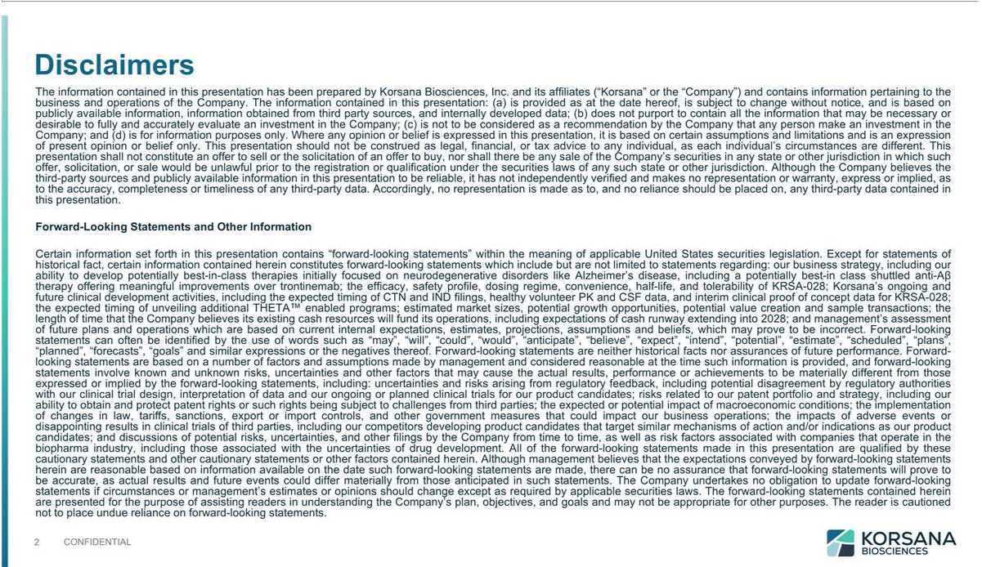

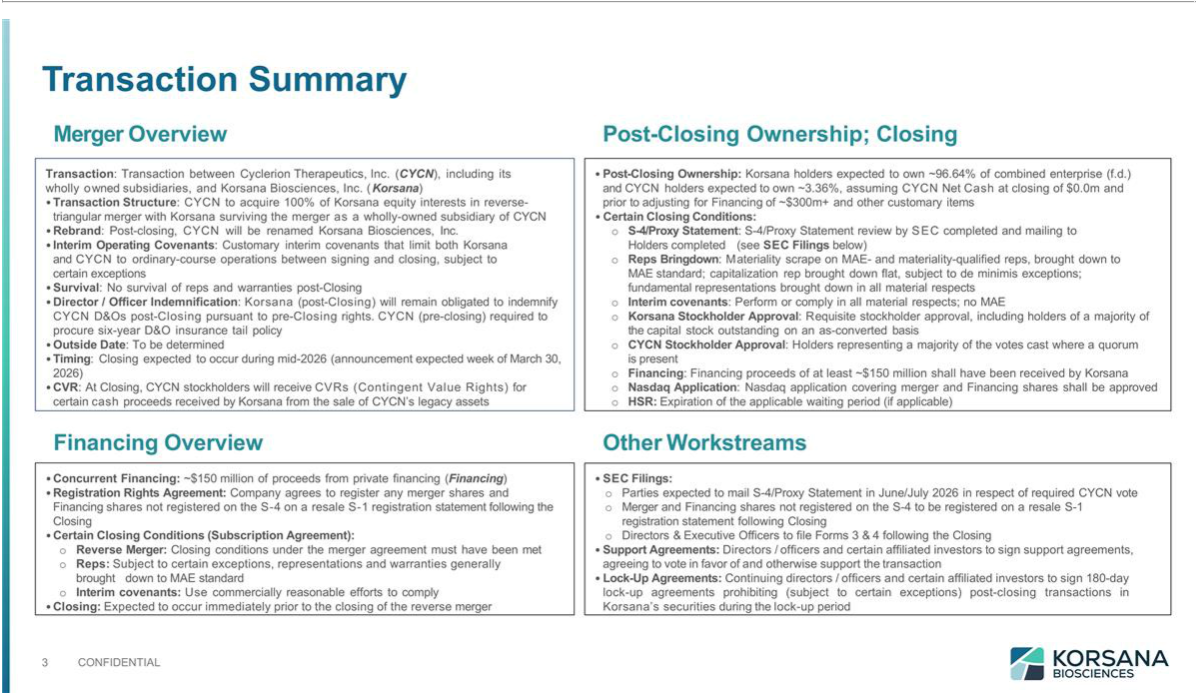

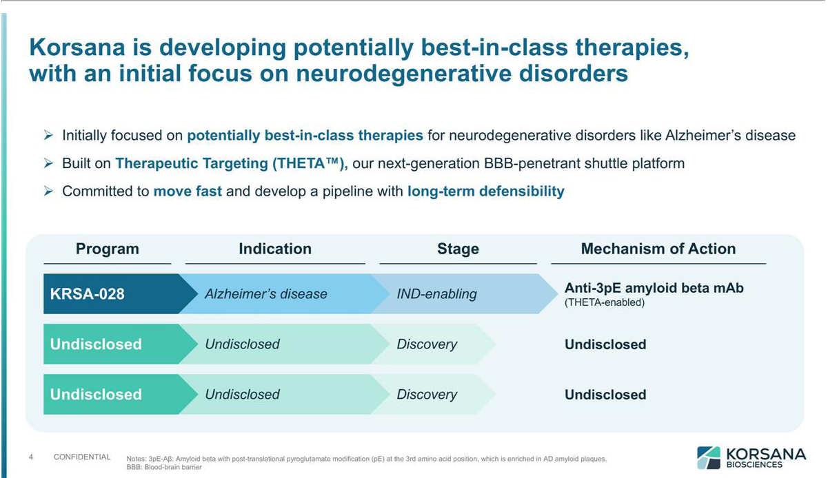

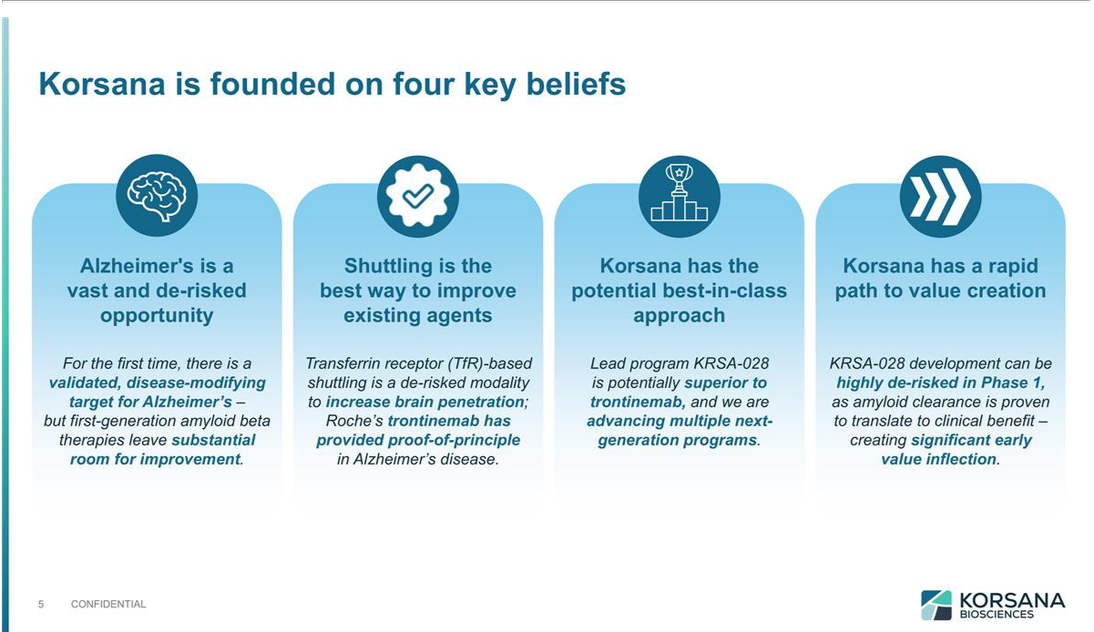





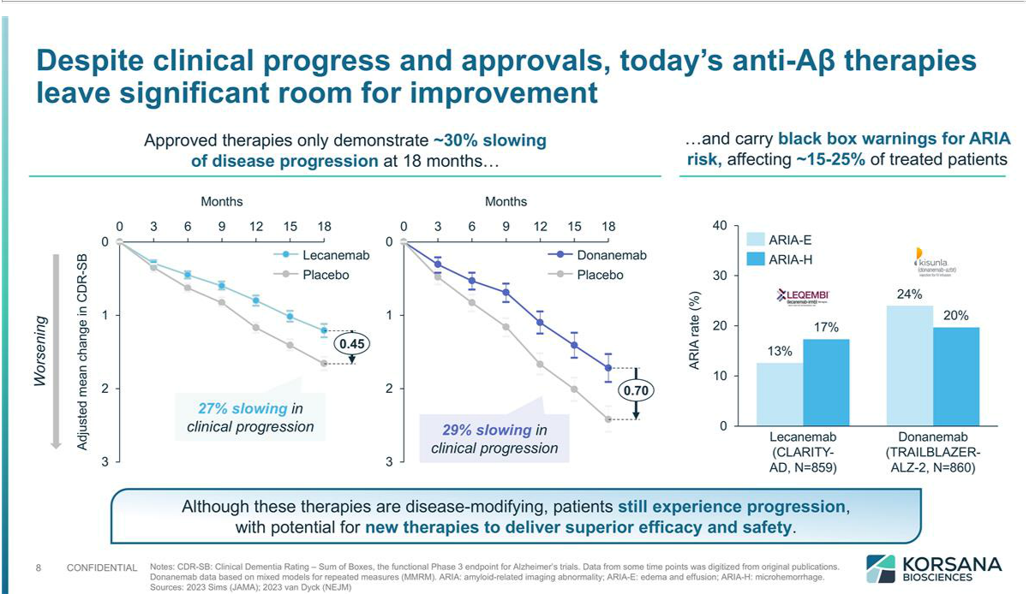

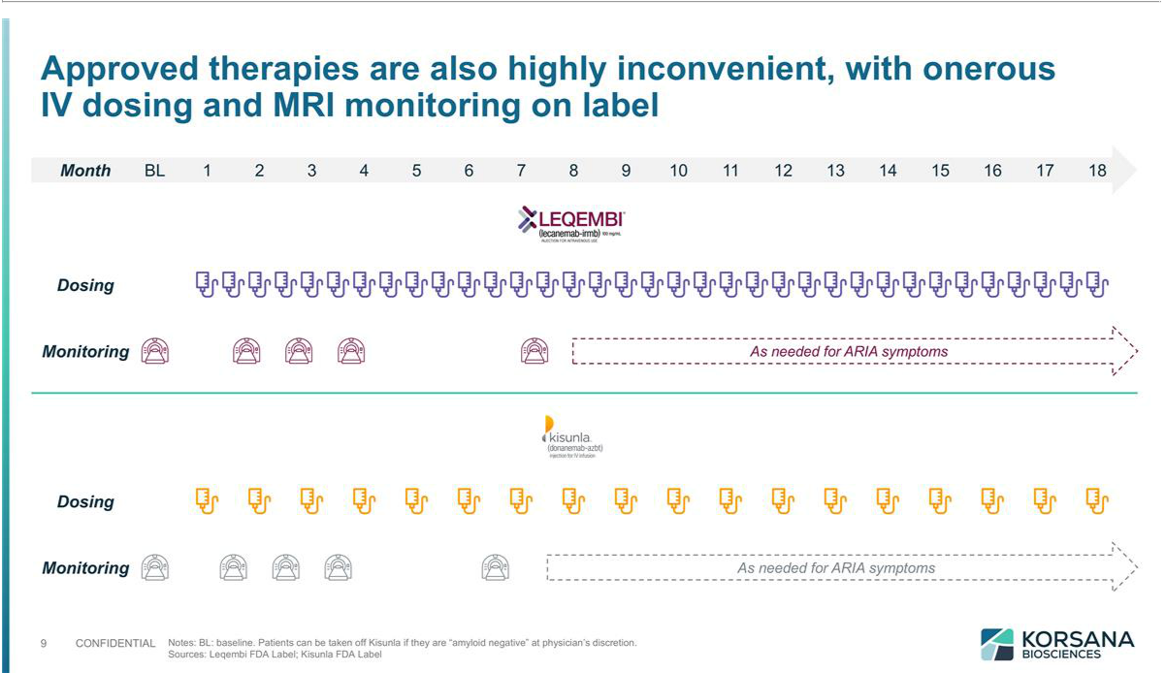



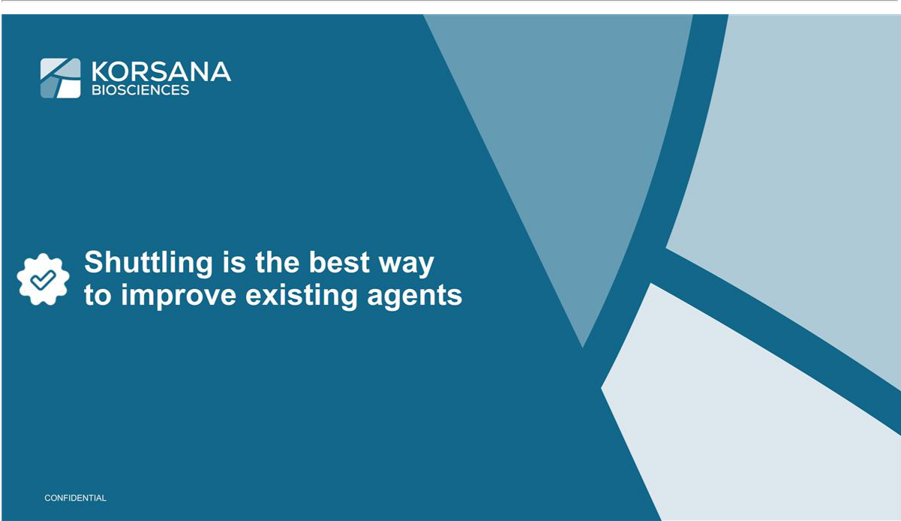

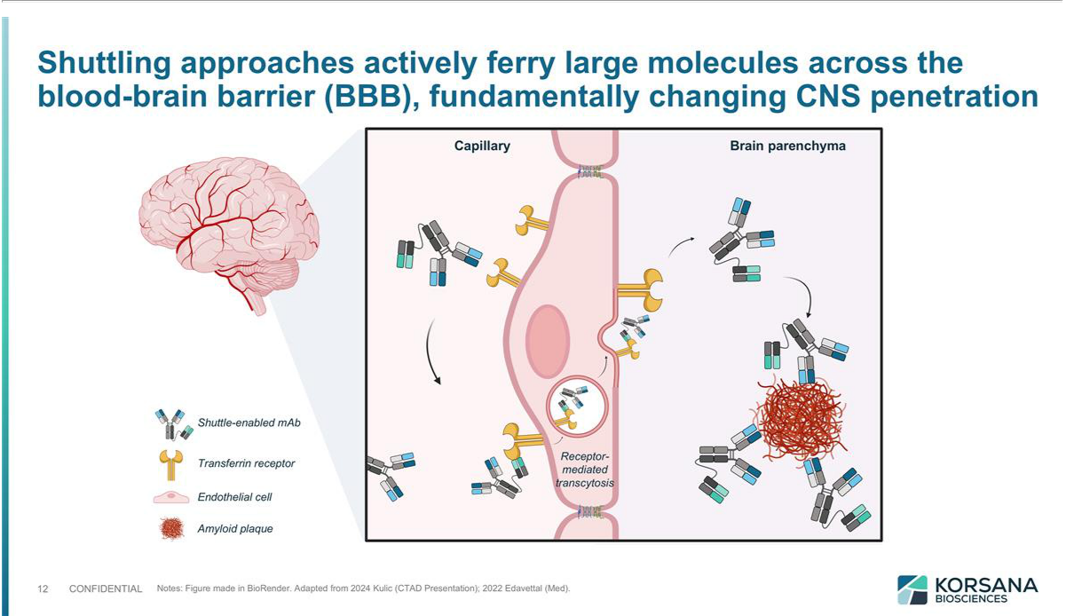

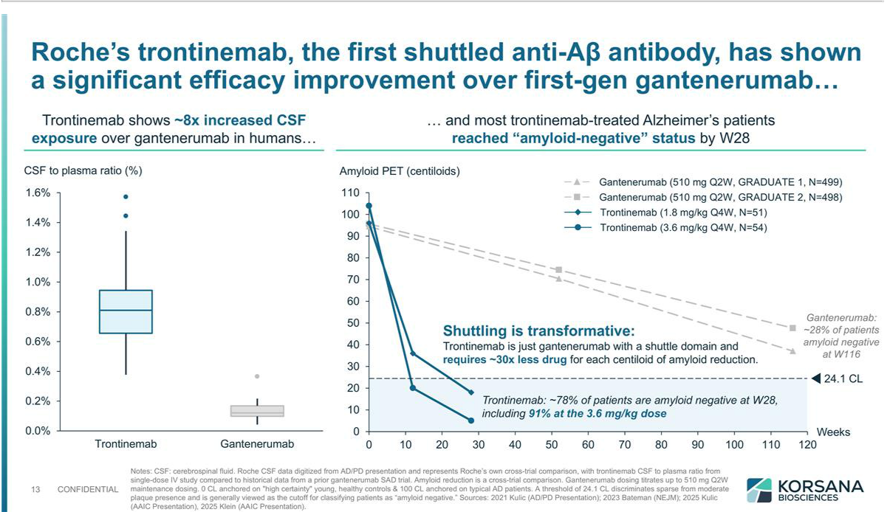

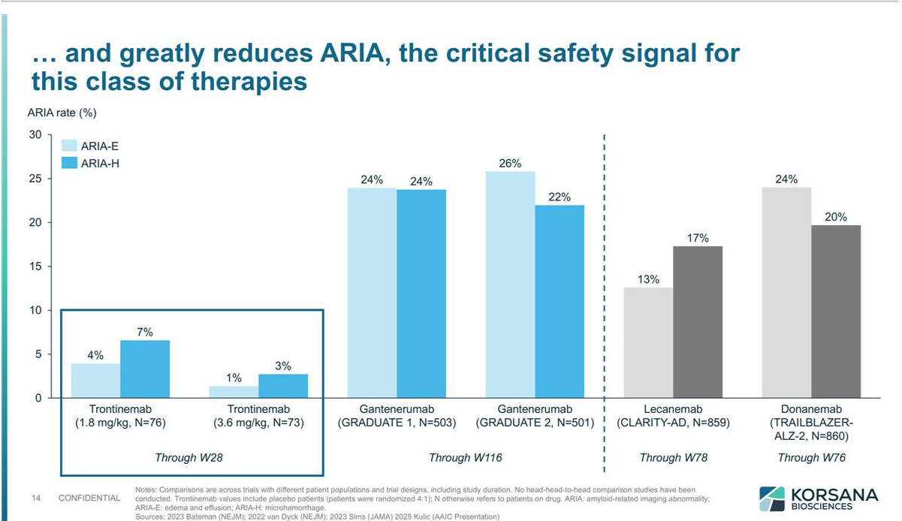

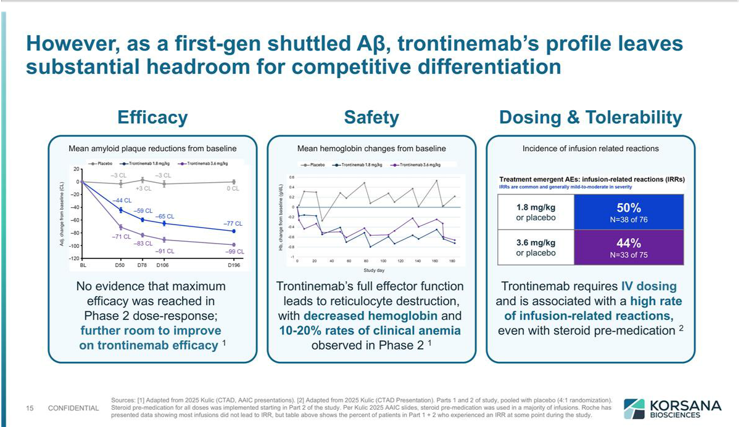



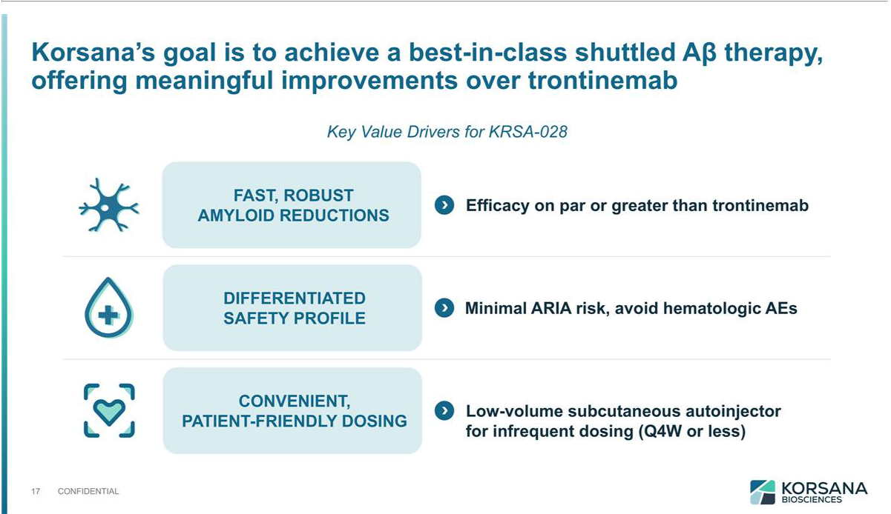

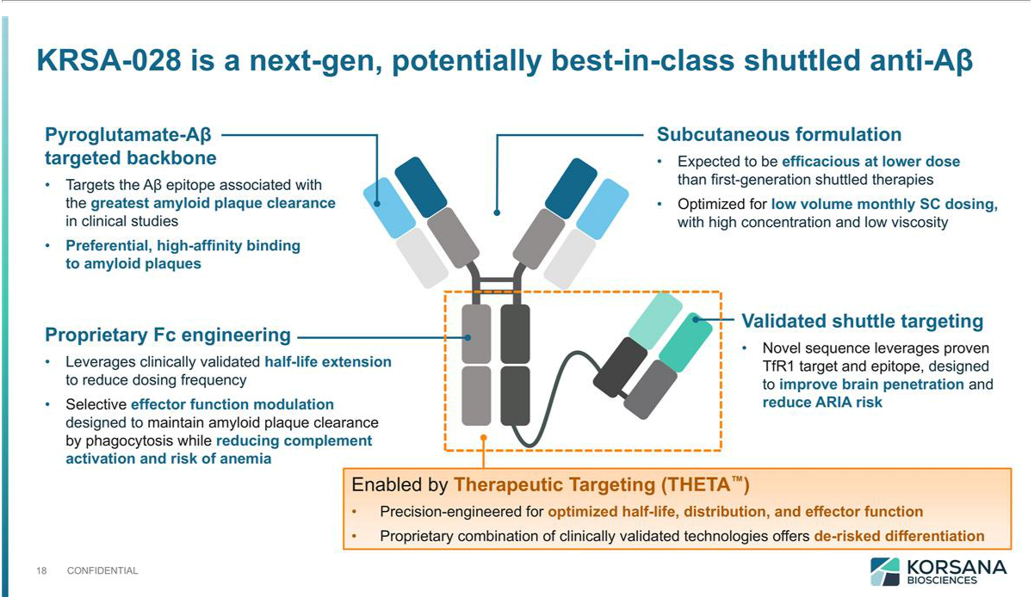

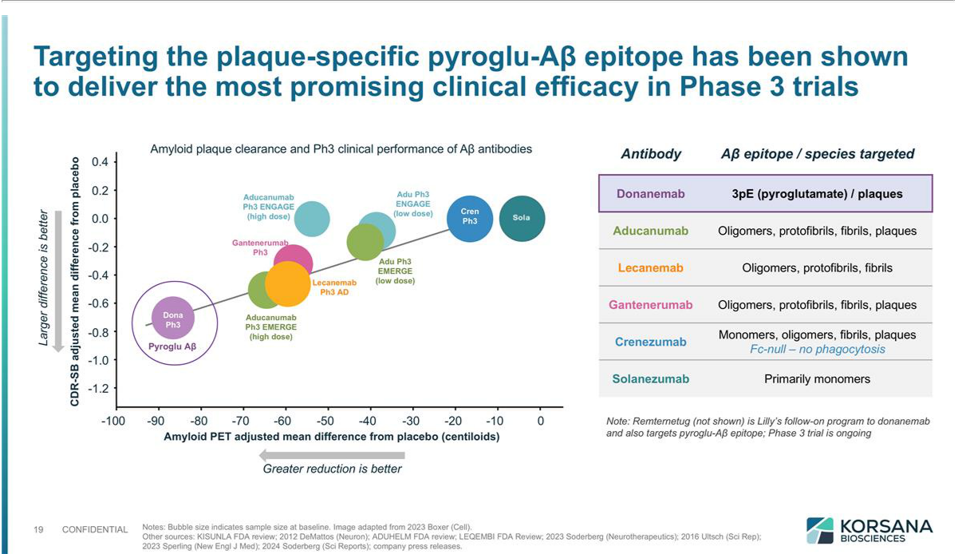

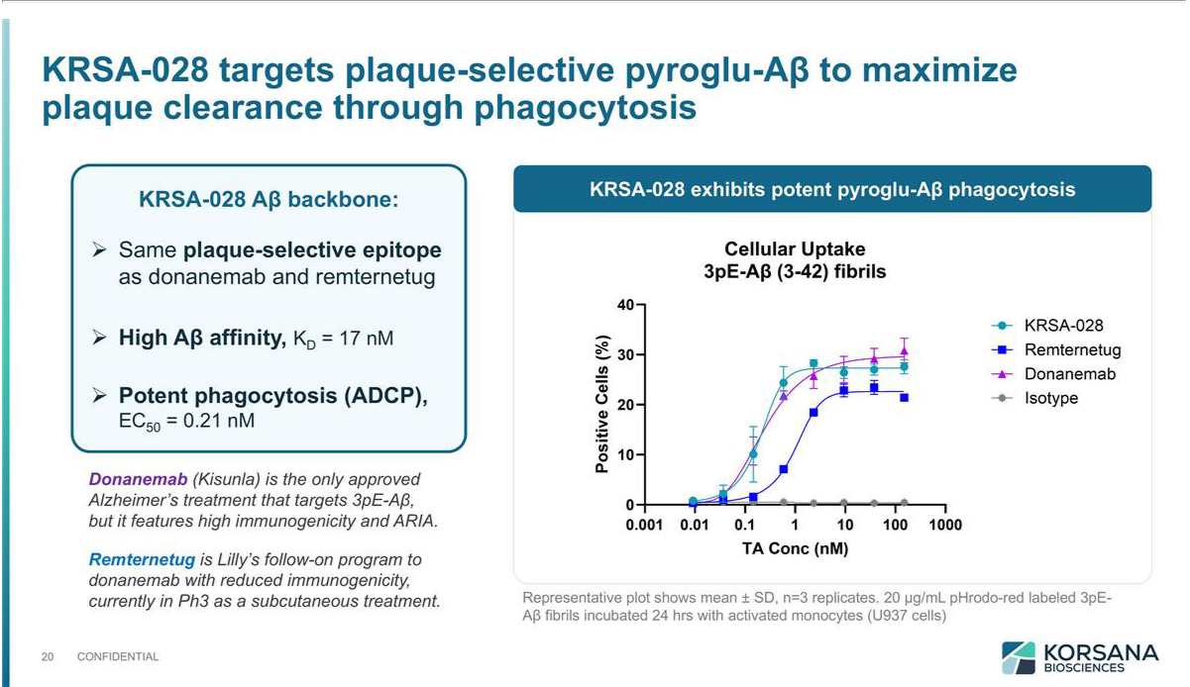

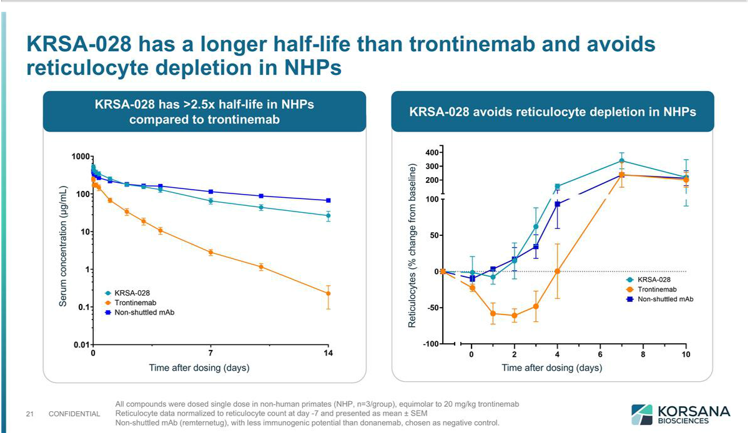

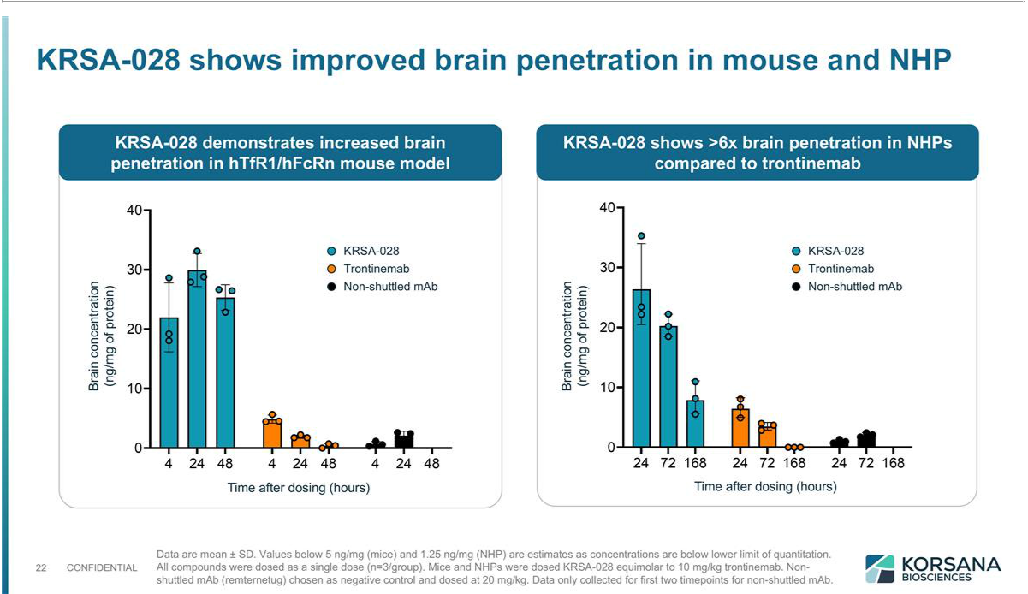

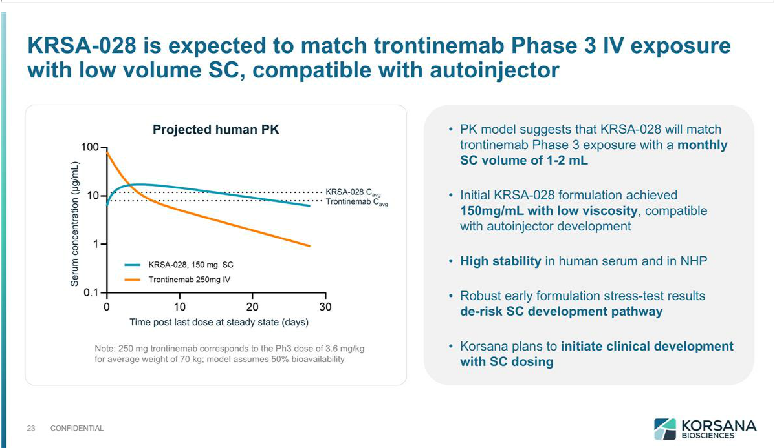

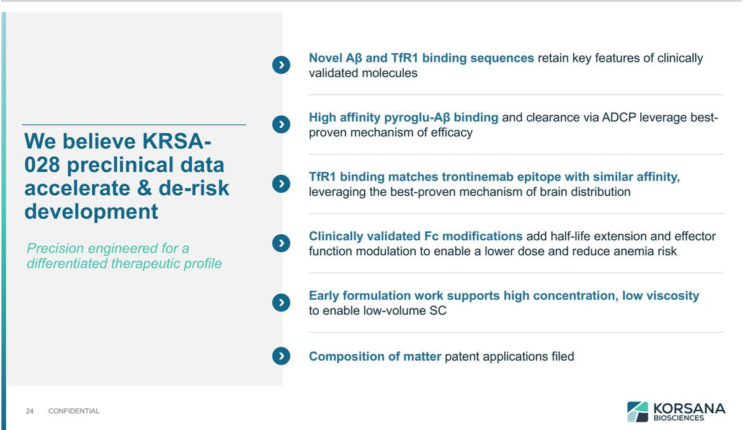



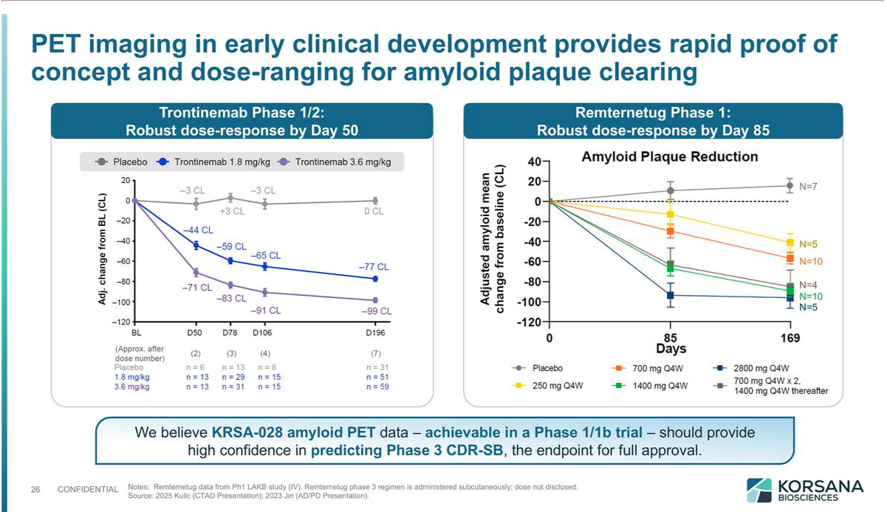

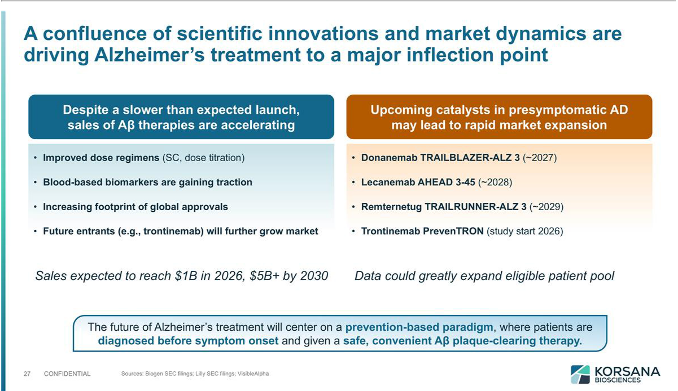

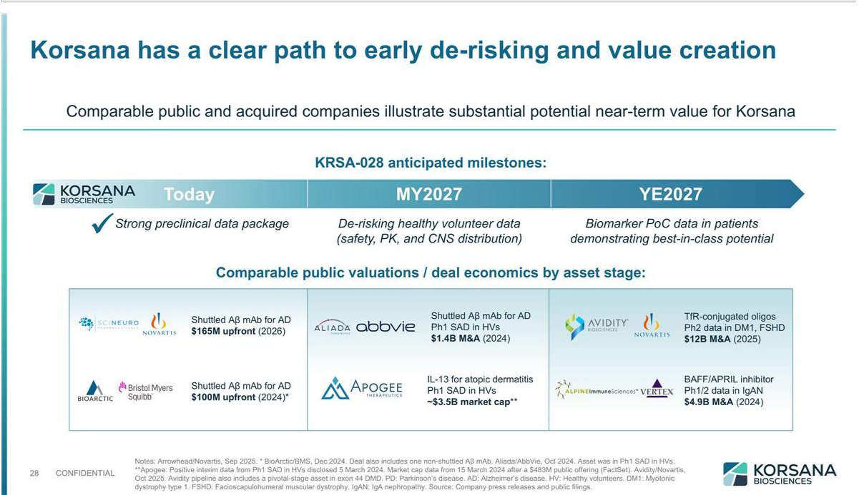

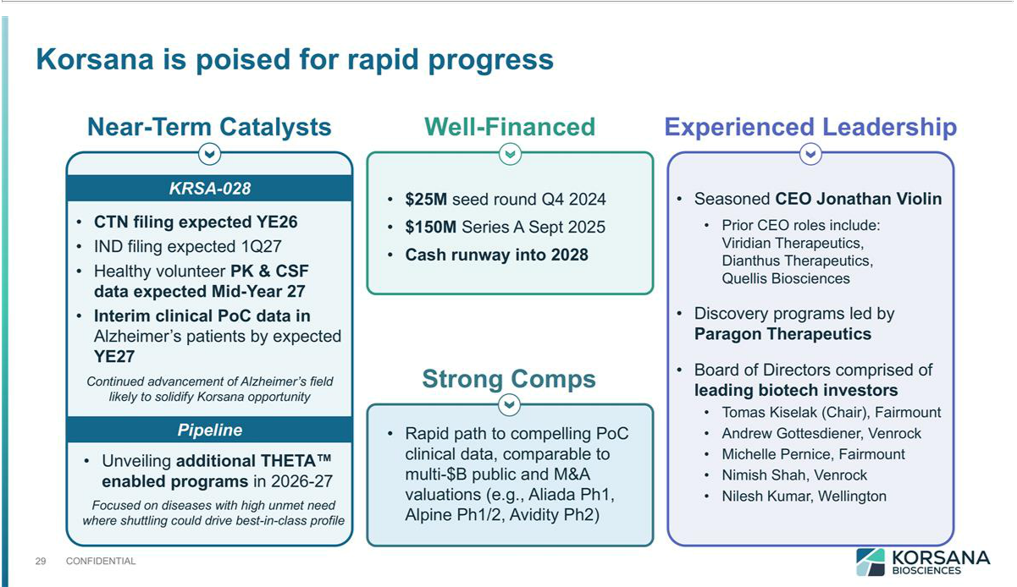





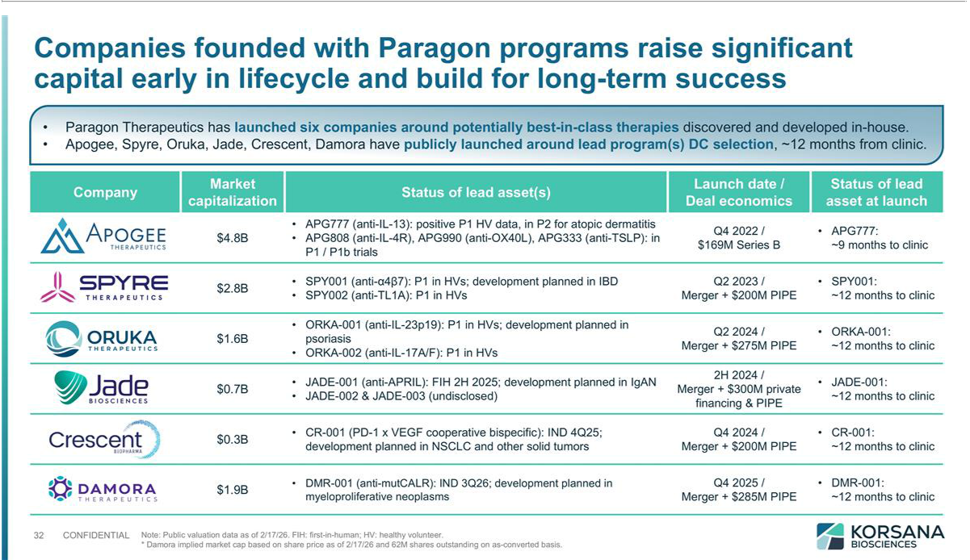

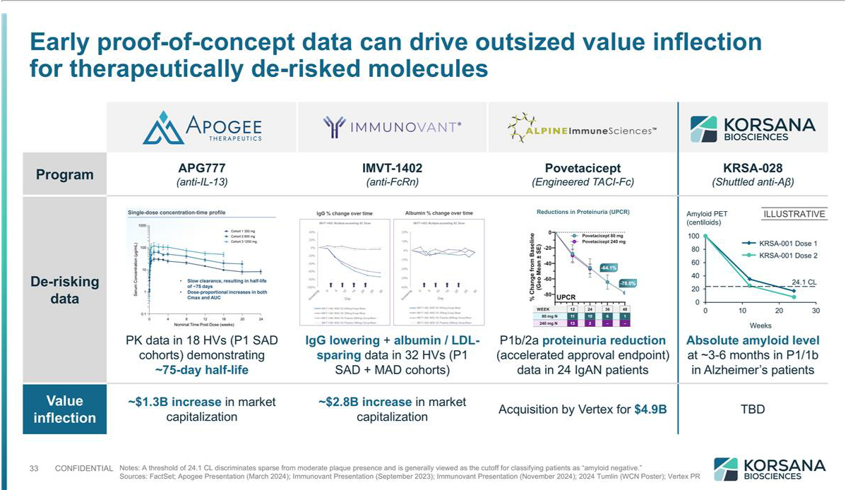

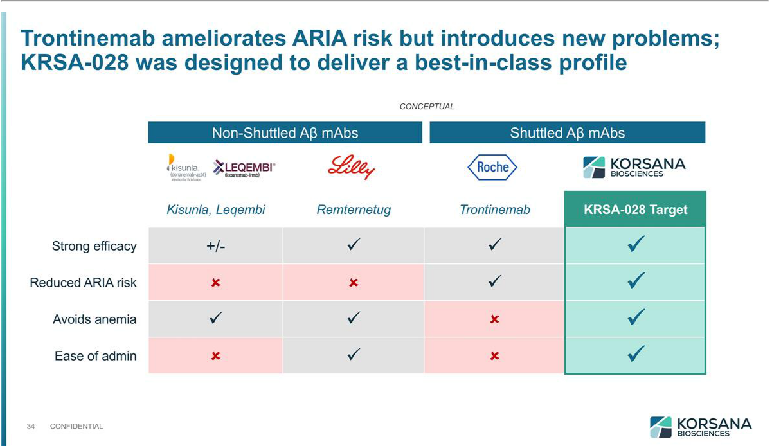

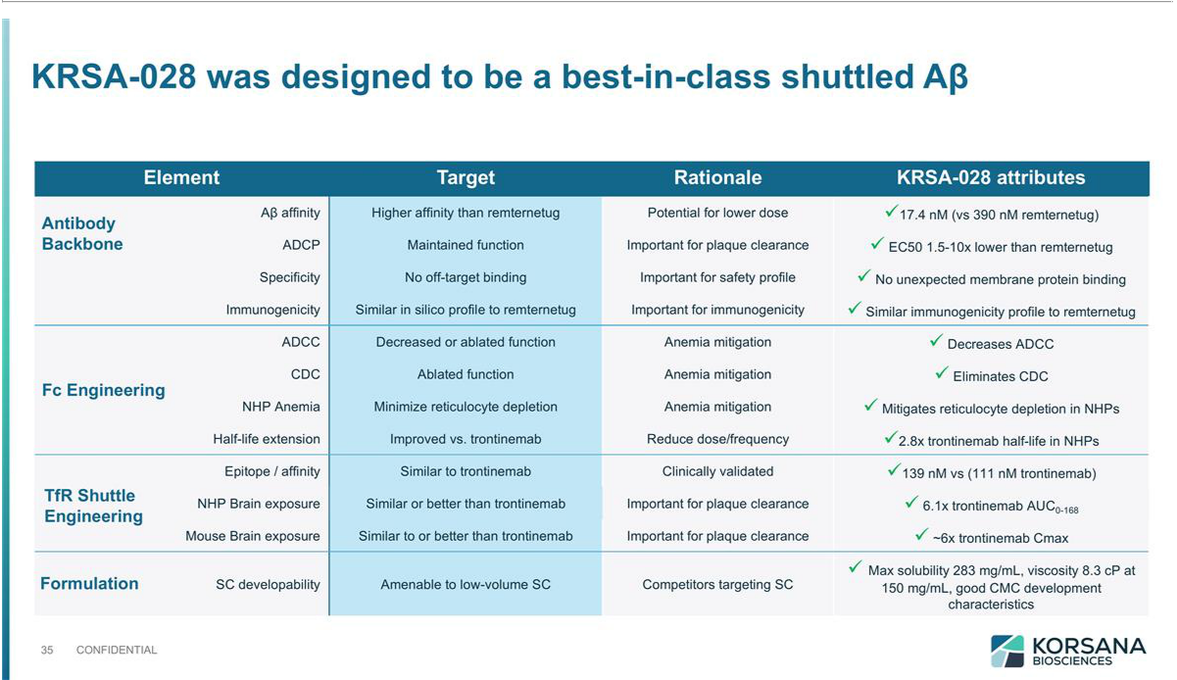

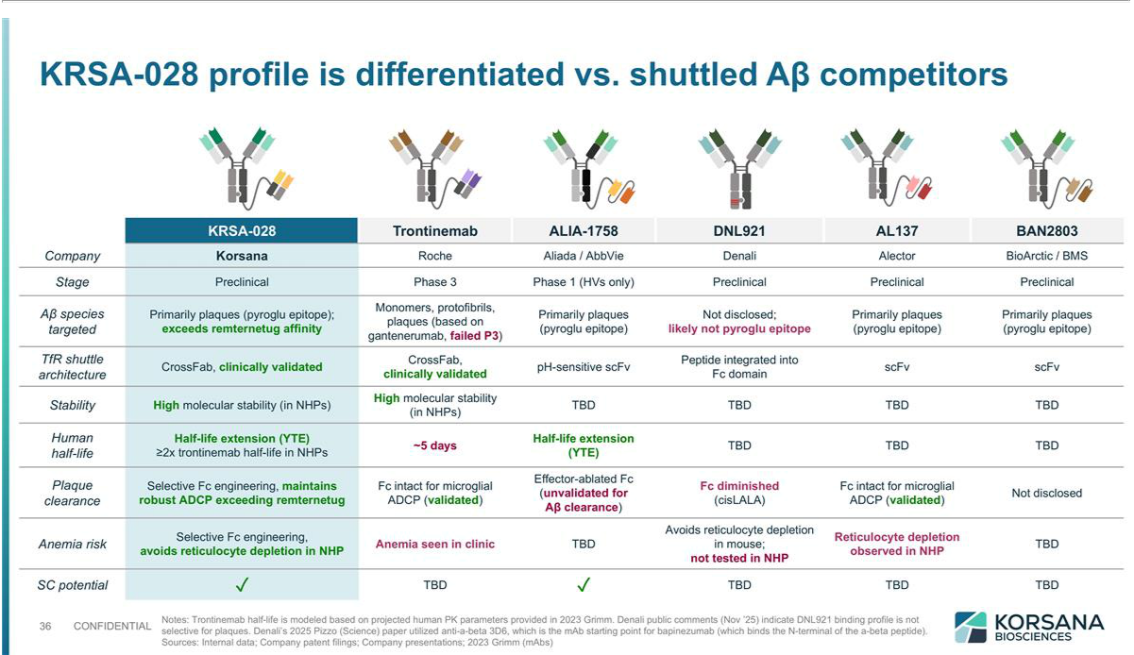

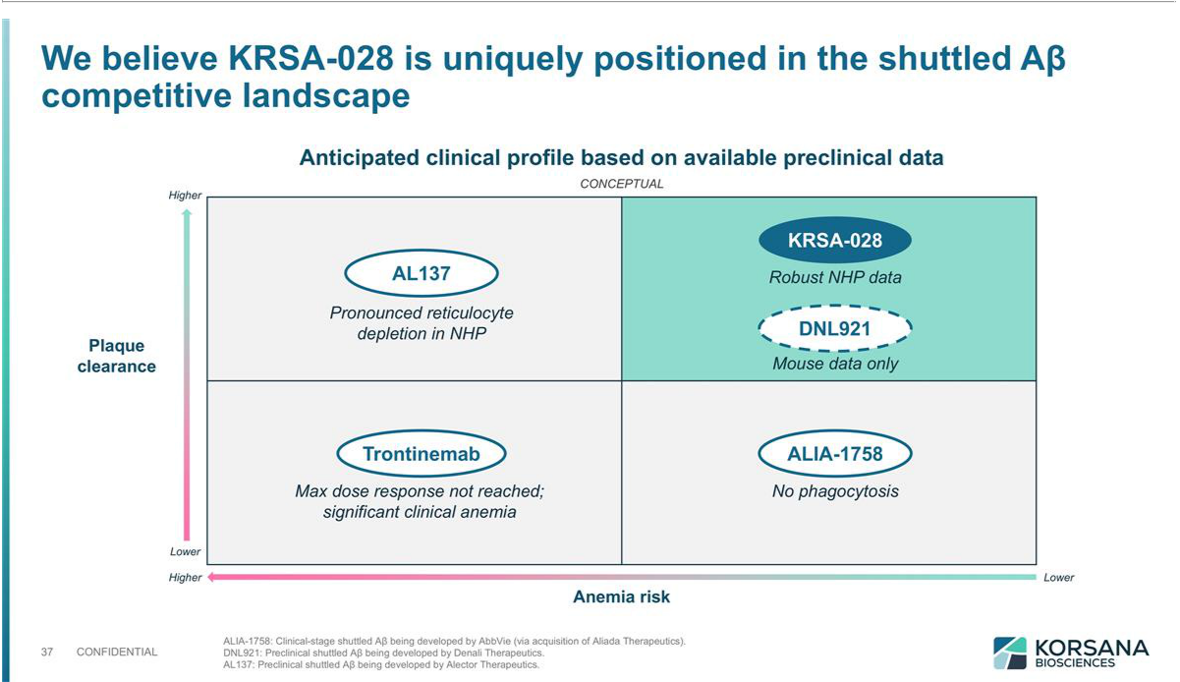

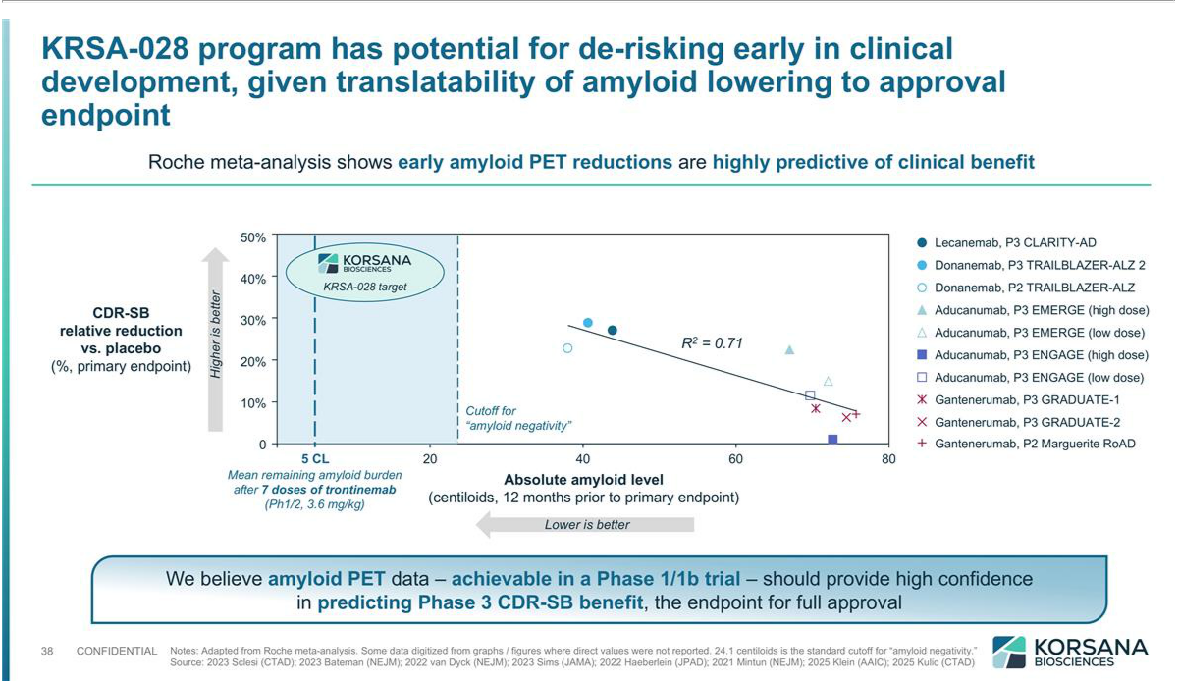

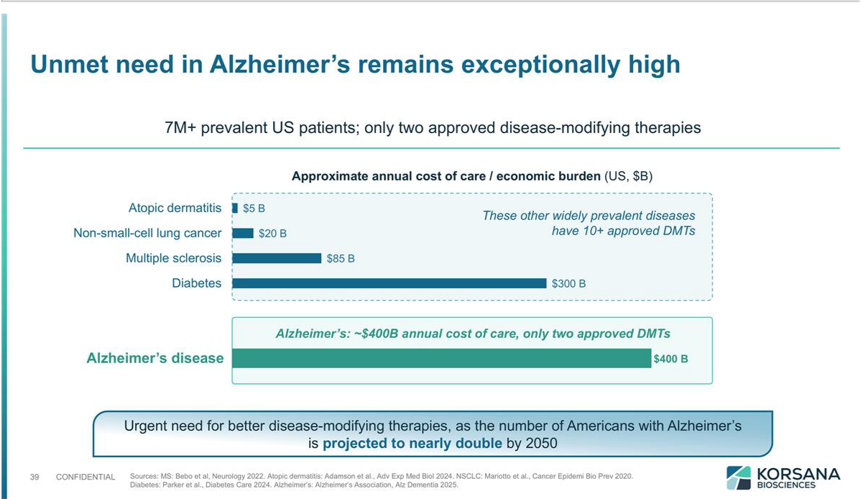

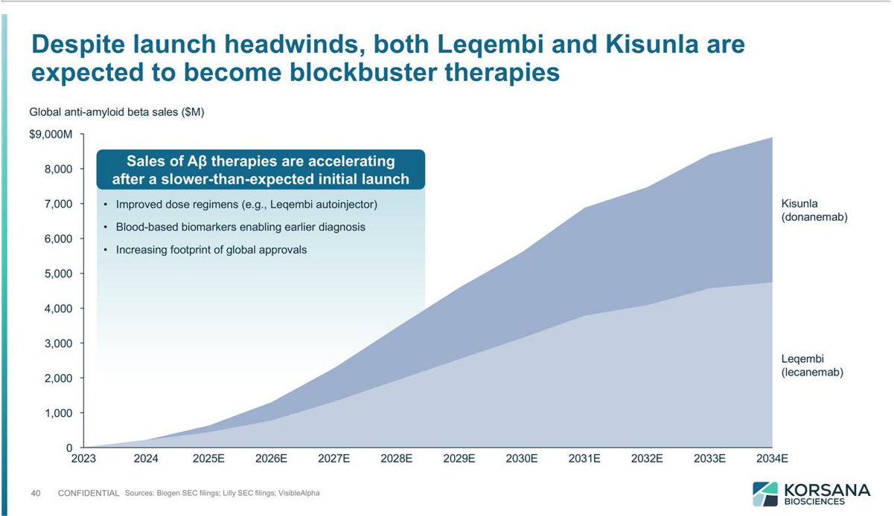

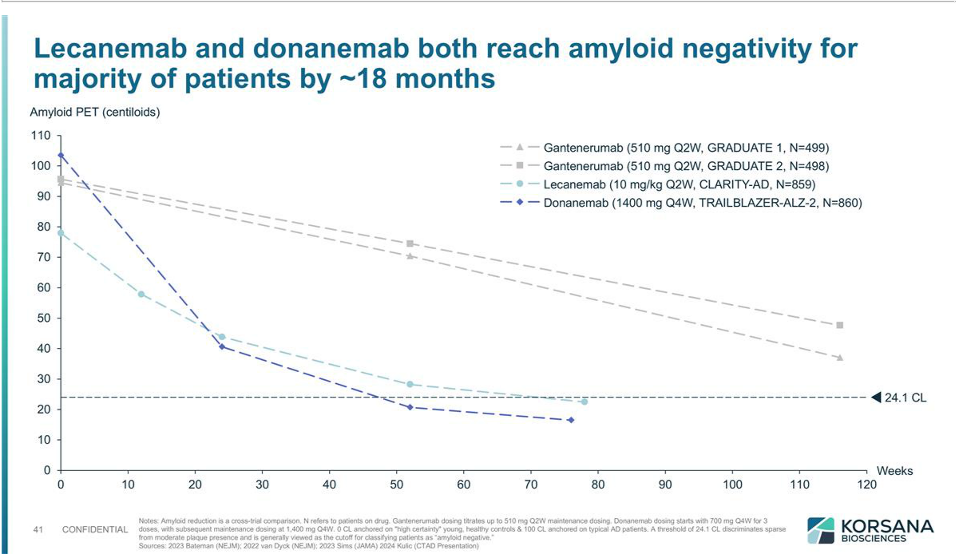

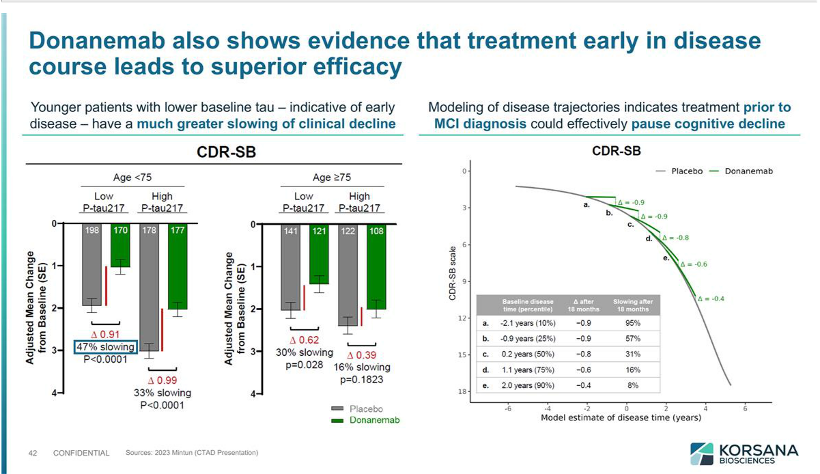

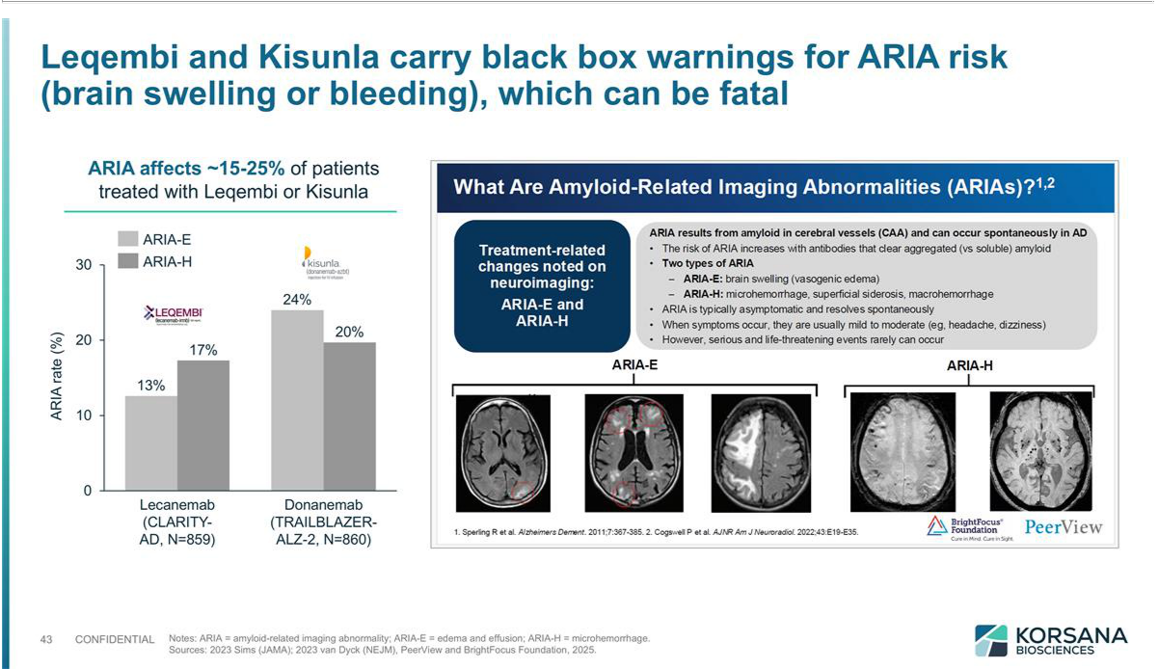

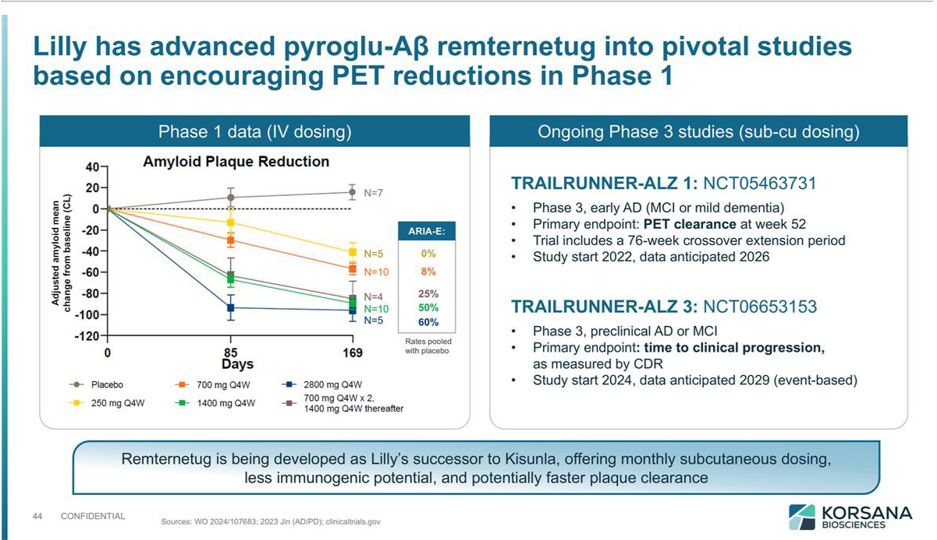

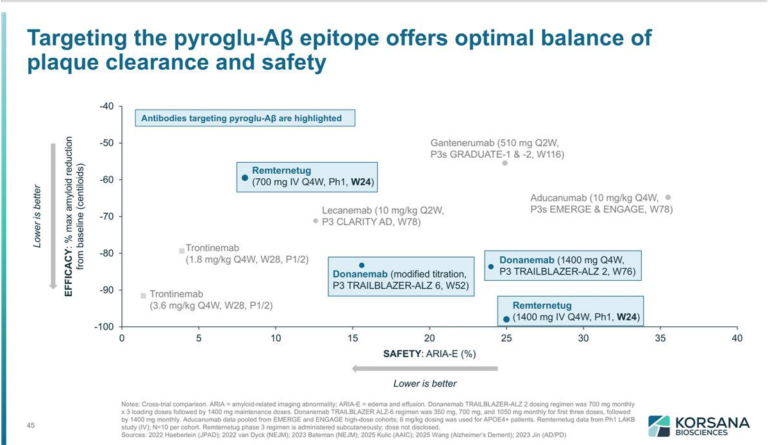

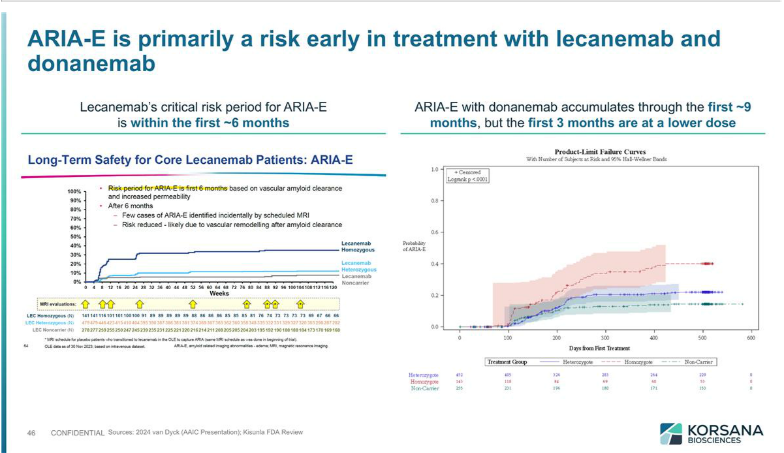

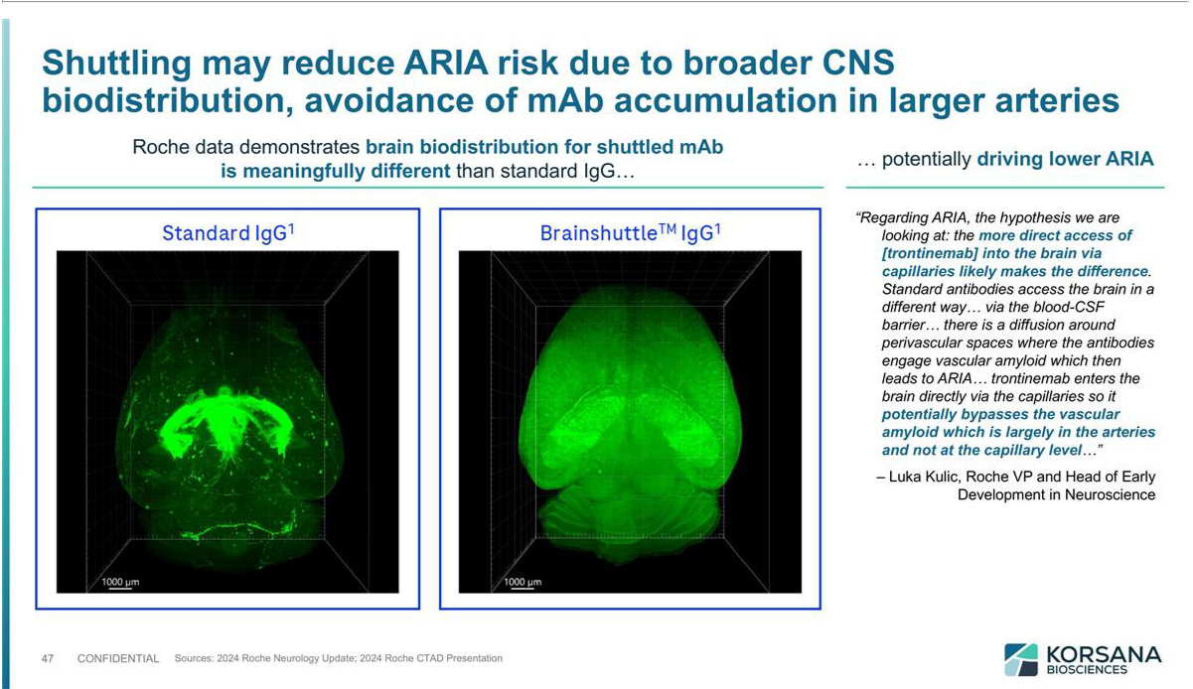

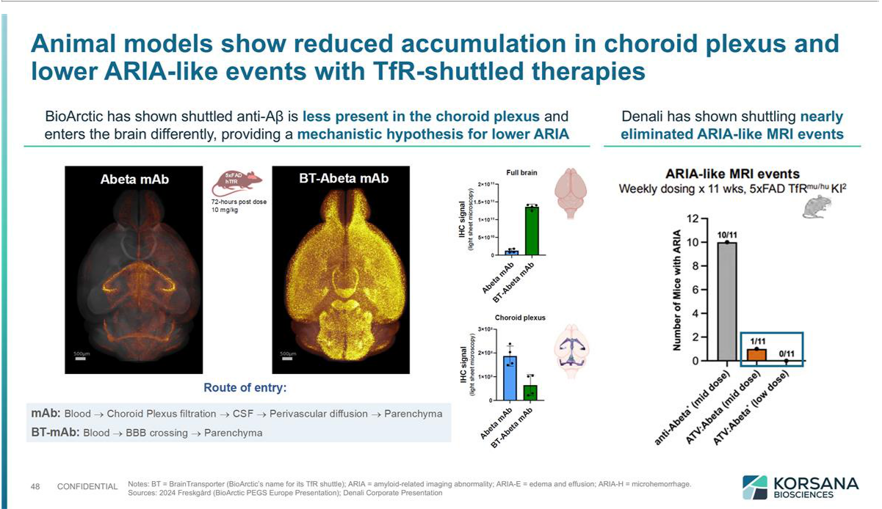

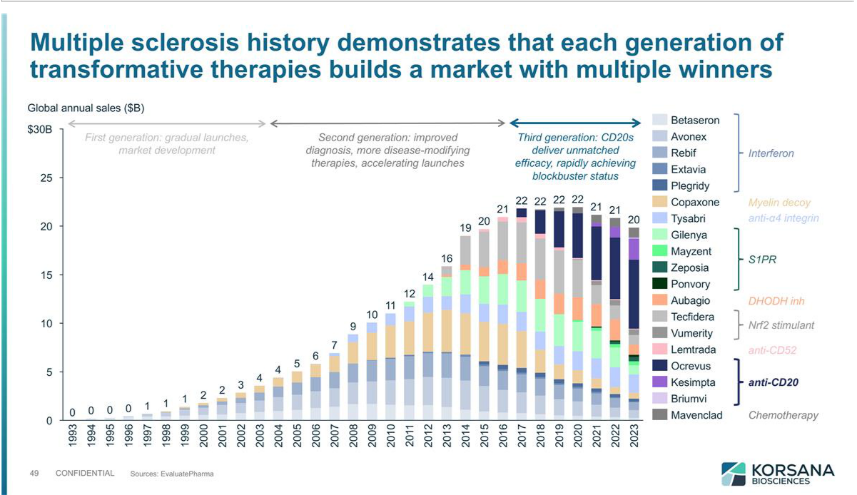

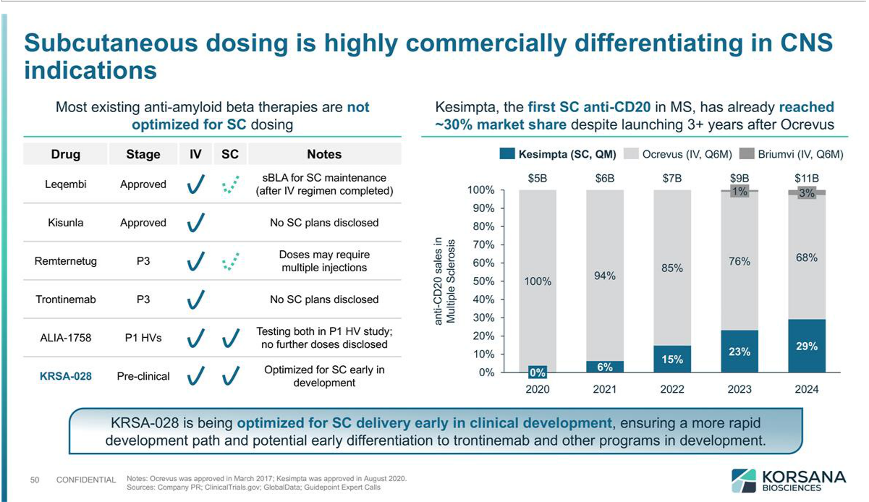

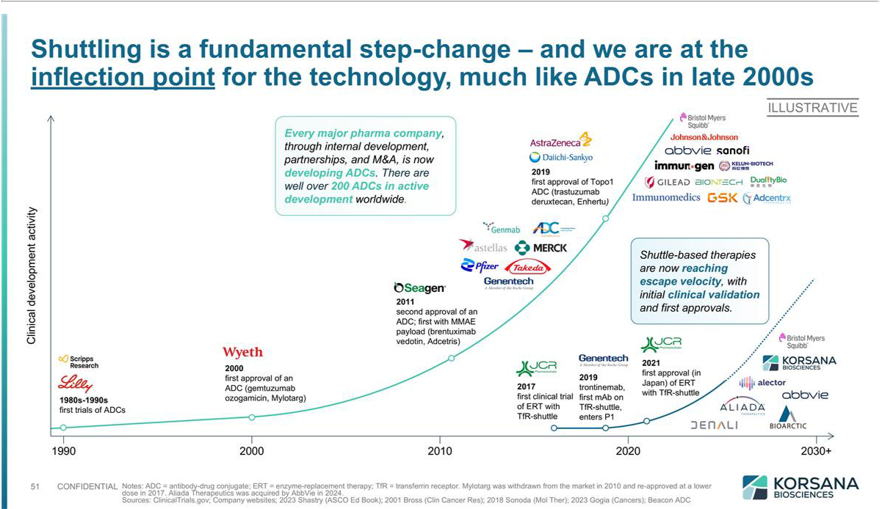

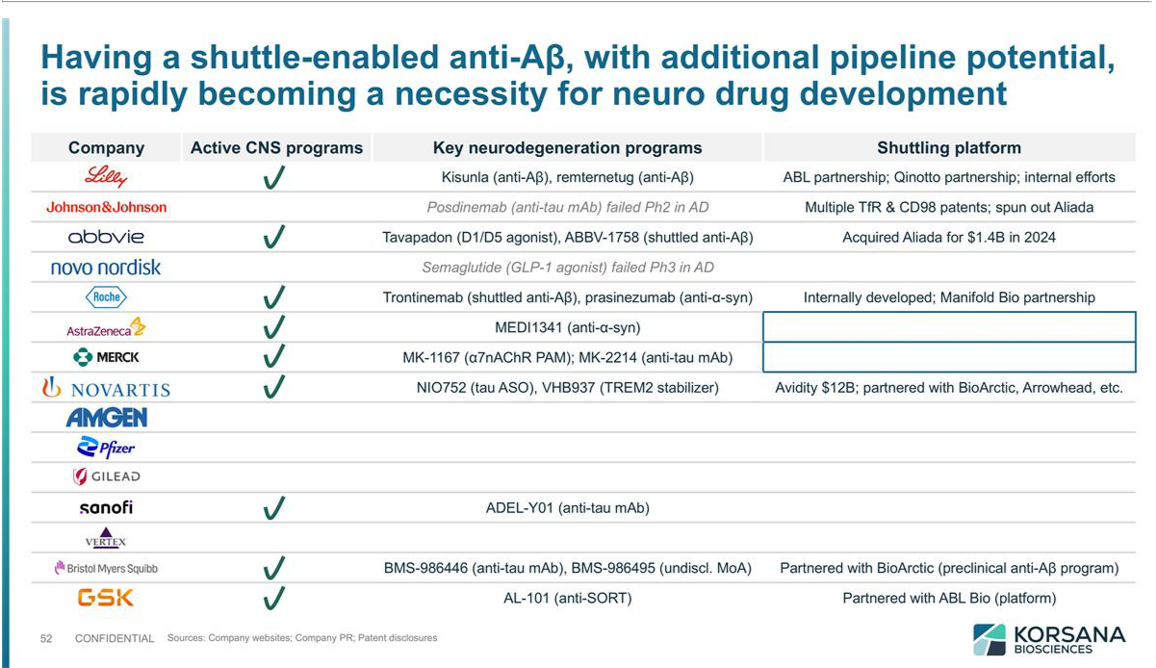

Exhibit 99.3

Cyclerion Therapeutics - Korsana Biosciences

Merger Agreement Announcement Conference Call

Wednesday, April 1

8:00am ET

Call Participants

Jon Violin, PhD

CEO, Korsana Biosciences

Regina Graul, PhD

CEO, Cyclerion Therapeutics

Rhonda Chicko

CFO, Cyclerion Therapeutics

Prepared Remarks

Operator

Good morning, and welcome to the Cyclerion Therapeutics-Korsana Biosciences Merger Agreement Announcement Conference Call. I would like to remind you that this call is being recorded for replay, and all attendees will be in listen-only mode.

I will now turn the conference call over to Rhonda Chicko, Chief Financial Officer of Cyclerion Therapeutics.

Rhonda Chicko

Thank you and good morning. Before we begin, I’d like to remind you that during this call, we may make forward-looking statements. These statements include expectations of both Cyclerion’s and Korsana’s management teams regarding the proposed transaction, including its anticipated timing and financial terms, and the post-closing ownership structure of Cyclerion. They also include expectations about Korsana’s lead program KRSA-028 and its THETA platform, including the potential differentiation from other therapies, clinical development plans and regulatory filing timelines, expectations for additional pipeline programs, and the anticipated cash position and runway of the combined company. These forward-looking statements are subject to certain risks and uncertainties.

Our actual results may differ materially from expectations. For a discussion of risks and uncertainties, please review the descriptions included under the heading “Risk Factors” and “Business” in Cyclerion’s most recent Annual Report on Form 10-K filed with the SEC, as well as other SEC filings made by Cyclerion from time to time. In addition, Cyclerion intends to file a proxy statement/prospectus with the SEC in connection with the proposed merger transaction, which will contain important information about Korsana, the combined company, and additional risk factors related to the transaction. Investors are urged to review the proxy statement/prospectus carefully when it becomes available. These filings are available through the website maintained by the SEC at www.sec.gov and also available on Cyclerion’s website.

All forward-looking statements are made as of today’s date. Except to the extent required by law, we do not undertake any obligation to update any forward-looking statements. We also caution you against placing undue reliance on any forward-looking statements.

I will now turn the conference call over to Regina Graul, Chief Executive Officer of Cyclerion.

Regina Graul

Thank you, Rhonda, and good morning. Joining me today is Jonathan Violin, Chief Executive Officer of Korsana Biosciences. In our press release this morning, we announced a merger agreement between Cyclerion and Korsana. Upon completion of this all-stock transaction, the combined company plans to operate under the name Korsana Biosciences, and Jon is expected to lead the company as its CEO.

I will review certain details of our proposed transaction with Korsana, as well as a concurrent private placement by a group of leading biotech investors to support Korsana’s pipeline programs. Jon will then provide an overview of Korsana, including its lead program and platform technology.

In support of the proposed merger, Korsana has secured a private placement of approximately $[XX] million from a syndicate of investors led by [Fairmount, Venrock Healthcare Capital Partners, and _________, with participation by _________, and other leading investment management firms].

The financing includes subscriptions by such investors to purchase Korsana common stock and pre-funded warrants exercisable for shares of Korsana common stock and is expected to close immediately prior to the completion of the merger.

The company’s combined cash position at closing, including the funds from the private placement, is expected to provide a runway into 2029 and fund Korsana’s KRSA-028 program through key clinical milestones in 2027. Under the terms of the agreement, as of the closing of the transaction, pre-merger Cyclerion shareholders are expected to own approximately [XX]% of the combined company. Pre-merger Korsana shareholders, inclusive of those participating in the private placement, are expected to own approximately [XX]% of the combined company as of the closing of the transaction. The percentage of the combined company that Cyclerion shareholders will own as of the closing of the transaction is subject to adjustments based on the estimated amount of Cyclerion net cash immediately prior to the closing date.

We expect the merger transaction to close in [the third quarter of 2026], subject to receipt of shareholder approvals and customary closing conditions.

I would like to thank the Board members of both Cyclerion and Korsana for their support in approving the transaction, which is the result of a comprehensive strategic review by Cyclerion’s Board and management team. We believe this is the best path forward for Cyclerion and our shareholders.

Furthermore, we are confident in the ability of Korsana’s seasoned leadership team to execute their vision of developing potential best-in-class therapies for neurodegenerative diseases with significant unmet needs. Through their proprietary platform and innovative pipeline, we believe the combined company is well-positioned to deliver on their key clinical milestones in the coming years.

With that, I will pass the conference call over to Jon.

Jonathan Violin

Thank you Regina, and good morning to everyone joining our call today.

First of all, I would like to thank the Cyclerion management team and Board for their support throughout this process and confidence in our strategy and clinical development plan.

I’m grateful for the opportunity to lead the combined company, and excited for the work ahead to discover and develop novel therapies to reduce the burden of neurodegenerative diseases – one of the largest unmet medical needs of our time.

I’ll share more about Korsana and our lead program KRSA-028, but first I’d like to note that listeners can access additional information about Korsana in our corporate presentation on our website, Korsana.com.

Korsana is the seventh company launched with assets that were discovered by the team at Paragon Therapeutics, who have a remarkable track record of creating precision-engineered biologics with potential to become best-in-class therapeutics. With this foundation, Korsana is advancing a pipeline of potential best-in-class therapeutics for neurodegenerative disorders.

Our lead program is KRSA-028, a novel and differentiated shuttled version of a pyroglutamate amyloid beta antibody for Alzheimer’s disease. Approximately 13 million Americans are projected to have Alzheimer’s by 2050, with long-term healthcare costs projected to be over $1 trillion by that time. This is a disease with a massive and growing unmet need, and we believe that Korsana is well-positioned to provide a best-in-class therapeutic for patients who deserve better options than what is currently available.

Korsana’s vision for advancing the treatment of Alzheimer’s disease is grounded in four key beliefs.

First, we believe that Alzheimer’s is at an inflection point. While it’s clearly one of the biggest unmet needs in medicine, it is now, finally, a derisked opportunity from a technical perspective. Two first generation amyloid-targeting drugs are now approved, validating the therapeutic approach – but they leave substantial room to improve on safety, efficacy, and convenience.

Second, we believe that shuttling technology – the ability to carry therapeutics to target tissues – increases brain exposure of amyloid-targeting drugs, remarkably improving their therapeutic profile, and is the best way to optimize amyloid-targeting drugs to treat diseases like Alzheimer’s.

Third, we believe our approach, based on our proprietary Therapeutic Targeting platform, or THETA, has the potential to deliver a best-in-class product, supported by a seasoned leadership team of drug developers that have the experience and capability to bring novel therapeutics to market.

And finally, we believe there is a path to rapid value creation with investigational products for Alzheimer’s disease. Advancements in imaging biomarkers now enable precise measurement of amyloid plaque clearance in small numbers of patients, accelerating timelines to generate proof-of-concept data and making this an attractive space for investment.

[pause]

Our initial focus is to develop a durably best-in-class amyloid-targeted therapy for Alzheimer’s – and we think we have that in KRSA-028. We optimized KRSA-028 based on lessons learned from the two approved amyloid-targeting products, investigational products like Roche’s trontinemab, and important discoveries made in partnership with our colleagues at Paragon Therapeutics. Notably, trontinemab is the first shuttled amyloid drug with clinical data, and it shows more rapid and thorough plaque clearance from the brain of Alzheimer’s patients compared to trials of non-shuttled drugs. Strikingly, the trontinemab clinical data show a markedly lower rate of amyloid-related imaging abnormalities, or ARIA, compared to trial data for non-shuttled drugs. Both approved amyloid-targeting drugs carry black box warnings for ARIA, and it has been a serious concern for this class of medications – so the trontinemab data have been met with high enthusiasm.

However, while trontinemab has served as a clear proof-of-concept for shuttle technology, its clinical data show substantial room for improvement.

In preclinical studies, trontinemab targets and depletes reticulocytes, which can interrupt erythropoiesis and lead to anemia. Clinical data show a 10 to 20 percent rate of anemia and trends of reduced mean hemoglobin in patients on trontinemab. Furthermore, trontinemab treatment is burdensome, requiring monthly intravenous infusions, and a high rate of infusion-related reactions requires pretreatment with steroids.

For patients, matching trontinemab’s efficacy while improving on these factors will be a welcome advance. And in fact, we have promising preclinical data that point to the potential of -028 as a best-in-class therapeutic in Alzheimer’s.

In partnership with the team at Paragon Therapeutics, we designed KRSA-028 to maximize efficacy, safety, and tolerability, including avoiding the anemia risk associated with trontinemab and other TfR1-shuttled molecules. We also designed KRSA-028 to optimize pharmacokinetics and biophysical properties to enable infrequent, low volume, subcutaneous dosing.

To maximize efficacy, KRSA-028 targets the pyroglutamate form of amyloid beta, which is enriched in plaques, making -028 a plaque-selective therapeutic versus molecules that target other amyloid beta species. Clinical trials of plaque-selective antibodies have shown more robust plaque clearance and numerically greater slowing of cognitive decline than antibodies that target other amyloid forms. We think this makes -028 well positioned to maximize the clinical benefit of anti-amyloid therapy.

To avoid anemia, and potentially to improve safety and tolerability, we designed KRSA-028 to include selective effector function modulation. We wanted to preserve anti-dependent phagocytosis, or ADCP, believed to be the mechanism by which the approved anti-amyloid drugs clear amyloid plaques – but we wanted to reduce other antibody effector functions, which we hypothesized were responsible for the reticulocyte destruction and other adverse immune effects of trontinimab, potentially including its infusion-related reactions. To achieve this, we incorporated a number of clinically precedented point mutations in the Fc region of the molecule, designed to reduce antibody-dependent cellular cytotoxicity, or ADCC, and complement-dependent cytotoxicity, or CDC, while preserving ADCP.

In addition, to improve pharmacokinetics to lower the dose and dose frequency required for efficacy, we also included clinically validated Fc modifications to extend half-life.

Finally, to shuttle KRSA-028 into the brain, we designed KRSA-028 to include a TfR1-binding antibody fragment that matches the clinically validated binding epitope and affinity of trontinemab.

Our preclinical data, which you can review in our corporate presentations, show that KRSA-028 delivers all the features we desired. It facilitates phagocytosis, matching the activity and potency of the approved pyro-glu amyloid-targeted drug donanemab. Compared to trontinemab, it achieves higher and more sustained exposure, does not destroy reticulocytes, and delivers 5- to 6-fold higher brain concentrations. We’ve also formulated KRSA-028 at high concentrations with low viscosity and high stability – all important for subcutaneous administration – and our modeling suggests it should match trontinemab efficacy at a low injection volume, well within the range needed for clinically proven autoinjectors.

We plan to initiate clinical development with an integrated Phase 1/2 design, beginning with single ascending doses in healthy volunteers, followed by multiple ascending dose cohorts in early Alzheimer’s patients. We will then enroll expansion cohorts at select doses to further characterize activity, safety, and tolerability and enable Phase 3 dose selection. We intend to file a CTN by the end of this year to initiate the SAD arm in healthy volunteers in Australia, and an IND at the beginning of 2027 to initiate the MAD arm in early Alzheimer’s patients. With this plan, we expect a key derisking readout from healthy volunteers in mid-year 2027, including data for half-life extension, hematologic safety, and CNS penetration. We then expect the first interim proof-of-concept data in Alzheimer’s patients by the end of 2027, using PET tracers to evaluate how quickly plaque is cleared. From there, we expect a rich stream of clinical data readouts as we complete dose-ranging and enroll expansion cohorts to collect all the data we believe we’ll need to discuss a pivotal Phase 3 program with global regulators. The transaction we announced today funds all of this, putting the combined company in a very strong position to accelerate the development of KRSA-028, with cash runway into 2029.

We believe KRSA-028 has best-in-class potential, and the technology behind it provides us a platform to build a broader pipeline. We call the combination of our proprietary TfR1 binding sequence and Fc engineering the Therapeutic Targeting platform or THETA. It has enabled us to initiate discovery programs for other CNS targets and indications where a subcutaneous, anemia-free shuttle can deliver best-in-class profiles. We aren’t revealing these programs yet for competitive reasons, but look forward to disclosing them later this year or in 2027.

[pause]

As some of you know, I’ve led the founding and growth of multiple biopharmaceutical companies. I’ve never been more excited about a company’s prospects as I am for Korsana – and I look forward to the important progress I believe we’ll make, together, in the coming years. We have a stellar team, an incredibly promising molecule in KRSA-028, and an immense opportunity in our pipeline. This is all anchored in a clear vision: delivering the best possible medicines for some of humanity’s most devastating diseases. I’d like to thank the team at Paragon Therapeutics for their partnership, the Korsana team for joining this mission, and Korsana’s investors for their support. We have important work ahead, and I look forward to sharing updates on our progress with you over the coming months and years.

With that, I will now conclude my remarks and hand the call back to the operator. Thank you for joining the call today.

Operator

Ladies and gentlemen, this concludes the conference call today. All parties may now disconnect.

