Filed by Cyclerion Therapeutics, Inc.
pursuant to Rule 425 under the Securities Act of 1933
and deemed filed pursuant to Rule 14a-12
under the Securities Exchange Act of 1934
Subject Company: Cyclerion Therapeutics, Inc.
Commission File No.: 333-295175
Date: July 10, 2026
This filing relates to the proposed transaction pursuant to the terms of that certain Agreement and Plan of Merger and Reorganization dated as of April 1, 2026, by and among Cyclerion Therapeutics, Inc., a Massachusetts corporation (“Cyclerion”), Cariboos Merger Sub Corp., a Delaware corporation and a wholly-owned subsidiary of Cyclerion (“First Merger Sub”), Cariboos Merger Sub II, LLC, a Delaware limited liability company and wholly-owned subsidiary of Cyclerion (“Second Merger Sub” and, together with First Merger Sub, the “Merger Subs”), and Korsana Biosciences, Inc., a Delaware corporation (“Korsana”) (as may be amended from time to time, the “Merger Agreement”), pursuant to which, among other matters, and subject to the satisfaction or waiver of the conditions set forth in the Merger Agreement, (i) First Merger Sub will merge with and into Korsana, with Korsana continuing as a wholly owned subsidiary of Cyclerion and the surviving corporation of the merger (the “First Merger”) and (ii) immediately following the First Merger and as part of the same overall transaction as the First Merger, Korsana will merge with and into Second Merger Sub.
On July 10, 2026, Korsana published the following communication:


Korsana Biosciences Overview July 2026

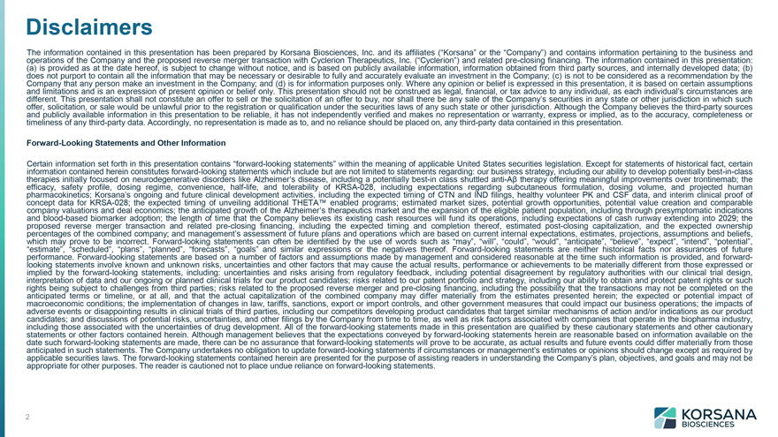
Disclaimers The information contained in this presentation has been prepared by Korsana Biosciences, Inc. and its affiliates (“Korsana” or the “Company”) and contains information pertaining to the business and operations of the Company and the proposed reverse merger transaction with Cyclerion Therapeutics, Inc. (“Cyclerion”) and related pre-closing financing. The information contained in this presentation: (a) is provided as at the date hereof, is subject to change without notice, and is based on publicly available information, information obtained from third party sources, and internally developed data; (b) does not purport to contain all the information that may be necessary or desirable to fully and accurately evaluate an investment in the Company; (c) is not to be considered as a recommendation by the Company that any person make an investment in the Company; and (d) is for information purposes only. Where any opinion or belief is expressed in this presentation, it is based on certain assumptions and limitations and is an expression of present opinion or belief only. This presentation should not be construed as legal, financial, or tax advice to any individual, as each individual’s circumstances are different. This presentation shall not constitute an offer to sell or the solicitation of an offer to buy, nor shall there be any sale of the Company’s securities in any state or other jurisdiction in which such offer, solicitation, or sale would be unlawful prior to the registration or qualification under the securities laws of any such state or other jurisdiction. Although the Company believes the third-party sources and publicly available information in this presentation to be reliable, it has not independently verified and makes no representation or warranty, express or implied, as to the accuracy, completeness or timeliness of any third-party data. Accordingly, no representation is made as to, and no reliance should be placed on, any third-party data contained in this presentation. Forward-Looking Statements and Other Information Certain information set forth in this presentation contains “forward-looking statements” within the meaning of applicable United States securities legislation. Except for statements of historical fact, certain information contained herein constitutes forward-looking statements which include but are not limited to statements regarding: our business strategy, including our ability to develop potentially best-in-class therapies initially focused on neurodegenerative disorders like Alzheimer’s disease, including a potentially best-in class shuttled anti-Aß therapy offering meaningful improvements over trontinemab; the efficacy, safety profile, dosing regime, convenience, half-life, and tolerability of KRSA-028, including expectations regarding subcutaneous formulation, dosing volume, and projected human pharmacokinetics; Korsana’s ongoing and future clinical development activities, including the expected timing of CTN and IND filings, healthy volunteer PK and CSF data, and interim clinical proof of concept data for KRSA-028; the expected timing of unveiling additional THETA enabled programs; estimated market sizes, potential growth opportunities, potential value creation and comparable company valuations and deal economics; the anticipated growth of the Alzheimer’s therapeutics market and the expansion of the eligible patient population, including through presymptomatic indications and blood-based biomarker adoption; the length of time that the Company believes its existing cash resources will fund its operations, including expectations of cash runway extending into 2029; the proposed reverse merger transaction and related pre-closing financing, including the expected timing and completion thereof, estimated post-closing capitalization, and the expected ownership percentages of the combined company; and management’s assessment of future plans and operations which are based on current internal expectations, estimates, projections, assumptions and beliefs, which may prove to be incorrect. Forward-looking statements can often be identified by the use of words such as “may”, “will”, “could”, “would”, “anticipate”, “believe”, “expect”, “intend”, “potential”, “estimate”, “scheduled”, “plans”, “planned”, “forecasts”, “goals” and similar expressions or the negatives thereof. Forward-looking statements are neither historical facts nor assurances of future performance. Forward-looking statements are based on a number of factors and assumptions made by management and considered reasonable at the time such information is provided, and forwardlooking statements involve known and unknown risks, uncertainties and other factors that may cause the actual results, performance or achievements to be materially different from those expressed or implied by the forward-looking statements, including: uncertainties and risks arising from regulatory feedback, including potential disagreement by regulatory authorities with our clinical trial design, interpretation of data and our ongoing or planned clinical trials for our product candidates; risks related to our patent portfolio and strategy, including our ability to obtain and protect patent rights or such rights being subject to challenges from third parties; risks related to the proposed reverse merger and pre-closing financing, including the possibility that the transactions may not be completed on the anticipated terms or timeline, or at all, and that the actual capitalization of the combined company may differ materially from the estimates presented herein; the expected or potential impact of macroeconomic conditions; the implementation of changes in law, tariffs, sanctions, export or import controls, and other government measures that could impact our business operations; the impacts of adverse events or disappointing results in clinical trials of third parties, including our competitors developing product candidates that target similar mechanisms of action and/or indications as our product candidates; and discussions of potential risks, uncertainties, and other filings by the Company from time to time, as well as risk factors associated with companies that operate in the biopharma industry, including those associated with the uncertainties of drug development. All of the forward-looking statements made in this presentation are qualified by these cautionary statements and other cautionary statements or other factors contained herein. Although management believes that the expectations conveyed by forward-looking statements herein are reasonable based on information available on the date such forward-looking statements are made, there can be no assurance that forward-looking statements will prove to be accurate, as actual results and future events could differ materially from those anticipated in such statements. The Company undertakes no obligation to update forward-looking statements if circumstances or management’s estimates or opinions should change except as required by applicable securities laws. The forward-looking statements contained herein are presented for the purpose of assisting readers in understanding the Company’s plan, objectives, and goals and may not be appropriate for other purposes. The reader is cautioned not to place undue reliance on forward-looking statements.

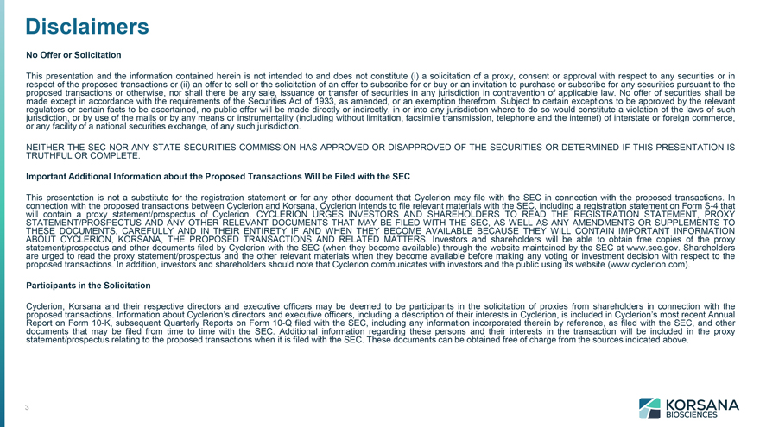
Disclaimers No Offer or Solicitation This presentation and the information contained herein is not intended to and does not constitute (i) a solicitation of a proxy, consent or approval with respect to any securities or in respect of the proposed transactions or (ii) an offer to sell or the solicitation of an offer to subscribe for or buy or an invitation to purchase or subscribe for any securities pursuant to the proposed transactions or otherwise, nor shall there be any sale, issuance or transfer of securities in any jurisdiction in contravention of applicable law. No offer of securities shall be made except in accordance with the requirements of the Securities Act of 1933, as amended, or an exemption therefrom. Subject to certain exceptions to be approved by the relevant regulators or certain facts to be ascertained, no public offer will be made directly or indirectly, in or into any jurisdiction where to do so would constitute a violation of the laws of such jurisdiction, or by use of the mails or by any means or instrumentality (including without limitation, facsimile transmission, telephone and the internet) of interstate or foreign commerce, or any facility of a national securities exchange, of any such jurisdiction. NEITHER THE SEC NOR ANY STATE SECURITIES COMMISSION HAS APPROVED OR DISAPPROVED OF THE SECURITIES OR DETERMINED IF THIS PRESENTATION IS TRUTHFUL OR COMPLETE. Important Additional Information about the Proposed Transactions Will be Filed with the SEC This presentation is not a substitute for the registration statement or for any other document that Cyclerion may file with the SEC in connection with the proposed transactions. In connection with the proposed transactions between Cyclerion and Korsana, Cyclerion intends to file relevant materials with the SEC, including a registration statement on Form S-4 that will contain a proxy statement/prospectus of Cyclerion. CYCLERION URGES INVESTORS AND SHAREHOLDERS TO READ THE REGISTRATION STATEMENT, PROXY STATEMENT/PROSPECTUS AND ANY OTHER RELEVANT DOCUMENTS THAT MAY BE FILED WITH THE SEC, AS WELL AS ANY AMENDMENTS OR SUPPLEMENTS TO THESE DOCUMENTS, CAREFULLY AND IN THEIR ENTIRETY IF AND WHEN THEY BECOME AVAILABLE BECAUSE THEY WILL CONTAIN IMPORTANT INFORMATION ABOUT CYCLERION, KORSANA, THE PROPOSED TRANSACTIONS AND RELATED MATTERS. Investors and shareholders will be able to obtain free copies of the proxy statement/prospectus and other documents filed by Cyclerion with the SEC (when they become available) through the website maintained by the SEC at www.sec.gov. Shareholders are urged to read the proxy statement/prospectus and the other relevant materials when they become available before making any voting or investment decision with respect to the proposed transactions. In addition, investors and shareholders should note that Cyclerion communicates with investors and the public using its website (www.cyclerion.com). Participants in the Solicitation Cyclerion, Korsana and their respective directors and executive officers may be deemed to be participants in the solicitation of proxies from shareholders in connection with the proposed transactions. Information about Cyclerion’s directors and executive officers, including a description of their interests in Cyclerion, is included in Cyclerion’s most recent Annual Report on Form 10-K, subsequent Quarterly Reports on Form 10-Q filed with the SEC, including any information incorporated therein by reference, as filed with the SEC, and other documents that may be filed from time to time with the SEC. Additional information regarding these persons and their interests in the transaction will be included in the proxy statement/prospectus relating to the proposed transactions when it is filed with the SEC. These documents can be obtained free of charge from the sources indicated above.

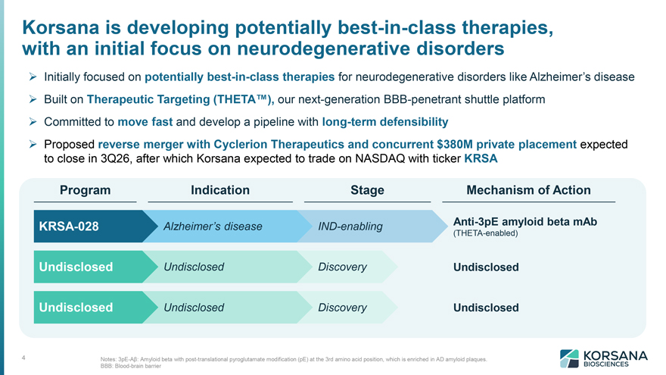
Korsana is developing potentially best-in-class therapies, with an initial focus on neurodegenerative disorders 4 Initially focused on potentially best-in-class therapies for neurodegenerative disorders like Alzheimer’s disease Built on Therapeutic Targeting (THETA ), our next-generation BBB-penetrant shuttle platform Committed to move fast and develop a pipeline with long-term defensibility Proposed reverse merger with Cyclerion Therapeutics and concurrent $380M private placement expected to close in 3Q26, after which Korsana expected to trade on NASDAQ with ticker KRSA Program Indication Stage Mechanism of Action KRSA-028 Anti-3pE amyloid beta mAb (THETA-enabled) Alzheimer’s disease IND-enabling Undisclosed Undisclosed Discovery Undisclosed Undisclosed Undisclosed Discovery Undisclosed Notes: 3pE-Aß: Amyloid beta with post-translational pyroglutamate modification (pE) at the 3rd amino acid position, which is enriched in AD amyloid plaques. BBB: Blood-brain barrier

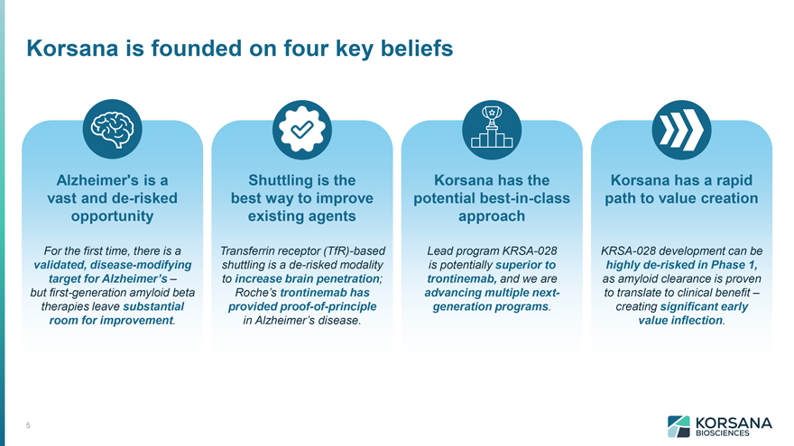
Korsana is founded on four key beliefs Alzheimer’s is a vast and de-risked opportunity For the first time, there is a validated, disease-modifying target for Alzheimer’s – but first-generation amyloid beta therapies leave substantial room for improvement. Shuttling is the best way to improve existing agents Transferrin receptor (TfR)-based shuttling is a de-risked modality to increase brain penetration; Roche’s trontinemab has provided proof-of-principle in Alzheimer’s disease. Korsana has the potential best-in-class approach Lead program KRSA-028 is potentially superior to trontinemab, and we are advancing multiple nextgeneration programs. Korsana has a rapid path to value creation KRSA-028 development can be highly de-risked in Phase 1, as amyloid clearance is proven to translate to clinical benefit – creating significant early value inflection.


Alzheimer’s is a vast and de-risked opportunity

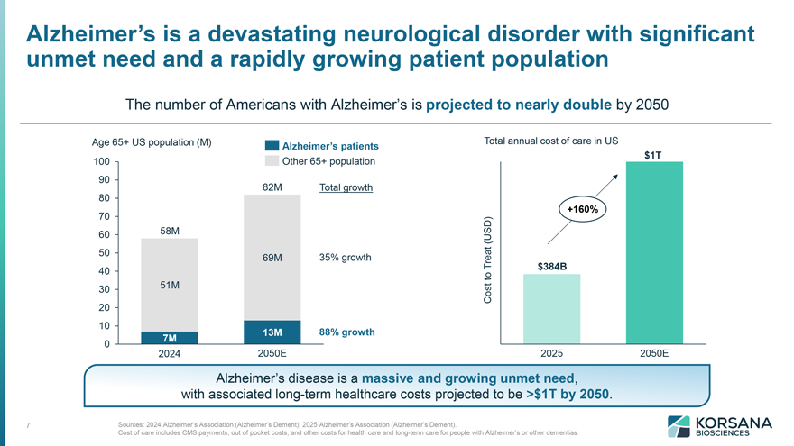
Alzheimer’s is a devastating neurological disorder with significant unmet need and a rapidly growing patient population The number of Americans with Alzheimer’s is projected to nearly double by 2050 Alzheimer’s disease is a massive and growing unmet need, with associated long-term healthcare costs projected to be >$1T by 2050. Sources: 2024 Alzheimer’s Association (Alzheimer’s Dement); 2025 Alzheimer’s Association (Alzheimer’s Dement). Cost of care includes CMS payments, out of pocket costs, and other costs for health care and long-term care for people with Alzheimer’s or other dementias.

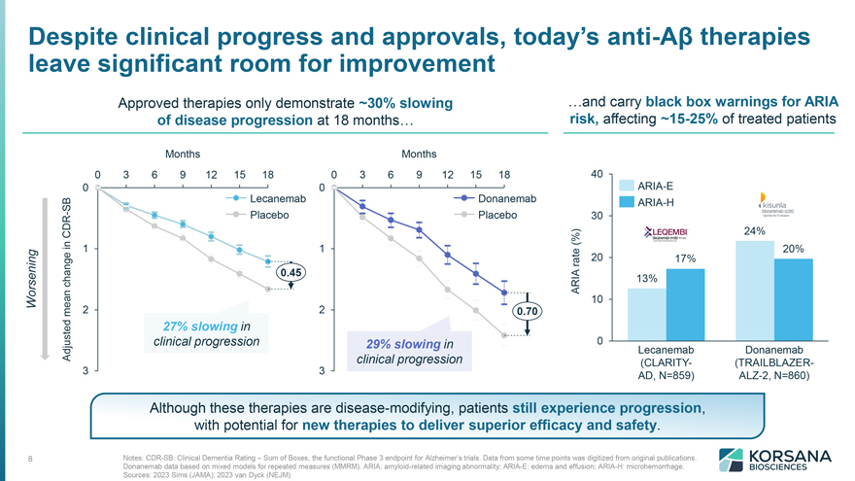
Despite clinical progress and approvals, today’s anti-Aß therapies leave significant room for improvement Approved therapies only demonstrate ~30% slowing of disease progression at 18 months and carry black box warnings for ARIA risk, affecting ~15-25% of treated patients Although these therapies are disease-modifying, patients still experience progression, with potential for new therapies to deliver superior efficacy and safety. Notes: CDR-SB: Clinical Dementia Rating – Sum of Boxes, the functional Phase 3 endpoint for Alzheimer’s trials. Data from some time points was digitized from original publications. Donanemab data based on mixed models for repeated measures (MMRM). ARIA: amyloid-related imaging abnormality; ARIA-E: edema and effusion; ARIA-H: microhemorrhage. Sources: 2023 Sims (JAMA); 2023 van Dyck (NEJM)

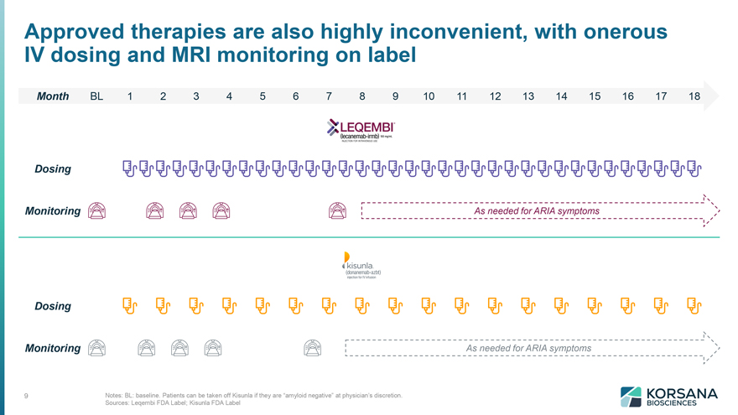
Approved therapies are also highly inconvenient, with onerous IV dosing and MRI monitoring on label Month BL 1 2 3 4 5 6 7 8 9 10 11 12 13 14 15 16 17 18 Dosing Monitoring Dosing Monitoring As needed for ARIA symptoms As needed for ARIA symptoms Notes: BL: baseline. Patients can be taken off Kisunla if they are “amyloid negative” at physician’s discretion. Sources: Leqembi FDA Label; Kisunla FDA Label

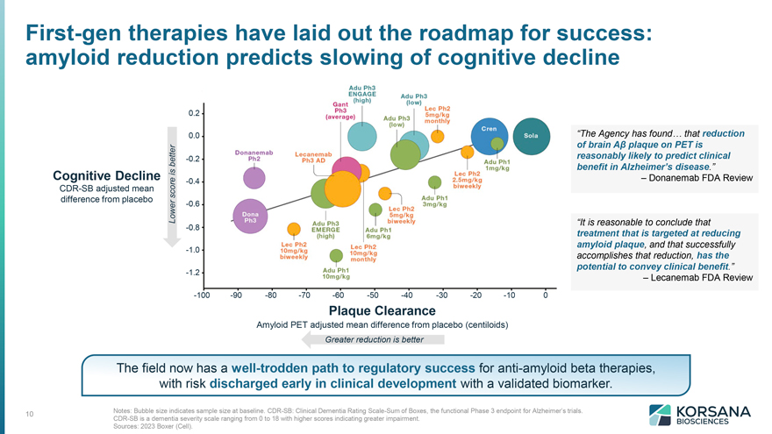
First-gen therapies have laid out the roadmap for success: amyloid reduction predicts slowing of cognitive decline “The Agency has found that reduction of brain Aß plaque on PET is reasonably likely to predict clinical benefit in Alzheimer’s disease.” – Donanemab FDA Review “It is reasonable to conclude that treatment that is targeted at reducing amyloid plaque, and that successfully accomplishes that reduction, has the potential to convey clinical benefit.” – Lecanemab FDA Review Cognitive Decline CDR-SB adjusted mean difference from placebo Plaque Clearance Amyloid PET adjusted mean difference from placebo (centiloids) Greater reduction is better The field now has a well-trodden path to regulatory success for anti-amyloid beta therapies, with risk discharged early in clinical development with a validated biomarker. Notes: Bubble size indicates sample size at baseline. CDR-SB: Clinical Dementia Rating Scale-Sum of Boxes, the functional Phase 3 endpoint for Alzheimer’s trials. CDR-SB is a dementia severity scale ranging from 0 to 18 with higher scores indicating greater impairment. Sources: 2023 Boxer (Cell).


Shuttling is the best way to improve existing agents

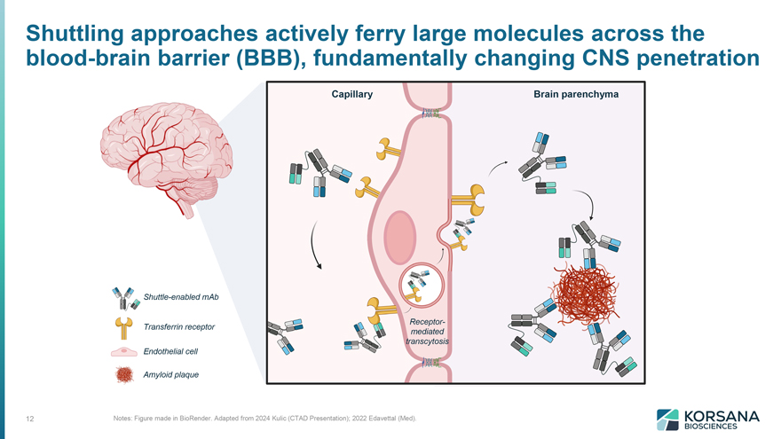
Shuttling approaches actively ferry large molecules across the blood-brain barrier (BBB), fundamentally changing CNS penetration Shuttle-enabled mAb Transferrin receptor Endothelial cell Amyloid plaque Notes: Figure made in BioRender. Adapted from 2024 Kulic (CTAD Presentation); 2022 Edavettal (Med). Capillary Brain parenchyma

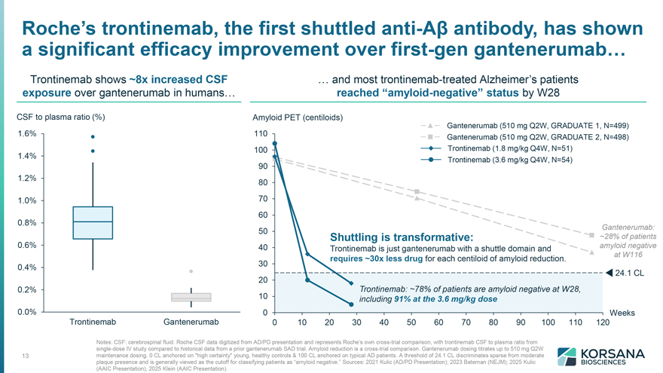
Roche’s trontinemab, the first shuttled anti-Aß antibody, has shown a significant efficacy improvement over first-gen gantenerumab Trontinemab shows ~8x increased CSF exposure over gantenerumab in humans and most trontinemab-treated Alzheimer’s patients reached “amyloid-negative” status by W28 CSF to plasma ratio (%) Amyloid PET (centiloids) Gantenerumab (510 mg Q2W, GRADUATE 1, N=499) Gantenerumab (510 mg Q2W, GRADUATE 2, N=498) Trontinemab (1.8 mg/kg Q4W, N=51) Trontinemab (3.6 mg/kg Q4W, N=54) Gantenerumab: ~28% of patients amyloid negative at W116 Shuttling is transformative: Trontinemab is just gantenerumab with a shuttle domain and requires ~30x less drug for each centiloid of amyloid reduction. CSF to plasma ratio (%) Amyloid PET (centiloids) Trontinemab: ~78% of patients are amyloid negative at W28, including 91% at the 3.6 mg/kg dose Notes: CSF: cerebrospinal fluid. Roche CSF data digitized from AD/PD presentation and represents Roche’s own cross-trial comparison, with trontinemab CSF to plasma ratio from single-dose IV study compared to historical data from a prior gantenerumab SAD trial. Amyloid reduction is a cross-trial comparison. Gantenerumab dosing titrates up to 510 mg Q2W maintenance dosing. 0 CL anchored on “high certainty” young, healthy controls & 100 CL anchored on typical AD patients. A threshold of 24.1 CL discriminates sparse from moderate plaque presence and is generally viewed as the cutoff for classifying patients as “amyloid negative.” Sources: 2021 Kulic (AD/PD Presentation); 2023 Bateman (NEJM); 2025 Kulic (AAIC Presentation), 2025 Klein (AAIC Presentation).

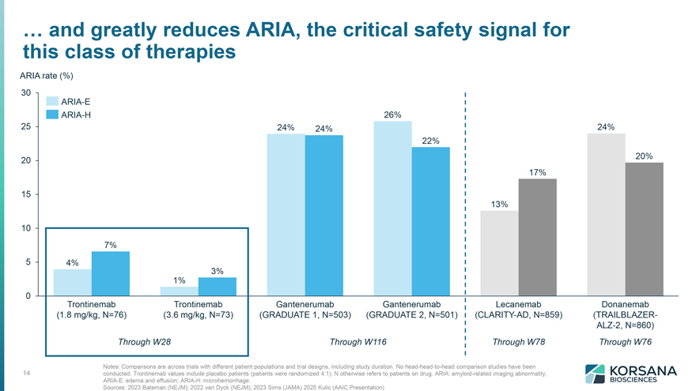
and greatly reduces ARIA, the critical safety signal for this class of therapies ARIA rate (%)Trontinemab (1.8 mg/kg, N=76) Trontinemab (3.6 mg/kg, N=73) Gantenerumab (GRADUATE 1, N=503) Gantenerumab (GRADUATE 2, N=501) Lecanemab (CLARITY-AD, N=859) Donanemab (TRAILBLAZERALZ- 2, N=860) 4% 7% 1% 3% 24% 24% 26% 22% 13% 17% 24% 20% ARIA-E ARIA-H Through W28 Through W116 Through W78 Through W76 Notes: Comparisons are across trials with different patient populations and trial designs, including study duration. No head-head-to-head comparison studies have been conducted. Trontinemab values include placebo patients (patients were randomized 4:1); N otherwise refers to patients on drug. ARIA: amyloid-related imaging abnormality; ARIA-E: edema and effusion; ARIA-H: microhemorrhage. Sources: 2023 Bateman (NEJM); 2022 van Dyck (NEJM); 2023 Sims (JAMA) 2025 Kulic (AAIC Presentation)

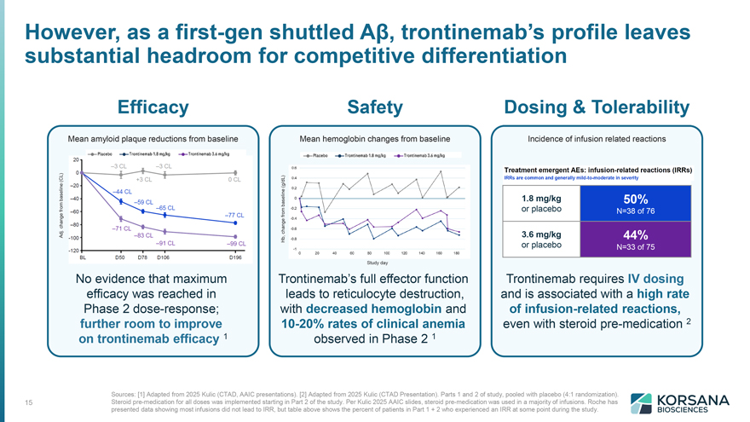
However, as a first-gen shuttled Aß, trontinemab’s profile leaves substantial headroom for competitive differentiation Efficacy Safety Dosing & Tolerability Mean amyloid plaque reductions from baseline No evidence that maximum efficacy was reached in Phase 2 dose-response; further room to improve on trontinemab efficacy 1 Safety Trontinemab’s full effector function leads to reticulocyte destruction, with decreased hemoglobin and 10-20% rates of clinical anemia observed in Phase 2 1 Dosing & Tolerability Incidence of infusion related reactions Trontinemab requires IV dosing and is associated with a high rate of infusion-related reactions, even with steroid pre-medication 2 Sources: [1] Adapted from 2025 Kulic (CTAD, AAIC presentations). [2] Adapted from 2025 Kulic (CTAD Presentation). Parts 1 and 2 of study, pooled with placebo (4:1 randomization). Steroid pre-medication for all doses was implemented starting in Part 2 of the study. Per Kulic 2025 AAIC slides, steroid pre-medication was used in a majority of infusions. Roche has presented data showing most infusions did not lead to IRR, but table above shows the percent of patients in Part 1 + 2 who experienced an IRR at some point during the study.


Korsana has the potential best-in-class approach

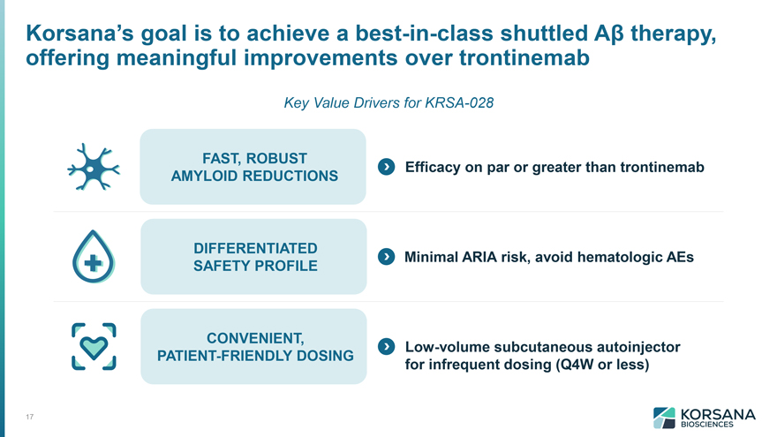
Korsana’s goal is to achieve a best-in-class shuttled Aß therapy, offering meaningful improvements over trontinemab Key Value Drivers for KRSA-028 FAST, ROBUST AMYLOID REDUCTIONS Efficacy on par or greater than trontinemab Minimal ARIA DIFFERENTIATED risk, avoid hematologic AEs SAFETY PROFILE Low-volume subcutaneous autoinjector for infrequent dosing (Q4W or less)

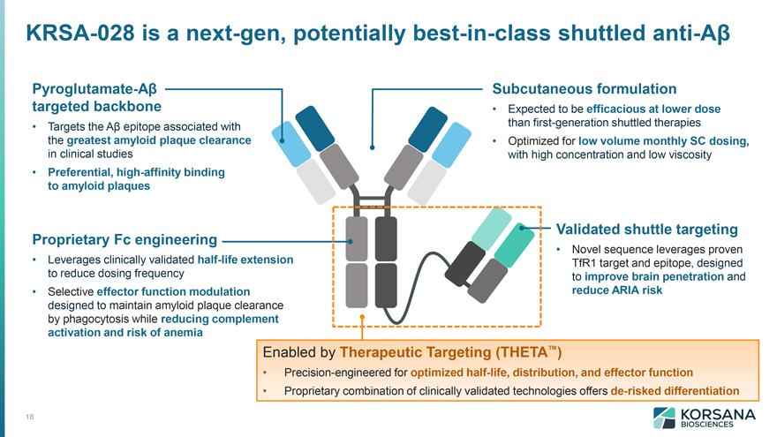
KRSA-028 is a next-gen, potentially best-in-class shuttled anti-Aß Pyroglutamate-Aß targeted backbone  Targets the Aß epitope associated with the greatest amyloid plaque clearance in clinical studies  Preferential, high-affinity binding to amyloid plaques Subcutaneous formulation  Expected to be efficacious at lower dose than first-generation shuttled therapies  Optimized for low volume monthly SC dosing, with high concentration and low viscosity Proprietary Fc engineering  Leverages clinically validated half-life extension to reduce dosing frequency  Selective effector function modulation designed to maintain amyloid plaque clearance by phagocytosis while reducing complement activation and risk of anemia Validated shuttle targeting  Novel sequence leverages proven TfR1 target and epitope, designed to improve brain penetration and reduce ARIA risk Enabled by Therapeutic Targeting (THETA )  Precision-engineered for optimized half-life, distribution, and effector function  Proprietary combination of clinically validated technologies offers de-risked differentiation

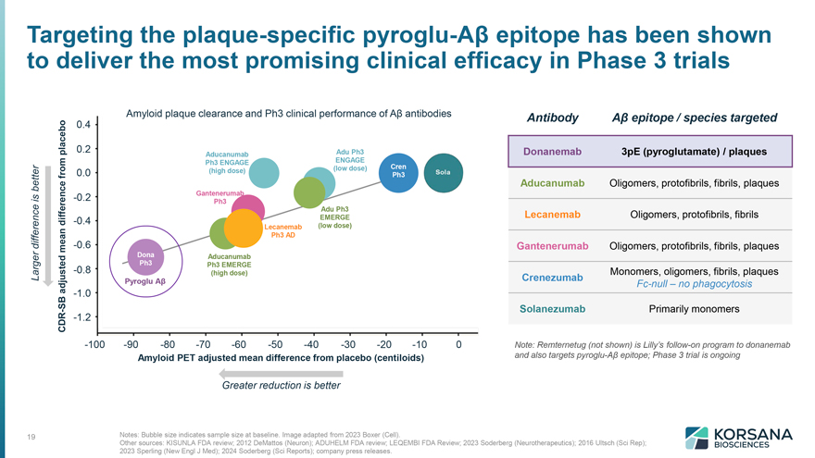
Targeting the plaque-specific pyroglu-Aß epitope has been shown to deliver the most promising clinical efficacy in Phase 3 trials Larger difference is better Amyloid PET adjusted mean difference from placebo (centiloids) CDR-SB adjusted mean difference from placebo Amyloid plaque clearance and Ph3 clinical performance of Aß antibodies Antibody Aß epitope / species targeted Donanemab 3pE (pyroglutamate) / plaques Aducanumab Oligomers, protofibrils, fibrils, plaques Lecanemab Oligomers, protofibrils, fibrils Gantenerumab Oligomers, protofibrils, fibrils, plaques Crenezumab Monomers, oligomers, fibrils, plaques Fc-null – no phagocytosis Solanezumab Primarily monomers Note: Remternetug (not shown) is Lilly’s follow-on program to donanemab and also targets pyroglu-Aß epitope; Phase 3 trial is ongoing Notes: Bubble size indicates sample size at baseline. Image adapted from 2023 Boxer (Cell). Other sources: KISUNLA FDA review; 2012 DeMattos (Neuron); ADUHELM FDA review; LEQEMBI FDA Review; 2023 Soderberg (Neurotherapeutics); 2016 Ultsch (Sci Rep); 2023 Sperling (New Engl J Med); 2024 Soderberg (Sci Reports); company press releases.

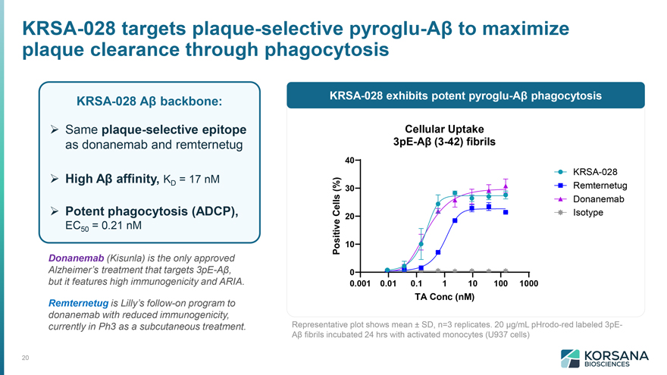
KRSA-028 targets plaque-selective pyroglu-Aß to maximize plaque clearance through phagocytosis KRSA-028 Aß backbone: Same plaque-selective epitope as donanemab and remternetug High Aß affinity, KD = 17 nM Potent phagocytosis (ADCP), EC50 = 0.21 nM Donanemab (Kisunla) is the only approved Alzheimer’s treatment that targets 3pE-Aß, but it features high immunogenicity and ARIA. Remternetug is Lilly’s follow-on program to donanemab with reduced immunogenicity, currently in Ph3 as a subcutaneous treatment. KRSA-028 exhibits potent pyroglu-Aß phagocytosis Representative plot shows mean ± SD, n=3 replicates. 20 µg/mL pHrodo-red labeled 3pEAß fibrils incubated 24 hrs with activated monocytes (U937 cells)

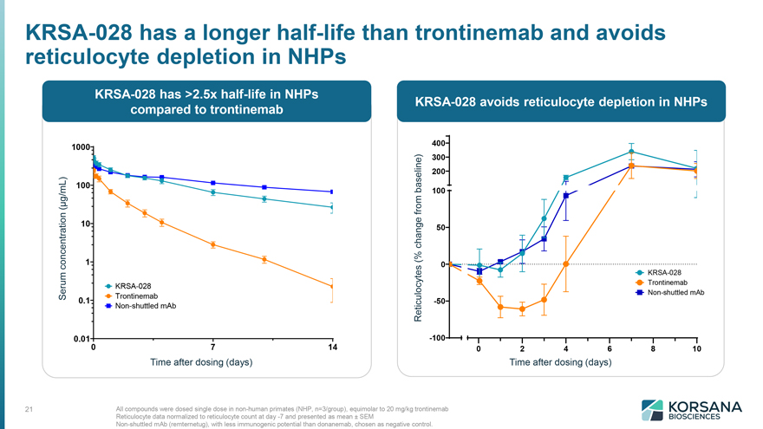
KRSA-028 has a longer half-life than trontinemab and avoids reticulocyte depletion in NHPs KRSA-028 has >2.5x half-life in NHPs compared to trontinemab Serum Concentration ( µg/mL Time after dosing (days) KRSA-028 avoids reticulocyte depletion in NHPs Reticulocytes (% change from baseline) Time after dosing (days) All compounds were dosed single dose in non-human primates (NHP, n=3/group), equimolar to 20 mg/kg trontinemab Reticulocyte data normalized to reticulocyte count at day -7 and presented as mean ± SEM Non-shuttled mAb (remternetug), with less immunogenic potential than donanemab, chosen as negative control.

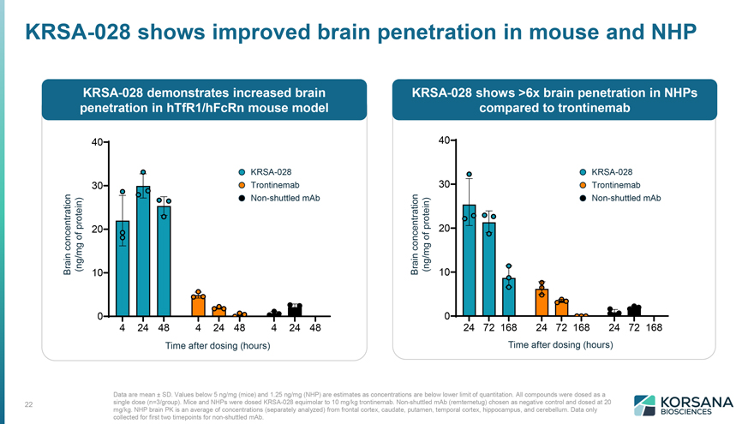
KRSA-028 shows improved brain penetration in mouse and NHP KRSA-028 demonstrates increased brain penetration in hTfR1/hFcRn mouse model Time after dosing (hours) Time after dosing (hrs) Data are mean ± SD. Values below 5 ng/mg (mice) and 1.25 ng/mg (NHP) are estimates as concentrations are below lower limit of quantitation. All compounds were dosed as a single dose (n=3/group). Mice and NHPs were dosed KRSA-028 equimolar to 10 mg/kg trontinemab. Non-shuttled mAb (remternetug) chosen as negative control and dosed at 20 mg/kg. NHP brain PK is an average of concentrations (separately analyzed) from frontal cortex, caudate, putamen, temporal cortex, hippocampus, and cerebellum. Data only collected for first two timepoints for non-shuttled mAb.

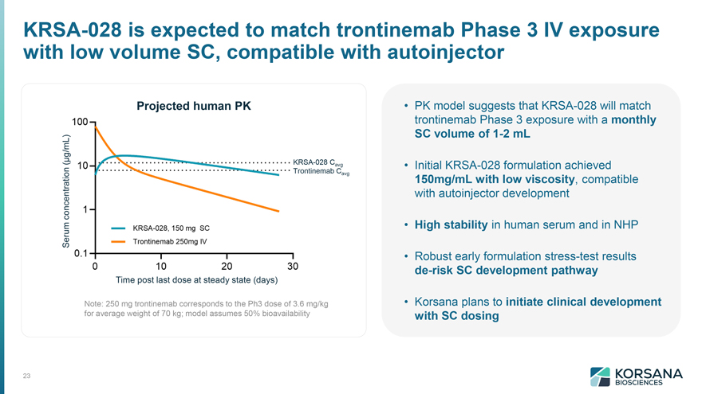
KRSA-028 is expected to match trontinemab Phase 3 IV exposure with low volume SC, compatible with autoinjector Projected human PK Serum concentration (µg/mL) Time post last dose at steady state (days) Note: 250 mg trontinemab corresponds to the Ph3 dose of 3.6 mg/kg for average weight of 70 kg; model assumes 50% bioavailability PK model suggests that KRSA-028 will match trontinemab Phase 3 exposure with a monthly SC volume of 1-2 mL  Initial KRSA-028 formulation achieved 150mg/mL with low viscosity, compatible with autoinjector development  High stability in human serum and in NHP  Robust early formulation stress-test results de-risk SC development pathway  Korsana plans to initiate clinical development with SC dosing

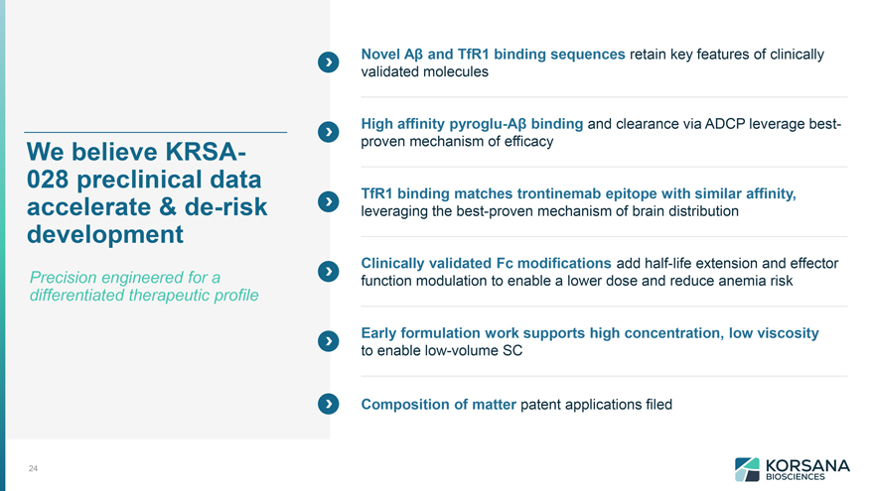
We believe KRSA- 028 preclinical data accelerate & de-risk development 24 Precision engineered for a differentiated therapeutic profile Novel Aß and TfR1 binding sequences retain key features of clinically validated molecules High affinity pyroglu-Aß binding and clearance via ADCP leverage bestproven mechanism of efficacy TfR1 binding matches trontinemab epitope with similar affinity, leveraging the best-proven mechanism of brain distribution Clinically validated Fc modifications add half-life extension and effector function modulation to enable a lower dose and reduce anemia risk Early formulation work supports high concentration, low viscosity to enable low-volume SC Composition of matter patent applications filed


Korsana has a rapid path to value creation

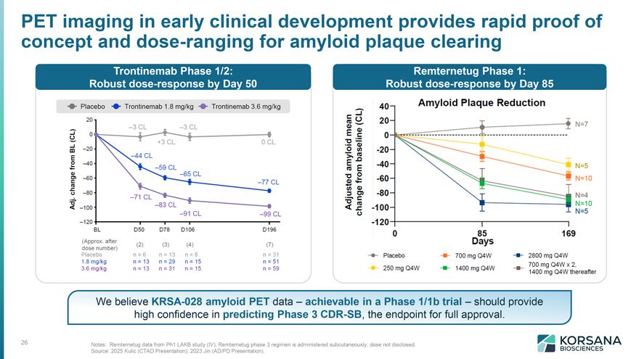
PET imaging in early clinical development provides rapid proof of concept and dose-ranging for amyloid plaque clearing Trontinemab Phase 1/2: Robust dose-response by Day 50 Remternetug Phase 1: Robust dose-response by Day 85 We believe KRSA-028 amyloid PET data – achievable in a Phase 1/1b trial – should provide high confidence in predicting Phase 3 CDR-SB, the endpoint for full approval. Notes: Remternetug data from Ph1 LAKB study (IV). Remternetug phase 3 regimen is administered subcutaneously; dose not disclosed. Source: 2025 Kulic (CTAD Presentation); 2023 Jin (AD/PD Presentation).

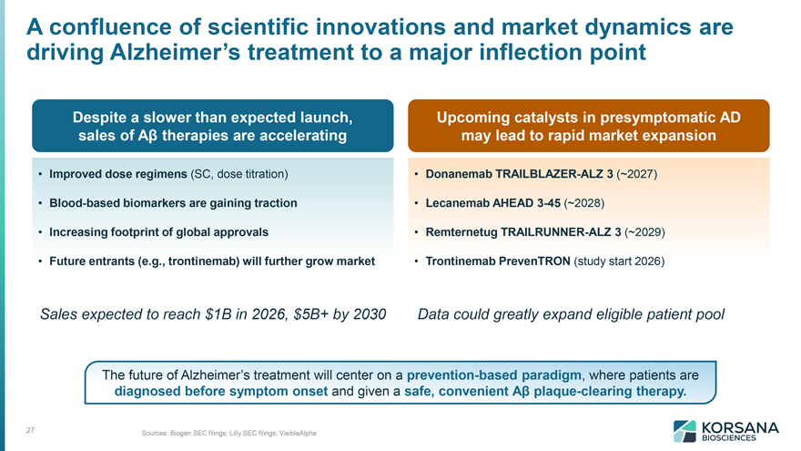
A confluence of scientific innovations and market dynamics are driving Alzheimer’s treatment to a major inflection point Despite a slower than expected launch, sales of Aß therapies are accelerating Improved dose regimens (SC, dose titration)  Blood-based biomarkers are gaining traction  Increasing footprint of global approvals  Future entrants (e.g., trontinemab) will further grow market Upcoming catalysts in presymptomatic AD may lead to rapid market expansion Donanemab TRAILBLAZER-ALZ 3 (~2027)  Lecanemab AHEAD 3-45 (~2028)  Remternetug TRAILRUNNER-ALZ 3 (~2029)  Trontinemab PrevenTRON (study start 2026) Sales expected to reach $1B in 2026, $5B+ by 2030 Data could greatly expand eligible patient pool The future of Alzheimer’s treatment will center on a prevention-based paradigm, where patients are diagnosed before symptom onset and given a safe, convenient Aß plaque-clearing therapy. Sources: Biogen SEC filings; Lilly SEC filings; VisibleAlpha

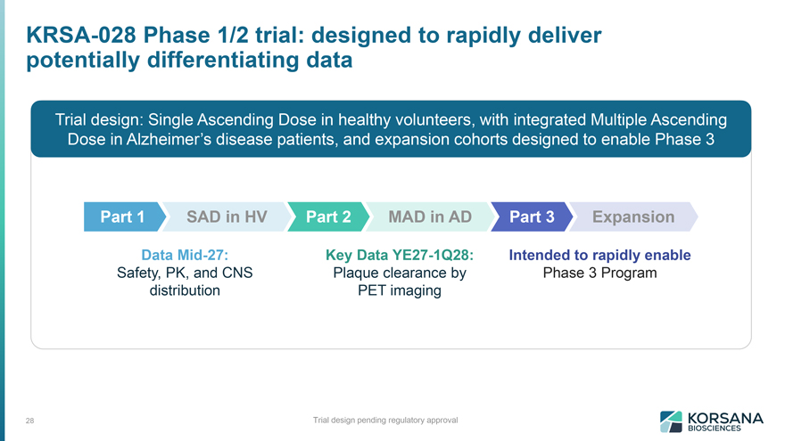
KRSA-028 Phase 1/2 trial: designed to rapidly deliver potentially differentiating data 28 Trial design: Single Ascending Dose in healthy volunteers, with integrated Multiple Ascending Dose in Alzheimer’s disease patients, and expansion cohorts designed to enable Phase 3 Part 1 SAD in HV Data Mid-27: Safety, PK, and CNS Distribution Part 2 MAD in AD Key Data YE27-1Q28: Plaque clearance by PET imaging Key Data YE27-1Q28: Plaque clearance by PET imaging Intended to rapidly enable Phase 3 Program Trial design pending regulatory approval

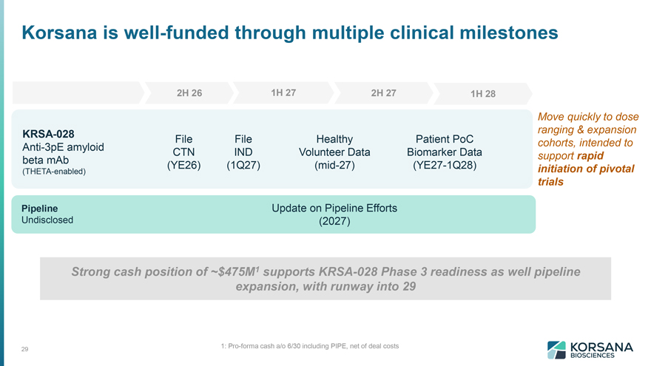
Korsana is well-funded through multiple clinical milestones 2H 26 KRSA-028 Anti-3pE amyloid beta mAb (THETA-enabled) File CTN (YE26) File IND (1Q27) 1H 27 2H 27 Healthy Volunteer Data (mid-27) 1H 28 Patient PoC Biomarker Data (YE27-1Q28) Pipeline Undisclosed Update on Pipeline Efforts (2027) Strong cash position of ~$475M1 supports KRSA-028 Phase 3 readiness as well pipeline expansion, with runway into 29 1: Pro-forma cash a/o 6/30 including PIPE, net of deal costs

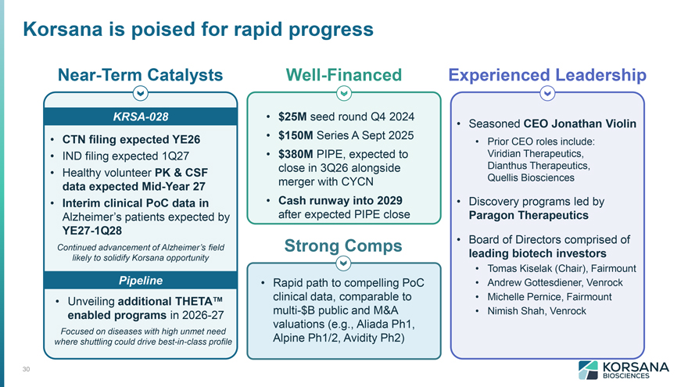
Korsana is poised for rapid progress Near-Term Catalysts KRSA-028 CTN filing expected YE26  IND filing expected 1Q27  Healthy volunteer PK & CSF data expected Mid-Year 27  Interim clinical PoC data in Alzheimer’s patients expected by YE27-1Q28 Continued advancement of Alzheimer’s field likely to solidify Korsana opportunity Pipeline Unveiling additional THETA enabled programs in 2026-27 Focused on diseases with high unmet need where shuttling could drive best-in-class profile Well-Financed $25M seed round Q4 2024  $150M Series A Sept 2025  $380M PIPE, expected to close in 3Q26 alongside merger with CYCN  Cash runway into 2029 after expected PIPE close Strong Comps Rapid path to compelling PoC clinical data, comparable to multi-$B public and M&A valuations (e.g., Aliada Ph1, Alpine Ph1/2, Avidity Ph2) Experienced Leadership Seasoned CEO Jonathan Violin  Prior CEO roles include: Viridian Therapeutics, Dianthus Therapeutics, Quellis Biosciences  Discovery programs led by Paragon Therapeutics  Board of Directors comprised of leading biotech investors  Tomas Kiselak (Chair), Fairmount  Andrew Gottesdiener, Venrock  Michelle Pernice, Fairmount  Nimish Shah, Venrock

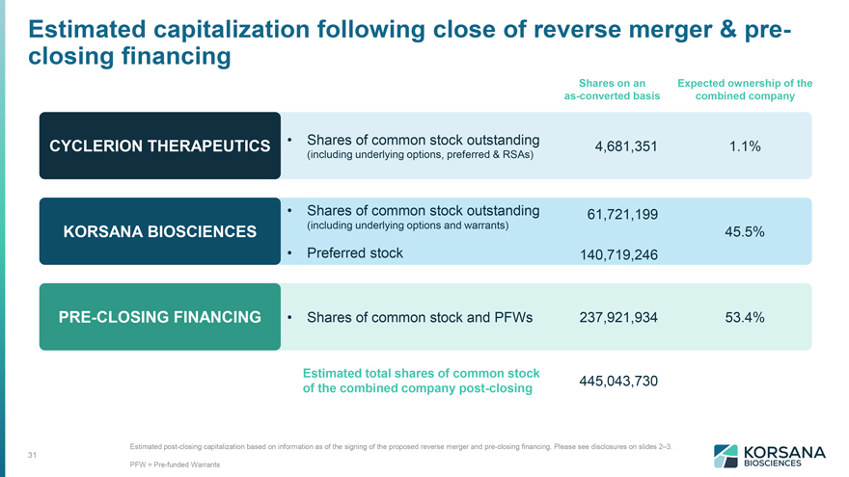
Estimated capitalization following close of reverse merger & preclosing Financing CYCLERION THERAPEUTICS  Shares of common stock outstanding (including underlying options, preferred & RSAs) KORSANA BIOSCIENCES  Shares of common stock outstanding (including underlying options and warrants)  Preferred stock PRE-CLOSING FINANCING  Shares of common stock and PFWs Shares on an as-converted basis Expected ownership of the combined company 4,681,351 1.1% 61,721,199 45.5% 140,719,246 237,921,934 53.4% Estimated total shares of common stock 445,043,730 of the combined company post-closing Estimated post-closing capitalization based on information as of the signing of the proposed reverse merger and pre-closing financing. Please see disclosures on slides 2–3. PFW = Pre-funded Warrants


Thank you

Forward-Looking Statements
This communication contains forward-looking statements (including within the meaning of Section 21E of the Exchange Act and Section 27A of the Securities Act) concerning Cyclerion, Korsana, the proposed transactions and other matters. These forward-looking statements include express or implied statements relating to the structure, timing and completion of the proposed Merger; the combined company’s listing on Nasdaq after closing of the proposed Merger; expectations regarding the ownership structure of the combined company; expectations regarding the financing transaction and the closing thereof; the expected executive officers and directors of the combined company; the expected contribution and payment of dividends in connection with the Merger, including the timing thereof; the future operations of the combined company; the nature, strategy and focus of the combined company; the development and commercial potential and potential benefits of any product candidates of the combined company; anticipated preclinical and clinical drug development activities and related timelines, including the expected timing for data and other clinical results; and other statements that are not historical fact. The words “anticipate,” “believe,” “contemplate,” “continue,” “could,” “estimate,” “expect,” “intends,” “may,” “might,” “plan,” “possible,” “potential,” “predict,” “project,” “should,” “will,” “would” and similar expressions (including the negatives of these terms or variations of them) may identify forward-looking statements, but the absence of these words does not mean that a statement is not forward-looking. These forward-looking statements are based on current expectations and beliefs concerning future developments and their potential effects. There can be no assurance that future developments affecting Cyclerion, Korsana or the proposed transaction will be those that have been anticipated.
The forward-looking statements contained in this communication are based on current expectations and beliefs concerning future developments and their potential effects and therefore subject to other risks and uncertainties. These risks and uncertainties include, but are not limited to, risks associated with the possible failure to satisfy the conditions to the closing or consummation of the Merger, including Cyclerion’s failure to obtain shareholder approval for the Merger, risks associated with the potential failure to complete the financing transaction in a timely manner or at all, risks associated with the uncertainty as to the timing of the consummation of the Merger and the ability of each of Cyclerion and Korsana to consummate the transactions contemplated by the Merger, risks associated with Cyclerion’s continued listing on Nasdaq until closing of the Merger, the failure or delay in obtaining required approvals from any governmental or quasi-governmental entity necessary to consummate the Merger; the occurrence of any event, change or other circumstance or condition that could give rise to the termination of the Merger prior to the closing or

consummation of the Merger, risks associated with the possible failure to realize certain anticipated benefits of the Merger, including with respect to future financial and operating results; the effect of the completion of the Merger on the combined company’s business relationships, operating results and business generally; risks associated with the combined company’s ability to manage expenses and unanticipated spending and costs that could reduce the combined company’s cash resources; risks related to the combined company’s ability to correctly estimate its operating expenses and other events; changes in capital resource requirements; risks related to the inability of the combined company to obtain sufficient additional capital to continue to advance its product candidates or its preclinical programs; the outcome of any legal proceedings that may be instituted against the combined company or any of its directors or officers related to the Merger Agreement or the transactions contemplated thereby; the ability of the combined company to obtain, maintain and protect its intellectual property rights, in particular those related to its product candidates; the combined company’s ability to advance the development of its product candidates or preclinical activities under the timelines it anticipates in planned and future clinical trials; the combined company’s ability to replicate in later clinical trials positive results found in preclinical studies and early-stage clinical trials of its product candidates; the combined company’s ability to realize the anticipated benefits of its research and development programs, strategic partnerships, licensing programs or other collaborations; regulatory requirements or developments and the combined company’s ability to obtain necessary approvals from the U.S. Food and Drug Administration or other regulatory authorities; changes to clinical trial designs and regulatory pathways; competitive responses to the Merger and changes in expected or existing competition; unexpected costs, charges or expenses resulting from the Merger; potential adverse reactions or changes to business relationships resulting from the completion of the Merger; legislative, regulatory, political and economic developments; and those risks and uncertainties and other factors more fully described in filings with the Securities and Exchange Commission, including reports filed on Form 10-K, 10-Q and 8-K and in other filings made by Cyclerion with the SEC from time to time and available at www.sec.gov. These forward-looking statements are based on current expectations, and with regard to the proposed transaction, are based on Cyclerion’s current expectations, estimates and projections about the expected date of closing of the proposed transaction and the potential benefits thereof, its business and industry, management’s beliefs and certain assumptions made by Cyclerion, all of which are subject to change. Such forward-looking statements are made as of the date of this release, and the parties undertake no obligation to update such statements to reflect subsequent events or circumstances, except as otherwise required by securities and other applicable law.
No Offer or Solicitation
This communication is not intended to and does not constitute (i) a solicitation of a proxy, consent or approval with respect to any securities or in respect of the proposed transaction or (ii) an offer to sell or the solicitation of an offer to subscribe for or buy or an invitation to purchase or subscribe for any securities pursuant to the proposed transaction or otherwise, nor shall there be any sale, issuance or transfer of securities in any jurisdiction in contravention of applicable law. No offer of securities shall be made except by means of a prospectus meeting the requirements of the Securities Act or an exemption therefrom. Subject to certain exceptions to be approved by the relevant regulators or certain facts to be ascertained, the public offer will not be made directly or indirectly, in or into any jurisdiction where to do so would constitute a violation of the laws of such jurisdiction, or by use of the mails or by any means or instrumentality (including without limitation, facsimile transmission, telephone and the internet) of interstate or foreign commerce, or any facility of a national securities exchange, of any such jurisdiction.
NEITHER THE SEC NOR ANY STATE SECURITIES COMMISSION HAS APPROVED OR DISAPPROVED OF THE SECURITIES OR DETERMINED IF THIS COMMUNICATION IS TRUTHFUL OR COMPLETE.
Important Additional Information About the Proposed Transaction
This communication does not substitute for the Form S-4, proxy statement/prospectus or for any other document that Cyclerion has filed or may file with the SEC in connection with the proposed transaction. In connection with the proposed transaction between Cyclerion and Korsana, Cyclerion has filed relevant materials with the SEC, including the Form S-4 that contains a proxy statement/prospectus.
CYCLERION URGES INVESTORS AND STOCKHOLDERS TO READ THE FORM S-4, PROXY STATEMENT/PROSPECTUS AND ANY OTHER RELEVANT DOCUMENTS THAT HAVE BEEN OR MAY BE FILED WITH THE SEC, AS WELL AS ANY AMENDMENTS OR SUPPLEMENTS TO THOSE DOCUMENTS, CAREFULLY AND IN THEIR ENTIRETY IF AND WHEN THEY BECOME AVAILABLE

BECAUSE THEY CONTAIN OR WILL CONTAIN IMPORTANT INFORMATION ABOUT CYCLERION, KORSANA, THE PROPOSED TRANSACTION AND RELATED MATTERS.
Investors and stockholders can obtain free copies of the Form S-4 and other documents filed by Cyclerion with the SEC (when they become available) through the website maintained by the SEC at www.sec.gov. In addition, investors and stockholders should note that Cyclerion communicates with investors and the public using its website (www.cyclerion.com) and the investor relations website (www.cyclerion.com/investor-resources) where anyone is able to obtain free copies of the Form S-4 and other documents filed by Cyclerion with the SEC and stockholders are urged to read the Form S-4 and the other relevant materials when they become available before making any voting or investment decision with respect to the proposed transaction.
Participants in the Solicitation
Cyclerion, Korsana and their respective directors and executive officers may be deemed to be participants in the solicitation of proxies from stockholders in connection with the proposed transaction. Information about Cyclerion’s directors and executive officers including a description of their interests in Cyclerion is included in Cyclerion’s Annual Report on Form 10-K, as filed with the SEC on March 30, 2026 and amended on April 30, 2026, and in subsequent reports filed with the SEC. Additional information regarding these persons and their interests in the proposed transaction are included in the Form S-4 relating to the proposed transaction filed with the SEC. These documents can be obtained free of charge from the sources indicated above.

